Rehan Ali Shah
Student Number : 2241266
Module:BMIH4002 Food & Beverage Operations
Title: Menu Engineering
Module Tutor: Antoinette Milne
Submission date: 10/11/2023
Word count 440

Table of Contents
Part 1: Restaurant Concept 3
Introduction 3
Restaurant Concept 3
Target Audience 3
Reasons behind the Menu Choice 4
Conclusion 4
Part 2: Menu Design 5
References 6

Part 1: Restaurant Concept

Introduction
Every successful restaurant begins its business with a unique and creative concept that attracts the customer to experience the hotel's great services (Walker, 2021). The assessment provides the restaurant concept for the hotel Trinity which is located in the UK within Swansea. The creative restaurant concept determines the identity of the hotel, its culture, experience, and menu. It helps the restaurant to create a difference from others (Nguyen et al., 2022). A well-managed restaurant concept helps the particular target customers to attract towards the services of the hotels and develop memorable dining experiences for the consumers. The menu has to be relevant to the restaurant concept to gain more attention from the customers (Şenel and Yılmaz, 2019).

Restaurant Concept
Selecting the seafood idea for the 4-star hotel Trinity at Swansea is the creative aspect of exploring the attention of people who love seafood (Juliana et al., 2021). Seafood makes an excellent choice to use as the small dishes on the menu which means the seafood is called the star of the restaurant. Seafood is easily prepared by the chef in the hotel kitchen (Chen et al., 2020). Hotel Trinity provides the top-quality ingredients that are used in the seafood as compared to its competitors which is Delta hotels at Swansea which also introduces the seafood in their menu. Hotel Trinity uses natural and organic ingredients to prepare the seafood (Kraak, 2019).
Target Audience
Seafood is considered lighter than the various kinds of meat dishes which have a chance to increase the fats in the body and people prefer light foods in their diet which makes them feel healthy and light (Chark and IP, 2023). People from different states visit the Hotel Trinity to taste the seafood specialty (Petrc et al., 2019). And it helps the hotel to gain attractive customers at the international level also along with local ones (ÖZAYDIN and GÜZELLER, 2021).
Reasons behind the Menu Choice
Crab cakes are the most prominent choice to have a strong position to put up in the seafood menu selection as the Hotel Trinity provides the amazing taste of the dish to the customers (Dua et al., 2022). The hotel provides fish pasta that tastes like heaven and is good to feel. Salmon with potatoes provides the comfort zone within the seafood with a healthier diet (Walker, 2021).

Conclusion
The seafood concept is selected for the hotel Trinity. The concept of Seafood has a specialty to attract and gain a majority of people towards the hotel because of its amazing taste and making the customers feel good. Naturally, Seafood can obtain the natural ingredients in it which is beneficial for people's health.

Part 2: Menu Design
4-Star Hotel Trinity (Swansea, UK)

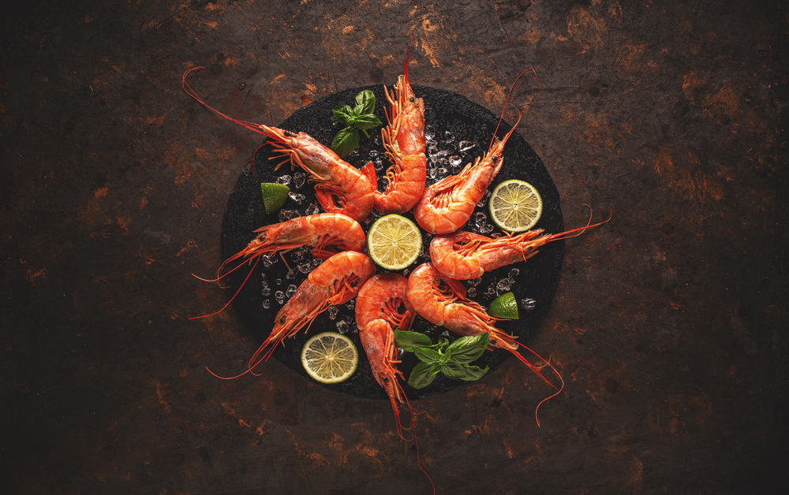

Drinks 🥤
Pine apple Juice £5
Mango Shake £20
Apple Juice £10
Beverages £15

Main Courses 🛎️
Lobsters £20
Fish Pasta £40
Salmon with Potatoes £50
Seasonal Crab Soup £40

Side Dishes 🍛
Fish Fries £10
Fish Steak £15
Fish and Salmon Rice (Seasonal) £20

Desserts 🍨
Crab Cakes £30 (Special)

References
Chark, R. and IP, M.M.H., 2023. Is menu design effective? A p-curving analysis. International Journal of Hospitality Management, 108, p.103378.
Chen, H.T., Chen, K.H. and Wang, C.H., 2020. Customer-based menu layout design and labeling indices. Journal of Economics and Management.
Dua, S., Sahai, C. and Mane, S., 2022. Can Healthy Food Menus be Introduced in Restaurants? ATITHYA: A Journal of Hospitality, 8(2).
Juliana, J., Pramezwary, A., Nukak, N.A. and Situmorang, J.M.H., 2021. Using contribution of menu engineering in upscale restaurants to enhance sales volume. International Journal of Social and Management Studies, 2(4), pp.1-12.
Kraak, V., 2019. Foodservice and restaurant sectors. In Healthy and Sustainable Food Systems (pp. 103-113). Routledge.
Nguyen, L., Gao, Z. and Anderson, J.L., 2022. Regulating menu information: What do consumers care and not care about at casual and fine dining restaurants for seafood consumption? Food Policy, 110, p.102272.
ÖZAYDIN, C. and GÜZELLER, C.O., 2021. Examining the selections in restaurant menus with eye-tracking technique. Journal of Tourism & Gastronomy Studies, 9(3), pp.1460-1481.
Petrc, A., Mikinac, K. and Edmonds, I., 2019, September. Strategic approaches to menu translation analysis. In ToSEE-Tourism in Southern and Eastern Europe-Conference Proceedings (Vol. 5, pp. 689-703).
Şenel, P. and Yılmaz, H., 2019, October. Concept Restaurants. In 20th National and 4th International Tourism Congress (pp. 134-141).
Walker, J.R., 2021. The restaurant: from concept to operation. John Wiley & Sons.

