PROFESSIONAL CAREER DEVELOPMENT
BMSK 4005_LON
LECTURER – DR ANUPAM MAZUMDAR.

CONTENTS
Introduction………………………………………………………………………………………………………………………………………..
Personal Lifeline Journey……………………………………………………………………………………………………………………..
Skills and Knowledge Contributed……………………………………………………………………………………………………….
Self-Motivation Review………………………………………………………………………………………………………………………
Self-Motivation Quiz…………………………………………………………………………………………………………………………..
Learning Styles……………………………………………………………………………………………………………………………………
VAK Learning Styles……………………………………………………………………………………………………………………………
Kolb Learning Styles…………………………………………………………………………………………………………………………..
Honey and Mumford Learning Styles…………………………………………………………………………………………………
Personal Development Plan………………………………………………………………………………………………………………
SMART Objectives……………………………………………………………………………………………………………………………..
Johari Model…………………………………………………………………………………………………………………………………......
SWOT Analysis…………………………………………………………………………………………………………………………………….
Analysis of findings from evaluation evidences from literatures…………………………………………………………
Review of your understanding and expectations of world of employment………………………………………….
Career Ambitions and Aspirations……………………………………………………………………………………………………….
Personal Development Plan…………………………………………………………………………………………………………………
Action Plan…………………………………………………………………………………………………………………………………………..
Conclusion…………………………………………………………………………………………………………………………………………..
Reference…………………………………………………………………………………………………………………………………………….

INTRODUCTION
A Journey of a million miles has to begin with a step and the experience from the beginning of life journey, and the experience will help one to reflect on what has been done well and the ones that one could have done better, improve self-knowledge and identity, build on your employability skills because to be relevant in this digital Technologies one need to build both on is talent and personal development. In this assignment I will be discussing self- motivation, what motivate me and my learning style which led to VAK Learning Style, Kolb learning style and Honey and Mumford Learning Style all these learning styles have different impact in peoples life, every child has is own way of learning. I will also discuss my personal development plan and how l plan to achieve my plan in future.

MY LIFELINE JOURNEY
Everything in life has beginning and the end and this happens to be the journey of my life so far, l Japhet Nwaeke was born into the family of Mr & Mrs Joseph Nwaeke on the 23/08/1970 in a small-town call Ubulu Uku in Delta – State in Nigeria, African precisely. I could remember things that happened in my life from when l was 10 years of age till date, at 10 years old l gain admission into Sint Anthony’s College in Ubulu/ Uku in Delta State in Nigeria where l spent 6 years instead of five years and after my secondly school why my mates proceed to university l decided to travelled to city call Lagos, on getting there l find life more interesting as a result of development, so l dump the idea of furthering my education to seek for employment, so luckily l gain employment with a Coca cola company where l started working as a store attendant in the company and money started coming and life was good for me and school was not in my agenda till l was 30 years when l fell sick and l stay away from work for 12 months and after l recovered from my sickness l lost my job and l was home for one year doing nothing, but within that period l met one person Mr John Black who introduced me into business, l partner with him for 2 years after that l started my own business and grew in my business with a lot of cash inflow, that was when l went into importation and most of my goods were coming from Europe and business was really good for me, so one day l though of travelling to Europe by myself to be doing the purchase by myself not knowing that will be a setback for me, so l met one person Mr Felix Duke who promise to get me visa and take me to Europe to show me where l can get the best product at the cheapest rate not knowing that the man was a fraudster, and l was defraud by this man call Mr Felix Duke l was 35 years old at that time and life became so unbearable for me so frustrating that nearly led me into depression for 5 years and that was the end of my business all the money l made was completely lost l did not know how to start life again things were really difficult for me at that time but that it is part of life experience in the journey of life, but during my lonely period l luckily met one woman Mrs Joyce who introduce me to one Miss Gloria Okafor who was a British citizen who just came to Nigeria for holiday and luckily for me the lady liked me and we started dating and after 1 year we got married I was 40 years old and that same year l came down to UK at the age and that was how my life turn around for good for me again, l got a job with TSS a security company and ever since then l have been working in security firm, so February 2019 at the age of 47 years l decided to further my education and l applied for admission to University of Wales Trinity Saint David and luckily was admitted into the University where am studying Certificate of Higher Education which is a step in a right direction. On October 2019 at the 48 years with the help of my wife l became a British Citizen it was a remarkable day for me and my family a dream come through but that same year one thing happened to me in the same month of celebration that am yet to recovered was a the saddest news l ever received in my life, was the passing away of my lovely mother which l have not being able to overcome the pains it has created in my heart but l believe with time l will be heal. This is the story of my life so far and below is the diagram of life journey.

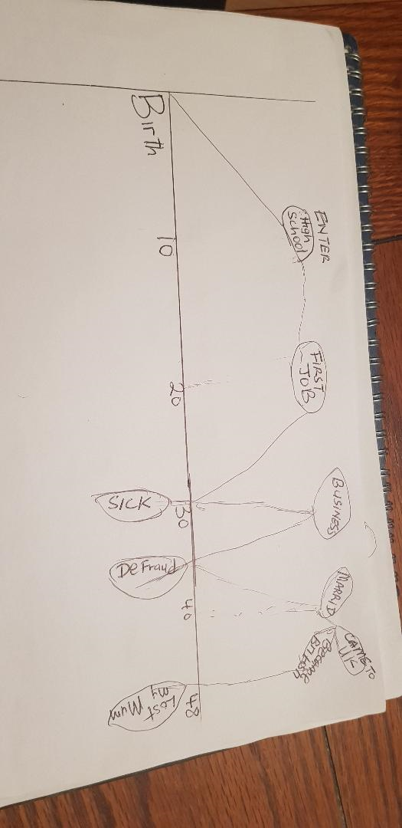

Skills and Knowledge Contribution: Skills are things you learn that will help you to do well in your work place, is a talent needed to do a particular task in your work place, the skills you got can make you stand out in your place of work. These are few skills that l will be discussing below, Communication Skills, Teamwork Skills, Problem Solving Skill, Initiative and Enterprise, Planning and Organising, Self- Management, Learning Skills, Technology Skills.

Communication Skill
Means being able to communicate with people in a very clear manner about what you mean and what you want to achieve when you speak or write, it involves listening to people and being able to understand where someone else is coming from. Communication Skills also include non-verbal communication, such as the body language you use when communicating with someone, there ways that one can improve his or her communication skills, for examples, writing your Assignment, by using Social Media [Facebook especially], through Oral presentation as part of your group class work ,School debate, Customer Service by communicating on the phone and in getting involved in your local community.

Teamwork Skill:
Means being able to get along with people you work with knowing fully that the aim is to achieve a common goal or to complete a task in the most effective and efficient way, examples of team work, is working together in a group assignments as a part of your studies, working as volunteer for local community organisation, joining a sporting team or Organising or planning event for family or friends.
PROBLEM SOLVING SKILL:
Means finding solutions to obstacles in a challenging or difficult situation, examples of ways one can improve or develop the problem solving skills is through research of assignments as part of your studies, watching you tube videos on problem solving, asking question from people who are more experience than you or people who have gone through similar situations.

INITIATIVE and ENTERISE SKILL --- means doing thing on your own without being told. Bing smart in your reasoning and being creative doing things differently, examples of Initiative Skills is setting up a fundraiser in your community or for your friend wedding or business, meeting business organisation for work placement, doing something in the house or community without being ask to do it.

PLANNING and ORGANSING
Means working out what one need to do and how it will be done. Planning and Organising involve developing project and meeting the time frame or deadline, examples of ways one can improve on planning and organising skills is by helping to plan weddings, Event, local community project, sporting competitions and end of year parties.

SELF MANAGEMENT SKILLS – means being able to manage situation independently or perform your job without someone supervising you at all time, delegating jobs to other people to make sure things get done at the appropriate time, examples of ways that you can develop management skills is by asking for new responsibilities at work, joining volunteer organisation and cleaning up your house is another way to improve self- management skill.
LEARNING SKILLS --- is about wanting to know or understand new things that you don’t know before, examples of ways to improve your learning skills is by researching skills and courses online, teaching yourself by watching you tube and practicing on you own, joining a class group through this you can share experience which is part of learning process.
TECHNOLOGY SKILLS--- means being able to use computer, phones, sending emails, word processing and knowing how to use office equipment like fax machines, photocopier in the workplace all this are technologies that needs skills to operate it.
SELF MOTIVATION
Self- Motivation is the ability to function well without the help from other people in a challenging situation, it means one encouraging himself to complete a task without the influence from others. The force that drives you to do things on you own is call self- motivation. According to [Bandura 1981] research, high self -efficacy result in an ability to view to view difficult goals are a challenge, whereas people with low self- efficacy would likely view the same goals as being beyond their abilities and might not even attempt to achieve them. It is not self- motivation when you go to the gym because your friend as you to go to the gym.

WHAT GIVES ME MOTIVATION
Good company --- when l speaks with my friends or colleague with positive mid set they help me to grow and see opportunities during challenging situation or tough times.
KEEP LEARNING---- When l read books, watch videos and research other great peoples work it motive me a lot and it makes me to read more and be hopeful that I will be greater than what I am today.
HELPING OTHERS--- I feel motivated when l see people that l have giving a helping hand becoming useful in the society or when people that l have help come back to me to appreciate me for what l have done for them in life, it gives me strength and makes me want to do more.
ACHIEVING MY GOALS---- When there is a targets set out for me to meet when l meet the deadline it gives me joy that l have being able to achieve my goal by meeting the target, it gives me a sense of accomplishment and sometime when l remember it motivate me that l can do better.
SOLVING PROBLEM---- when am able to analysis complex data in order to draw clear understanding in my workplace it makes me feel great and that encourages me to do more.
THE SELF- MOTIVATION QUIZ—my score interpretation – total was 33 you allow your personal doubts and fears to keep you from succeeding, you have probably had a few incomplete goals in the past, so you may have convinced yourself that you are not self—motivated and then you have made that come true. Break this harmful pattern now star believing in yourself again.
You are doing ok on self- motivation, you are certainly not failing, however you could achieve much more. To achieve what you want, try to increase motivation factors in all sections below and work on them to strengthen your self- motivation.
Wonderful: you get things done, and you don’t let anything stand in your way, you make a conscious effort to stay self- motivated and you spend significant time and effort on setting goals and acting to achieve those goals. You attract and inspire others with your success. Treasure this and be aware that not everyone is as self-motivated as you are.

THE LEARNING STYLES:
The word learning styles means the understanding that every child or student learns differently, how every person learning style uses different parts of the brain. By involving more of the brain when learning, we are more active and we remember more of what we learn. Technically every student style of learning depends on his or her own preferential way in which the child absorbs and keep information. For example, when learning how to make wall clock, some students understand the process by following verbal instructions, while some students will want to manipulate it physically by themselves. They are different types of learning style but l will be discussing only three out of many learning styles that it is available.
VAK LEARNING STYLES—The VAK learning style believe in three main sensory receivers, Visual, Auditory, and Kinesthetics to determine the dominant learning style. According to VAK theorists, we need to present information using all three styles, this gives all learners the chance to participate no matter what their preferred style may be [Rourke,al.2002],

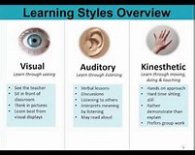

Figure 1: VAK LEARNING STYLE (Visual,Auditory,Kinaesthetic,&Tactile]. 29 May 2000. VAK learning style believe in three main sensory receivers: Visual, Auditory, and Kinaesthetic learning. It is based on modalities channels by which human expression can take place and is made up of a combination of perception and memory. VAK learning style seems to be about the most know or popular model as of today as a result of its simplicity. [University of Pennsylvania, 2009], it is more of preference style.
VISUAL LEARNING STYLE--- is a fashion in which a learner makes use of graphs, chart, maps and diagrams to learn.

KINESTHETIC LEARNING STYLE—is a learning style in which gaining knowledge of takes location by using of students carrying out physical activities, rather than listening to a lecture. According to Favre[2009], Dunn and Dunn outline kinaesthetic novices as students who require entire physique motion to procedure new and tough statistics.

AUDITORY LEARNING STYLE—is a learning style in which a person learns through listening, they depend on listening and talking as a predominant way of learning. Auditory learners should be capable to hear what is being said in order to understand. Auditory learners also use their listening and repeating competencies to type via the data that is sent to them.

Figure 1:KOLB LEARNING STYLE:[Kolb, 1984,p.38] Kolb learning style is on two theory works on two levels, a four-stage cycle of learning and four separate learning styles. He believes that learning involves the acquisition of abstract concepts that can be applied flexibly in different situations. Kolb also believe that learning is the process whereby knowledge is created through the transformation of experience. The four stage of Kolb learning cycle in which the learner touches all the bases; Concrete Experience this means a new experience or when the old experience is re explain again.
Reflective Observation of the New Experience - this is where one reflect on the experience he acquired. Abstract Conceptualization—is when your reflection of your experience on what you have learnt gives new idea or modification of an existing experience and the last one out of the four stages of Kolb learning cycle is the, Active Experimentation- this is where the learner will show case the world the ideas and experience he or she has acquired for the world to see what happens.

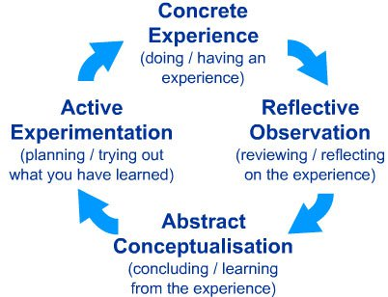

Figure 3 HONEY AND MUNFORD LEARNING STYLE [Honey & Alan Mumford, 1986] Honey and Mumford[1986] discovered four distinct learning styles that people prefer to use in learning: The Activist, Theorist; Pragmatist and Reflector, These are the learning approaches that individuals naturally prefer and they recommend that each learner ought to understand their learning style, seek out opportunities to learn using that style. Honey and Mumford have developed a learning Style QUESTIONNAIRE and with this information you will be in a better position to do three really useful things

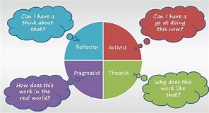

SMART OBJECTIVES-- It means that any person, group or organisation that wants to achieve their goal must be Specific, Measurable, Achievable, Realistic and Timely. Great goals are well defined and focused that means that before you go chasing off to measure your goals you must think of what your goals are.

JOHARI MODEL---Is materials use to demonstrate and develop self awareness and share understanding between individual within a circle. This model can be used to evaluate and develop a groups relationship with others team.

SWOT ANALYSIS--- Is a combination of skills and frameworks to help you to identify your Strengths, Weakness, Opportunities, and Treats to solve your business obstacles. It helps one to know he or she need to improve on for better tomorrow.

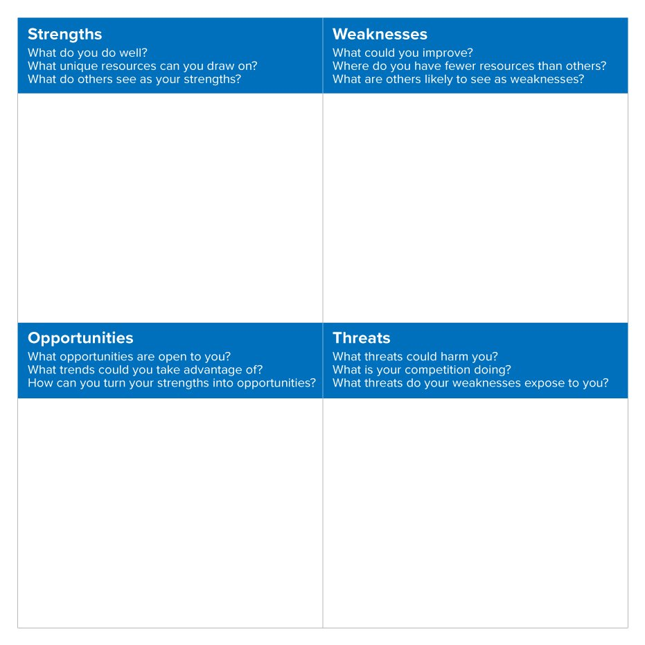
MY STRENGHT--- is communication
Because of my communication skills l will be able to communicate effectively which is the most important of all life skills. It is what help us to reach out to colleagues in the workplace. Communication is the ability to transfer information from one place to another. It might be verbal or non-verbal[ using body language, gestures and the tone]

MY WEAKNESS--- Time Management
Am not good at managing time very well which is not good for some one who wants to progress in life, when time is properly manage one stand to gain a lot both at workplace and outside work.
Time management is very important if it is properly managed it will reduce workplace stress and it will help one to build healthy and dedication in the workplace. Time management is important because it help to manage colleagues and projects and all the business will function efficiently and successfully.

MY OPPORTUNITIES—Communication skills
Because am good in communication l will be able to communicate with staffs and customers and this is added advantage for me to secure job in the labour market, l can relate with both employees and employers with my communicational skills.
MY THREATS--- HEALTH
Health challenges can prevent one from functioning in full capacity in the workplace.

REVIEW OF YOUR UNDERSTANDING AND YOUR EXPECTATION IN THE WORLD OF EMPLOYMENT.
In the employment world it involve the employers and the employees, there must be mutual understanding between both party. There are expectations from both side, and when the expectation is not fulfil there is always tendency that there will be conflicts because of breaking promises, when you take up a new job you try as much as possible to understand of what the employer is expects of you and think over it if it is obtainable before you accept the offer in other to avoid confrontation. Your new boss will expect you to have an open mind , so as to catch up with the learning process. They will expect you to take instructions and directions from the people training you and from your new supervisor. They will expect you to be that workplace on time and stay at work till your shift is over before you can leave your duty post. They will expect you to be reliable. Give a call to the office you are sick or unable to meet up your duty if there is unavoidable delayed on your way to work don’t just assumed that they will know. They will expect you to be honest and conduct yourself at all time professionally and always look dress in appropriate position.
EMPLOYEE EXPECTATION.
Just as employer has his own expectation from the employee the same way the employee have is own expectation from the employer too. The employee first expectation is always his or her timely accurate payment wages, adequate training, safe working environment, share of company policies especially in relation to their job responsibilities, and fair and constructive feedback from their supervisor. By law most of this expectations are required in other to avoid open confrontation.
When Expectations are not Met
The relationship between the employer and the employer is likely to run into trouble if either of you feels that the expectations are not being met. If your pay is delay from the day you suppose get your pay the employer is clearly not meeting legitimate expectation. If the employee leave is work and go home an hour before is closing time every day that employee is not meeting expectation. If the employer expect respect from the employee and is not getting it that it is unfair treatment from the employee the expectation is not met. When you are dealing with employer expectations always look at them objectively to decided how important they are.[Scott,2018]

MY AMBITION
In life everyone has ambition, but most times we don’t achieve our ambition, but in my own case my ambition has always been to be a security director, so when I was 15 years of age l started reading books and videos concerning security industry and when l was 30 years old l joined the police in my country and l work as police officer for 5 years and l enjoy every moment as a policer until l came down to UK, and even when l came to UK it was still my priority and l stayed one year at home without doing any other job not until l got my SIA Licence which qualifies me to work as security officer in this country. After that l secure a job as a security officer and since then l have being working as a security officer that means am still at the right track chasing my ambition. L believe in few years to come l will be able to achieve my goal my owning a security company here in UK and in Nigeria as the same time to be the best security company both home and abroad, putting smiles in the faces of thousands of people all over the world by providing employment to thousands of hopeless men and women who have lost hope in life then my joy shall be full that my ambition has be as be achieve. This is my ambition that am looking forward to achieve in life and l will be satisfied with my life.

PERSONAL DEVELOPMENT PLAN
My personal development is to spend more time on Time Management which is my major problem. Time administration is paramount to succeed and function properly in activity. Time management sketch is considered some thing past the bounds of possibility. The solutions, they are all intended to help us organize out time this valuable resource that can without problems be wasted if we are now not mindful about the way we allocate it. This is my personal development plan, getting up in the morning, spending 1 hour on physical exercises, 2 hours a day going through social media including e-mails and messaging, 3 hours per day for my meetings and conference calls, 4 hours on tasks and project.

Reference
Kolb D[1984] Experiential learning styles
Dr Dunne R,& Dr Dunne K [1975]
Jones, P & Fosters, M.[2015]
Honey, P & Mumford, A [2086]
Bandura, A [1981]
VAKT [visual, Auditory, kinaesthetic & Tactile] 29 may, 2000
Natalia, N [2018].
Atkinson, J.W.[1974] Factors affecting motivation

