Catrin Young
1807139
Surface Pattern Design : Textiles for Interiors
Word Count: 1496
Julia Lockheart

Following a study trip to the Fashion Museum in Bath, I was inspired for my exhibition by many different aspects. I was mostly interested in the historical outfits and the way they fitted the body compared to modern fashion. Through my exhibition I am going to explore how historically, women were expected to create the ‘perfect figure’ using corsets to give them unrealistically thin waste lines just to ensure they fit into their dresses. Women suffered extreme health issues and injuries from wearing them. Body image is an ongoing issue that has been around for decades, especially with women. I am also going to look at the outfits worn by catwalk models who are extremely thin. We are taught from a young age that these are the most beautiful girls on the planet, which has now been proven to be linked to anorexia and mental health issues.
Within the Fashion Museum, Bath, there was also a room where you can try on costumes and outfits, this interaction led to me deciding where I would have my exhibition. I have decided to use women of the general public within a changing room of a local clothing store. This is so I can ensure I have a range of different shapes and sizes. I decided on this location as I would like an interactive experience where they themselves will be the exhibition, wearing the fashion objects. My exhibition is going to include different types of corsets as well as an outfit straight off the catwalk, designed to fit a mannequin and super models. As my objects are uncomfortable, I want to create an anxious and slightly distressing environment. Each participant will have their own cubicle in which the walls are covered in mirrors. They will be looking at themselves from all angles in order to see and feel the exhibition.
After looking at Barthes – Death of the Author, I was interested at looking into the idea of ‘there and then becoming the here and now’ bringing history to the present. I am also focussing on body ideals and stereotypes and how historically women would have moulded their bodies to fit fashion objects such as corsets, likewise we now use very thin models to wear our collections on the catwalk. As a society it seems we have always sent out the same message; to be beautiful, we need to be thin.
I am looking at the idea of ‘fashion infidelity’ as being disloyal to ourselves, trying to make our bodies fit the clothing rather than the clothing fit our bodies:
“All new fashion is a refusal to inherit; it is a subversion of the oppression left by the preceding fashion. Fashion experiences itself as a right, the natural right of the present over the past; defined by its very infidelity," (Barthes ,1983, p.112)
This fashion infidelity was very much the case with corsets. There was a medical danger with wearing them. “The corset has been blamed for causing dozens of diseases, from cancer to curvature of the spine, deformities of the ribs and displacements of internal organs” (Steel, 2001 p.67). The corset is seen as being a cultural significance throughout history. Culturally it showed a women’s ideal shape by accentuating her curves. The keyword Cultural, meaning: “Relating to the ideas, customs, and social behaviour of a society”. (Oxford dictionary, 2019) Suggesting that it was socially expected of women to use them.
Once the women have entered the fitting room, they will be handed a variety of two corsets in order of timeline in which they existed. I have picked the ones I find the most significant in history. I have decided to use the first recorded corset, as this is where it all started. Followed by the corset of the 1700’s, this was known to have been the most constricting shape and the most ncomfortable. I will then finish with a garment worn on the catwalks we see today.
Starting with the first corset believed to have existed, this being tracked back to Minoan culture, originating from Crete, Greece. These corsets consisted of “form fitting belts and vests with leather rings or straps that constrict and shape the waist. Often exposing bare breasts. “Corset Timeline. Culturally, Minoan people started wearing waist restrictions from children; stopping their waist from growing properly. “The corseted figure had become such a sign of femininity that women were reluctant to give into their expanding stomachs during pregnancy” (Pitts-Taylor, 2008, p.540). This led to many pregnancy terminations and health risks. Below is an image I have found of the original corset. We were able to create this drawing based on paintings found on the side of pots, dating back to Minoan years.

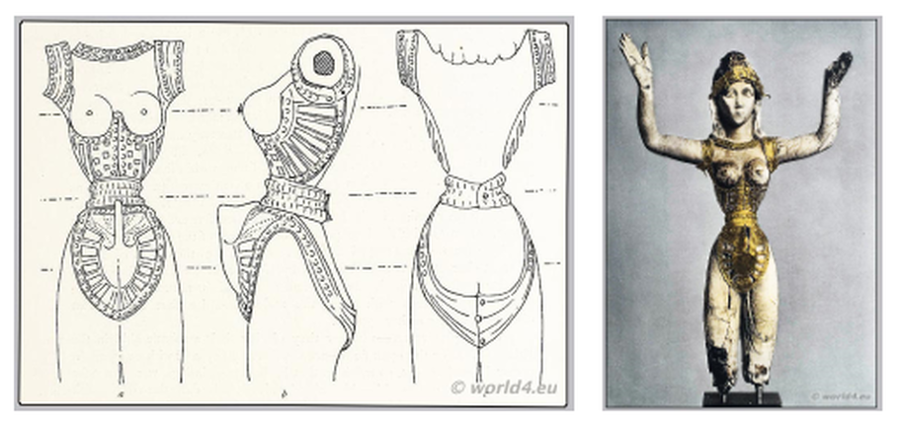
Image from Corset Timeline
www. tahliamckellartextiles.weebly.com

Whilst this corset is being tried on there will be a brief description over the overhead speaker system. It will describe the era in which the corset was worn, the materials used to create it and some background information like I have included in this text. There is a very slim chance that the woman will be able to fit into the corset as we naturally have bigger waist lines compared to when corsets were worn religiously every day.
Once the overhead speaker has finished describing the first corset, there will be a moment before the second corset is placed into each cubicle to be tried on next. Once again, the reflection of the woman in the mirrors will be the focus. After trying on the corset their attention will most definitely be on their body. “To be on display is to have the surface of one's own skin, the hairs of one's own body, turned into a disguise which, in that situation, can never be discarded. The nude is condemned to never being naked. Nudity is a form of dress.” (Berger, 1972, p.54).
The next corset in the exhibition was used through the 1700-1800’s and was known to have been one of the most uncomfortable corsets. During the 18th century, this corset was made from stiff material which was encased with whalebone to create the structure. “Throughout the Victorian era, corsetieres used half the world’s supply of whalebone” (Snodgrass, 2014, p.636) This shows complete disregards to the impact on the environment and sustainability.
Whilst trying on this corset, an actress of a chambermaid will make her way around the fitting rooms, assisting the women into their corsets. These corsets will be pulled and laced tightly at the back to create the hourglass figure. This is what would happen traditionally to create the tightest corset possible. Below is a drawing demonstrating the silhouette of the whalebone corsets:
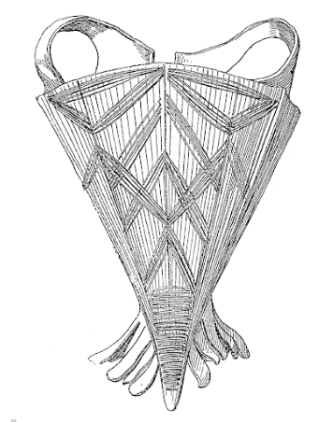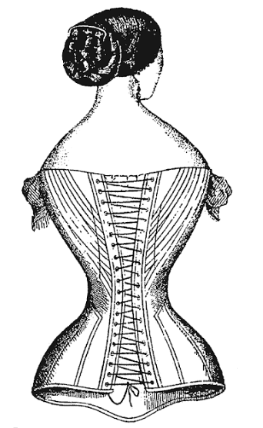
Image: (Seleshanko, 2012, p.3 & p.5)
After a few moments, these corsets will be removed as they will be extremely uncomfortable to our waists which aren’t used to being pulled tight.
After another short pause of the woman analysing herself in the mirrors, my final garment will be brought out. For this final piece I have decided to pick a sample sized garment straight off the catwalk. These models are renowned for being very thin and unhealthy. Former editor of Vogue, Kirstie Clements describes how models resort to “eating tissues and surgery” when dieting doesn’t make them thin enough. She also mentions how some girls end up on the drip due to their eating disorders. I want the women in my exhibition to realise how small these size 0 samples are and how crazy it is that society expects women to fit into them, I don’t expect the women to try these on as I know looking at it will be enough, I understand it may fit some women but not the majority. Most women have natural curves and aren’t 6ft tall so why are designers creating them this way for the catwalk?
Below is an image of a catwalk sample worn on the run way. You can see the skeleton like figure of the model:
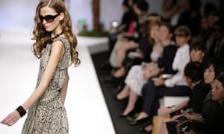
Photograph: Leon Neal, (2013).
Once again, through the overhead speaker system, there will be a description of the lives and health issues these models face due to their job. Many of us aspire to be the women we see in the magazines, but I want the women to realise it isn’t as glamorous and fun as we may assume. This will then conclude my exhibition.
Throughout this exhibition I want the women to feel like they are the piece of art on display, the audience and the critic. By seeing the reality of having this ideal feminine figure, I want them to question what they see as beautiful disregarding what they have been told in the past. Barthes (1967) idea: “the birth of the reader must be at the cost of the death of the Author” supports this. By overlooking this idea of a perfect female figure which has been passed down for decades, we as the readers may be able to see ourselves as beautiful and create a whole new way of seeing.

Bibliography
2019 ,‘cultural’, Oxford Dictionary, Oxford University Press, Oxford
Barthes, R. (1967) The Death Of The Author: Image, Music, Text. London: Fontana.
Barthes, R. (1983) The Fashion System, Berkley and Los Angeles: University of California Press.
Berger, J. (1972) Ways of Seeing, London : Penguin Group
Clements, K. (2013) The Truth About Size 0. Available at : https://www.theguardian.com/fashion/2013/jul/05/vogue-truth-size-zero-kirstie-clements (Accessed: 26th April 2019).
History of Corsetry. Available at: http://tahliamckellartextiles.weebly.com/corset-timeline.html# (Accessed: 26th April 2019).
Pitts Taylor, V. (2008) Cultural Encyclopaedia of the Body, Westport: Greenwood Publishing Group.
Seleshanko, K. (2012) Bound & Determined: A Visual History of Corsets, 1850-1960, Dover Publications. Inc. p.3 & p.5.
Snodgrass, M. (2014) World Clothing and Fashion: An Encyclopaedia of History, Culture, and Social Influence, London and New York: M.E Sharpe and Routledge.
Steel, V. (2001) The Corset: a cultural history, New Haven and London: Yale University Press.

