
Student name: | Daniela Nadia Stochita | Student ID number: | 2113969
Programme: | BA Business Management
Module: | Management Economics
Module code: | LCBB5008 | Contribution to Overall Module  Assessment (%): | 50%
Module Leader: | Muno Zuwirai | Internal Verifier: | Khaza Ahmed

Table of Contents
Introduction 3
Tesco's History and Background 4
Profit Maximization Theory and TESCO 5
Appropriate Economic Theories and Business Environment Issues in Tesco 6
Business Objectives and Market Structure 7
Stakeholders Issue the Interests and Concerns of Tesco 8
Issues Impacting TESCO for Decision-Making 9
Recommendations 12
Conclusion 13
References 14

To: Tesco Executive Committee
From: Business planning director
Date: 17.10.2023
Subject: A business report to TESCO Executive Committee.

Introduction
Tesco has been around for more than a century, making it not just a retail powerhouse but also one of the UK's most well-known grocery businesses. Tesco was established in 1919 by Jack Cohen as a stall at a market in London as well as has since grown to become a major retailer across the world. The purpose of this report is to provide an overview of Tesco's background, an assessment of the company's present standing in the competitive UK supermarkets as well as the retail industry, and an examination of pressing matters requiring the attention of Tesco's Executive Committee (Ahuja, 2022). The grocery and retail industry in the UK has changed drastically throughout the years. Intense rivalry and variations in customer tastes have shaped the industry, which has seen the rise of local, neighborhood shops as well as the consolidation of big supermarket chains. Additional factors that have altered the scene include the proliferation of e-commerce, shifting customer preferences, and worries about environmental impact.

Tesco's History and Background
Tesco has been on a path characterised by creativity, growth, and flexibility. Tesco has gone a long way from its early days, when it was an innovator in the retail market, to where it is now.
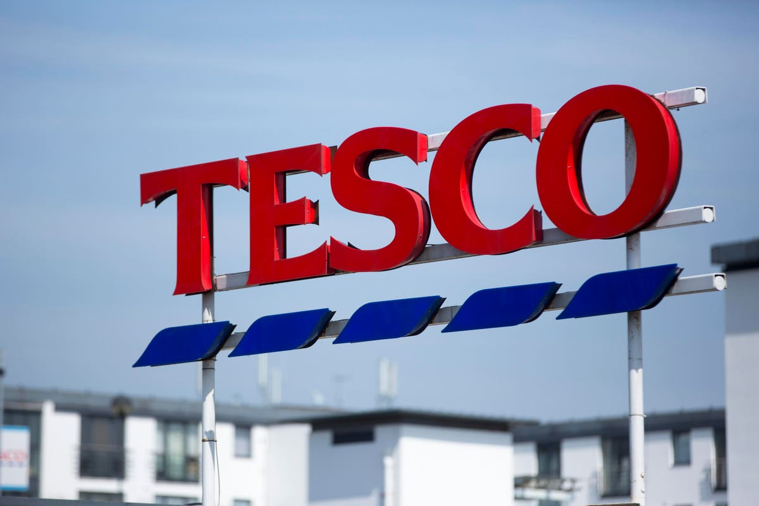
Figure: Tesco (Martin, 2021).
The company's success may be attributed to its dedication to client satisfaction and the provision of high-quality goods at reasonable pricing (Goodman, 2020). Tesco's influence on the world arena has been bolstered by the company's international growth, which has included forays into both Asian markets and Europe.

Profit Maximization Theory and TESCO
The Profit Maximization Theory
The theory of maximising profits is a cornerstone of business studies and economics. The maximisation of profits is assumed to be the firm's key motivation. Here, "profit" is the monetary gain achieved after deducting all business expenses (Daly, 2019). In general terms, a business will strive to maximise profits while minimising expenditures. This notion is fundamental to business judgment because it helps businesses achieve their full financial potential.
Incorporate this theory into TESCO's business practises
The maximisation of profits has always been central to Tesco's business strategy as one of the largest supermarket chains in the UK (Simon, 2019). The company's activities are extensive and varied, extending beyond the standard storefront to include both online and offline storefronts, as well as international development.
Supply chain and operational efficiency is a top priority for Tesco. Acquisition, distribution, and retail processes may all be optimised to save money without sacrificing quality. Tesco's pricing strategy is developed to maximise profits while still luring consumers with low costs. To strike this equilibrium, it makes use of tools like pricing that is dynamic and price discriminating. To appeal to a wide range of customers, Tesco puts a premium on a wide variety of product categories, including both high-margin and value items. Tesco's growth into new markets is motivated by the pursuit of profit. It analyses the potential for development and profit in untapped geographies or product categories.
TESCO profit maximization and selling price increases to improve profitability
Tesco, implementing Profit Maximisation Theory, may increase profits in a few different ways:
Optimized Pricing: By tracking what customers buy, Tesco can dynamically set prices that bring in the most money. Tesco can increase prices on inelastic commodities while maintaining competitive rates on more price-sensitive items by determining price elasticity.
Save Money: Supply chain and retail operations expenses may be reduced by continuously recognising and fixing inefficiencies. Tesco can improve its profit margins by negotiating better terms with its suppliers.
New Product Development: Creating and advertising private-label items with a high-profit margin may increase earnings (Chernev, 2019). When compared to their branded alternatives, these items may provide a distinct advantage and earn larger profits.
Programs to Reward Loyal Customers: Retention of customers and spending may be increased by well-designed loyalty programs, leading to greater long-term earnings.
Market Development: Finding untapped markets or niches with high-profit potential is an option. Tesco has to do extensive market as well as feasibility studies before opening new stores.

Appropriate Economic Theories and Business Environment Issues in Tesco
Demand and Supply Theory
Tesco's business model relies heavily on this pillar of economics. It is crucial to know what customers want and have a well-oiled supply chain (Ahuja, 2022). Tesco uses data analytics to predict customer needs based on historical trends, seasonality, and product popularity. Successful cost management requires well-managed supply chains that make things accessible when and where they are needed.
Demand Elasticity
Tesco's strategic pricing is grounded on the economic theory of demand elasticity. Tesco may raise prices for necessities with inflexible demand (like food) without seeing a large drop in sales (Kerr, 2020). More price sensitivity is required for more price-sensitive items (like electronics).
Principles of Market Theory
In the United Kingdom, where Tesco is based, the retail sector is characterised by a small number of large players (oligopolies). Because of this, price decisions, product differentiation, and advertising initiatives must be made (Drucker, 2022). Tesco is better able to evaluate the competition environment and establish a strong market position thanks to a firm grasp of the market structure.
Theory of Games
Tesco uses game theory to foresee and counteract the moves of rivals in the UK retail industry, a highly competitive market. It analyses competitors' moves and takes future outcomes into account so that pricing, advertising, and market growth choices may be made with confidence.
The Current Business Environment Affecting TESCO
Tesco faces a dynamic and complicated business environment, marked by several elements that affect its operations as well as objectives.
Competition in the Market: Established businesses like Sainsbury's, Asda, as well as Morrisons compete with up-and-coming online marketplaces like Amazon in the UK retail industry (Armstrong, 2021). To keep its current market share, Tesco has to constantly improve and experiment.
Modifications in Purchasing Patterns: Tesco has expanded its product lines and bolstered its digital presence in response to shifting customer tastes, such as the growing popularity of online shopping and the need for more environmentally and socially responsible goods (Goodman, 2020). It is essential to recognise these changes and adjust accordingly
Conditions of Regulation: Food safety, fair labour practices, and environmental responsibility are just a few of the issues that have led to new rules for the retail sector. To prevent legal trouble and protect the company's image, adherence to these laws is necessary.
Innovations in technology: Rapid technological progress has altered the retail industry (Armstrong, 2021). Tesco uses data analytics, supply chain technology, and online retail platforms to provide better service to its customers.
Global Economic Factors: Tesco's pricing and financial plans may be affected by customer purchasing patterns and economic situations including rates of interest, inflation, as well as consumer confidence.

Business Objectives and Market Structure
TESCO's Business Objectives and Goals
Tesco, a major participant in the British retail industry, has well-defined long-term and short-term business goals. Its goals of serving consumers, creating value, and providing long-term development are consistent with these initiatives. Tesco's mission is to identify and cater to its consumers' ever-changing wants and preferences (Chernev, 2019). To achieve this goal, we will work to improve the online and in-store buying experience, expand our selection of high-quality items, and give discounts wherever possible. Tesco is always looking for ways to streamline its operations by streamlining its supply chain, revamping its shop designs, and cutting down on waste. Managing expenses and optimizing workflow are critical to success.
Tesco's goal is to continue to be the most successful grocery store chain in the United Kingdom. This necessitates a persistent commitment to innovation and flexibility in the face of ever-changing market conditions, such as evolving consumer tastes and new forms of technology (Briscoe, 2023). Tesco looks for ways to expand by entering new local and foreign markets. In addition to providing grocery delivery online and other services, the firm also offers banking services and non-food products.
The Market Structure in Which TESCO Operates
The retail market in the United Kingdom, which Tesco serves, has features of an oligopoly, in which just a handful of major enterprises have a dominant position. Important facets of the marketplace's structure that have an impact on Tesco are:
Only a select few companies, such as Tesco, Sainsbury's, Asda, and Morrisons, may be considered "major players" in the UK retail industry. These companies have a dominant position in their industries, allowing them to set prices and shape the competitive landscape. Product specialisation, price, and promotional initiatives fuel industry competition. Using loyalty programs and advertising efforts, shops try to stand out from the competition by providing special benefits to customers. Barriers to entrance include high start-up costs, economies of scale, and well-known brands already in the market. This keeps the current power structure intact.
One big player's choices may have far-reaching effects on the tactics of the others (Brennan, 2023). As a result of their dependency on one another, businesses often engage in price wars, discounting, and other methods to increase their market share. To guarantee honest competition and safeguard consumers, the retail sector is subject to oversight by regulators (Drucker, 2022). Businesses are impacted by rules governing things like price, marketing, and food safety. The retail industry has been revolutionized by the rise of e-commerce and other technological developments. Industry staples include online retail, digital advertising, and data analytics.

Stakeholders Issue the Interests and Concerns of Tesco
Customers: Customers want affordable pricing, high-quality goods, a diverse inventory, accessible stores, and a pleasant shopping experience. They can be worried about the cost, the quality, or the longevity of the product.
Employees: Workers want competitive pay, stability in their positions, opportunities to advance in their careers, and a welcoming and diverse workplace (Brennan, 2023). Issues of job loss, workplace violence, and pay disparities may all cause concern.
Investors and Shareholders: Investors hope to profit monetarily from their stock purchases via dividends and price increases. They worry about the company's capacity to make money and stay afloat financially.
Suppliers: When dealing with suppliers, it is important to be fair and prompt with payments, to form lasting relationships, and to conduct ethically (Elsner, 2023). Contractual disagreements and policy shifts in procurement might cause them anxiety.
Institutions of Governmental Oversight: Food safety, fair labor practises, and fair competition are just a few of the areas where regulators concentrate their efforts. Infractions might result in monetary penalties and even legal trouble.

Issues Impacting TESCO for Decision-Making
Profitability Issues
Tesco, like many other companies, confronts several obstacles to making a profit:
Tesco's profit margins are affected by the fierce competition in the UK retail industry, which drives prices down. To attract frugal customers, supermarket chains like Sainsbury's, Asda, Sainsbury's as well as Morrisons are continually engaging in price wars with one another. The COVID-19 epidemic has hastened the trend toward online buying, which in turn necessitates substantial investments in online infrastructure and fulfillment capabilities. While this increases Tesco's accessibility, the added expenses may reduce the company's capacity to turn a profit.
Costs of doing business have gone higher due to interruptions in the world's supply chain caused by things like Brexit's effect on commerce and the pandemic's effect on logistics (Rendtorff, 2021). For continued financial success, Tesco must master these obstacles.
Competition-Related Challenges
Tesco is part of a highly competitive oligopolistic market. The market is very competitive, and businesses are always looking for new ways to increase their portion of it. Customers' tastes have shifted in response to the availability of low-priced alternatives at bargain stores like Aldi and Lidl. Tesco has to keep prices down while still making a profit. E-commerce rivalry has heated up as a result of the proliferation of online merchants like Amazon (Kerr, 2020). Tesco has to keep putting money into its digital products if it wants to stay competitive.
Demand and Supply Issues
Product preferences have shifted in recent years to prioritize health and sustainability. Tesco will need to modify its inventory and distribution methods to keep up with customer demand. As seen with the COVID-19 outbreak, supply chain interruptions may cause shortages, higher prices, and inefficiencies in operations (Martin, 2021). To alleviate these problems, Tesco needs efficient supply chain management. The sustainability of Tesco's supply chain, which includes concerns like ethical sourcing, decreased waste, and greenhouse gas emissions, is coming under increasing scrutiny. Reputation and profits are at stake if these issues are ignored.
The Implications of These Issues for TESCO's Management
To successfully handle competitiveness and profitability challenges, management must make educated judgments about price, and product mix, including market growth. For sustained success, businesses must make long-term investments in areas such as digital transformation as well as sustainability. To weather supply chain interruptions without compromising profitability, management must place a premium on efficiency in operations, cost control, along supply chain resilience. Improving methods and adopting new technologies consistently is essential. It is essential to get the right people involved (Briscoe, 2023). A company's image and market position may benefit from addressing environmental responsibility, ethical sourcing, and staff wellness issues. Management must take precautions to mitigate risks connected with things like supply chain dangers, market competitiveness, and government regulations. Strategies for reducing risks should be taken into account wherever possible.
Influence Decision-Making within the Company
Data-Driven Decision-Making: When deciding on price, inventory levels, and consumer preferences, Tesco uses data analytics. Insights gleaned from data help businesses adjust to shifting market conditions and enhance efficiency.
Customer-First Philosophy: The management of Tesco places a premium on the shopping and browsing experience of its customers, and this outlook informs their choices of in-store design, product lines, and customer services.
Customer-Centric Approach: Decisions on sourcing, packaging, & and carbon reduction are all influenced by the company's dedication to sustainability (F Fishwick, 2020). Tesco's sustainability over time aims are supported by these choices.
Combating the Competition: Management at Tesco considers both rival companies and customer preferences while developing competitive strategies. The marketing, pricing, and sales initiatives all stem from these plans.
Setting Priorities for Investments: The leadership of Tesco prioritises investments in areas like the Internet of Things as well as environmental efforts because of the strategic value and future payoffs they provide.

Conclusion
This report has taken a deep dive into the issues facing one of the UK's biggest retailers, Tesco. We looked at how increased competition, shaky supply chains, and the digitization of retail are threatening profits. Critical elements such as sustainability efforts and compliance with laws and regulations, as well as competition-related obstacles and supply-and-demand concerns, have also been evaluated. Tesco's continuing success depends on the company's ability to strike a balance between profitability & sustainability, deal with intense competition, and adjust to changing market conditions. Tesco's future achievement and position of leadership in the UK retail sector depends on its ability to strategically and aggressively meet these issues and adapt to the changing demands of its stakeholders.

Recommendations
The following recommendations are made to help Tesco's management deal with the issues highlighted and improve the company's overall performance:
Tesco must accept the New Technological Reality by investing heavily in digital transformation initiatives including state-of-the-art online stores, data analytics, including automated handling of supply chains. Tesco will be able to better serve its online customers and streamline its operations as a result. Tesco need to boost environmental protection Efforts Quicken the pace of sustainability initiatives by establishing concrete carbon reduction goals, advocating for ethical sourcing methods, and adopting waste-reduction plans. Promote Tesco's image and win over eco-conscious shoppers by being open and honest about these efforts. If Tesco wants to save costs, then needs to streamline processes, improve procurement, and use cutting-edge technology. Tesco has to adopt pricing policies based on data and make use of analytic data to establish dynamic pricing approaches that provide a happy medium between profitability and competitive price, especially for necessities. Tesco needs to develop separate price plans for various groups of customers. Tesco needs to improve the participation of stakeholders and boost interactions with the most important constituencies, including customers, workers, and suppliers. Also improve Tesco's reputation as a responsible corporate citizen by focusing on environmental issues, maintaining a culture of ethics in the workplace, and supporting local causes.
By embracing digital transformation as well as sustainability, Tesco may be able to enhance its position as a leader in the highly competitive retail market, increase its customer base, as well as enhance operational efficiency. Data-driven marketing and cost optimization may improve profitability, while fostering stakeholder engagement may improve brand perception and loyalty. If Tesco prioritizes these recommendations, it is going to be able to thrive in the competitive UK retail business.

List of References
Ahuja, H.L. (2022). Managerial economics : Analysis of managerial decision making. 43rd ed. New Delhi: S Chand And Company Limited.
Armstrong, M. (2021). A handbook of employee reward management and practice. 54th ed. London: Kogan Page.
Bethke, U. (2022). The Influence of Business Associations in the European Decision Making Process. 76th ed. diplom.de.
Brennan, L. (2023). Beyond The Dark Arts: Advancing Marketing And Communication Theory And Practice. 87th ed. World Scientific.
Briscoe, F. (2023). Social movements, stakeholders and non-market strategy. 23rd ed. United Kingdom: Emerald Publishing.
Chernev, A. (2019). Strategic Marketing Management: Theory and Practice. 87th ed. Cerebellum Press.
Daly, J.L. (2019). Pricing for profitability : activity-based pricing for competitive advantage. 43rd ed. New York: Wiley.
David Parker (2020). Political Decision Making in Ecuador: The Influence of Business Groups. Sagwan Press.
Drucker, P.F. (2022). The Theory of the Business (Harvard Business Review Classics). 09 ed. Harvard Business Press.
Elsner, S. (2023). Retail Internationalization Analysis of Market Entry Modes, Format Transfer and Coordination of Retail Activities. 34th ed. Wiesbaden Springer Fachmedien Wiesbaden, Imprint: Springer Gabler.
F Fishwick (2020). The geographical dimension of competition in the European Single Market. 34th ed. Luxembourg: Office For Official Publications Of The European Communities.
Goodman, M. (2020). Creativity and Strategic Innovation Management Directions for Future Value in Changing Times. 87th ed. Milton Routledge Ann Arbor, Michigan Proquest.
Janat Shah (2019). Supply chain management : text and cases. 76th ed. Upper Saddle River, N.J.: Pearson Education.
Kerr, W. (2020). A Guide to the Global Business Environment. 87th ed. Edward Elgar Publishing.
Martin, C. (2021). Max-e-marketing in the net future : seven imperatives for outsmarting the competition in the net economy. 65th ed. New York: Mcgraw-Hill.
Rendtorff, J.D. (2021). Stakeholder Theory A Model for Strategic Management. 87th ed. Cham Springer International Publishing.
Simon, H. (2019). Price management : strategy, analysis, decision, implementation. 43rd ed. Cham, Switzerland: Springer.

