BA Fine Art: Studio, site and context

Research and Context (ADAD5003)

Essay and Exhibition title: Explore how artists have expressed gender in art practice providing evidence from at least 2 artist’s and thinkers.

Word count: 2,429 (excluding title page, table of contents, in-text chapter titles, in-text illustrations titles and bibliography)
19th April 2023

Table of contents

Introduction…………………………………………………………………………. 3

Freddie Robins: Knitted Homes of Crime………………………………………. 4

Walter Sickert ……………………………………………………………………… 9

Comparison ………………………………………………………………………. 14

Conclusion ……………………………………………………………………… 16

Introduction

Gender in art has existed since art practice began, this has provided a main form of portrayal throughout many years, however gender can be depicted in many different ways depending on cultural forms. Art has been used as an expression to convey emotions or important events since the beginning of art practice, over 10,000 years ago. In this essay I am going to focus on an important aspect of gender, feminism, to be precise. I will look at how Freddie Robins used her chosen art technique, knitting, to create an exhibition about female killers. Robins used research into these murders as background context into each house and added this onto the object label for public viewing. I will then look into Walter Sickert’s work, more precisely his work relating to Jack the Rippers Bedroom, which features the artists ‘fantasy’ of murdering women. He was queried to be Jack the Ripper himself, however this was never confirmed. During this I will focus on how women were depicted throughout these works and contrast these two artist’s pieces against each other. By looking into, what may seem like two largely different artists, I will show that these two different perspectives have the same femininity issue. Disrespect towards women.

Freddie Robins: Knitted Homes of Crime

Freddie Robins is an English artist who uses knitting as her chosen art technique. Robins is the creator of an exhibition called, Knitted Homes of Crime. These are tea cosies knitted into the shape of houses, more specifically, the homes of female killers or the homes where they committed their crimes. Murder is one of the most heinous crimes a man can commit, however when a woman commits these crimes it is condemning. Women are perceived as nurturing, kind and life giving not murderous, but all these qualities can still be applied to these women. While the victims ranged from women, men and even children, the killers never murdered their own children, this suggests to me that even though these women were cold blooded murderers they loved for their own offspring enough not to murder them. Having a female killer is a rarity, we do not hear about it often, while we may often hear about couples who have collaboratively murdered, it is not as heard of for a lone woman, this is due to the fact that women only kill for very few reasons. Money, lust, and the most common, ‘power-seeking’. These killers attest to this fact.

Robins uses knitting as a weapon against female expectations. Knitting is commonly seen as a ‘feminine’ tool, when I think of knitting, I stereotypically think of an older generation of women. They are gentle, mindful and safe. Robins work challenges this, her work is frequently dark and provocative, often enough her work encompasses death, loss, religion and depression. I see Robins work as a full contradiction; tea cosies are designed to keep hot beverages warm, or in other words, comforting. When we think of comforting places for us to be we think of our home, where we are safe, warm and protected, exactly what a tea cozy represents. However, the homes where the killers lived and committed their crimes were deceiving and contained fear, danger and a lot of pain.
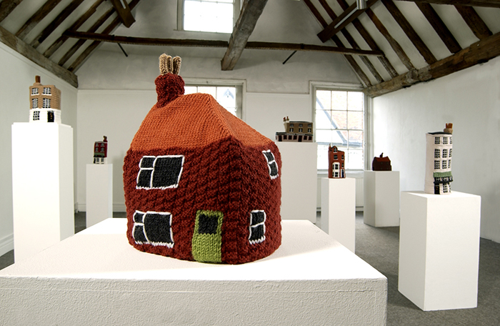

Figure 1. Freddie Robins, Knitted Homes of Crime (2002)

Knitted Homes of Crime was inspired by Robins personal collection of tea cosies. A collection of tea cosies that were made to look like stereotypical cottages. Quaint, peaceful and relaxing. This is the opposite of Robins knitted Home of Crime, which is a representation of death, fear and extreme terror. Looking at Figure 1, these knitted homes look warm and cozy on the outside, which is how many would describe their own houses. Where as, in reality while a house may look safe and peaceful on the outside, the inside may contain fear and danger, which was the case for these houses in particular. White, brown, beige and even some lime green colours are shown on these houses, these are a symbolic reference of what a house should contain. innocence, dependability and calmness.

It is important to note that while Freddie Robins was the mastermind behind the exhibition, she did not fully knit the pieces herself. Robins conducted all the research into these women and their victims' homes. Robins then moved on to sample and create the patterns for the knitted homes, however she did recruit a fast and skilled knitter, Jean Arkell for assistance. Robins would complete the the knitted cosies with finishing embroidering details. Robins and Arkell completed one house per month over the span of seven months. They worked using post, where Robins would send the pattern, yarn and the story of the house to Arkell to complete and then return.

There is a key aspect that is missing from Figure 1, and this is the text that correlates with each knitted piece. The included text entails the amount of time each piece had taken to be made and the details of the murders that had been committed in each house.
Charlotte – 14 1/2 hours
Coombe Farm Cottages, Sherborne, Dorset – 1935

Charlotte Bryant, a 33-year-old illiterate mother of five, lived here with her husband Frederick. She enjoyed a drink and had a reputation as an amateur prostitute in the local pubs. Apparently her toothlessness and lice did not put the men off. Sometimes she even brought them home. One of these men was Leonard Parsons, a gypsy horse trader. Leonard became an occasional lodger in the Bryant household and Frederick did not seem to mind sharing Charlotte with him. Charlotte decided otherwise and started poisoning Frederick so that she would be free to marry Leonard. Frederick eventually died on 22 December 1935 after drinking a cup of Oxo containing arsenic. Charlotte was caught after the post-mortem on Frederick’s body. A friend also told the police that she had seen Charlotte trying to destroy a tin of weedkiller. She was hanged at Exeter Prison on 15 July 1936. (Robins, 2002)

Many of the women that had been written about were described using demeaning terms. In Charlotte, the quote above, it refers to the killers “toothless mess an lice” (Robins, 2002). I found this to be derogatory towards women, killers or not, it suggests the point that women are judged by their looks and looks alone. It speaks for society that we perceived, and still do perceive, women that are ‘toothlessness’ or that have ‘lice’ to be undesirable to all men, it also suggests that because of these attributes, these women should not be wanted. Further evidence of societies judgment is the shock that was shown when, in fact, men did still desire these women and their company.
In most of the murders there was a domestic nature to the killings. For example, an extract from Ethel, describes how she poisoned her husband by making him “corned beef sandwiches containing strychnine” (Robins, 2002) . In addition to this, Christina injected chocolate creams using the same toxin, this was an attempt to poison her lover's wife, unfortunately Christina did end up accidentally poisoning a young child. The connection between these two killers is a psychological one, Ethel killed in a ‘power-seeking’ manner. She killed someone she was meant to care about because she believed her delusion that her husband was lusting over someone that was not her. Where as, Christina killed purely for lust, she “became infatuated with a married man” (Robins, 2002) someone that was not hers to have and attempted to poison his wife.
In modern day we do not instantly connect women to cooking, cleaning and home caring when we think of them. However, if we take into account that these crimes were executed between 1871 and 1955, society was slightly different. Back then women were seen as the home makers, this makes a well-known reference come to mind, “women belong in the bedroom and the kitchen, that order” (Bobby Riggs, 1973),the fact that this quote was said in 1973 goes to show how society is still mindfully wrapped and sees women as a figure to cook, clean, raise children and care for their husbands. When we think of the women that were being refereed to in this text we think innocent, caring, safe, warm and most importantly, nonthreatening. The killers opposed this, they twisted qualities that were seen as nurturing and a sustenance of life and made it an act of extinguishing lives that they deemed unworthy.

Walter Sickert
Walter Sickert was an “actor and artist, who was born in Munich” (Jones, 2022) but then lived in Britain from a young age. In 1888, he wrote a series of letters claiming to be Jack the Ripper, however this was never proven to be a fact. Alternatively, to support his claim of being the Ripper, he created quite a few pieces showing a range of grotesque scenes. Sickert drew sketches of “brutal male faces with sketches of men with knives standing over women’s bodies.” (Jones, 2022) These are the works that I will be looking into throughout this part of my essay.
This does not mean he actually was the serial killer, stated by Anna Gruetzner Robins in her essay. There were a lot of letters that had similarity. However, the letters with an artistic flare, including the use of a draughtman’s pen and even a woodcut, do really seem to have been created by Sickert. (Jones, 2022)

In 2002, Tate’s conservation department recruited a paper analyst Peter Bower to compare Sickert’s corresponding letters with some of the Ripper letters. “His research revealed the paper of three letters written by Sickert in 1890 matches two Jack the Ripper letters written during 1888” (Bower, 2002) However, even though though Sickert may not have been the killer, he may have “believed or even fantasised about being the serial killer.” (Bower,2002)

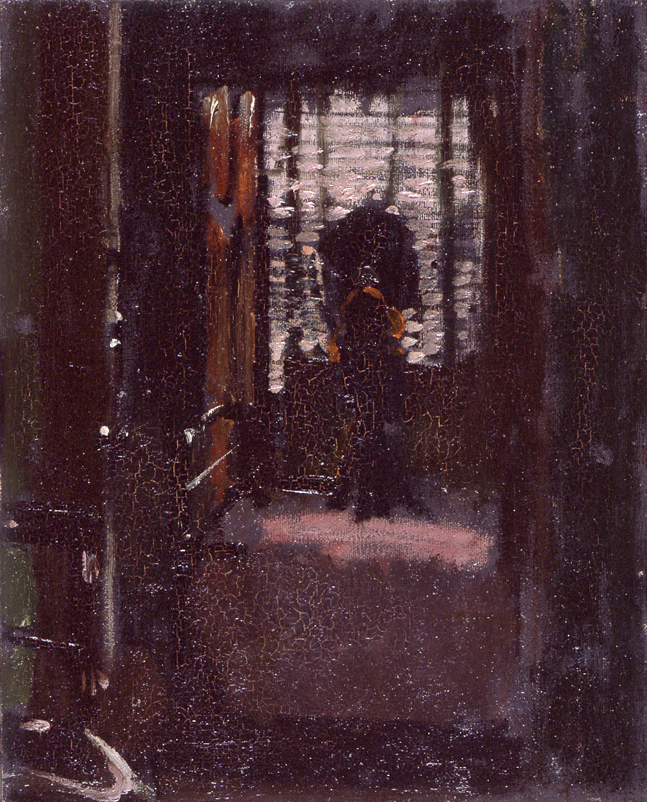
Sickert’s work consisted of a darkness that some viewers found ‘compelling’. His pieces are often described using words such as ‘ambiguous’ and ‘unnerving’. When i look at his paintings with great interest and detail I start to feel uncomfortable. I would compare it to a gut feeling, when you know something isn’t right or feel like something is wrong, but you cannot exactly say what the issue is.

Figure 2. Walter Sickert, Jack the Rippers Bedroom (1907)

This leads me to look at Figure 2, a piece by Sickert called Jack the Rippers Bedroom, created using oil on canvas in 1907. This painting was of Sickerts own flat and evokes the same uncomfortable feeling in me. while i can clearly make out that a room is part of the piece, the vertical lines of a doorway, a chair and even horizontal lines of blinds in the background. The colours and textures blend into each other obscuring any clear detail that eyes can pick up on. I can make out a silhouette in the painting, but apart from that there are not any identifying qualities. It could be suggested that the unknown silhouette in the piece is Jack the Ripper himself, or at least Sickerts representation of him. The piece does not allow your eyes time to focus clearly, there is too much simplicity in the painting. Referring back to the uncomfortable feeling i described earlier, this piece is comparable to being in a pitch-black room with another human but being unable to see them and only sense the other persons presence.

The Camden Town murder paintings are a series of images created by Walter Sickert. The most common denominator between these works are the main portrayals of a fully clothed man with a naked woman who is laying on a bed frame. Due to the fact Sickert used the same titles for alternative paintings, even going as far as overlapping titles as well, the true context behind the paintings is not made clear.
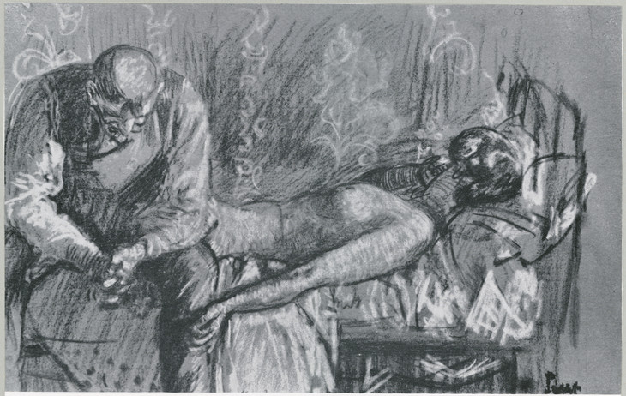

Figure 3. Walter Sickert, Study for ‘The Camden Town Murder’

The main piece that caught my attention was Figure 3 called Study for ‘The Camden Town Murder’, created in 1908. Sickert uses the same technique of blurring the details to a point that no distinguishable aspects can be seen. In the sketch we see, who we can only assume is, Sickert sat on a bed leaning onto his knees while a naked woman is laying on a metal bed frame. From this image we cannot make out weather the woman is still alive or not, however the head of the woman looks like it is turned at an awkward angle, while the rest of her body appears to be limp. While the man, who could also be Sickert himself, appears to be in deep thought, but sat comfortably next to the body, almost as if he has done the same activity time and time again. However it could also be said that the woman is asleep, hence the relaxed body and head turned away. While Sickert is sat on the edge of the bed with his head hanging with regret over what has just transpired, if we use his fascination with Jack the Ripper, the woman is most likely a representation of a prostitute.

The way in which the woman is this sketch has been represented can be seen as disrespectful. Her body is thrown carelessly over the bed, with no attempt to cover her up, this shows no respect towards women and their privacy. Taking into account that most of the pieces are created with illuminations of sunlight it does make me think, why would these women be randomly laying around naked in the middle of the day.

The answer that is suggested to me through the paintings are that the women work during the night, more specifically they are ladies of the night, and that they are working all hours of the day. This could also suggest why the painting shows such disrespect towards the women in them, prostitutes are not seen as desirable and wanted women. They are seen as “dirty and diseased ridden” (independent, 2007) which can be shown through the paintings, as the Study for ‘The Camden Town Murder’ have blurred facial features. This suggests that Sickert believes these women do not deserve to have their own identities and should not be discovered or even seen.

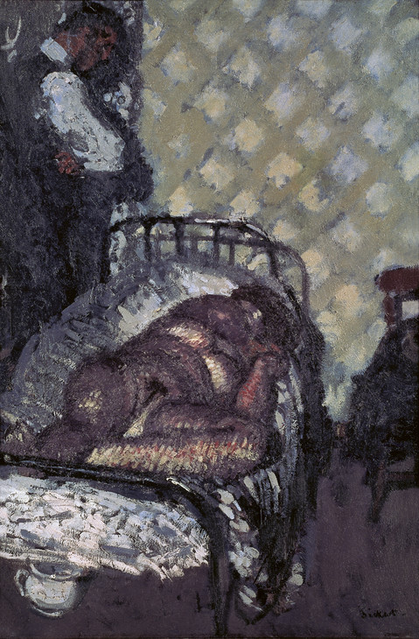
Comparison
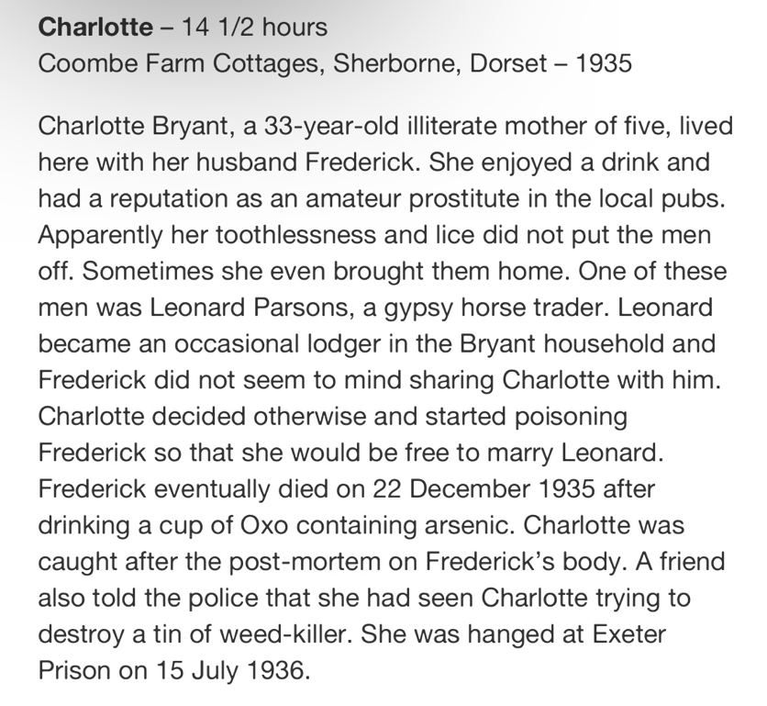

Figure 4. Walter Sickert, L’Affaire de Camden Town (1909) Figure 5. Freddie Robins, Charlotte (2002)

I am going to highlight the blatant disrespect that is shown towards the women in both The Knitted Homes of Crime and study for ‘The Camden Town Murder’. In figure 4, the woman is painted almost as if she is on display, her breasts, pubic hair and her legs are wide open for the viewers eyes. This woman is a symbolism of women not having the privilege of privacy, especially given the decade that the works are based on. Privacy was a privilege that women were not entitled to.

What both, Figure 4 and Figure 5, demonstrate is the impact a woman’s image had on society. If women were not pretty enough, they were not taken seriously, they were not to be desired. It adds to the fact that in the decade the works originate from, women were only wanted for one thing, what they could offer a man. These 2 figures are a true representation of how objectified women are, and used to be. Figure 4 shows Walter Sickert standing over the naked woman and just watching her, while fully clothed. This leaves the woman at a disadvantage, she physically can not hide any part of her, she is on display for the male viewers gaze, this leaves her vulnerable while the male viewer is fully clothed, his body is ‘hidden’ and ‘protected’ in comparison to her. Similarity, figure 5 depicts that “sometimes she even brought them home” (Freddie Robins, 2002), suggesting that it was a shock that this woman was wanted due to her “toothlessness and lice” (Freddie Robbins, 2002).

Conclusion

The objectification by men that these two works show is exactly what I wanted to translate throughout this essay. My aim was to show that these two different artist perspectives have the same misogynistic issue, I feel like I have proven this point throughout. In both artist’s work women were objectified, one through her looks and the other through her body. Women were, and still are, largely judged by how they appear and act. Both these women were wanted for their bodies, to be used and gazed upon for a man’s pleasure with no thought of how it would make the women feel. The women’s feelings and wellbeing were shown to be insignificant to men unless it was beneficial towards the men themselves.
However, I will mention the fact that Walter Sicket’s work was blatantly disrespectful towards women with no regard to how it would make a female viewer feel, I felt that is was an attack towards women and felt a great sense of danger myself. Freddie Robbins’ work showed how women were viewed through societies eyes, while Robbins did not fully show or say anything disrespectful about the various murderous women, I do wonder why she felt that keeping the degrading way some of these women were talked about was a necessity for her work.

Bibliography
Alabanza, T. (2021) Gender. London: Tate Gallery Publishing Ltd. New York, Ny.
Art-theoria.com. (2016) Jack the Ripper’s Bedroom. Available at: https://www.art-theoria.com/painting-of-the-month/jack-the-rippers-bedroom/ (Accessed: 25th November 2023)

Blanchard, T. (2002) Gripping yarns. The Observer. Available at: https://www.theguardian.com/lifeandstyle/2002/nov/03/shopping.homes (Accessed: 25th November 2023)
Chapin, A. (2017) Four decades after the Battle of the Sexes, the fight for equality goes on. the Guardian. Available at: https://www.theguardian.com/sport/2017/mar/11/billie-jean-king-battle-of-the-sexes-tennis (Accessed: 21st November 2023)
Evaristo, B. (2021) Feminism. London: Tate Gallery Publishing Ltd.
Goldsmith’s, University of London (2012) Knitted Homes of Crime | Freddie Robins. Available at: https://www.freddierobins.com/blog/knitted-homes-of-crime. (Accessed: 22nd November 2023)

Jones, J. (2022) Walter Sickert review – serial killer, fantasist or self-hater? This hellish, brilliant show only leaves questions. The Guardian. Available at: https://www.theguardian.com/artanddesign/2022/apr/26/walter-sickert-review-serial-killer-tate-britain-london-show-women-victorian-painter (Accessed: 12th December 2023)
Robins, F. (2003) Knitted Homes of Crime | Freddie Robins. Available at: https://www.freddierobins.com/blog/knitted-homes-of-crime (Accessed: 21st November 2023)
Tickner, L. (2012) Walter Sickert: The Camden Town Murder and Tabloid Crime. Available at: https://www.tate.org.uk/art/research-publications/camden-town-group/lisa-tickner-walter-sickert-the-camden-town-murder-and-tabloid-crime-r1104355 (Accessed: 30th November 2023)
Unknown (2007). A closer look at Walter Sickert’s taste for flesh. The Independent. Available at: https://www.independent.co.uk/arts-entertainment/art/features/a-closer-look-at-walter-sickert-s-taste-for-flesh-744385.html (Accessed: 15th November 2023)
Unknown (2016). Jack the Ripper’s Bedroom. Art-theoria.com. Available at: https://www.art-theoria.com/painting-of-the-month/jack-the-rippers-bedroom/ (Accessed: 10th December 2023)

