Introduction
Throughout my life, I have been intimidated by words and grammar. In my late teens I was diagnosed with dyslexia and refused help by naively trying to overcome it independently. Personally I found it hard to process information and articulate my own emotions and thoughts. This made me feel confined and unable to relate to others. Dyslexia, although it’s normally seen as a negative, has actually allowed me to have an insight into things differently and perceive the world in my own way. I pursued for help in university and overcame my vulnerability of words by the process of free writing, building confidence. Capturing my thoughts effectively without the intimidation of grammar, free writing allowed me to express myself in the medium that I fear.
I wish to explore theories of perception which will allow further development in my personal visual language and acknowledge its development during recent years. By forming questions, this allows me to use theoretical deconstruction to answer my thoughts.
What happens when we perceive art? Think, assert similarities, look, listen, feel, embody to understand, deconstruct.
To deconstruct thought, to deconstruct me, to deconstruct the world.
The world is conditioned. I am a dissertation, a dissertation conditioned.
I am black and white all over, ready to deconstruct ready to explode.
“It may take many years of patient practice to grasp some works fully, whereas others may require specific kinds of knowledge, before one can begin to attune oneself in art” (Bolla)
Jacques Derrida was the founder of deconstruction and used language and communication to create his theory. Derrida was influenced by political institutions and studied the idea that deconstruction consisted of reforming the differences that separates self-consciousness, in an act to attempt to draw justice.
Deconstruction is the act of exploring different concepts as well as contexts for a full understanding and acknowledgment of a piece or thing being viewed. Deconstruction is an ironic act of breaking down segments to perceive a full potential of art work.
This dissertation will investigate primary concepts in research and present deconstruction as a theoretical construct that has been defined as a philosophical or critical method.
As well as exploring Derrida’s theory of deconstruction, I will manipulate deconstruction as well as a non-methodological argument present a theoretical context in order to understand and subjectively view art works developing a personal relationship which will depend on home factors such as cultural and religious beliefs. I will present side by side artists who explore the concept of deconstruction alongside my own personal works.
Perception is important to artists because it is the core of visual art, and is suppressed by the essence of the viewer and the observer. Perception forms the insight of the artist, in the same way that the artist contributes their work to the world and the viewers included within it. By engaging in the art creates a deep and meaningful fabrication of personal perspective concepts relying on an attitude dependant suspicion. As art is only observed by the outlook of the viewer and the artist itself. Perception is something learnt and can only be seen when acknowledged.

Chapter 1.
Jacques Derrida founded the term deconstruction as we know it today, however, the theories themselves date back to the times of Plato; Metaphysics and Platonism contribute to deconstruction and are so complex within themselves. Metaphysics by definition is a philosophical method which deals with the first principles of being: identity, time and space. Deconstruction is a “kind of formalism because it interprets as symptoms of a metaphysical syndrome…what are actually the internal reflections of the outer historical conditions of a texts production” (Tucker, 2010). Platonism explored the existence of abstract things as an object out of space and time, which creates a non-physical being. Abstract objects can be argued as non-spatiotemporal (Standford Encyclopedia of Philosophy, 2004-2016). Qualities of Platonism are seen as structural components used in the methodology of deconstruction, yet Derrida's criticism of Plato’s ideas created the foundation of deconstruction and structural opposites(Standford Encyclopedia of Philosophy, 2004-2016) (Ricoeur, 2006).
Derrida speaks of ‘metaphysics’ and ‘Platonism’. Within this one’s position is more value than the other; by reversing the element of Platonism, it can create differences and a switch within importance; Derrida asserts meaning when a new reader engages with a script of text, whereas Plato asserts itself when a translator in confronted. (Sweetman, 1994). Examples can be shown in visible essence of appearance between voice and writing between body and soul and also good and evil. It is possible that essence is more important than appearance. In deconstruction, the second rather than the primary aspect is appreciated to be more important. This can be solved and acknowledges by the essence depending on its appearance. Also, meaning would imply that essence and appearance are not related and are not separated oppositional roles and may involve memory anticipation. Derrida relates and speaks of the idea of relation (Philosophy, 2014), he then pointed out similarities between the texts however this does not make them equal or balanced but a diversion of hierarchised with one term being more preferred than the other due to the emotional essence of the word. Deconstruction is the act of finding what is not acknowledged (Willette, 2017). This paradoxical relationship ultimately leads to contractionary and confusing theories around what deconstruction is. Plato and other philosophers talk about speech being privileged over writing, as spoken language creates a speciality of truthfulness and authenticity deriving from the relationship between word and idea. When listening to words conceived from a speaker, we grasp their true sense by an exchange of mind, language, and reality. On the contrary language can only imply shared conventions which articulate distinctive sounds and meanings (Norris, n.d).
Derrida indicates that deconstruction only highlights what is already there and you have to apply and analyse the elements used to construct. Derrida’s work consisted of theoretical ideas and interpretations used in western philosophical, literacy and artistic conditions. Derrida fabricated closed meaning that created new ideas for a creative imagination (Taylor, n.d). Derrida believed that deconstruction cannot be under one single meaning and within his earlier findings he attempted to stimulate this from the 1960’s to create a strategy or methodological step that he claimed to be impossible (Rolfe, 2004). Deconstruction is neither an analysis nor a critique. Deconstruction is neither a method and cannot be defined into one, it must also be made clear that deconstruction is not even an act or an operation (Derrida, 1991). This helps to understand why Derrida uses the act of deconstruction to find meaning trough aspects of life and to understand and acknowledge the ‘now’. Derrida asserts deconstruction with traditional culture questioning that to understand religion is impossible without uncertainty. How one claim to know what god can is? Yet we live in an age where major conflicts are happening. And believe that God is always on their side. Whereas some people believed that Derrida threatens to break and tear apart the beliefs of God. Fortunately, Derrida taught us to have no certainty in God (Taylor.n.d). The outcome of our perceptions is to choose to judge an imperatorial situation and deconstruction is just a view.
However research has shown that Derrida’s theory was not set in stone and has developed throughout an evolution of his work; “Of course not everyone agrees with deconstruction interpretations, and some people reject the whole idea of deconstruction, but most of us have run into it by now even if we didn’t realise it”(Merriam-Webster). It is critical that Derrida shows that there is no apparent moment of when a decision has been made. Either is has not followed its requirement meaning it is incompatible or it has followed the requirements which has no foundation then this means it is incompatible. If this piece followed its requirements but in an incorrect manor than the case is still incompatible (Foucault, 2014). There is a strong acknowledgment here that Deconstruction as a theory is an enormous area of research and along with that, comes harsh criticism and debate. However, for the purpose of this piece, the definition of deconstruction as set out by Derrida is used in to explore the concept of perception within art. Most of Derrida’s theory consist of interpretations from philosophers for example Plato, Martin Heidegger and Husserl of western philosophical, literary and artistic traditions creating closed meaning and new possibilities for imaginative expression.
Derrida was influenced by other theorists like Heidegger who looked at the concept of metaphysics. Derrida said “What I have attempted to do would not have been possible without the opening of Heidegger’s questions” (Raffoul, 2013). ‘Deconstruction’ is the main term that Derrida uses derived from what we know as Heidegger’s book Destruction in Being and Time. (Stanford Encyclopedia of Philosophy, 2014). Heidegger’s concept opens texts to alternative meaning that resides out of the metaphysical tradition. This influences Derrida’s decision to “invent in your own language to give an understanding to my language” (Derrida, MO57). It is recognised that Derrida’s theory arrives from philosophers intertwined with whomever, or whatever, he seeks to deconstruct. For example, Derrida critiques Edmund Husserl’s ‘now’ moment constructed upon resources of the self- presence. Derrida concludes that Husserl’s failed to disavow any transcendental position. This argues that Husserl’s work fits into margins of philosophy rather than simply being philosophy.
Deconstructive readings by Sigmund Freud drew attention to language and questioned the formation of the psyche. Derrida as a result says the meaning in text shifts depending on the relationship to the subject and text, and can come from cultural and social world impacts. Deconstruction is the process of rhetorical closed reading that creates moments when philosophy attempts and fails (Norris, n.d).
Philosophers tried to create connections of truth, knowledge, and the relationships with the art world. Deconstruction highlights that language is the core factor used to create a series of contradictions so that deconstruction can be carried out. Artists, art critics, writers, and architects have found resourceful insights that have led to strengthening of the arts and humanities thanks to Derrida’s theory. Being interpreted into artworks by acknowledging the skills used to create deconstruction applied within an art from such as a stroke mark on a canvas. This is translated into a very real and present understanding of how artwork can be misread, or the artist’s intent; Deconstruction presents language as an episode of physical elements that can be created in absence of the speaker. This is done by creating art which is thoughts communicated (Culler,1983). The outcome of perspective within art is to judge it, deconstruction is just a view. Deconstruction is a critical analysis of art works and the viewpoint and understand we choose to perceive it from based upon our own knowledge and experiences. Simply creating ones understanding of its own discourse (Markovik, n.d.). In aspects of fine art, this formula is exposed more often and can attract emotion as we express thought. This is applied directly into the mind of the viewer without the presence of the beginning, this can redirect the thought of the art work. As art is subjective and is produced to be conceived in a personal interpretation. To manage such a strong affective response within art no matter what context the viewer is placed in, whether or not the viewer is informed or the context can create a cultural subjective response and is often very intense. Walt Anderson creates a meaning for Derrida’s technique saying “Deconstruction goes well beyond saying right-you-are-if-you-think-you-are; its message is closer to wrong you are whatever you think, unless you think you may be wrong, in which case you may be right- but you don’t really mean what you think you do anyway” (Sweetman, 1994).
Artists have interpreted theories of deconstruction, creating a language from thoughts to form a perspective to take place. Artists may not fully comprehend deconstruction theoretical method but include aspects in their practice. As deconstruction can be seen as an embedded organic technique inseparable from an artist.
Chapter 2.
In the twentieth century artists explored abstraction as a narrative, by fragmenting spatial elements and removing notions of a figurative by working to reconfigure mark making to create a language Reforming the relationship form canvas to the viewer or audience, and the so called picture plane.
During the second decade of the twentieth century, Artists explored abstraction by creating canvases that contained as little as a mark, or no more than a single colour.
Interpretation of abstraction by artists has been expressed affectively, visually, and in written form. Expression is varied, some artists specifically identify how their work should be perceived, whereas others are less direct towards showing deconstruction in elements of their practice.
Artists themselves may not necessarily refer to deconstruction however, it is an embedded organic philosophy which is a foundation for all artists’ perception.
Art itself is varied. Artists interpretations of deconstruction is not exactly the same, key themes or concepts can be seen throughout, such as Barnett Newman’s painting ‘Vir Heroicus Sublimis’ who creates a space for the viewer to create a subjective interpretation by deconstructing and personally breaking down aspects of the painting to view and interpret cultural effects into the perception of the art. This reaction is considered as there remains no set definition of what deconstruction is but by acknowledging the factors that created the art itself.
How does one prepare for art, how can one create an experience to view art, how does one accept art? How does one prepare for art? By creating a relationship between the painting and the viewer to accommodate ones presence of the painting is to create an effective response by using the theoretical term deconstruction.

Newman explores the visual art and the experience made with his painting Vir Heroicus Sublimis showed in figure 1 below creating a spiritual experience.
Figure 1
Newman highlights the experience of visual and affective aspects in art by saying “visual artworks come upon us, ready-made, so that our sense of perceiving something out there leaves a kind of imprint within the viewing experience” whereas “our affective experience gives us the sensation of becoming intimate with the work of art, closing the distance between it and ourselves.” (Bolla, p. 25). It is apparent that we only become instinctually aware of art work when one is encounter with it. No matter what situation the viewer may be in knowable or not of interpreting art works the capacity to create an effective response is often very strong. By creating an effective response we must acknowledge, deconstruct and create an initial perception to cause an insight into the context of art.
“On Occasion this feeling may become so intense that we almost identify ourselves with the work, or colonize it, appropriate it.” (Bolla, p. 25)
“How does it make me feel, what does it make me feel? What is the content of my affective response? Beyond these questions there lies the insistent murmur of all great art, the nagging thought that the work holds something itself.” (Bolla, p. 31)
As Newman creates art works for the intellect of accessibility in his paintings, creating passion and an emotional aura. Newman expresses this thought through the act of colour and creating a language within his paintings.
These experiences are none the less the conceptualization of the art creating time for the viewer to enhance the act of ‘looking’ creating connections between canvas and viewer and allowing to question and break down the elements to promote a structure of deconstruction.
“Some viewers accustom to representational art find abstract art ‘inhuman,’ lacking a point of entry. According to a general philosophical account of the fragmentation of the modern subject, abstract art ‘re-presents’ the alienation of the modern world. This is too simplistic and unsupple, and in the case of Newman precisely the opposite is true: abstraction is merely the formal language in which he paints and not the representational content of the image.” (Bolla, p. 36)
Joseph Beuys creates art work deconstructing social, political and economic issues. Beuys investigates the concept of art perception creating a formula of art works to create a personal experience. Beuys makes art to inform and create a presence of being, publicly being performative highlighting the requirements of a situation. In figure 2 shown below Beuys creates a dialogue of thoughts to produce a hypothetical gateway into the idea that the human realm is not the only realm that exists. Acknowledging animal materiality create a language to create a provoking feeling for the viewer. To generate an outer body understanding that the human land is not the only to exist.

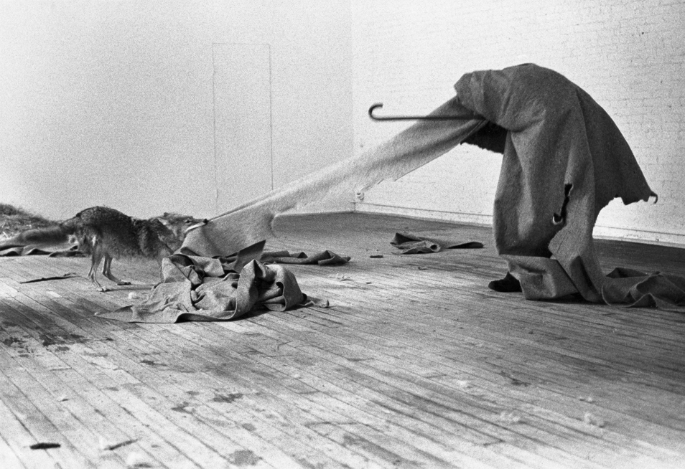

Beuys applies deconstruction upon a viewer in society, by dominating the idea that every person made up of emotions and thought has clarity of being an artist.
Beuys believed that if one were an artist, then one might be an artist everywhere, or in every context in which one finds oneself - the art studio proper, the classroom, and the "street" offering equally advantageous circumstances for creative experience.
“Each time another stick was added we tried to observe carefully whether anything changed in our feelings and experience, and what direction this change took. From time to time each person sat in a different place. This made it possible to see that the way in which this person perceived the detailed relationships between things was independent of his or hers physical position.” (Beuys, 1986, p. 5)
Beuys deconstructs life, not as an occupation but rather a deepened and intensified humanitarian attitude, considering in most situations conducting an advance in one’s life which forms a platform of Beuys’ work, acknowledging a response in social commentary and political activism. Deconstruction is the element that constructs an artist’s view. By using deconstruction Beuys creates a logical thought provoking process which breaks down the reality of life to promote a definition of everyday truth through the process of highlighting the ‘normality’ of ‘social codes of so-called ‘proper’ conduct. Beuys claimed that art should confront social, political and corresponding issues.
Beuys confirms that his political work doesn’t have the same response as others, as he create diverse and intimate art works that have deep meaning and may seem disrespectful. Beuys doesn’t feel like the expression of words has to be literal, and if doing so would not seem suitable for the upbringing of political change. Beuys controls his art works and finds more comfort in them with the idea being portrayed subjectively rather than revealing the context directly.
“I do not want to carry art into politics, but make politics into art” (Beuys).
Beuys’ influences were inspired by the world and its discomfort and dissatisfaction. Beuys finds confrontations within life and uses these highlighted aspects to create art, they are problematic and we become conscious to those situations and create a responses to these positions. Beuys is literal when describing the essence of making art and where one should start with a direct observation.
“If you just describe what you see, you’ll be sure to get there, you’ll arrive in the sphere of the things I mean. People are not moved enough in their interior life, and therefore they don’t change. Your demand — art instruction should continue throughout one’s life, there should be an evolution — can only be achieved if art instruction invades all disciplines.”
Rebecca Horn
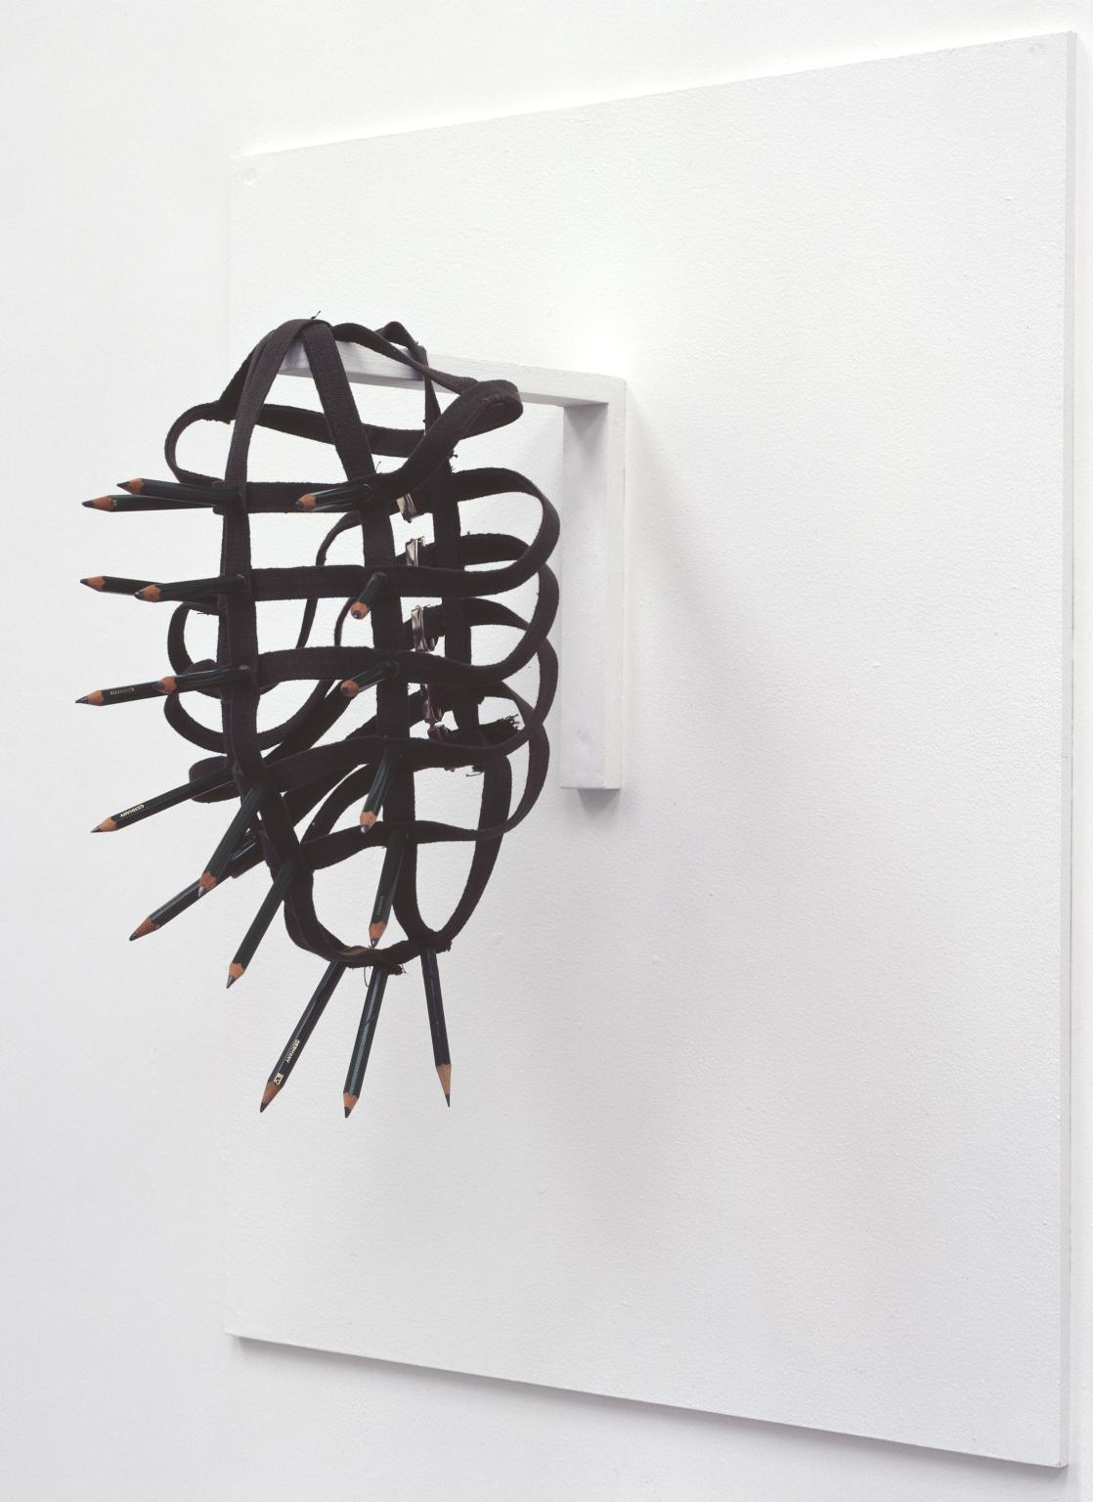
It is obvious that there’s a narrative behind each of Horns work, they create an emotional background and a growing feeling from within. The resemblance of this piece comes from a conditioned environment of which one cannot voice their opinion and outlook. Horn uses the sounds of the pencils to create an atmospheric surrounding allowing the performer to generate a serious discomfort and playfulness to emote protection and creation.
Horn has created an environment of discussion, to allow the concentration of deconstruction within the elements space and body. Inventing a representation of mark making equipment, allowing a discourse of aura to arise from the original drawing method. Using the role of deconstruction to explore a different belief system in the act of capturing marks in drawing. Granting rhythmic movement of one’s body and allowing it to present itself as a movement of language, reflecting self-awareness and allowing a representation of internal thoughts reflected to create a performative habitat. Horns work requires responding to space and establishes diverse and capturing art. Horn is woven into her bodily sculptural creations operating them to become one with her body, finding difficulty in separating body from sculpture. Horn implies aspects of machinery in her performances allowing connections of the body to deconstruct and find similarities within the two, responsively allowing limitations of space to acknowledge themselves within her work. Horn uses her own experiences to create conscious work allowing a close relationship between artist and work. Horn safeguards her body whilst exposing it, allowing exposure generates new possibilities of ideas to reform organically.

Chapter 3
Any personal artwork can have the act of deconstruction used upon it, to an extent deconstruction is a perception learnt and used as a tool to find subjectivity.
Upon first glance one would assume the literal notion of life and death, as the initial thought process would relate to decomposition. By using the act of deconstruction, other hypotheses can emerge allowing multiple subjective meanings. Other interpretations could include the idea of grotesque beauty or potentially the fragility of time, allowing an array of possible connotations.

One may use this approach to underpin elements of art works that one may have missed and disregard elements that may have been unseen to create a full potential capability of the art works.
Art and philosophy have created a sameness in the act of searching for truth. Deconstruction is just a tool used to create a hypothesis which may act and reproduce as art work.
Although deconstruction allows art works for more than one single meaning, these can often be conflicting and depend on the context. This allows us to have our own personal opinion whether it being political, cultural or social and can come from factors consisting of identity and cultural points of view.
It is important as individuals to promote personal attitude and refer to deconstruction to reform thoughts, to never have closed meaning and designate change to different aspects depending on the concepts.
As an approach to underpin criticism by discovering to recognise and puzzle out any undeclared speculation, deconstruction has been used in one’s own personal practice to gather information to acknowledge and be respectful towards others art works.
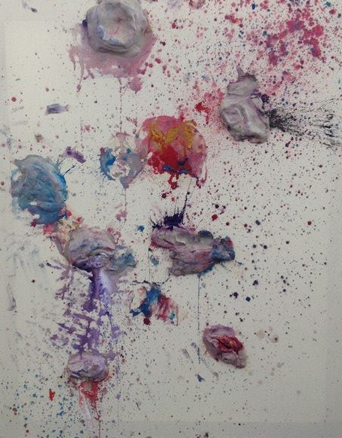
Evidently, this is a visual representation of literal deconstruction. However, the conceptual idea was heavily influenced by the act of deconstruction. “Throwing a pot” is the correct terminology of creating a ceramic vessel on a pottery wheel. By deconstructing the name and process of the method, I was able to create a double entendre with the notion in both a literal and lateral sense. On the other hand deconstruction has been manipulated through an evolution of work to go further than criticism, which has emerged reforming a reduced set formula. The threat here is that deconstruction has evolved into a formula taking away the subjective realness of its organic technique missing the capacity to amplify a self-reflective operation.
Detecting deconstruction has broadened an awareness of ones self-practice reforming a way of seeing to grant aspects that may not have been noticed, creating a path to decipher reasoning of the world, creating a structured response to create art work, and any situations that may arise. Following this structure to create art works finalising elements of ‘normality’ to create an artistic response.
One finds delightfulness in trying to understand the non-understandable as a form of contemplation on literal elements of ‘normality’. The act of deconstruction has been used for years in schools such as Glasgow School of Art, The Slade and Goldsmiths these institutions have created a high end of understanding art through the context of theory and an embedded organic practice in art.
Deconstructing a conditioned world, conditioned by noise, by surrounding, hormones and non-natural coherent thought.

In a response to political constitutions and the implications voting can bring, one can create a responsive installation requiring deconstruction to highlight these involvements. Distinguishing a responsive argument, by using newspaper which held the initial vote allowed a language of materials. Newspaper became the material and informed us of a language, confessing the doubt and integrity in humanity. To deconstruct the use of newspaper into the essence of rubbish, reforming the usage of newspaper to allow a dialogue in an installation. This control allowed an aesthetic presence from something troubled exploring the notion of deconstruction to find different elements to create a positive condition from a negative.
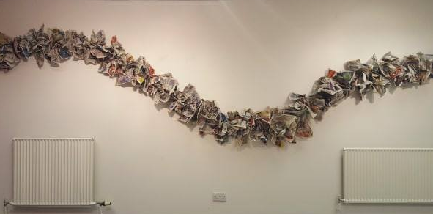
There is no political correctness, nothing is right, nothing is concrete, nothing is correct.
“Art is not there to be simply understood, or we would have no need for art”.

Conclusion

Bibliography
Peter De Bolla (2003) Art matters, Serenity:Barnett Newman Vir Herocius Sublimis. Harvard University Press.
Jason Powell (2006)Jacques Derrida, retrieved from: https://plato.stanford.adu/entries/derrida/ [13/07/2017]
Patrick Bourgeois(1997)Art and Humanities, retrieved from: https://search.proquest.com/docview/205392584?accountid=130472
Brendan Sweetman(1998)The review of metaphysics, Review of Metaphysics, retrieved from:
https://search.proquest.com/docview/223458017?accountid=130472
Jacques Derrida and Deconstruction/ Jeanne Willette(2014) http://arthistoryunstuffed.com/jacques-derrida-deconstruction/ [12/08/2017]
Christopher Norris/ Andrew Benjamin (1988) Deconstruction, Post-Modernism and the Visual Arts,Wiley.
Mark C. Taylor (2004) retrieved from: http://www.nytimes.com/2004/10/14/opinion/what-derrida-really-meant.html [15/08/2017]
Gary Rolfe (2004) http://onlinelibrary.wiley.com/doi/10.1111/nup.2004.5.issue-3/issuetoc [10/08/17]
Jacques Derrida (1991) retrieved from: https://pdfs.semanticscholar.org/7a98/7adda06c0268f8956ef1591f36755c2762d3.pdf [11/07/17]
Logocentrism (n.d.) retrieved from: https://www.merriam-webster.com/dictionary/logocentrism [31/07/17]
Paul Ricoeur (2006) retrieved from: https://plato.stanford.edu/entries/derrida/ [20/09/17]
Foucault (2005) retrieved from: https://plato.stanford.edu/entries/postmodernism/ [02/09/17]
Jonathan Culler (1983) retrieved from: https://www.lrb.co.uk/v05/n13/ed-hirsch/derridass-axioms [12/07/17]
Joseph Beuys (n.d.) retrieved from: https://www.flashartonline.com/article/joseph-beuys/ [12/10/17]
Volker Harlan (2004) What is Art? Was ist Kunst? Clairview.
Thomas Deane Tucker (2009) Derridada, Lexington Books.
Joshua L. Kates (2003) Derrida, Husserl and the commentators: introducing a developmental approach. St. John’s College.
Tiffany Tsantsoulas (2014) Plato Exits the Pharmacy: An answer to the Derridean Critique of Phaedrus and Timaeus. Department of philosophy Faculty of Arts.
Rudolf Arnheim (n.d.) Art and Visual Perception.
Dr Brendan Sweetman.(n.d.) Postmodernism, Derrida and Difference: A critique.
Ellen Lupton(2004)

