Module Code: BMIH5006
Module Title: Sustainable Hospitality &Tourism Management

Student Name: Claudia Butnariu
Student ID: 2239415
Lecturer: Lisa Knight, Kathryn Roberts

AI Acknowledgement:
I confirm that I have not used any Al tools in the research and creation of this assignment. I confirm that I have not presented any Al generated materials as my own work. I confirm I have copies of my drafts, notes, and other resources that I have used, which may be asked to provide in evidence.

Executive Summary
The following report discusses air transportation which is one of the major contributors in facilitating trade, tourism and economic growth. The importance of this mode of transportation in improving the lives of social communities is discussed in the report. The hospitality transport services help people to go from one place to another and indulge themselves in tourist activities with the various transportation services. The mode of transport the report has chosen is air transport which contributes to economic growth and improvement of local businesses. The air transport has impacted on the environment in negative ways and created air pollution and noise pollution. As a result, it has caused health problems for local people and impacted their living standards. Air transport has also led to traffic congestion and social displacements which has led to various issues for local individuals. The potential solutions for solving the issues are provided where the airline operators are suggested to use fuel-efficient aircraft, improve their infrastructures, make use of sustainable aviation fuel and propulsion technology and reduce plastic waste. The benefits of these solutions are elaborated in the report to understand their effectiveness.

Table of Contents
Introduction 5
Air Transportation 6
Damage caused by air transport on the environment, landscape and community 8
Possible solutions to remedy and respond to the damage caused 11
Conclusion & Recommendations 14
References 15

Introduction
Hospitality transport is the combination of transportation services which is designed to fulfil the needs and demands of tourists within the hospitality sector. The wide variety of transportation facilities such as air transfers, buses, and others help people travel from place to place and have a chance to enjoy the hospitality services. The facilities have provided visitors with a convenient travel experience which has positively impacted the overall tourism industry. Hospitality transport is considered to be the lifeline of the hospitality industry as it has it contains the ability to help visitors reach their destinations. The transportation services provide easy access to different locations and allow guests to participate in tourism activities. The seamless travel experience directly impacts the purchasing consideration of tourists which leads to economic growth in the tourist destinations (Cooper, 2021). The following report will discuss air transport as the mode of transport services to elaborate its impacts on the tourism industry. The transportation service allows visitors to travel short and long distances by aircraft in comparatively less time. The services also contribute to the movement of goods in an effective way. British Airways is one of the leading airlines in the United Kingdom which has a record of 12.7 billion British pounds in their annual passenger revenue (statista , 2024). This showcases the contribution of the transport business in the hospitality industry.

Air Transportation
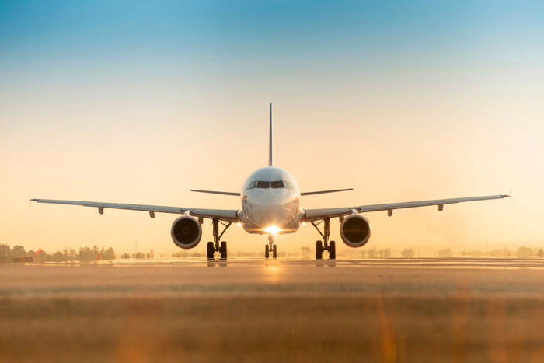
Source: (Dodd, 2025)
Air transport contributes highly to the facilitation of trade, economic growth, and tourism. This mode of transport helps the tourism industry in connecting people from different parts of the world and provides a lifeline for remote communities which enables them to improve their standards of living. Air transport is a key part of the global economy as it allows the rapid movement of products and services across different locations. Multinational businesses highly rely on air transportation facilities for shipping goods in the fastest way possible. This helps them establish global connectivity as they are able to reach their primary markets easily and participate in the global economy. It is a convenient type of transport facility for tourism as people can reach varied locations within the minimum time possible. Approximately 58% of international tourists prefer to travel by air transport for travelling to new destinations which is creating new tourism markets (Dodd, 2025). It enables the destinations to develop new infrastructures like restaurants, hotels and tourist attractions which can help in increasing employment opportunities. The mode of transportation is one of the major global employers as it supports a total of 86.5 million jobs worldwide. In times of emergency, air transport can help in delivering medical supplies anywhere in the world within a few hours (aviationbenefits, 2025). This mode of transportation is necessary for the economy of different countries and for improving the lives of people around the world.

Damage caused by air transport on the environment, landscape and community
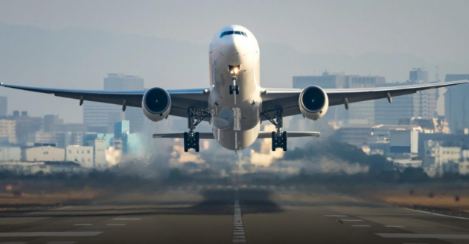
Source: (Timperley, 2021)
Environmental impact
Pollution
The air transport sector plays a significant role in polluting air which leads to environmental degradation and climate change. Airplanes produce ample amounts of greenhouse gases which harm the environment and cause global warming. It also emits vapor trails which can trap heat from the atmosphere. Therefore, continuous transportation services led to more global warming and damage to the environment (Timperley, 2021). The air transport services, especially the aviation sector generate waste from food and drinks and infrastructures of airports. The usage of single-use plastics has increased the amount of waste generation in the aviation sector.
Heavy use of natural resources
The air transport sector uses various fossil fuels such as kerosene, aviation gasoline and leaded gasoline in their aircraft. However, excessive usage strains the natural resources which negatively impacts the environment (Inkson and Minnaert, 2018). The transportation sector relies on natural resources which are not renewable. Therefore, excessive usage of the resources will lead to the extinction of the aspects and may lead to environmental issues.
Landscape
Usage of large areas
For expanding flight paths and improving the efficiency of the overall air transport services, airport construction uses large landscapes. They go through different methods and change land patterns to establish an organised infrastructure that values customer experience. However, the excessive usage of the areas creates problems for local communities and impacts on their quality of life (Timperley, 2021). To expand the infrastructure, businesses purchase significant amounts of land which impacts property value in the adjacent areas. Airport construction also disrupts natural habitats which leads to an impact on the aspects of biodiversity. It also causes air pollution in highly populated locations and impacts their health condition.
Traffic congestions
With the increasing number of passengers in the tourist location, the adjacent areas are facing traffic problems which are disrupting the living standards of local people. The excessive traffic is raising difficulties for local businesses and impacting their economic health. Due to the continuous flight arrangements, areas seem to be always crowded with traffic which is impacting the living standards of the local people. Local individuals and tourists are finding it difficult to reach their destinations in time which is affecting their quality of life. The over-traffic is leading to accidents in the local areas and raising health concerns issues.
Community
Health concerns
Due to the emission of greenhouse gases, the air transport industry causes air pollution which leads to various health issues in the local communities. Diseases such as heart issues, breathing problems and others are created by air pollution and affect the health standards of individuals. Air transport emits nitrogen oxides which have the ability to damage agricultural production (ariannajohnson, 2023). Therefore, the produced vegetables and fruits are at high risk of consumption and can damage the respiratory system as well as the eyes and skin. Air transport also increases noise pollution which leads to various cardiovascular diseases. Listening to aircraft noises for a longer period of time can cause damage to the ears of people in the local areas.
Social displacements
As the air transport services take huge areas for their business to integrate, local people are forced to move from another place to live. This factor impacts their quality of life and affects their mental health. Air transport also increases the property value of adjacent areas which puts pressure on local individuals to stay in an accommodation as per their choice.

Possible solutions to remedy and respond to the damage caused

Source: (greenworldwide, 2023)
Fuel-efficient aircraft: The utilisation of fuel-efficient aircraft is a significant solution for the issue of sustainability in the hospitality industry. The use of such aircraft can drastically reduce the consumption of fuel which will initially reduce carbon emissions per flight. Such air transport vehicles can make air travel more environmentally friendly, decreasing the impact of tourism on climate change. Boeing 777, Airbus A350-900, Boeing 787 streamlines and various other fuel-efficient aircraft are being launched to bring sustainable changes in this mode of transportation (greenworldwide, 2023). Such modern designs of aircraft incorporate features like lightweight materials and improved engines which can help in achieving greater fuel efficiency. The less fuel-burning vehicles will result in lower carbon dioxide and other pollutant emissions while travelling from one location to another.
Improvement of infrastructures: It is necessary for the air transport operators to make necessary improvements in infrastructures like airports. Airports are supposed to be located in locations that are away from residential areas as the sound of the flight take-offs is very loud which can be highly disturbing for the local residents. However, the areas near airports often experience high traffic congestion which is disturbing the lives of local residents. The operators need to build other infrastructures as well, in areas with low population. This will help in dividing the traffic into two halves reducing congestion in a single location. For example, the Heathrow Airport infrastructure operates at a near capacity which causes delays and reduces its connectivity due to which it is welcoming an expansion plan (Labiak, 2025). With a new infrastructure, the operators can access more runways and handle passengers in an organised way. This also reduces noise pollution as new runways could move the low-flying traffic away from cities.
Sustainable aviation fuel (SAF): The use of sustainable aviation fuel can be helpful for the air transport industry to reduce carbon emissions and improve air quality. Sustainable aviation fuel is a biofuel that can be used by blending it with the traditional jet fuel that is currently used in most aircraft. This alternative energy resource can help reduce dependency on fossil-based fuel sources and reduce carbon footprint. Around 820,019 commercial flights have been using sustainable aviation fuel for operation since 2011 which reduces emissions by 80%. There are 69 airports in the world that regularly supply SAF for the operations of aircraft (aviationbenefits, 2025). Los Angeles International Airport is one of those that tries to practice air transportation in a sustainable manner by using 30% of sustainable aviation fuel and 70% of conventional jet fuel (signatureaviation, 2024). The use of SAF will enable airlines to reduce their greenhouse gas emissions by up to 94%, which will initially help in improving the quality of air.
Use of propulsion technologies: The use of new technologies like electric and hydrogen propulsion can help in cutting carbon emissions by 80% (iata.org, 2025). Through this, aircraft can operate with fuel-burning engines and electric motors and batteries. This can help in improving the efficiency of fuel and reduce carbon emissions. The propulsion technology can enable engines to create thrust through which the aircraft can move forward. This can help accelerate the aircraft and enable it to gain altitude. The new generation rotorcrafts including Bell 505, Avicopter AC352, Airbus Helicopter H160 and Russian Helicopter Ka-62 use the propulsion technology (Perry, 2022). This enables a more efficient movement of transportation systems and leads to reducing fuel consumption, environmental footprint and emissions. This technology also enables the aircraft to reduce noise during take-offs and make effective use of sustainable aviation fuel.
Reduce plastic waste: The use of plastic products in airlines for serving food and essential items to passengers needs to be reduced. Non-renewable plastic can generate huge waste in airlines which can be difficult to compost. Instead, the airlines need to switch to biodegradable plastics for plates and trays and paper products such as beverage cups. The airlines can set clear targets for reducing this waste as it is necessary for reducing the waste production in the airports. The airports are required to bring reusable products so that the customer does not need to purchase them again and again. This can help in conserving natural resources and reducing landfills and pollution. Etihad Airways is an excellent example of an airline company that does not use plastic products on board. The company has reduced its use of plastic by 80% and provides passengers with sustainable products onboard. It provides its customers with reusable tableware which is made from high-quality plastics for improving the dining experiences of the customers (etihad, 2022).

Conclusion & Recommendations
The report has discussed hospitality transport which helps travellers to reach their destinations with various transportation services in an effective way and indulge in tourism activities. Air transport offers visitors a chance to travel by aircraft and arrive at tourist destinations. The industry has contributed to the economic growth of countries and helped local communities in various ways. However, the air transport sector has impacted the local communities environmentally and socially. It has led to health issues, traffic congestion, pollution, overuse of natural resources and many other factors. To mitigate the issues, air transport can make improvements in their infrastructure, use propulsion technologies, and reduce the usage of plastic and others. To decrease the amount of air pollution, air transport can transform their facilities into fuel-efficient services. Boeing 777, Airbus A350-900, and Boeing 787 are considered to be fuel-efficient aircraft that can lead to a more sustainable hospitality industry. The usage of new technologies such as electric and hydrogen propulsion can help in reducing carbon emissions by the rate of 80%. Decreasing the usage of plastic products in the airlines for serving food and drinks will help in preventing waste generation. Sustainable aviation fuel is an alternative energy resource that can help reduce reliability on fossil-based fuel.

References
Ariannajohnson, (2023). Air Pollution More Dangerous Than Previously Understood: Here Are The Biggest Health Risks And How To Reduce It. [Online] Available at: https://www.forbes.com/sites/ariannajohnson/2023/02/16/air-pollution-more-dangerous-than-previously-understood-here-are-the-biggest-health-risks-and-how-to-reduce-it/ [Accessed 15 January 2025].
Aviationbenefits, (2025). Sustainable aviation fuel. [Online] Available at: https://aviationbenefits.org/environmental-efficiency/climate-action/sustainable-aviation-fuel/ [Accessed 16 January 2025].
Aviationbenefits, (2025). Tourism enabler. [Online] Available at: https://aviationbenefits.org/social-development/tourism-enabler/ [Accessed 15 January 2025].
Butler, R. (1980) The concept of a tourist area cycle of evolution: implications for management of resources. Canadian Geographer 241, 5–12.
Cooper, C. (2021) Essentials of tourism. Third edition. London: SAGE.
Dickman, S. (1997) Tourism: An Introductory Text. Holder Education, Rydalmere, New South Wales.
Dodd, H., (2025). Supporting economic & social development. [Online] Available at: https://atag.org/industry-topics/supporting-economic-social-development [Accessed 15 January 2025].
Etihad, (2022). Etihad Airways unveils new sustainability-driven economy experience. [Online] Available at: https://www.etihad.com/en/news/etihad-airways-unveils-new-sustainability-driven-economy-experience [Accessed 16 January 2025].
Gentinetta, J. (2020) 11 Examples Of CSR Practices In The Hospitality Industry. [online] Hospitalityinsights.ehl.edu. Available at: https://hospitalityinsights.ehl.edu/csr-practices-hospitality-industry [Accessed 24 January 2021].
Greenworldwide, (2023). Top 5 Most Fuel-Efficient Airplanes in the World. [Online] Available at: https://www.greenworldwide.com/top-5-most-fuel-efficient-airplanes-in-the-world/ [Accessed 16 January 2025].
Iata.org, (2025). Air Travel & Sustainability. [Online] Available at: https://www.iata.org/en/youandiata/travelers/environment/#:~:text=Sustainable%20aviation%20fuels%20(SAF)%20and,a%20landing%20slot%20is%20available [Accessed 16 January 2025].
Inkson, C. and Minnaert, L. (2018) Tourism management: an introduction. 2nd ed. London: SAGE.
Labiak, M., (2025). Reeves expected to welcome Heathrow expansion plans. [Online] Available at: https://www.bbc.com/news/articles/c8j8r79d4rro [Accessed 15 January 2025].
Perry, D., (2022). Rotorcraft industry eyeing recovery as new models arrive. [Online] Available at: https://www.flightglobal.com/flight-international/rotorcraft-industry-eyeing-recovery-as-new-models-arrive/147587.article [Accessed 16 January 2025].
Signatureaviation, (2024). Signature Aviation at Los Angeles International Airport Now 100% Supplied by Blended Sustainable Aviation Fuel. [Online] Available at: https://www.signatureaviation.com/news/signature-aviation-at-lax-now-100-percent-supplied-by-blended-saf/ [Accessed 16 January 2025].
Statista , (2024). Annual passenger revenue of British Airways plc from 2011 to 2023. [Online] Available at: https://www.statista.com/statistics/1131563/passenger-revenue-british-airways-plc/ [Accessed 15 January 2025].
Timperley, J., (2021). The six problems aviation must fix to hit net zero. [Online] Available at: https://www.theguardian.com/environment/2021/sep/05/the-six-problems-aviation-must-fix-to-hit-net-zero [Accessed 15 January 2025].
UNWTO World Tourism Organisation definition (2007).
UNWTO (2021) www.unwto.org/glossary-tourism-terms.
United Nations (2015) THE 17 GOALS | Sustainable Development. [online] Sdgs.un.org. Available at: https://sdgs.un.org/goals [Accessed 24 January 2021].

