Title Page
Student Name: Sonam Akhtar
Student Number: 2439007
Module Number: LCLM4004
Title: Problem solving and decision making
Lecturer's Name: Sujeewa Hearth
Assignment Title: Green Haven Individual Report

Table of Contents

Title Page 1
Table of Contents 2
Explanation of the business problem faced by Green Haven 2
Two Alternative Solutions 3
Justification for Selected Solution 4
Risk Analysis of the Selected Solution 4
Plan to Implement the Selected Solution 4
Means of Measuring the Effectiveness of Implementation of Selected Solution 5
Key findings 5
Reference List: 6
Appendix 8
Appendix 1: Grid Analysis Table 9
Appendix 2: Risk Analysis Table 10
Appendix 3: Implementation Plan 11
Appendix 4: KPI and SMART Table 12

Explanation of the business problem faced by Green Haven
In an era where a single click can have a bouquet delivered to your doorstep, Green Haven Florists must expand their reach beyond the traditional storefront to thrive in the digital marketplace. Over the past twelve months, this small independent flower shop has experienced a significant thirty per cent decline in sales. This downturn can be attributed to reduced foot traffic, increasing operational costs, and heightened competition, all of which have adversely affected the shop’s performance. Additionally, this report will examine how Green Haven's limited digital marketing efforts and lack of customer engagement have contributed to diminished profits. The International Fresh Produce Association (2025) believe that Social media and AI shape consumer behaviour, influencing product choices and purchases. The floral industry should use these tools to engage customers and boost sales.

Two Alternative Solutions
Solution A – Digital Marketing Strategy
Green Haven should consider digital marketing as a potential solution to address the issue of declining sales. Sawicki (2016) and McGruer (2020) suggest that businesses that successfully establish a digital connection with customers are more likely to thrive. As an initial step, Green Haven should develop a modern, user-friendly e-commerce website with optimised SEO to enhance their online visibility and reach new potential customers. Green Haven can also enhance their marketing strategy by creating captivating social media content and implementing targeted email campaigns. Engaging social media posts can capture the interest of existing customers and draw in new ones. Additionally, email campaigns can function as effective customer reminders, leading to increased sales.
Solution B - Customer Engagement
Green Haven can elevate their customer engagement strategy by implementing a loyalty program that rewards customers with every purchase. This initiative will create a loyal customer base and encourage repeat purchasing. Nagaraj (2021) believes that organisations that neglect new and repeat customers risk losing potential loyal clients and failing to retain existing ones. Additionally, Green Haven can strengthen customer connections by inviting customers to share photos of their bouquets, which will also help cultivate an online community. Finally, gathering customer feedback will be crucial to identifying areas for improvement. This will help Green Haven secure repeat purchases and build a loyal customer base.

Justification for Selected Solution
Following a grid analysis (see Appendix 1), it has been determined that customer engagement is the most effective strategy for Green Haven. This approach received the highest score due to crucial factors such as growth potential, customer loyalty, and long-term sustainability, which are all needed in the long term for business success. According to Decision Marketing (2024), the growth and digital evolution of Tesco's Clubcard scheme have equipped the company to gather comprehensive consumer data. This enables more targeted and personalised engagement approaches, ultimately reinforcing Tesco's market position and creating stronger customer relationships. In today's retail circumstances, loyalty programs are essential. Green Haven stands to benefit substantially from this strategy. Customer engagement is a cost-effective approach that builds trust and strengthens loyalty.

Risk Analysis of the Selected Solution
Following a thorough risk analysis (see Appendix 2), the customer engagement strategy has identified risks that are moderate yet manageable. According to Aven (2015), conducting a risk analysis helps create a clear risk overview and compare alternatives or solutions based on their risk levels. The primary concern is the potential for negative feedback from customers on public platforms. The evaluation criteria focused on assessing both the likelihood of these risks occurring and their potential impact. The risk analysis revealed that low-risk factors significantly outweighed the high-risk factors. If Green Haven applies and implements the findings from the risk analysis, Liam and Priya will be better equipped to prepare for any challenges that could hinder their growth through enhanced customer engagement.

Plan to Implement the Selected Solution
Green Haven can implement a straightforward plan (see Appendix 3) that allows for easy tracking of progress at each stage. The Institute of Leadership & Management (2013) believes that it is essential to track progress after implementing changes and assess their effectiveness over time. Green Haven should start by gathering insights from customers through a well-designed survey. Next, Green Haven can create and launch a loyalty program to encourage repeat purchases, along with scheduling emails and social media posts to attract new customers. Following this, they can analyse the data collected from the customer surveys and develop a referral program to further expand their customer database. Sending follow-up emails would also add a personal touch for customers. Finally, it is important for Green Haven to regularly review and plan to ensure that progress and improvements continue to be made. This structured approach will support Green Haven's growth effectively.

Means of Measuring the Effectiveness of Implementation of Selected Solution
The Key Performance Indicators (see Appendix 4) aim to enhance social media engagement, increase repeat purchases, and improve customer feedback alongside a referral program. According to Ishak, Fong and Shin (2019), it is important to monitor progress following the implementation of changes and evaluate how effective they are over time. The SMART objectives include the development of a loyalty program and the encouragement of customer feedback. The Key Performance Indicator tracker will provide a visual representation, enabling Liam and Priya to gain better insights into how well each target is performing, thereby assisting Green Haven in strengthening customer engagement. The combination of key performance indicators and SMART goals establishes clear objectives for Green Haven and facilitates the monitoring of each goal's progress.

Key findings

- Green Haven Florists is experiencing a thirty per cent decline in sales, primarily due to decreased foot traffic, inadequate digital marketing efforts, and limited customer engagement on social media. Addressing these challenges is essential.

- Enhancing customer engagement through targeted emails, effective social media strategies, and the introduction of a loyalty rewards program is crucial for building strong connections, encouraging repeat business, and cultivating brand loyalty.

- The potential risks of negative customer feedback on public platforms are considerable, yet they can be reduced through effective customer service training. By providing customers with the necessary skills, it improves customer satisfaction and diminishes the likelihood of public criticism.

- A structured implementation plan is essential for effectively tracking progress in projects. It establishes clear objectives, timelines, enabling Liam and Priya to monitor and make necessary adjustments, leading to efficient goal success.

- Well-defined Key Performance Indicators and SMART goals will enable Liam and Priya to effectively measure the progress and growth of Green Haven. This framework will allow them to evaluate performance, monitor milestones, and make informed decisions to achieve their objectives.

Reference List:
Aven, T. (2015). Risk Analysis. Chichester: John Wiley & Sons.
Decision Marketing (2024) ‘Clubcard data in the driving seat as Tesco profits surge’, Decision Marketing, 3 October. Available at: https://www.decisionmarketing.co.uk/news/clubcard-data-in-the-driving-seat-as-tesco-profits-surge (Accessed: 5 November 2025).
Institute of Leadership & Management (2013). Solving Problems and Making Decisions. 5th ed. Abingdon: Routledge.
International Fresh Produce Association (2025). 2025 Floral Industry Trends. Available at: https://www.freshproduce.com/resources/floral/2025-floral-industry-trends/ (Accessed: 1 November 2025).
Ishak, Z., Fong, S.L. and Shin, S.C. (2019) ‘SMART KPI Management System Framework’, IEEE International Conference on System Engineering and Technology (ICSEngT). Piscataway, NJ: IEEE, pp. 172–177. Available at: https://doi.org/10.1109/ICSEngT.2019.8906478
McGruer, D. (2020). Dynamic digital marketing : master the world of online and social media marketing to grow your business. Chichester, West Sussex, United Kingdom: John Wiley & Sons Ltd.
Nagaraj, S. (2021) Insights, innovation, and analytics for optimal customer engagement. Hershey, PA: IGI Global. Available at: https://doi.org/10.4018/978-1-7998-3919-4.
Sawicki, A. (2016). Digital marketing. World Scientific News, (48), pp.82-88.

Appendix

Appendix 1: Grid Analysis Table
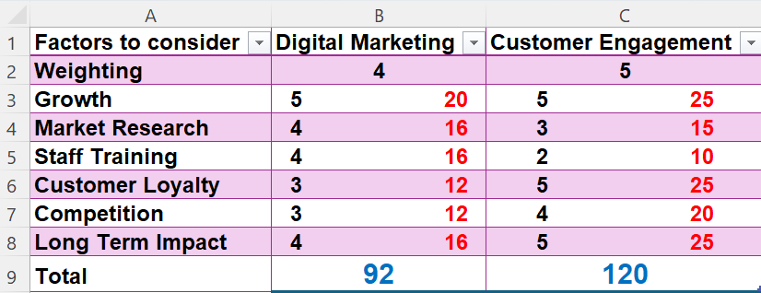

Appendix 2: Risk Analysis Table
Customer Engagement Risk Analysis Table
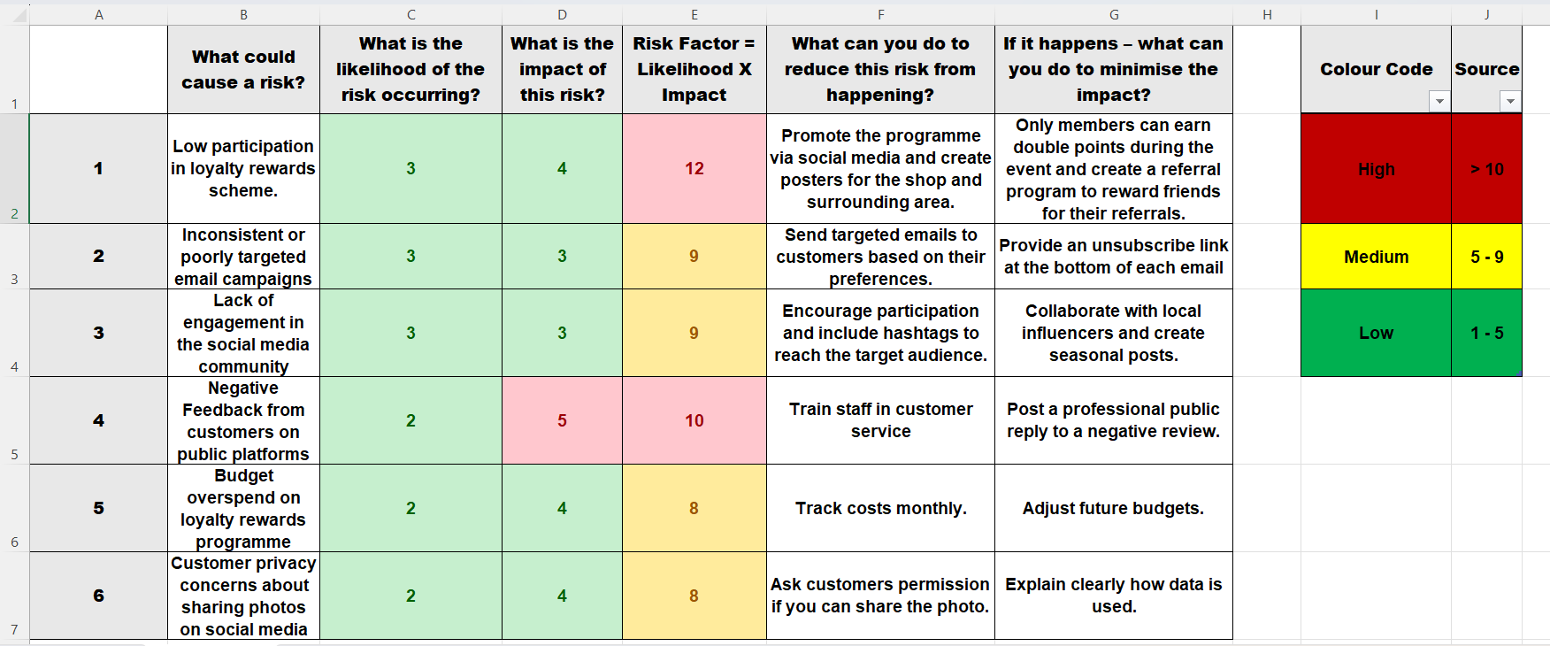

Appendix 3: Implementation Plan
Problem: A thirty per cent decline in sales due to limited customer engagement.
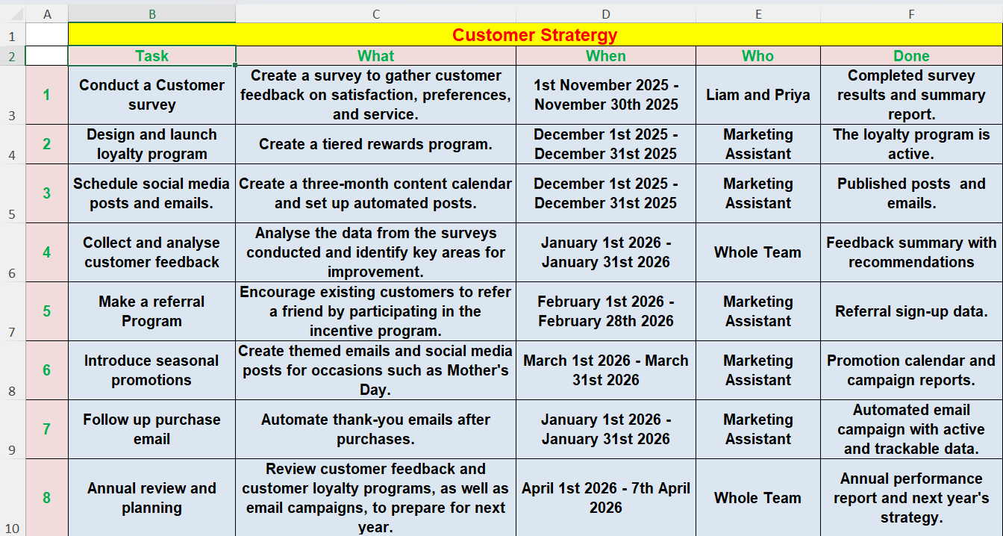
Solution: Customer engagement strategy will include customer loyalty programs and outreach through social media.
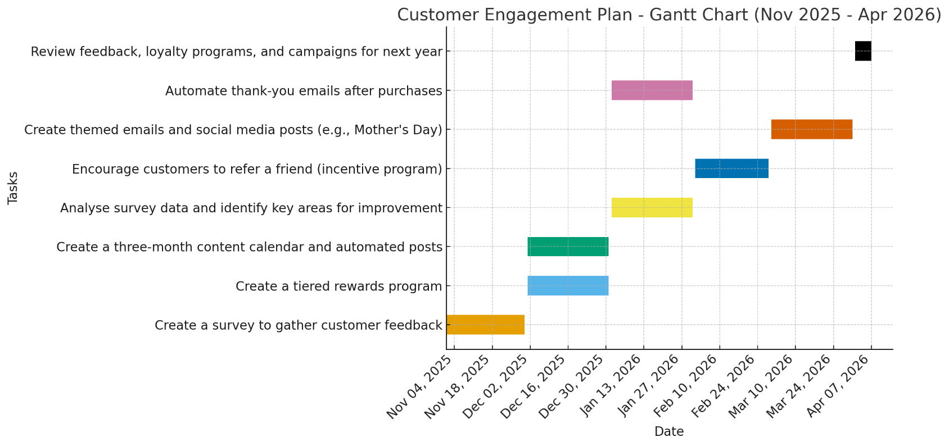

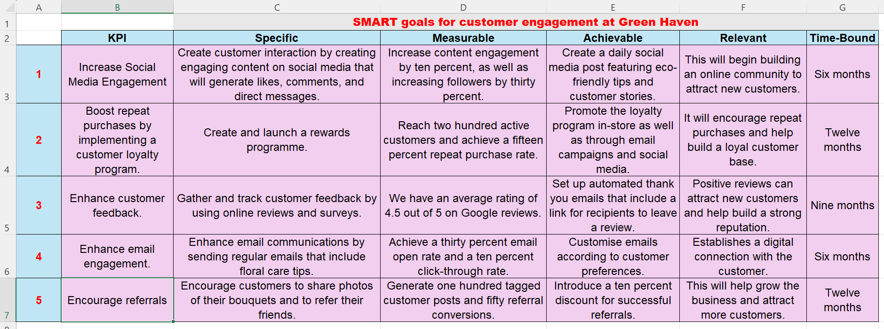
Appendix 4: KPI and SMART Table


