University of Wales Trinity St. David

MSc Policing (Operational and Strategic Leadership)

Module: Strategic Management in Policing

Assignment: Strategic Business Plan

Course Code: BMPO7004D

Submitted by:

Name: Mark Skelton

Student Number: 2414812

Date:

Contents

AI declaration- Page 3

- Executive Summary – Page 4
- Scope of the Strategic Proposal- Page 6
- Strategic Objectives- Page 8
- The Strategic Business Proposal- Page 10
- Financial and budgeting resources- Page 14
- Proposed implementation of the strategic proposal- Page 17
- Communications strategy and stakeholder plans- Page 22
- Analysis of options identified in the proposal- Page 27
- Recommendations and conclusions- Page 35
- Abstract- Page 36
Bibliography- Page 44

I acknowledge the use of Microsoft CoPilot between 28th May and 29th June 2026 to support my research using prompt(s) such as:
- Strategic Management in Policing
- Strategic Plan for a Strategic Business Proposal
- Creation of diagrams and charts to include in the Strategic Business Plan

I acknowledge the use of Microsoft CoPilot between 28th May and 29th June 2026 to write my rough notes into submission format using prompt(s) such as or similar to:
- Rough notes prepared into an essay paragraph at university level.
- Assistance with structure and word count and flow.

I acknowledge the use of Chat GPT on between 28th May and 29th June 2026 to create diagrams and charts to include in the Strategic Business Plan.

I confirm that I have not presented any AI generated text as my own work. I confirm I have copies of my drafts, notes, and other resources I used before, and after the use of AI tools which I may be asked to provide in evidence.

- Executive Summary
Policing now operates within an increasingly complex digital environment in which digital evidence features in almost every investigation, with over 90% of crime containing a digital element (NPCC, 2020). Mobile devices have become the most common and behaviourally rich source of evidence, often surpassing traditional forensic approaches such as fingerprints, DNA, and witness testimony in both frequency and investigative value. This shift has fundamentally altered investigative expectations and placed digital forensics at the centre of modern policing (Rappert, et al., 2022; Jones & Brookman, 2024).
However, national assessments highlight that policing has not kept pace with this demand. HMICFRS (2022) identified widespread confusion about digital forensics, inconsistent capability, and a national backlog exceeding 25,000 devices. In some forces, delays were so severe that victims were being failed, with digital forensic services described as slow, ineffective, and less professionally managed than other forensic disciplines (HMICFRS, 2022).
National drivers reinforce the urgency for reform. The NPCC Digital Strategy (2025) and the Forensic Science Regulator’s Code of Practice (2025) require scientifically robust, ISO‑aligned digital forensic processes. The NPCC Digital Strategy (2025) highlights systemic issues including legacy systems, fragmented governance, digital skills shortages, and weak business‑change capability. These pressures are intensified by post‑pandemic financial constraints and rising digital demand (HMICFRS, 2025). The Policing Productivity Review (2023) estimates that up to 38 million hours of police time could be saved through improved technology and processes.
Within this national context, Humberside Police faces acute local pressures (NPCC, 2025). The force operates a two‑tier extraction model using ten MSAB Mk2 kiosks across five sites. These kiosks are technologically outdated, limited to logical extractions, and unable to recover deleted or app‑based data. They are not networked, requiring manual updates and creating inefficiency, downtime, and governance risks. Workflow fragility is compounded by manual data transfer processes that introduce risks to evidential integrity and ISO compliance (Humberside Police, 2025; MSAB, 2015).
Around 87% of all mobile‑device examinations—approximately 5,000 per year—are conducted via kiosks, consuming an estimated 20,000 hours of officer time annually at a cost of £500,000. Their limited capability results in high volumes of devices being diverted to the Digital Forensics Unit (DFU), which already faces 12‑month turnaround times and rising demand, particularly in high‑harm areas such as CSAM (Humberside Police, 2025; NPCC, 2025).
This Strategic Business Proposal sets out a modernised solution: the creation of two dedicated Mobile Device Examination Hubs at Clough Road and Birchin Way. These hubs will deliver full‑file extraction, PIN‑bypass capability, ISO‑aligned workflows, and a trained, accredited workforce operating seven days a week. Locating the hubs at custody centres will reduce officer abstraction, accelerate investigative progression, and strengthen evidential integrity through secure digital delivery.
The model will reduce Level 1 turnaround times to under 14 days, enable same‑day processing for urgent cases, and cut DFU referrals by at least 90% within the first year. It provides a scalable, future‑proofed capability aligned with the Humberside Police Strategic Plan, Op Soteria, and national digital‑forensics expectations—delivering faster justice and improved outcomes for victims.
- Scope of the Strategic Proposal
The scope of this Strategic Proposal covers the full end‑to‑end design, resourcing, and operationalisation of Level 1 mobile‑device examinations through the establishment of two dedicated Mobile Device Examination Hubs. This includes the introduction of full‑file extraction and PIN‑bypass capability, the development of ISO‑aligned workflows, and the creation of a trained and competent workforce capable of delivering consistent, legally defensible outcomes. The scope also incorporates the procurement of extraction tools and licences, infrastructure and network upgrades, workspace configuration, recruitment, specialist training, quality‑assurance processes, and the establishment of governance and performance‑monitoring arrangements.
The proposal extends to changes in investigative workflows, referral pathways, and supervisory oversight to ensure that the hubs integrate effectively with existing investigative structures. Stakeholder engagement across Investigations, the Digital Forensics Unit (DFU), ICT, and senior leadership is central to the scope, ensuring alignment with organisational priorities and national expectations for modern digital‑forensics capability.
Out of scope are Level 2 DFU examinations, cloud‑based extraction, and any changes to force‑wide digital‑forensics accreditation beyond the processes directly affected by the new hubs.
Success will be measured through clearly defined Key Performance Indicators (KPIs):
- Reduction of Level 1 turnaround times to under 14 days for standard cases and same‑day for urgent or custody cases within 12 months.
- Reduction of Level 2 DFU referrals by ≥90% in the first operational year.
- Achievement of full ISO 17025/17020 alignment within 24 months, evidenced through internal and external audits.
- Strengthened audit and quality‑assurance outcomes, including monthly case audits and zero critical non‑conformities.
Collectively, this scope ensures the proposal is targeted, measurable, and strategically aligned with both force priorities and national policing expectations.
- Strategic Objectives
There are four strategic objectives for this proposal, each designed to strengthen investigative effectiveness, reduce demand on specialist services, and ensure ISO‑aligned, legally defensible digital‑forensics practice:
- Improve investigative timeliness:
Reduce Level 1 mobile‑device turnaround times from the current multi‑week average to under 14 days for standard cases and same‑day turnaround for urgent or custody cases within 12 months of the hubs becoming operational. This has the dual objective of emphasise improving the victim experience and strengthening justice outcomes though increased timeliness of investigations.
- Reduce demand on the Digital Forensics Unit (DFU):
Decrease downstream referrals for Level 2 examinations by at least 90% in the first operational year through full‑file extractions and PIN‑bypass capability at Level 1. Only CSAM cases or those with specific technical requirements will be escalated to DFU.
- Increase compliance with ISO standards:
Achieve full alignment with ISO 17025/17020 within 24 months, evidenced through documented workflows, internal audits, and successful external quality‑assurance checks.
- Strengthen audit and quality‑assurance outcomes:
Embed consistent supervisory oversight, routine case audits, and continuous improvement mechanisms to ensure high‑quality, legally defensible examinations and early identification of risks or process failures.
These objectives align directly with the Humberside Police Strategic Plan (2026) and the recommendations set out in the Op Soteria Self‑Assessment (2025) both of which emphasise improving the victim experience and strengthening justice outcomes. They also reflect wider national expectations, including the Home Office (2023) focus on improving police productivity and the National Policing Digital Strategy (2025), which calls for enhanced digital capability, modernised systems, and the development of a digitally skilled workforce.
- The Strategic Business Proposal
This Strategic Proposal outlines the development and implementation of two dedicated Mobile Device Examination Hubs to modernise Humberside Police’s digital‑forensics capability, improve investigative timeliness, and significantly reduce demand on the Digital Forensics Unit (DFU). The hubs will provide a resilient, ISO‑aligned Level 1 extraction service that supports faster justice outcomes, enhances victim experience, and strengthens organisational productivity.
The hubs will be located at Clough Road and Birchin Way, the force’s primary custody and investigative centres. These locations were selected for their secure infrastructure, centrality, and proximity to frontline investigative teams. Positioning the hubs at these sites enables officers to deposit devices directly at the point of investigation, eliminating unnecessary travel to remote kiosk sites and reducing officer abstraction. Extracted data will be delivered to investigators via a secure digital platform, removing reliance on removable media and improving evidential integrity, auditability, and chain‑of‑custody compliance.
Operationally, the hubs will function 08:00–20:00, seven days a week, providing capacity for both routine investigations and urgent custody‑related extractions. Each hub will be equipped with modern extraction tools, networked management suites, and secure digital‑storage solutions, enabling real‑time oversight, governance, and compliance with the Forensic Science Regulator’s Code and ISO 17025/17020 standards (2025). Integrated workflow management will ensure efficient data flows through minimal human touchpoints, consistent documentation, and seamless escalation to DFU where Level 2 expertise is required.
The proposed model delivers a sustainable, standardised, and operationally effective Level 1 digital‑extraction capability. It directly supports organisational priorities by enabling:
- Faster justice through reduced turnaround times
- Reduced DFU demand and improved Level 2 capacity
- Improved victim experience through quicker investigative progression
- ISO compliance and strengthened forensic governance
- Better productivity through reduced officer abstraction and streamlined workflows
- Alignment with force and national strategies, including the Humberside Police Strategic Plan (2026), Op Soteria (NPCC, 2025), and the National Policing Digital Strategy (NPCC, 2025)
This proposal therefore provides a coherent, evidence‑based, and strategically aligned solution to the force’s growing digital‑forensics demand.
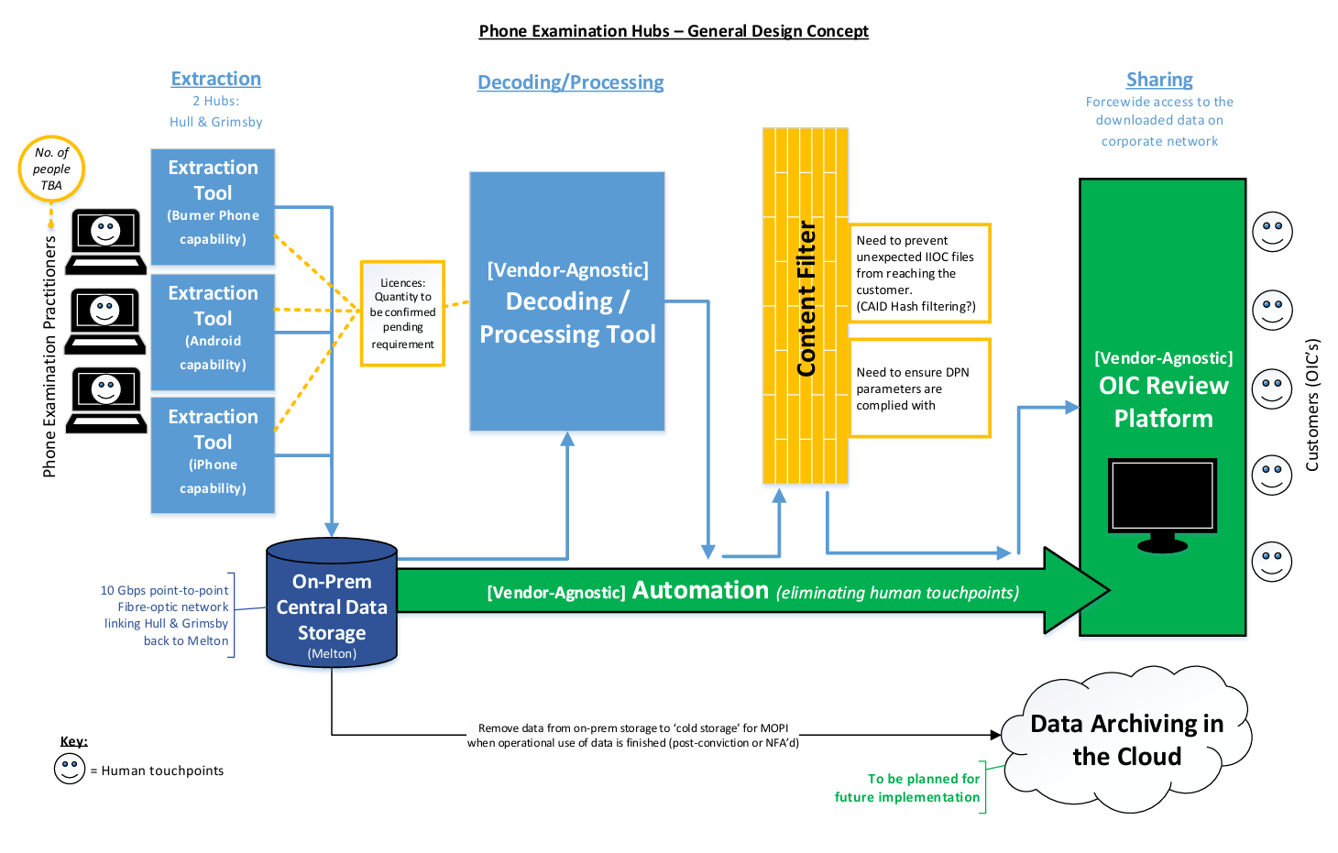
(Humberside Police, 2026)
Risk mitigation and responsibility assignment
Risk management for the Mobile Device Examination Hubs focuses on safeguarding operational continuity, financial stability, and ISO‑aligned quality. The most significant risks relate to staffing shortfalls and equipment failure, either of which would prevent Level 1 examinations and push demand back onto the DFU. These are mitigated through a resilient staffing model and rigorous supplier testing. Additional risks—including procurement delays, training gaps, infrastructure failures, resistance to change, and cost escalation—are controlled through established governance processes such as early market engagement, structured CPD, IT resilience measures, targeted stakeholder communication, and monthly financial monitoring. Clear ownership through the RACI framework ensures accountability and timely mitigation, providing confidence that the hubs can be delivered sustainably and achieve the intended operational benefits.
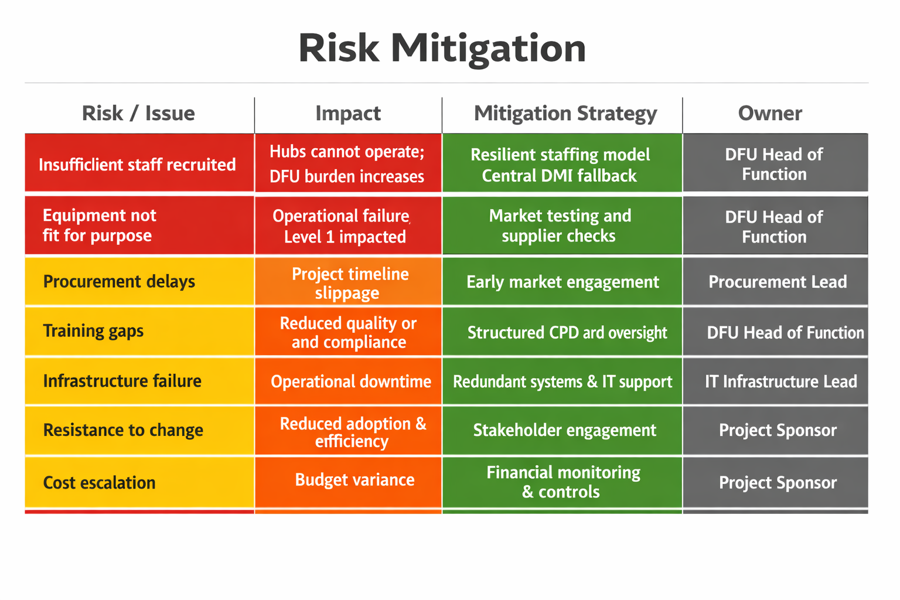
(Skelton, 2026)
- Financial and budgeting resources
A clear and defensible financial strategy is essential to ensuring that the Mobile Device Examination Hubs represent a sustainable and strategically aligned investment. This section demonstrates the application of financial modelling financial governance and procurement principles, the use of financial data to inform decision‑making, and responsiveness to stakeholder requirements.
Capital Investment
The total capital investment required to establish the hubs is £305,000. This includes £210,000 for extraction tools, licences and associated software; £55,000 for network and infrastructure upgrades; and £40,000 for secure digital‑storage expansion and workspace configuration. These costs reflect the need to modernise digital‑forensics capability, ensure ISO‑aligned processes, and create a scalable infrastructure that can meet rising digital demand. Capital modelling demonstrates that this upfront investment will reduce long‑term pressure on the Digital Forensics Unit (DFU) and improve investigative timeliness across the force.
Revenue Costs
Annual revenue expenditure is estimated at £900,000, covering staffing, training, licence renewals, and equipment refresh. This includes specialist training to ensure competence in ISO 17025/17020‑aligned workflows, supervisory oversight, and continuous professional development. These costs are essential to maintaining a skilled workforce capable of delivering high‑quality, legally defensible examinations. Financial modelling shows that these revenue costs are offset by reductions in officer abstraction, improved case progression, and reduced reliance on DFU for Level 2 examinations.
Cost–Benefit Analysis
The financial case is strengthened by clear operational benefits. Reducing Level 1 turnaround times from several weeks to under 14 days, and enabling same‑day processing for urgent or custody cases, will significantly reduce abstraction hours and improve investigative efficiency. The introduction of full‑file extraction and PIN‑bypass capability at Level 1 is projected to reduce DFU referrals by at least 90%, alleviating backlog and improving Level 2 timeliness. These improvements support faster justice outcomes, improved victim experience, and reduced investigative delays—key priorities for both local and national stakeholders.
Procurement and Governance
All procurement activity will comply with force financial regulations and the Public Sector Procurement Policy (2023). Market testing, supplier evaluation, and transparent scoring matrices will ensure value for money, competition, and compliance with legal and ethical standards. Supplier resilience, product lifecycle, and long‑term support arrangements will be assessed to ensure sustainability and minimise future cost escalation. Financial monitoring, variance analysis, and reporting to governance boards will ensure accountability and early identification of risks.
Long‑Term Sustainability
This financial strategy balances upfront investment with recurring efficiencies, ensuring that resources are allocated responsibly and in line with organisational priorities. By reducing DFU demand, improving investigative timeliness, and strengthening ISO compliance, the hubs deliver both operational and financial returns, supporting a sustainable and future‑proofed digital‑forensics capability.
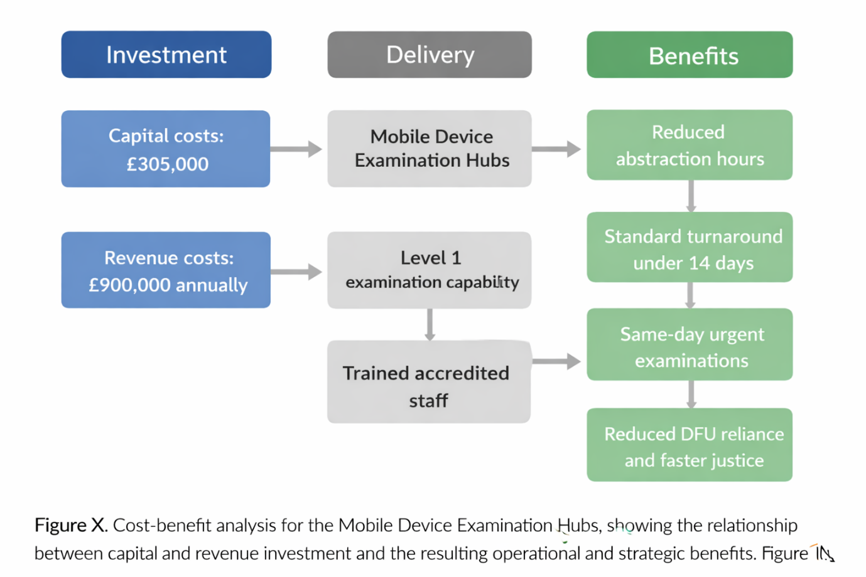
(Skelton, 2026)
- Proposed implementation of the strategic proposal
Phase 1: Project Initiation (Month 1)
This phase establishes the foundations for delivery and secures organisational commitment.
- Establish governance board and project team: Engage senior leaders early to secure strategic buy-in and confirm oversight arrangements.
- Confirm scope, KPIs, and success criteria: Agree the project boundaries, performance measures, and evaluation criteria with senior leadership.
- Initial stakeholder engagement and communication plan: Identify key stakeholders and develop a communication strategy to ensure transparency, feedback, and early sensemaking.
- Procurement planning, technology scoping, and market testing: Assess available technologies, including tools already in use within the DFU, and identify the optimal configuration to meet operational needs.
- Agree IT timeline: Confirm the significant ICT infrastructure requirements—including fibre connectivity—and secure a delivery timetable.
- Agree staffing model: Determine whether hubs will be staffed by police officers, police staff, or a blended model.
- Agree staffing structure: Define staffing numbers, shift patterns, and contingency arrangements to ensure full operational coverage.
Phase 2: Procurement & Contract Award (Months 2–3)
This phase secures the technology and infrastructure required for delivery.
- Supplier evaluation and scoring: Conduct structured testing and piloting of available technologies, including those currently used in the DFU.
- Compliance checks against Public Sector Procurement Policy: Ensure procurement processes meet legal, ethical, and financial governance standards.
- Budget profiling and financial approval: Confirm capital and revenue budgets to enable procurement and infrastructure work to begin.
- Contract award: Finalise contracts for extraction tools, licences, infrastructure upgrades, and associated services.
Phase 3: Infrastructure & Workspace Preparation (Months 3–5)
This phase prepares the physical and digital environment for the hubs.
- Identify suitable rooms at each location: Confirm secure, fit-for-purpose workspace for hub teams.
- Network upgrades and security configuration: Install required fibre-optic connectivity and ensure secure integration with force systems.
- Digital-storage expansion: Increase storage capacity to accommodate higher volumes of extracted data.
- Workspace design and installation: Install equipment in consultation with Estates, Health & Safety, and ICT; identify any additional cost implications.
- ISO-aligned workflow mapping: Develop a Service Level Agreement (SLA) and process map to ensure staff understand and follow compliant workflows.
Phase 4: Recruitment & Training (Months 4–7)
This phase builds the workforce capability required for go-live.
- Recruitment of hub staff: Conduct internal/external recruitment, including job adverts, interviews, vetting, and appointment.
- Specialist training: Deliver training in Level 1 extraction, PIN-bypass, and ISO-aligned processes.
- Supervisor and QA training: Equip supervisors with the skills to oversee quality, governance, and escalation.
- Competency sign-off: Confirm staff competence prior to operational deployment.
Phase 5: System Deployment (Months 7–9)
This phase tests the system and ensures readiness for full implementation.
- Installation of extraction tools and software
- Full pilot phase: Test systems and workflows before removing the existing structure.
- Initial audit and quality-assurance checks
- Refinement of workflows: Incorporate learning from the pilot to optimise processes.
Phase 6: Full Operational Go-Live (Month 10)
This phase transitions the hubs into full operational service.
- Hubs become fully operational
- Communication to all commands
- Monitoring of turnaround times and DFU referral rates
Phase 7: Benefits Realisation & Continuous Improvement (Months 10–12)
This phase ensures the hubs deliver measurable improvements and embed sustainable practice.
- Performance reporting against KPIs
- Financial variance analysis
- ISO audit preparation
- Lessons-learned review and process optimisation
Parallel Working
Although presented linearly, several activities—such as recruitment, training, piloting, and technology assessment—will run concurrently to maximise efficiency and reduce implementation time. This parallel approach ensures the project remains agile, responsive, and aligned to operational demand.
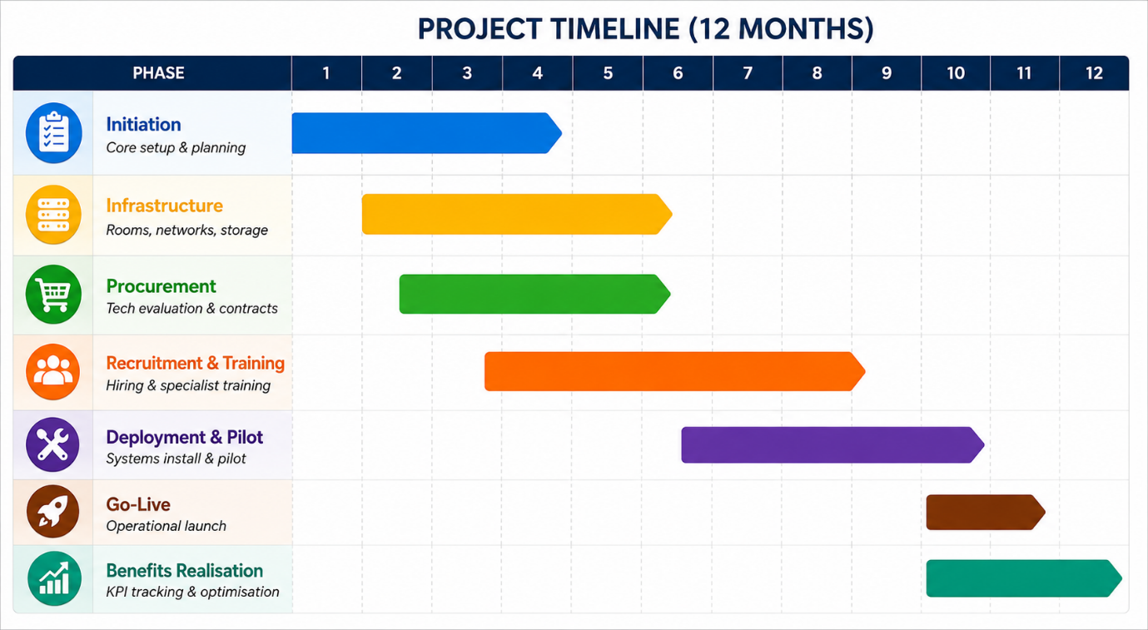
(Skelton, 2026)
- Communications strategy and stakeholder plans
The communications strategy provides a structured, transparent, and evidence‑based approach to informing, engaging, and influencing stakeholders throughout the development and implementation of the Strategic Plan. Its purpose is to ensure clarity of intent, build shared understanding, and support organisational readiness for change.
Stakeholder Identification and Analysis
Effective communication begins with a systematic identification of stakeholders and a clear understanding of the force’s digital landscape. Stakeholders have been mapped according to their influence, interest, and proximity to the proposed changes. This ensures communication activity is proportionate, targeted, and aligned with organisational priorities.
Primary stakeholder groups include:
- Operational users and investigative teams who rely on digital examination outputs.
- IT and Networking functions responsible for infrastructure, security, and system integration.
- Senior Leadership with accountability for strategic alignment, resourcing, and organisational risk.

This analysis informs the communication approach, ensuring that messaging, channels, and timing reflect the needs and expectations of each group.

Early Engagement During the Initiation Phase
Structured engagement will take place during the Initiation Phase to surface concerns, test assumptions, and build early ownership. This engagement will explore:
- Stakeholder definitions of what good looks like.
- Views on the proposal’s feasibility, risks, and opportunities.
- Identification of barriers, dependencies, or required amendments.
- Expectations regarding service quality, governance, and operational impact.
Feedback from this phase will be collated and incorporated into the options analysis, ensuring the Strategic Plan is grounded in operational reality and informed by stakeholder insight.
Key Messaging Framework
Key messages will be issued at defined milestones to maintain clarity, consistency, and alignment with organisational values. Messages will be:
- Clear – providing unambiguous information on purpose, progress, and decisions.
- Concise – focused on essential content to avoid information overload.
- Consistent – aligned with the force’s strategic objectives and digital transformation agenda.
Messaging will be tailored to audience needs and delivered through appropriate channels, including briefings, written updates, dashboards, and targeted engagement with high‑impact stakeholders.
Implementation of the Communications Strategy
The implementation phase will operationalise the communications plan through coordinated activity and disciplined resource management. Key components include:
- Assignment of Roles and Responsibilities – defining ownership for communication tasks and ensuring accountability.
- Development of Timelines – establishing deadlines aligned to programme phases and decision points.
- Resource Allocation – ensuring capacity, tools, and subject-matter expertise are available to support delivery.
- Progress Monitoring – tracking implementation, identifying slippage, and adjusting plans where required.
This structured approach ensures communication activity remains proactive, timely, and aligned with programme governance.
Monitoring, Evaluation and Continuous Improvement
Monitoring and evaluation will assess the effectiveness of communication activity and support continuous improvement. Data will be collected and analysed to understand reach, engagement, and impact.
Evaluation metrics include:
- Reach – the number and type of stakeholders receiving communications.
- Engagement – levels of interaction, attendance, and feedback.
- Impact – the extent to which communication supports programme objectives.
- Stakeholder Feedback – qualitative insights on clarity, tone, and usefulness.
Findings will be reported to governance boards and used to refine future communication activity, ensuring the strategy remains responsive, evidence‑based, and aligned with organisational needs.
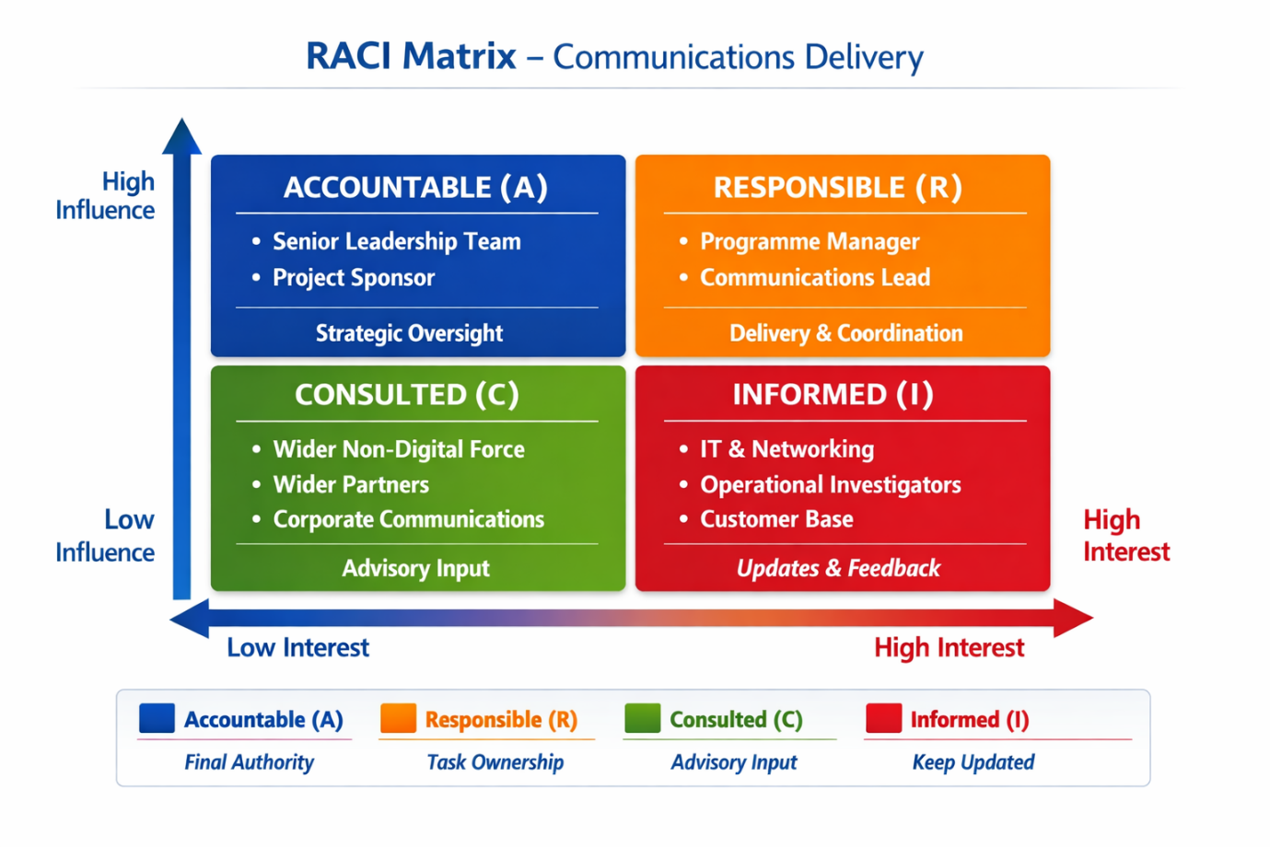
(Skelton, 2026)
- Analysis of options identified in the proposal
1. Option 1 — Do Nothing
Summary: Maintain the current kiosk estate and renew licences for 12 months.
Strengths:
- Minimal immediate financial outlay (licence renewal only).
Weaknesses:
- High operational risk: Equipment is antiquated, unreliable, and unlikely to survive another 12 months.
- Capability gap: Logical extraction only; no PIN brute force, limited app data recovery, no deleted data recovery → continues to push demand into DFU.
- Non‑compliant: No networking, no audit trail, removable media reliance, no accreditation monitoring → fails ISO 17025/17020 requirements.
- Inefficient: Officers must travel to kiosks and physically move data; maintenance requires transporting devices across the force.
- Strategic failure: Does not improve timeliness, productivity, victim experience, or governance.
- Organisational risk: Likely to increase DFU backlog and risk service collapse.
Assessment:
Option 1 is not viable. It fails every strategic, operational, and compliance objective and increases organisational risk.
2. Option 2 — Partial Upgrade
Summary: Replace kiosks with newer versions and network them for maintenance and training.

Strengths:
- Existing estate structure and trained staff reduce implementation complexity.
- Lower cost than full hub creation.
- Networking improves maintenance and accreditation oversight.
Weaknesses:
- Capability remains insufficient: Even upgraded kiosks are still logical‑only, vendor‑locked, and cannot perform advanced extractions (PIN brute force, deleted data, full file system).
- DFU demand remains high or increases.
- Operational inefficiency persists: Officers still travel to kiosk sites; removable media still required.
- ISO compliance still not achievable: Kiosk model cannot meet forensic governance standards.
- Strategic misalignment: Does not deliver improved timeliness, productivity, or victim experience.
- No capacity for future growth into other areas of digital policing.
Assessment:
Option 2 is a marginal improvement but still fails to meet core capability, compliance, and strategic requirements. It is a short‑term patch that prolongs structural weaknesses.
3. Option 3 — Single Mobile Device Examination Hub at Melton 2
Summary: Centralise Level 1 extraction at Melton 2 alongside DFU.
Strengths:
- Lower networking cost: Existing DFU infrastructure reduces setup complexity.
- Faster implementation due to existing estate.
- Centralised staffing simplifies abstraction management.
- Fewer devices required → lower capital cost.
- Enables modern extraction tools and secure digital delivery of data.
- Improves governance, auditability, and ISO alignment.
- Reduces DFU demand and improves Level 2 capacity.
Weaknesses:
- Significant officer travel burden:
Grimsby → Melton 2: 30 miles
Scunthorpe → Melton 2: 20 miles
Clough Road → Melton 2: 12 miles
Bridlington → Melton 2: 33 miles
- Increased travel → reduced productivity, increased abstraction, slower investigations.
- Turnaround times may worsen, undermining “faster justice”.
- Misaligned with force strategy to reduce officer abstraction and streamline workflows.
- Victim experience may be negatively affected due to delays.
- Limited capacity for future growth into other areas of digital policing.
Assessment:
Option 3 delivers technical and governance improvements, but at the cost of significant operational inefficiency. It solves the ISO problem but creates a new abstraction problem.
4. Option 4 — Two Dedicated Mobile Device Examination Hubs (Clough Road & Birchin Way)
Summary: Establish two fully equipped, networked Level 1 hubs at the main custody centres.
Strengths:
- Operational efficiency: Devices can be delivered immediately after arrest → minimal abstraction.
- Faster justice: Reduced turnaround times and quicker investigative progression.
- Improved victim experience: Faster outcomes and reduced investigative delay.
- ISO compliance: Modern tools, secure digital delivery, auditable workflows, governance aligned with FSR Code.
- Reduced DFU demand: Full‑file extractions and PIN brute force reduce Level 2 referrals.
- Better productivity: Streamlined workflows, reduced travel, reduced officer abstraction.
Strategic alignment:
- Humberside Police Strategic Plan (2026)
- Op Soteria (NPCC, 2025)
- National Policing Digital Strategy (NPCC, 2025)
- Future‑proofing: Vendor‑neutral tools, scalable infrastructure, networked management suites.
Weaknesses:
- Higher initial cost: equipment, networking, estates, staffing.
- Networking is significant: two 10Gbps fibre lines (£55,000 p/a).
- Estates work required to prepare rooms.
- Need to maintain staffing resilience across two sites.
- Some travel still required for non‑custody‑based teams (e.g., Bridlington, Scunthorpe).
Assessment and SWOT analysis
Option 4 is the only option that meets all strategic, operational, governance, and compliance objectives. It is the most expensive but delivers the highest return on investment and long‑term sustainability.
Strengths
- Modern, vendor‑neutral extraction capability enabling full file‑system, deleted‑data, and PIN brute‑force recovery.
- Significant reduction in DFU demand and improved Level 2 capacity.
- Strong ISO compliance and strengthened forensic governance.
- Reduced officer abstraction through proximity to custody centres.
- Faster investigative turnaround and improved victim experience.
- Secure digital delivery enhances evidential integrity and auditability.
- Strong alignment with force and national digital‑forensics strategies.
Weaknesses
- Higher capital and networking costs, including two 10Gbps fibre lines (£55,000 p/a).
- Estates work required to prepare suitable rooms.
- Need to maintain staffing resilience across two sites.
- Some travel still required for non‑custody‑based teams.
Opportunities
- Establishes a scalable, future‑proofed digital‑forensics capability.
- Enables expansion into wider digital‑evidence workflows (e.g., cloud extraction, advanced analytics).
- Supports force ambitions for faster justice and improved public confidence.
- Creates a foundation for regional collaboration or shared services.
- Enhances workforce skills through structured accreditation and governance.
Threats
- Delays in estates or networking work could impact implementation timelines.
- Recruitment or retention challenges could affect hub resilience.
- Rapid technological change may require periodic reinvestment.
- Failure to maintain ISO compliance could undermine evidential integrity.
- Rising digital demand could outpace capacity if not monitored and scaled.
- Significant potential for future growth into other areas of digital policing.
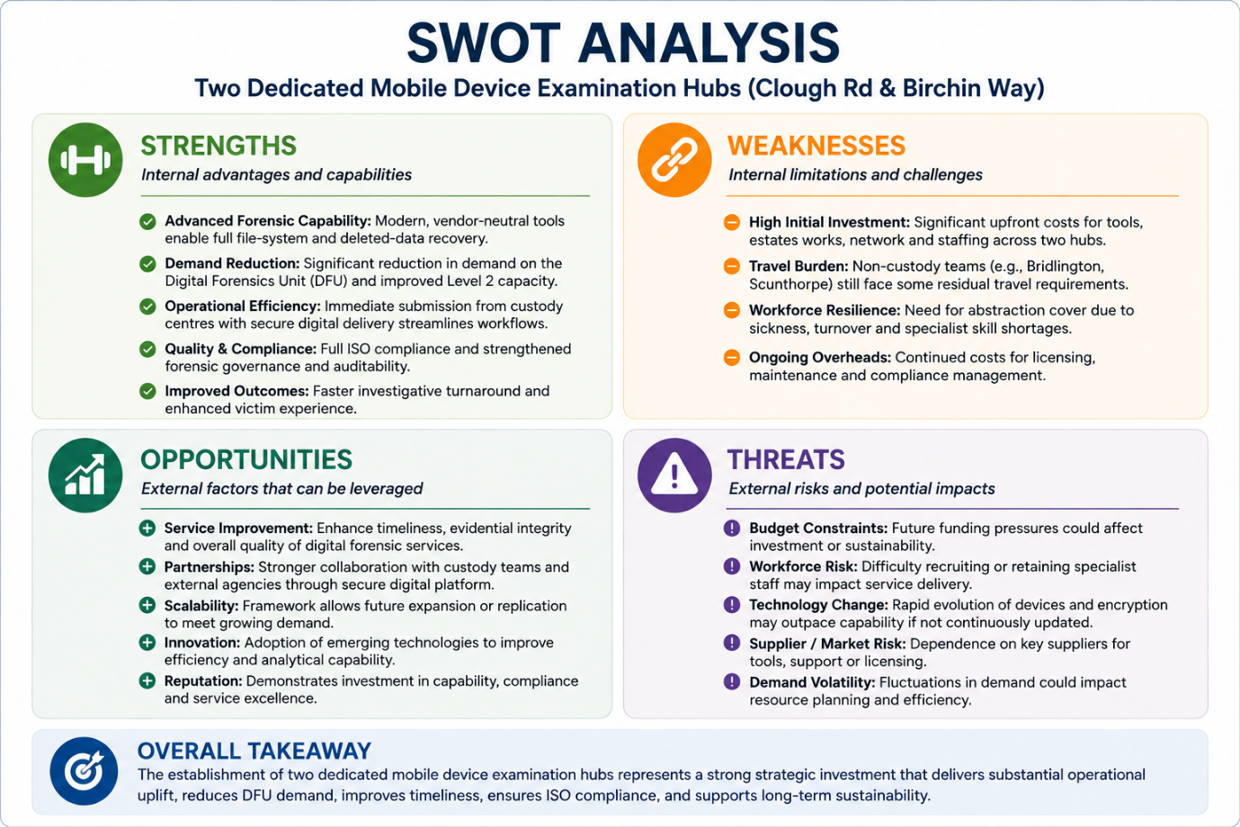
(Skelton, 2026)
- Recommendations and conclusions
Following detailed evaluation of all delivery options, Option 4—establishing two dedicated Mobile Device Examination Hubs at Clough Road and Birchin Way—is the only solution that meets Humberside Police’s operational, forensic‑governance, and strategic requirements. It delivers modern, ISO‑compliant mobile‑device extraction capability; significantly reduces demand on the Digital Forensics Unit; improves investigative timeliness; strengthens evidential integrity; and enhances victim experience through faster progression of digital‑led investigations.
While Option 4 requires higher initial investment, it provides the greatest long‑term value, resilience, and alignment with the Humberside Police Strategic Plan (2026), Op Soteria, and the National Policing Digital Strategy. It also ensures reduced officer abstraction by locating capability at the force’s primary custody centres.
The Chief Officer Group (COG) is therefore recommended to approve Option 4 as the preferred delivery model, enabling a sustainable, future‑proofed digital‑forensics capability that supports faster justice and improved public confidence.
- Abstract
This strategic plan sets out the development of two Mobile Device Examination Hubs for Humberside Police. Rising digital demand and increasing reliance on mobile evidence have exposed structural weaknesses in the force’s current model—ageing equipment, inconsistent training, officer abstraction, and gaps in ISO compliance (Humberside Police, 2025). These issues mirror national concerns (HMICFRS, 2022) and reflect what Lynch (2018) describes as a high‑turbulence environment, where complexity, rapid technological change, and low predictability require organisations to adapt their capabilities. Such pressures slow investigations, increase DFU demand, and risk undermining organisational legitimacy (NPCC, 2025).
Johnson et al.’s (2005) concept of strategic drift further illustrates how policing has struggled to keep pace with this turbulence. Incremental, historically shaped practices have become misaligned with accelerating digital change, exposing cultural and structural constraints that inhibit timely adaptation. PESTLE analysis reinforces this diagnosis by identifying the external variables most likely to shape future conditions. It is not a list‑making exercise but a sorting mechanism that clarifies the political, economic, technological, social, legal, and environmental pressures acting on the organisation (del Marmol & Feys, 2015). Applied to policing, PESTLE highlights political mandates for improved digital capability, economic constraints following the pandemic, rapid technological change, rising social expectations for timely justice, legal requirements for ISO‑aligned processes, and environmental factors such as the increasing volume and complexity of digital devices (HMICFRS, 2025). Together, these pressures demonstrate why digital forensics is now a critical strategic priority for Humberside Police.
This strategic plan will establish Mobile Device Examination Hubs at Clough Road and Birchin Way to deliver a professional, ISO‑compliant Level 1 extraction capability. Staffed by specialist practitioners and equipped with modern tools, the hubs will streamline workflows, reduce officer abstraction, and accelerate investigative timelines. Their location within main custody facilities ensures immediate access when arresting suspects and seizing devices.
Porter’s Value Chain Model illustrates how this configuration strengthens value across operations, service delivery, infrastructure, technology, and workforce competence (Raun, 2020). Mintzberg and Waters’ (1985) conception of strategy as emergent rather than purely deliberate reinforces the rationale: in fast‑moving digital environments, effective strategy evolves through adaptive, iterative capability development. The hubs embody this by creating a flexible, scalable model that can adjust to changing investigative demand and technological complexity.
From a Resource‑Based View, the hubs represent intentional capability building. Barney (1991) argues that organisations secure sustained advantage by developing internal resources that are valuable, rare, difficult to imitate, and well‑organised. The hubs meet these criteria by consolidating specialist expertise, standardising ISO‑aligned workflows, and embedding governance structures that enhance quality, throughput, and organisational resilience.
This synthesis also exposes tensions between deliberate capability building (Barney, 1991) and the emergent, adaptive strategy required in volatile digital contexts (Mintzberg & Waters, 1985). The hubs therefore represent a pragmatic compromise: a structured investment designed to support, rather than constrain, ongoing strategic adaptation.
The plan has been developed with full consideration of Humberside Police’s leadership structures, governance arrangements, and decision‑making pathways. Engagement with divisional investigation teams, senior leaders, DFU management, IT specialists, and Chief Officers has shaped the operational design, risk assessment, and implementation plan, ensuring the hubs reflect real investigative demand and align with organisational priorities. Operating within the force’s digital‑investigation governance framework, the hubs will provide clear accountability, auditable processes, and ISO‑aligned standards, ensuring the capability is operationally effective, ethically robust, and legally defensible.
Senge (2010) argues that strategy fails when organisations rely on linear forecasts, top‑down control, and static assumptions. A learning organisation instead treats strategy as continuous, adaptive, and emergent, aligning with Mintzberg and Waters (1985) critique of rational planning and the risks of strategic drift. Systems thinking enables leaders to see interdependencies, anticipate unintended consequences, and understand delays and feedback loops (Senge, 2010). Applied to this plan, it reinforces the need for digital‑forensics reform to be adaptive, holistic, and grounded in organisational learning rather than episodic planning.
Stakeholder relationships will be managed through structured consultation, clear communication, and service‑level agreements that define expectations and responsibilities. This strengthens collaboration and ensures the hubs remain responsive to emerging threats, technological change, and investigative need. Performance will be assessed through four indicators—turnaround times, DFU backlog reduction, ISO‑aligned compliance, and audit and quality‑assurance outcomes. Faster processing improves investigative timeliness; reduced backlog diverts routine demand from specialist services; and ISO‑aligned audits ensure legally defensible, scientifically robust practice. Embedded supervisors maintain standards and identify issues early.
These indicators reflect a Balanced Scorecard approach, which Kaplan and Norton (1996) argue must be strategy‑driven and multi‑dimensional, offering a more holistic view of capability, quality, and legitimacy than traditional policing metrics. Kotter’s (2012) 8‑Step Model reinforces this by emphasising urgency, leadership, and cross‑functional coalitions. Digital threats evolve faster than traditional structures (HMICFRS, 2022), making his call for urgency and collaborative leadership directly relevant. Centralised Mobile Device Examination Hubs embody his guiding‑coalition principle, while early improvements in turnaround times provide the short‑term wins needed to build credibility. Anchoring digital‑first thinking into culture and governance is essential for long‑term legitimacy, ensuring capability development becomes a sustained organisational norm rather than a temporary initiative.
Zajac et al.’s (2000) concept of dynamic strategic fit strengthens the rationale for this model. They argue that alignment must be dynamic rather than static, and that organisations risk misalignment when they over‑ or under‑scale change. Applied to policing, this underscores the need to calibrate digital‑forensics reform proportionately: insufficient change leaves rising digital demand unmet, while excessive restructuring exceeds workforce capability and organisational readiness. Dynamic fit therefore provides a critical lens for ensuring the hubs develop at a pace and scale that match policing’s operational environment, technological volatility, and internal capacity for sustainable change (Zajac, et al., 2000).
Around 87% of mobile‑device examinations—around 5,000 annually—are completed via kiosks, consuming 20,000 hours of officer time at an estimated cost of £500,000 a year. This excludes the wider costs created by investigative delay, repeat offending, victim withdrawal, and the non‑financial impact of reduced public legitimacy. The £1.1 million required for the hubs largely reflects equipment that needed replacement regardless. Viewed through Boardman et al.’s (2018) cost–benefit principles, the hubs deliver clear net benefit: reduced abstraction, faster investigations, fewer re‑works, and lower legal and operational risk. They also avoid long‑term costs associated with inefficient handovers, repeated DFU demand, and poor‑quality examinations. This represents a high‑return, capability‑building investment and a more efficient allocation of scarce policing resources.
Strategic change in policing is complicated by how organisations interpret and respond to uncertainty, and internal resistance is a persistent barrier (Hann & Mortimer, 1993). This Strategic Business Proposal is likely to encounter similar challenges. The financial, structural, operational, and cultural implications of centralising mobile‑device examination expose assumptions about autonomy, workload, and risk, generating predictable friction. Weick et al.’s (2005) sensemaking perspective shows that resistance is not simple opposition but a product of how staff construct meaning from ambiguous change; competing interpretations can fragment understanding and weaken coherence. Kotter’s (2012) model reinforces that without shared urgency, vision, and coalition‑building, these interpretations harden into barriers. The challenge is therefore not only technical implementation but shaping a collective narrative that aligns expectations and sustains commitment. By engaging with stakeholders from the outset, this Strategic Business Proposal aims to surface concerns early, negotiate meaning collaboratively, and build the shared understanding required to maintain momentum throughout the change process.
Together, these changes will deliver clear strategic impact. Faster investigations demonstrate improved organisational responsiveness, consistent with Zajac et al.’s (2000) argument that well‑aligned capabilities enhance performance in turbulent environments. Reduced officer abstraction reflects more efficient deployment of scarce resources, aligning with the Resource‑Based View’s emphasis on capability optimisation (Barney, 1991). Improved victim outcomes illustrate the benefits of evidence‑based, learning‑oriented practice (Senge, 2010), while enhanced legitimacy shows the organisation has begun to correct the strategic drift identified by Johnson et al. (2005). Collectively, these impacts confirm that the hubs not only address operational weaknesses but also strengthen strategic alignment, public value, and long‑term organisational resilience.

