Exploratory Data Analysis of Telecom Customer Churn:
Classification and Cluster-Based Customer Segmentation
ACCA7015: Data Mining and Visualisation
Component 2: Exploratory Data Analysis Report
MSc Data and Artificial Intelligence
Student Name: Sravanthi Sangam
Student ID number: 2536458
Lecturer: Dr Nouh Elmitwally

Contents
Abstract 4
1. Introduction 5
2. Literature Review 6
3. Dataset Description 8
4. Model Implementation and Evaluation 9
5. Results Analysis 10
6. Discussion 15
7. Business Recommendations 16
8. Conclusion 17
References 18

Abstract
This report contains an exploratory data analysis of customer churn from a telecommunications dataset that has 100,000 customer records, with 100 attributes of usage, billing, demographic, and handset characteristics. After data cleaning and preprocessing, two complementary tasks of data mining were done: predictive classification of churn status and clustering of the churned customers in an unsupervised way to identify different behavioural segments. Thirty features were selected using the Random Forest algorithm, and four classification algorithms (Logistic Regression, Decision Tree, Random Forest, and Gradient Boosting) were trained and evaluated by accuracy, precision, recall, F1 score, and ROC AUC. Gradient Boosting had the best discriminative performance of 0.669 ROC AUC, followed closely by Random Forest with 0.666. The 49,562 churned customers were clustered into four distinct segments using the K-Means clustering algorithm, with some recently churned and having a low tenure, while a small group is high-value, high usage customers, with a high potential for churn due to commercial value. The results are translated into prioritised retention recommendations for the business, by segments.

1. Introduction
Customer churn, or the loss of subscribers to other service providers or due to service terminations, is one of the most important commercial challenges for Telcos in today's saturated and highly competitive markets. In the CRM literature, it is well documented that it is much more expensive to acquire a new customer than to retain an existing one, so that, at scale, there is significant revenue protection to be gained in making even relatively small gains in churn prediction accuracy. This report is for the assignment for Component 2 of the ACCA7015 Data Mining and Visualisation module, which builds upon the data cleaning and pre-processing of Assignment 1 that utilised the Telecom Customer Churn dataset. This analysis has two aims: In the first phase, predictive classification models can be developed based on a variety of customers' usage, billing, handset, and demographic data, captured over a large number of variables, to identify customers who are likely to churn. Second, unsupervised clustering is used specifically on the churned population to understand whether churn is caused by one homogeneous reason or it is more likely caused by several distinct behavioural reasons, each of which requires a specific churning retention reaction. The entire data mining pipeline was developed in Python, with the scikit-learn library, which included the imputation of values for missing data, encoding of the categorical data, feature selection done by performing a Random Forest algorithm, training and evaluation of the model, and finally, a 2-D visualisation using the K-Means algorithm and Principal Component Analysis. Four classifiers were compared, all with different degrees of model complexity: Logistic Regression as an interpretable linear baseline, a single Decision Tree as a simple non-linear baseline, and the two ensemble classifiers Random Forest and Gradient Boosting as more powerful models to capture nonlinear interactions between features. The rest of this report is organized as follows: the Literature Review places the selected techniques in context with the current research on churn prediction. The Dataset Description contains a summary of the structure and characteristics of the data after preprocessing. The Model Implementation and Evaluation section explains the steps of the modelling process and presents quantitative results for all four classifiers. The results are analysed with the clustering outputs in Results Analysis, and a discussion on implications and limitations of the results is provided in the Discussion section. Finally, Business Recommendations provide recommendations for retention strategies based on the findings of the analysis, and the Conclusion provides an overview of the contributions of the study.

2. Literature Review
Given the high cost of acquiring customers compared to retaining them, churn prediction has become a mature field of telecom analytics. In a recent large-scale systematic review of published literature, Manzoor et al. (2024) reported that although there is significant research interest, the work in the field is heavily focussed on comparing algorithms and comparatively little work has been focused on providing practical guidance to practitioners on the end-to-end model development process, a gap that this report will attempt to bridge by connecting model evaluation to segment-level retention suggestions. Their review also shows that no single classification algorithm outperforms all the telecom churn datasets consistently, and thus, in this study, several algorithms of varying complexity were compared to get a better understanding of the situation instead of beginning with a single algorithm. Logistic Regression is perhaps the most commonly used baseline in churn prediction research due to the ease of relating the coefficients directly to business-meaningful odds ratios. Although more advanced models become prevalent, Logistic Regression remains a benchmark model in customer churn studies due to its ease of computation and the interpretability of the relationship that was modeled, which is still desirable in these studies (Sikri et al., 2024). It assumes, however, that the decision boundary is linear in the space of the log odds, which severely restricts its ability to model the non-linear relationships of usage and billing variables typical of telecom behavioural data. Tree-based methods tackle this limitation by repeatedly splitting the feature space and are enhanced by ensemble techniques that do exactly that, ensembling many trees to become more robust.
Wagh et al. (2024) evaluated ensemble classifiers in comparison to Decision Trees using a large telecom churn data set and found that the predictive accuracy of ensemble classifiers was always higher than the accuracy of Decision Trees, and Akbar and Apriono (2023) tested the same two classifiers along with other boosting based classifiers on the same dataset sourced from Kaggle and concluded that, across both accuracy, precision and recall, the boosting based classifiers (Extreme Gradient Boosting) outperformed the Decision Tree and Naive Bayes classifiers. The results in this report are in line with the wider trend in recent churn research in telecommunications, where ensemble methods consistently outperform individual classifiers in the presence of high-dimensional usage data, as in this study, characterized by behaviourally rich usage information. Amin et al. (2020) designed a just-in-time churn prediction system based on stacking ensemble models, which includes Support Vector Machine and k Nearest Neighbour base classifiers, and showed that the ensemble stacking has greater flexibility and predictive performance than the individual classifiers on different telecom companies having few historical data. Likewise, Zhou et al. (2023) used ensemble learning to build an early warning system for customer churn in the telecommunications industry and determined that the new model could predict customer churn in advance better than single classifier baselines; this indicates that ensemble classifiers like Random Forest and Gradient Boosting are the best candidate models for high predictive power and were therefore proposed in this study. Recently, deep learning architectures have also used for churn prediction. Further, while traditional ensemble models are still used, there are many different types of models beyond ensembles that are maturing the field, such as the proposed hybrid BiLSTM-CNN model by Khattak et al. (2023), which performed well on a benchmark telecom churn data set but required significantly larger amounts of labelled data and lacked much of the interpretability that is desirable for the present coursework context (where the emphasis is on explainable, business-interpretable modelling). As mentioned in this report, the multi-metric evaluation approach is adopted, and it is advised by Manzoor et al. (2024) that when selecting the operational model, it is better to consider ROC AUC, precision, and recall together, as it can hide the meaningful differences when the evaluations are based on a single metric like accuracy and the near-balanced datasets.
In addition to binary classification, unsupervised clustering of the churned population is known as a good complement to predictive modelling, as it captures the heterogeneous nature of the churned population that a single classification model cannot uncover. The k-means algorithm is still the most frequently used partitioning algorithm for this purpose, and the resulting cluster centroids are interpretable. In their review of K-Means variants, Ikotun et al (2023) note that the main drawbacks of the algorithm are that its choice of centroid and the number of clusters K are based on a previous assumption, and it is sensitive to the initial choice of centroids. They further note that on high dimensional behavioural data, K-means results can be expected to show clusters that are not sharply differentiated but rather gradational, as seen in the clusters generated in the results of this study.
In modelling high-dimensional correlated telecom usage data, such as that used for this study, feature selection is also crucial; Bhatnagar and Srivastava (2025) show that feature engineering coupled with data balancing techniques significantly boost churn classifier performance on imbalanced telecom datasets, and that the latter method, selecting the most important variables affecting churn rather than using all available features, improves performance as well as the output's interpretability and business relevance. This leads to the use of the tree-based feature important ranking strategy used in the present study, which is preferred over traditional correlation-based filters since it uncovers the nonlinear and interaction effects between the features that the correlation-based filters cannot identify.

3. Dataset Description
This data set was the Telecom Customer Churn dataset (Abhinav89, 2017) with 100,000 customers and 100 original attributes. These include call and data usage statistics as monthly means (e.g. rev_Mean, mou_Mean, ovrmou_Mean), change_mou and change_rev, which indicate change in the usage and revenue between periods; dropped_call, dropped_data, and blocked_call, which represent measures of service quality; customer_care_contact, which represents a statistic of contact with customer care; handset_type, equipment_type, marital_status, adults, income band, presence of children in various age bands, and the binary target variable churn, which takes the value 1 if a customer churned and 0 if the customer remained active. After importing the dataset, the data was seen to be almost perfectly balanced with 50,438 customers labeled as not churned (50.4%) and 49,562 labeled as churned (49.6%), an overall churn rate of 49.56%. This near-balanced distribution is advantageous for classification because no extra rebalancing techniques are needed after just a simple class_weight adjustment to improve additional robustness, and it allows the use of accuracy as a meaningful and not misleading evaluation metric for evaluation, in addition to precision-recall and AUC.
The original 100 columns were reduced to a working set of 77 numeric and 21 categorical variables after removing the unique customer identifier, which has no predictive value. Categorical attributes like creditcd, marital status, and the different kid age band indicators had the U value indicating unknown or unrecorded responses and were treated as missing and filled with the most frequent category value in that column; similarly, missing numeric values were filled with the column median to prevent the influence of outliers that are common in usage data, for example, very high call minute values. All categorical variables were then label encoded into a feature matrix of 98 numeric features, with no missing values after pre-processing and ready to be fed into scikit-learn estimators.

4. Model Implementation and Evaluation
The modelling process consisted of five successive steps that clearly defined a process to create a fair, reproducible comparison among the four classifiers: feature selection, train-test splitting, modelling, thresholding, and multi-metric evaluation. A preliminary Random Forest (RF) classifier was used for feature selection with the full 98-feature matrix, using feature importance based on the mean decrease in Gini impurity across 100 trees. To preserve the dimensionality and noise reduction, and to enhance the efficiency of training while not losing the signal predictive capacity, the 30 most important features were reserved for all subsequent modelling. The top five features were found to be eqpdays (days since the equipment was last upgraded), change_mou (change in monthly minutes of use), months (months in the system), mou_Mean (average monthly minutes of use), and adjrev (adjust revenue for credits and promotions).
The fact that eqpdays and months are the most prominent predictors is in line with the churn literature, which often uses tenure and handset age as proxies for the maturity of a contract and potential for upgrades, both of which are highly correlated with churn risks. The resulting reduced feature matrix was divided into two sets: 80,000 training records and 20,000 held-out records for testing, with near-balanced class distribution maintained in both sets. To avoid chance imbalance during random splitting, it was important for performance estimates on the test set not to be distorted by stratification. Four classifiers were trained subsequently. Logistic Regression was fitted to the standardised features with a maximum of 2,000 iterations to convergence and balanced class weighting. In order to retain the interpretability of the model and reduce overfitting, a single Decision Tree was limited to a maximum of 10 and a minimum of 20 samples per leaf, with class weighting. The parameters of the Random Forest were set as 200 trees, maximum depth of 15, minimum training samples per leaf of 10, balanced class weighting, and parallel training over available cores. Gradient Boosting was based on 100 sequentially trained trees of maximum depth 4, learning rate 0.1, and subsampling of 80% of training instances at each iteration to add stochastic regularisation. To guarantee the complete reproduction of the presented results, a fixed random state of 42 is used for all models.
The following five complementary metrics were used to evaluate each model on the held out test set: accuracy (the overall proportion of correct predictions), precision (the proportion of predicted churners that churn, or the proportion of true churners that get predicted, whichever one is less), recall (the proportion of churners that are predicted to churn, or the proportion of true churners that are predicted churn, whichever one is larger), F1 score, which is the harmonic mean of precision and recall, and ROC AUC (the area under the receiver operating characteristic curve, a summary of the model's discriminatory ability across all classification thresholds). The complete results are given in tabular form in Table 1.
Table 1: Model Performance Summary on the Held Out Test Set (n = 20,000)
Model | Accuracy | Precision | Recall | F1 Score | ROC AUC
Logistic Regression | 0.575 | 0.571 | 0.578 | 0.574 | 0.600
Decision Tree | 0.597 | 0.597 | 0.576 | 0.587 | 0.636
Random Forest | 0.617 | 0.606 | 0.650 | 0.627 | 0.666
Gradient Boosting | 0.617 | 0.611 | 0.628 | 0.619 | 0.669

Gradient Boosting had the highest ROC AUC of the four models at 0.669, followed closely by Random Forest at 0.666, while both ensemble models far outperformed the single Decision Tree model (0.636) and Logistic Regression baseline (0.600). Random Forest had the highest recall of all the models (0.650) and is the best model for this task, which is especially relevant in a retention scenario where the costs of a missed churner are generally higher than those of a false positive retention offer.

5. Results Analysis
Figure 1 shows the confusion matrices for each model, giving a detailed picture of the errors made by each model. Logistic Regression correctly classified 5,775 out of 10,088 non-churners and 5,732 out of 9,912 churners with a relatively even number of false positives and false negatives, which were relatively modest and not differentiated across the two classes. The Decision Tree increased the number of non-churners correctly classified to 6,231, but had little effect on churner recall. Random Forest yielded the most favourable churn classification, with the highest number of actual churners correctly classified (6,444) and the lowest number of non-churners misclassified (3,335). Gradient Boosting had the best balance overall between the two classes, with 6120 non-churners correctly classified and 6,222 churners correctly classified.
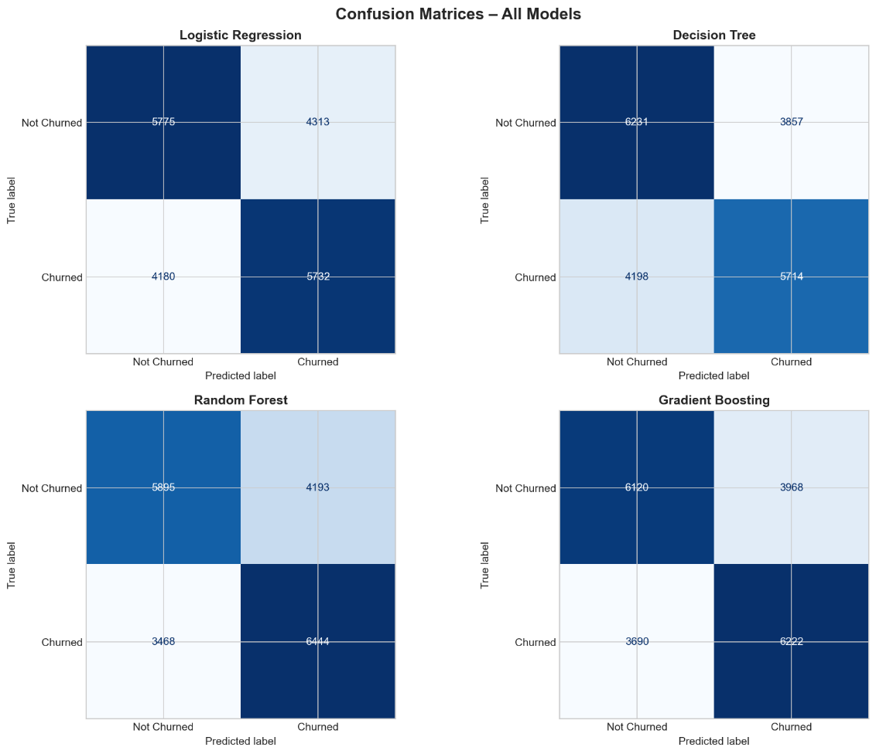
Figure 1: Confusion matrices for Logistic Regression, Decision Tree, Random Forest, and Gradient Boosting on the test set.
The ROC curves presented in Figure 2 also support the ranking presented in Table 1. The Random Forest and Gradient Boosting curves are consistently above the Decision Tree and Logistic Regression curves at all points on the curve, and not just at the default classification threshold of 0.5. While absolute performance is still moderate, all four curves stay well above the diagonal random classifier line, thus indicating that each model contains only real (non-random) predictive signal from the underlying features.
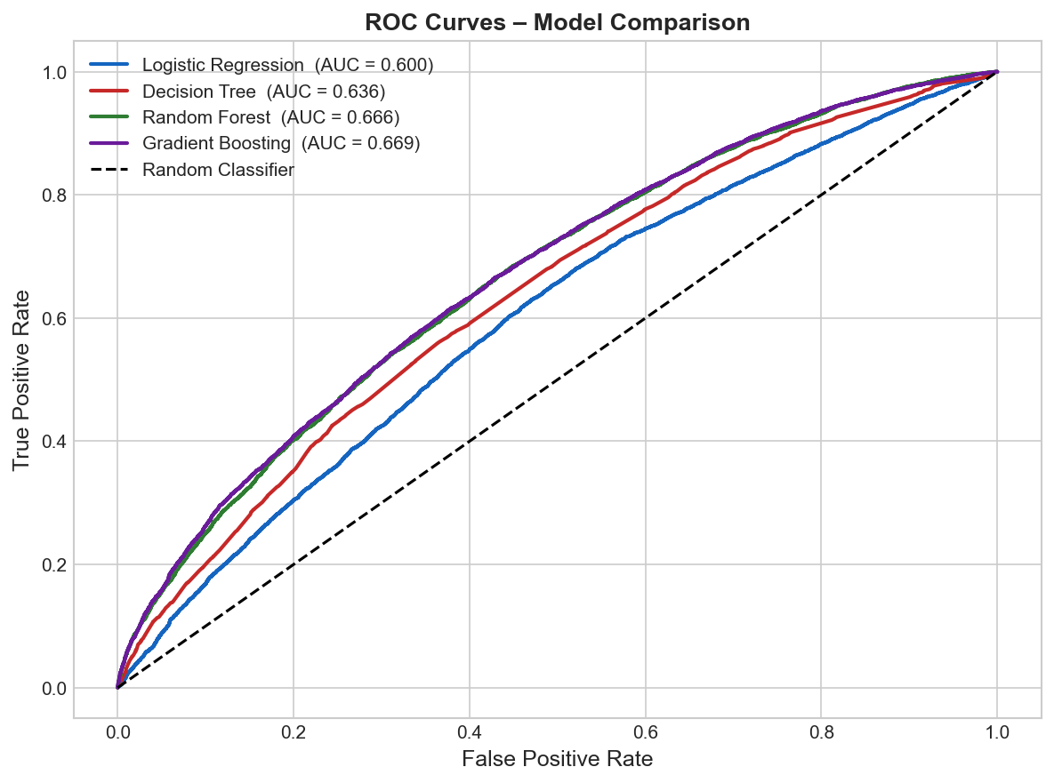
Figure 2: ROC curves comparing discriminative performance across all four classifiers.
Figure 3, the feature importance results, show that the top twenty features are mostly usage change variables (change_mou and change_rev), tenure and equipment age (months and eqpdays), and a group of revenue and minutes of use are summarized (mou_Mean, adjrev, avgrev, totrev, and avgmou). This pattern reinforces the importance of the variables designed to capture changes in the customer population, rather than any one attribute of the customer, and highlights the relevance of the various variables describing the changes in customer behavior over time.
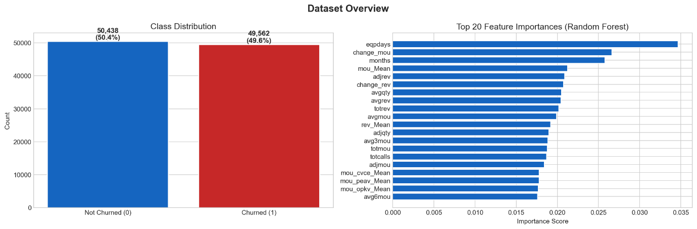
Figure 3: Class distribution (left) and top twenty Random Forest feature importances (right).
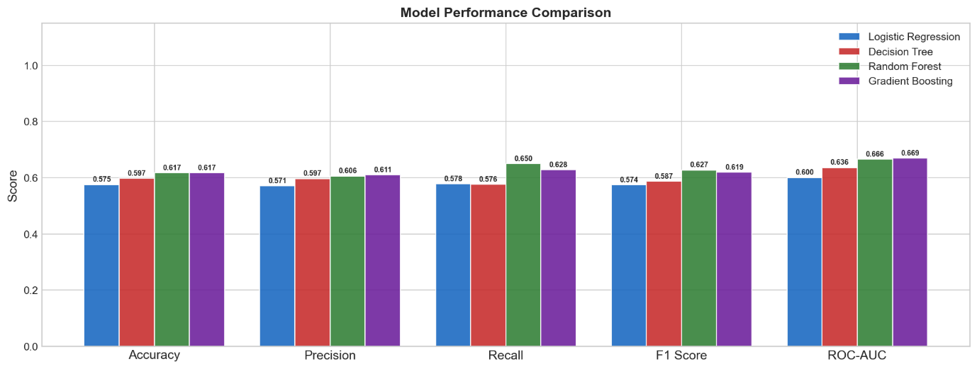
Figure 4: Side-by-side comparison of accuracy, precision, recall, F1 score, and ROC AUC across all models.
For the unsupervised analysis, only the 49,562 customers who churned were used, and the same 30 features were extracted after min-max scaling and then fed into the K-Means clustering algorithm. In the case of the elbow plot in Figure 5, there is a gradual decrease in inertia from K=2 to K=8 and no clear, sharp bend in the plot, indicating that this study's behavioural data may be high-dimensional with boundaries between the clusters being gradational, which may make the analysis challenging. A value of K = 4 was chosen because it was felt to be a reasonable compromise between segment granularity and interpretability, past the point of clearly diminishing marginal gains in inertia.
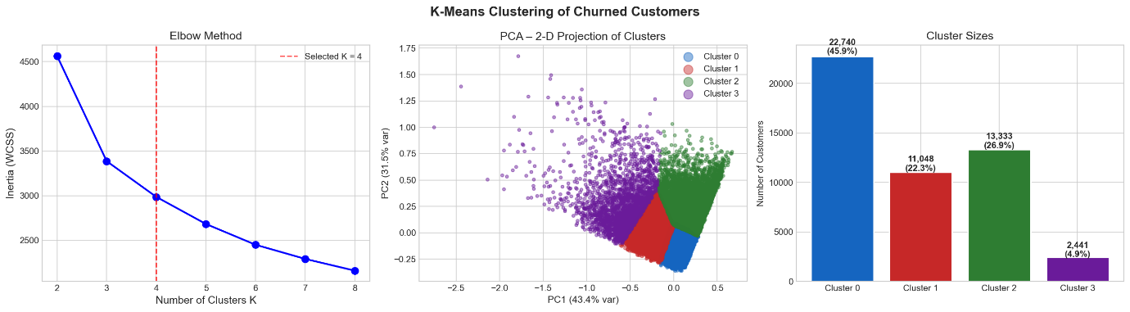
Figure 5: Elbow plot, PCA projection of clusters, and cluster size distribution for K-Means clustering of churned customers (K = 4).
After visualising this data in 2D using Principal Component Analysis (PCA), as shown in Figure 5, and profiling it using a normalised mean feature value, as shown in the heatmap in Figure 6, the resulting four clusters are clearly distinct behavioural archetypes amongst churned customers. The largest cluster, “cluster 0” at 22,740 customers (45.9% of churners) is characterised by very low tenant age, very low equipment age, and the most extreme negative change in minutes of use and revenue of all the clusters, suggesting customers who churned shortly after a sudden and sharp drop in engagement, consistent with the profile of an early life churner or a recently disengaged churner. Customers in Cluster 1 (11,048 customers, 22.3%) have moderate numbers for all usage and revenue metrics, but no extreme values in any single dimension, making them an average or undifferentiated churner segment. Cluster 2 (13,333 customers, 26.9%) is characterized by the longest tenure and oldest equipment of all the clusters and by a high negative absolute rate of change, indicating that customers in this cluster had high equipment ages and poor usage trend in their last year, likely making them long-time customers who experienced a sharp decline in usage before departing. Cluster 3 is the smallest (4.9%) and is very different on all use and revenue measures, with high normalised values on all measures and almost no negative change in its use before churn, suggesting that the customers in this cluster are likely to be high-value, heavy-using customers who churned with little apparent warning in their usage trend.
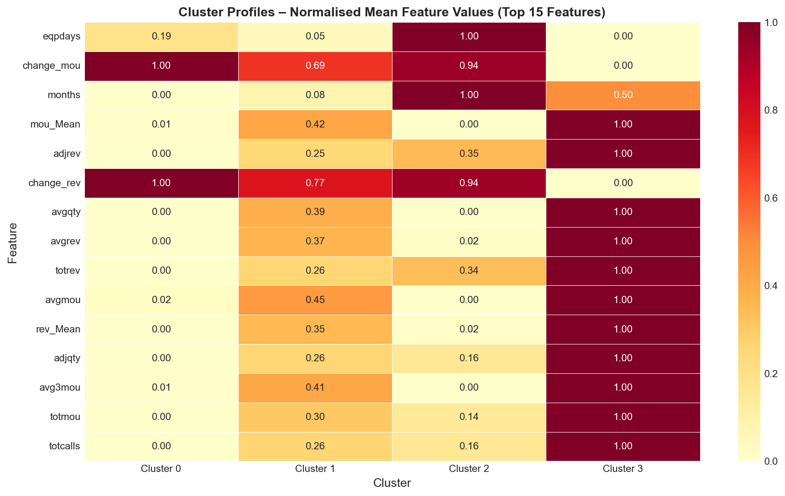
Figure 6: Normalised mean feature values for the top fifteen features across the four churned customer clusters.

Table 2: Summary of Churned Customer Cluster Profiles
Cluster | Size | Share | Behavioural Profile
0 | 22,740 | 45.9% | Recently disengaged: has been disconnected from the platform for a short time, the revenue from the platform is low, and the usage rate is decreasing the fastest.
1 | 11,048 | 22.3% | Average churners: moderate usage and revenue with no extreme values on any dimension.
2 | 13,333 | 26.9% | Long-term decliners: length of tenure, age of equipment, absolute usage, and a big drop in change before churn.
3 | 2,441 | 4.9% | High value churners: the lowest segment size of all the clusters and the highest number of uses, revenues, and calls.

6. Discussion
While the classification results are statistically significant, they are not very strong (the best result is approximately 0.67 for the top model). This result calls for a true description, not exaggeration. The well-balanced distribution of the targets in the dataset description shows that the classification problem is not so easy that a naive majority class classifier would easily do well; in fact, it is a difficult problem. Also, using 98 features to select, many of which are highly correlated, the signal predictive of the behaviour may not be as salient as the signal predictive of the behaviour itself, in the sense that many of the features are weakly informative, reflected in the relatively flat feature importance profile observed beyond the first few features. As reported in the literature cited above, the fact that the three classifiers can be seen as outperforming the Logistic Regression and the single Decision Tree reinforces the conclusion that in this dataset, churn is affected by nonlinear interactions between variables, and this kind of interaction is clearly present in Cluster 2, a relationship that a linear model cannot structurally represent. The relatively small gap in performance between Random Forest and Gradient Boosting across all the ROC curves in Figure 2, along with the small differences in performance across each curve, indicates that there is currently no noticeable structural superiority to one machine learning method over the other when it comes to this dataset, and that both are reaching a practical limit in terms of accuracy with the features that are provided. The clustering results provide much additional interpretive value beyond what the classification models can provide. Tightly defined optimum K as assessed by the elbow method was not achieved, but a four-cluster solution created behaviourally distinct segments of business-interpretable business segments instead of arbitrary statistical ones, which is more important in applied segmentation. The drawback of this is that the K-Means model assumes that the clusters in the feature space are roughly spherical and have equal sizes, which may be a challenge for the model to accurately capture the true structure due to the significant size difference between the largest cluster (45.9%) and the smallest (4.9%). The results here could be compared with the comparison of the density-based and the hierarchical clustering methods, which do not assume this four-segment structure, to investigate the robustness of the four-segment structure obtained here. Finally, one can note that the classification and clustering analyses are complementary and not independent. The dimensions that were most significant for predicting churn (tenure, equipment age, and change in usage) also clearly and most easily distinguish the four churned customer clusters. The agreement between the two methodologically different approaches provides increased confidence that these variables are true indicators of the underlying factors of churn behaviour, instead of being artifacts of the modeling approaches themselves.

7. Business Recommendations
The classification and clustering results have been useful in identifying several concrete and prioritised retention actions. First, since equipment age and tenure are among the top churn predictors, the business should implement proactive equipment upgrade offers or loyalty offers for customers nearing important churn milestones, before a significant usage drop-off is noticed with Cluster 0 and Cluster 2 customers. Second, change in usage and revenue, and not just the level of usage, is always one of the strongest indicators at the feature importance ranking level and in the cluster profiles, so the business should use automated monitoring of period-on-period usage decline as an early warning sign indicator to trigger retention outreach efforts, instead of relying on absolute usage thresholds.
Third, the highly churned Cluster 3 (4.9% of churned customers) has by far the highest usage and revenue per customer, thus presents the highest opportunity for loss of revenue due to churn, and offers a higher level of commercial value compared to other clusters, so this segment should be prioritized as a high priority churned group to be retained through bespoke offers and/or account management rather than mass market ones. Fourth, even though Cluster 0 is the largest group, it is linked with an extremely short customer life expectancy, indicating that investing in onboarding and early life engagement programmes in the first few months of a contract can have a significant impact on the volume of churn at a relatively low cost per customer. Lastly, considering the high level of recall that Random Forest has as compared to the other four models, it is recommended to use Random Forest as an operational model where the cost of not identifying the genuine churner outweighs the cost of a retention offer, while Gradient Boosting, slightly better in terms of overall balance, could be preferred if the cost of the retention offer is higher and false positives have more impact.

8. Conclusion
The report has demonstrated the entire exploratory data mining pipeline employed on a large-scale telecommunications churn dataset, including supervised classification and unsupervised segmentation of churned customers. Among the four classifiers tested, Gradient Boosting showed the best overall discriminative performance, followed closely by Random Forest, which also had higher recall than the other two and significantly outperformed the Logistic Regression baseline, suggesting that there is a nonlinear structure in the churn relationship. Further, K-Means clustering of the cluster showed that churn is not a monolithic event, but rather, there were at least four different behavioral paths for churn, ranging from short tenure disengagement to high value customer attrition, each deserving a different approach to retaining customers. Combined, these results offer a defensible predictive base and a segmentation framework to assist the organization in more targeted, cost-effective customer retention decision-making.

References
Abhinav89, 2017. Telecom customer [dataset]. Kaggle. Available at: https://www.kaggle.com/datasets/abhinav89/telecom-customer [Accessed 30 June 2026].
Akbar, T. A. R., and Apriono, C., 2023. Machine Learning Predictive Models Analysis on Telecommunications Service Churn Rate. Green Intelligent Systems and Applications, 3(1), 22–34. https://doi.org/10.53623/gisa.v3i1.249
Amin, A., Al-Obeidat, F., Shah, B., Tae, M. A., Khan, C., Durrani, H. U. R., and Anwar, S. 2020. Just-in-time customer churn prediction in the telecommunication sector. The Journal of Supercomputing, 76(6), 3924–3948. https://doi.org/10.1007/s11227-017-2149-9
Bhatnagar, A., and Srivastava, S., 2025. Customer Churn Prediction: A Machine Learning Approach with Data Balancing for the Telecom Industry. International Journal of Computing, 9–18. https://doi.org/10.47839/ijc.24.1.3873
Ikotun, A. M., Ezugwu, A. E., Abualigah, L., Abuhaija, B., and Heming, J., 2023. K-means clustering algorithms: A comprehensive review, variants analysis, and advances in the era of big data. Information Sciences, 622, 178–210. https://doi.org/10.1016/j.ins.2022.11.139
Khattak, A., Mehak, Z., Ahmad, H., Asghar, M. U., Asghar, M. Z., and Khan, A., 2023. Customer churn prediction using a composite deep learning technique. Scientific Reports, 13(1). https://doi.org/10.1038/s41598-023-44396-w
Manzoor, A., Atif Qureshi, M., Kidney, E., and Longo, L., 2024. A Review on Machine Learning Methods for Customer Churn Prediction and Recommendations for Business Practitioners. IEEE Access, 12, 70434–70463. https://doi.org/10.1109/access.2024.3402092
Sikri, A., Jameel, R., Idrees, S. M., and Kaur, H., 2024. Enhancing customer retention in the telecom industry with machine learning-driven churn prediction. Scientific Reports, 14(1). https://doi.org/10.1038/s41598-024-63750-0
Wagh, S. K., Andhale, A. A., Wagh, K. S., Pansare, J. R., Ambadekar, S. P., and Gawande, S. H. (2024). Customer churn prediction in the telecom sector using machine learning techniques. Results in Control and Optimization, 14, 100342. https://doi.org/10.1016/j.rico.2023.100342
Zhou, Y., Chen, W., Sun, X., and Yang, D., 2023. Early warning of telecom enterprise customer churn based on ensemble learning. Plos One, 18(10), e0292466. https://doi.org/10.1371/journal.pone.0292466

