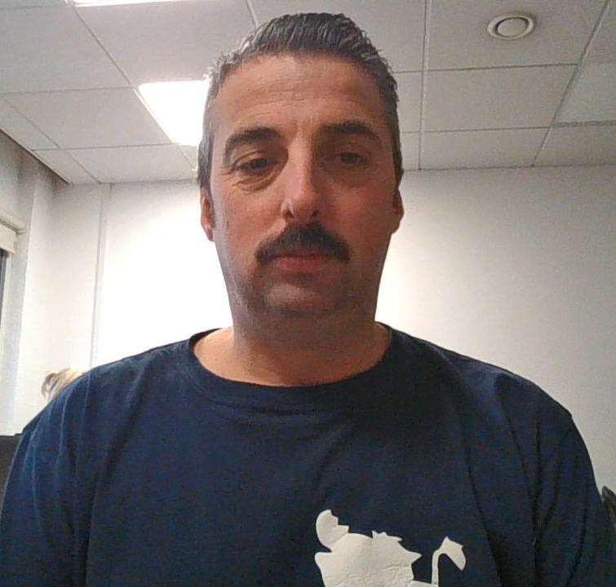

Name / Stephen paul wallis

Student number / 1907199

Student e-mail address / 1907199@student.uwtsd.ac.uk

Contact number / 07979408622

Please use the remaining space to give a brief outline of why you have chosen your course of study and any relevant special interests or experiences

Working as a health care assistant I developed a love for helping people.
Even as a child I was best when kept busy being hyperactive. I grow up to love being social I loved cooking and feeding people.
Taking care of my friends and family it was not long before I was hands on personal care.
Getting to meet new people and having fun with old friends I am always in my
Element and I have never been shy unless on stage.
I also take emergency care very serious as a firefighter first responder my role is to keep people alive. And I am at university to learn how too do that to the best of my ability.
I personally want to continue learning to improve and enhance my skills.

S Wallis; Learner.

