Effective Team Working & Communication

(BMSW 4002_LON)

IRINA BATA GYORFI (2115390)

LECTURER: EJIRO ESOHWODE

Introduction –
Almost in every business organisations employees works in a team because it helps them to handle and organise all organisational work. Due to this, it becomes very important for business organisations to handle or manage teams. This presentation will discuss some best and most effective ways to build and manage a team, it will also talk about the importance of supportive communication in teams with some suitable theories, models and examples as well. The presentation will be separated into 5 main sections. The first section will highlight the advantages of team working while the second section will talk about team building stages. The roles and responsibilities of the team leaders will be highlighted in the third section of the presentation. Conflict management will also be the main topic of the presentation. All the important ideas discussed in the assignment will be summarised in the conclusion section of the presentation which will give a complete idea of the presentation.

Benefits of the team working –
Many business organisations mostly prefer to work in a team system because a team system provides incredible benefits to employees and the business organisation. It is very important to know the exact meaning of teamwork to effectively apply a team system in a business organisation. As per the business dictionary, teamwork is nothing but the process of collaborative working with a group of people to accomplish all the personal, professional or organisational goals. Teamwork provides numerous benefits and improvements in productivity and creativity is one of them. Many business managers use a team system because the team working automatically motivate employee to work harder to achieve all the organisational goals and improve the work quality of employees as well.
As per the research, it has been found that the team working automatically encourages team leaders and team members to take healthy risks (Weiss et al., 2018). It is very important to take the health risk to grow more and the team system encourages it. It has been also found that when people or employees work in a team they learn faster, grow more and automatically improve the work quality of employees. As result business organisations achieve all their organisational goals in time; and this is another major reason behind the use of team systems in the business organisation. Realise in stress, boosting employee morale, better problem solving, time management, increment in potential innovation, personal growth and more opportunities are also some of the benefits of team working. IBM and Deloitte are some consulting companies that use team systems in their organisational tasks.

Stages of team development –
Developing or building a team is a tough and challenging process for every business organisation because it includes various tasks such as forming and providing training. To simplify this process many businesses organizations, use various team building models, for example, The Katzenbach and Smith Model. As per the research, it has been found that the Tuckman model is one of the best team building models that many business organisations use. The Tuckman model was first introduced back in the year 1965 by Dr Bruce Tuckman (Davis et al., 2020). At that time it was only containing 4 stages but in the year 1970 Tuckman added one more stage named “Adjourning”. Each stage of the model is classified into little sub-stages.
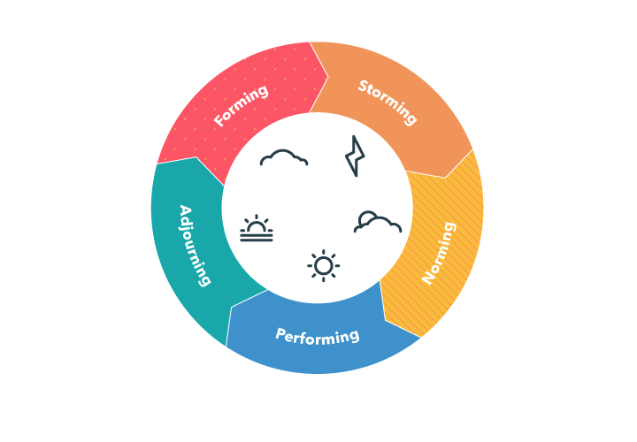
(Source – project.co, 2022)

Team Building Stages of Tuckman model –

Forming –
This is the first stage of the model in which the leader guide and directs their team members to complete a particular task. In this stage leaders mostly focus on giving a proper structure to the team. In this stage people, employees or team members highly depend on the leaders for guidance.

Storming –
In this stage team members to begins to work on an actual project or organisational tasks. In this stage, the excitement and joy may fade off because the intensity of work pressure may hit team members badly. Personalities of employees or team members may clash in this stage (Collins and Castro, 2020).

Norming –
In this stage employees of the team start noticing the strengths of their team members and start working on their weaknesses to improve their overall work quality.

Performing –
In the stage of performing, employees or team members feel motivated, confident and familiar enough with other team members and organisational projects. In this stage team members need minimal guidance and direction from the leaders or managers.

Adjourning –
This stage is also known as mourning because after completing the project team disbands. In this stage, the team may again need a new structure, guidance and direction from the leaders.

Leadership Roles (Hersey & Blanchard) –
Leaders play a very important role in business organisations. A leader is a person who has the ability to motivate employees to improve work quality and achieve all organisational objectives. There are various leadership styles that help leaders to fulfil their all roles and responsibilities. Democratic, autocratic, transactional and transformational are some of the styles of leadership. The aim of all these strategies is the same but the approaches are different. All leadership styles help leaders to motivate employees and fulfil all other leader’s responsibilities. All these leadership strategies have some advantages and disadvantages as well. There are also famous models and Hersey & Blanchard model is one of them. According to the Hersey & Blanchard model, no leadership strategy is better than another (Raza and Sikandar, 2018). The Hersey & Blanchard model recommends to leaders that instead of sticking to the one leadership strategy they should choose leadership style according to the workplace need and organisational tasks.
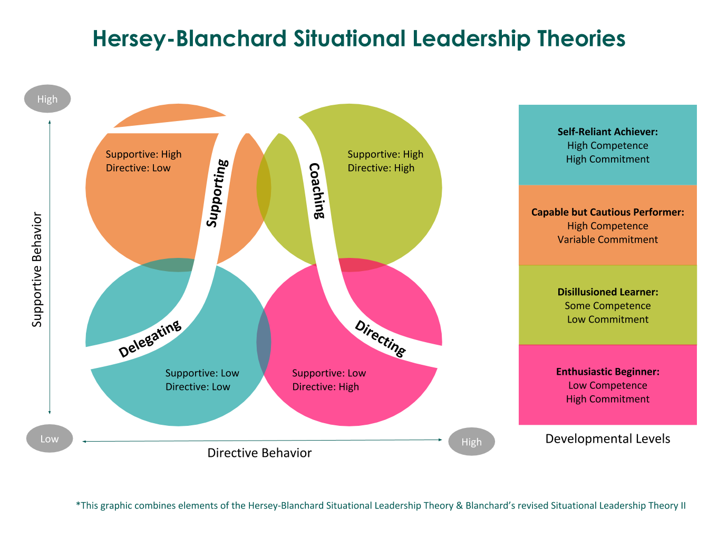
(source – guntergroup.com, 2022)
The Hersey & Blanchard model includes four styles and is known as delegating style, selling style, participating style, and telling style. All styles are very important for every leader to work effectively in the workplace. As per the research, the Hersey & Blanchard model indirectly recommends the situational leadership style of the leaders. The situational leadership style can be recommended as a combination of all types of leadership. One of the best things about the situational leadership style is, that it allows leaders to switch or change to other leadership styles if they want to (Smith et al., 2018). In simple words, in situational leadership style leaders can use and change their leadership style according to the surroundings.
Many leaders and business organisations use the situational leadership style or Hersey & Blanchard model because they are very easy to use and simple to implement. They also provide various benefits to the business organisations, for example, they minimise the error rate and automatically improve the performance of employees.

Managing conflict –
Conflicts are an inevitable part of the business organisation or teams. The reason behind it is very obvious, in a team or business organisations people from different backgrounds, ideas, opinions and thoughts work together. Sometimes small conflicts help teams and business organisations to grow more and generate huge amounts of profits by trying new ideas and taking calculated risks. But sometimes organisational conflicts can directly damage the whole team or business organisation. Due to this, it is very important for every team leader to manage their inter-team conflicts.
To effectively manage all the organisational conflicts many leaders and business organisations use various conflict management models. The bargaining model, System model and Bureaucratic model are some of the best organisational conflict management models. Apart from those Thomas and Kilmann’s conflict management style is also a widely used model. Many HR departments of large organisations use this conflict management model.
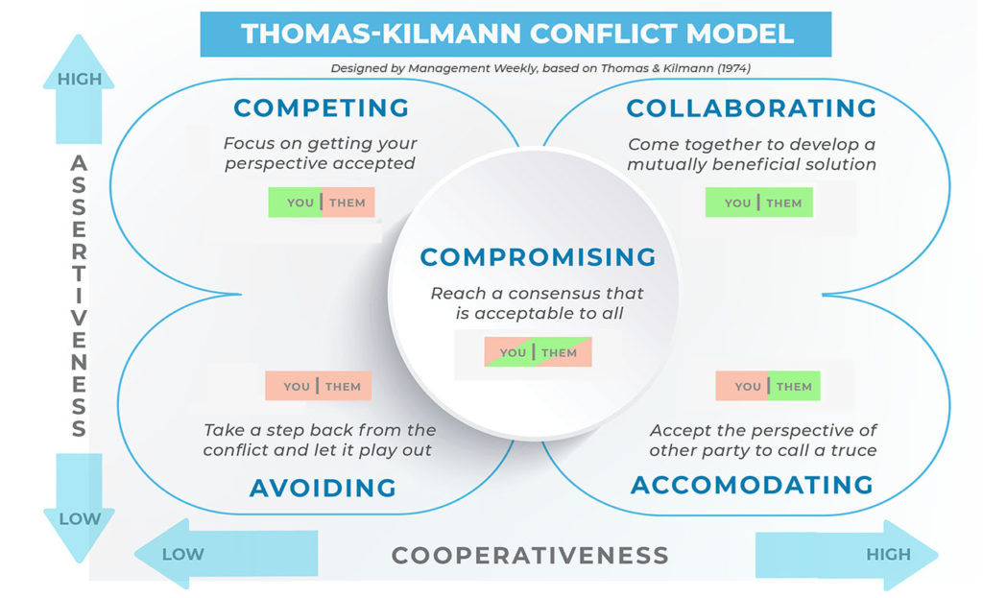
(source – managementweekly.org, 2022)
Thomas and Kilmann’s model contains only 5 simple but effective styles and those are known as, Competing, Compromising, Collaborating, avoiding and accommodating. In collaborating style leaders try to satisfy both parties by fulfilling their demands. Generally, leaders use a collaborative style if they want to maintain long term relationships.
Leaders or managers use competing leadership styles when the relationship is not important but the outcomes are important. Many HR managers suggest that leaders or managers should not use the competing style inside the business organisation because it can damage relations.
Avoiding is another conflict management style of Thomas and Kilmann’s conflict management model (Piryani and Piryani, 2019). It can be said that Avoiding is a combination of unassertive and uncooperative. Avoiding is just about ignoring the conflicts or issues. Generally, leaders use this style if the outcomes and conflicts are not so serious and if they don’t have the potential of throwing serious consequences on the organisation (Martin, 2020). In the Accommodating style, leaders accept the requests of the first person without arguing about the conflict. The compromising style is the last style of the Thomas and Kilmann model. In this style, leaders use to try to find middle ways to stop the conflicts.

Successful team development –
As mentioned above, developing and building a successful team is one of the tough, challenging and complicated tasks. The work environment plays a very important role in the process of developing success. From the research, it has been found that the work environment directly impacts the work quality of the business organization or employees. Due to this, it is very important for every leader or manager to maintain or develop a positive work environment in the business organization. To develop a good work environment in the business organization leaders and managers can assign tasks in partnership with the employees as well as team leaders and managers should also organize parties or games to help employees and all team members to be comfortable with each other. This automatically helps team leaders and employees to organizational performance and work quality. as a result, business organizations automatically perform well in the business market and generate a huge amount of profit.
To build a successful or best team, it is a must for every team leader and manager to focus on the process of hiring (Kalenda et al., 2018). Leaders should only hire skilled, talented people who have enough experience in the related field. This automatically improves the team’s performance. Apart from it leaders will also need to provide training to the newly recruited people of the business organization. As mentioned above, conflicts are an inevitable part of the business organization and team management. Due to this, leaders will also need to work on employee engagement to build a successful team in the business organization.

Conclusion –
From the above discussion, it is clear that the above discussion team system is one of the best ways to improve the work quality in the business organisation. due to this many business organisations use team systems. A team system provides benefits to the business organisation, for example, it boosts employee morale, helps employees to learn fast and improves overall organisational performance. Building a team in tough and challenging tasks but there are some tools like the Tuckman model that helps business organisations build a good team. The situational leadership style and Hersey & Blanchard model are the best leadership style that helps leaders to minimise errors in the decision making process. Conflicts are an unavoidable part of the team or business organisations. There are some models such as Thomas and Kilmann which again help business organisations and leaders to effectively manage all the organisational conflicts. Organisational or work environment is one of the most affecting factors of employ work quality due to this it is very important for the leaders to develop and maintain positive work environment.

Reference List –
Weiss, M., Kolbe, M., Grote, G., Spahn, D.R. and Grande, B., 2018. We can do it! Inclusive leader language promotes voice behavior in multi-professional teams. The Leadership Quarterly, 29(3), pp.389-402.
Davis, D.M., Rosenberg, M., Davis, M.C., Burns, C.D.P., Jaksha, E. and Guizani, I., 2020. Proactive Natural Language Processing: Addressing Terminology Disparity and Team Coalescence. In the Proceedings of the SISO Simulation Innovation Workshop. Orlando, Florida: SISO.
Collins, C. and Castro, E., 2020. The Five Stages of Team Development.
Raza, S.A. and Sikandar, A., 2018. Impact of leadership style of teacher on the performance of students: An application of Hersey and Blanchard situational model. Bulletin of Education and Research, 40(3), pp.73-94.
Smith, G., Minor, M. and Brashen, H., 2018. Spiritual Leadership: A Guide to a Leadership Style That Embraces Multiple Perspectives. Journal of instructional research, 7, pp.80-89.
Piryani, R.M. and Piryani, S., 2019. Conflict management in healthcare. J Nepal Health Res Counc, 16(41), pp.481-482.
Martin, D.W., 2020, June. Evaluating the evolution of construction management students’ conflict management styles as a result of andragogical methods. In 2020 ASEE Virtual Annual Conference Content Access.
Kalenda, M., Hyna, P. and Rossi, B., 2018. Scaling agile in large organizations: Practices, challenges, and success factors. Journal of Software: Evolution and Process, 30(10), p.e1954.

