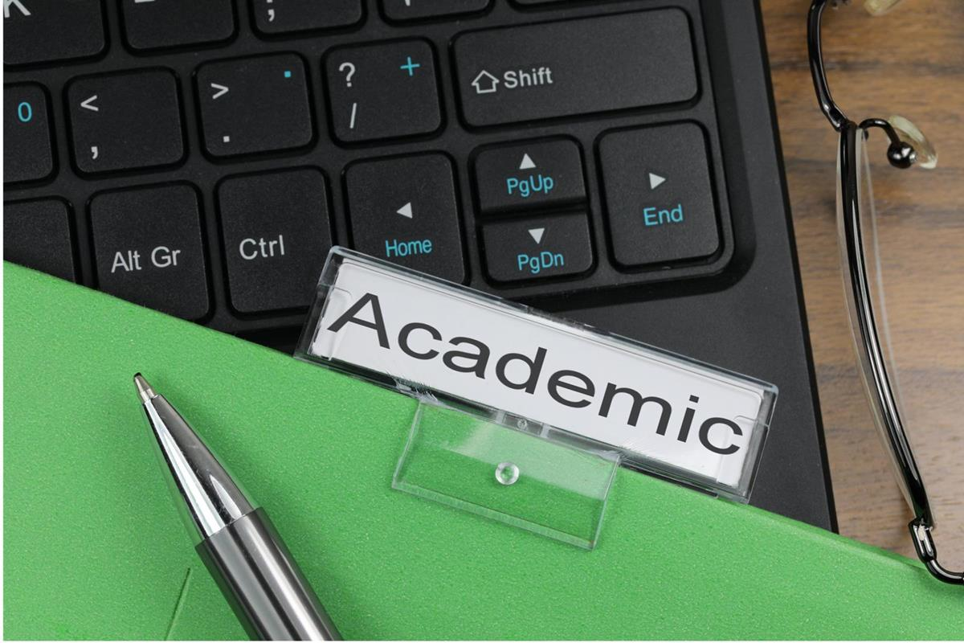

Academic skills

STUDENT NAME : HAZEM MAHMOUD ALI HUSSEIN
STUDENT ID : 2336469
MODULE CODE :LCLM4001
LECTURE’S NAME : SUKHPREET GREWAL
TITLE : Social Media For Staff Recruitment

- Introduction
This is a reflection on my academic skills that I have learned during this module which will give me knowledge to be able to explore a key academic skill that is essential to succeeding and be more effective, from note taking and finding information to reflective writing and many more other skills.

I aim to practice these new skills in the future with my work world or with even my personal life.

- Reflective model
In the lectures We have learned a few ways for example Gibbs reflective model (Gibbs, 1988) where we use our initial experience to feeling and how we evaluate on the situation and how we analysis it to what to consider for solution and how we going to solve it in the best way, and this is the model I will be using.
The lecture was about reflective writing and finding new way of thinking and saying things, which has helped a lot to see other views and learn new way of how tackle things in an effective way ,in the beginning I was confused and a bit un comfortable but over the weeks I start to learn the new way to allow in new way of thinking , I find that way very useful because is not just you find solution but you also learn to see more side to it.

3.ACADEMIC SKILLS
. note taking is one of the greatest tools to help understand thing in a better way as information can be hard to understand or get first time things said, looking back at the note can give a chance to understand it better and more, or even chance to organize it to be used in future.

- Reflecting writing is one of the best things I have learned in this module as its perfect way to practice our own skills and responses to learn and improve, taking time to reflect on something and analyzing it in more details and different ways to think carefully about what mean for you and how you use it in your best way for your personal outcome, even if not used for the time been it’s a good and great experience to go throw as it might be useful tools for future, Gibbs’ Reflective Cycle (1988) is the one that stand out for me as its very simple and prefect to give time to reflect on what happened and how to find more solution keeping in mind my feeling and what was good and bad about the experience and what iam going to do next solve the situation , or even things to use for future problem
. finding information, in now days information can be found everywhere from social media to news paper or TV and to use this information in my academic writing or life I found it difficult at beginning, but as my study went on I got more structured and balanced and precise and presented thing in a formal way, not an expert level but in very clear structured way.

GIBBS Reflective model:
During my study I have learn how to be more effective when iam writing an email, or sending a formal letter and that made it very useful for my future job as now days it can raise the opportunity to find a better job, in the future I will focus more on mastering my formal writing and work more on my writing especially misspell or grammar , I will take a course in English or English writing to be much better than what iam now .

Reference:
Bacchus E (2010) ‘Changing your career: How to identify your transferable skills’ The Guardian, 29 June 2010. Available at https://www.theguardian.com/careers/careers-blog/changing-your-career-how-to-identify-your-transferable-skills
(Accessed 10 February 2021)
Association for Learning Development in Higher Education (2021) What is academic writing? Available at: https://aldinhe.ac.uk/teaching-learning/what-is-academic-writing/)
(Accessed 19 March 2022)
EAP Foundation (2013) ‘Academic Writing – what is it?’
https://www.eapfoundation.com/writing/what/ (Accessed 19 March 2022)
Lijphart, Arend, (1984) “The Westminster Model of Democracy’’ In Democracies: Patterns of Majoritarian and Consensus Government in Twenty-One Countries, 1–20. Yale University Press, 1984 Available at: JSTOR https://www.jstor.org/stable/j.ctt1ww3w2t
(Accessed on 21 March 2022)
More on academic writing :
https://aldinhe.ac.uk/teaching-learning/what-is-academic-writing/

