Research and critically evaluate representations of gender
from a binary logic to fluid gender forms.

Emily Lacey-Freeman
Submitted in partial fulfilment of the requirements
for the degree of BA (Hons) Illustration

University of Wales Trinity Saint David, Swansea

December 2017

Word count: 6501

Dissertation Supervisor: Julia Lockheart

Contents

List of Illustrations

Introduction 4

Chapter 1 5

Chapter 2 8

Chapter 3 13

Conclusion 27

Bibliography 29

Illustration Reference List 33

List of Illustrations

Figure 1: Brut 1960s Advertisement, n.d. 10

Figure 2: I know my taste, 1976. 10

Figure 3: Van Huesen, n.d. 11

Figure 4: Weyenberg Massagic shoes ,1974. 11 .
Figure 5: Lustre Crème hair care adverts, 1967. 11

Figure 6: Brown, n.d. 11

Figure 7: Levi jeans advert, 2014. 17

Figure 8: Model Poses as Both to Challenge Gender Stereotypes, 2017. 17

Figure 9: Dimension of femininity and masculinity in Bem’s sex role inventory, 1995. 20

Figure 10: Bowie onstage, 1974. 26

Figure 11: David Bowie, 1973. 26

Figure 12: David Bowie, n.d. 26

Figure 13: Annie Lennox, n.d. 26

Figure 14: Annie Lennox, n.d. 26

Figure 15: Annie Lennox, n.d. 26

Figure 16: Annie Lennox, n.d. 26

Introduction

This dissertation will examine the role of gender within society and how representations have altered perceptions over time. Taking into consideration the role of binary gender through to fluid gender forms I will investigate how understanding has changed throughout history as society has evolved. Critically evaluating the representation of binary to fluid identity I will argue for the evolution of gender through the ages and how representations have changed as a result. I am writing this dissertation because the notion of fluid forms in gender have been apparent in our societal history since Plato in 370 BC. I feel it’s important to understand this, so we can inform others that there are more than the two-inherent male and female binary genders and that these genders are real and matter within our society.

In this study, I will frame my ideas using keywords related to my chosen topic. These words are: social, individual, physiological, biological and performativity. In chapter one I will give a brief overview of gender throughout history and how societal ideals have come to a binary conclusion. In chapter two I will explain how the 1960s were a pivotal point for social change regarding gender. For examples of how the gender balance was negative I will critically analyse posters from that time. In chapter three I will consider the keywords social, individual, physiological and performativity in greater detail and how they create a gender framework as a result, using public figures and theory to substantiate the argument. My outcome will be to answer if the historical evidence of fluid gender will become more apparent within our society leading to a better understanding towards other representations of the self. Further conclusions will be drawn regarding the representation of gender in contemporary society and its impact upon understanding.

CHAPTER ONE

Gender over time is a subject that has been an area of speculation and persecution. It must be questioned especially within the increasingly diverse contemporary society of the 21st century, whether there are more than the two binary genders that have been contextualised throughout history, or that we have chosen to ignore others and societal restrictions have glossed over.

Gender has commonly been seen and understood as a binary option a choice of two halves. As Simone De Beauvoir discusses in her work, stated also by Butler (2004:114), “Gender is… a construction that regularly conceals its genesis”. Throughout history gender has been shown in different ways and understood differently as a result, beginning with the Bible and the binary portrayal of Adam and Eve. By the 14th century however artists such as Leonardo da Vinci were depicting androgynous portraits (Mona Lisa) whereby male and female were fused together as argued by critics (James L. Garlow, 2015). Even these artistic and mythical examples would suggest that fluid gender has been around for centuries; within ‘The Symposium’ by Plato he mentions the concept of the children of the moon. This refers to a third gender which was then and is now known as androgynous whereby he describes the people of this other gender to have both male and female genitalia, a fuse of both the binary genders. Throughout history there is evidence of multiple communities of people who do not identify within the gender binary as described by Devin Trently (Listverse, 2015); examples are Mahus in Hawaii, Two-Spirited People of North America and the Kocek of the Ottoman Empire. Trently states that all of these represent groups of people that have been present in society for generations, clearly locating a third gender or a fluid representation outside of the binary code. This links to the concept of ‘otherness’; Butler (1990) identifies the notion of otherness corresponding to gender fluidity. She argues that gender is a construct that we have created within our society but this does not mean biological sex; it’s an authentic expression of the self. When born we are given a set of pre-existing collective stereotypes that will depict what we do and how we act for the rest of our lives within the heterosexual matrix. We live by these preconceived ideals of gender normality because it’s all we have known from birth; if we were to stray from the normalcy of the heterosexual matrix we become an outcast or seen as the ‘other’ within our own society (Butler, 1990). This creates separation and often segregation within communities as the ‘others’ are ostracised for arguably being themselves. Societal constraints form a tight hold against free expression of the self and although arguably equal, society still defines and dictates.

It can be argued that within society, ideals have become logocentric and this has resulted in an unwillingness to question the boundaries that are in place around us; there is reluctance to question or challenge gender constructs as a result. There’s so much coding for the set binary that as a culture we have learnt not to think or question outside of it; a violent hierarchy of binary exists to the point where a person becomes the ‘other’ in society. The other are people who have chosen to identify outside of the binary matrix, they have become self-aware and have the independent freedom to express themselves within a different gendered identity. By doing this they have estranged themselves by not conforming. (1900:59)

Binary opposition is the theoretical outlook that defines and contradicts itself as there are differences between the so-called mutually exclusive terms. Binary is just a part of the structure of gender, fundamental to its foundation but not inherently monistic. Derrida argues that society thinks its syntagmatic in its relationship with gender when really, it’s a paradigm; we can’t understand X gender if we don’t first understand X gender (Derrida, 1984:14). The question of understanding is crucial to the argument on gender and this changes with each individual’s perception and opinion; societal notions of gender have encouraged a certain way of thinking and challenging a broad objective view of gender as a concept.

Chapter 2

In the 1960s the gender binary was at its most reinforced (Ryan,1992:92). This idea that the nuclear family has the ideal household scenario consisting of a lovely wife, hard-working husband and son and daughter. These roles were important for giving society structure for living and were heavily reinforced by the culture they lived in. Pre-sets like the ‘house wife’ and ‘the bread winner’ are common gender performance acts seen in society. Roles like the housewife and hard-working husband were two binary roles that most people lived by; this ideal of the nuclear family still exists in present society to a certain degree particularly with older generations. These roles have certain duties for each gender attached to them, for example the house wife would cook, clean and look after the children whilst the bread winner’s main role is to go to work and make enough money to support the family. These jobs contained and restricted the roles and amount of responsibilities that people could have. To step outside of your respective duty would have been frowned upon. Even though the 1960s was seen as an era for social change with the younger generation rebelling against the previous ideas of the last century, a lot of the older generation didn’t see it this way. As a result of World War Two family values had become more important and a very close-knit family structure had developed; through this, religion and jobs became heavily influential (Pugh, 2000:102). A reason for this was that during the war people were devastated by death and family became an important value; society needed a structure to get back on its feet. Women had been given a new level of independence and freedom during war time roles meaning they could step out of their restrictive binary duties. As a result, some women experienced difficulties in returning to the binary way of thinking and the roles that accompanied it.
Societal influences such as the church became a constraining force holding binary gender firmly in place. Having a major influence in society and people’s lives, some churches believe against the idea of more than two binary genders. The role of religion played a major part in society and to this day still does to a certain degree. The aspects of religion control the opinions and influence the actions of others in our society. You have to live up to the church’s ideals or face exclusion from the church and therefore society. Joy Ladin (2015) looks at the book of Genesis to see how the church reinforces binary gender. She says that God created humanity as male and female, suggesting that that is the way humanity is meant to be. When doing this God is referring to physical sex and not gender identity. When God creates these humans he also gives them roles, feelings, characteristics according to their gender, much like we still do today. Although when God creates Eve in Genesis 1:27 she is made from Adam’s rib and not from the earth. Eve is meant to be equal to Adam in the eyes of God, their physical and biological appearance was not meant to be a defining difference but to bring them together as representative of humanity (Ladin, 2015:40). The Bible was used as gospel teaching for centuries so it could be argued that we get our inherent sense of binary gender from these teachings. God is said to have created humans in his own image, yet he made Adam and Eve both male and female so one could argue from this perspective that God is a fluid form, yet in western society God is depicted as male.

An example of the way this binary thinking was imposed on society is through 1960’s advertisements which clearly demonstrate opinions at the time (Williamson, 1978:11.) Many of the posters in the 1960s were heavily coded with binary connotations and stereotypes on each gender. They used a similar method to propaganda, influencing people and society’s opinions towards certain things, for example gender identity. The definition of propaganda is ‘information, especially of a biased or misleading nature, used to promote a political cause or point of view’ (en.oxforddictionary.com [Accessed September 2017]). Arguably these posters fit that description as they are biased and misleading in nature due to their reinforcement of binary gender ideals. They depict a world whereby you need to fit within constrained often sexist roles, promoting the woman as subservient to the man and the man as a sexualised masculine ‘God’ figure. These posters act as a certain type of propaganda reinforcing social aspects of the time, gendered heavily with separate ideals as to what the two binary genders should be like. The women are the ones who stay at home, she cooks, she cleans, she looks petite and pretty for her husband. Many female adverts were for make-up, cleaning products or household items that were all considered a feminine duty. Men’s adverts were typically for cars, cigarettes or footwear. All the men in these adverts were portrayed as strong and overtly masculine.

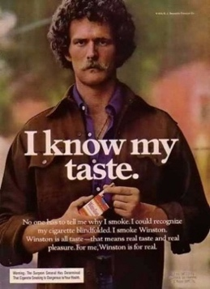
Fig. 1: Brut Advert, n.d. Fig. 2: I know my taste, 1976.

Examining posters for men we can see that in the 1960s they were sexualised and portrayed to be shown as strong and masculine (see examples fig 1 & 2). To reinforce this, women are used to adorn them to show how attractive they are and to demonstrate that using these products will enable the man to be strong and sexual and the woman to have her perfect place within society, by a man’s side (see fig 3-4). Women in these adverts are shown to be lesser than men, the connotations of using women like this is that they are there to serve within their binary roles ‘it’s a man’s world’.

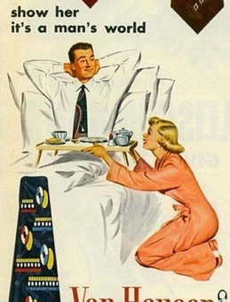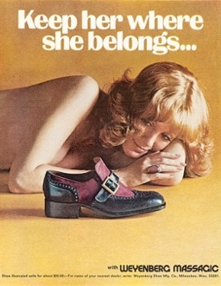
Fig. 3: Van Huesen, n.d. Fig. 4: Weyenberg Massagic shoes, 1974.

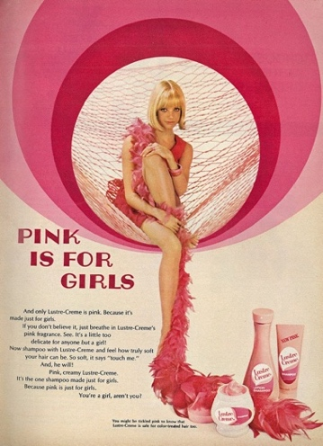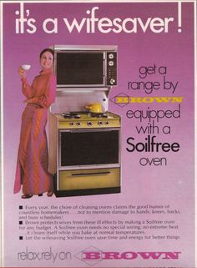
Fig. 5: Lustre Crème hair care adverts, 1967 Fig. 6: Brown, n.d.

All of women’s products are targeted at making them better, improving themselves for men or selling them appliances that improve their statuses as house wife’s. They use now offensive imagery to convey how these products are useful and tied to their gendered identity. For example, in Fig. 5 the phrase “it’s a wife saver” is used; kitchen appliances were targeted towards women because it was their job to cook for the family, ‘a wife’s duty’. In Fig. 4 the form is sexualised and almost phallic in shape, the colour is also pink which adds further connotations to its meaning.

In Jo Paoleti’s book (2012) she discusses that the concept of pink for girls and blue for boys is actually a concept for the last century. Previously gender had no colour, it was gender neutral and all babies were dressed in white when born. This was so clothes could be bleached if they were dirty and there was no risk of ruining the clothes. White also had religious connotations for purity. During the Victorian times children’s clothes did take on colour but only because new dyes were being used. In 1918 colours were being assigned by the use of hair or eye colour with it taking another seven decades for gendered colours to be used. It wasn’t until the end of the war in the 1940s that we really enforced the colour binary between the genders. Originally pink was used for boys as it depicted that they were bold and strong, blue was used for girls as it was a lot paler and daintier but modern-day thinking has changed these colours with preferred gender connotations; pink now symbolises femininity and blue conveys masculinity.

Chapter Three

In order to understand and explain how gender identity is formed it is useful to create a theoretical framework. This frame work will be formed of four different aspects of gender identity; social, individual, psychological and biological. These aspects will be explored in this chapter.

SOCIAL

Identity and personality are two separate things. The Oxford dictionary definition of personality is “The combination of characteristics or qualities that form an individual's distinctive character” (Oxford Dictionary, 2017). Your personality is affected by different things that you like and choose to identify with; you see something and think ‘that is me’ and you choose to identify with it. Things like being funny or having a cheery disposition are not the same as identifying with a gender. Identity is something that we are, some people feel comfortable in the gender that they were born into but others don’t and search for an identity that feels right to them. Oxford Dictionary definition of identity is “The fact of being who or what a person or thing is” (2017). We choose a particular identity often through a search to belong or feel accepted by ourselves; an understanding of who we are comes through our identity and this can be a greater search for some than others as a means of self-discovery.

Identity is key to a person understanding who they are and this is most influential within society whereby a person must live under a certain set of societal and social rules. As Gilroy argues, “We live in a world where identity matters. It matters both as a concept, theoretically, and as a contested fact of contemporary political life” (1997:301). Gender is important to political life as a fact and also as a concept to people. Binary identity arguably holds life in place for people who live within the binary representation which counts for the majority; most of society, especially within politics, work on this level but it is important for those who perform outside the matrix that their identity matters too. There are three main ways in which identity matters. Conceptually it is when people take up the sociological gender constructs and perform them. Sometimes they will take up an identity that is different in its processes and question themselves as a result, on how they are positioned in the social world and how they integrate as a result. Those who change their identities explore the different social aspects of identity which lead them to explore the social structures that arguably lives are organised by. Within these social structures to what extent do we shape our own identities? If gender is a social concept, then can we perform in any manner we choose? Does the hierarchy of the heterosexual matrix (Butler,1990:34) not dictate the way we have to perform? One of the arguments is that our identities are shaped by the imposing social structure around us. This means that we follow the binary into which we were born. But the other is that we are also playing a vital part in shaping our own identities.
Butler says that gender is an expression or performance, “One is not born, but rather becomes, a woman” Beauvoir’s interpretation of the nature of gendered identity is not only are we culturally constructed but we also construct ourselves (Butler,2004:23). To ‘become a woman’ is to perform a set of acts that have the gender connotations of being female. We learn how to become a gender through the acts and performances we see throughout the early stages of our lives. We are already culturally expected to become something. It is unclear if our interpretations of our own gender are natural or a social imprint.

Societal structures in place such as the economy, technologies, migration, ethnic diversity and family life can restrict the ability to change your engendered identity. Due to the fact that adopting a new gender is mostly due to performance and the mind most of these aspects shouldn’t be considered a hindrance. The only factor that may matter could be family life due to the stigma and lack of education of unknown gender. Things like new technologies should help more people with factors like reassignment surgery and testosterone/estrogen shots. If gender is a performance, then these facts should not constrict anyone doing so.
“Identity necessarily involves an interrelationship between the personal and the social” (Woodward ed., 2000:1.) Identity is largely influenced by society and although a matrix a person can feel outside of this and decide for themselves if their gender is something other than the binary.

Post war changed many things that people did then and still do now take for granted such as domestic living, family and jobs. Women were employed in traditionally men’s jobs which paved the way for women taking on more than just domestic duties; reduced numbers of men meant that women were now employed in domestic factories in addition to making guns, bombs and aircrafts for the war effort. This led to the interpretation of women’s gendered identity changing; their roles were no longer constricted to stereotypical female jobs. This liberated women and continues in today’s modern society.

INDIVIDUAL

Having an identity requires awareness on our part and the ability to realise what constructs we are living and performing by, so we can understand them and undo them to become ‘ourselves’. For many this is an awareness that something may be wrong and that they do not fit in the narrowly confined ideals that have been made. A person may be characterised by having personality traits, but they have to identify with and actively take up an identity. Each identity is individual to a person; we have to be conscious on some level to decide if our identity isn’t right for us. As people, we choose to take up characteristics actively and if we feel we don’t fit amongst our chosen role then we search for one that is right. An identity is not necessarily the product of the society in which we live and our relationship with others.

The concept of identity encompasses some notion of human agency, an act that produces a particular result (Oxford, 2017); the idea that a person has some control in constructing their own identity. The adoption of a trait or characteristic is dependent upon the person’s acceptability of it as they will need to conform as a result. There are distinguishing features to gender, each one has its own connotations on how it is seen and represented to others within society. Symbols and representations are important in the production of identities; without these we would have no signifiers. For example, the inherent binary coding makes men masculine and females feminine although this is not always the case. In recent years’ androgyny has become more apparent, portraying both masculine and feminine traits to combine an ambiguous appearance. This it could be argued is a result of the binary ideals no longer being appropriate within contemporary society; men often aren’t masculine and females not feminine. Erika Linder, for example, born female, models both women’s and men’s fashion. Linder models within the performance of androgynous depicted in the below Levi Jeans advert, within the binary roles of male and female alike.
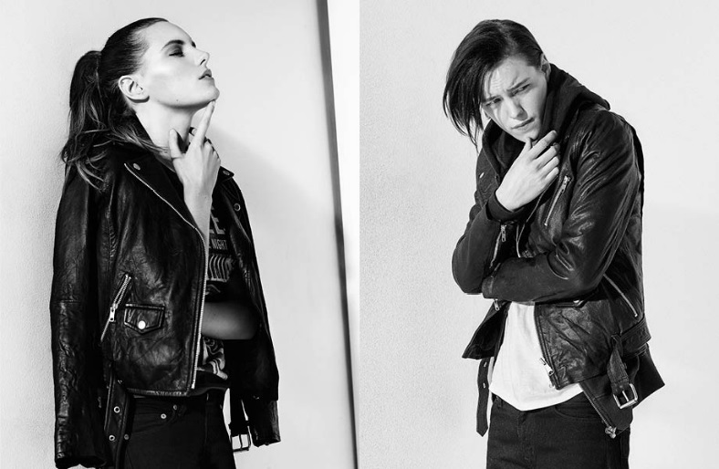
Fig. 7: Levi Jeans advert, 2014

Another example is Rain Dove an androgynous model who also models for both male and female. Rain Dove has lived as both male and female. “The gender thing doesn’t exist; it’s a social construct you don’t have to fit into…” (BoredPanda, 2017). Although Rain does have a masculine frame, the performance is still a series of gestures and acts. You can see the difference between the male and female poses are due to their posture signifying what gender they are portraying.

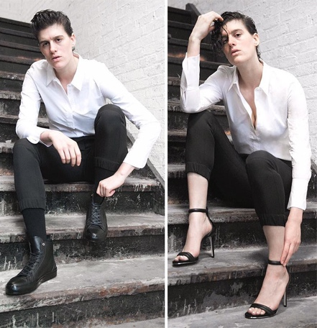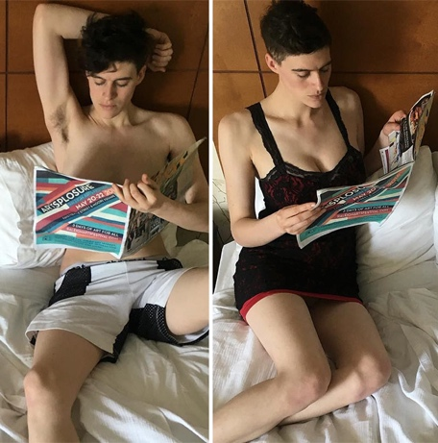

Fig. 8: Model Poses as Both to Challenge Gender Stereotypes, 2017

PSYCHOLOGICAL

When I rummage through my wardrobe in the morning I am not merely faced with the choice of what to wear. I am faced with the choice of images; the difference between a smart suit and a pair of overalls, a leather skirt and a cotton shirt, is not one fabric or style, but merely one identity. You know perfectly well that you will be seen differently for one whole day, depending on what you put on; you will appear as a particular kind of women with one particular identity which excludes others. The black leather skirt rather rules out girlish innocence, oily overalls tend to exclude sophistication… often I have wished I could put them all on together – just to say, ‘how dare you think any of these are me. But also, see, I can be all of them – Williamson (1986:91)

Williamson argues that we have a choice in how we portray ourselves to others and that through making this decision other people will understand the choice we have made.
Identity involves how people see themselves and how others see them, therefore as Williamson has pointed out how we present ourselves to others will enable them to interpret our performance. There’s a physiology around clothes that we have learned to associate with creating gender traits. Trousers are masculine and dresses are feminine, however this poses a problem as clothes and identity have become more of an aesthetic presentation of the self (Butler, 1990:43) making it harder to tell someone’s gender. Goffman (1959) says that how we present ourselves to others is like acting out a part in a play. The society into which we are born presents us with a series of roles which patterns our behavior, routines and responses like having a part in a play. We have all these social cues that we play as a part of our gender. Our speech, acts and gestures can and are gendered, for example men are a lot rougher in their gestures with women being more quiet and reserved; these are gendered stereotypical characteristics and don’t apply to all men and women. These give off certain impressions of a gender we are maintaining in society. Goffman suggests that there are limited roles offered in society and the parts they play are restrictive. For example, the male and female roles that society present to us are limited. If we are conveying an identity are we performing certain traits to achieve this? For example, someone that is FTM (female to male) still performs binary traits in accordance with conveying their new identity. Androgynous is using both male and female traits in a performance, even though it is a different gender identity it’s still using the binary traits. What we are is not given, it must have been created; therefore, we make our own performance.

Turner (Turner et al, 1987) created the Self-Categorisation theory. This is a social psychological theory that describes how a person will perceive others and their faults. People are seen as social categories and this is used as a form of identification; a person takes on the identity with which they most align, if you don’t you are seen as other. Identity is shaped by self-categorisation, people looking at social categories and deciding whether or not they fit into them, if they do it becomes a part of their identity. As well as the theory of Self-categorization, a Marxist theory called ‘Interpellations’ as seen by Althusser (1971:11) shares a similar view. That someone will see themselves as a representation of a social category and instantly connect to the concept that it relates to them and chooses to identity with it. (Woodward, 2000, pg.19). This theory is to do with symbols and recognition, how a person recognises a symbol as a part of themselves and choose to identify with it.

Sandra Bem’s sex role inventory (1974) is a method used to determine the gender identity role of the subject. In fig .8 the y axis shows the measure meant of how feminine the answer is between a high and low point and for masculine it is on the x axis. The height of the answer to your question determines your binary identity. The subject’s scores were rated masculine if the masculine score was higher than their feminine score; androgynous if both scores were above 4.9. 20% of the participants scored as being androgynous. Thus, this is a strong argument that as we have progressed, the binary is now merging into the androgynous way of identity due to the restrictive performance roles they offer. We are taking on coded roles from other genders and have started performing them.

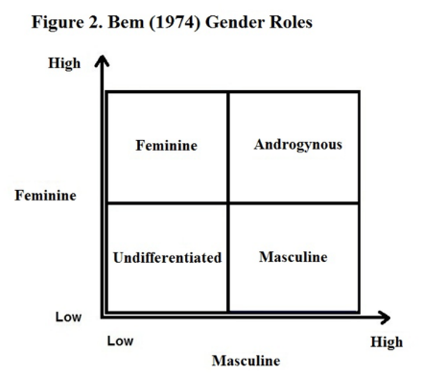

Fig 9: Dimension of femininity and masculinity in Bem’s sex role inventory. (Turner, 1995)

A study by Williams (1977) and Best (1990) was also conducted called Sex Stereotype Index; a long list of adjectives, which act as symbols, was shown to both genders and they were asked to rate each word according to its association to either men or women. It was found that people picked words that associated with themselves and an overlap occurred; men had described themselves as more feminine and females more masculine. When asked to assign traits to friends however they generalised more stereotypical binary roles to them. (Gauntlett, 2009:140) This suggested that people don’t see themselves as stereotypes and despite applying it to categorise others they rarely apply it to themselves.

BIOLOGICAL

It may be considered that society is up to date and at ease with sexuality and gender but when challenged faces the consequences of time and lack of self-education. Michel Foucault argued that since the 18th century the concept of gender understanding has not progressed past our anatomical gender and understanding has become stilted as a result. Science for a long time has looked at gender as a biological standpoint and not from a mind-set. Science is using anatomical evidence to determine that our gender is defined by the genitals one has. There are several problems with using anatomical evidence to define gender. We wear clothes to hide our bodies and if you identify as androgynous you may be wearing clothing that are ambiguous to your biological gender as we do not reveal our genitalia to other people; using clothing to identify someone’s gender is no longer an appropriate method. Also in recent years clothes such as trousers are no longer inherently masculine, clothing is becoming more non-conforming. Despite this, presumptions are regularly made regarding a person’s gender and misgendering happens. Although we sometimes wear clothes that present gender cues, social evidence is complicated by bodily aesthetics such as clothes that hide anatomical evidence. Humans have a total set of 46 chromosomes with males and females having a different combination of sex chromosomes which determine a person's biological gender. Females have XX chromosomes while males have XY chromosomes. Even though this could be used to identify a person’s gender there are still faults in using this DNA evidence concerning the odd amount of chromosomes someone may have due to mutation. It is possible for a female to be born female bodied but have male chromosomes, much like the musician Eden Atwood who had Androgen Insensitivity Syndrome (a mutation in DNA where your chromosomes have the other gender’s sex chromosomes) (ABC news, 2008). However, you also have people who are born as intersex, born with both genitalia and reproductive systems; they choose to live either as one gender or both simultaneously. Atwood is evidence that no matter what your biological gender is your identity is something that a person feels is right to them.

Science and facts have stopped the concept of ‘other’ as biologically there are only 2 medicalised genders, male and female; as a result of this a person doesn’t feel comfortable outside of the binary boundary. People have long accepted that a person is either male or female due to the biological and sociological conditioning within society. As a result, a person becomes scared to identify outside of the strict gender matrix because of how long they have been taught to live by these connotations of gender; the traditional male and female roles and characteristics such as the male as masculine and the female as homely and comforting. The safety and comfort of self-identity and understanding of oneself enables a life within these boundaries avoiding confusion and misunderstanding for others. The ability to be assured in who you are regardless of boundary constrictions is a place we are reaching within contemporary society but one may question whether this is enough or whether a broader categorisation of gender must instead be implemented. Without new gender boundaries society may again reach a point of repressed and unrepressed as was originally seen in the dominance of male over female in previous years.

PERFORMATIVITY

Gender in many ways is a performance, a way of acting in a certain way to encourage a specific response; a person’s actions are not necessarily representative of their identity but rather a way of fitting into a certain set of criteria often societally based.

When we say that gender is performed, we usually mean that we've taken on a role; we're acting in some way… We act and walk and speak and talk in ways that consolidate an impression of being a man or being a woman…we act as if that being of a man or that being of a woman is actually an internal reality or simply something that is true about us. Actually, it is a phenomenon that is being produced all the time and reproduced all the time. (Butler, 2006)

When performing a gender, you are acting out a role or expressing its characteristics in some way. Certain characteristics are given to specific genders and these are used to ‘perform’ like the given gender. Just as an actor takes a specific role and reads his lines he cannot play his own part and gender performance is the same, living up to a role defined by ideals that are not necessarily your own as suggested by Goffman (1959). Although an individual can perform in any way they wish, in or out of the gender binary, people are often constrained to act and feel a certain way; this leads to identity as a performance piece, designed to encourage a response but not always positively especially for the individual’s own understanding of their identity. Someone who found identity to be constricting was Anaïs Nin.
My life is not possible to tell. I change every day, change my patterns, my concepts, my interpretations. I am a series of moods and sensations… (1971:176)

In this quote Nin describes how her performance as a person isn’t fixed and changes every day and how her identity is merely a performance. “I play a thousand roles. I weep when I find others play them for me. My real self is unknown. My work is merely an essence of this vast and deep adventure…”. (1971:176)

Here Nin says that she plays thousands of roles and weeps when others play them for her. This gives the interpretation that Nin believes that everyone should perform the way they want to and not be constricted by society’s ideals. It could be argued therefore that we never really stop finding ourselves within identity as we are constantly changing against the matrix of gender.

I create a myth and a legend, a lie, a fairy tale, a magical world, and one that collapses every day and makes me feel like going the way of Virginia Woolf. I have tried to be not neurotic, not romantic, not destructive, but maybe all of these in disguises.
Nin (1971:176)

The narrowly confined ideals that we have been led to follow are slowly changing and becoming more open minded and understanding considering the constricting norms that have been oppressing other genders. Butler says that as soon as we enter this world we are gendered as a foetus and we are programmed to perform a set of pre-existing characteristics. “Gender is nothing more than a performance” (2004:64). Butler says that gender is an aesthetic performance of whatever you wish yourself to be. In these terms Butler suggests gender as a choice, not defined biologically as previously argued but instead a social construct defined by the person; you can perform any way you choose. Gender becomes fluid in this respect no longer constrained by the binary sets long imposed on society. Within contemporary society there are several other genders apart from the binary including gender fluid, androgynous, demi-gender and transgender. These give way to the convention of the societal ideals that have been put in place through not following the strict set of out dated rules laid down by binary gender.

Butler’s theory that gender is a performance can be contested by the emergence of drag.
Drag illuminates the fictitious nature of gender by taking on certain characteristics of another gender and reinforcing them, but an argument against this would be that a man performing traits that are inherently female coded is a performance in itself. People have been changing the way we view gender for a long time with public examples such as David Bowie, Annie Lennox and Erika Linder being recognisable. People often thought that Bowie did drag but he merely blended the gender binary using performance. David Bowie in 1970 was an important advocate for questioning gender ideals; he removed the gender boundaries through cross dressing in a visually ambiguous way. His outfits often confused people and arguably exposed the fictitious nature of gender. But Bowie never did drag, he simply expressed himself through performance, which Butler suggests is all gender is. Bowie wore female clothing examples of which were a pink maxi dress, knee high boots, colourful make-up and long hair, all which are heavily associated with being feminine. On the other side of the scale Annie Lennox in 1980 did the opposite, she sported a more masculine androgynous look. She had short boyish cropped hair, an androgynous frame, exaggerated shoulder pads to look more masculine. Butler’s argument that gender is a performance is supported by the personas of Bowie and Lennox who used gender to their advantage as a stage technique designed to push gender understanding; Bowie took on the androgynous alter ego Ziggy Stardust and this
allowed him freedom to perform past binary constraints.

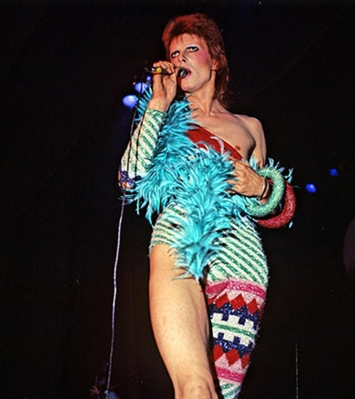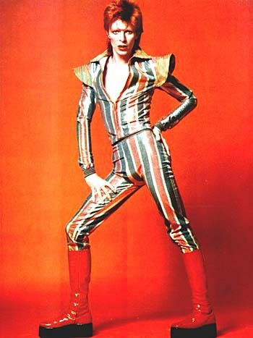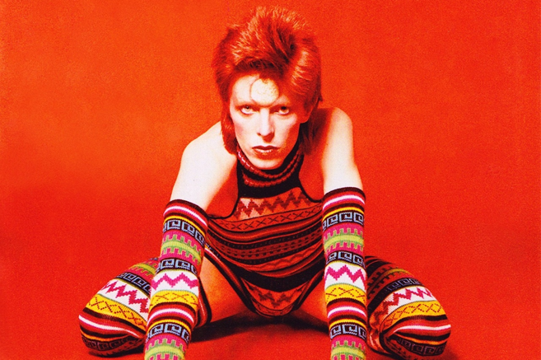
Fig. 10: Bowie onstage,1974 Fig. 11: David Bowie, 1973 Fig. 12: David Bowie, n.d.

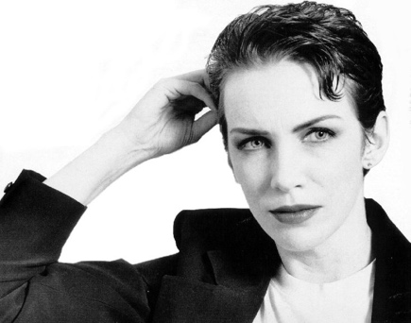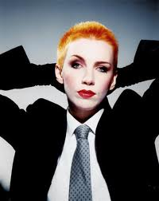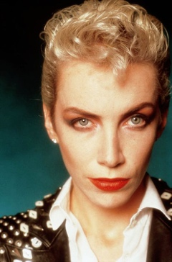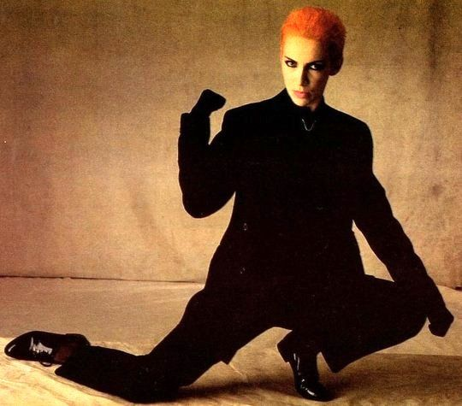
Fig. 13: Annie Lennox, n.d. Fig. 14: Annie Lennox, n.d Fig. 15: Annie Lennox, n.d Fig. 16: Annie Lennox, n.d.

CONCLUSION

Gender has been apparent in our history for generations; with historical evidence we can see that even before our modern awareness the concept of ‘other’ was already there. Even with this knowledge there are still powerful binary messages in tales such as Adam and Eve. Knowledge of the ‘others’ has erased it slowly over time but that has not stopped people from feeling there wasn’t something right with their identity.

I agree with Butler and believe that gender is an aesthetic performance of the self. Identity is self-aware and those outside of the binary have chosen to question the ideals in which we live. There’s a great link between social and cultural aspects influencing our views on gendered identity and for people to notice that they don’t fit within these ideals.
Looking at a time period such as the Sixties we can see where the binary was at one of its most fixed points; the 1960s was a pivotal point for change as the younger generation saw how oppressing these norms were and began moving to a more fluid approach to the inherently binary coding they were used to. There are several important aspects that make up someone’s gender. Society places a huge role on identity and as society changes we evolve with it. As individuals, we have this freedom to identify outside of the binary, to take on a new identity different to the one we were born with. Fluid representations have come about due to the ability to be at one with our feelings and accept who we are; society has evolved allowing freedom of choice. It’s an amazing concept to think we can now be something else entirely to which we were born. Physiologically our gender is how we feel and how we translate these feelings into a performance. Biological factors have been held in place to explain gender using anatomical evidence for too long, as argued by Butler; gender is a performance so the body shouldn’t be the main or the only signifier to a person’s gender. In the end, all these factors are individual pieces that make up a performance. Gender is an expression that comes from within; like Bowie we perform who we see ourselves, whether that be as a completely different fluid gender or just fluid binary roles.

In the end, a person’s gender identity is up to the individual, all these factors come into play to make up said person’s identity. Some people are comfortable living within the binary we have been raised in but more and more people are becoming self-aware to the factors that are changing social ideals. I hope that society becomes more tolerant and understanding that fluid forms are now an everyday occurrence even within some binary roles. Most binary representations are a thing of the past with their ideals being outdated. I can’t say for certain but the aim is for a society whereby gender can be more of a concept of fluid performance, hopefully with more powerful examples and insight we can one day reach this.
Bibliography
Althusser, L. (1971) Lenin and philosophy, and other essays. London: New left books.

Paoletti, Jo. (2012) Pink and Blue: Telling the Boys from the Girls in America. Indiana University Press.

Barthes, R. (1967) Elements of Semiology (trans. Annette Lavers & Colin Smith). London: Jonathan Cape

Bazilian, E. (2014) Erika Linder Is Him and Her in Mesmerizing Campaign for Crocker Jeans, Androgynous model shows off male and female styles. [online] Available at: http://www.adweek.com/brand-marketing/ad-day-erika-linder-him-and-her-mesmerizing-campaign-crocker-jeans-156024/ [Accessed 16th August 2017]
Bem, S. (1974) ‘The measurement of psychological androgyny’, journal of consulting and clinical psychology, vol.42, pp.155-62.
Berger, J. (1972) Ways of seeing. London: Penguin classics

Butler, J and Salih, S. (2004) The Judith Butler reader. Oxford: Blackwell publishing.

Butler, J. (1990) Gender trouble, Feminism and the subversion of identity. New York: Routledge books.
Butler, J. (1990) Gender Trouble. New York: Routledge.
Butler, J. (2004) Undoing gender. New York: Routledge.
Calhoun, G. (2012) Contemporary sociological theory. Chichester: John Wiley & Sons, 2012.

De Beauvoir, S. (1949) The Second Sex. New York: Random House

Derrida, J. (1984) Margins of Philosophy. USA: University of Chicago Press.

English online. Society and life in the 1960s. [online] Available at: http://www.english-online.at/history/1960s/society-and-change-in-the-sixties.htm [Accessed 5th June 2017]
Foucault, M. (1979). The History of Sexuality Volume 1: An Introduction. London: Allen Lane.
Gauntlett, D. (2009) Media, Gender, and Identity. New York: Routledge.

Gergen, K. J. (1985). The Social Constructionist Movement in Modern Psychology. USA: American Psychologist

Goffman, E. (1959) The presentation of self in everyday life. New York: Doubleday anchor.

Grasyte, R. (2017) Man Or Woman? Androgynous Model Poses As Both To Challenge Gender Stereotypes. [online] Available at: https://www.boredpanda.com/androgynous-model-rain-dove/ [Accessed 17th August 2017]
Hanan, M. Women with Male DNA All Female. (2008) [online] Available at: http://abcnews.go.com/Health/MedicalMysteries/story?id=5465752&page=1 [Accessed 11th July 2017]
Holton, S. (1996) Suffrage days. New York: Routledge.
L. Garlow, J. (2015) The Da Vinci Codebreaker: An Easy-To-Use Fact Bethany House. Publishers: Minnesota.

Nesbitt Oppel, F. (2005) Nietzche on gender, beyond man and women. Usa: University of Virginia Press.
Nin, A. Stuhlmann, G. (1971) The diary of Anaǐs Nin, 1944-1947. New York: Harcourt Brace & Co.

Plato, The Symposium. (1999) Translated by Christopher Gill. Harmondsworth: Penguin Books.
Pugh, M. (2000) Women and the women’s movement in Britain. London: Macmillan Press ltd
Ryan, B. (1992) Feminism and the women’s movement. Dynamics of change in social movement, ideology and activism. New York: Routledge.
Trently, D. (2015) Examples of Non-Binary Genders Throughout History. [online] Available at: http://listverse.com/2015/10/21/10-examples-of-nonbinary-genders-throughout-history [Accessed 23rd June 2017]
Turner, J.C., Hogg, M.A., Oakes, P.J. and Wetherell, M. (1987) Rediscovering the social group: a self-categorization theory. Oxford: Basil Blackwell.
Turner, P.J. (1995) Sex, gender and identity, Leicester. The British psychologist society.
Williamson, J. (1981) Decoding advertisements. London: Marion Boyars publishers ltd

Williamson, J. (1986) Consuming passion. London: Marion Boyars.

Illustrations

Figure 1: [Brut advert] n.d. [image online] Available at:< http://www.vintag.es/2016/06/14-vintage-mens-cologne-ads-from-1960s.html> [Accessed 12 June 2017].

Figure 2: [I know my taste] 1976 [image online] Available at: http://www.vintageadbrowser.com/tobacco-ads-1970s/17> [Accessed 12 June 2017].

Figure 3: [Van Huesen] n.d. [image online] Available at: https://www.boredpanda.com/vintage-ads/> [Accessed 12 June 2017].

Figure 4: [Weyenberg Massagic shoes] 1974. [image online] Available at: http://www.nydailynews.com/entertainment/tv/sexist-ads-mad-men-era-gallery-1.1050013?pmSlide=1.1050011> [Accessed 12 June 2017].

Figure 5: [Lustre Crème hair care adverts] 1967. [image online] Available at: <http://www.ghostofthedoll.co.uk/retromusings/lustre-creme-pink-is-for-girls/> [Accessed 12 June 2017].

Figure 6: [Brown] n.d. [image online] Available at:
<https://flashbak.com/miracle-appliances-and-the-desperate-1970s-women-that-loved-them-3315/> [Accessed 12 June 2017].

Figure 7: [Erika liner crocker jeans advert] 2004. [image online] Available at: http://www.adweek.com/brand-marketing/ad-day-erika-linder-him-and-her-mesmerizing-campaign-crocker-jeans-156024/> [Accessed 13 August 2017]

Figure 8: [Androgynous Model Poses as Both to Challenge Gender Stereotypes] 2017. [image online] Available at: < https://www.boredpanda.com/androgynous-model-rain-dove/> [Accessed 13 August 2017]

Figure 9: Model Poses as Both to Challenge Gender Stereotypes, 2017

Figure 10: [Bowie onstage] 1974. [image online] Available at: <http://bowiebrokemyheart.blogspot.co.uk/2015/04/how-david-bowie-was-accidentally.html> [Accessed 24th August 2017]

Figure 11: [David Bowie] 1973. [image online] Available at: <http://www.5years.com/Gall28.htm> [Accessed 24th August 2017]

Figure 12: [David Bowie] n.d. [image online] Available at: <https://thevinylfactory.com/features/how-david-bowies-ziggy-stardust-redefined-sexuality/> [Accessed 24th August 2017]

Figure 13: [Annie Lennox] n.d. [image online] Available at: <http://www.annielennox.com/photos/> [Accessed 24th August 2017]

Figure 14: [Annie Lennox] n.d. [image online] Available at: <http://www.crossdreamers.com/2011/10/crossdreamer-diva-annie-lennox.html> [Accessed 24th August 2017]

Figure 15: [Annie Lennox] n.d. [image online] Available at: <http://www.annielennox.com/photos/> [Accessed 24th August 2017]

Figure 16: [Annie Lennox] n.d. [image online] Available at: <http://www.annielennox.com/photos/> [Accessed 24th August 2017]

