Principles of Marketing

Component 1: Coursework: Individual Report
  - Adrian Mihai Neacsu 2312529

Name: Adrian Mihai Neacsu
Student number: 2312529
Module Code: LCBB5015
Module Title: Principles of Marketing
Assignment Title: Component 1: Coursework: Individual Report
UWTSD Birmingham

Table of Contents
Introduction 3
SWOT Analysis 3
Strengths 4
Weaknesses 4
Opportunities 5
Threats 5
Critical Analysis and Evaluation 6
Conclusion 8
References: 8

Introduction
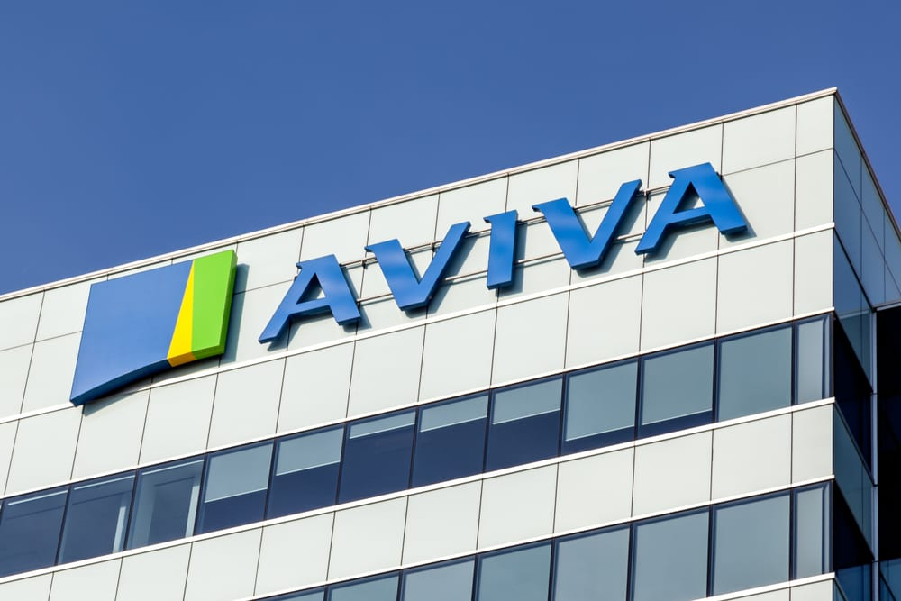
Decision-making in the UK financial services industry takes place in a competitive and highly regulated environment, where organisations must respond to market pressures and changing customer needs (Johnson, Scholes and Whittington, 2021; Grant, 2022). In this context, Aviva is a major provider of insurance and long-term savings products in the UK. The company offers life and general insurance alongside retirement solutions, and holds a strong position in the domestic market supported by its scale and established customer base (Hooley et al., 2020). A SWOT analysis is used to examine internal strengths and weaknesses and external opportunities and threats, as this approach is widely applied in marketing planning and strategic analysis (Kotler and Armstrong, 2020; Vaněk, 2022).
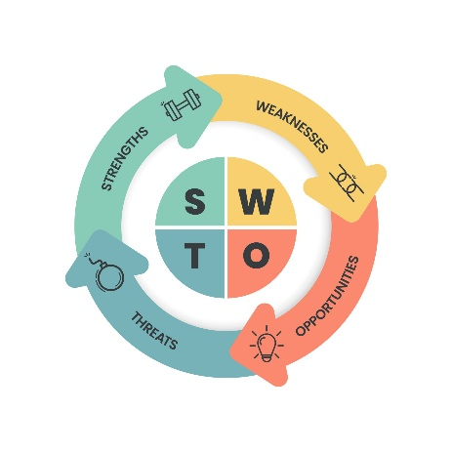

SWOT Analysis
This SWOT analysis examines the internal and external factors influencing Aviva’s competitive position in the UK financial services market, with a focus on their implications for marketing decision-making (Vaněk, 2022).


Strengths
Aviva’s long-established presence within the UK insurance and pensions market represents a key strength, as trust and perceived credibility play a central role in consumer choice for financial products (Solomon, Marshall and Stuart, 2017). The company’s broad customer base and scale of operations support effective risk diversification and cost efficiency, which are critical sources of competitive advantage in mature service markets (Porter, 2008). Aviva also benefits from a diversified product portfolio across insurance, pensions and long-term savings, which helps to reduce exposure to fluctuations in any single market segment (Hooley and Nicoulaud, 2020).


Weaknesses
A significant weakness for Aviva relates to organisational complexity, which is common among large financial institutions. Complex structures can slow internal processes and limit the organisation’s ability to respond quickly to technological or market change (Johnson et al., 2020). High fixed costs associated with regulatory compliance, legacy systems and administration further constrain flexibility and may place Aviva at a disadvantage compared with newer, digitally native competitors (OECD, 2021). In addition, dependence on established systems may reduce the speed at which innovation and digital transformation initiatives can be implemented (Chaffey, 2022).


Opportunities
Demographic and social trends in the UK present opportunities for Aviva, particularly increasing demand for pensions, retirement planning and long-term savings as life expectancy rises (ONS, 2023). Advances in digital technology also provide opportunities to improve service efficiency, enhance customer engagement and develop personalised financial products using data analytics (Verhoef et al., 2021). Furthermore, growing public and regulatory focus on environmental, social and governance (ESG) issues creates opportunities for Aviva to strengthen differentiation through responsible investment and sustainable insurance offerings (UN PRI, 2021).


Threats
The UK financial services market is characterised by intense competition, with pressure from both established insurers and new fintech entrants offering lower-cost and simplified digital products (EY, 2023). Macroeconomic uncertainty, including inflation and interest rate volatility, may reduce consumer confidence and negatively affect demand for long-term financial commitments (Bank of England, 2023). Ongoing regulatory change also represents a persistent threat, as increased regulatory scrutiny may raise compliance costs and limit strategic freedom within product development and pricing decisions (OECD, 2021).


Critical Analysis and Evaluation
The SWOT analysis shows that Aviva’s position is shaped by the need to maintain stability while also becoming more adaptable. In practice, this means Aviva relies on its established strengths, but at the same time must respond more quickly to market and technological change. While the company benefits from brand trust, scale and a diversified product base, these strengths do not automatically translate into sustained competitive advantage. Strategic management research shows that resources create value only when organisations can reconfigure them in response to environmental change, particularly in industries facing technological disruption and regulatory pressure (Teece, Peteraf and Leih, 2016).
From a resource-based perspective, Aviva’s brand reputation and customer relationships represent assets that are difficult to imitate, which supports its competitive position in the UK financial services market (Barney, Ketchen and Wright, 2021). However, peer-reviewed studies also highlight that dominant businesses often struggle to convert such advantages into superior performance when organisational complexity restricts speed and innovation (Karimi and Walter, 2015). For Aviva, having complicated structures and old systems might make it harder to keep up with digital-first competitors, which could weaken the advantages that come with being a large company over time.
The external environment presents opportunities that appear well aligned with Aviva’s existing capabilities, particularly increasing demand for pensions and long-term savings driven by demographic change. Research on strategic fit suggests that alignment between internal strengths and external opportunities is associated with stronger performance in mature service sectors (Vorhies and Morgan, 2005). However, this opportunity is constrained by economic uncertainty and heightened consumer risk sensitivity, which may limit demand for long-term financial commitments (Baker et al., 2020). As a result, reliance on demographic trends alone is unlikely to secure growth without parallel improvements in flexibility and customer engagement.
Competitive threats from fintech firms further challenge Aviva’s operating model. Studies of digital transformation show that new entrants often reshape markets by lowering costs and simplifying customer experiences, placing pressure on established firms to adapt or risk erosion of market share (Vial, 2019). In this context, Aviva’s strategic choices around digital investment are critical. Without meaningful organisational change, digital initiatives risk becoming incremental rather than transformative, limiting their impact on competitiveness.
From a strategic perspective, Aviva faces a clear trade-off between maintaining its traditionally cautious, risk-controlled operating model and pursuing faster digital and service innovation. A strategy focused primarily on risk minimisation may protect short-term stability, but risks weakening customer value if service simplicity and responsiveness lag behind competitors. In contrast, a stronger emphasis on customer experience, digital personalisation and service differentiation could improve long-term competitiveness, though it may increase operational and regulatory complexity. Research suggests that firms in regulated service industries achieve stronger outcomes when innovation is aligned with customer value rather than cost reduction alone (Vorhies and Morgan, 2005; Verhoef et al., 2021). For Aviva, this implies that strategic decisions should prioritise marketing-led digital transformation that enhances customer engagement while retaining robust risk governance.
Overall, Aviva’s long-term performance is likely to depend more on reducing internal rigidity than simply relying on its existing strengths. Findings from peer-reviewed research suggest that firms capable of continuous learning and organisational renewal are better positioned to sustain performance under conditions of uncertainty (Teece et al., 2016; Barney et al., 2021). For Aviva, strategic decision-making must therefore balance risk management with a willingness to challenge established processes in order to remain competitive.

Conclusion
This report has shown that Aviva’s strategic position is shaped by a combination of strong internal resources and significant external constraints. The SWOT analysis identified brand trust, scale and product diversification as key strengths, while organisational complexity and exposure to regulatory and technological change limit strategic flexibility. External opportunities linked to demographic change and demand for long-term savings align with Aviva’s core capabilities, yet these are tempered by economic uncertainty and increasing competitive pressure from digital-first firms.
Based on this analysis, Aviva should prioritise strategic decisions that reduce structural rigidity while accelerating marketing-led digital transformation, with a particular focus on service differentiation, customer experience and long-term value creation within pensions and savings markets. Investment in organisational learning and process simplification would improve responsiveness without undermining risk management. The results also highlight the importance of situational analysis in strategic planning, as it allows organisations to evaluate the relationship between internal strengths and external circumstances, facilitating more informed and resilient strategic decision-making in complex and uncertain environments.

References:
- Baker, S.R., Bloom, N., Davis, S.J. and Terry, S.J. (2020) ‘COVID-induced economic uncertainty’, National Bureau of Economic Research Working Paper, 26983.
- Bank of England (2023) Financial Stability Report. London: Bank of England.
- Barney, J.B., Ketchen, D.J. and Wright, M. (2021) ‘Bold voices and new opportunities: An expanded resource-based view’, Journal of Management, 47(7), pp. 1671–1695.
- Chaffey, D. (2022) Digital Business and E-Commerce Management. 8th edn. Harlow: Pearson Education.
- EY (2023) UK Insurance Outlook. London: Ernst & Young.
- Grant, R.M. (2022) Contemporary Strategy Analysis. 11th edn. Chichester: John Wiley & Sons.
- Hooley, G.J., Piercy, N.F. and Nicoulaud, B. (2020) Marketing Strategy and Competitive Positioning. 7th edn. Harlow: Pearson Education.
- Johnson, G., Scholes, K. and Whittington, R. (2020) Exploring Strategy. 11th edn. Harlow: Pearson Education.
- Johnson, G., Scholes, K. and Whittington, R. (2021) Exploring Strategy: Text and Cases. 12th edn. Harlow: Pearson Education.
- Karimi, J. and Walter, Z. (2015) ‘The role of dynamic capabilities in responding to digital disruption’, MIS Quarterly, 39(1), pp. 261–280.
- Kotler, P. and Armstrong, G. (2020) Principles of Marketing. 18th edn. Harlow: Pearson Education.
- Office for National Statistics (ONS) (2023) Overview of the UK Population. London: ONS.
- OECD (2021) Financial Consumer Protection and Regulation. Paris: OECD Publishing.
- Porter, M.E. (2008) ‘The five competitive forces that shape strategy’, Harvard Business Review, 86(1), pp. 78–93.
- Richardson, J.G. and Carolina Cooperative (2021) Situational Analysis. Raleigh, NC: Cooperative Extension Service.
- Solomon, M., Marshall, G. and Stuart, E. (2017) Marketing: Real People, Real Choices. 9th edn. Harlow: Pearson Education.
- Teece, D.J., Peteraf, M.A. and Leih, S. (2016) ‘Dynamic capabilities and organisational agility’, California Management Review, 58(4), pp. 13–35.
- UN Principles for Responsible Investment (2021) Responsible Investment and Insurance. London: UN PRI.
- Vaněk, M. (2022) ‘Evaluation methods of SWOT analysis’, GeoScience Engineering, 58(2), pp. 23–31.
- Verhoef, P.C. et al. (2021) ‘Digital transformation: A multidisciplinary reflection’, Journal of Business Research, 122, pp. 889–901.
- Vial, G. (2019) ‘Understanding digital transformation: A review and research agenda’, Journal of Strategic Information Systems, 28(2), pp. 118–144.
- Vorhies, D.W. and Morgan, N.A. (2005) ‘Benchmarking marketing capabilities for sustainable competitive advantage’, Journal of Marketing, 69(1), pp. 80–94.

