TITLE PAGE

Student name:
Khaled Mahmood Khaliq
Student ID number:
1910834

Module code: | BMSW6102
Lecturer: | Khaza Ahmed
Assignment Title: | Coursework  (Innovative Service Plan)
Submission deadline: | Written submission:  3pm 29/07/2022

Contents Page

Title page – p1

Contents page – p2

Introduction – p3

Main Body: - p4
Value chain analysis – p5
Swot analysis – p7
Marketing – p8

Conclusion – p8

References – p10

Introduction

In today’s world emerging customer needs are key and I have identified an area where customers may have a need by setting up an e-commerce website called Desishop.co.uk where customers may want to purchase traditional Asian clothes or artefacts posters or beauty treatments or anything which may be considered Desi etc .
The meaning of desi can be defined as local produce or something which may be considered traditional in terms of food, clothing or anything associated with the culture or tradition.

As suggested by Christopher Freeman (1982) “not to innovate is to die” and has proven that market leaders across many different industries have demonstrated a strong ability to innovate. (Page 5)

Whilst there are plenty of Asian online stores they are mainly associated with Chinese or Japanese as an example however there are far fewer and emerging online traditional Asian stores that cover traditional cultures from Pakistan India and Bangladesh which would be more considered as Desi.

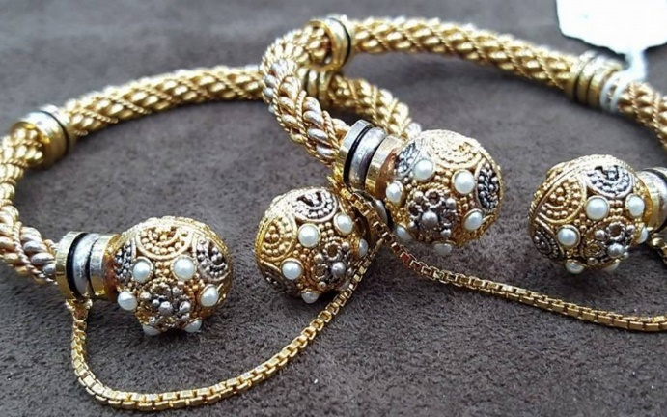

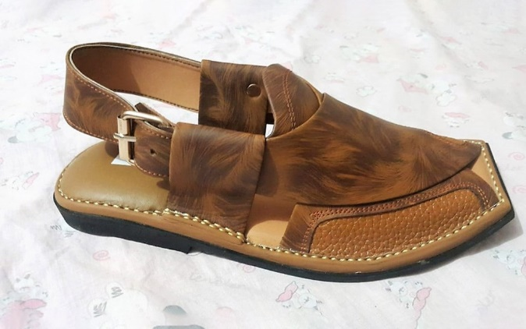

https://www.zameen.com/blog/9-amazing-handicrafts-pakistan.html - Peshawari-Chappal

Main Body

The Innovation behind this is as more local cultural shops are closing due to overhead costs it is becoming increasingly hard to source certain Asian products in mainstream stores such as Asda or Tesco for example even though, they may have world food isles, there is still an area which is not being exploited.
The demographic would be young to middle aged and elderly Asian most likely women but some men also with a traditional outlook on life or up bringing in a traditional way these are the types of customers who we are appealing to, and the phrase Desi would surely stand out to them.

For example the need for Henna Products or Multani Mitti also known as Fullers Earth are becoming increasingly difficult to source as well as traditional items used such as cooking utensils or specialised clothing items for Asian weddings etc as Schumpeter suggests the importance of new products may act as a stimuli to economic growth, also suggested by Kondratieff (1935/51) page 7 was the view that popular views and life cycles of many industries thus prompting the need for traditionally made products as they are now becoming popular once again this could be described as the cycle.

The concept behind the idea is to buy locally sourced or manufactured products and offering them a fair percentage of the sales once the products are sold helping to keep local economies ticking over and keeping customers advised of how well they may be getting on through telling their stories through the website.
The Unique selling point for the business will be to source local products in local economies to support the poor and needy of that area and to help them maintain a decent living and earning. We will always aim to source new initiatives in the growing economy in local areas to help them survive and thrive.

We have opted to go down the resource-based view of innovation to help us achieve this as we consider ourselves as one of the firms who has an ability to scan and search the environment more effectively as suggested by Cohen and Levinthal (1990) and Trott (1998). Page 21
Below we have a value chain analysis on the business model to describe the inbound logistics will be carried out by a postal carrier in the Eastern countries whilst the individuals who make the product will be advised by our overseas staff how to correctly package the products to avoid disputes or damages etc, this also comes under operations and the outbound logistics would again be carried out by our parcel carrier partner.

The Marketing and Sales would be all done here in the uk but with content all coming from our various sellers and overseas staff helping us to provide the content we may need in these cases it would be quite transparent thus ensuring we provide a proficient service model so that the customer would receive their products when stated helping to avoid disappointment. We would also encourage our manufacturers to provide new customers with a smaller gift of their choice if they can as to supersede the customer expectation with an element of surprise upon receiving their goods thus ensuring excellent service.

This helps the customers expectations to be over exceeded and thus giving them more happiness and confidence in the products.
As an example, we could ask someone who would be making the traditional chappal(sandal) from leather to add for the customer a leather keyring as a free gift obviously utilising the overseas manager to convey this message and idea to our handmade suppliers as just an example.

Value Chain Analysis

The firm infrastructure would work by having 2 managers here and 1 overseas manager the managers here would look after Human Resources, media sales and customer support whilst the overseas manager would look after content, procurement, creativity, and logistics etc. as suggested by (Tidd and Bessant 2009)
The innovation needs of the infrastructure needs to be carefully assessed and used to gain maximum input/output across all needs across the globe for the business model to function correctly. It is therefore very important to have the right overseas manager as most functions will fall on them, we will make sure the right person is hired by advertising for the role and making sure we have the correct job description to avoid disappointment for the role and to create a successful team. The core values and strengths of the firm will solely be based on ethical values sustaining the poor and needy who have skills to produce products but not much income this will help them to look after themselves and their families.

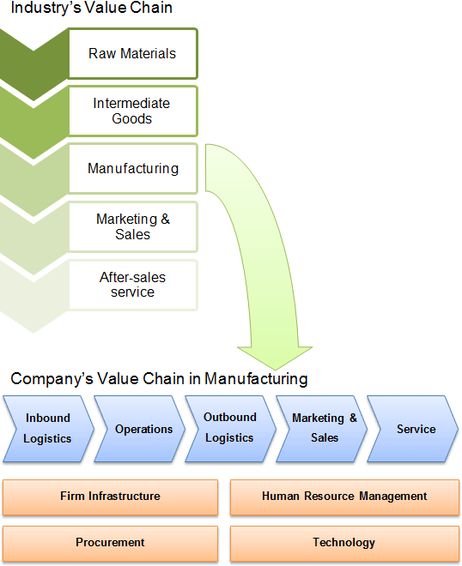
https://strategicmanagementinsight.com/tools/value-chain-analysis/

The customer target are the traditional Asians living in the west who still hold old values and products and lifestyle close to their hearts to help them find what they need whilst also giving to a good cause and creating sustainability in their home regions.

Our competitors would be considered the likes of e bay or many other desi shops that sell different items such as clothing, fancy goods as they provide some but maybe not all of the range we supply, and we differentiate ourselves by having locally sourced products to help the local people to sustain themselves through our company so we are ethically based with a wide range of hand made products which is where we differ to our competitors. As quoted by Sergey Brin co-founder of google and quoted by him in the Guardian (2009) page 30 “the fact is coming up with an idea is the least important part of creating something great. The execution and delivery are what’s key” and we would have a similar outlook whilst creating a unique selling point.
The benefit to the customer would be to be able to purchase a unique authentic product which is handmade whilst also helping to achieve sustainability for local manufacturers thus creating a sustainable business model where you could find many more locals who survive on selling their local goods.

We plan to sustain the business model by constantly seeking new products which are traditionally made with great skill care and attention by utilising our overseas staff members to search what is available in the different regions of the countries based on unique small suppliers in the wider regions who may not have the scope to get to market or sell the products in large amounts.

Our business model is different to Amazon as they simply sell online only whereas we are trying to sustain these small businesses for many generations to come which is where our product is more unique and innovative, and we plan on sustaining this by constantly seeking new products which are solely handmade thus giving us new products on a regular basis and creating long term sustainability (Han et al., 1998; Ismail, 2015) and we will do this by helping our product suppliers to innovate where possible by providing them with machinery or better working processes or cheaper materials as an example.

Swot analysis

Strengths  Niche Product Range  Online Market Place Strength  TV advertising Campaign  Ethical working for community  and sustainability | Weaknesses  Price range may be at threat  Copycat companies  Unsure of Rivals  Damages and Learning
Opportunities  Take market share of current companies  Offer wider and diverse product range  Room to expand to vary different product range  Grow to become a desi marketplace | Threats  Large online websites selling clothing etc  Copycat companies from South Asia  Finding the right staff  Rate of inflation and currency rates

The website will run independently although we will fulfil through Amazon shop to fulfil orders and redirect traffic back to our site where the sustaining local business theory would come in to play and to help support the local economies.

Customers will be able to pay through Amazon or by debit or credit card using a secure payment services provider such as stripe for example to enable us to take secure online payments whilst protecting our customers data.

This is very important as customer data breaches have been commonplace in the past and we must avoid this at all costs hence why we have decided to use a 3rd party provider who will look after all payments etc.

The website will be very colourful and pleasing to the eye showing our portfolio of products and how they are linked to the individuals who are making or helping
to manufacture their products.

The website design and set up will cost approximately £1250 and other costs include marketing and advertising including posters and advertising on the Asian tv channels in the uk at peak times to drive customer numbers up and eventually getting customers worldwide we will need 2 to 3 staff abroad to help us in sourcing the products and finding new products for the future and we will need 2 pro rata staff members here to help with the advertising and admin work etc the costs of all of this could run in to 2 to 3 thousand pounds and the money will be secured from the bank as a business start-up loan.

Marketing

Social media is nowadays playing a big part in promotion of products using videos on tik-tok, Instagram, Facebook and Google also using emotion to promote which is the route we will also be using in effect this is possibly one of the channels where the customer journey may start as they may see the video then click on the link which would take them either to the website or the Amazon store.
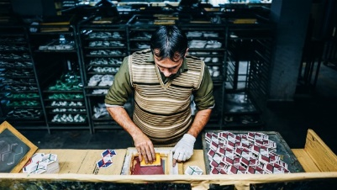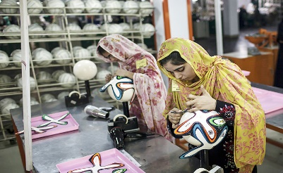
The customer Journey could start by looking at a tik-tok video advertising the products which then takes them to the Amazon shop link for them to buy and then eventually to our own website which would also highlight people who are working to manufacture the products promoting the ethical side of the business so the customer knows that not only are they purchasing a product but they are helping someone in a third world country to sustain their living standards and help to feed their families.

The Launch for the Desishop.co.uk would take place by placing heart touching adverts across peak drama shows on Asian channels and promotional tik-tok, Instagram and Facebook videos. We would also hold a special event in Birmingham city centre with many of the hand-crafted products on display for people to look at and purchase on the day with local tv and radio coverage arranged through the local business chambers to help with the launch of the online store. We would also put up a storyboard to help people understand where and how the products are made and how they help those people to survive.

We will also add to the google search engine many keywords to help bring our results to the top of the search engine every time.

Conclusion

The new business innovation is a fantastic idea with quite a large scope covering lots of clever ideas with ethical values covering a diverse workforce helping them to survive and help them maintain and improve their own local businesses also.
As suggested in the article
Brown, T., 2016. Leaders Can Turn Creativity into a Competitive Advantage. Harvard Business Review Digital Articles, pp.2–6.
Creating a new idea is key to success of a business but in our case, we are using traditional products for start up as a new idea.
This could be described as a new business phenomenon to root the topic of business models as suggested by Amit and Zott (2010).

The Desishop.co.uk is a unique idea which will attract many trades as time develops and the website grows as it will be more of a marketplace where vendors will want to advertise their products to gain a market share or even be part of something bigger.
The idea is that the marketplace will be the biggest place or supplier of desi products attracting sellers and buyers from across the world.

In short, the idea is to grow the online website using ethical values and cores to help sustain local businesses and eventually growing to a huge marketplace where other vendors will want to use your platform to advertise their goods and services helping us to become one of the biggest desi shops in the west.

This should then help us to attract much larger businesses which we would then use to help us grow and make better our local vendors to help sustain them in future.
This shows our ethical values and standards in trying to help people create a better life and future for themselves by using Desishop.co.uk.

REFERENCES

Brown, T., 2016. Leaders Can Turn Creativity into a Competitive Advantage. Harvard Business Review Digital Articles, pp.2–6.

Gassmann, O., Frankenberger, K. and Sauer, R. (2016). Exploring the Field of Business Model Innovation: New Theoretical Perspectives. [online] Google Books. Springer. Available at:https://books.google.co.uk/books?hl=en&lr=&id=JAUtDQAAQBAJ&oi=fnd&pg=PP5&dq=related:qLrLZqj6Dx8J:scholar.google.com/&ots=OTFjd59MFU&sig=vsX14hlZGIvsgwAr35yMra6QWuQ#v=onepage&q&f=false [Accessed 27 Jul. 2022].

Hülsmann, M. and Pfeffermann, N. (2011). Strategies and Communications for Innovations: An Integrative Management View for Companies and Networks. [online] Google Books. Springer Science & Business Media. Available at: https://www.google.co.uk/books/edition/Strategies_and_Communications_for_Innova/Z9T617zZ7YkC?hl=en&gbpv=1&dq=tidd+and+bessant+2009&pg=PR6&printsec=frontcover [Accessed 27 Jul. 2022].

Jurevicius, O. (2021). Value Chain Analysis: The Ultimate Guide - SM Insight. [online] Strategic Management Insight. Available at: https://strategicmanagementinsight.com/tools/value-chain-analysis/.

O’Reilly, C. and Binns, A.J.M. (2019). The Three Stages of Disruptive Innovation: Idea Generation, Incubation, and Scaling. California Management Review, 61(3), p.000812561984187. doi:10.1177/0008125619841878.

ProQuest. [online] Available at: https://www.proquest.com/docview/1760495358?accountid=130472&parentSessionId=X2zZUamxvniLsc7B%2FxIPQQYn%2FBDfh%2B%2FL%2B%2Bsi6Xp6XGk%3D&rfr_id=info%3Axri%2Fsid%3Ap
Tidd, J. and Bessant, J. (2009), Managing Innovation: Integrating Technological, Market and Organizational Change, 2nd ed, Chichester: John Wiley

Trott, P. (2008), Innovation Management and New Product Development, 4th ed, Harlow: FT Prentice Hall.

Trott, P. (2017) Inovation management and new product development. 6th ed. Pearson, England.

Zameen Blog. (n.d.). 9 Amazing Handicrafts That Reflect the Beauty of Pakistani Culture. [online] Available at: https://www.zameen.com/blog/9-amazing-handicrafts-pakistan.html#Peshawari-Chappal [Accessed 27 Jul. 2022].

