Appendices
 | School B
Child | 1 |  | 2 |  | 3
 | Engagement | Well-being | Engagement | Well-being | Engagement | Well-being
Pre choice | 3 | 3 | 3 | 4 | 3 | 3
Post choice | 3 | 3 | 3 | 4 | 2 | 3
10 minutes | 4 | 4 | 4 | 4 | 2 | 3
20 minutes | 4 | 3 | 3 | 3 | 3 | 3
30 minutes | 3 | 3 | 4 | 4 | 2 | 2
Range | 1 | 1 | 1 | 1 | 1 | 1
Table 1

 | School A
Child | 1 |  | 2 |  | 3
 | Engagement | Well-being | Engagement | Well-being | Engagement | Well-being
Pre choice | 2 | 3 | 4 | 3 | 2 | 2
Post choice | 3 | 4 | 3 | 4 | 4 | 4
10 minutes | 2 | 3 | 4 | 4 | 4 | 4
20 minutes | 4 | 3 | 3 | 4 | 2 | 4
30 minutes | 4 | 3 | 2 | 3 | 3 | 4
Range | 2 | 1 | 2 | 1 | 2 | 2
Table 2

Participant Information Sheet
What are we doing?
We are looking to find out if children are more engaged in their school work if they can choose how hard the task they are completing is. We will use this method today and will then observe how this affects how you work.
We will be looking at how you enjoy having the option to choose your level of task and if this helps you feel better about learning.
After the lesson, 3 children will be asked to share their ideas in an informal interview with myself and Mr Wakeling. This chat will be recorded for our research purposes but will not be shared with anyone except the research partners. We may write parts of the interview down in our research paper, but no one will be able to tell who has said it.

Who is doing the research?
This research will be carried out by myself and Mr Wakeling who is a trainee teacher in a different University of Wales Trinity Saint David partnership school.

Will anyone know what I’ve said?
You and the school will not be named in the research. Any information given to us will be kept by myself in password protected files in online University of Wales Trinity Saint David One Drive networks.
The results of this research will not be shared and will be used to improve our own teaching practice. Results will only be seen by university staff.

Who can take part?
We will choose 3 children in the class to talk to that we feel represent the class.

What if I don’t want to take part?
You do not have to take part in the research, but it would be really helpful to us if you do. You will still be in the lesson if you say you don’t want to take part, but we will not involve you in our observations or chat after the lesson. To stop taking part, please let us know or change your card to red.

Will this help me?
We are trying to see if our research shows that this way of teaching helps children learn. This may not help you right away but may help us with our teaching in the future.
If you have any questions about the research, please ask us.

Observation Schedule
School A
 | Child 1 |  | Child 2 |  | Child 3
Pre-Choice | E | WB | E | WB | E | WB
Comments
Post-Choice | E | WB | E | WB | E | WB
Comments
10 minutes after choice | E | WB | E | WB | E | WB
Comments
20 minutes after choice | E | WB | E | WB | E | WB
Comments
30 minutes after choice | E | WB | E | WB | E | WB
Comments
Range | E | WB | E | WB | E | WB
Comments

School B
 | Child 1 |  | Child 2 |  | Child 3
Pre-Choice | E | WB | E | WB | E | WB
Comments
Post-Choice | E | WB | E | WB | E | WB
Comments
10 minutes after choice | E | WB | E | WB | E | WB
Comments
20 minutes after choice | E | WB | E | WB | E | WB
Comments
30 minutes after choice | E | WB | E | WB | E | WB
Comments
Range | E | WB | E | WB | E | WB
Comments

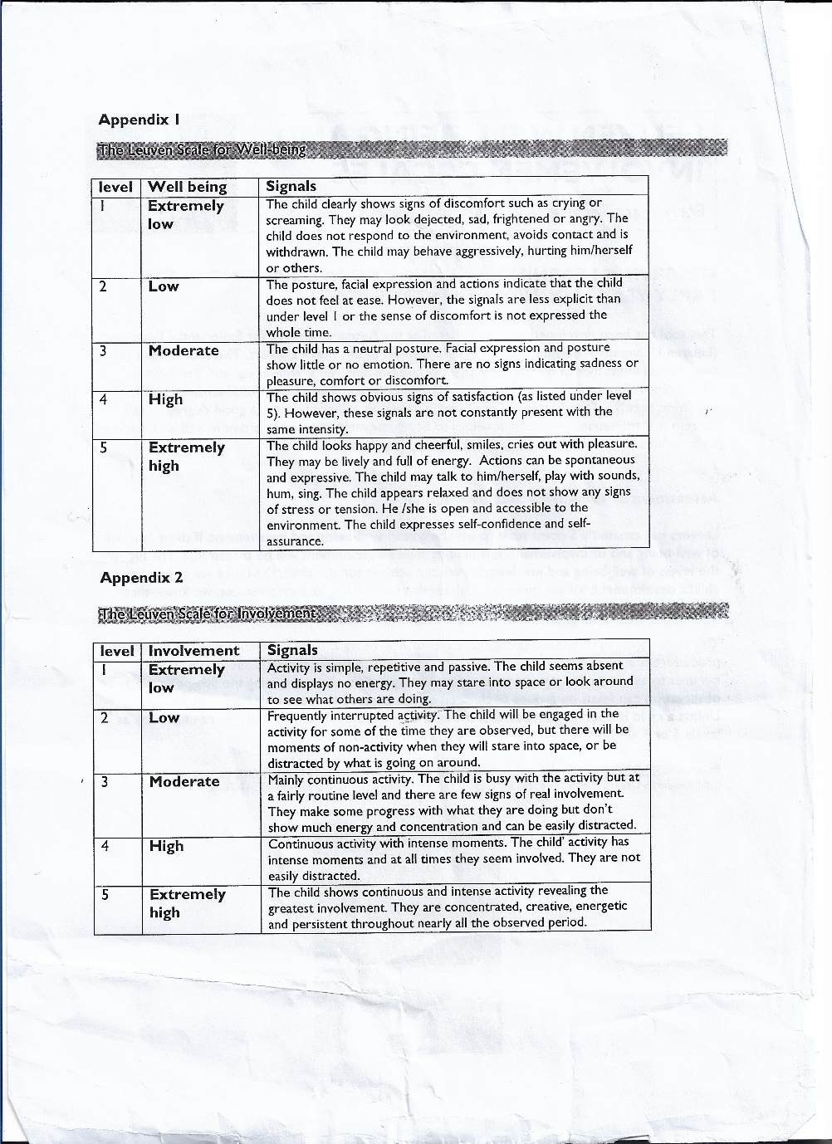

Leuven Scale value descriptors

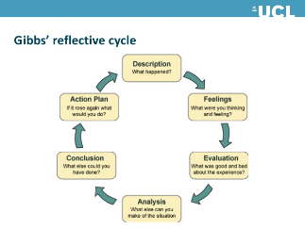
Reflection technique
Brookfield 4 Lenses – autobiographical, child view, peer view and Theoretical Literature
Within autobiographical, using the Gibbs model (reflective cycle) to reflect.
School A

Autobiographical (Teacher) |  | Child view |  | Peer review (Observer) |  | Theoretical literature
Gibbs reflective cycle  - Description  - Feelings  - Evaluation  - Analysis  - Conclusion  - Action Plan |  | Focus group Interview |  | Observer Leuven scores |  | Links to relevant literature.

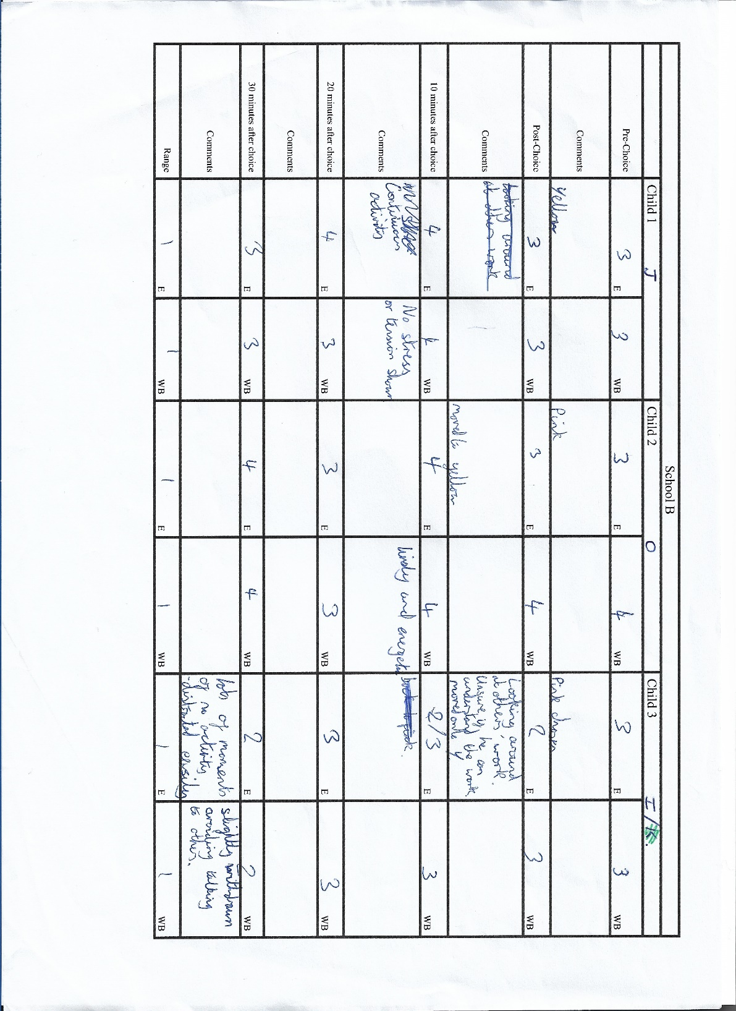

School B observation field notes (1)
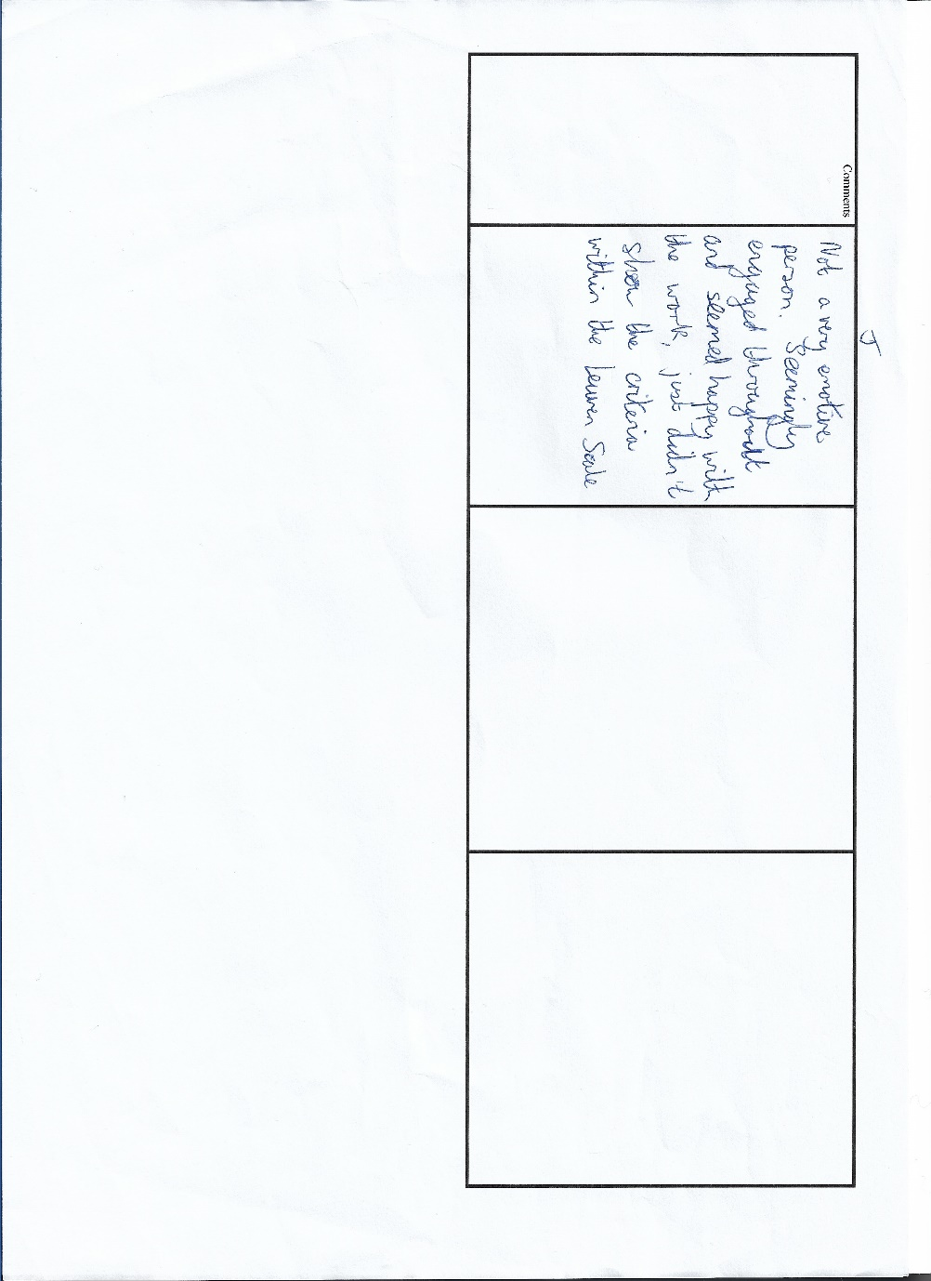
School B observation field notes (2)

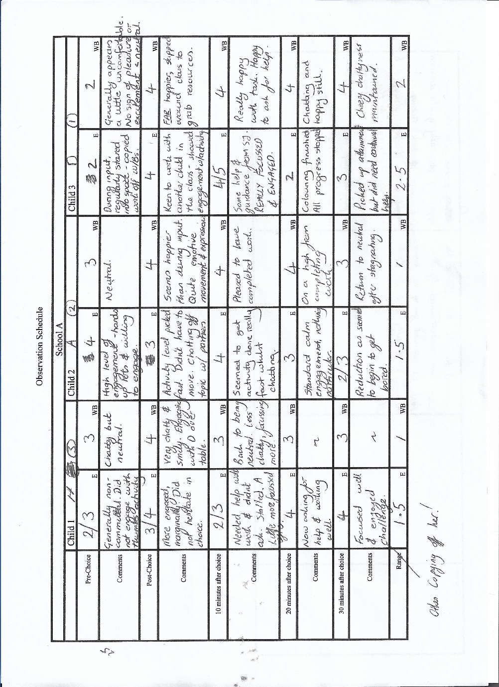
School A Observation field notes (1)
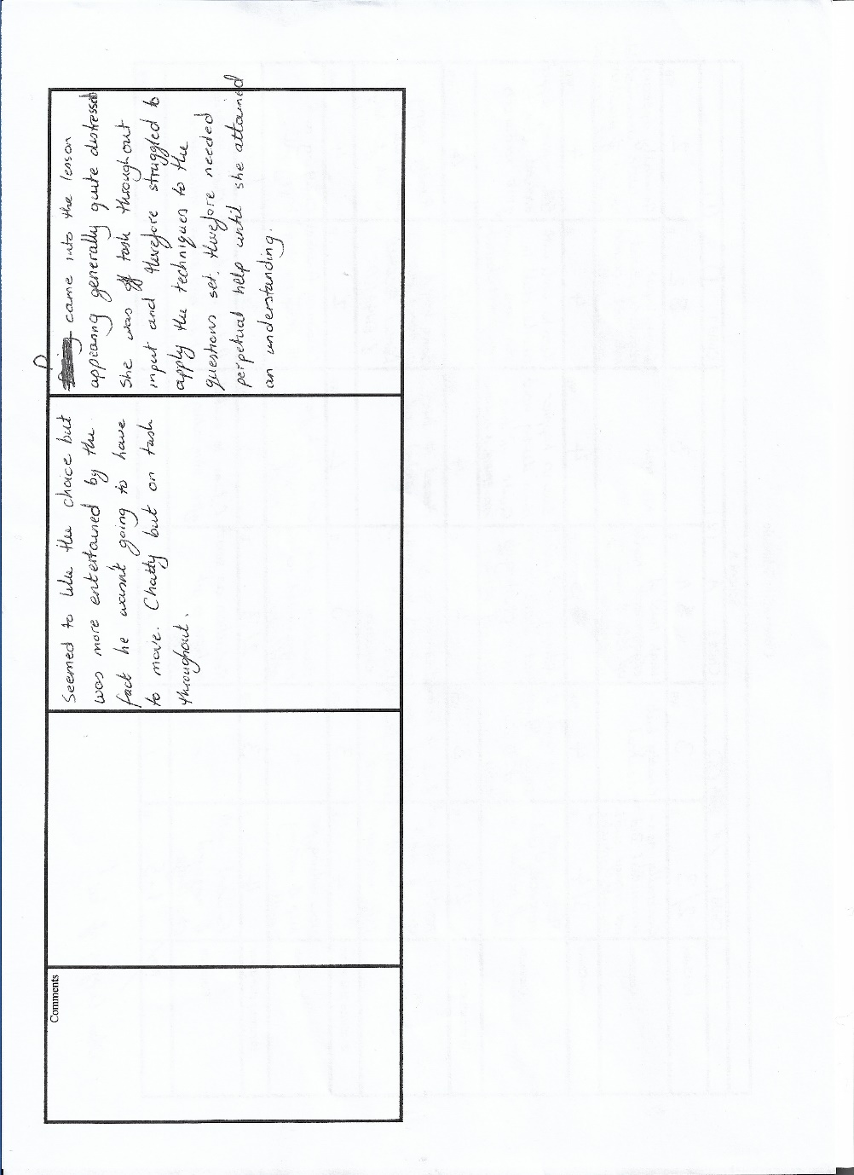
School A Observation field notes (2)
Interview Questions

Interview
Thank you for agreeing to answer these questions for us, it is really helpful. You do not have to answer these questions if you don’t want to and can stop at any time.
We want you to be honest and tell us how you really feel so we can improve and use this skill again in the future. We would like to find out what things you liked and what things you didn’t like in the lesson and will not be offended if you did not enjoy how the lesson was taught.
If you don’t understand a question you can ask us to explain.

Show the worksheets/examples of the work given as choices.

Interview questions
Out of 10, how did you enjoy being able to choose your own task?
- How do you feel you did in this lesson?
- What did you think of having the chance to choose your own task?
- What do you like best about choosing your activity?
- What did you like least about choosing your activity?
- What do you think about your teacher choosing your activity?
- Think back to making your choice, how complicated was the decision to make?
- Do you feel that you achieved differently in this lesson because of being able to choose your own task?
- Do you think you chose the right level of task for yourself?
- Would you like to see more opportunity to choose your own tasks?
- Is there a time where this wouldn’t be the right idea to use?
- Mr …. will be teaching this tomorrow, how could we improve the lesson?

Lesson Plan 1
 |  |  |  |  |  |  |  |  |  |  | 1B

Session Plan – Key Stage 2
Name of trainee: |  | Ashley Wakeling |  |  |  | Session ref: |  |  | 2002NUM (Research Lesson)
Personal target(s) in relation to QTS: |  |  |  | Keep pace in a lesson and ensure all work is marked appropriately to the school marking scheme.
Year group: | 3-4 |  | No. of learners: |  | 28 |  | ALN: | ASD, Behavioural
Additional Adults: |  |  | SJ – Observing and recording information.  AJ – Observing  KB – To assist with lowest ability group in the class and maintain them on task.
Learning objective(s): to be able to represent data using pictograms where one symbol represents more than one unit using a key and extract and interpret information from charts, timetables, diagrams and graphs. |  |  |  |  |  |  | Success criteria:
Links to previous learning: Recap of previous work in this subject. AJ has stated that they have all covered this topic already and therefore should have a good understanding. More able children will need extensions to make sure they are challenged and have tasks to complete for the time that the other children are working.
Curriculum coverage (range, skills)

Literacy(LNF) |  |  |  |  |  | Numeracy (LNF)  to be able to represent data using pictograms where one symbol represents more than one unit using a key and extract and interpret information from charts, timetables, diagrams and graphs.
DCF  Use of IT on the board in front of the children at the beginning of the lesson. |  |  | Thinking  Link to previous work carried out – Have we done anything like this before? |  |  | ESDGC |  |  |  | YCC
Key vocabulary(English/Welsh):

Time | Session activities, organisation and management
1045  1050  1055  1100  1105 | Input to session – Not differentiated.
1045  1050  1055  1100  1105 | Children have already covered pictograms.  Quick recap of times tables, 2,4,5,10s and remind the children that these will be really useful throughout this session!  Place pictograms presentation up on the board – 1 to 1 initially and then 1 to show 2,4,5,10.  Talk and discuss with partner activities. Answer questions on whiteboards together  Ask the children how they would display a pictogram for school dinners/packed lunches for the day in the classroom.  Put it up on the whiteboard as 1 to 1 initially and work through with the children.  Address misconceptions by asking if we include the picture before the line too?  Then introduce a scale, stating that we can improve how easy the pictogram is to read by making the bars smaller.  https://uk.ixl.com/math/year-4/interpret-pictograms  If needed to ensure understanding.
1110  Independent work to last a maximum of 35 minutes, with extensions for more able and assistance for lower ability children.  Finish by 1145 | Children are given the choice whether they pick the easiest, middle or hardest work from the front of the classroom to complete.
1 – Gwyrdd
Basic one to one pictogram work, extracting data from a pictogram and inputting other data into it using information on a sheet.
Maximum of three separate questions to ensure that lowest ability are not daunted by the task.
Ext – Make your own pictogram using information from people on your table using a scale you are comfortable with.

2 – Glas
One to 2 on one sheet and then extension one to 4 and 10 pictogram work.
Page 47 of Abacus 4 Textbook 1.
Ext – Make your own pictogram using information from 10 people in the class.

3 – Melyn
Various ratio levels of pictograms with emphasis on then representing data using a pictogram from data provided.
How else could you show this data without having to draw out a picture every single time?
Ext – Make your own pictogram by asking the children in the classroom their favourite colour/drink/fruit/sport – Think about the scale if you’re representing the whole class of 28 with 4 adults as well.

1145  1150  1155  1200 | Bring the lesson to a conclusion as the children begin to struggle or the session comes to a natural end.
1145  1150  1155  1200 | Ask the children to complete a self-assessment sheet which will also be placed up on the board.  How did they feel during the start of the lesson out of 10.  How did they feel when they found out they could pick their own work today?  Do they think they picked the correct sheets straightaway or did they have to change their level?  Do they think they tried their hardest in the lesson?  Would they like more opportunity to select their own work in the future?  Tidy the classroom, books into a pile with self assessment sheets slipped inside to the front.  Children go out to lunch.

Reflection1.
Research lesson 20th February 2019
AW – Numeracy/Year3-4/Pictograms

Description

The lesson began with an introductory PowerPoint containing a very basic introduction to pictograms as a concept, firstly by using one picture to denote one item. This was then followed by altering the scale to 1 picture to denote two items and so on. Throughout the introduction, I also demonstrated how a picture can be halved to show that an item has between two of the pictures. This was then followed by attempting to draw a pictogram of the classes’ dinner choices for the day. I made a emphasis on showing that drawing out 14 sandwiches and 16 dinner ladies made the 1 to 1 scale on the pictogram really challenging and then asked the children if they could show me a better way talking to their partners and using the whiteboards.
Once I had taken the ideas, we agreed that a scale of 1 to 2 would be most effective. I then asked the children to show me how the pictogram would appear, and they again used the whiteboards to show their thoughts. The ideas were seen to be quite basic by several the children, but around a third of the class did seem to struggle with the concept of not having 1 picture per item.
I then began to introduce the children to the opportunity to choose their own worksheets to work from during the time they would have for the remainder of the lesson. I had colour coded them and place them in piles which were to be completed in order. I did not show any further examples at this stage. There were three stages of work, ranging from ‘tricky’ being the most basic skills worksheets, to trickiest being more appropriate for higher ability year 4s in the class. The class were not grouped or sat by ability and were free to chose where to sit once they had collected their worksheets. They were reminded that they could change their mind about a worksheet at any time, if they initialled the sheet and wrote their thoughts about it on it. The children worked for approximately 40 minutes with assistance from myself. They were stopped around five times during the session as I noticed misunderstandings which I felt would hinder their work.
I brought the lesson to a close as it seemed to be reaching a natural end around 10 minutes before their lunch break and displayed a PowerPoint slide, requesting the children to write several pieces of information, relating to a self-assessment for the session. Due to poor reading abilities in the class however, several children were unable to complete this task, and the results were therefore not collatable.

Feelings

I believe the children liked being able to choose their own level of work, and they saw the increased independence as a positive thing throughout the session. However, I did note that most of the children perpetually asked permission to change their sheets, asked what they should do next and continuously asked for support when it had been made clear to them that if they needed this help they should approach peers before coming to the teacher. I feel this was down to the children not being given the opportunity previously to work in this way, and therefore, whilst the concept seemed positive, it also came across as distinctly alien to them also. Most children chose the level which was expected of them, except for some of the highest levels of ability choosing the middle sheets. When asked about this choice, they said that the word ‘trickier’ to denote the sheet had led them to choose the middle group and make sure they were sure they could complete this, before moving on. The most able students in the class found even the most complex sheet a little too simple and I would therefore ensure there was an enhanced extension prepared for these.
A number of the less able children in the class felt they were unable to choose their own level and therefore relied on some pointers from myself. I felt I did not place enough emphasis on giving the lower ability children challenging work, or praise, and therefore their attainment and engagement did dwindle slightly throughout the lesson. Nonetheless, several of the middle ability children did work very effectively independently throughout the session, to my surprise, using their peers for support. One of the children focussed on in the observation and subsequent interview was particularly focussed on his activity throughout the session from my perspective, significantly more than usual, although this was not noted by my research partner as he does not know the children personally.

Analysis

I feel that the novelty of this idea was its main success during this lesson. Several children worked more independently than usual, resulting in higher levels of engagement throughout the session. However, a large number also failed to engage with the idea, relying solely (as they had done previously under a standard differentiated lesson) on the teacher for support on nearly a one to one scale. Nonetheless, I think being given the opportunity to chose helped some of the children edge towards increased independence and therefore can be seen as a success. Allowing the children free roam around the classroom and being able to chose where they would sit also was a novelty for the class, and this did result in a lot of time being wasted, especially initially when they went to collect the worksheets. Some children struggled to work independently as a nature of the class in question, and therefore, this technique may have been lost to a certain degree. More independent children worked well and produced more work than expected and they often remarked around how they felt that this way of learning empowered them more. This does bode well for the future use of the technique, particularly in a class with fewer members having additional learning needs or difficulties. The allowing of children to sit wherever they wanted in the class often meant that the children who were friends, sat next to one another, but instead of copying one another, many of them chose different sheets and worked collaboratively with one another, which was a highlight. On speaking to my partner, we discussed this in great detail, and taking feedback from the interviews with the children afterwards, we agreed that we would look at a different technique of placing the children on different tables by chosen ability, rather than wherever they wanted in order to try to increase the output from the class. The children in the interview reported that they use of ‘tricky, trickier, trickiest’ was misleading, and they believed that it would be far more useful just to have them numbered from 1 to 3 or have easy medium hard written on them. I chose to use the tricky scale to make the lower ability children feel that they were challenging themselves regardless of the level they chose. My attempt to maintain the wellbeing of the children therefore seemingly backfired, and they would have preferred an extended challenge also, as the highest ability in the class reported not being pushed hard enough.

Furthermore, we found that the Leuven Scale, whilst appropriate for this observation, was inherently limited in its nature, with children in key stage two very rarely dropping below a 3, and not likely to rise above a 4. Whilst we noted the reasons for the changes between these numbers, it became quite difficult to show that there had been a huge range in the numerical data as a result, and the qualitative data became increasingly important as a result. My research partner had taken very few qualitative notes however, and we noted that we must take far more for the following observation to make the research show the differences we had seen ourselves.

Conclusions
We learned that the technique of allowing the children to choose their own task level generally improved both engagement and wellbeing of the children taking part. However, we found that it was also incredibly important in the way it was delivered in the class, particularly as the children had never completed a task in this way before. Therefore, a significant amount of time was needed to scaffold the entire construct and make sure the children understood the process.
The lesson could have been significantly better if it was based around a technique that the children were familiar with, and on a topic that they had covered before, resulting in less time being set aside to stop the class and address misconceptions. I believe the self-selection of task concept would therefore work far more effectively in a sort of ‘practice’ or end of unit activity to gauge understanding more effectively than a test. As a result, we have decided that the lesson studied tomorrow would be on a topic the children have already been introduced to and be for practicing their understanding.
I believe that I needed to develop my ability of class control a little more effectively before trying this model again. Because of attempting to cover too much in one session, the output was a little chaotic, and misconceptions the children had were often not picked up on until it was a little too late.
Action plan
If I was to do this lesson again, I would ensure that the children had been given an outline to how they should conduct themselves prior to the lesson and leave this on the board for the duration for them to refer to should they need to. This would have prevented them having to come to me so regularly to ask basic questions. This is a reflection on the nature of the members of the class, but also a consideration that cannot be ignored. I will reflect on the feedback we have attained both from the children who were in the focus group interview, and on the feedback from the class teacher on the day to make sure that I develop better class management skills, remain calmer and less excitable during lessons, as this results in the class rising to this level of excitement and a poorer output as a result. We found that having an extra person in the room, even as a non-participant passive observer, helped keep an eye on the children who were not achieving to their expected standards, and this made me appreciate the high value of a teaching assistant.

Lesson plan 2

 |  |  |  |  |  |  |  |  |  |  | 1B

Session Plan – Key Stage 2
Name of trainee: |  | Stuart Jones |  |  |  | Session ref: |  |  | 210219 maths (partner research lesson)
Personal target(s) in relation to QTS:
Year group: | 5 |  | No. of learners: |  | 31 |  | ALN: | * supported group - ensure understanding. Last time they only coloured in the number of sweets given in the ratio, rather than how many that ratio represented.
Additional Adults: |  |  | AW - observing
Learning objective(s): WALT: Use ratio to find amounts |  |  |  |  |  |  | Success criteria: Can simplify ratio ***  Can find amounts of items using ratio by finding one part and multiplying by the amount needed ** and***  Can find amounts of items using ratio by splitting the total amount in steps *
Links to previous learning:
Curriculum coverage (range, skills)
share objects in a given ratio, e.g. red blocks and blue blocks in a ratio of 1:2
Literacy(LNF) |  |  |  |  |  | Numeracy (LNF)
DCF |  |  | Thinking |  |  | ESDGC |  |  |  | YCC
Key vocabulary(English/Welsh):
Ratio.

Time | Session activities, organisation and management | Key questions & Assessment for Learning opportunities
 | Introduction  Demonstrate how ratio can also be calculated by adding the numbers in the ratio (4:3 = 7) you can then divide the total amount by the total (21) to then work out what one part is. Then, to find 4 parts, you can multiply it by 4. |  | There are 21 bananas, they are split into a ratio of 4 yellow, ripe bananas:3 green, unripe bananas.  How many are yellow? How many are green?
 | Children to attempt the next question on a whiteboard using this method.  There are 16 apples ratio is red:green 6:2.  Child chosen to talk through the question. Other children show if they agree using thumbs, if disagree, child can talk through how they worked it out. Can evaluate mistakes if there are any or show an alternative method if that is used. |  | TTYP – tell them how you can work this out.  Using a whiteboard complete the question.
 |  |  | Lollipop stick to choose a child
 |  |  | Peer assess of method – peer teaching if unknown.
 | Main activities |  | Children choose own difficulty
 | Explain to children there are 3 different levels of difficulty to choose from today. Each sheet shown on visualiser so they aware of the work on each sheet.  **** - Using new rule - using a range of units and 3 and 4 value ratios i.e. A:B:C:D  *** - Apply new rule to find one part and then multiply that by each side of the ratio to work out how the total is split between the ratio. Simplify the ratio to its lowest common factor.  ** - apply rule to split amount into the ratio’s given (numbers up to 200)  * Consolidating previous lesson, splitting amounts with a ratio by drawing/colouring |  | Children told they can change
 |  |  | their level at any point to raise or lower challenge.
 | Plenary
 | Children to self-assess their work using self-assessment cards (Novice/apprentice/practitioner/expert) |  | How do you feel you have done today?

Reflection 2
Research lesson 21/2/19 – SJ – Maths, ratio. Reflection
Description
The lesson consisted of a brief introduction showing the children how one ‘part’ of a ratio can be found by dividing the given total by the total of the two parts of the ratio. For example, if the question asks to ‘find how many sweets each person gets in a ratio of 2:7 when there are 36 sweets’, then the given total – 36 – is divided by the total of each part of the ratio 2:7, therefore 2 + 7 = 9. Subsequently, 36 ÷ 9 = 4. Therefore, one part of the ratio is 4. In this case, the children were then shown that 2 get the two parts, you multiply that 4 by 2, which is 8. Then, the seven parts are found by multiplying the 4 by 7, which is 28.
This method seemed to be grasped by most children during the introduction, which I gleaned from their answers on whiteboards during a pair question to the class. The worksheets that the children were being offered to choose from were then displayed on the visualiser and example questions explained. The children were then asked to move to a table that corresponded with the worksheet they wished to work at. There were 4 tables of 8 and 4 worksheets.
The lesson was stopped on 2 occasions to check all learners were happy with their choice and give them the opportunity to change their levelled difficulty if they so wished. They were also reminded that they could do this at any opportunity.
The lesson was finished with the children allowed time to self-assess their work from that day. They were given the option to describe their knowledge of the subject ranging from novice, apprentice, practitioner and finally expert. The children rated their knowledge using one of these categories.

Feelings
I felt the children enjoyed having the choice of difficulty work they completed today. Some children chose different levels to what I expected, some higher and some lower ability to what I would perhaps set them. This was a surprise. I would suggest that most children chose a level I would feel they were capable of though. Some children expressed their happiness throughout the lesson that they could choose their difficulty.
Some children lacked confidence to challenge themselves in my opinion. They chose a difficulty they could do comfortably, instead of challenging themselves.
The children who were normally completing the highest-level work in the class took delight in choosing the task labelled ‘ultimate challenge’. They saw this as a really big challenge and felt really proud when they completed the work. This was great to see. Some children did choose tasks that were too difficult for them and this led to them requiring lots of help. This may lead to less time for other children that may not be as vocal with their struggles.
I felt the changes made to the original lesson strategy allowed the children further their progress and increase engagement and well-being.

Analysis
The method allowing the children to choose their own difficulty proved reasonably successful. The changes made to the strategy from the previous day’s reflection seemed to have the desired effect. The more able children seemed more impressed with the added challenge and with the fourth option available. This ensured that all learners were challenged, regardless of their ability.

The fact that the children were shown the worksheets prior to making their choice helped the children decide what to choose more independently rather than choosing ‘where they normally are’, which was a limitation observed from the previous day. This made progress in eliminating children just going with the norm they are used to and considering and self-evaluating their own academic ability in this subject area.

Evaluation
I would continue to use the strategy as it is. The children gave good feedback during and post lesson. The changes made to the strategy were a success. This may lead to further planning and resourcing as an extra differentiation is added. This may help progress certain children though, so could be worthwhile. Further explanation and more examples shown in the introduction could help the children decide more independently at the start also. This was highlighted in the interview after the lesson. One of the children mentioned they would have preferred further instruction and examples of each sheet given to them. This was brief in the introduction due to time constraints of the lesson.

Conclusion
The strategy of allowing the children to make their own choice of the difficulty of the differentiated work they are to complete allows the children to consider their own ability. This means that they are putting more thought into their self-evaluation and not just ‘going through the motions’ of a self-evaluation which has been observed previously. This leading the children to become more independent learners and taking charge of their learning. This will hopefully continue if this strategy is used going forward.
The children will need to become accustom to the strategy used to see the full extent of its strengths and limitations. As this was the first time this strategy has been used in the class, it may be slightly alien to the children. This may have brought about some excitement and distraction away from the learning itself. Once the children have become used to this teaching strategy, it may run more smoothly and further, and more accurate observations may become present when the children develop more autonomous tendencies in the process.

Action Plan
To progress this idea further, I would continue to allow the children to familiarise themselves with this process. As this was a first and second study lesson, it would be interesting to see if further progress was made as the strategy is continued to be utilised. This can then be rolled out to other subjects, not just mathematics. If successful, and progress is made, this could then be a suggestion to change whole school teaching. Further monitoring is required and if progress in children’s academic learning does not show progress over time, then re-evaluation should occur.
When explaining and presenting the different levels of difficulty, there will need to be more examples shown. This will allow the children to make their choice more independently and give some of the more anxious students more confidence to choose a level that will challenge them appropriately.

School B (1st school) – Transcript of interview

Out of 10, how did you enjoy being able to choose your own task?
Child 3 - 10
Child 1 – 8.5
Child 2 – I would at least give it…I don’t really know because… we haven’t done it before, but I would give it at least a 9 because we have never done it before.

- How do you feel you did in this lesson?
Child 2 – Out of 10? I would say…
Child 3 - 10 - excellent
Child 2 – I would say…
Child 1 – 9…and 3 quarters
Child 2 – I would say 8 or 9.
Interviewer – Do you think you did better or worse after choosing your own task?
Child 2 – better actually.
Child 1 – Done better
Child 3 – better

- What did you think of having the chance to choose your own task?
Child 2 – I think it was actually quite different
Child 3 – Really different
Child 1 – It was a good different

- What do you like best about choosing your activity?
Child 1 – Probably, cos sometimes we do easier work because there is some lower levels in the class so they could choose their own level.
Child 2 – So like yeah, different levels, if you are a lower level, you can pick a lower one.
- What did you like least about choosing your activity?
Child 1 – For me, I didn’t really see any down sides but some other people might need help and then everyone else around them might have different sheets so they can’t ask for help from them
Child 2 – I liked choosing my own level because children might need help and the year fours might not need help and can pick their own level rather than the teacher giving a green sheet and can have the yellow sheet straight away instead of being given the yellow.
- What do you think about your teacher choosing your activity?
Child 1 – In maths, me and [Name of child in the class redacted], we’re normally set different work to the others and then there’s another group of children and they do…Me and [name redacted] normally go outside to do it because its different and they have a small work to do, a bit harder work than the other ones
Child 2 – So they are on task 6,7 ,8, 9 and 10 and they are on 13/14. (Referring to Click tasks)
Child 2 – The teachers are in charge and they know what levels you are. They usually make the right choice for you but can have some hard work
- Think back to making your choice, how complicated was the decision to make?
Child 1 – I think it was easy to pick because I always go for the hardest work in maths.
Child 3 – When I was sitting down, I was thinking, and I went straight for pink.
Child 2 – I was thinking because I know how easy the work… I thought the pink would be easy, but I didn’t think it would be that easy. I thought it would be quite hard, but I done it. I didn’t want to choose yellow.
Interviewer – Was it me putting, Tricky, trickier and trickiest on the back that threw you a bit?
Child 2 – Yeah
Child 1 - Yeah
- Do you feel that you achieved differently in this lesson because of being able to choose your own task?
All - Yes
- Do you think you chose the right level of task for yourself?
Child 1 – Yeah
Child 3 - Yeah
Child 2 – No I had to change and I wrote I found this too easy.

Child 1 – I think there should have been a bit harder work as well.

- Would you like to see more opportunity to choose your own tasks?
All - Hmm – yeah
Child 1 – Maybe a bit of a hint what the work will be like.
Child 2 – Earlier on, we didn’t know what the work was going to be like because we thought it was going to be like…
Child 3 -…really hard work
Child 2 – Maybe the people who chose the first level…they might think that it’s quite hard or easy so I think we should have a little hint so we can see what it would be like so then we could have individual choices.
Child 1 – If some of the people think that the hardest one might be easy, you might need a back-up one.

Interviewer - Would you like this choice in other subjects?
Child 1 -hmm, yes.
Child 3 – Yes!
Child 2 – It would be good.

- Is there a time where this wouldn’t be the right idea to use?
Child 1 – Maybe…science.
Child 2 – Maybe History.
Child 1 – History maybe because if you’re picking a different level of history, then you might not have…and you didn’t know what it was like and the teacher said, once you’ve picked it, that’s your final choice, you can’t choose and you might not have read about it or know about anything they’ve given you.

Interviewer – so you did like the fact you could go back and change your activity?

All – yes.

- Mr …. will be teaching this tomorrow, how could we improve the lesson?

Child 1 – Maybe have more than 3 levels
Child 2 – Maybe you could do…
Child 3 – Science

Interviewer – Did you like the names of tricky, trickier and trickiest?
All - Yeah
Child 1 – because they were all tricky.
Child 2 – I thought trickier was going to be trickier than it was.

Child 2 – I think the lesson was one of the best lessons because normally the children don’t get to pick their work and they might think its hard and they might need some help. In this lesson if you needed help, you could just choose tricky, trickier or trickiest.

Child 1 – I think you should change the names. Instead of saying trickier, trickier, trickiest, say ‘this one is one level, and this one is a different level’

Child 3 – Hard, hardest, hardest?

School A (second) Interview transcript

Out of 10, how did you enjoy being able to choose your own task?
Child 2 – I think 10 because you can pick what is easier for you and maybe challenge yourself ‘cause we had an extra task like a four star…say if some people think 3 star is easy, you have got an extra star to go up to.
Child 3 – I think 10 because usually I get given ‘A’ but I got to try ‘B’ and I actually thought that was easy and fun to do.
Child 1 – I think 10 because if you like started on ‘A’, you can go up onto the harder tasks.
- How do you feel you did in this lesson?
Child 2 – Good, although there was one part I got stuck on.
Child 3 – I think I did okay, I might have done better. I could have done a bit more. I got stuck on a bit.
Child 1 – I think it was good because I’m not sure I got them all right because I did get stuck on a few and some bits were a bit tricky, but I got the hang of it.
Child 2 – There’s parts where you know what you’re doing it’s just because you’ve done so many, you get stuck on that last one, the last part of that sum you are doing.
- What did you think of having the chance to choose your own task?
Child 2 – More happy about it because sometimes you… say if you are on a ‘C’ table you pretty much have to do ‘C’ then because if you’ve been put on a ‘C’ table, you are more likely to do ‘C’ then, you know more about it and people on ‘b’ are more likely to do ‘b’ as well.
Child 3 – I think like [Child 2]. If you are on ‘C’, you can go to ‘A’ if you think it’s quite hard and that’s why I think it was good.
Child 1 – I think it was good because I’m usually on ‘C’ but I actually sometimes struggle on them and sometimes I want to go lower.
- What do you like best about choosing your activity?
Child 2 – On ‘A’ some people might find it hard, but on ‘B’, some people would like to do ‘C’ or more because they think it will be easier then once they do it, they want to come back to doing ‘B’ again because they think ‘C’ is more complicated sums because they are going up higher. And ‘B’ has got like a medium range.
Child 3 – I think you have more power.
Child 1 – I think the same
Child 2 – If you know what you’re doing, you have more courage to do more work and get to the next group.
- What did you like least about choosing your activity?
Child 2 – Some people on ‘B’ table couldn’t fit on so they could still do ‘B’ but on a different table so the people around them were doing a different activity.
Child 2 – I wanted to go on ‘A’ table but there was so many people on there so I had to go on another table but then I thought it was okay in the end and I didn’t mind it. It put me off at the start because I thought it would be harder.
Child 1 – I’m not sure, not really.

Child 2 – Everybody wanted to go on one so people weren’t trying to challenge themselves, they wouldn’t have enough courage for them to do it. They wouldn’t feel like they would be able to do it so they…If they normally do ‘C’, they didn’t get it so they just went down to ‘B’.

- What do you think about your teacher choosing your activity?
Child 3 – Less power. Sometimes you think you can do better than the one that you have
Child 1 – I sometimes get stuck on the ones I get given and I want to go down but then I’m given that one.
- Think back to making your choice, how complicated was the decision to make?

Child 2 – Some people normally do ‘B’ all of the time, so they’d be more encouraged to do ‘C’ again if they’ve done it before. When they normally do ‘B’ they’re more likely to get some of them right than all of them wrong.
Child 3 – When you’re always on ‘B’ you think you should get that one all of the time but then you don’t. I thought ‘A’ would be too easy, but ‘B’ would be too hard. So then I decided to do the both.
Child 2 – If you think ‘A’ is too easy and ‘B’ is too hard then just complete ‘A’ then do ‘B’.
Child 1 – I thought it was quite hard to choose because I wanted to do ‘most challenging’ but then I wasn’t sure whether I wanted to do the ‘more challenging’ so I just ended up doing the ‘most challenging’.

- Do you feel that you achieved differently in this lesson because of being able to choose your own task?

Child 2 – yeah, because sometime people do ‘B’ and they know what they’re doing but they don’t have enough time to do the others, so you pick. Say if you do two lessons on maths, you can go back so the next lesson, you could move onto ‘B’.
Child 3 – That’s basically what I was thinking of.
Child 3 - agree

- Do you think you chose the right level of task for yourself?

Child 1 – Not really. When I started doing it, I was a bit puzzled. I didn’t really know what to do but then I had some help.
Child 3 – No I don’t think. I think I could have done ‘B’ straight away because ‘A’ was actually quite easy.
Child 2 – Yes at the start but as I got more up in the levels I started thinking no. It got a bit too hard then. When you think about all the sums, when you do the first sum there’s quite a lot of adding up, dividing, times so you get ready and think about that, you get that sum right as you think you might get it right. You go to the next one and you keep going up. Then you get muddled up. So you feel like going down to ‘A’ or sometimes if you think it’s getting easier and easier, you go up on to ‘C’.

- Would you like to see more opportunity to choose your own tasks?

All - yeah
Child 2 – Topic you could but were all usually doing the same sheet of paper, just harder work for the older…better groups. Not better, like…People doing ‘A’ might be doing the same but there’ll be less on their sheet. They could get a harder sheet when they complete the first.
Child 3 – Again, what [Child 2 ] said
Child 3 – I would like a choice in a few more, like Welsh. Because some of the Welsh bits are too hard.

- Is there a time where this wouldn’t be the right idea to use?

Child 2 – Topic would be harder. People are used to doing the same sheet as others so they might get muddled up.
Child 3 – No I don’t think so. For me it wouldn’t work in Welsh sometimes.
Child 3 – I don’t think it would work doing spelling if you could choose which group you were in because the groups we are in, the teacher put us there for our spelling tests and if we did that and we just got to choose our groups, it wouldn’t really work as we you wouldn’t be pushing yourself.

- Mr …. will be teaching this tomorrow, how could we improve the lesson?

Child 2 – Have a ‘B’ sheet and another ‘B’ sheet but the two ‘B’ sheets, one would be a bit harder than the other ‘B’ sheet but not as hard as the ‘C’ sheet. So a bit harder.
Child 3 – No I don’t think so, I wouldn’t change anything.
Child 2 – You could have an ‘A’ sheet, a ‘B’ sheet and a ‘C’ sheet, then do ‘A’, then ‘B’ a bit slower, then maybe ‘C’ takes a while because it’s getting harder as you go up. You have a big sheet with A, B and C, cut them out and stick them in then move onto the next one. It’s much easier for some people.
Child 1 - Maybe we could have had a bit more explaining. How we work it out a bit more.

PG2 / E1 FORM
July 2017 1 Ethical Approval Form v6
APPLICATION FOR ETHICAL APPROVAL

In order for research to result in benefit and minimise risk of harm, it must be conducted ethically. A researcher may not be covered by the University’s insurance if ethical approval has not been obtained prior to commencement.

The University follows the OECD Frascati manual definition of research activity: “creative work undertaken on a systematic basis in order to increase the stock of knowledge, including knowledge of man, culture and society, and the use of this stock of knowledge to devise new applications”. As such this covers activities undertaken by members of staff, postgraduate research students, and both taught postgraduate and undergraduate students working on dissertations/projects.

The individual undertaking the research activity is known as the “principal researcher”.

Ethical approval is not required for routine audits, performance reviews, quality assurance studies, testing within normal educational requirements, and literary or artistic criticism.

Please read the notes for guidance before completing ALL sections of the form.

This form must be completed and approved prior to undertaking any research activity. Please see Checklist for details of process for different categories of application.

SECTION A: About You (Principal Researcher)

Full Name: Stuart Luke Jones
Tick all boxes which apply: Member of staff: ☐ Student: ✗ Honorary research fellow: ☐

Faculty/School/Centre: Yr Athrofa Campus: SA1, Swansea E-mail address: 1803240@student.uwtsd.ac.uk Contact Telephone Number: 07581418281 For students: Student Number: 1803240 Undergraduate ☐
Programme of Study: Primary PGCE
Taught Postgraduate
✗
Director of Studies/Supervisor: Catherine Morgan Research ☐

SECTION B: Approval for Research Activity

Has the research activity received approval in principle? (please check the Guidance Notes as to the appropriate approval process for different levels of research by different categories of individual)
YES ☐ NO ☐
Date
If Yes, please indicate source of approval (and date where known):
Research Degrees Committee ☐
Faculty Research Committee ☐ Other (write in) Catherine Morgan
✗ 18/01/19 Approval in principle must be obtained from the relevant source prior to seeking ethical approval.

PG2 / E1 FORM
July 2017 2 Ethical Approval Form v6
SECTION C: External Ethical Guidance Materials
Please list the core ethical guidance documents that have been referred to during the completion of this form (including any discipline-specific codes of research ethics, and also any specific ethical guidance relating to the proposed methodology). Please tick to confirm that your research proposal adheres to these codes and guidelines. BERA (2018) Ethical Guidelines for Educational Research ✗ UWTSD Research Ethics & Integrity Code of Practice ✗ EWC Ethics materials ✗

SECTION D: External Collaborative Research Activity
Does the research activity involve collaborators outside of the University?
YES ☐ NO ✗

If Yes, please provide the name of the external organisation and name and contact details for the main contact person: Institution Contact person name Contact person e-mail address

Where research activity is carried out in collaboration with an external organisation Does this organisation have its own ethics approval system? YES ☐ NO ☐ If Yes, please attach a copy of any final approval (or interim approval) from the organisation

SECTION E: Details of Research Activity

Indicative title:
How can we improve pupil engagement through self-selection of task level in a KS2 classroom
Proposed start date: February 2019 Proposed end date: March 2019
Purpose of research activity (including aims and objectives) Outline the purpose, aims and objectives of the research activity, including key research questions. Show briefly how existing research has informed the proposed activity and explain what the research activity will add and how it addresses an area of importance. (Maximum 300 words) This research aims to identify whether children being given the option to choose their own level of task engages them further with the activity. The research question was decided on as previous research (Shirley Clarke, Black & Wiliam) has identified that children should be allowed to have an input to their learning and given the opportunity to choose their activity allows them to self-assess their learning. As Carol Dweck has written, children should be encouraged to have a “Growth mindset”, which can be developed using this method as the children can progress through tasks onto more difficult tasks. Also, the children may choose the wrong level of task for themselves and then they can be encouraged to persevere with the task and build on their experience. Using Dweck’s approach, children should also want to learn, therefore progressing onto more challenging tasks. By looking at engagement and well-being, we can see if the children are enjoying the approach to the lesson and therefore, it can be assumed that they would be wanting to learn, at least subconsciously. This approach should help to inform us as trainee teachers, on a technique we could use going forwards. This is a form of differentiation, but led instead by pupils, rather than teacher directed. Whilst differentiation has been proven to work when initiated by teachers (Tomlinson, 2000), it is our hope that we can lead pupils to increased levels of confidence, engagement and well-being by placing more responsibility for their own learning in their hands and increasing independence. The hope is that undertaking this research can allow us to build on our previous experience and knowledge and improve our own teaching practice. (this box should expand as you type)
PG2 / E1 FORM
July 2017 3 Ethical Approval Form v6
Proposed methods Provide a brief summary of all the methods that may be used in the research activity, making it clear what specific techniques may be used. If methods other than those listed in this section are deemed appropriate later, additional ethical approval for those methods will be needed. (Maximum 600 words) We will use the research method of Lesson Study (Peter Dudley), where we will observe the whole class for engagement and well-being. With this method, we will be looking at children’s learning and not the teaching itself. We shall concentrate on 3 children to observe and then interview those children after the lesson, asking questions related to their thoughts of the method used and how this affected their engagement and well-being. The research will be conducted in a partnership. One partner will take the lesson in their partnership school, whilst the other trainee will make written observations as detailed below. Using lesson study, the following protocol will be followed:

Lesson observation The lesson, with the intervention incorporated, shall be observed with emphasis of 3 case study pupils. Well-being and engagement shall be observed. Other field notes shall also be recorded by the observer. The observing partner shall use the Leuven scales for engagement and well-being to observe and record these factors. These will take place at different moments of the lessons: During the introduction of the lesson to form a baseline, once the children have made their choice of their activity in order to gauge the effect of the teaching technique, 10 minutes after making their choice, 20 minutes after making their choice and 30 minutes after making their choice. We anticipate that the children will take interest and pleasure in being able to choose their own level of task but expect some children to pick the incorrect level. Therefore, this will be noted in the written observations, and the children will be allowed to return to the choices at any point in the lesson, to enhance their learning further, or to increase the scaffolding available to them, but choosing a less challenging task.

Reflection The teacher, who teaches the lesson in question, shall make reflective notes on the lesson using a combination of approaches. Brookfield’s four lenses approach, merged with Gibbs’ reflection cycle, shall be used as the reflection tool for our research. We shall reflect on our first lesson and use this reflection to refine our method for the lesson in the second partnership school. With this in mind, we shall reflect on each lesson by looking at the teaching partner’s own reflection of the lesson, the observer’s reflection of the lesson, the lesson from the children’s point of view and also the theoretical links with the lesson (Brookfield). Within our own reflections, we shall describe the event, describe our feelings, consider what was good and bad about the response, use theory to make sense of the situation and response, create conclusions and create an action plan for future (Gibbs).

Pupil Interview The 3 selected case study pupils shall be interviewed post lesson to glean their views on the lesson. These interviews will be semi structured, with a list of questions formulated that allow the children to deviate where applicable. The questions will be mainly open to encourage discussion and avoid Yes/No answers. The interviews will be conducted in a group to allow the children to relax and help them feel at ease (Cohen et al., 2011). In addition, the interview will take place in a familiar location within the school and be conducted by a recognised person (I.e. myself or research partner). The interviews shall be recorded so they can be transcribed, if necessary, at a later date.

From these findings, the research partners shall refine the intervention to reproduce the lesson the following day. This second lesson shall be observed using the previously mentioned methods and analysed and evaluated to show the strengths and any limitations of the intervention. (this box should expand as you type)
PG2 / E1 FORM
July 2017 4 Ethical Approval Form v6
Location of research activity Identify all locations where research activity will take place. A medium sized suburban school on the outskirts of a large city in South Wales. A medium sized school in a village in the South Wales valleys. Both schools are UWTSD partnership schools. (this box should expand as you type)
Research activity outside of the UK If research activity will take place overseas, you are responsible for ensuring that local ethical considerations are complied with and that the relevant permissions are sought. Specify any local guidelines (e.g. from local professional associations/learned societies/universities) that exist and whether these involve any ethical stipulations beyond those usual in the UK (provide details of any licenses or permissions required). Also specify whether there are any specific ethical issues raised by the local context in which the research activity is taking place, for example, particular cultural sensitivities or vulnerabilities of participants.

N/A (this box should expand as you type)

SECTION F: Scope of Research Activity
Will the research activity include: YES

NO Use of a questionnaire or similar research instrument? ☐ ✗
Use of interviews? ✗ ☐
Use of diaries? ☐ ✗ Participant observation with their knowledge? ✗ ☐
Participant observation without their knowledge? ☐ ✗
Use of video or audio recording? ✗ ☐ Access to personal or confidential information without the participants’ specific consent? ☐ ✗ Administration of any questions, test stimuli, presentation that may be experienced as physically, mentally or emotionally harmful / offensive? ☐ ✗ Performance of any acts which may cause embarrassment or affect self-esteem? ☐ ✗ Investigation of participants involved in illegal activities? ☐ ✗ Use of procedures that involve deception? ☐ ✗ Administration of any substance, agent or placebo? ☐ ✗ Working with live vertebrate animals? ☐ ✗ Other primary data collection methods, please explain in this box

Personal reflections

✗ ☐

If NO to every question, then the research activity is (ethically) low risk and may be exempt from some of the following sections (please refer to Guidance Notes).

If YES to any question, then no research activity should be undertaken until full ethical approval has been obtained.
PG2 / E1 FORM
July 2017 5 Ethical Approval Form v6
SECTION G: Intended Participants

Who are the intended participants: YES

NO Students or staff at the University? ☐ ✗
Adults (over the age of 18 and competent to give consent)? ☐ ✗
Vulnerable adults? ☐ ✗
Children under 18? ✗ ☐ Prisoners? ☐ ✗
Young offenders? ☐ ✗ Those who could be considered to have a particularly dependent relationship with the investigator or a gatekeeper? ☐ ✗ People engaged in illegal activities? ☐ ✗ Others (please identify):

☐ ✗

Participant numbers and source Provide an estimate of the expected number of participants. How will you identify participants and how will they be recruited? An observation of a whole KS2 class (approx. 30 children) will take place in each school. 3 children in each class will be chosen to concentrate research on. These will be recruited from the class both researchers have been placed in. The children will be chosen after discussion with the class teacher and will be assigned based on their attainment in the subject being taught. We will try and achieve a representative sample of the class by choosing one high attaining pupil, one middle attaining pupil and one low attaining pupil. Where possible, the selection of pupils will replicate the ratio of gender present in the class. Consent/assent will be gained prior to the research taking place (discussed later).

this box should expand as you type)

Information for participants: YES NO

N/A
Will you describe the main research procedures to participants in advance, so that they are informed about what to expect?
✗ ☐ ☐
Will you tell participants that their participation is voluntary? ✗ ☐ ☐
Will you obtain written consent for participation? ✗ ☐ ☐ Will you explain to participants that refusal to participate in the research will not affect their treatment or education (if relevant)? ✗ ☐ ☐ If the research is observational, will you ask participants for their consent to being observed? ✗ ☐ ☐ Will you tell participants that they may withdraw from the research at any time and for any reason? ✗ ☐ ☐ With questionnaires, will you give participants the option of omitting questions they do not want to answer? ☐ ☐ ✗ Will you tell participants that their data will be treated with full confidentiality and that, if published, it will not be identifiable as theirs? ✗ ☐ ☐ Will you debrief participants at the end of their participation, in a way appropriate to the type of research undertaken? ✗ ☐ ☐ If NO to any of above questions, please give an explanation
PG2 / E1 FORM
July 2017 6 Ethical Approval Form v6

(this box should expand as you type)

Information for participants: YES NO

N/A Will participants be paid? ☐ ✗ ☐ Is specialist electrical or other equipment to be used with participants? ☐ ✗ ☐ Are there any financial or other interests to the investigator or University arising from this study? ☐ ✗ ☐ Will the research activity involve deliberately misleading participants in any way, or the partial or full concealment of the specific study aims? ☐ ✗ ☐ If YES to any question, please provide full details

(this box should expand as you type)

PG2 / E1 FORM
July 2017 7 Ethical Approval Form v6
SECTION H: Anticipated Risks

Outline any anticipated risks that may adversely affect any of the participants, the researchers and/or the University, and the steps that will be taken to address them.

If you have completed a full risk assessment (for example as required by a laboratory, or external research collaborator) you may append that to this form. Full risk assessment completed and appended?

Yes ☐ No ✗

Risks to participants For example: emotional distress, financial disclosure, physical harm, transfer of personal data, sensitive organisational information There is a risk associated with children being upset that they have or have not been chosen as one of the three focus children in the class. To mitigate this potential issue, we will ensure that all children feel involved with the running of the session, with all opinions listened to and noted. To ensure that the three children chosen as a focus group continue to assent, we will provide them with a two-sided card, and allow them to display their feelings without having to verbally communicate them. Data breaches will be mitigated by ensuring that all data is completely anonymised with no names included in any written documentation. All paper copies will be kept in a locked cabinet, and computerised files will be kept in a password secured file on the university ‘OneDrive’ network, with its associated security. We will follow the school and university safeguarding procedure. To ensure that children do not miss any educational input from their class teacher, the research lesson will take place during the day in line with the normal school day.

(this box should expand as you type)

If research activity may include sensitive, embarrassing or upsetting topics (e.g. sexual activity, drug use) or issues likely to disclose information requiring further action (e.g. criminal activity), give details of the procedures to deal with these issues, including any support/advice (e.g. helpline numbers) to be offered to participants. Note that where applicable, consent procedures should make it clear that if something potentially or actually illegal is discovered in the course of a project, it may need to be disclosed to the proper authorities N/A

(this box should expand as you type)

Risks to investigator For example: personal safety, physical harm, emotional distress, risk of accusation of harm/impropriety, conflict of interest To make sure that pupil absence doesn’t impact on the ability to interview the children, we shall ensure that we have permission from all the parent/guardians of the children to interview anyone on the day. Refusal to take part by the children will be mitigated by observing the full class and having permission to observe and interview all the children in the class. If a child withdraws consent after the observation, their data will be removed from the research. The observation and interviews will take place in an open doored room with both student teachers always present to prevent any issues arising around professional conduct. To maintain professionality, the school and university will be informed surrounding the time and dates of the observation and subsequent interviews. This will make sure that all concerned parties are suitably informed when attendance will be at different schools.

(this box should expand as you type)

University/institutional risks
PG2 / E1 FORM
July 2017 8 Ethical Approval Form v6
For example: adverse publicity, financial loss, data protection Research will be taking place in a partnership school, meaning both the school and university are aware of the procedures and policies for this research. We will uphold the good name of the university and follow both school and university procedure, act professionally and adhere to BERA/EWC guidelines

(this box should expand as you type)

Adverse outcomes List measures put in place to limit any adverse effects or outcomes of research activity where appropriate. Include any emergency protocols. Parents/Guardians will be informed of the research taking place and can refuse consent if they wish to do so. Children will be able to withdraw from the process at any point by either verbal communication or non-verbal display of displeasure (red card) as provided by the researchers. All school and university policies will be upheld with regards to safeguarding.

All school emergency protocols will be followed.

(this box should expand as you type)

Disclosure and Barring Service If the research activity involves children or vulnerable adults, a Disclosure and Barring Service (DBS) certificate must be obtained before any contact with such participants.

YES

NO

N/A Has a DBS certificate been obtained? ✗ ☐ ☐
PG2 / E1 FORM
July 2017 9 Ethical Approval Form v6
SECTION I: Feedback, Consent and Confidentiality

Feedback What feedback will be provided to participants, how will this be done and when? Feedback can be given to participants and the school on request. If a child requests individual feedback, this can be given, but it will just be of that child’s own involvement. Unless specific requests are made, the results and data shall not be shared.

(this box should expand as you type)

Informed consent Describe the arrangements to inform potential participants, before providing consent, of what is involved in participating. Describe the arrangements for participants to provide full consent before data collection begins. If gaining consent in this way is inappropriate, explain how consent will be obtained and recorded. Parental consent will be gained prior to the research taking place in the form of a letter to parents with a signing slip. An information sheet shall be available for all children to read prior to the lesson. This will be summarised and explained by the teaching member of the research partnership prior to beginning the lesson. Children will be given the opportunity to assent using a two-sided card (green/red). Children will be given opportunity to withdraw from the research at any time but will still be present in the lesson, but no further data will be collected about/from that participant. If the child wishes to remove assent for the research completely, we will not use any data collected up to that point. The children’s assent will be monitored throughout the process by observing body language and questioning whether the child still agrees to continue.

(this box should expand as you type)

Confidentiality / Anonymity Set out how anonymity of participants and confidentiality will be ensured in any outputs. If anonymity is not being offered, explain why this is the case. All Names of children and schools anonymised and be referred to as School A etc. or Child 1 etc. Original documents kept in a locked cabinet for the duration of the Primary PGCE. All data that is stored electronically, will be stored in the University network’s one drive facility in a password protected file. Each author will keep access to their own school’s data.

(this box should expand as you type)

PG2 / E1 FORM
July 2017 10 Ethical Approval Form v6
SECTION J: Data Protection and Storage

In completing this section refer to the University’s Research Data Management Policy and the extensive resources on the University’s Research Data Management web pages (http://uwtsd.ac.uk/library/research-data-management/). YES NO Does the research activity involve personal data (as defined by the Data Protection Act)? “personal data” means data which relate to a living individual who can be identified— (a) from those data, or (b) from those data and other information which is in the possession of, or is likely to come into the possession of, the data controller, and includes any expression of opinion about the individual and any indication of the intentions of the data controller or any other person in respect of the individual. ☐ ✗ If YES, provide a description of the data and explain why this data needs to be collected:

(this box should expand as you type)

Does it involve sensitive personal data (as defined by the Data Protection Act)? “Sensitive personal data” means personal data consisting of information as to – (a) the racial or ethnic origin of the data subject, (b) his political opinions, (c ) his religious beliefs or other beliefs of a similar nature, (d) whether he is a member of a trade union (within the meaning of the Trade Union and Labour Relations (Consolidation) Act 1992), (e) his physical or mental health or condition, (f) his sexual life, (g) the commission or alleged commission by him of any offence, or (h) any proceedings for any offence committed or alleged to have been committed by him, the disposal of such proceedings or the sentence of any court in such proceedings.
☐ ✗
If YES, provide a description of the data and explain why this data needs to be collected:

(this box should expand as you type)

Will the research activity involve storing personal data on one of the following:
YES NO
Manual files (i.e. in paper form)? ☐

☐

University computers? ☐

☐

Private company computers? ☐

☐

Home or other personal computers? ☐

☐

Laptop computers/ CDs/ Portable disk-drives/ memory sticks? ☐

☐

“Cloud” storage or websites? ☐

☐

Other – specify:

☐

☐

For all stored data, explain the measures in place to ensure data confidentiality, including details of password protection, encryption and anonymisation:

Whilst I will not collect any personal data, the data I collect will be stored in a password protected file.

PG2 / E1 FORM
July 2017 11 Ethical Approval Form v6
(this box should expand as you type)

Will the research activity involve any of the following activities: YES NO Electronic transfer of data in any form? ☐
✗
Sharing of data with others at the University? ✗
☐
Sharing of data with other organisations? ☐
✗
Export of data outside the European Union or importing of data from outside the UK? ☐
✗
Use of personal addresses, postcodes, faxes, emails or telephone numbers? ☐
✗
Publication of data that might allow identification of individuals? ☐
✗
Use of data management system? ☐
✗
Data archiving? ✗
☐

If YES to any question, please provide full details, explaining how this will be conducted in accordance with the Data Protection Act (and/or any international equivalent):

Data will be shared between research partners for discussion and analysis purposes. This data will be anonymised to ensure participants are not identifiable. Data will be stored securely in password protected files on the UWTSD Microsoft One Drive facility. Each research partner will store only the information for their own school. This will be stored until the completion of the Primary PGCE. (this box should expand as you type)

List all who will have access to the data generated by the research activity: Stuart Jones Ashley Wakeling

(this box should expand as you type)

List who will have control of, and act as custodian(s) for, data generated by the research activity: The partner from each school will take responsibility for the data in their school. Stuart Jones Ashley Wakeling (this box should expand as you type)

Give details of data storage arrangements, including where data will be stored, how long for, and in what form. Will data be archived – if so how and if not why not. Data will be stored securely in password protected files on the UWTSD one drive facility. Each research partner will store only the information for their own school. This will be stored until the completion of the Primary PGCE.

(this box should expand as you type)
PG2 / E1 FORM
July 2017 12 Ethical Approval Form v6
SECTION K: Declaration

The information which I have provided is correct and complete to the best of my knowledge. I have attempted to identify any risks and issues related to the research activity and acknowledge my obligations and the rights of the participants.

In submitting this application I hereby confirm that I undertake to ensure that the above named research activity will meet the University’s Research Ethics and Integrity Code of Practice
Signature of applicant: Date:

For students: Teacher / Senior Mentor / Headteacher:
Signature:

Date:

Supervisor:
Signature:

Date:

Checklist: Please complete the checklist below to ensure that you have completed the form according to the guidelines and attached any required documentation: ✗ I have read the guidance notes supplied before completing the form.
✗ I have completed ALL RELEVANT sections of the form in full.
✗ I confirm that the research activity has received approval in principle
☐ I have attached a copy of final/interim approval from external organisation (where appropriate)
☐

I have attached a full risk assessment (and have NOT completed Section H of this form) (where appropriate)

✗ I understand that it is my responsibility to ensure that the above named research activity will meet the University’s Research Ethics and Integrity Code of Practice.
✗
I understand that before commencing data collection all documents aimed at respondents (including information sheets, consent forms, questionnaires, interview schedules etc.) must be confirmed by the DoS/Supervisor, module tutor or Head of School.

RESEARCH STUDENTS AND STAFF ONLY All communications relating to this application during its processing must be in writing and emailed to pgresearch@uwtsd.ac.uk , with the title ‘Ethical Approval’ followed by your name. You will be informed of the outcome of your claim by email; therefore it is important that you check your University and personal email accounts regularly.

STUDENTS ON UNDERGRADUATE OR TAUGHT MASTERS PROGRAMMES should submit this form (and receive the outcome) via systems explained to you by the supervisor/module leader.

PG2 / E1 FORM
July 2017 13 Ethical Approval Form v6
This form is available electronically from the Academic Office web pages: http://www.uwtsd.ac.uk/academic-office/

Application Process

All staff research projects and all research students must submit the Ethical Approval Form to the University Ethics Committee via the Academic Office (pgresearch@uwtsd.ac.uk). Staff research directly in relation to personal study for taught undergraduate or Masters programmes should be submitted via the Faculty procedures explained below.

Taught masters and taught undergraduate research Ethical Approval Forms are considered within Faculties. Faculties will provide details of the specific processes for this. Where the Ethical issues within any single ethical application are of particular concern the Faculty will refer these to the University Ethics Committee. Any student activity that involves the collection of primary data needs to undergo Ethical approval, this includes assignment work as well as dissertations.

Notes for guidance in completion of this form

Section A: About You Please complete all relevant sections

Section B: Approval for research activity Research proposals must be approved in principle before applying for Ethical Approval. The proposal approval only becomes final when the ethical approval is received.
The process for proposal approval varies according the individual and programme of study: • Research students, by application on form PG1 to the Research Degrees Committee • Taught students by review of research proposal within Faculties (Faculties provide specific details of these processes) • Staff, by agreement by the Head of School/Assistant Dean

Section C: External Ethical Guidance materials Many discipline areas are required to operate with the discipline specific codes of research ethics (for example health, psychology, education etc.), any such codes must be listed and you must tick to confirm that you have consulted with these.

Section D: External Collaborative Research Activity Provide details of the external collaborative partners, where appropriate you might want to submit a copy of the external collaboration agreement with the Ethical Approval Form. If the partner requires the research to be subject to its own internal Ethical approval process then please provide details of that process and a copy of any final (or interim) approvals received from the organisation.

Section E: Details of Research Activity Remember that the individuals reviewing this Ethical Approval Form may not have seen your research proposal, and also may not be experts in the specific area of your research. The information provided should therefore be jargon free and clearly stated. Indicative Title: please use the same title as used on the research proposal. Purpose: the Ethical approval process will want to ensure that the methods you propose are adequate and appropriate to address the research aims and objectives. Excessive additional data collection can be seen as unethical. Proposed Methods: the Ethical approval process seeks to ensure that you understand the methods that are intended, and that the implementation of those methods will be appropriate and without unnecessary impact on respondents. Please be specific. Location: this needs to mention geographical location and also local situation (for example, within Local Authority Offices in Cardiff, using a private room but close to other individuals). If you are collecting data within an organisational setting then you need to explain the permissions that you have obtained to do this. Research Activity outside of the UK: please complete this section in detail, and note any guidance you have received. Also describe your own familiarity (or not) with the location that you will be utilising.

Section F: Scope of Research Activity
PG2 / E1 FORM
July 2017 14 Ethical Approval Form v6
Please tick ALL of the research activities that might be undertaken. If any additional types of activity are intended then please add an extra box and describe these. If you have answered no to all questions in F then sections G and J do not need to be completed. Section H should be considered, and may be completed. Signatures are still required in section K.

Section G: Intended Participants Please tick all categories that might apply. Numbers & Source: if you are using a series of different methods or research activities please list numbers for each stage/phase. Be clear about how you will find respondents. Will you use intermediaries, and if so how? How will you ensure compliance with your sampling strategy? Information for participants: all participants should be appropriately informed about the research, what is expected of them and what will happen to the information that they provide. The Ethical review process does not ask to see this documentation, but requires this to be reviewed and approved by the Director of Studies in the case of research students, the supervisor/module tutor in relation to students on taught programmes and the Head of School/Assistant Dean in relation to staff research.

Section H: Anticipate Risks All research carries some level of risk. The answers you provide to questions in this section will be reviewed to ensure that you have an appropriate understanding of the type of risks involved and how you can mitigate against these risks. If you have completed a full risk assessment, as required for example for laboratory work, field work, clinical tests, diving operations, or by a collaborative partner, you may append that to this form. In that case, please tick the box indicating this has been provided. You will not then be required to complete Section H. Risk to participants Think very carefully about how your actions/questions/discussions might affect the people you are involving as participants. You might identify the risk as small but it would still be a risk. Many types of question have the potential to make respondents less content with their life / job; you need to recognise and try to ameliorate any such effects If these are business owners, time with you may reduce profit. In some locations physical risk is very real to both participants and yourself, please consider this. Risk to you, the researcher Think about where you will meet people, if there are any dangers involved in the location. If you are meeting people as individuals think about using a public place. In general do not visit people in their own homes or remote locations. If you are talking to individuals about certain issues think about how their responses might affect you emotionally. What about the risk of collecting insufficient data? Risk to the University When undertaking your research, you are acting as a member of the University (student or staff). Professionalism is important, so it is important to be well organised and well prepared. Punctuality, clarity etc. are all part of this. What will you do to ensure this? You must ensure you do not harm the good name of the University in any way and do nothing to undermine the reputation of the research it conducts and sponsors. Upholding high standards of conduct and integrity are vital in this regard. You must also conduct the research in such a way to minimise the potential for claims of negligence made against the University, its researchers and any collaborating individual or organisation. In this respect you should always comply with ethical, legal and professional frameworks, obligations and standards as required by statutory and regulatory authorities, as well as the university’s Research Integrity and Ethics Code of Practice. Research misconduct in this respect can take many forms, including: • fabrication: making up results or other outputs (eg, artefacts) and presenting them as if they were real • falsification: manipulating research processes or changing or omitting data without good cause • plagiarism: using other people’s material without giving proper credit • failure to meet ethical, legal and professional obligations: for example failure to declare competing interests; misrepresentation of involvement or authorship; misrepresentation of interests; breach of confidentiality; lack of informed consent; misuse of personal data; and abuse of research subjects or material • improper dealing with allegations of misconduct: failing to address possible infringements such as attempts to cover up misconduct and reprisals against whistle-blowers

Adverse Outcomes. Think carefully about the possibilities, and cover here

Section I: Feedback, Consent and Confidentiality Feedback to participants: outline your approach. Will interview transcripts be shared with respondents to check accuracy? Will summaries of questionnaire analysis be made available to respondents in some way? Will an overview report be provided? How and when? Informed consent: Draft letter / e-mail / or heading (or footer) section of questionnaire must be approved by DoS/supervisor (if research student), supervisor/module tutor if taught student, or Head of School / Assistant Dean if a member of staff. Confidentiality/Anonymity. Explain clearly how you will ensure confidentiality and anonymity.

PG2 / E1 FORM
July 2017 15 Ethical Approval Form v6
Section J: Data Protection and Storage Before completing this section it is necessary to read the University’s Research Data Management information. The questions that follow are designed to ensure compliance with the Data Protection Act as well as established research protocols.

Many research activities will involve electronic transfer of data and use of data management systems in the summarisation and analysis of data. You will need to explain these in relation to compliance with the Data Protection Act. Think carefully about who will have access to your data, this will include supervisors and examiners. Also that a thesis will be made available via the University library and the British Library system. If you are seeking an access bar for a period of time after completion then mention it here. If you will provide a copy of your findings, or intend to give a presentation, to a facilitating/ supporting/accessing organisation then explain that in this section. But also think about the general principle of data sharing, as explained in the Research Data Management information. In terms of storage of data please ensure security, and also mitigate against loss of data.

Section K: Declaration Ensure the appropriate countersignatures have been provided Look carefully at the checklist and ensure that you comply with and tick all that are relevant to your research.

