Introduction to Web and Database Concepts : Assignment 2
Jordan Sparkes

Contents
Introduction 3
Requirements 3
Design and Planning 4
Site Map 4
Design Principles 4
Implementation 5
Tools 5
Pages 5
Code Structure 7
Validation 9
HTML Validation 9
CSS Validation 9
Evaluation 11
Usability 11
Accessibility 11
SEO 11
References 12
Appendices 13
Index 13
About 14
Projects 15
Gallery 17
Contact 19
CSS 21

Introduction
This report documents the process of designing and implementing a website titled "My Project” The website showcases my passion for technology, including projects such as PiKVM setups, car audio overhauls, vintage Mac upgrades, and Raspberry Pi analogue TV broadcasting. The project demonstrates skills in HTML, CSS, web design, and accessibility compliance.
The purpose of this site will be to allow users to find out more information and such on my hobbies and projects and will allow you to view images relating to it. All of which will be easy to navigate with the use of menus, colour and other styling effects.
As far as audience requirements go, it will be aimed at a more academic target very. It will mainly be aimed at age ranges of 10-25 as that is typically the age range that might be in an educational environment where this may be of interest although really anyone could view this information so the site will be made to cater to all.
There will as always be constraints to this sort of project such as how the site will work on different Devices, Browsers and in different countries. In terms of device and browser compatibility the site should scale itself to fit a mobile device form factor, as for the browser it boils down to if the browser conforms to such web standards as HTML5, CSS, JavaScript and Flash which I will be using elements of therefore older browsers may not work.
This site will meet the requirements outlined below by following what was instructed in the brief and will contain 5 interlinked pages containing multimedia elements. It will also include an accessibility option or two such as an alt text or text enlargement.
The design will fulfil its purpose by containing all the relevant information to the topic such as project information, contact information and other things which you would typically find on a portfolio style website.

Requirements
- A responsive website with at least five pages.
- Content detailing various tech projects and personal interests.
- Validation for HTML and CSS.
- A focus on usability, accessibility, and search engine optimization (SEO).

Design and Planning
Site Map
- Home Page: Overview of the website and its purpose.
- About Page: Background information on my tech journey.
- Projects Page: Detailed write-ups of key projects.
- Gallery Page: Visual highlights of tech-related setups.
- Contact Page: Information to connect with me.

Design Principles
- Responsive Design: Mobile-first approach to ensure compatibility across devices.
- Consistency: Uniform styling using a single CSS file.
- Accessibility: Adherence to WCAG 2.1 guidelines.

Implementation

Tools
- Text Editor: Nova for Mac, VS Code, Notepad++
- Validation Tools: W3C HTML Validator and CSS Validator.
- Testing Browsers: Chrome, Firefox, and Safari.

Pages
- Home Page: Overview of my tech passion.
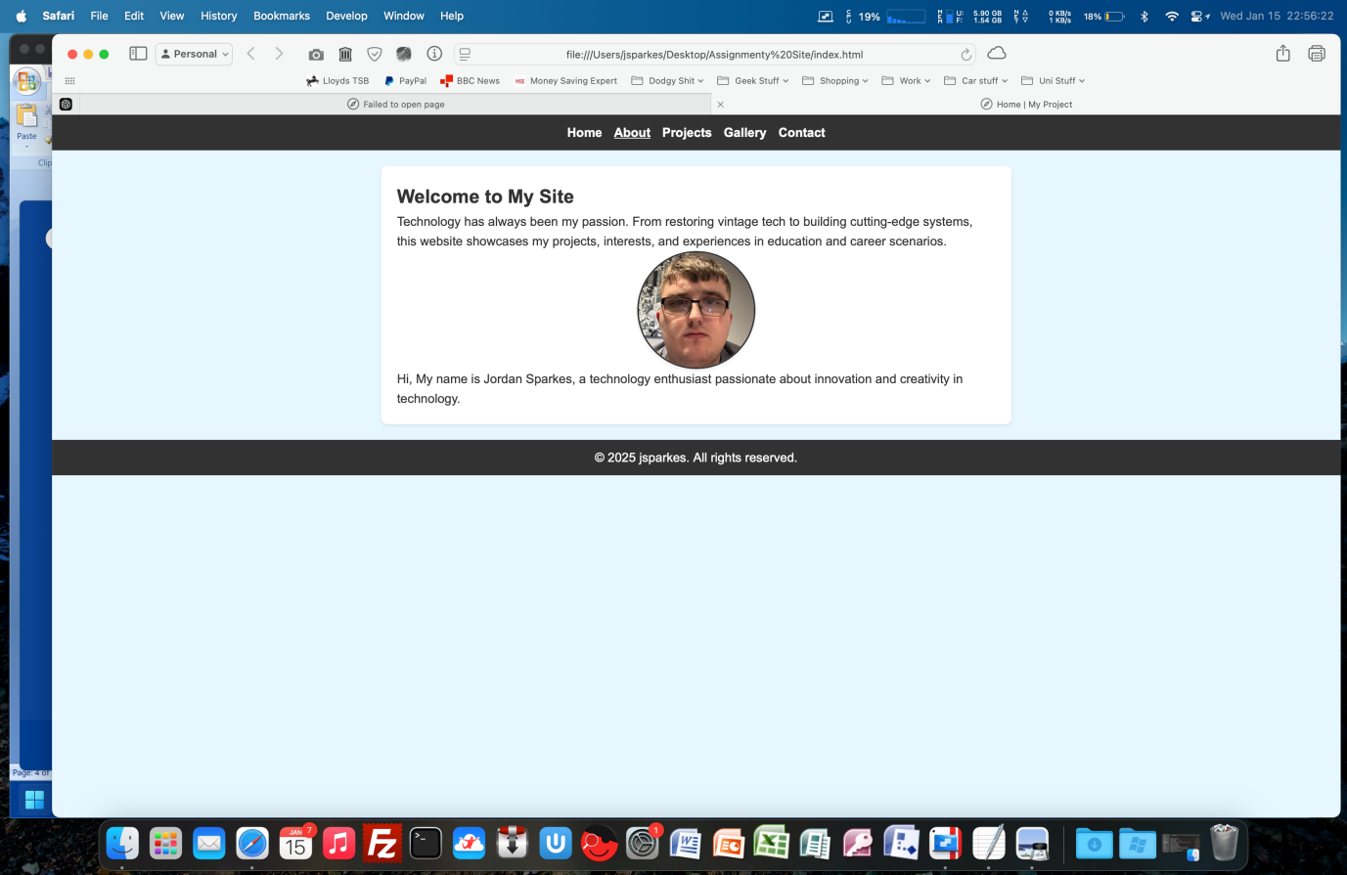
- About Page: Personal background in technology.
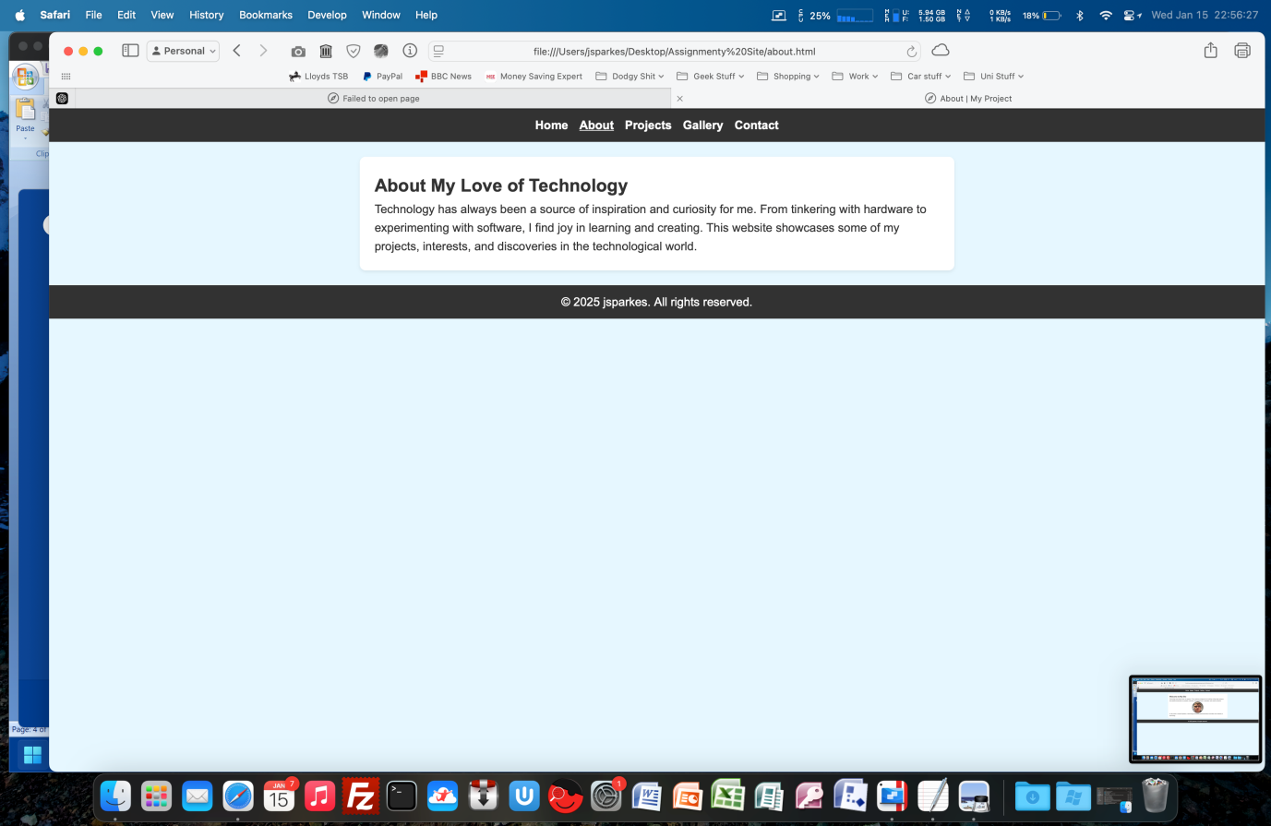
- Projects Page: Detailed descriptions of projects with images.
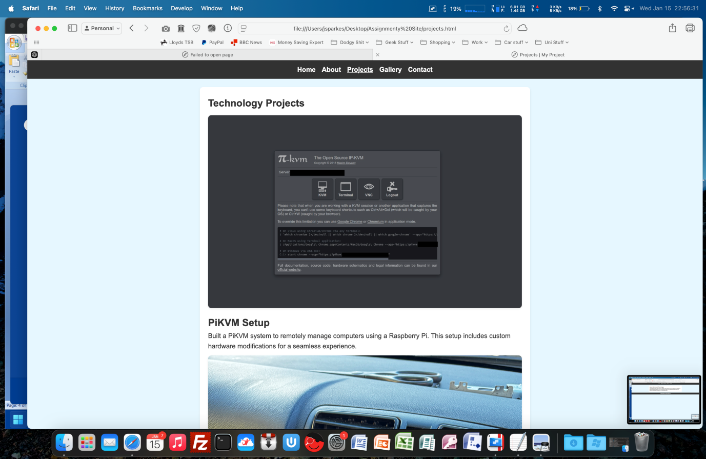
- Gallery Page: Highlights from my journey.
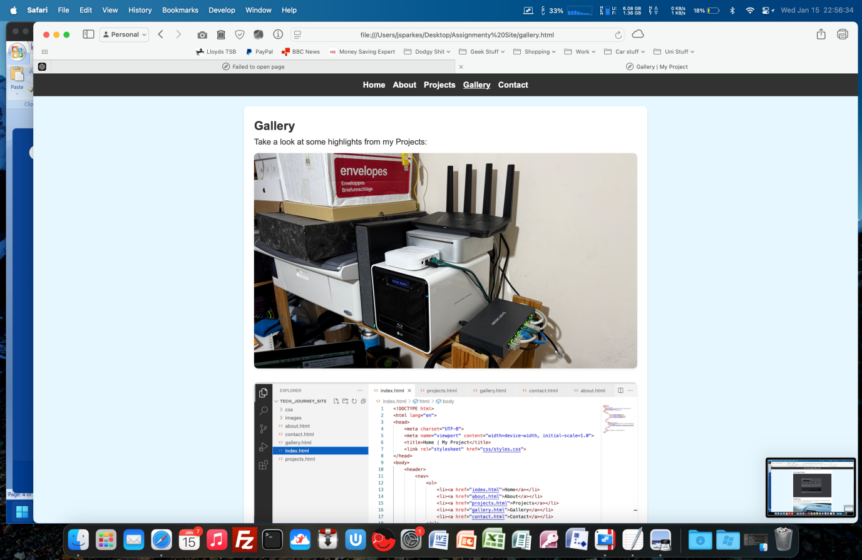
- Contact Page: Email, phone, and social media links.
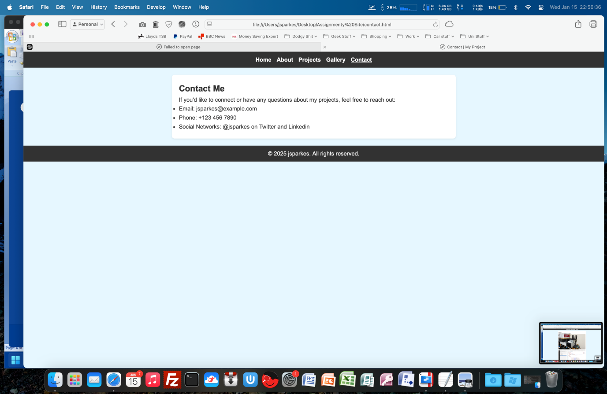

Code Structure
- HTML: Semantic structure with `<header>`, `<main>`, and `<footer>` tags.
- CSS: External stylesheet for consistent design.

Validation

HTML Validation
- Results: All pages passed validation with no errors. [1]
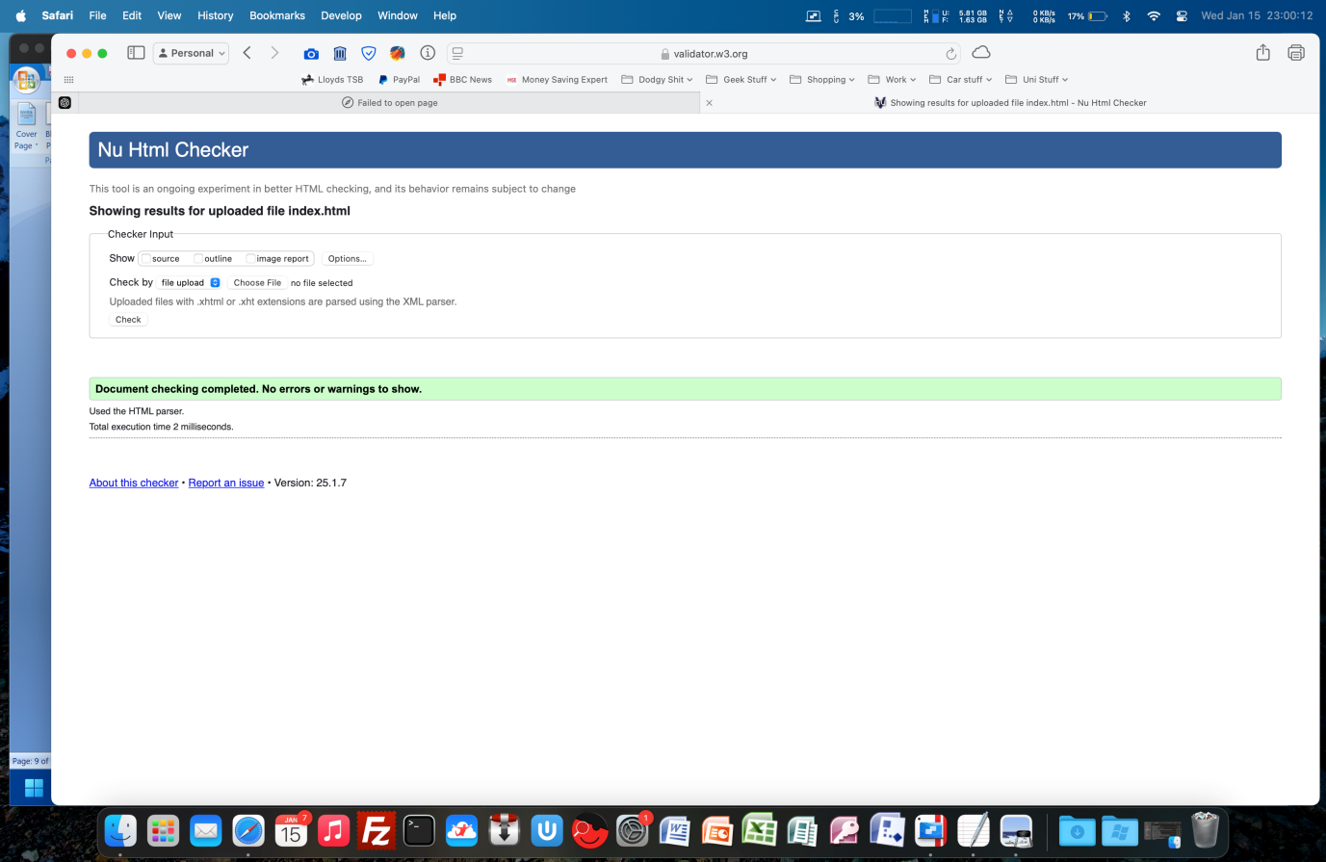

CSS Validation
- Results: Stylesheet validated successfully with no errors. [2]
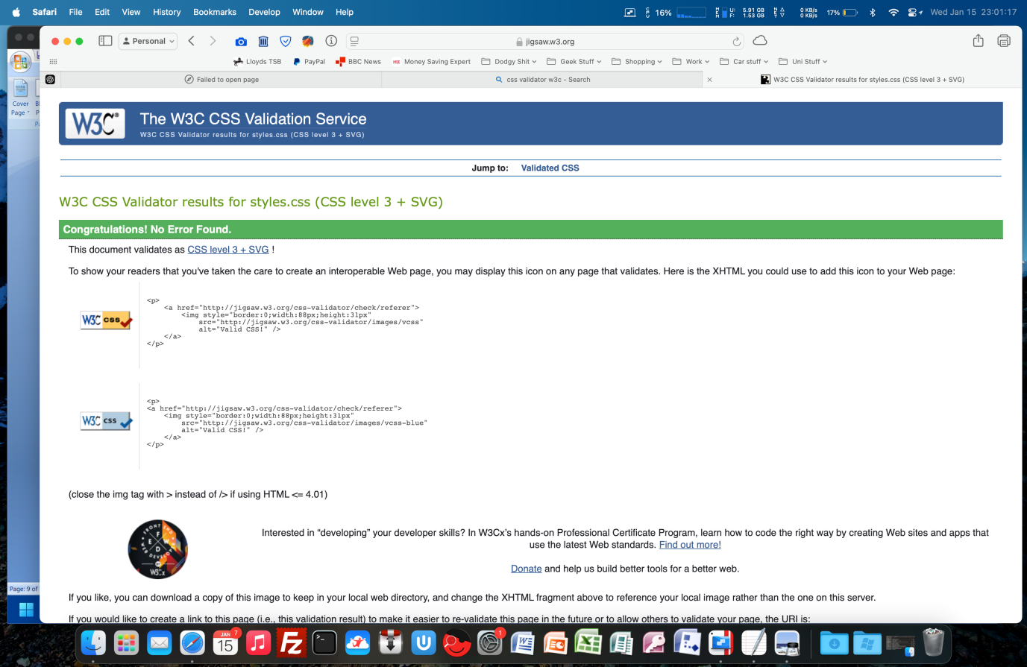

Evaluation
After careful review this site meets the requirements I outlined in my introduction by following what was instructed in the brief and does contain more the required five interlinked pages. These pages all contain multimedia. The site does also include an accessibility option; in this case it is alt text for each image used.
The design fulfils its purpose by containing all the relevant information to the topic such as ticket project information, images of the projects and a brief introduction of me which you would typically find on a website like this. This is can be backed up by feedback I was given from others who have said how well my site works.
As I said, this site contains all the requirements outlined in the brief I received and is a more than adequate solution for the job it is meant to perform. It does also go a slight bit further providing more features to ensure everything works well and is visually appealing to the target audience.

Usability
  - Simple navigation with a consistent menu.
  - Responsive design ensures usability on various devices.

Accessibility
  - WCAG 2.1 Compliance [3]
    - Perceivable: Alt text for images.
    - Operable: Keyboard-friendly navigation.
    - Understandable: Clear headings and labels.
    - Robust: Compatible with modern browsers.

SEO
  - On-page techniques applied:
  - Descriptive titles and meta descriptions.
  - Relevant alt text for images.
  - Semantic HTML structure.

References
[1] W3C, "HTML Validator," [Online]. Available: https://validator.w3.org. [Accessed: Jan. 2025].
[2] W3C, "CSS Validator," [Online]. Available: https://jigsaw.w3.org/css-validator. [Accessed: Jan. 2025].
[3] W3C, "Web Content Accessibility Guidelines (WCAG) 2.1," [Online]. Available: https://www.w3.org/TR/WCAG21/. [Accessed: Jan. 2025].
[4] J. Nielsen, "Usability Engineering," 1st ed., Academic Press, 1993.

Appendices

Index
<!DOCTYPE html>
<html lang="en">
<head>
<meta charset="UTF-8">
<meta name="viewport" content="width=device-width, initial-scale=1.0">
<title>Home | My Project</title>
<link rel="stylesheet" href="css/styles.css">
</head>
<body>
<header>
<nav>
<ul>
<li><a href="index.html">Home</a></li>
<li><a href="about.html">About</a></li>
<li><a href="projects.html">Projects</a></li>
<li><a href="gallery.html">Gallery</a></li>
<li><a href="contact.html">Contact</a></li>
</ul>
</nav>
</header>

<main>
<section>
<h1>Welcome to My Site</h1>
<p>Technology has always been my passion. From restoring vintage tech to building cutting-edge systems, this website showcases my projects, interests, and experiences in education and career scenarios.</p>
<div class="profile">
<img src="images/myself.jpg" alt="A picture of me" class="profile-img">
<p>Hi, My name is Jordan Sparkes, a technology enthusiast passionate about innovation and creativity in technology.</p>
</div>
</section>
</main>

<footer>
<p>&copy; 2025 jsparkes. All rights reserved.</p>
</footer>
</body>
</html>

About
<!DOCTYPE html>
<html lang="en">
<head>
<meta charset="UTF-8">
<meta name="viewport" content="width=device-width, initial-scale=1.0">
<title>About | My Project</title>
<link rel="stylesheet" href="css/styles.css">
</head>
<body>
<header>
<nav>
<ul>
<li><a href="index.html">Home</a></li>
<li><a href="about.html">About</a></li>
<li><a href="projects.html">Projects</a></li>
<li><a href="gallery.html">Gallery</a></li>
<li><a href="contact.html">Contact</a></li>
</ul>
</nav>
</header>

<main>
<section>
<h1>About My Love of Technology</h1>
<p>Technology has always been a source of inspiration and curiosity for me. From tinkering with hardware to experimenting with software, I find joy in learning and creating. This website showcases some of my projects, interests, and discoveries in the technological world.</p>
</section>
</main>

<footer>
<p>&copy; 2025 jsparkes. All rights reserved.</p>
</footer>
</body>
</html>

Projects
<!DOCTYPE html>
<html lang="en">
<head>
<meta charset="UTF-8">
<meta name="viewport" content="width=device-width, initial-scale=1.0">
<title>Projects | My Project</title>
<link rel="stylesheet" href="css/styles.css">
</head>
<body>
<header>
<nav>
<ul>
<li><a href="index.html">Home</a></li>
<li><a href="about.html">About</a></li>
<li><a href="projects.html">Projects</a></li>
<li><a href="gallery.html">Gallery</a></li>
<li><a href="contact.html">Contact</a></li>
</ul>
</nav>
</header>

<main>
<section>
<h1>Technology Projects</h1>

<article>
<img src="images/pikvm_project.jpg" alt="PiKVM Project">
<h2>PiKVM Setup</h2>
<p>Built a PiKVM system to remotely manage computers using a Raspberry Pi. This setup includes custom hardware modifications for a seamless experience.</p>
</article>

<article>
<img src="images/car_audio_overhaul.jpg" alt="Car Audio Overhaul">
<h2>Car Audio Overhaul</h2>
<p>Completely upgraded my car's audio system with new speakers, amplifiers, and a subwoofer for an enhanced listening experience. Integrated modern features into a legacy setup.</p>
</article>

<article>
<img src="images/vintage_mac_upgrade.jpg" alt="Vintage Mac Upgrade">
<h2>Vintage Mac Upgrades</h2>
<p>Restored and upgraded vintage Macintosh computers by adding SSDs and replacing outdated components. These upgrades breathed new life into iconic tech.</p>
</article>

<article>
<img src="images/analogue_tv_project.jpg" alt="Raspberry Pi Analogue TV Project">
<h2>Raspberry Pi Analogue TV Project</h2>
<p>Created a Raspberry Pi-based system to broadcast custom analogue TV channels to vintage TVs. This project combined modern tech with retro aesthetics.</p>
</article>
</section>
</main>

<footer>
<p>&copy; 2025 jsparkes. All rights reserved.</p>
</footer>
</body>
</html>

Gallery
<!DOCTYPE html>
<html lang="en">
<head>
<meta charset="UTF-8">
<meta name="viewport" content="width=device-width, initial-scale=1.0">
<title>Projects | My Project</title>
<link rel="stylesheet" href="css/styles.css">
</head>
<body>
<header>
<nav>
<ul>
<li><a href="index.html">Home</a></li>
<li><a href="about.html">About</a></li>
<li><a href="projects.html">Projects</a></li>
<li><a href="gallery.html">Gallery</a></li>
<li><a href="contact.html">Contact</a></li>
</ul>
</nav>
</header>

<main>
<section>
<h1>Technology Projects</h1>

<article>
<img src="images/pikvm_project.jpg" alt="PiKVM Project">
<h2>PiKVM Setup</h2>
<p>Built a PiKVM system to remotely manage computers using a Raspberry Pi. This setup includes custom hardware modifications for a seamless experience.</p>
</article>

<article>
<img src="images/car_audio_overhaul.jpg" alt="Car Audio Overhaul">
<h2>Car Audio Overhaul</h2>
<p>Completely upgraded my car's audio system with new speakers, amplifiers, and a subwoofer for an enhanced listening experience. Integrated modern features into a legacy setup.</p>
</article>

<article>
<img src="images/vintage_mac_upgrade.jpg" alt="Vintage Mac Upgrade">
<h2>Vintage Mac Upgrades</h2>
<p>Restored and upgraded vintage Macintosh computers by adding SSDs and replacing outdated components. These upgrades breathed new life into iconic tech.</p>
</article>

<article>
<img src="images/analogue_tv_project.jpg" alt="Raspberry Pi Analogue TV Project">
<h2>Raspberry Pi Analogue TV Project</h2>
<p>Created a Raspberry Pi-based system to broadcast custom analogue TV channels to vintage TVs. This project combined modern tech with retro aesthetics.</p>
</article>
</section>
</main>

<footer>
<p>&copy; 2025 jsparkes. All rights reserved.</p>
</footer>
</body>
</html>

Contact
<!DOCTYPE html>
<html lang="en">
<head>
<meta charset="UTF-8">
<meta name="viewport" content="width=device-width, initial-scale=1.0">
<title>Projects | My Project</title>
<link rel="stylesheet" href="css/styles.css">
</head>
<body>
<header>
<nav>
<ul>
<li><a href="index.html">Home</a></li>
<li><a href="about.html">About</a></li>
<li><a href="projects.html">Projects</a></li>
<li><a href="gallery.html">Gallery</a></li>
<li><a href="contact.html">Contact</a></li>
</ul>
</nav>
</header>

<main>
<section>
<h1>Technology Projects</h1>

<article>
<img src="images/pikvm_project.jpg" alt="PiKVM Project">
<h2>PiKVM Setup</h2>
<p>Built a PiKVM system to remotely manage computers using a Raspberry Pi. This setup includes custom hardware modifications for a seamless experience.</p>
</article>

<article>
<img src="images/car_audio_overhaul.jpg" alt="Car Audio Overhaul">
<h2>Car Audio Overhaul</h2>
<p>Completely upgraded my car's audio system with new speakers, amplifiers, and a subwoofer for an enhanced listening experience. Integrated modern features into a legacy setup.</p>
</article>

<article>
<img src="images/vintage_mac_upgrade.jpg" alt="Vintage Mac Upgrade">
<h2>Vintage Mac Upgrades</h2>
<p>Restored and upgraded vintage Macintosh computers by adding SSDs and replacing outdated components. These upgrades breathed new life into iconic tech.</p>
</article>

<article>
<img src="images/analogue_tv_project.jpg" alt="Raspberry Pi Analogue TV Project">
<h2>Raspberry Pi Analogue TV Project</h2>
<p>Created a Raspberry Pi-based system to broadcast custom analogue TV channels to vintage TVs. This project combined modern tech with retro aesthetics.</p>
</article>
</section>
</main>

<footer>
<p>&copy; 2025 jsparkes. All rights reserved.</p>
</footer>
</body>
</html>

CSS
* {
margin: 0;
padding: 0;
box-sizing: border-box;
}

body {
font-family: Arial, sans-serif;
line-height: 1.6;
color: #333;
background-color: #e6f7ff; /* Light blue background */
margin: 0;
}

header {
background: #333;
color: #fff;
padding: 10px 0;
text-align: center;
}

header nav ul {
list-style: none;
display: flex;
justify-content: center;
gap: 15px;
}

header nav ul li a {
color: #fff;
text-decoration: none;
font-weight: bold;
}

header nav ul li a:hover {
text-decoration: underline;
}

main {
padding: 20px;
background: #fff;
max-width: 800px;
margin: 20px auto;
border-radius: 8px;
box-shadow: 0 2px 5px rgba(0, 0, 0, 0.1);
}

footer {
text-align: center;
padding: 10px 0;
background: #333;
color: #fff;
margin-top: 20px;
}

.profile-img {
display: block;
margin: 0 auto;
border-radius: 50%;
max-width: 150px;
height: auto;
object-fit: cover;
border: 2px solid #333;
}

img {
max-width: 100%;
height: auto;
border-radius: 8px;
margin: 10px 0;
box-shadow: 0 2px 5px rgba(0, 0, 0, 0.1);
}

