The Dairy Farming Industry

This assignment will investigate how one of the problems of the dairy industry has found several solutions to negate the pollutant of too much nitrate from animal waste being found in water sources. It will concentrate on Welsh Government initiatives and those found through innovative recent technology.
Agriculture practices have the potential to harm the environment through mass pollution. It can also put rural communities, food safety, and animal welfare at risk. Although there may be differences of opinion on specific concerns and possible solutions, it is commonly acknowledged that public participation is required in the development of socially sustainable agriculture systems. (Cardoso, C. S., Hötzel, M. J., Weary, D. M., Robbins, J. A., & von Keyserlingk, M. A., 2016)
Slurry is a mixture of manure and water that is slowly broken down by microbes over time. Gases such as methane, carbon monoxide, ammonia, and hydrogen sulphide are created as a result of these reactions (Searle A, 2016). Wang et al. (2021) discuss how anthropogenic livestock production produces a vast amount of nitrogen related gases released into the atmosphere. Slurry, in particular, is responsible for 60 % of anthropogenic ammonia emissions and can, in severe cases, lead to eutrophication of the soil and harmful runoff into rivers and estuaries (Wang et al., 2021). However, these emissions can be significantly reduced by creating lower temperature environments (<15 degrees) to let these materials decompose.
Large amounts of collected animal excreta come from regular livestock cultivation practices. If not properly handled, farm wastes such as cattle slurry, livestock manure, and silage effluent can cause substantial water pollution. These wastes can be used as helpful crop fertilisers with minor damage to the environment if they are appropriately managed (Fact file, 2022).
There are two types of water contamination that can result from farming: point source and diffuse. Point source contamination occurs when a water channel has been contaminated by a single source, such as a slurry tank, silage clamp, farmyard, or building. Slurry, silage effluent, dirty yard water, oil, and agrochemicals are examples of point sources that can contaminate stream and river life(Fact file, 2022). Nutrients such as nitrates and phosphates from animal manure and fertilisers leak from farmland to surrounding waterways, causing diffuse pollution (Harrison et al., 2019). Agriculture-related diffuse pollution is a significant difficulty for governments attempting to implement the European Union's Water Framework Directive (WFD). How to best integrate and align effective strategies for managing diffuse pollution within the context of the EU's multilevel governance structure remains an outstanding subject in the study field. (De Vito, L., Fairbrother, M., & Russel, D. 2020).
According to Tang et al. (2020), slurry is an excellent natural fertiliser made from cow manure and water that farmers may use to boost the development of grass and other crops and recycle essential nutrients back into the land. This is Dairy (2020) shows how bacterial action breaks down the slurry, releasing gases. Methane, carbon monoxide, ammonia, and hydrogen sulphide are all components of slurry gas, and they all pose a health risk to humans and animals. Some gases are combustible, while others are poisonous and will remove oxygen from the air, putting people at risk of asphyxiation. Nausea, dizziness, unconsciousness, and death are all symptoms of hydrogen sulphide poisoning. Any steps taken to reduce hydrogen sulphide exposure will help protect you from the effects of any other gases present. (Health and safety, 2022)
Significant amounts of nitrogen are lost during and after the spreading of slurry and digestate. This nitrogen can be released into the atmosphere as ammonia and nitrous oxide or by nitrate leaching. The ammonium in the slurry and digestate is converted to nitrate depending on post-application environmental factors such as temperature, soil moisture, and soil characteristics. Because nitrate is mobile in soil, it can quickly travel to lower soil layers and hence into groundwater (Basf, 2020)
In 2015 according to (Searle A. 2016), the Department for Food and Rural Affairs (DEFRA) published a cross-compliance guide for England. The document relates to different soil types and gives information and guidance for claimants who are engaged in certain activities throughout the year. For example, if a farmer follows the SMR1 guidelines, he/she can apply organic-rich manure (slurry) in January and February, with August, September, and October designated as the "start of the closed season" for slurry application.
Slurry spreading must also adhere to guidelines such as the Code of Good Agricultural Practice (COGAP), which states that the use of slurry as a fertiliser is prohibited in the following circumstances:
- Soil ground is saturated
- Soil ground is completely frozen
- Grounds are snow-covered
- Ground has been cracked down to field sewers that keep filling
- Within the next 48 hours, severe rain is expected.
(Searle. A, 2016) states, manure or slurry should never be applied within 10 metres of any ditch, pond, or surface water, within 50 metres of any spring, well, downhole, or water storage that supplies water for human consumption or agricultural dairy farms, on very steep hills where runoff is a serious risk during the year, or on any areas where you are not allowed to due to specific management agreements, according to the COGAP.
Our streams are dying across the world as a result of increasingly severe algae blooms carried through natural flow out to sea, causing eutrophication of marine environments. This rapid development of algae blocks light, preventing aquatic vegetation from sprouting, and depletes oxygen levels in the water, killing fish and insects. Eutrophication is the term for this process, which can be harmful to both animals and people (Bol et al., 2018). This process has been described as an increasingly concerning problem resulting from human activity and in need of urgent action to reduce the effect that Nitrogen runoff is having on aquatic environments (Bol et al., 2018), but also including the ocean, where all rivers output much of this nutrient runoff (Desmit et al., 2018).
Algal blooms are fuelled by nutrients like phosphorus and nitrogen, which can be found in animal manure and fertilisers used to improve agricultural productivity and feed the world's billions of farmed animals. When these nutrients end up in waterways, they have disastrous repercussions. This is happening across the world - in the UK, the US, India, Ireland, New Zealand, and wherever elsewhere, there is significant dairy production. Dairy and other animal farms are poisoning the waterways (Veganuary, 2022).
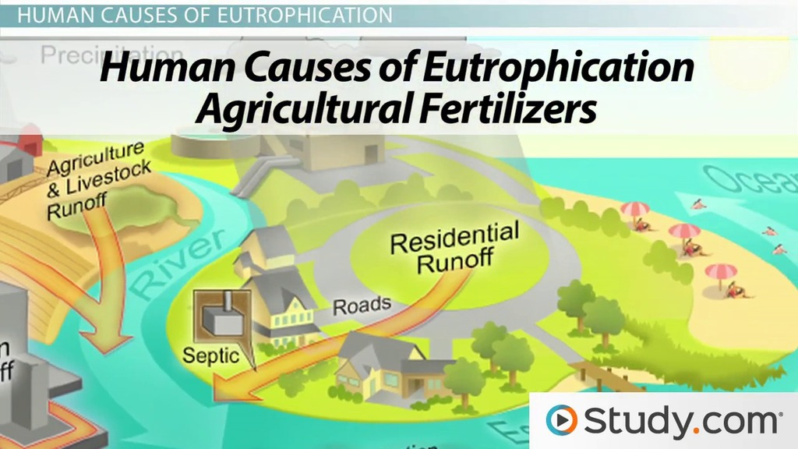
Figure 1 explanation of eutrophication (2021)
Artificial fertilisers are a big problem in agriculture, granular nitrate-containing chemical fertilisers are applied to crops to aid growth, but they can also be washed away by rain into surrounding ponds and waterways (ScienceDirect Topics, 2017). They do not directly harm wildlife, but the abundant nitrogen allows aquatic plants, mainly algae, to flourish rapidly. During the night and the decomposing processes, the plants consume so much oxygen that none is available for the other pond species (Chislock et al., 2013). Additionally, the growth blocks sunlight from reaching the creatures below. All the algae eventually die, leaving a stinky, decomposing mass behind. Eutrophication is when there are too many nitrates in the water (Chislock et al., 2013).
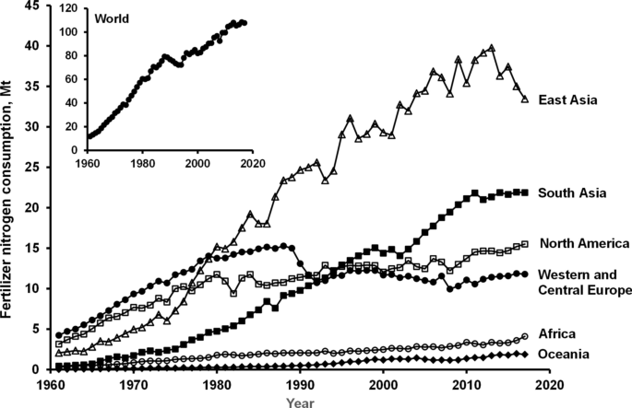
Figure 2 graph
In Wales, there are many nitrate vulnerable zones (NVZ) that impact rivers and lakes around Wales. The Welsh Government has set out rules which impact farmers. An NVZ was established on 2.4 per cent of Wales’s territory. In effect, this means a restriction on the use of slurry and fertiliser on farmland in Wales. Still, farmers claim it will have a particularly negative impact on dairy farms, forcing some to close permanently. (Wales Online, 2022)
Farmers will be required to upgrade slurry storage facilities, farms will be required to have at least five months' worth of slurry storage, and a three-month ban on slurry spreading will be imposed every autumn to prevent runoff from fields during wet months, according to the rules (Wales online, 2022)
Y BydarBedwar discovered over 600 incidences of agricultural contamination in Welsh waterways in 2017 after submitting a Freedom of Information request to Natural Resources Wales, the organisation responsible for protecting natural resources such as rivers. Slurry was to blame for nearly half of them. According to the Freedom of Information request, Carmarthenshire has had the most significant number of agricultural pollution events in Wales during the last four years, accounting for 20% of all occurrences in the country. (ITV, 2021)
There could be detrimental effects on the farming industry as these rules take effect, as the cost of upgrading the slurry storage containers will take a massive hit on each dairy farm. The ban for three months of the year will also create a problem for farms as they need the clean the pallets down twice a day to be able to milk the cow in a hygienic area to reduce the contamination when withdrawing milk from the cow.
Without dairy farms, we would not have milk, cheese, yoghurts, and other basic dairy products. The need for milk has grown over the years, which has forced farmers to breed more cows to be able to provide milk by the bulk load, for supermarkets, corner shops, butchers and market stalls or even to transport out of the country as dairy products have become a necessity for humans to consume for bone and teeth health and for developing children and toddlers.
If Carmarthenshire farmers had been penalised, it would have solved or decreased the problem rather than forcing others to pay the price when there was no need. (ITV, 2021)
There have only been two prosecutions for agricultural contamination in Welsh waterways since 2017. Natural Resources Wales conducted enforcement action, issuing cautions, warnings, civil sanctions, notifications, or advice and guidance. Two of the cases are still pending. (ITV, 2021) According to Farmers Weekly (2021), a farmer in Somerset was fined £37,184.00 for two accounts of water pollution causing harm to the environment.
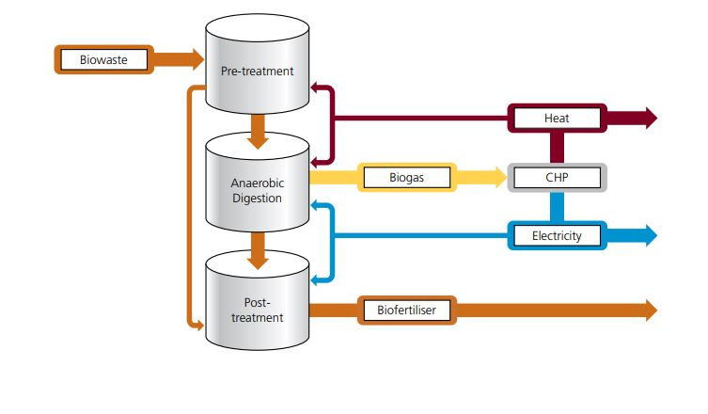
Figure3How a biowaste system works (2022)

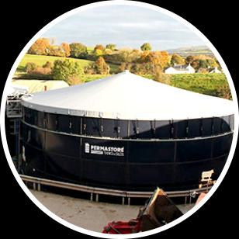
Figure 4 Slurry Storage with Cover (2021)
Anaerobic digestion, according to several witnesses, could be a means to cope with agricultural and food waste while also reducing nitrate and other nutrient pollutants. Anaerobic digestion (AD) is a process that breaks down organic matter like animal or food waste to produce biogas and biofertiliser. An anaerobic digester is a sealed, oxygen-free tank where this process takes place in the absence of oxygen. The procedure creates a nutrient-rich digestate or bio-fertiliser that can be pasteurised to eliminate germs before being kept in big, covered tanks to be applied twice a year on fields in place of commercial fertilisers (UK progress, 2017). According to the Nitrates Directive, (2015), farmers who plan to keep slurry or anaerobic digestate fibre in their fields should contact the NIEA's Agricultural Regulation Team first. Slurry and anaerobic digestate fibre can only be held in field heaps for a maximum of 120 days in the field before being applied, and they must be covered with an impermeable membrane within 24 hours after being placed in the field.
However,(Font-Palma. C,2019) states that for manure management, anaerobic digestion is mostly used in Europe. The advantages are that biogas is produced and can be used to generate energy. Biogas usually contains 53–70 percent CH4 and 30–47 percent CO2 and other contaminants. The pH, temperature, type of the feedstock (e.g., composition and nutrients), presence of hazardous or inhibitory compounds, and organic loading rate all affect anaerobic digestion. Microorganisms need carbon and nitrogen to grow in AD(Font-Palma. C,2019).
It is important that solutions are found to the problem of slurry dispersal as the UK Government would like to have liquid milk food security as it is a staple food for many households, including products made from it such as cheese and yoghurt. Farmers in NVZs may incur costs to comply with the Nitrates Directive, such as investments in slurry storage facilities; nevertheless, there is presently support available to farmers. Through Farming Connect, qualified farmers can get 80% funding for nutrient management planning and advice on the NVZ Regulations under the Rural Development Plan (RDP) for Wales (2014-2020). The RDP Sustainable Production Grant Scheme provides financial assistance to increase resources and company efficiency (Nitrate pollution Wales, 2022).

The Welsh Government has been quick to fine farmers who break the rules of spreading slurry, but this is only a partial method of solving the problem. Farmers are now investing in better slurry containers and are adhering to forthcoming legislation on Nitrate Vulnerable Zones in Wales (Wales Regulations, 2021). There is still much debate over these zones, put in place to protect natural waterways and rivers throughout Wales. The NVZ regulations are to be replaced by the Water Resources (Control of Agricultural Pollution) (Wales) Regulations 2021. Farmers must follow the Water Resources Act to the letter. The Agricultural Pollution Control (Wales) Regulations 2021 came into effect on April 1, 2021 (Wales regulations, 2021).
Slurry will always be needed to act as a fertiliser, but overuse can be detrimental. However, farmers are under constant pressure to produce more milk for a growing population and to meet market demands, all while being pressured to maintain the farm gate price of liquid milk at a comparatively low price. Grants are becoming available for the installation of better storage of slurry, so it is only spread in the months allowed under new Welsh Government regulations. Under these new guidelines (Wales Regulations, 2021), the spreading of slurry is prohibited on grassland from September 15 to January 15 and on tillage land from September 1 to January 15; this will cause issues for farmers (Wales regulations, 2021).
Farmers in NVZs may incur costs to comply with the Nitrates Directive, such as investments in slurry storage facilities; nevertheless, there is presently support available to farmers. Through Farming Connect, qualified farmers can get 80% funding for nutrient management planning and advice on the NVZ Regulations under the Rural Development Plan (RDP) for Wales (2014-2020). The RDP Sustainable Production Grant Scheme provides financial assistance to increase resource and company efficiency (Nitrate pollution Wales, 2022).

The best solution for finding a way forward is that investment is made in anaerobic digesters, which have a dual fold action involving ultra filtration of slurry (Zeng et al., 2022). They remove many of these small molecule pollutants so, preventing water pollution whilst obtaining biomass fuel for heating and electricity (Triolo et al., 2013). In these times of fuel price hikes and global warming, there is a move away from fossil fuels toward renewable sources, and biomass boilers may play a role in this (Saidur et al., 2011; Malico et al., 2019).

To conclude, pollution in waterways and rivers from nitrates in slurry is causing a problem and harming oxygen levels within rivers, causing fish and other water animals harm. This additional nitrogen can cause the overgrowth of vegetation and algae and reduce bioavailable oxygen levels for aquatic life. Some of these algal blooms are toxic and harmful to living organisms polluting drinking water supplies. In Wales, there are numerous nitrate vulnerable zones known to be affected negatively by agricultural runoff and resulting nitrification, prompting the Welsh government to take drastic action on farming to help reduce pollution levels.
The Welsh Government aims to do this by setting out strict rules and harsh fines if farmers do not comply and cause harm to the environment. To assist in nitrogen safety, they are willing to provide grants and financial help to build better storage containers for slurry, especially during the months that the spreading of slurry is prohibited. Anaerobic digesters could be a solution for reducing slurry spreading as gas produced can provide heating and electricity, which creates a recycled use for agricultural waste and reduces costly bills from traditional sources of energy that are dwindling. Further to this, with processing is in place, ultra filtration at one stage of the processing operation can further mitigate against nitrogen from slurry being put into the environment, improving the sustainability of farming and providing another source of renewable energy.

References
The Water Resources (Control of Agricultural Pollution) (Wales) Regulations 2021 Guidance for Farmers and Land Managers. (n.d.). https://gov.wales/sites/default/files/publications/2021-03/water-resources-control-of-agricultural-pollution-wales-regulations-2021-guidance-for-farmers-and-landmanagers.pdf

‌Zeng, W., Qiu, J., Wang, D., Wu, Z., & He, L. (2022). Ultrafiltration concentrated biogas slurry can reduce the organic pollution of groundwater in fertigation. Science of The Total Environment, 810, 151294.

‘You can’t sleep – it’s a constant worry’ Farmers plea to Welsh Government to rethink agricultural pollution rules | ITV News Wales

Bol, R., Gruau, G., Mellander, P. E., Dupas, R., Bechmann, M., Skarbøvik, E., ... &Gascuel-Odoux, C. (2018). Challenges of reducing phosphorus based water eutrophication in the agricultural landscapes of Northwest Europe. Frontiers in Marine Science, 276.

Cardoso, C. S., Hötzel, M. J., Weary, D. M., Robbins, J. A., & von Keyserlingk, M. A. (2016). Imagining the ideal dairy farm. Journal of Dairy Science, 99(2), 1663-1671.

Chislock, M. F., Doster, E., Zitomer, R. A. & Wilson, A. E. (2013) Eutrophication: Causes, Consequences, and Controls in Aquatic Ecosystems. Nature Education Knowledge 4(4):10

DAERAhttps://www.daerani.gov.uk/articles/nitratesdirective#:~:text=The%20Nitrates%20Directive%20(91%2F676

De Vito, L., Fairbrother, M., & Russel, D. (2020). Implementing the Water Framework Directive and tackling diffuse pollution from agriculture: Lessons from England and Scotland. Water, 12(1), 244.

Desmit, X., Thieu, V., Billen, G., Campuzano, F., Dulière, V., Garnier, J., ... & Lacroix, G. (2018). Reducing marine eutrophication may require a paradigmatic change. Science of the Total Environment, 635, 1444-1466.

Environmental Impact of Dairy Farming | Is Dairy Good for the Planet? (veganuary.com)

Font-Palma, C. (2019). Methods for the treatment of cattle manure—a review. C, 5(2), 27.

Harrison, S., McAree, C., Mulville, W., & Sullivan, T. (2019). The problem of agricultural ‘diffuse’pollution: Getting to the point. Science of the Total Environment, 677, 700-717.

Health and Safety Executive Health and Safety Executive Agriculture Information Sheet No 9 (Revision 2) Managing slurry on farms. (n.d.). Retrieved March 17, 2022, from https://www.hse.gov.uk/pubns/ais9.pdf?msclkid=63b43e18a61711ecbc2f3701594dc212
https://attachments.office.net/owa/1910397%40student.uwtsd.ac.uk/service.svc/s/GetAttachmentThumbnail?id
https://attachments.office.net/owa/1910397%40student.uwtsd.ac.uk/service.svc/s/GetAttachmentThumbnail
https://attachments.office.net/owa/1910397%40student.uwtsd.ac.uk/service.svc/s/GetAttachmentThumbnail?id
https://publications.parliament.uk/pa/cm201719/cmselect/cmenvaud/656/65607.htm
Leading dairy farmer fined £29,000 for pollution offences - Farmers Weekly (fwi.co.uk)
Malico, I., Pereira, R. N., Gonçalves, A. C., & Sousa, A. M. (2019). Current status and future perspectives for energy production from solid biomass in the European industry. Renewable and Sustainable Energy Reviews, 112, 960-977.
McGregor, A., Rickards, L., Houston, D., Goodman, M. K., &Bojovic, M. (2021). The biopolitics of cattle methane emissions reduction: governing life in a time of climate change. Antipode, 53(4), 1161-1185.
Nitrates Directive | Department of Agriculture, Environment and Rural Affairs. (2015, August 18).
‌Pollution and Farm Waste GCSE FACT FILE Agriculture and Land Use. (n.d.). Retrieved March 17, 2022, from https://ccea.org.uk/downloads/docs/Support/Fact%20File%3A%20Unit%202/2020/Agriculture%20Pollution%20and%20Farm%20Waste.pdf?msclkid=63b4bff6a61711ec95434527097d1758
Pollution regulations threaten to 'cripple' Welsh farming, industry warns - Wales Online
Publications.parliament.uk.
‌Saidur, R., Abdelaziz, E. A., Demirbas, A., Hossain, M. S., &Mekhilef, S. (2011). A review on biomass as a fuel for boilers. Renewable and sustainable energy reviews, 15(5), 2262-2289.
Sciencedirect topics. (2017)Nitrate Fertilisers - an overview. Sciencedirect.com. https://www.sciencedirect.com/topics/agricultural-and-biological-sciences/nitrate-fertilizers
Searle. A, Environmental Impacts of Agricultural Land Use. (2016, April 18). Groundsure. https://www.groundsure.com/resources/environmental-impacts-agricultural-land-use/#:~:text=Typical%20environmental%20impacts%20associated%20with%20the%20improper%20storage
Tackling Nitrate Pollution in Wales. (n.d.). Research.senedd.wales. Retrieved March 30, 2022, from https://research.senedd.wales/research-articles/tackling-nitrate-pollution-in-wales/?msclkid=32121526b06511ecac4ffabb0458709b
Tang, Y., Wang, L., Carswell, A., Misselbrook, T., Shen, J., & Han, J. (2020). Fate and transfer of heavy metals following repeated biogas slurry application in a rice-wheat crop rotation. Journal of Environmental Management, 270, 110938.
Triolo, J. M., Ward, A. J., Pedersen, L., & Sommer, S. G. (2013). Characteristics of animal slurry as a key biomass for biogas production in Denmark. Biomass Now-Sustainable Growth and Use, 307-326.
UK Progress(2017) on Reducing Nitrate Pollution - Environmental Audit Committee - House ofCommons. (n.d.).
Vizura_Brochure_FV_Dec2020 (basf.co.uk)
Wang, Y., Zhu, Z., Li, X., Yang, J., Liang, L., Sui, Q., ... & Dong, H. (2021). NH3, N2O, and NO emissions from digested pig slurry stored under different temperatures: Characteristics and microbial mechanisms. Journal of Cleaner Production, 319, 128560.
What is slurry? (thisisdairyfarming.com)

‌

