Jae Morris 2112933

A Practitioners Guide to a Smooth Start at School


(Mas and Pas)
Rationale
The Needs of the Child
Introduction
Interventions
P8
P8-9
P4 - 7
P3
P3
The Role of the Adult
5
4
3
2
1

Rationale

This handbook has been created to help with the preparation for nursery teachers, and other practitioners, in the setting to provide the transition of children starting nursery at ease.
A huge part of a child’s life is when they start school for the first time, usually between the ages of 3 and 5. It can be a very exciting time for both the child and their parents but also a very nervous and anxious time for them both too. This is why it is vitally important to ensure that this transition goes as smoothly as it possibly can for everyone involved.
This handbook will explain what a transition is and the importance of it. It will also discuss the needs of the child and what is important to them during the transition. After discussing the needs of the child, the handbook will then go on to give information on the role of the adult, both practitioners and parents. Different types of attachments will also be discussed along with theorists and their theories.

Introduction

Merriam Webster dictionary states that transition is a form of change. It is a change from one thing to another whether it is an action or state of being.
Even though stability is vitally important in a child’s life, transitions are an unavoidable process, which will happen several times during their early years.
Transitions in early years could involve a child starting in a setting for the first time, whether it is in a school or in a childcare setting. A child goes also through transition when they are moving up a school year, for example from year 1 to year 2. There are many other transitions that children go through throughout their life such as moving house, having a new baby brother or sister, separation of parents.
Every child will experience transitions at some point in their lives and it is a vital process that involves exciting changes for the child providing new opportunities and growth. Elizabeth Walker (2019) explains that research suggests that a child experiencing transition is a central part of their development and the way a child will cope with change in the future will depend on how the first transitions in their early life were handled. This is the reason why it is very important to ensure that children’s needs are fully met during their first experiences of transitions.

The Needs of the Child

Understanding that each child is unique is crucial to meeting their requirements and needs. A child starting school for the first time is a very emotional process for both the child and their family, which is why it is extremely important that the child’s needs are met accordingly.
It's critical to understand that not all children will respond to methods in the same manner. Some children will be more distressed and challenged by the process than others. Children with higher emotional demands must be given more attention. Toxic stress accumulates over time and can be harmful to a child's welfare, coping skills, and general health. It's critical to engage with these young people, communicate with their parents, focus on how and why they are distressed, and provide further help. (Harvard University)

Maslow’s Hierarchy of Needs is a theory that is psychological and motivational. It consists of a five-tier model of human wants, which is sometimes shown as hierarchical tiers within a pyramid. The bottom tier of the pyramid shows the basic physical needs that everyone requires which are food, water, sleep and warmth. Individuals can then move to the next stage of requirements which are for safety and security, once the lower-level demands have been recognised and addressed. As people move up the pyramid, the importance of their psychological and social requirements increases. As the time passes, love, companionship, and intimacy become increasingly crucial. Maslow's hierarchy of needs has an advantage of providing a clear insight into human nature; yet, it also has a disadvantage: it fails to account for individual differences in terms of culture or social status.

When there are strong relationships between the family and practitioner it creates a more positive experience for the child, as they will feel safe and secure. It is common for both child and parents to experience separation anxiety at this stage in a child’s life therefore a strong relationship between the parent and teacher can have a beneficial impact on the process.
The personal esteem and emotions of accomplishment for people become more important as they advance up the pyramid. Maslow highlighted the necessity of self-actualisation, which is the process of a person’s growth and development in order to reach their full potential.

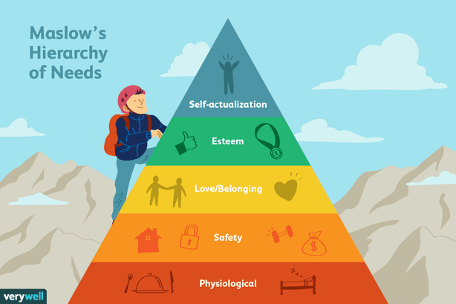
(Seong, J. 2021).

The Foundation Phase Framework
The Foundation Phase Framework emphasises the seven learning outcomes for children and promotes the development of strong relationships between home and childcare. To accomplish outcomes in the following categories, the child requires a diversity of play opportunities:
- Personal and Social Development
- Cultural Diversity and Well-Being
- Language, Literacy and Communication
- Mathematical Development
- Welsh Language Development
- Knowledge and Understanding of the World
- Creative Development.

A vital aspect of the transition process is play, and the United Nations Convention on the Rights of the Child protects the child's right to play. Play can be initiated by both children and adults, with healthy interaction between the child and the practitioner. Piaget (1951), Vygotsky (1978), and Bruner (1974) were all influential in establishing today's educational procedures. (Maynard and Thomas 2004)

Attachment
John Bowlby was the first theorist to explore attachment, describing it as a “lasting psychological connectedness between human beings.” (Simple Psychology 2017). He focused on the anxiety and discomfort of the child when they were being separated from their parents/caregivers. Although there are many theorists to say that attachment is a process that is learned, Bowlby agrees with the opposite and that children are born with a natural desire to create attachments. He also concluded that children who struggled emotionally in their early years typically went on to experience behavioural, psychological and mental struggles in their later life. Bowlby highlights that if attachment hasn’t form in the first 2.5 years of a child’s life then it will not occur at all, he called this time the critical period. From Bowbly’s findings, he concluded that when the secure relationship that a child has created with their parents or carer gets broken it will cause distress rapidly and a possible potential for psychological damage in the long-term.
With many strengths to Bowlbys theory, there are also weaknesses. For example, Bowlby focuses on the mother figure where correspondent to many psychologists, all attachment figures are equally essential. According to research, secondary bonds to a father or their siblings can help with sensitivity and emotional adjustment. Fathers have an important influence in their children's development. (Grossman and Grossman 2002)
Simply Psychology states how Bowlby was influenced by Lorenz’s theory of imprinting. Lorenz believed that attachment is innate and that animals form their attachment with the first large moving object that they see. Lorenz carried out an investigation to prove his beliefs. He had several goose eggs and placed half under the mother and the remaining half in an incubator ensuring that the first moving object that they would see would be himself. After the geese in the incubator had hatched, they looked at Lorenz as if he was their mother, after him imitating a mother duck as they hatched. This implies that attachment is present from birth.
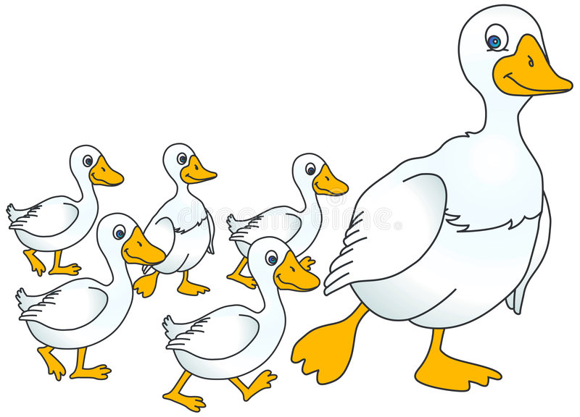
(Tonybilge)

In her now-famous "Strange Situation" study from the 1970s, psychologist Mary Ainsworth extended on Bowlby's revolutionary work. The research entailed watching how young children aged 12 to 18 months reacted as a result to being left alone for a short time before being reunited with their mother.
Ainsworth believed that there were three basic forms of attachment based on his observations: secure attachment, ambivalent-insecure attachment, and avoidant-insecure attachment. Disorganised-insecure attachment was established as a fourth attachment form by researchers Main and Solomon. Ainsworth's findings have been backed up by several studies, and more study has found that these early attachment types might assist predict actions later in life.

Secure Attachment is when an infant is deeply attached to an attachment figure, the attachment figure can promptly calm them down. Infants build a secure bond with their caregivers when they are active to their signals and respond correctly to their demands.
Ambivalent-insecure Attachment results in a child to feel quite upset when the parent leaves. These children cannot rely on their immediate caregiver to be there when they need them because of deficient parental availability.
Avoidant-Insecure Attachment children tend to avoid their parents or carers, displaying no desire between a caregiver and a total stranger. This attachment sequence could be the result of caretakers that have been abusive and been neglectful. If a child is penalised for relying on a caregiver, that child will become aware of who to avoid when they are in need of help in the future.
Disorganised-Insecure Attachment is a combination of anxious attachment and avoidant attachment. That person has both a high level of anxiety and a high level of relationship avoidance. This is frequently related to childhood trauma or neglect, but it could also be the result of a parent's unresolved pain or loss. As a result of this event, the parent may exhibit dissociative tendencies toward their child.

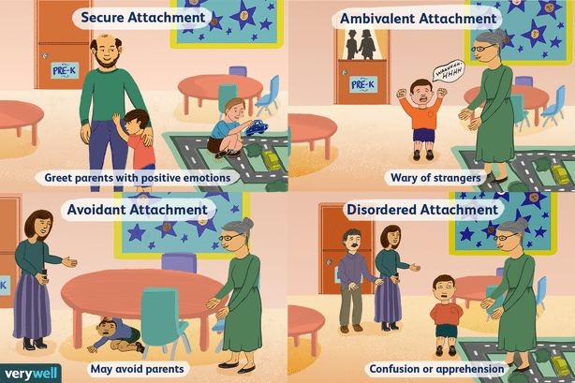
(Olah, J.)

The Role of the Adult

Responsibilities of the Practitioners
A child will feel a numerous amount of emotions when they start school for the first time, the main emotion that they feel may be anxiousness. To allow the child to feel safe and secure and to lessen the negative feelings as much as possible the practitioner needs to deal with the transitions sensitively and effectively.
It is important that the practitioners of the nursery have policies and procedures in place that support children and their families to a smooth and comfortable transition. A very useful policy to have is the settling in policy with the aim of settling in children as quickly as possible but also with ease and consideration taken in to account.
As already mentioned, strong trusting relationships between the staff and the parents have a crucial impact on the child. It builds understanding and trust for the child and adults. Having a good relationship will allow the parents and practitioners to communicate effectively allowing them to discuss the child’s wellbeing and needs and keeping them up to date with the child’s progress during this vital time. Parents will feel relaxed and experience less worry when they are able to openly talk to their child’s teachers as the information on what has happened during the day and how their child has been will come from the practitioner themselves.
It is not always easy for parents to have a trusting relationship with their child’s teacher and there are many reasons why. One reason could be due to work commitments therefore the child will be taken to school and picked up by a childminder or another relative, resulting in the parents not having a chance to speak to the child’s teacher face to face regularly or even at all. To overcome this, communication diaries are a useful strategy for parents and teachers to keep in contact and up to date on the child’s progress.
According to the Welsh Government (2017), the transition process should be inclusive, and the child's and family's requirements should be planned for, as well as any additional needs. The practitioner can accomplish this by collaborating closely with families and other relevant agencies. Be especially mindful of any children or families that may require more assistance, and be prepared to adjust any plans to meet their needs.
Practitioners must be flexible in your communication with the parents and be aware of the need to adjust to diverse scenarios where English is not the primary language or the parent has a unique learning need. (Pacey 2021)

The Nation Minimum Standards are intended to ensure that care is suitable for purpose and meets the assessed requirements of persons who receive social care. (Care Inspectorate Wales, 2016)
Within these 17 standards, there are key points that staff should adhere to to allow a smooth transition for the child and their parents.
These Are:
- NMS 3 Assessment
This entails gathering as much information about the child as possible in order to provide the practitioner with a complete picture of the child.
- NMS 4 Meeting Individual Needs
This is to ensure that any requirements and needs that a child may have can be arranged beforehand prior to the child starting at the school.
- NMS 6 Working in Partnership with Parents
It is vitally important that the parents also feel valued. This can be resolved by always keeping them fully informed with what is going on regarding their child. With parents and practitioners exchanging significant information it will allow for a better understanding resulting in better care.
NMS 8 Nurture and Wellbeing
This standard is intended to ensure that practitioners understand their critical role in assisting children in feeling happy, secure, safe and valued.

Responsibilities of the Parents
Parents will also experience a numerous range of emotions that will be caused by being away from their child for a length of time, and for the first time in some instances. It is important that the parents try to stay relaxed and supportive to their child as when they are showing signs of stress and nervousness the child will pick up on these emotions and may start feeling them themselves.
There are many things that the parents can do to help prepare their child when starting school. The parents can encourage the child to become more independent such as letting them dress themselves, allowing them to play independently with other children. It would also be beneficial to take the child on a trip to the library and allow them to choose a book on starting school so it can be read together prior to them starting nursery.
Talking positively about school to the child may help them feel relaxed about the process, even the parents sharing their own memories of school can help the child to feel excited to go.
It is normal for the parents to feel worried and it is important that they speak to the school with any concerns that they have. They can speak to the school about what happens on the child’s first day and how they are introduced, this can then be spoken about with the child so they know what is expected.


(Villines, Z.)

Interventions

It is critical that the environment is professional, consistent, structured, kind and welcoming. This viewpoint is supported by Frobel (Tovey 2016) and Montessori’s (Aubrey and Riley 2016) practices.

For the child to experience the best possible chance at both short and long term, they need to receive the highest quality of childcare, including support from practitioners. To help support the child through this transition, there have been many interventions created to help maintain close relationships between the families and children.

The childcare service must have a written statement of purpose that describes all of the practical features of the setting, according to Standard 1 of the National Minimum Requirements. The Statement of Purpose document will allow the parents to make a well-informed choice regarding the services they require. (Care Inspectorate Wales, 2016)

All About Me
The parents will be asked to fill in an All About Me booklet with their child that will allow the teacher to get to know the child and their interests. The book is intended to be used by the parents and practitioners at the nursery to help prepare for the transition. The booklet will include the child’s likes and dislikes, their favourite things such as food, colour and toys.
This booklet will help the child to feel that their interest and opinions are valued. It is also beneficial for staff members to see what stage the child is at so that they can plan accordingly for benefiting any new staff members that arrive at the setting.

First Day Pack
When the child attends their first settling in session, they will receive their first day pack. This pack will include activities similar to what they carry out in the classroom so that they are able to get familiar with the new activities at home. It will also include photos of the classroom and the school to remind the child familiarise them with their new surroundings as they may become overwhelmed on their visit and not take much in.

Settling in Session
Prior to the child starting their first day, they will be invited to the nursery with their parents for a visit. This allows the child and their parents to have a chance to meet the teachers and have a look around the classroom and school so that it is not all completely new to them on the first day. The hours that a nursery child attends school for is 3 hours a day, however for the first week the child will not complete the full 3 hours. The first and second day the child will attend for one hour following by two hours for the rest of the week and the week after the child will attend for the full three hours if they are ready to do so.


(Golftyncp)

Reference List

Aubrey, K. and Riley, A. (2015). Understanding and Using Educational Theories. London: SAGE Publications Ltd

Bowlby, J. (1969) Attachment and loss. (OKS Print.) 2nd Ed. New York: Basic Books.

Cherry, K. (2021). The 5 Levels of Maslow's Hierarchy of Needs. [Image]. Available at: https://www.verywellmind.com/what-is-maslows-hierarchy-of-needs-4136760 (Accessed 21st Nov 2021).

Cherry, K. (2021). The Different Types of Attachment Styles. [Image]. Available at: https://www.verywellmind.com/attachment-styles-2795344 (Accessed 21st Nov 2021).

Croner-i. (2019) Managing transitions in early years provisions. Available at: https://app.croneri.co.uk/feature-articles/managing-transitions-early-years-provisions (Accessed: 21st Nov 2021).

Early Years Matters (2021) ‘Early Years Matters’, Transitions - Early Years Matters. Available at: https://www.earlyyearsmatters.co.uk/eyfs/positive-relationships/transitions/ (Accessed: 25th Nov 2021).

Golftyncp (2021) ‘Nursery’ [Image] Available at: http://golftyncp.wales/nursery/ (Accessed 24th Nov 2021).

Harvard University (2021) Stress and Resilience: How Toxic Stress Affects Us, and What We Can Do About It. Available at: https://developingchild.harvard.edu/resources/stress-and-resilience-how-toxic-stress-affects-us-and-what-we-can-do-about-it/ (Accessed 22nd Nov 2021).

Mas and Pas (2021) 9 Easy Ways to Prepare for the First Day of School [Image]. Available at: https://masandpas.com/childs-first-day-of-school/ (Accessed: 14th Nov 2021).

Maynard, T. and Thomas, N. (2004) An Introduction to Early Childhood Studies. 2nd Ed. London: Sage Publications Ltd.

McLeod, S. (2017) Bowlby's Attachment Theory. Available at: https://www.simplypsychology.org/bowlby.html (Accessed 21st Nov 2021).

Mcleod, S. (2017). ‘Simple Psychology’ Attachment Theory Available at: https://www.simplypsychology.org/attachment.html (Accessed: 17th Nov 2021).

PACEY (2021) Starting School. Available at: https://www.pacey.org.uk/working-in-childcare/spotlight-on/starting-school/ (Accessed: 16th Nov 2021).

Pacey. (2021) Working in partnership with parents. Available at: https://www.pacey.org.uk/working-in-childcare/spotlight-on/partnerships-with-parents/ (Accessed: 21st Nov 2021).

Patel, A. (2021) ‘Teach Early Years’, Supporting Transitions in the Early Years. Available at: https://www.teachearlyyears.com/a-unique-child/view/supporting-transitions-in-the-early-years (Accessed: 14th Nov 2021).

Psychology Hub (2021) The Role of the Father, Multiple Attachments. Available at: https://www.psychologyhub.co.uk/the-role-of-the-father-multiple-attachments/ (Accessed: 24th Nov 2021).

Tonybilge (2021) Mother Goose and Baby Geese. [Image] Available at: https://www.dreamstime.com/royalty-free-stock-photos-mother-goose-baby-geese-image7206318 (Accessed 23rd Nov 2021).

Villines, Z (2016) Study: Parenting Style Matters for Difficult Children. [Image]. Available at: https://www.goodtherapy.org/blog/study-parenting-style-matters-most-for-difficult-children-1201161 (Accessed 16th Nov 2021).

Webster, M. (2021) ‘Merriam Webster Dictionary’, Transition. Available at: https://www.merriam-webster.com/dictionary/transition (Accessed: 14 November 2021).

Welsh Government (2017) Transition Guide, Flying Start-Annex. Available at: https://gov.wales/sites/default/files/publications/2019-07/flying-start-transition-guidance-for-professionals.pdf (Accessed: 23rd November 2021).

Welsh Government. (2016) National Minimum Standards for Regulated Childcare for children up to the age of 12 years. Available at: https://careinspectorate.wales/sites/default/files/2018-01/160411regchildcareen.pdf (Accessed: 22nd Nov 2021).

