
life in the digital era


Student Id -1712713
Ayasha Khatun
Lecturer – Christian Felices
Submission date -25/11/2022
Word count + - 1500

Table of Contents
1.Introduction page 1
2.Main findings page 2
3.Task 1 page 3
4.Task 2 page 4
5.Task 3 page 5
6.Conclusion page 6
7.Refrences page 7

Introduction
It is generally understood that an introduction of any academic piece is undoubtedly one of the easiest parts of an assignment. A lot of important points that can be utilised within the piece of writing can be found in the introduction of the text. However, it can sometimes be troublesome to summarise a large amount of writing in a short number of lines. According to Solent.ac.uk. (2022) this results in some results being excessive due to the reason that individuals may go into too much depth, which is unnecessary for an introduction it is intended to be vague and give an idea of what the assignment is generally about.

Main Finding
The core purpose of the key findings section of any form of writing is to exhibit the results of the of the investigation in a way that it is convenient and comprehensive for the reader. Research Paper Topic Ideas & Suggestion for Students. (2021) says that this can be carried out by making use of range of formats, such as charts, tables and graphs. Key findings also serve at providing people; businesses and companies with information that they can use to evolve their business strategies and techniques, expand on previous research, and advance any products and services they feel require improvement. For instance, ‘the use if product life cycle theory with reference to various product categories’ is an academic piece of writing that goes into depth about the various aspects of the product life cycle. Furthermore, it also gives evidence through relevant case studies derived from a wide variety of sectors.

Task 1 What is Academic writing
The aspect Academic writing is a formal and professional way to communicate. Academic writing can vary with different settings. There are many forms this can include schools’ college and university. According to Smith (2020) it can take a long time to master the skills to become an expert. New students might find it challenging; however, it is possible to master the skills of an expert. The components of an academic writing would be:
In terms of focus, academic writing focus is particularly important. Focus has the dominance of guiding your writing.
Additionally, academic writing must be balanced. Academic writing requires an individual to be fair and balanced throughout, it should be equally understood amongst students and professional academic writers. Like all other researcher’s arguments and evidence can be challenging.
Moreover, academic writing pieces must hold a strong and clear structure. Academic writing needs to be clear and easily understood by both the writer and reader.
In addition, academic writing is concerned with information and arguments as opposed to focusing on the writer. Noun phrases and nouns are utilised rather than adverbs and verbs. Academic writing can occasionally be complex when trying to collect information. This may mean that in Academic writing if something is well prearranged, clear, and serene to understand you are undoubtedly on the right track.
Furthermore, academic writing has a significant tone, which is usually sophisticated. According to The Royal Literary Fund (2014) the subject itself is a body of art converted in writing. The positive attribute is that it requires evidence. However, this can only be achieved from assignments and real-life examples and experiences.
Communication is the key skill in academic writing, one must be prominent when writing about a particular subject. It is vital that you understand and are clear of the subject you are referring to as there is a vast potential for mistakes. For example, University of Sunderland (2022) explains that a practical tone can emphasise the whole paragraph whereas an informal tone will not. Undoubtedly one can get their voice heard to the outer Academic world with their research, ideas and evidence.

Task 2 What is a similarity check?
A similarity check ensures that you are not copying others’ work, to avoid plagiarism. Plagiarism is when you claim somebody else’s work as your own without references. A similarity check works by making connections between the work that you submit and resources from the internet. Similarity checks are commonly used for universities to make sure that students ‘work is authentic. My similarity check score was 0%. This demonstrates that my work is well referenced using Harvard referencing. To improve, I should incorporate more in text citations to deepen the breadth of my report. This will develop my report as it will cover a range of ideas from different individuals.

Task 3 Critical Thinking
Critical thinking is a tool that may require a lot of effort; however, it helps us reach a solution with the long-term thinking and aids us to make the correct decision. In relation to critical thinkers, they collect information arguments and point of others and themselves
According to BBC Bitesize (2022) critical thinking is also useful in identifying fake news, which is quite common nowadays. It is important to distinguish real news from fakes news, as it is crucial there is no miscommunication or inaccurate information being spread while performing research.
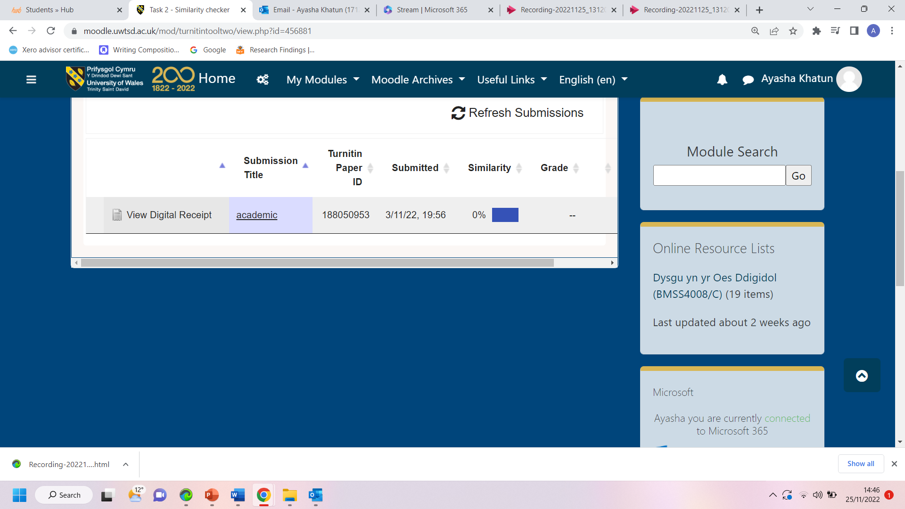

Critical analysis gives us the power to think distinctly. University of Greenwich (2022) it is all about connecting thoughts and ideas and having a greater understanding of a subject. We often use many methods to enhance our ideas and inputs. Critical thinking entitles us to use our views and evaluate arguments made by others, this may be organisations, schools, workplaces, or others in general. Although we may think we have enough information we should always investigate various sources to analyse the differences and to support our views on topics, ideas, and critical writing skills. It can help us with our own assumptions.
Leeds Library (2022) an individual with various critical skills can recognise and build arguments. Critical thinkers can approach problems in a harmonious way and will eventually find a solution. It is particularly important to acknowledge ideas and methods given by others if there is no misinformation. To critically think we must try to gather the correct information this can potentially be the name of Author, date it was published and any evidence and sources to back it up. However, it is crucial to collect information and ideas to critically think and plan.

Task 4 This is the recording for my sense of place and identity
Recording-20221125_131202.webm

Conclusion
To conclude, an introduction gives an idea of everything that will be discussed in the piece of writing. The key findings are the area of the writing that puts forward all the results that have been gathered (Emphasis, 2013). Furthermore, academic writing should be both clear and sophisticated. Moreover, a similarity check is when your work is cross checked with other resources from the internet to ensure that nothing was plagiarised. Critical analysis refers to assessing the strengths and weaknesses of something to make an executive decision. A sense of place is somewhere that one feels at peace and tranquil within themselves.

References
BBC Bitesize. (2022a). Understanding critical thinking and problem solving - Critical thinking and problem solving - WBQ National: Foundation KS4 Revision - BBC Bitesize. [online] Available at: https://www.bbc.co.uk/bitesize/guides/zcjhfcw/revision/1 [Accessed 19 Nov. 2022].
Duncan, S. (2022b). Sense of Place: What is it? | Lupton Center. [online] Lupton Center. Available at: https://www.luptoncenter.org/sense-of-place-what-is-it/ [Accessed 22 Nov. 2022].
Emphasis. (2013). How to conclude a report – like a rock star - Emphasis. [online] Available at: https://www.writing-skills.com/how-to-conclude-a-report-like-a-rock-star [Accessed 25 Nov. 2022].
Jagannath, T. (2018a). What is Sense of Place? - Interviews and Articles on Art & Public Spaces - Medium. [online] Medium. Available at: https://medium.com/interviews-and-articles-on-art-public-spaces/what-is-sense-of-place-cd749f924712 [Accessed 24 Nov. 2022)
Library (2022). Critical thinking. [online] Leeds.ac.uk. Available at: https://library.leeds.ac.uk/info/1401/academic_skills/105/critical_thinking [Accessed 25 Nov. 2022].
Playfullearning.com. (2014a). Developing a Sense of Place – Playful Learning. [online] Available at: https://w
Research Paper Topic Ideas & Suggestion for Students. (2021). Research Findings - Objectives , Importance and Techniques. [online] Available at: https://www.myresearchtopics.com/guide/research-findings/ [Accessed 25 Nov. 2022].
‌ Smith (2020). Academic Writing. [online] Eapfoundation.com. Available at: https://www.eapfoundation.com/writing/what/ [Accessed 12 Nov. 2022].
Solent.ac.uk. (2022). Successful Academic Writing: Introduction. [online] Available at: https://learn.solent.ac.uk/mod/book/view.php?id=116226&chapterid=15161 [Accessed 25 Nov. 2022].
The Royal Literary Fund. (2014b). Academic writing: key features. [online] Available at: https://www.rlf.org.uk/resources/academic-writing-key-features/ [Accessed 20 Nov. 2022j
University of Greenwich. (2021). What is critical thinking? | Articles | University of Greenwich. [online] Available at: https://www.gre.ac.uk/articles/ils/critical-thinking [Accessed 19 Nov. 2022].
University of Sunderland. (2022b). What is academic writing? - University of Sunderland. [online] Available at: https://www.sunderland.ac.uk/student-experience/explore/health-sciences-wellbeing/what-is-academic-writing/ [Accessed 19 Nov. 2022].

