

Programme: BA (Hons) Business Management
Student: Alina Ionela Scarlaciuc, 2318839
Module: Stakeholder Engagement
Module code: LCBB4013
Assignment title: Component 1: Coursework-Portfolio (4 elements)
Lecturer: Ivan Rodriguez Hernandez

NEW PUBLIC PARK PROJECT

TABLE OF CONTENT

Introduction………………………………………………………………….3-4
Application to include stakeholder engagement strategies………………….5-8
Ethical consideration in stakeholders’ consultation, participation and feedback……………………………………………………………………8-10
Conclusion and reflection…………………………………………………11-12
Reference list…………………………………………………………………13
NEW PUBLIC PARK PROJECT

Introduction

This stakeholder management plan focuses on the development of a new public park in Leicester, a community centred project designed to enhance wellbeing, promote social inclusion, and support Leicester City Council’s wider sustainability agenda. The park is planned for redevelopment in under used urban land and aims to create an accessible, safe, and multifunctional green space for residents of all ages.
The design of the park will include the essential features expected in a modern urban green space- walking routes, cycling paths, play areas, open lawns, picnic area, landscaped gardens, and environmentally sensitive planting. However, additional community focus elements have also been proposed to maximise social value and long-term engagement.
These include:
- Outdoor fitness zones with equipment for adults and older residents to support Leicester’s public health objectives.
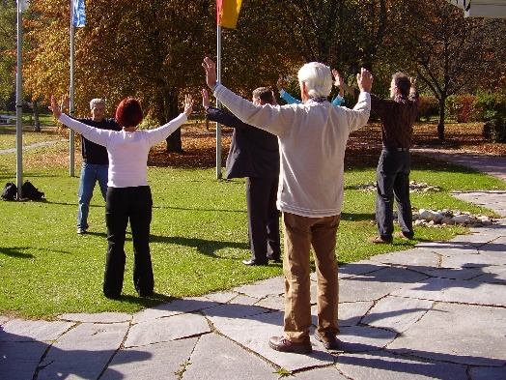
- A community garden and allotments, providing opportunities for intergenerational learning, food growing, and environmental education.
- A small outdoor performance space, which local schools, dance groups, and cultural organisations can use for events, concerts, and community celebrations.
- Wildlife learning areas, including “mini-habitats” such as bug hotels, bird-watching points, and pollinator-friendly planting beds, to promote biodiversity awareness.
- Weekly community activities, such as guided nature walks, children’s eco-clubs, weekend fitness classes, and volunteer-led maintenance sessions
- An outdoor study and seating area, designed for school groups, college students, and residents who want a quiet, natural space to read or relax.
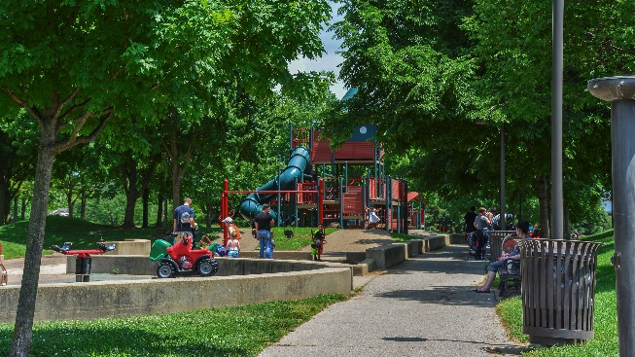
By incorporating these features, the new park becomes more than a green space: it becomes a community hub that supports physical health, social connection, environmental stewardship, and educational opportunities.
The project also responds to key local needs. Leicester’s increasingly diverse and growing population requires more public spaces that encourage cultural exchange and community cohesion. In this context, the park will provide a shared environment where residents can interact, participate, and take pride in their local area. Successful delivery of the project depends on effective stakeholder management, as different groups-residents, businesses, community organisations, environmental groups, and Leicester City Council- possess varying levels of interest and influence.
Freeman (2010) defines stakeholders as individuals or groups who can affect or are affected by an organisation’s objectives.
At least six key stakeholders will directly benefit from this project:
- Residents – They will benefit from improved access to nature and recreation, which supports both physical and mental wellbeing. The park will also provide a space for community events and family activities.

- Leicester City Council – The council will achieve its goals related to sustainability, public health, and green infrastructure, while strengthening its relationship with the local community.

- Environmental Organisations – Local environmental groups such as Leicester Environmental Volunteers can collaborate on biodiversity projects and awareness campaigns within the park.

- Local Businesses – Shops and cafes located near the park are likely to experience increased customer traffic and revenue as the area becomes more attractive.

- Construction and Landscaping Companies – These stakeholders will benefit through employment and contracting opportunities during the park’s development phase.

- Schools and Community Groups – The park will provide an educational resource, supporting outdoor learning, environmental education, and youth engagement activities.

Overall, the New Public Park in Leicester aims to promote wellbeing, sustainability, and community identity, offering a long-term space that supports both environmental goals and inclusive community development.

The next section of this report will analyse the stakeholders in more detail and outline effective strategies for communication and engagement.

Element 2: Application to Include Stakeholder Engagement Strategies

Introduction to Stakeholder Engagement
Effective stakeholder engagement is crucial for the successful planning and implementation of the New Public Park in Leicester. Stakeholders are individuals or groups who are affected by or can influence the project’s outcomes. According to Allen (2019), stakeholder management in community projects requires transparent communication, inclusivity, and shared decision-making to foster trust and collaboration. The engagement process ensures that diverse perspectives are integrated into project design, leading to outcomes that are socially equitable and environmentally sustainable.
In community-based projects such as public parks, engagement also strengthens local ownership and long-term stewardship of the space (Day, 2006). The stakeholder management process therefore involves identifying stakeholders, analysing their influence and interest and establishing appropriate methods of communication and participation.

Power, influence and interest table
Stakeholder | Power | Influence | Interest |  | Engagement level
Leicester City Council | High | High | High |  | Collaborate closely and involve in decision-making
Residents | Medium | High | High |  | Consult regularly and gather feedback
Environmental Organisations (e.g. Leicester Environmental Volunteers | Medium | Medium | High |  | Partner on sustainability initiatives
Local Businesses | Low | Medium | Medium |  | Keep informed about progress and opportunities
Construction and Landscaping Contractors | High | Medium | Medium |  | Manage through contracts and progress meetings
Schools and Community Groups | Low | Low | High |  | Engage through community events and education programmes

This table is informed by the power-interest grid model (Gilchrist, 2009), which helps prioritise stakeholders according to their capacity to influence and their level of concern. Those with high power and interest, such as the City Council, require close collaboration, whereas those with lower power but high interest, such as residents and schools, should be regularly consulted to maintain inclusion and transparency. According to Bryson (2018), mapping stakeholders by power and interest helps identify their potential influence on project outcomes.

Stakeholder Map and Justification

The stakeholder Map (based on Gilchrist, 2009 and Banks et al., 2016) divides stakeholders into four quadrants:
- High Power, High Interest: Leicester City Council
- High Power, Low Interest: Construction and Landscaping Contractors
- Low Power, High Interest: Residents, Schools Environmental Organisations
- Low Power, Low Interest: Distant business stakeholders or occasional park visitors

Mapping stakeholders allows the project team to tailor engagement efforts according to the needs of each group. As Banks, Shaw and Meade (2016) highlight, effective community development depends on recognising the political dynamics of power and ensuring that less influential voices, such as residents or young people are still meaningfully included in consultation processes.

Communication and Consultation Strategy
Stakeholder communication should be transparent, inclusive and adaptable. Moon (2004) emphasises that reflective practice in community projects helps practitioners adapt communication styles to suit different audiences and cultural contexts. Therefore, a variety of communication tools will be used for the Leicester Park project:
Stakeholder | Communication Method | Frequency | Type of Information | Responsible Party
Leicester City Council | Formal meetings, reports and email updates | Monthly | Budget, planning, progress updates | Project Manager
Residents | Public meetings, online surveys, social media updates | Quarterly | Design plans, timelines, opportunities for input | Stakeholder Manager
Environmental Organisations | Workshops and partnership meetings | Bi-monthly | Sustainability initiatives, habitat management | Sustainability officer
Local Businesses | Email newsletters, business forums | Quarterly | Commercial opportunities, community events | Communication officer
Contractors | Weekly progress meetings and site reports | Weekly | Technical updates, health and safety information | Site Manager
Schools and Community groups | Educational sessions, newsletters | Termly | Environmental learning activities | Community Liaison Officer

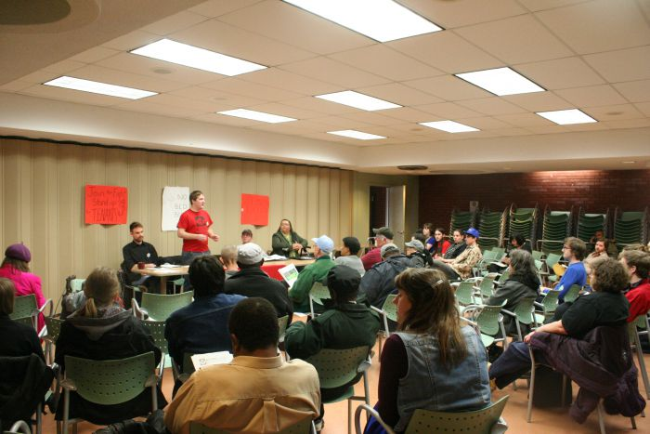
This structure ensures that communication remains consistent, relevant and two-way. The CTSA (2011) framework for Principles of Community Engagement highlights that authentic participation requires early involvement, shared planning, and respect for community knowledge.
This Photo by Unknown Author is licensed under CC BY-NC
Moreover, Rochester, Ellis and Howlett (2012) note that volunteering and civic participation are enhanced when communities are kept informed and feel ownership of outcomes. To support this, the project will host community planting days, youth art projects for park’s design and open consultations during the planning stages.
Mayo (2019) also argues that community engagement should be viewed as a continuous relationship rather than a one-off consultation. Thus, the Leicester Park Project will maintain communication channels post-construction, allowing for feedback and ongoing collaboration through a “Friends of the Park” group.

In summary, stakeholder engagement in the New Public Park Project will focus on transparency, collaboration, and inclusion. By applying established frameworks of community engagement and reflective practice, the project aims to build trust among stakeholders and ensure the park meets the diverse needs of Leicester’s residents.

Element 3: Ethical Consideration in Stakeholders Consultation, Participation and feedback

Ethical considerations are fundamental to stakeholder consultation and participation in community projects. The New Public Park in Leicester project aims to create an open, inclusive, and transparent consultation process that respects participants rights, promotes equity, and values all voices. According to Allen (2019), ethical community engagement requires practitioners to act with integrity, maintain transparency, and ensure accountability in all stages of consultation. The consultation process must therefore be designed to minimise bias, encourage diverse participation, and protect personal data.

Ethical methods of consultation
The project will adopt a combination of face-to-face consultations, public meetings, online surveys, and focus groups. Each method is selected to maximise accessibility and inclusivity. Day (2006) argues that everyday community interactions provide opportunities for dialogue and shared meaning-making, suggesting that informal spaces such as local events or markets can also be used to gather input from underrepresented groups.
To ensure fairness, all participants will be informed about the purpose of the consultation, how their feedback will be used, and their right to withdraw at any time. The process will follow the ethical principles outlined by the CTSA Community Engagement Task Force (2011), which will include respect for autonomy, transparency, and mutual benefit. Participants consent will be obtained prior to data collection, and their autonomy will be preserved when reporting outcomes.
Special attention will be given to accessibility. Consultation materials will be made available both in digital and printed forms to ensure inclusion of individuals with limited internet access. In addition, meetings will be held at various times and locations around Leicester to accommodate people with differing work schedules and mobility needs. According to Gilchrist (2009), inclusivity in community engagement depends on removing barriers that prevent full participation, particularly for marginalised or less vocal groups.

Addressing ethical concerns and bias
Bias in consultation can occur when certain stakeholder voices dominate, while others are ignored or undervalued. Banks, Shaw and Meade (2016) highlight that ethical community development requires practitioners to challenge inequalities of power and representation. To prevent bias, the Leicester park project will employ multiple feedback channels - anonymous surveys, suggestion boxes, and open forums - ensuring that both supportive and critical perspectives are captured.
Project staff will undergo ethical awareness training, focusing on confidentiality, impartiality, and non-discrimination. This aligns with Rochester, Ellis, and Howlett’s (2012) argument that ethical volunteer and civic engagement depend on fairness and accountability in interactions between organisers and participants. Moreover, facilitators at consultations events will ensure that discussions remain respectful and inclusive, and that no individual or groups dominate the dialogue.
Moon (2004) suggests that reflective practice plays a vital role in maintaining ethical standards, as practitioners are encouraged to evaluate their own assumptions and behaviour throughout the engagement process. For this project, a reflective log will be maintained by the stakeholder manager to record key ethical decisions and learning points from consultations. This will support continuous improvement and transparency in the management process.

Diversity, Equity, and Inclusion (DEI)
A strong commitment to Diversity, Equity, and Inclusion (DEI) will guide all engagement activities. Leicester is one of the most culturally diverse cities in the UK, and ensuring equitable participation is therefore essential. According to Mayo (2019), community engagement in multicultural contexts must recognise social differences and provide equitable opportunities for all groups to contribute.
The project will ensure DEI by:
- Using plain and inclusive language in communication materials.
- Providing translation support where needed.
- Ensuring venues are physically accessible to individuals with disabilities.
- Encouraging participation from a diverse range of community groups, including young people, older residents, and minority ethnic associations.
As Allen (2019) notes, equitable engagement not only improves project legitimacy but also strengthens community trust. Therefore, DEI is viewed not as a procedural requirement but as foundational principle that enhances both ethical integrity and project sustainability.

Feedback collection and review
Stakeholder feedback will be collected through multiple channels, including online forms, paper surveys, email correspondence, and public meetings. Data will be stored securely following the UK’s General Data Protection Regulation (GDPR) standards. Only authorised project staff will access the data, and feedback will be anonymised before analysis to protect privacy.
Feedback will be categorised by stakeholder group (residents, businesses, organisations) and analysed thematically to identify recurring issues or suggestions. Findings will then be summarised in progress reports shared with all stakeholders through the council’s website and newsletters. Gilchrist (2009) recommends that feedback loops should be closed by informing participants of how their input influenced decisions – this helps maintain engagement and accountability.
Additionally, community representatives will be invited to join a Stakeholder Review Panel, meeting quarterly to assess consultation outcomes and monitor project progress. This participatory approach reflects Day’s (2006) idea of “everyday democracy”, where community members play an ongoing role in shaping their local environment.

Ethical stakeholder consultation in the New Public Park in Leicester project is grounded in principles of transparency, inclusivity, and respect. By integrating ethical safeguards, DEI strategies and reflective practice, the consultation process ensures that all voices are heard and valued. As Banks, Shaw and Meade (2016) emphasise, ethically sound engagement not only builds trust but also enhances the legitimacy and long-term success of community projects. Ultimately, these approaches will help create a public park that truly represents the diverse needs and aspirations of Leicester’s residents.
Element 4: Conclusion and Reflection.

The New Public Park in Leicester project has shown me how effective stakeholder management can strengthen community trust and lead to more inclusive and sustainable outcomes. In developing this plan, I learned that engaging with stakeholders is not only about gathering opinions but about creating genuine collaboration and shared ownership of the project’s goals. This section concludes the portfolio and provides my personal reflection on what I have learned about stakeholder engagement, ethical practice, and professional development.

Conclusion
From my analysis of stakeholders involved in the Leicester park project, I realised that successful engagement requires a balance between communication, ethics and collaboration. According to Allen (2019), effective engagement depends on integrating diverse community voices into the decision-making process. This was particularly relevant when identifying residents as key stakeholders with high interest but limited power. Developing strategies to give them a stronger voice, such as open meetings and digital surveys, helped to promote inclusion and transparency.
I also learned that ethical practice is essential for building trust. As Banks, Shaw and Meade (2016) highlight, ethical principles such as fairness, respect and accountability must guide every stage of community development. I applied this by ensuring that participation methods were voluntary, confidential, and accessible to all community members. This process reinforced my understanding that ethical engagement not only fulfils professional responsibilities but also improves the credibility and success of the project.
Another important conclusion was that stakeholder engagement is a continuous process, not a single consultation event. Building relationships takes time and maintaining communication after the park’s completion will be vital for long-term community ownership and care for the space. This insight has shown me that stakeholder management is as much as relationship-building as it is about planning and strategy.

Reflection
Working on this project gave me a clearer understanding of the human side of stakeholder management. At the start, I viewed it mainly as a structured process of identifying and analysing groups. However, as I developed the engagement plan, I realised how much empathy, patience and adaptability are required to truly connect with people. Reflecting on this experience helped me to appreciate the emotional intelligence involved in community projects. Moon (2004) suggests that reflection allows practitioners to make sense of their experiences and use them to improve future practice, and I found this to be true throughout the project.
One of the main things I learned is the importance of two-way communication. I noticed that engagement becomes much more effective when stakeholders feel heard and valued rather than simply informed. Day (2006) emphasises that everyday communication builds belonging and cohesion, which I saw as essential for encouraging community participation. In future projects, I would focus even more on informal, accessible engagement activities such as local events, feedback sessions, and social media interaction, as these create stronger connections that formal reports alone.
Another key reflection is the need for adaptability and inclusivity. During the planning stage, I realised that some community members – such as older residents or those with limited internet access – could easily be overlooked if engagement methods were not flexible. This experience reminded me of the importance of designing consultation approaches that meet the needs of different groups, so that everyone has a fair opportunity to participate. Allen (2019) also supports this idea, noting that inclusive engagement enhances social capital and ensures that communities become active partners in development.
On a personal level, this project has helped me to develop important professional skills. I have improved my ability to analyse stakeholder dynamics, communicate clearly, and reflect critically on my actions, I also became more aware of the ethical responsibility I hold when managing community relationships. As Moon (2004) explains, critical reflection transforms experience into learning, and I feel that this project has helped me grow into a more self-aware and ethical practitioner.
Finally, I have come to understand that true project sustainability depends on continuous engagement. When stakeholders feel ownership over a project, they are more likely to maintain and protect it in the long term. Banks, Shaw and Meade (2016) argue that this sense of shared responsibility supports social justice and democratic decision-making. In the case of the Leicester park, ongoing collaboration through events and volunteer programmes will help ensure the park remains a welcoming and inclusive space for the whole community.

Final Thoughts
Overall, developing this Stakeholder Management Plan has been a valuable learning experience. I have gained practical knowledge about stakeholder analysis and engagement methods, but more importantly, I have developed a deeper understanding of the values that underpin ethical and inclusive practice. I now recognise that communication and reflection are essential tools for improving tools for improving both project outcomes and my professional growth. In future projects, I will continue to apply these lessons – listening actively, engaging ethically, and reflecting critically – to create positive and sustainable impacts within the community.

Reference List

Allen, J.A. (2019) The Cambridge Handbook of Organisational Community Engagement and Outreach. Cambridge: Cambridge University Press.
Banks, S., Shaw, M. and Meade, R. (2016) Politics, Power and Community Development. Bristol: Policy Press.
Bryson, J.M. (2018) Strategic Planning for Public and Nonprofit Organizations: A Guide to Strengthening and Sustaining Organizational Achievement. 5th edn. Hoboken: Wiley.
CTSA Community Engagement Key Function Committee Task Force (2011) Principles of Community Engagement. 2nd edn. Atlanta: National Institutes of Health (NIH). Available at https://www.atsdr.cdc.gov/communityengagement/pdf/PCE_Report_508_FINAL.pdf (Accessed: 8 November 2025).
Day, G. (2006) Community and Everyday Life. London: Routledge.
Freeman, R. E. (2010) Strategic Management: A Stakeholder Approach. Cambridge: Cambridge University Press.
Gilchrist, A. (2009) The Well-Connected Community: A Networking Approach to Community Development. 2nd edn. Bristol: Policy Press.
Mayo, P. (2019) Higher Education in a Globalising World: Community Engagement and Lifelong Learning. Baltimore: Project Muse.
Moon, J. (2004) A Handbook of Reflective Practice and Experiential Learning: Theory and Practice. London: Routledge.
Rochester, C., Ellis Paine, A. and Howlett, S. (2012) Volunteering and Society in the 21st Century. Basingstoke: Palgrave Macmillan.

