
Skills for the Workplace
Module Assignment Submission
Student Name: | Isac Ndejeya
Student Number: | 1712481
Module No: | 4002
Module Title: | Effective Team Working and Communication
Lecturer`s Name: | Gregory Cowan

Contents
Introduction 3
Process of communication: 3
Conflicts and Communication: 4
Importance of Effective Team Work and Communication in the work place: 6
Communication Model: 6
Other models: 9
Interpersonal Communication: 10
Analysis: 11
Recommendation: 11
Conclusion: 12

Introduction
Effective team working and communication is very essential in every step of life. In this report I am going to describe about effective team working and about communication from the perspective of real life of my class mate Francis. We need to clarify that what is team working and communication. Communication is very essential to enter a new work. Communication can be verbal, written or activity. A person when try to contact with another person or individual then communication can be created. According to Brown “Communication is a transfer of information from one person to another, whether or not it elicits confidence. But the information transferred must be understandable to the receiver”, According to Brown “Communication is a transfer of information from one person to another, whether or not it elicits confidence. But the information transferred must be understandable to the receiver”, (Brown, 2013). So, communication must be sufficient to satisfied other.
Team working refers to, working in a team to achieve goal. Effective team working is very essential for workplace. According to, Reddy and Jamison, “Key to the concept of the team is communication within the group and there has to be a singleness of mission and a willingness to cooperate”, (Reddy & Jamison, 1995, p. 15)I am going to express communication experience that my friend Francis, described to me.

Process of communication:
Francis recently worked as marketing officer in a multinational organization. He said me several things about communication. I frequently asked him that, what types of communication usually often happen in his organization, he replied me, they used several processes to communicate with employee including him. Francis also use lots of process to communicate with his employee and boss. However, group working is very effective, it is important to know how to work effectively in groups. I also tried to know from Francis that how he effectively works in group. Francis worked with different types of people and he know how to communicate with them. As a corporate worker he need to maintain different types of rules. He needs to communicate with employee, colleague and his boss. However, Francis told me that he preferred to communicate with written format. He told me about several types of written and oral communication.
- Letter: letter is very common format of communication. Through latter, he communicates with his colleague and other employee of the organization. His organization used this format to communicate. The letter used different types of format including brief summery of communication. It shows respect to other. Francis said that, letter should be used in proper word format. Francis used this letter for asking or proposing any kind of decision or steps. It helps to reach direct to the point of subject and without any hesitation letter can be send.
- Report: Report is also an important elements of communication process. Fracis told me, that their report sometimes can be formal or can be informal. Francis made various reports to research about something. It helps to know about deeply about the issue. As a marketing manager, he needs to create several reports to solving problem, so, report is also helped to solved problem.
- Memos: Memos used to purchase different types of product. As a marketing manager, he needs to purchase different types of product and need to inform that to higher level or accountant department. Then he creates memos and which can also be a legal proof.
- Informal Communication: Francis not only used these types of communication in organization but also, he used lots of informal communication. Every Organization has an informal communication network, (Butterfield, 2009). Francis used several processes to communicate informally with employee. Such as,
-eyes
-Posture
-Gesture
All this method used through body movement, personality and so on. Francis used his expression to communicate with other informally.

Conflicts and Communication:
Francis described me about lots of problem regarding communication in his workplace. However, he recently joined in his organization. That’s why he faced lots of problem to communicate with his other employee. Frances shared me about some problems when he tries to communicate with his colleague and boss. As he was new in that time, he hardly copes up with the organization culture. He felt embarrassed that how to start communicate with his colleague. As we said before, team working is essential so, he obviously need to communicate with colleague properly. He cannot talk properly with the manager and hesitated. He also did not feel well in his workplace because others are not interested to talk him and everyone was busy with their work. He faced lots of problem. Some works are not done properly and he thought he cannot create a good face in front of his boss. There was some conflict. Conflict occur between interdependent parties or people who dependent each other some way. Here I am going to tell some of specific problem regarding communication what he faced,
- Personal Problem: As he was new in organization, he faced some problem those are inside him. He was new in corporate life and in academic life, he hardly studied with teams and groups. He had not so many friends. He was a kind of, introvert. Then he faced some sort of same problems in wok place. He told me, he found problems in in formal communication. He did not give enough time to his colleague. He just worked and then went to his home. It creates a distancer between him and his colleague. Now, often while he tries to communicate with his colleague he hesitates. Creating unpredictability occurs when he thinks that, the opposite greets him but unfortunately, he did not, then misconception create.
- Organizational Problem: There were some problem he shared with me, those are the internal problem of organization. As his company was a multinational company, there are lots of foreign people and as a multinational company the company had different culture. The company where he working, is not so friendly. The boss is rude, colleagues did not practice friendly culture. When he tried to communicate, there were some problems such as, technical problem, cultural problem he found. While he worked with team, the team was not so sufficient. Colleague are not share their problem and that’s why the friendly environment was not created through them. He often in confusion that if the information should share with his boss or not, if he shared then if his boss will angry with him that what will happen.

Importance of Effective Team Work and Communication in the work place:
Better communication makes better relationship. Through communication people can know other and get information and give information. Better communication means, sufficient interact with other, opposite may feel so friendly. Effective team work, increase productivity and enhance skill of individual. According to Michael West, “In many areas of human activity and endeavour, research has shown how group working can lead to greater efficiency or effectiveness”, (A.West, 1994, p. 2). Communication and team work both are related with each other, if communication is sufficient then team work must be satisfactory. Warner Burke also focus on team building, that why it is important, according to him, “the way team is working, its norms, decision making and communication and inter team relation.” So, communication and team working both are related to each other. Francis told me also various importance as well,
- It helps to better relationship with colleague
- It helps him to achieve success.
- It helps him to work in a team, as in his organization team work is very essential.
- Effective team work increases his output.

Communication Model:
Francis told me about the process of communication in his organization. He also shared me about some problems. He told me that, his organization follow Berlo’s Model of communication. In 1960, David Berlo crated his SMCR model, SMCR refers to, sender, message, channel, receiver model from Shannon weaver model of communication which is created in 1949, (Businesstopia, n.d.). This model helps to separate each and every component which used in conversation. The model described about communication process.
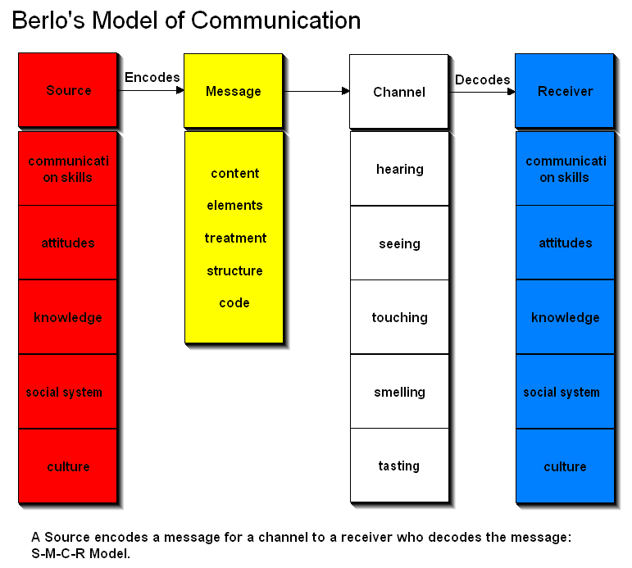
1 Barlo's Communication Model
The above figure is Berlo’s Communication model, which described about source, message, channel and receiver.
Source: According to Barlo’s, sender is the main source of message. If sender do not commit to send message or information then communication will never be happened. Sender must have aware about, communication skill, attitude, knowledge, social system and culture.
- Communication Skill: Communication skill is basic skill to start communication. Francis told me, every employee should have basic communication skill in his organization. The message can be unsuccessful if the sender has skill of communication.
- Attitude: Sender must have attitude for deliver the message appropriately. Receiver can approach through the style of sender attitude.
- Knowledge: Sender must have knowledge what he is sending about. Francis told me, if employee don’t have knowledge, then the communication is not done properly.
- Social System: values, rule, religion and so on thing are categorized as social system. A person may have different religion, sender should change his greetings style. As a multinational company, Francis told me, they have different types of employee with different types of religion and Francis need to maintain those.
- Culture: Culture may change the whole message. Some culture may offensive for other, Francis told me that he needs to maintain all of these.
Message: A message is the main body of the conversation. Voice, audio, video, text are the elements of a message. Message is th thing that send by sender to receiver. Message have differet element:
- Content: Content is the short thing that are in message and the main elements of the subject of message.
- Elements: Gesture, signs, language all the non-verbal things are in elements.
- Treatment: A message is mainly converting through treatment and then go to receiver. Francis told me, while they send a message, they need to brainstorming and each and every word can be costly.
- Code: which message has been sent, code is tat form such as, voice, text.
Channel: In which through a message is send to others channel is that process such as, telephone, internet, email, mobile. Francis told me there are different elements of channel.
- Hearing: Francis told me, he receives the message from hearing.
- Seeing: Francis also see different types of mail, message, reports those are part of seeing conversation.
Receiver: Who get message from sender he is the receiver. Francis often play as a receiver role in conversation. While his boss giving message to then he was a receiver. However, receiver has to have same knowledge of sender such as, communication skill, attitude, knowledge, social system and culture. Then he can reply of that message.

Other models:
Shannon and Weaver Model of Communication: This model created in 1948 by Shannon weaver. This model has five components,
- Sender
- Encoder
- Channel
- Receiver
- Noise
The sender encodes the message to send it the receiver through different types of technical media, then sender converts the message into codes and then send it to receiver through different channel.
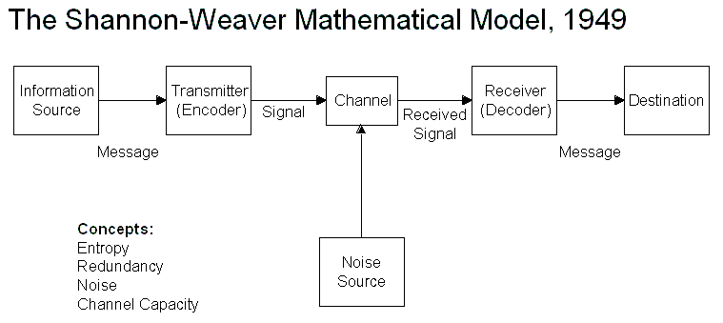
2 Shannon Weaver model

Linear Model: linear model is the process, where sender will only send messages and receiver cannot give any feedback. The components of linear model are: Sender, encoding, decoding, message, channel, receiver, noise.
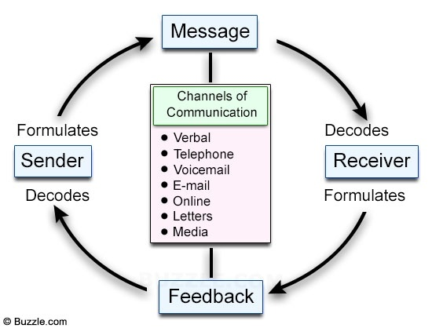
3 Linear Model

Interpersonal Communication:
The interpersonal communication is basically about personality of the sender. It is not about just message but also how the message is presented is focused also. Francis told me, while he communicates with his colleague how he communicates with them as well as how to attract them through showing attitude. It is not only about language but also, how it said, how the voice tone was, gesture, posture and so on, (Skills you Need, n.d.). Francis told me different types of interpersonal communication elements while he used in his communication.
Body Language: Body language is very essential element for conversation. Francis do not use any type of body language that is not like to others. Body language shows about behavior. If he communicates with hiss boss, he does not show his movement, if he communicates with his colleague he shows friendly movement and if he communicates with his employee then he shows him like a leader.
Active listening: While he communicates with other, he shows himself as an active listener. It helps him to do better communication. Other believe that, the listener conscious about what he is talking. Francis told me, while he did with his boss, the communication make effective.
Personal Presentation: Personal presentation is very essential tools of interpersonal communication. As a worker of multinational company, Francis always present himself as gentle man. This helps to interact each other.

Analysis:
The overall description regarding communication of Francis organization and regarding Francis experience, Communication is very essential for any kind of organization. Without that effective communication Francis cannot stay there or worked there. While he was new, he was uncomfortable, but now he is feeling good. Communication helps to enhance is productivity. In conclude and as summery,
- Communication is very essential elements in workplace.
- Communication helps to get feedback regarding work.
- Communication build strong relationship with upper level to lower level.
- In Francis organization, he also uses verbal communication, so it is also important and it can help to know about culture.

Recommendation:
In this report I can find some gap and common mistake those can be found in communication. Communication should be efficient and sender and receiver both should be satisfied. I can say about several thing such as,
- In effective communication, irrelevant word should be removed.
- In first sight of a message, reader should be known about what the sender wants to talking about.
- Culture of an organization should not be changed and should be friendly.
- Communication training need to developed for new comer in organization.
- Communication and team work both are related with each other, so for better team work, a team should be communicating with each other properly.

Conclusion:
The report completed about effective team work and effective communication. Effective communication is very important for an organization, because without communication not a single work can be done properly. Francis told be his experience regarding communication. He faced lots of problem while he was new comer in the organization, but now the boss like him most. Because he applied communication theory and he also applied proper way of communication in his workplace. Communication is not only about some word or sentence but also it about personality, behavior, attitude of a person. It is not only important in corporate life but also in every aspect of life, a person should communicate properly. On the other hand, if the communication process and communication is effective then the team work also be effective. Group member can know each other properly. So, in conclude, better communication means better team work, better corporate life, better personal life. ss

Bibliography
A.West, M., 1994. Do Teams Work?. In: Effective Teamwork. New Delhi: The British Psychological Society, p. 2.
Brown, G., 2013. Defination of communication. [Online]
Available at: http://communicationtheory.org/definition-0f-communications
Businesstopia, n.d. Berlo’s SMCR Model of Communication. [Online]
Available at: https://www.businesstopia.net/communication/berlo-model-communication
Butterfield, J., 2009. Communicating informally. In: Illustrated Course Guides: Verbal Communication - Soft Skills for a Digital workplace. NY: Cengage Learning, 2009, p. 75.
Maund, A., Schriek, M. & Tinkler, P., 2017. Program. Certificate in Higher Education: Skills for the Workplace Student Yearbook.
Morgan, P., 2016. Team Development. In: The Business Student's Guide to Study and Employability. London: SAGE, pp. 210-212.
Reddy, W. & Jamison, K., 1995. Why Team Building. In: Team Buildings Blue Print Fot Productivity and Satisfaction. New Delhi: S Chand and Company, p. 15.
Skills you Need, n.d. What is Interpersonal Communication?. [Online]
Available at: https://www.skillsyouneed.com/ips/interpersonal-communication.html

