Evidence Portfolio Rachel Owen- 1801974
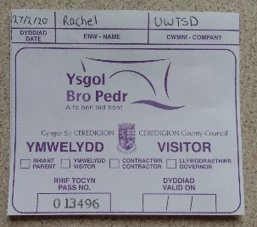
- Every morning before entering the school. I had to fill out my pass in reception; listed on the slips were our names, date, institution, and signatures. We were given lanyards to pop them in, they made us identifiable on school grounds to members of staff and students.

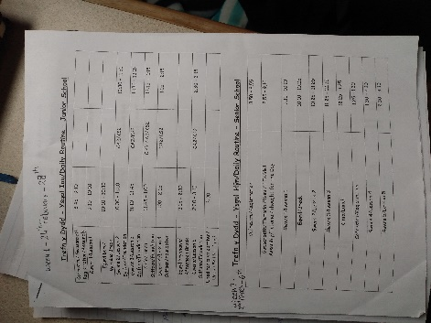
- This booklet was presented to me on the 1st day. It provides all the basic information on both the primary and secondary school schedules for the day. The general rules were listed inside: uniform code, attendance and punctuality regulations etc. The school’s internet policy and repercussions for breaking it were clearly stated. While using the internet pupils are responsible for their behaviour, supervision is necessary, warnings for stranger danger and misinterpretation of information, zero tolerance policy on cyber bullying. Consequences are temporary or permanent ban from internet access depending on the infraction, in extreme cases police involvement.

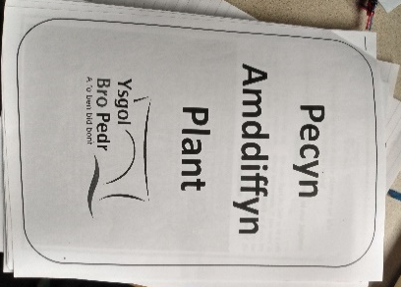
- The student welfare booklet outlined all the safeguarding policies we had learned in lectures. Opening on the aims of safeguarding in the school, then followed by a picture board of 7 members of staff, their names and positions as welfare officers. Information on the responsibility to protect children in your care was noted under the Children Act 2004, along with definitions of child abuse. An itemised list of protocol for referral of an issue to staff including protection procedures, confidentiality, and reporting process. Contact details of safeguarding officers are recorded as well as an out of hours number. The PREVENT scheme was new to me, the school have a strategy to reduce the threat of terrorism, radicalism, and extremism through educating staff on warning signs. Definitions of the previous terms are provided and manners in which the vulnerable are converted/brainwashed. Criteria for indicators in addition to preventative measures for the classroom are noted. The welfare officers for this issue are recorded with web links for further research. Attached to the back was a template form for reporting concerns if needed.

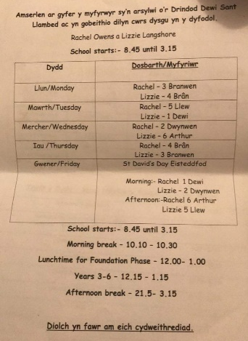
- The primary school timetable saw me placed with a different class daily. I unfortunately could not participate until Wednesday due to set backs with my DBS certificate. However, I observed some brilliant content in Dwynwen 2 in relation to the issue of behaviourism, positive learning culture and positive relationships.

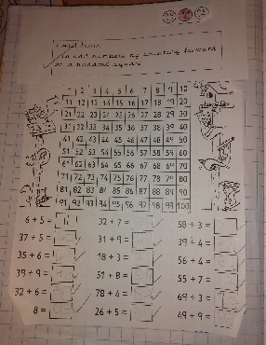
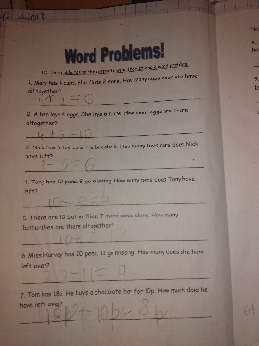
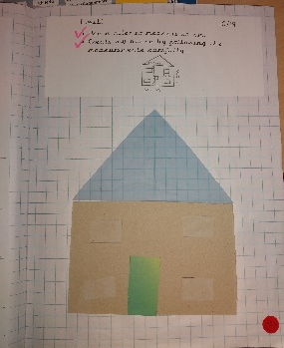

I supervised a table where the pupils morning task was to make corrections in their mathematics books, this challenged my dyscalculia slightly but I managed to help all the students with worded questions, measuring and simple addition. Some pupils were working in pairs to understand questions and used whiteboards to work them out before putting answers in their books. Positive relationships were clear between the pupils and they all showed immense capability for mathematics. The pupils are given a progress tracker at the bottom of the page to rate how difficult they found a task, colouring a smiley face in green, yellow, or red. Measuring progress in this manner is a great form of positive learning culture, it is helpful for the teacher to see what said child needs to improve on and an easy communication form for the pupils.
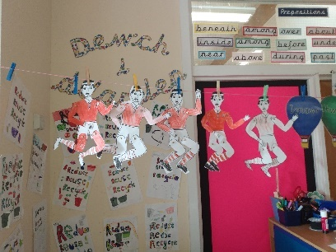
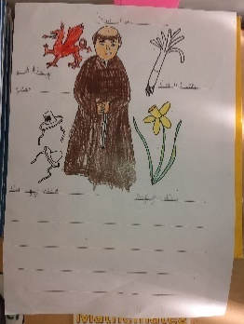

The class were split into two groups based on capability, one group coloured in and used split pins to make a paper puppet of a rugby player. Once completed they were hung on string to show to the class, teachers also praised the pupils on their colouring skills; open praise in the classroom and encouragement when work is completed, both elements of positive relationships. The other group had a sheet with Saint David and other objects associated with Wales on, their task was to write the names of the items in welsh and then they could colour them in. This group were given clear instructions to not colour until they had labelled everything correctly, the motivation to label quickly to get the colouring was expected but they all listened.
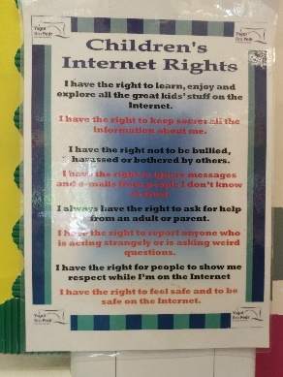
- This poster was on the wall next to the computers, in a clear position for the pupils to see and understand. They are aware of what their rights are and to inform a member of staff if anything raises concerns. The poster is a prime example of positive learning culture measures. Computer privileges were the result of finishing incomplete work in Bran 4, I observed the pupils playing learning games already programmed in and a few were telling a story and using Google images to look up visual of what they were describing. T was telling L she had seen horses on a car drive so found a picture close to what the horse looked like.

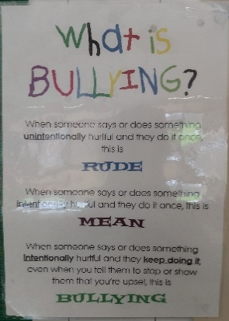
- I observed this announcement in every classroom, it was posted in both English and Welsh so everyone would be able to understand it. It provides clear definitions for the pupils to interpret whatever situation they find themselves in and what to say to a teacher when reporting it. The poster could also aid in student awareness of what to look for in cases of bullying, so if the person being bullied doesn’t want to speak up maybe someone who witnesses it will. Another form of preserving the positive learning culture.
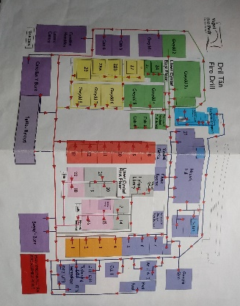
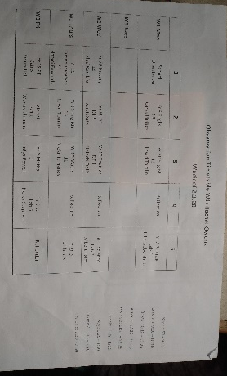

My timetable for the secondary segment needed explanation, the first hour of orientation was a conversation about the timetables and a tour of the school grounds. We were given an hour every day for “reflection” as a break in the day to pull together our notes. Tuesday was blank due to Estyn inspection scheduled for that day, there was an absence of any year 11 or 6th form classes available to us due to the year groups sitting mock exams all week. I noticed a lack of history lessons considering Mr C had asked what I majored in in order to tailor the experience. He informed me there was another student on placement that had the arrangement for history lesson. We were given a map which at first was daunting, I was sure I was going to lost the whole week. After a tour with Mr C he advised we walk around ourselves to find rooms for the day, Lizzie and I didn’t do too bad but it was all very confusing. As the week went on and I roughly knew where I was, navigating wasn’t too bad but I did get lost twice.
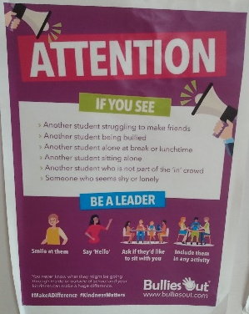
- I first saw this announcement on the doors entering the school and then again all over the school and in classrooms. Both the English and Welsh versions were side by side. It’s aims, to encourage positive relationships among students and create a positive learning culture are listed in different approaches working for the same outcome of inclusivity.

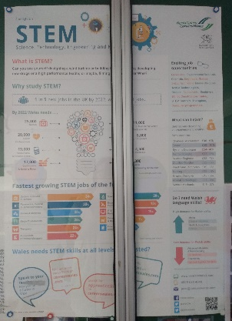
The corridors had plenty of displays of projects correlating to classrooms in said hall, science practical’s, periodic tables etc in the Science building. This STEM poster from Careers Wales outlines the subjects it promotes highlighting 1 in 5 jobs by 2022 will include Science, Technology, Engineering or Mathematics. Careers such as health professionals, accountants, engineers, scientists, and telecommunications are presented as possible paths for students specialising in the 4 main topics. Listed are the average wages for these professions, the opportunities they present and what qualifications are required. Statistics are provided as encouragement to pursue these STEM jobs as they are some the fastest growing of the future. Links are provided for further research if applicable.
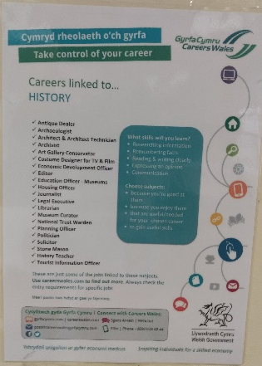
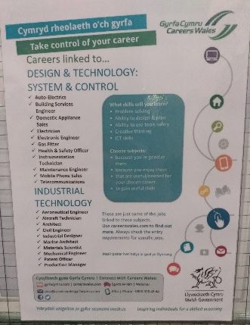

These Careers Wales posters were all over the school in the classrooms corresponding to their subject. They listed potential career paths linked to the subject and the skills you could gain learning them. A checklist for potential drives in choosing subjects for GCSE and A Level were enjoyment and talent in said subject, obtain skills needed for future career path. Contact information on all social media platforms are provided for further research. These resources provide pupils with a starting point for decisions they will be making in the years to come, they kick start the process of evaluating your strengths and weaknesses adhering to certain professions.
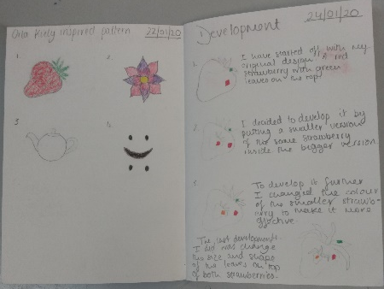
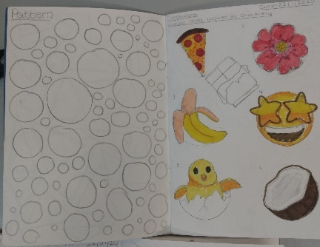
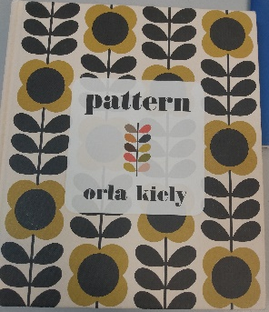

Year 10 Textiles gave me copious amounts of evidence for the New Curriculum, covering the 12 pedagogical principles and 4 purposes laid out over the 3 curricular skills. Pupils were following the design brief of a pencil case decorated with a pattern of their own design. Students took responsibility for their learning by researching the work of Orla Kiely, an artist specialising in pattern work to gain inspiration for their products. Literacy skills were present in the students written evaluations and recording of the process in designing their patterns throughout their coursework.
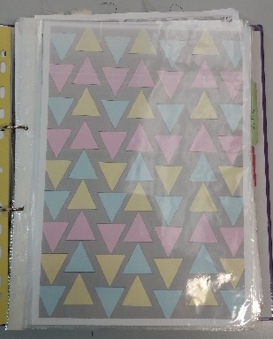
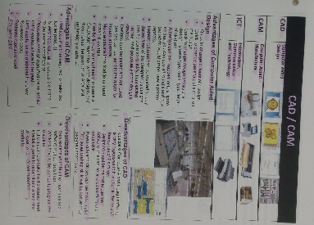

Pupils then converted their hand drawn designs to the computers using CAD (computer aided design) testing their digital competence. Students had to assess the advantages and disadvantages to using the programme then evaluate as they applied them to their projects. The process was repeated when the patterns were then transferred to CAM (computer aided manufacture) in order to be printed on fabric for the pencil cases.
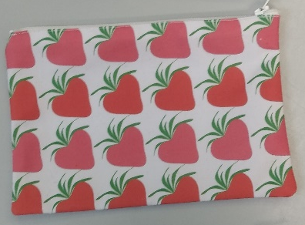
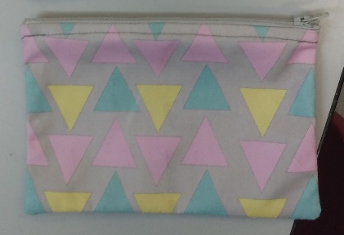
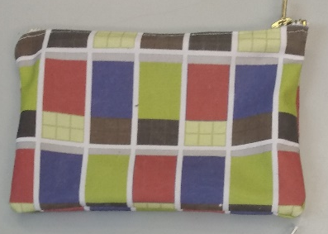

Once students had their fabric, they researched and tested stitching techniques and effective seams to use when sewing the fabric in order to create a pencil case. Once the shell of the pencil case was made, they attached zips using the same stitching techniques. Their evaluations were step by step analysis of materials, techniques, and thought processes written with key vocabulary terms for textiles. The brief challenged their responsibility for individual learning, creative thinking, problem solving, literacy, and digital competence skills; all meeting the 12 pedagogical principles.
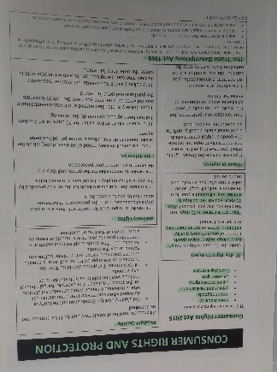

- Pupil folders were full of information on standard requirements of products and contemporary issues that arise when product designing. The consumer rights and protection section cover the Consumer Rights Act 2015 and the Trade Description Act 1968. Listed are the basic aims it fulfils and descriptions of the 30-day right to reject or return items, product quality expected from all manufacturers, and delivery rights in regards to timelines or damage. This information aids in creating ethically informed citizens as outlined in Donaldson’s 4 purposes.

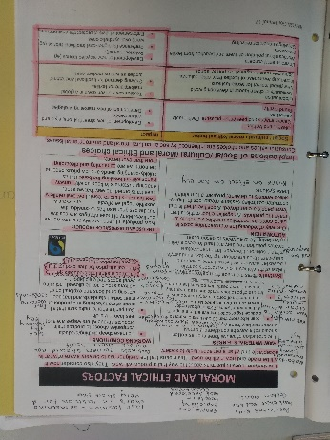
- Pupils were informed of the contemporary ethical issues behind the creation of Fairtrade. The production of RAW materials in natural fibres like cotton and synthetic fibres like polyester. Their environmental impact and process for obtaining are important factors to consider when choosing a material to work with. Manufacturing costs note that automation reduces costs but results in unemployment causing a knock-on effect in society. Companies can often use workshops and exploit workers to produce products, Fairtrade was founded to help prevent this buy offering realistic prices for products that cover the production fees. The information ethically educates students on realities of sweat shops, pollution, and the global market.
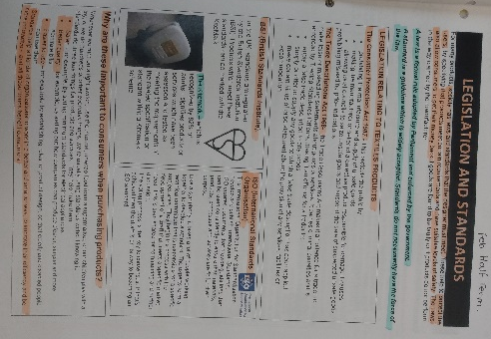
Legislation and standards basically provide students with definitive criteria for what their product must absolutely be in order to be sold. Information on companies that legislate products fit for sale are provided with explanations of their roles. Clarifications of why these organisations are important are given to increase pupil knowledge. BSI (British Standards Institute) ensure testing and assessments of a product for safety and ISO (International Standards Organisation) monitor materials used for maximum control over environmental impact.

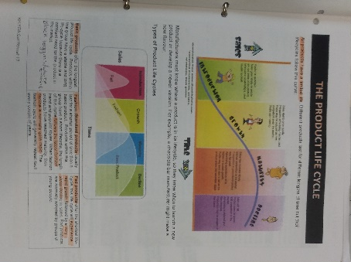
- Product life cycle is an important factor is choosing materials for manufacturing as the introduction, growth, maturity, and decline all have to be considered. PLC falls under the contemporary issue of recycling and environmentally friendly products. An element of problem solving applies to choosing certain materials for certain purposes and relating those to sale rates and time span. Students use the previous pieces of information to evaluate their work and create portfolios. The testing of various different methods and techniques before reaching their preferred process for making the final product.

Bibliography
Donaldson, G. (2015) Successful Futures. Available at: file:///C:/Users/Home/AppData/Local/Packages/Microsoft.MicrosoftEdge_8wekyb3d8bbwe/TempState/Downloads/Donaldson%20Report%20-%20Successful%20Futures%20(1).pdf [Accessed 17th February 2020]

Welsh Government. (2012) Practical Approaches to Behaviour Management in the Classroom. Available at: http://wales.gov.uk/docs/dcells/publications/120713primaryen.pdf [Accessed 17th February 2020]

Welsh Government, Practical Approaches to Behaviour Management in the Classroom (2012) p.9-13. Available at: http://wales.gov.uk/docs/dcells/publications/120713primaryen.pdf [Accessed 17th February 2020]
Practical Approaches, p.9-13
Practical Approaches, p.9-13
Practical Approaches, p.9-13
Practical Approaches, p.9-13
Practical Approaches, p.9-13
G. Donaldson, Successful Futures (2015) p.23. Available at: file:///C:/Users/Home/AppData/Local/Packages/Microsoft.MicrosoftEdge_8wekyb3d8bbwe/TempState/Downloads/Donaldson%20Report%20-%20Successful%20Futures%20(1).pdf [Accessed 17th February 2020]
Successful Futures, p.23
Successful Futures, p.23

