

Connecting Rod Accelerations, Forces and Displacements
Advanced Engine Design (M5X00404)
Student: Alex Oke (P151012)
Professor: Malcolm McDonald
Due Date: 04/11/2019
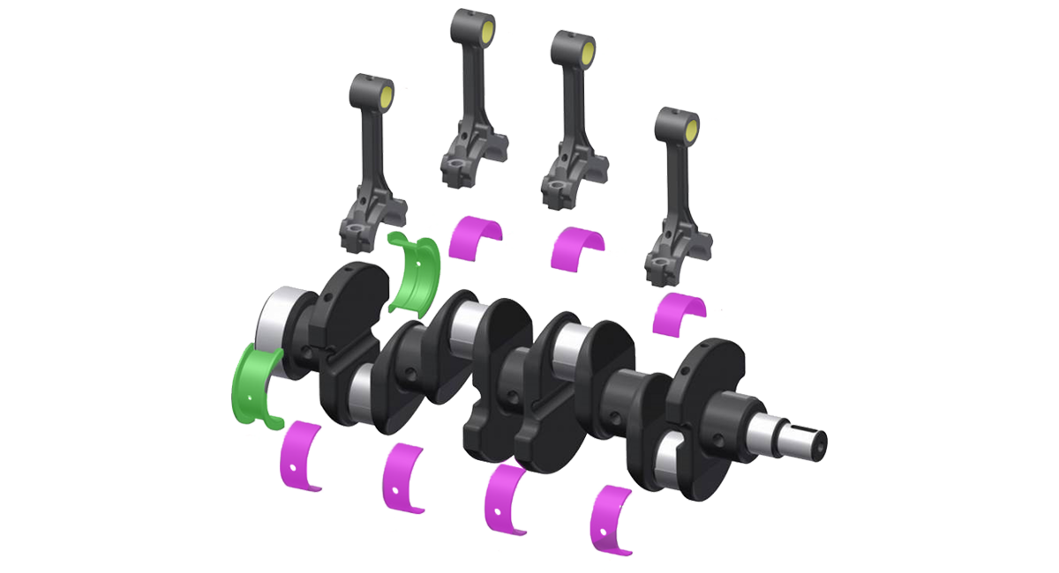
Table of Contents
1 Introduction 1
2 Preliminary Work/Modelling Techniques 2
3 Task A: Calculate the peak gas forces 4
3.1 Methodology 4
3.1.1 Production Engine 4
3.1.2 Modified Engine 4
3.2 Results 5
3.3 Analysis 5
4 Task B: Plot a graph of inertia loads which piston puts on rod against crank angle 6
4.1 Methodology 6
4.2 Results 7
4.3 Analysis 7
5 Task C: Calculate the highest net compressive force put on the rod 8
5.1 Methodology 8
5.2 Results 9
5.3 Analysis 9
6 Task D: Calculate the highest net tensile load put on the rod 10
6.1 Methodology 10
6.2 Results 11
6.3 Analysis 11
7 Task E: Using simple rod shank minimum cross-sectional area, calculate max compression and tensile stresses in rod shank 12
7.1 Methodology 12
7.1.1 Production Engine 12
7.1.2 Modified Engine 12
7.2 Results 13
7.3 Analysis 13
8 Task F: Calculate nominal safety factors for both tensile and compressive loads put on the rod 14
8.1 Methodology 14
8.1.1 Production Engine 14
8.1.2 Modified Engine 14
8.2 Results 15
8.3 Analysis 15
9 Task G: Calculate the maximum compression distance and tensile stretch in the rod using the stresses calculated in Task E 16
9.1 Methodology 16
9.2 Results 17
17
9.3 Analysis 17
10 Task H: Calculate the maximum compression distance and tensile stretch in the rod if it was made from Titanium 18
10.1 Methodology 18
10.1.1 Steel 18
10.1.2 Titanium 18
10.2 Results 19
19
10.3 Analysis 19
11 Analysis Conclusion 20
12 Appendix of Further Work 21
12.1 Frictional Model 21
12.1.1 Methodology 21
12.1.2 Results 22
12.2 Power and Torque 23
12.2.1 Methodology 23
12.2.2 Results 24
13 Derivations 25
14 Proof of own work 26

Introduction
One of the critical components of an internal combustion engine is the connecting rod. The rod at its little end connects to the piston forming a reciprocating motion, whilst at the big end it follows the rotational motion of the crankshaft. The conversion of piston motion to crankshaft rotation causes the connecting rod to be subject to complex loading patterns.
These complex loads are both compressive and tensile, the compressive being caused by the peak cylinder pressure’s resulting gas force due to combustion, whilst the tensile loads are caused by the inertial force which the piston transfers to the connecting rod. Considering this fact, the maximum compressive and tensile loads are considered in the design process as this is where the connecting rod is known to fail.
In this report, simple load analysis on a Ford Sigma 1.6 connecting rod has been documented and graphical results are documented within. The Ford Sigma 1.6 production engine has a maximum of 6000rpm, so to see what effect of increased engine rotational speed has on the loads being subjected to the connecting rod, a logarithmic extrapolation to take the limit to 9000rpm was completed.
An investigation upon why the loads occur when they do is what the primary aim of this report sets out to achieve. Linking the increased inertia, forces and rod displacements in a concise document showing how this has been carried out.
Lastly, throughout the report there are tables of information which have been colour coded, a key has been identified below.

Preliminary Work/Modelling Techniques
Data for the Ford Sigma 1.6 production engine was provided, however, to find the results for the same engine but with increased rpm has been calculated using a logarithmic trendline. The original limit was 6000rpm and now raised to 9000rpm. This can be simulated but for instance can have an increased rpm limit by changing the camshaft, increasing the turbo boost pressure or both combined with cylinder head work and reduced friction components.
Maximum cylinder pressure
Logarithmic Trendline= (25.584*LN(RPM)) - 124.9
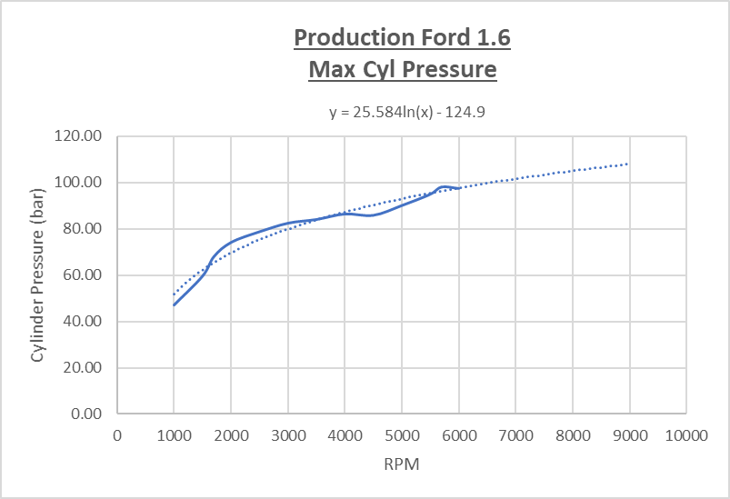
Figure 1 Production maximum cylinder pressure over all engine speeds

Maximum net compressive force
Logarithmic Trendline= (9167.6*LN(RPM)) - 35561
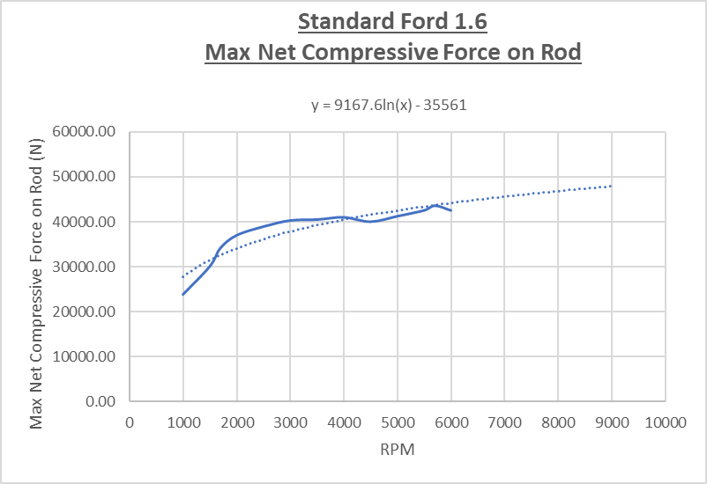
Figure 2 Production maximum net compressive force over all engine speeds

Maximum net tensile force
Linear Trendline = (1.6111*RPM) - 3800
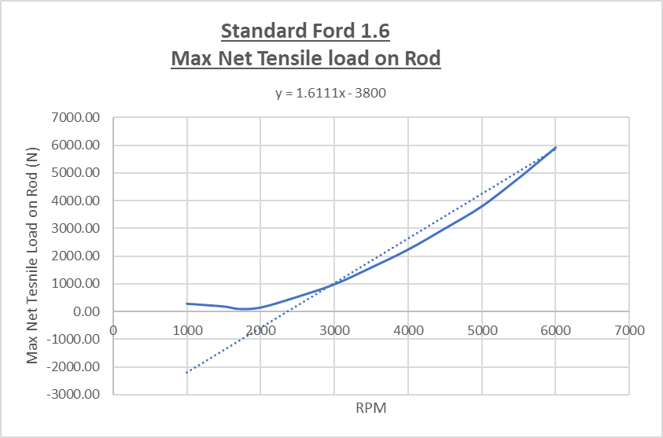
Figure 3 Production maximum net tensile load over all engine speeds

Inertia loads at increased RPM
In order to find the inertia loads that the piston is putting on the rod vertically, the simple method for this was to increase the angular velocity with the following results:
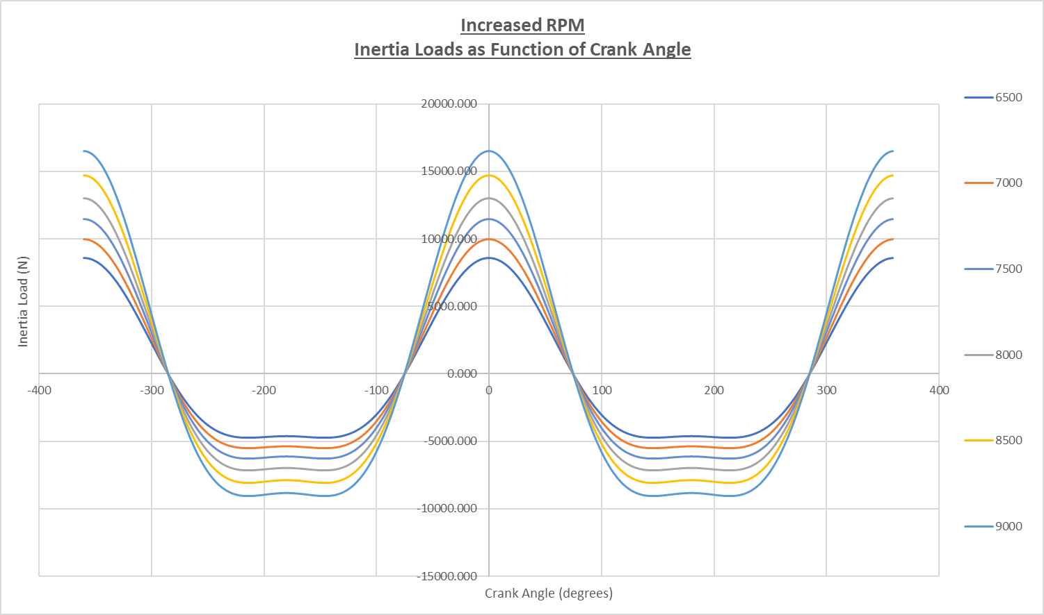
Figure 4 Table showing angular velocities

Figure 6 Screenshot from data tables of modified engine inertias from the piston acceleration
Figure 5 Graph showing the inertia loads against crank angle for modified engine

Task A: Calculate the peak gas forces

Methodology
$$Peak gas force=Peak cylinder pressure∙ Cylinder bore area$$
Where:
Peak cylinder pressure = Nm²
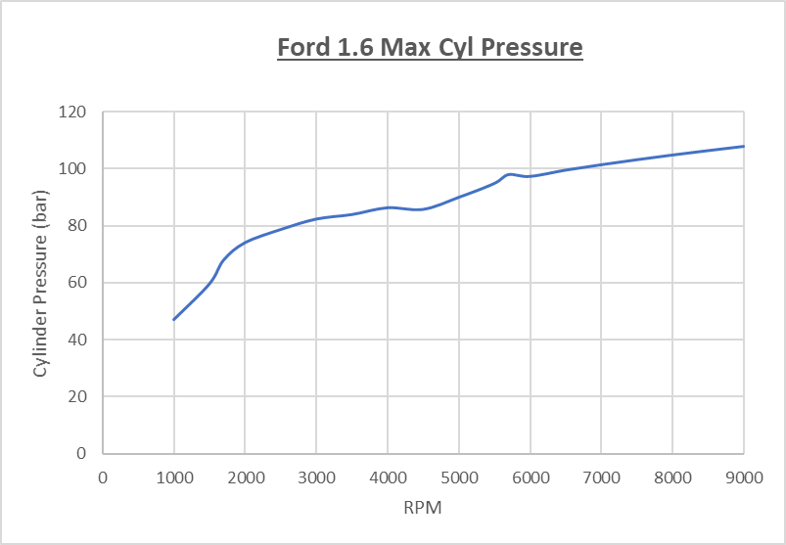
Cylinder bore area = m²
Figure 8 Graph showing maximum cylinder pressure for all RPM’s
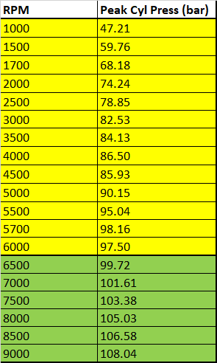
Figure 7 Table of peak cylinder pressures

Production Engine
$$Peak gas force=\left(98.158×{10}^{5}\right)×π ×\frac{{0.08}^{2}}{4}$$
$$= 49339.59 N$$
$=$4.9 𝑇𝑜𝑛𝑛𝑒𝑠

Modified Engine
$$Peak gas force=\left(108.042×{10}^{5}\right)×π ×\frac{{0.08}^{2}}{4}$$
$$= 54307.83 N$$
$$= 5.4 Tonnes$$

Results
Figure 9 Tables showing peak cylinder pressure with peak gas force for all RPM’s

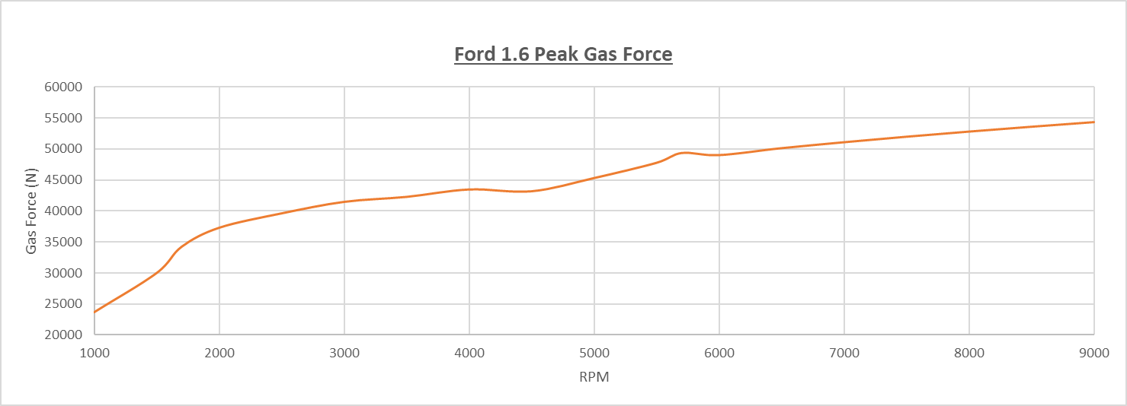
Figure 10 Graph showing the peak gas forces against RPM

Analysis
With increasing cylinder pressures at higher rpm’s due to more air and fuel being sucked into the cylinder due to different cams for the higher revving engine, this results in an increased gas force.
The Table of results above show the trend of higher peak cylinder pressure directly correlates to a higher peak gas force, this is caused by the equation involving the cylinder pressure to calculate the gas force.

Task B: Plot a graph of inertia loads which piston puts on rod against crank angle

Methodology
To find inertia loads which piston puts on the connecting rod, these processes must be completed first.
Angular Velocity (ω) (rad/s) for each rpm:
$ω$$=2∙π∙\left(\frac{RPM}{60}\right)$

Figure 11 Table showing angular velocities for all RPM’s
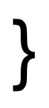
Piston Acceleration $\left(\frac{d^{2}s}{dt^{2}}\right)$(m/s²) at each crank angle $(θ)$:
$$Piston Acceleration=\left(Rω^{2}∙\cos{θ }\right)+ \left(\frac{R}{L}∙Rω^{2}∙\cos{2θ}\right)$$
2nd Order
1st Order

Due to Newton’s 2nd Law $F=m∙a$, this is the Inertia force equation:
$$F_{Inertia}= {Mass}_{Piston}∙{Acceleration}_{Piston}$$
To re-solve this force for the inertia being put through the connecting rod:
$$F_{Inertia Resolved}= \frac{\left({Mass}_{Piston}∙{Acceleration}_{Piston}\right)}{cos∙\left(rod angle(radians)\right)}$$

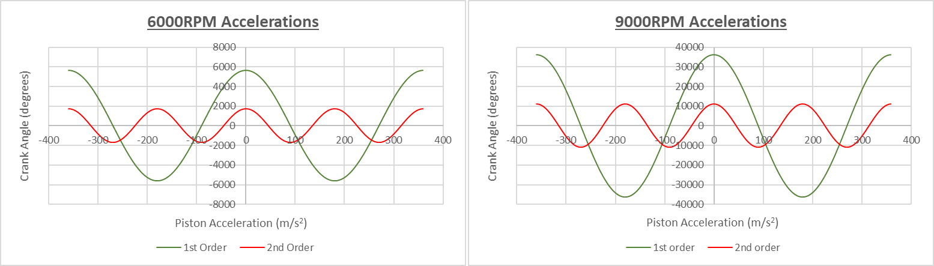
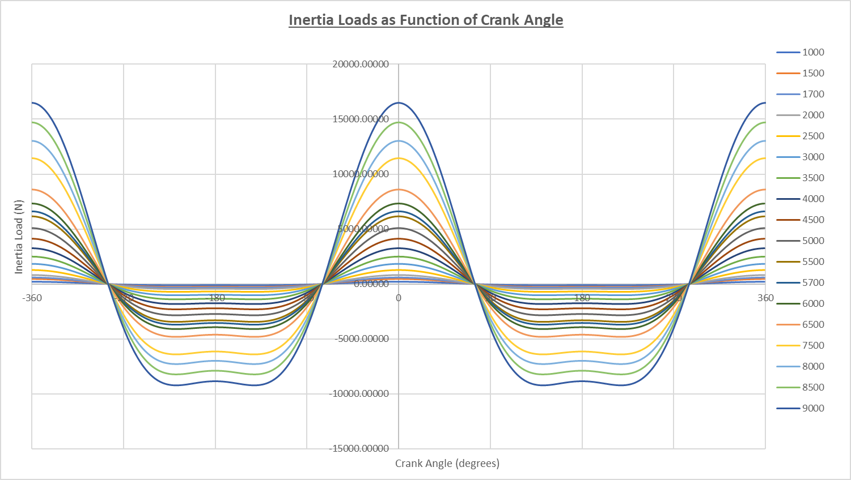
Results
Figure 13 Graphs showing the 1st and 2nd order acceleration for 6000rpm and 9000rpm
Figure 12 Graph showing the inertia loads for all RPM’s against crank angle

Analysis
The graph above shows the inertia forces which the connecting rod is being subjected to, below that the correlation of piston acceleration and inertial loads of the 1st and 2nd order.
Highlighted in green are the tensile loads being put on the conrod, whilst, in red are the compression loads. These loads are increasing as the engines rotational crank RPM is increasing, thus proving that the increased angular acceleration, the higher the inertia loads put on the connecting rod from the reciprocating motion of the piston. The point at which the inertia switches between tensile and compression is generally found at Piston V_{max} which translates to roughly 80° ATDC and 80° BTDC where piston acceleration is 0 as the piston has evidently reached terminal velocity.

Task C: Calculate the highest net compressive force put on the rod

Methodology
This equation below gives a force acting on the rod vertically for each crank angle:
$$F_{Net Rod}=F_{Gas}- F_{Inertia}$$
To calculate rod angle ($φ$) as used in inertia calculation:
$$φ= \sin^{-1}\left(\frac{R}{L}∙\sin{θ}\right)$$
Force on the rod resolved for rod angle during crank rotation:
$$F_{Net Rod Resolved}=\frac{\left(F_{Gas}- F_{Inertia}\right)}{\cos{φ}}$$
The highest which is a positive value over the 720-degree 4 stroke cycle is the maximum net compressive load (N) acting on the rod, whilst the lowest value which is negative is the maximum net tensile load (N) put through the rod.
Figure 14 Production maximum compressive force on rod for all RPM’s

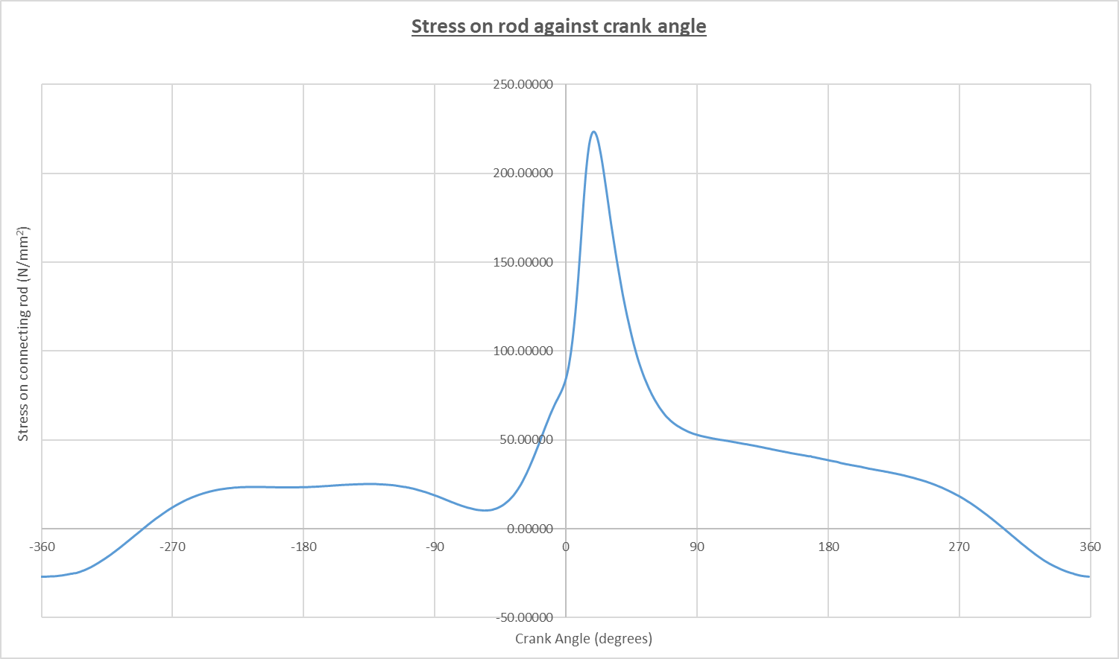
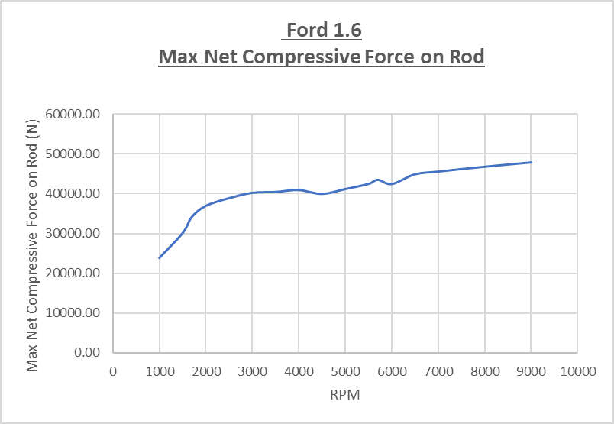
Results
Figure 16 Graph of maximum net compressive load on the rod for all RPM’s
Figure 17 Graph showing the stress which the rod is subjected to against crank angle
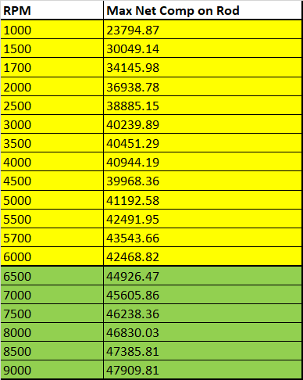
Figure 15 Table of maximum compressive force on rod for all RPM’s

Analysis
The relationship between increased engine rotational speed and increase in compressive load on the connecting rod can be seen in Figure 15.
To show the influence which ignition and combustion has on the compressive force being exerted on the rod, Figure 17 is key. Peak stress on the conrod is occurring at the same time as peak cylinder pressure and gas force which is putting an increased load on the top of the piston being transferred to the connecting rod, causing a compression in the rod.

Task D: Calculate the highest net tensile load put on the rod

Methodology
The same technique was used to find the highest net tensile load put on the rod as was used to find the highest net compressive force on the rod.
Force on the rod resolved for rod angle during crank rotation:
$$F_{Net Rod Resolved}=\frac{\left(F_{Gas}- F_{Inertia}\right)}{\cos{φ}}$$
Over the 720-degree 4 stroke cycle, the lowest value which is negative is the maximum net tensile load (N) put through the rod.

Figure 18 Graph showing the production maximum tensile load on the rod for all RPM’s

Results
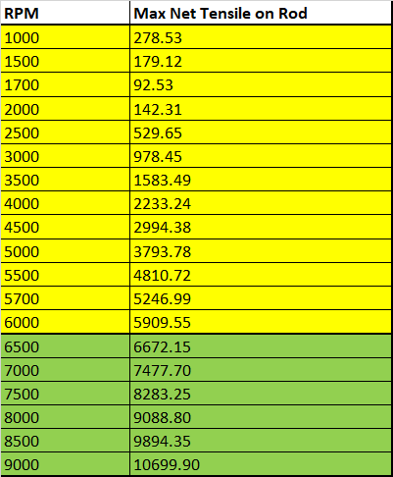

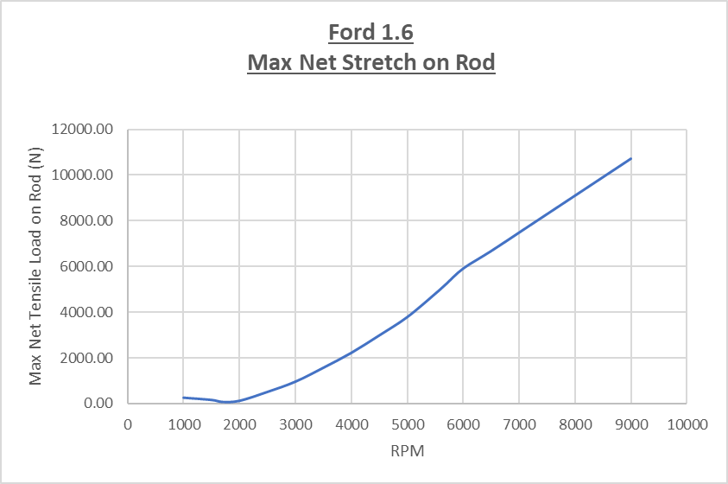
Figure 19 Table showing the maximum tensile loads on the conrod for all RPM’s
Figure 20 Graph showing the maximum tensile loads on the conrod for all the RPM’s

Analysis
Where maximum compressive force is influenced and caused by combustion in the cylinder, the inertia force from the piston acting on the rod is where the maximum tensile force is being exerted onto the rod. Figure 20 shows the increase of RPM is proportional to the increase in tensile force place on the rod, this is due to the increased inertia from the faster reciprocating motion of the piston.
As the piston acceleration and angular acceleration of the crank increases, this causes a higher tensile force acting on the rod, this can be seen in the table Figure 19 against all RPM’s.

Task E: Using simple rod shank minimum cross-sectional area, calculate max compression and tensile stresses in rod shank

Methodology
$$Maximum compression rod shank stress=\frac{F_{Compressive}}{Cross sectional area}$$
$$Maximum tensile rod shank stress=\frac{F_{Tensile}}{Cross sectional area}$$
Where:
F _{Compressive} = Max net compressive force on rod (N)
F _{Tensile} = Max net tensile force on rod (N)
Cross-sectional area = Minimum rod shank cross-sectional area (mm²)

Production Engine
$$Maximum compression rod shank stress=\frac{43537.96}{195}$$
$$=223.27160 N/{mm}^{2}$$
$$Maximum tensile rod shank stress=\frac{5922.21}{195}$$
$$=30.37033 N/{mm}^{2}$$

Modified Engine
$$Maximum compression rod shank stress=\frac{47909.81}{195}$$
$$= 245.69133 N/{mm}^{2}$$
$$Maximum tensile rod shank stress=\frac{10699.90}{195}$$
$$=54.87128 N/{mm}^{2}$$

Results
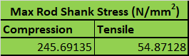
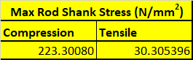
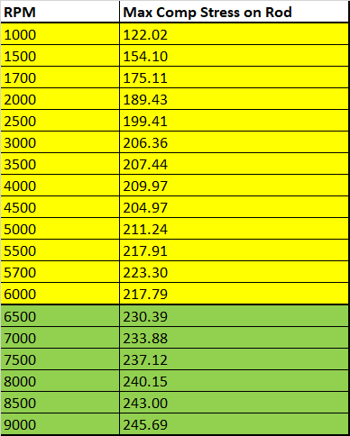
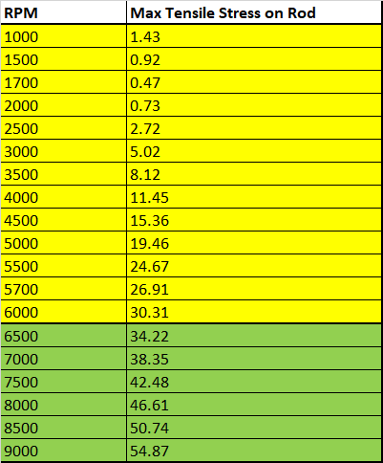

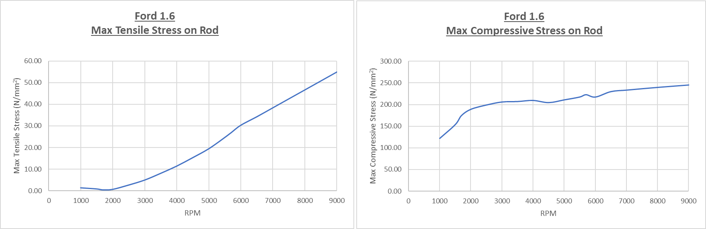
Figure 21 Tables showing the results from the rod shank compression and tensile stresses on the rod across all RPM’s
Figure 22 Graphs showing the maximum tensile and compressive stress which the rod is subjected to across all RPM’s

Analysis
In Figure 21, it can be seen again the production engine and modified engine with increased RPM follow the same pattern as the tensile force exerted on the rod.
Figure 22 display the increased inertia and piston acceleration effecting the tensile stresses put on the rod in a linear relationship which is as expected, however, the compressive stress put on the rod shows that with increased engine speed this is not as much of a factor as the increased cylinder pressure is what causes the increase in compressive stress.
The cylinder pressure only rising by 10.54 bar between 6000rpm and 9000rpm means the increase in compressive stress placed on the rod is not as exponential as that of the tensile stresses.

Task F: Calculate nominal safety factors for both tensile and compressive loads put on the rod

Methodology
Figure 23 Table of material properties for powder forged steel

$$Static safety factor= \frac{UTS}{Nominal Stress}$$
$$Static safety factor= \frac{UTS}{Nominal Stress}$$
Where:
UTS = Ultimate Tensile Strength of material
Nominal Stress = $\frac{F_{Net}}{Cross sectional area}$

Production Engine
$$Tensile safety factor= \frac{750}{30.30539}$$
$$= 24.74$$
$$Compressive safety factor= \frac{750}{223.30080}$$
$$= 3.35$$

Modified Engine
$$Tensile safety factor= \frac{750}{54.87128}$$
$$= 13.66$$
$$Compressive safety factor= \frac{750}{245.69135}$$
$$= 3.05$$

Results
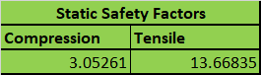
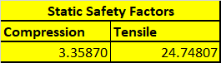
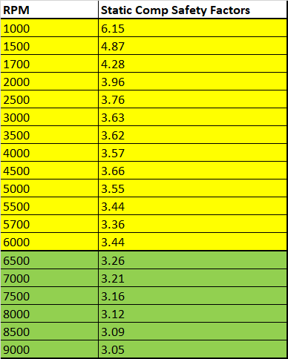
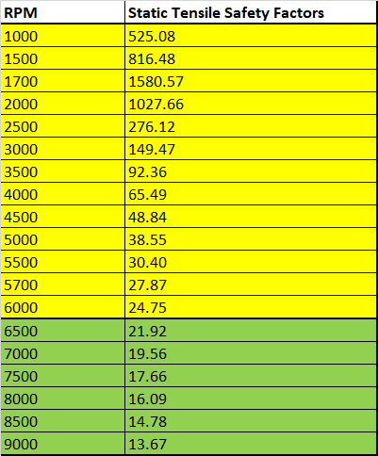

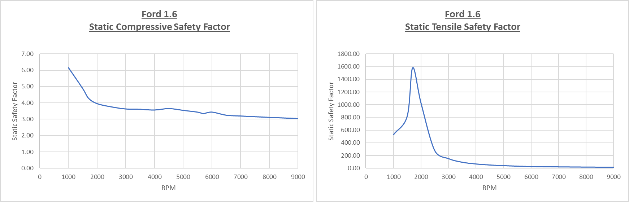
Figure 24 Tables showing the compressive and tensile static safety factors for all RPM’s
Figure 25 Graphs showing the compressive and tensile static safety factors for all RPM’s

Analysis
The Figure 25 graphs show results for the powder forged steel connecting rod under compressive stress through the smallest cross-sectional area of the rod shank. With production RPM limit, the connecting rod has been designed with a safety factor of 3.44 and when increased to 9000rpm the rod is 3.05 so this is still within the manufacturer’s guidelines of a safety factor of ≅ 3.
Figure 25 suggests that from what the manufacturer has defined as a safety factor for 6000rpm is not deemed safe at 9000rpm, this is due to the increased piston acceleration causing greater momentum exerted on the rod.

Task G: Calculate the maximum compression distance and tensile stretch in the rod using the stresses calculated in Task E

Methodology
$$Rod Displacement \left(x\right)= \frac{σ∙A}{K}$$
Where:
σ = Stress (N/mm²)
A = Rod Shank Cross-sectional area (mm²)
L = Conrod length (mm)
E = Young’s Modulus (GPa)
K = Rod Stiffness (N/mm)
$$K=\frac{E ∙A}{L}$$
To get Rod Displacement as the subject, a transposition must be completed as below:
2
1
$$F= K∙x$$
$$σ= \frac{F}{A}$$
Substitute 1 into 2:
$$∴ σ= \frac{K∙x}{A}$$
$$∴ σ∙A= K∙x$$
$$∴ x= \frac{σ∙A}{K}$$

Results
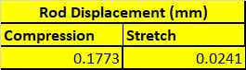
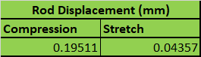

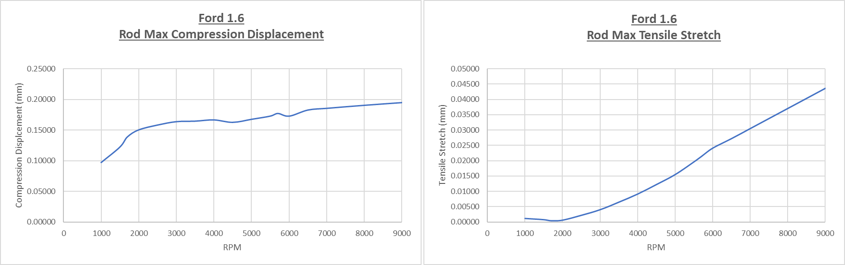
Figure 26 Tables showing the compression and tensile rod displacement for all RPM’s using powder forged steel
Figure 27 Graphs showing the maximum compression displacement and tensile stretch in the connecting rod for all RPM’s using powder forged steel

Analysis
Figure 26 is showing the maximum rod displacement for both production engine and modified engine with increased RPM, along with the compression and tensile rod displacement across all RPM’s for powder forged steel.
Figure 27 shows, with a rise of cylinder pressure as the rpm rises from different cams in the engine for the modified version, the rod is compressed more due to this. As the gas force which is consequently rising from a greater cylinder pressure it is causing the greatest compression force on the rod at combustion, therefore rising with a greater cylinder pressure as rpm rises.
The tensile stretch in the rod is affected by the increased rpm as the inertia force on the rod is rising creating a linear pattern in tensile stretch and inertia and acceleration from the piston motion converted to angular motion on the crank.

Task H: Calculate the maximum compression distance and tensile stretch in the rod if it was made from Titanium

Methodology
Figure 28 Table of material properties for Titanium and Powder forged steel

To find the connecting rod’s deformation displacement with Titanium as the material, the Young’s Modulus must be changed for that of Titanium as can be seen in the table above.
Changing the Young’s Modulus for Titanium results in a different value for K:
$$K=\frac{E ∙A}{L}$$

Steel
$$K=\frac{(170×{10}^{3}) ∙195}{135}$$
$$=245555.6 N/mm$$

Titanium
$$K=\frac{(110×{10}^{3}) ∙195}{135}$$
$$=158888.8 N/mm$$
The final calculation to find the connecting rod deformation displacement for both the compression and tensile directions, the same equation as used in Task G has been applied.
$$x= \frac{σ∙A}{K}$$

Results
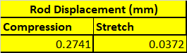
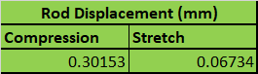
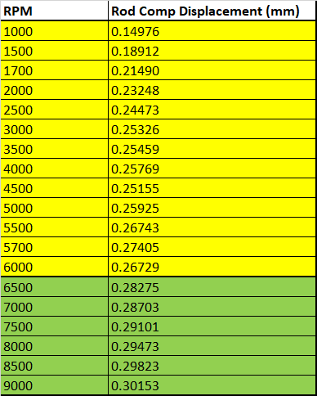
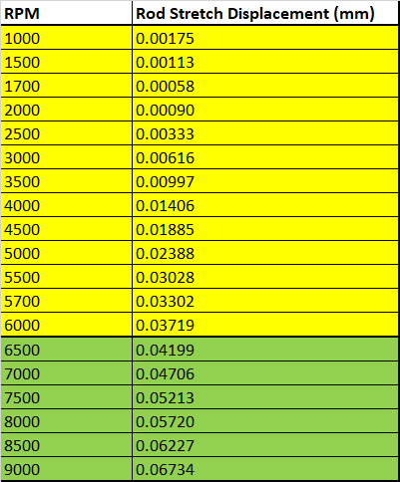

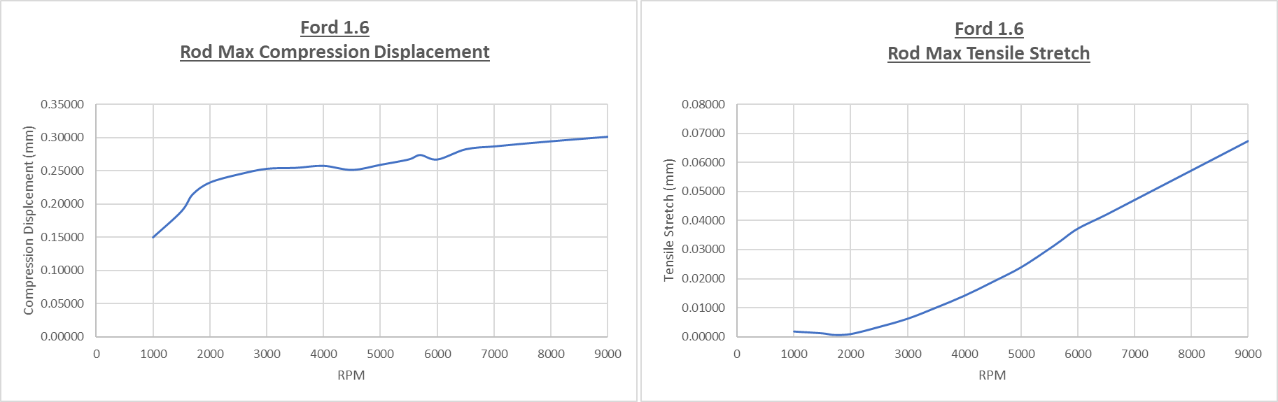
Figure 30 Graphs showing the maximum compression displacement and tensile stretch in the connecting rod for all RPM’s using Titanium
Figure 29 Tables showing the compression and tensile rod displacement for all RPM’s using Titanium

Analysis
The rod deformation distance through the compression and tensile directions is shown in Figure 29 and proving that the use of Titanium is causing a higher compressive distance and tensile as opposed to that of the powder forged steel conrod from Ford.
This is caused by the lower young’s modulus that Titanium has compared to that of Powder forged steel as shown in Figure 28. This causes the Stiffness (N/mm) of the conrod to reduce significantly. This is what is causing an increase in the compression distance of the rod, however, the tensile distance which the rod is rising still however the safety factor for tensile stress will be closer to that of the manufacturers due to the higher UTS value which Titanium has. Operating clearances will be affected with a reduction of compression ratio when the rod is under a compressive load and an increase in ratio when the rod is experiencing tensile stretch.

Analysis Conclusion
In an internal-combustion engine, the connecting rod which is pin jointed between the piston and crankshaft is subjected to compression and tensile forces. These forces are varying throughout the 720 cycle of a 4-stroke engine.
Intake stroke: Tensile force, as the piston accelerates it hits peak inertia force which creates a tensile force stretching the rod, this is the maximum tensile stress seen.
Compression stroke: Compressive force, at the end of the compression stroke, the mixture which is ready to combust is forcing down on the piston as it reaches the top of this stroke.
Power stroke: Compressive force, as the mixture in the cylinder combusts, the peak gas force acting vertically on the piston is being exerted onto the rod which causes the peak compression stress and distance which the rod will see.
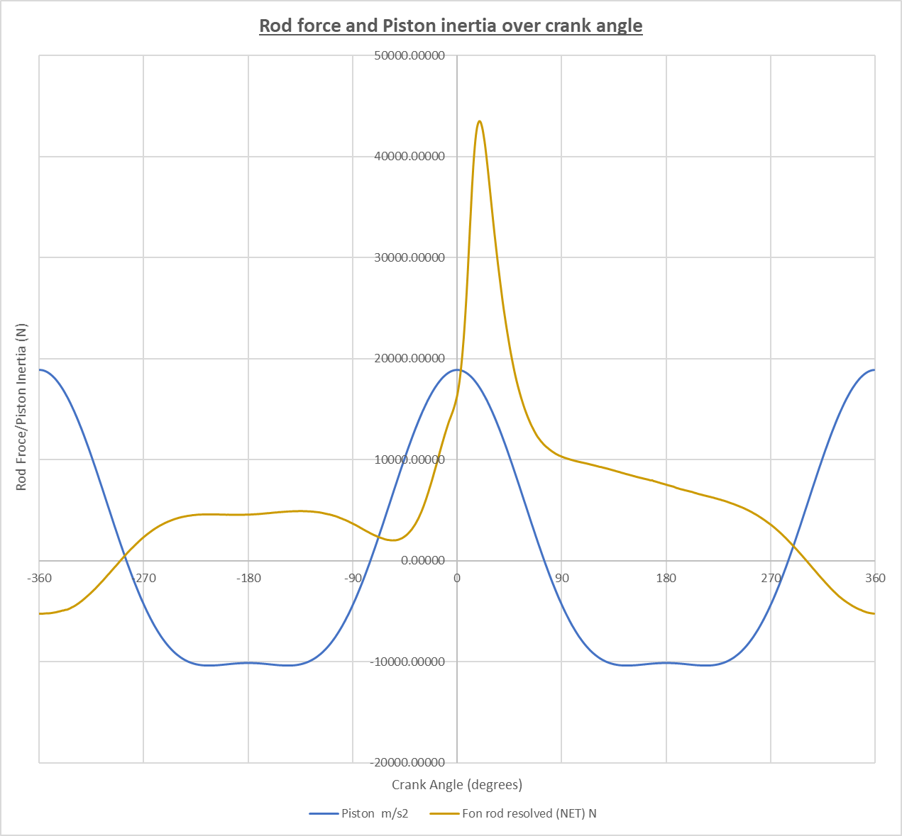
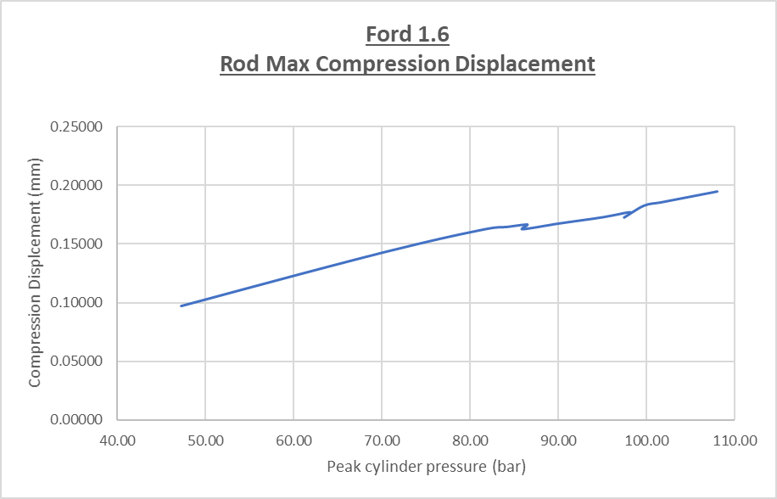
Exhaust: Tensile force, the exhaust gases are occupying the cylinder therefore there is a small opposing force which the rod meets but not as high as the vacuum process occurring due to lower pressure outside the engine where the gases are trying to escape to. This means there is not much of a force being exerted to the rod during this cycle however at the top of the exhaust stroke the rod will be stretched due to the mass of the piston pulling up on the rod.

Peak compression force, at combustion.

Peak tensile force, at peak inertia from piston.

Appendix of Further Work

Frictional Model

Methodology
Where:
φ = Rod angle
$μ$ = Co-efficient of friction
P = Cylinder pressure (N/m²)
H = Height of piston ring
Skirt friction
First step was to find the side force:
$$F_{Side}= F_{Net}∙\tan{φ}$$
To find friction from side of piston (skirt):
$$F_{Skirt Friction}= F_{Side }∙ μ$$
Work done by skirt friction:
$$Work Done (Joules) =\frac{{F_{Skirt Friction}}_{1}+{F_{Skirt Friction}}_{2}}{S_{2}-S_{1}}$$
Ring Friction
The radial force of the ring being pushed out from the piston due to gas force:
$$F_{Radial} (N)= P∙Surface area of rings contact on cylinder$$
$$F_{Radial}=P∙ \left(π∙bore∙H\right)$$
To find friction from piston ring:
$$F_{Ring Friction}= F_{Radial }∙ μ$$
Work done by ring friction:
$$Work Done (Joules) =\frac{{F_{Ring Friction}}_{1}+{F_{Ring Friction}}_{2}}{S_{2}-S_{1}}$$

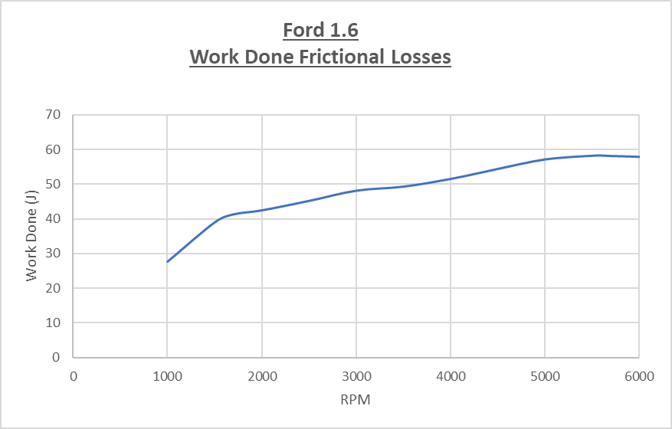
Results

Power and Torque

Methodology
Where:
R = Crank throw radius
$θ$ = Crank angle
$φ=$ Rod angle

Gas Torque
$$Gas Torque=F_{Gas}∙\left(R∙\sin\left(θ+φ\right)\right)$$
Average gas torque per cylinder:
$$Gas Torque per Cyl= \frac{Σ({Gas Torque }_{360}^{-360})}{720}$$
Total gas torque for engine:
$$Gas Torque Total= Gas Torque per Cyl∙\# of cylinders$$

Instantaneous Inertia Torque
$$Inertia Torque=F_{Inertia}∙\left(R∙\sin\left(θ+φ\right)\right)$$
Average inertia torque per cylinder:
$$Inertia Torque per Cyl= \frac{Σ(Inertia {Torque }_{360}^{-360})}{720}$$
Total inertia torque for engine:
$$Inertia Torque Total= Inertia Torque per Cyl∙\# of cylinders$$

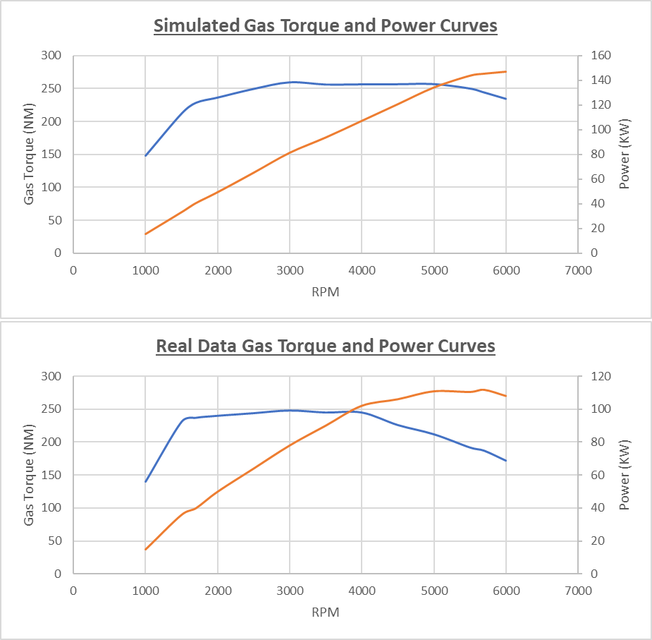
Results

Derivations
Where:
R = Crank Radius
L = Conrod Length
S = Stroke
Piston Position

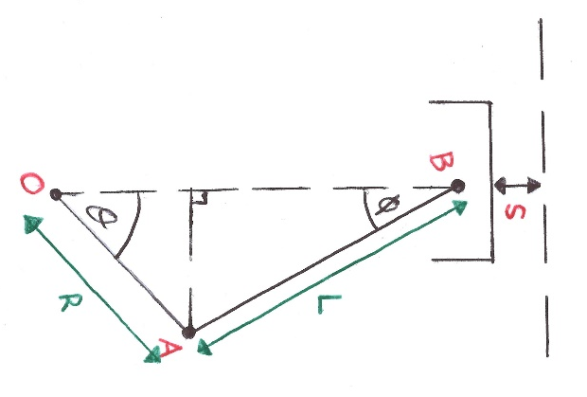

$$S=\left(R+L\right)-{OB}_{New}$$
$$OB=φC+CB$$
$$\left(∆OAC\right) OC=R∙\cos{θ}$$
$$\left(∆ABC\right) CB=L∙\cos{φ}$$
Therefore,
$$OB=R∙\cos{θ}+L∙\cos{φ}$$
$$S=\left(R+L\right)-(R∙\cos{θ}+L∙\cos{φ)}$$

Proof of own work



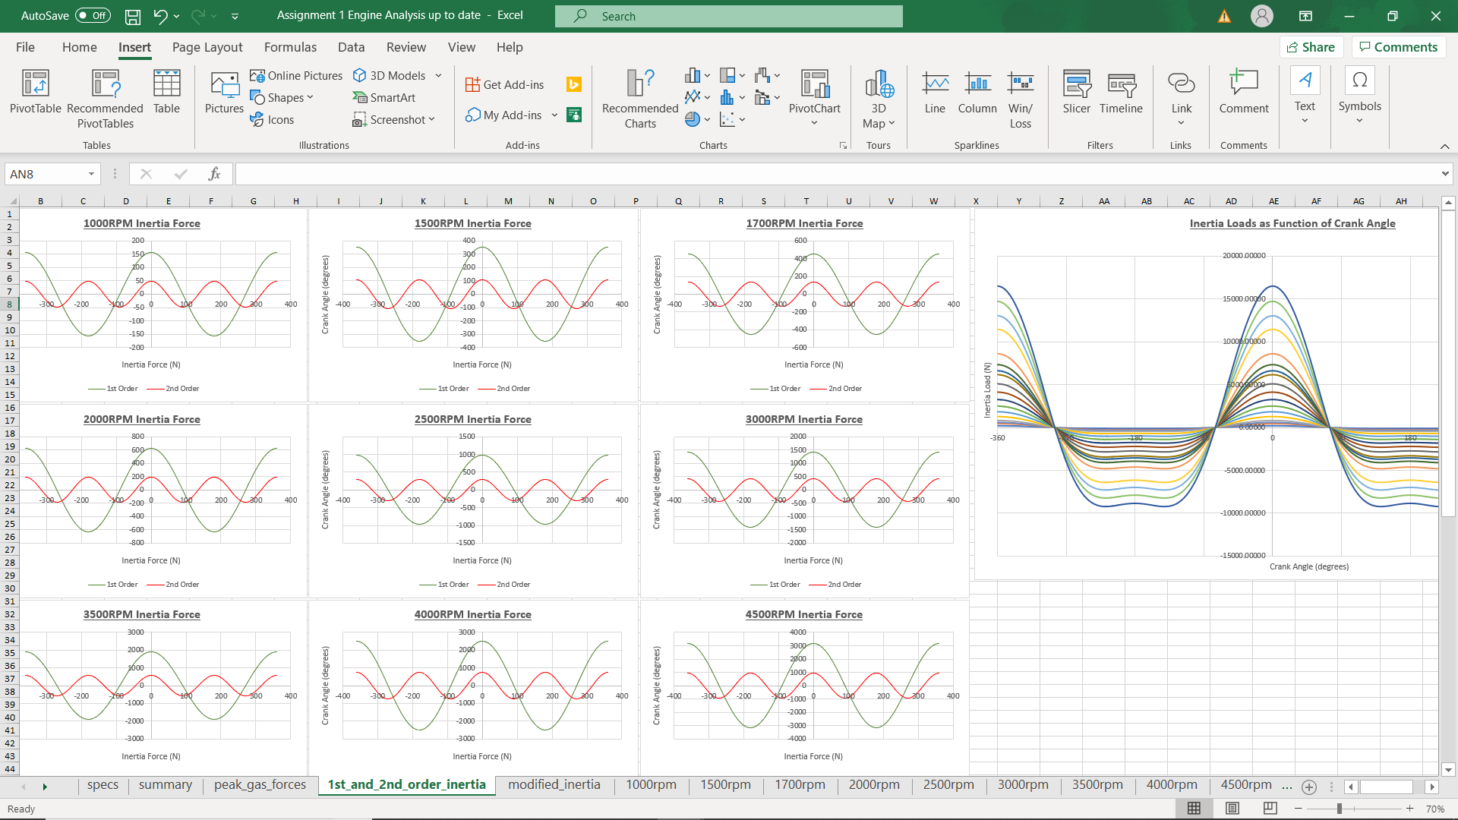
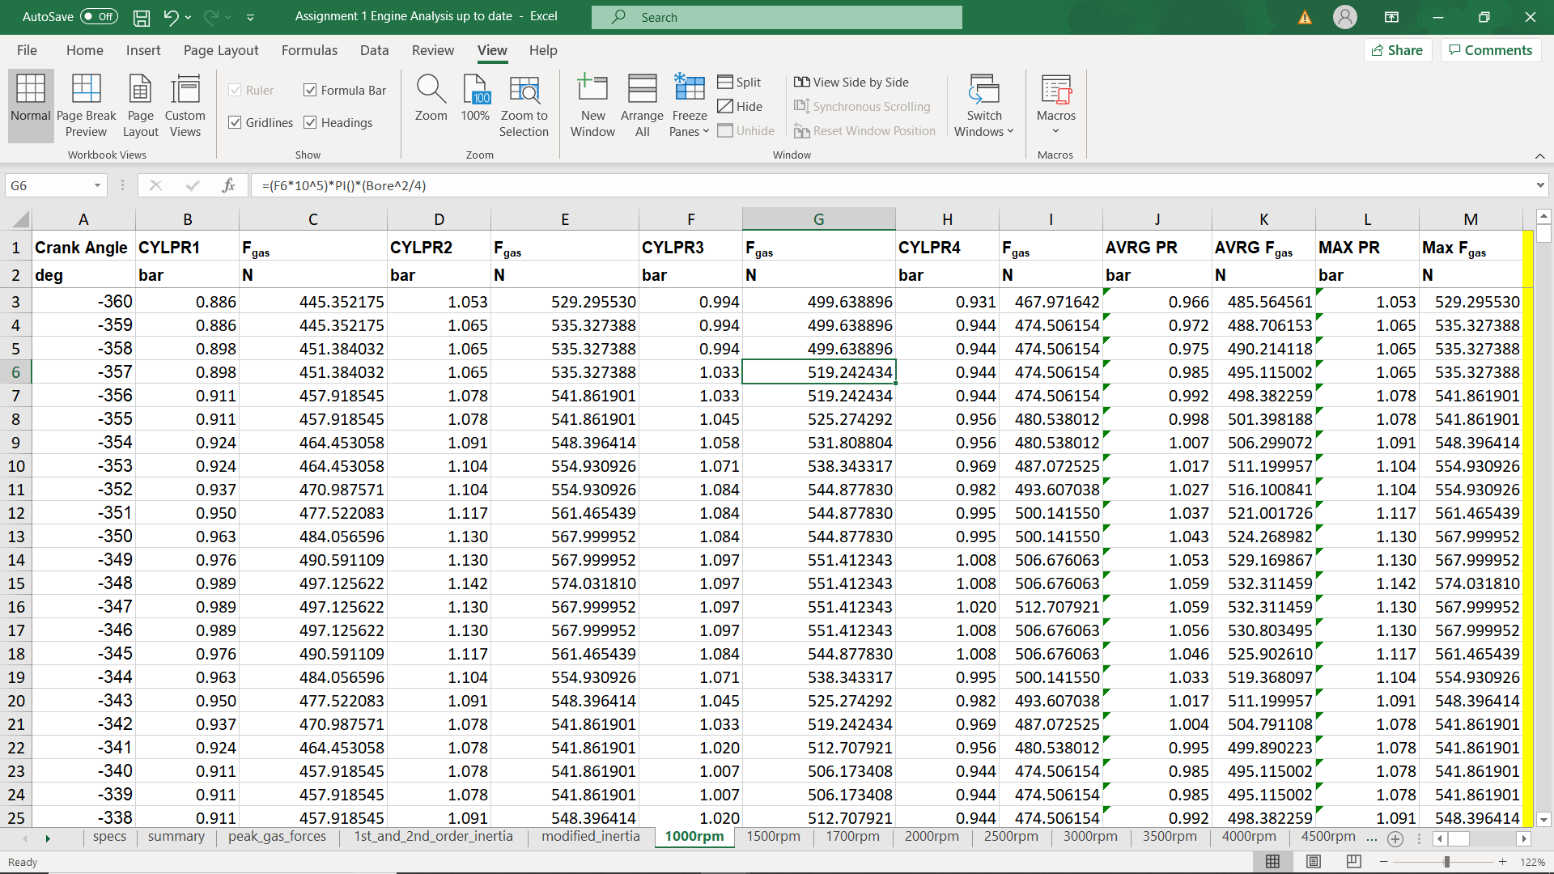
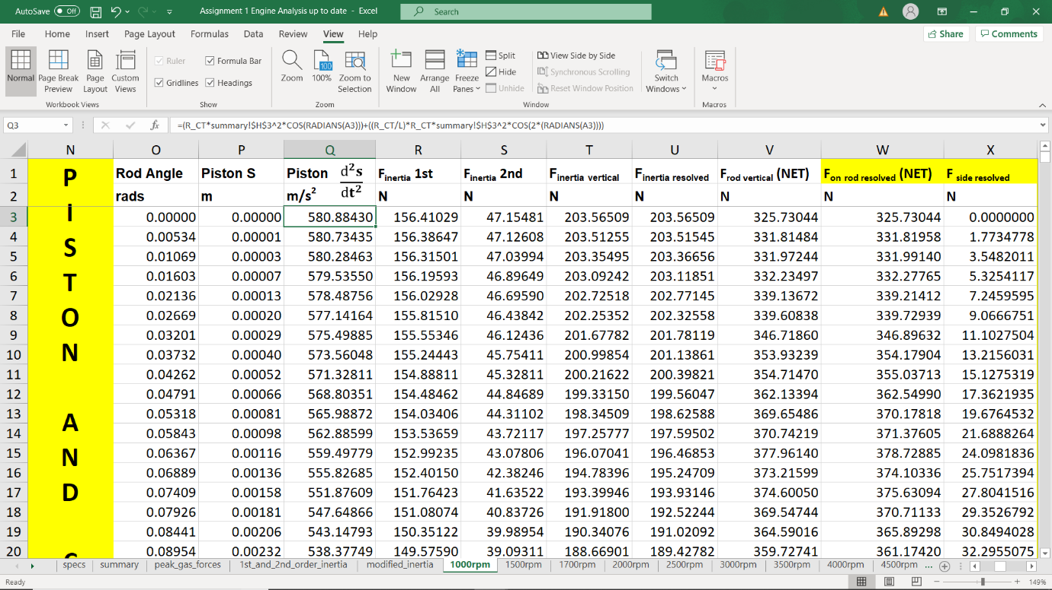


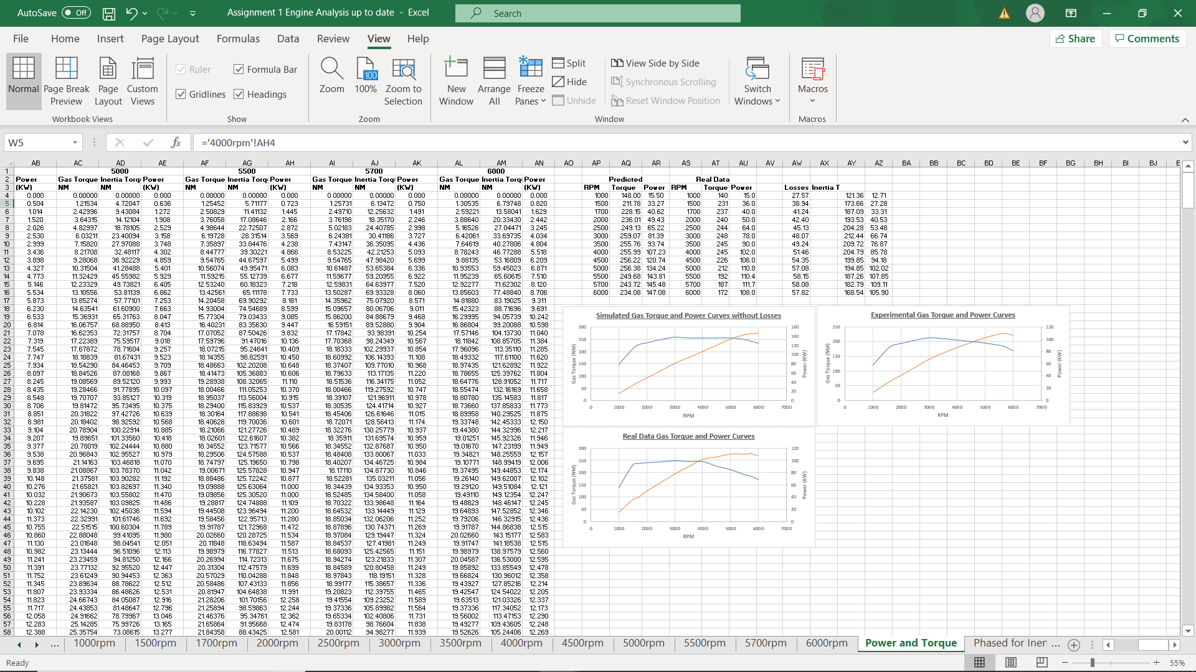
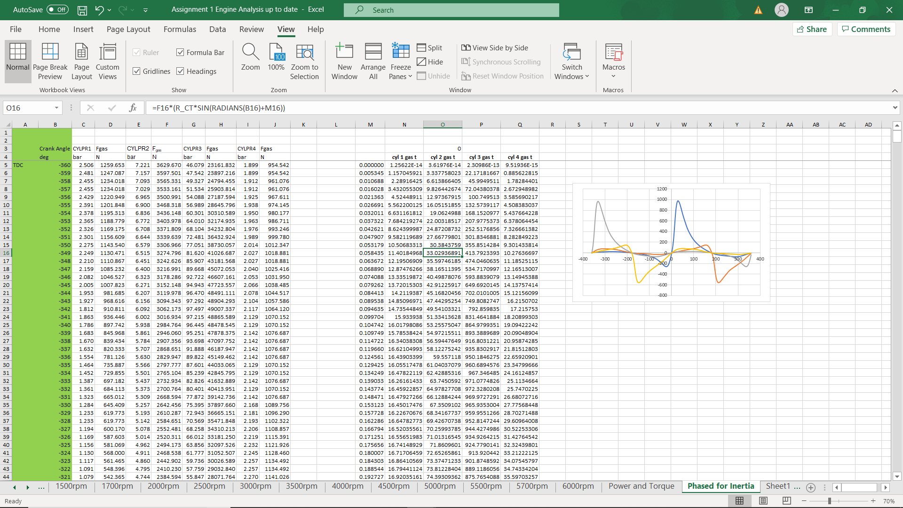

Bibliography

BOSCH, n.d. BOSCH Automotive Handbook. s.l.:s.n.
Taylor, 1985. Internal Combustion Engine in Theory and Practice. Volume 2 ed. s.l.:The MIT Press.

