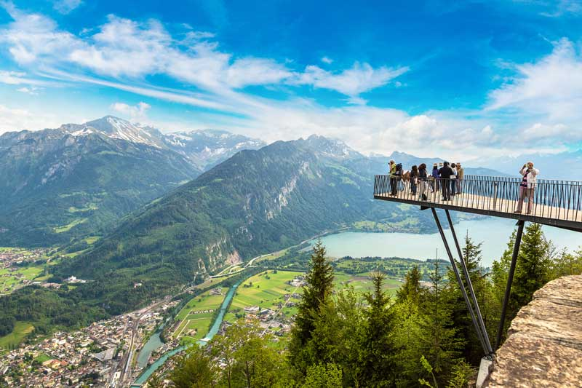
Travel Review
Interlaken, one of the most popular destinations for tourists to visit when in Switzerland, is located on an alluvial plain, in the middle of Lake Brienz and Lake Thun. Home to many adventurous activities, Interlaken is a focal point for all adventure tourists whom visit Switzerland annually for the snow related happenings.
Source: HolidaysToEurope, (2017).
Known for its impressive mountain scenery, the town is surrounded by Eiger Mountain, Jungfrau Mountain and Mönch Mountain – providing the perfect mixture between scenic and city tourism. These forms of tourism are known as ‘niche tourism’, a form of tourism that offers ‘greater opportunities and a tourism that is more sustainable, less damaging and, importantly, more capable of delivering high-spending tourists’ (Robinson & Novelli, 2005).
The idea of niche tourism is to define specific types of tourists and market/offer products and services to these individuals. Segmentation and differentiation of the typical types of mass tourists allows for an easier and more meaningful experience for travellers – with travel organisations being able to meet their wants and needs more efficiently in this manner. In the 21st Century, mass tourism simply does not cater to all types of potential tourists, with the stereotypical package holiday not cutting it for most holidaymakers. Although mass tourism is and will likely continue to be the largest segment in the tourism industry, the sustainable impacts from this are worth noting in comparison to the effects of niche tourism.
Popular tourism destinations such as Spain, Turkey and Greece have all seen economic benefits from mass tourism, with improved infrastructure and new businesses coming hand in hand with this. However, where economic benefits have been displayed, environmental and sustainable impacts are often disregarded by these destinations and often, outweigh the positive impacts shown elsewhere.
Damages to wildlife, preserved areas, destinations natural beauty – along with pollution and waste issues, have been a key focal point in the emerging success of niche tourism (Marson, 2011). Simply put, niche tourism is allowing other destinations to shine for holidaymakers with specific wants and needs – providing economic benefits for the hosts and lower sustainable impacts than seen in mass tourist destinations.
The town of Interlaken welcomes an estimated 900,000 overnight stays per year, with typical guests visiting from Japan, the UK, the USA, China and domestic Swiss tourists (Interlaken Tourismus, n.d.). With the destination being one of the most popular in the country, it is sure to be one of the main contributors to Swiss tourism income: 46.7 billion in 2017, with 16 billion of this from international visitors (Schweizer Tourismus-Verband, 2018). After a recent visit to Interlaken, a review in terms of the destinations appeal and success to the niche market of adventure tourism can be found below – with first hand experiences of adventure tourism activities (e.g. ice skating and curling) and research into key performance indicators.

Interlaken and adventure tourism – success or failure?
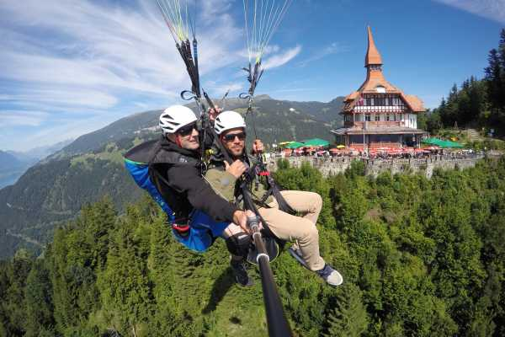
For Interlaken, and more importantly Switzerland in general, niche tourism is highly important for the country’s foreign tourism income. The destination is not always first on the agenda for most international tourists, however, by offering and catering to niche markets, the country and Interlaken itself have demonstrated a longstanding success of appealing to the opposite of stereotypical holidays. Switzerland and the Switzerland Tourism Board are aware of where they stand in the global travel market, and by continuously offering differing types of trips and visits to specialist tourists and focusing on consumer trends, the destination is a prime example of niche tourism marketing and appeal (Travel Monitor, 2017).
No matter what season a tourist may visit Interlaken, the town offers all year-round activities that cater to the wants and needs of adventure tourists. These tourists are thrill seekers; looking for the extraordinary and taking part in all excursions thrown their way. An estimated 42% of all types of tourists take part in an adventurous activity while on holiday, with the industry growing by 195% between 2010 and 2014, showing a significant rise in popularity (Corporate Greenland, n.d.). In fact, ABTA Travel Trends accounted adventure/activity holidays in their top ten types of holiday taken in the past 12 months in 2018 (ABTA, 2018).
Source: Outdoor Interlaken, (2019).
Interlaken is adapting to these trends by offering several adventurous activities that are not stereotypical for a primarily winter destination. One of those adventure activities that is out of the ordinary for an adventure holiday is ice skating.
Ice skating has become ever more popular in recent years, with rinks appearing in countries across the world. However, the activity is often forgotten about for more thrilling excursions e.g. snowboarding, skiing. From mid-December to mid-February, Ice Magic Ice Skating is available for visitors and locals in Interlaken town centre. Surrounded by snowy mountains, this is the ideal location and set up for the thrill seeking yet family friendly activity. Ice Magic features a larger than most rink, which contains a large square skating area, a smaller area for small children and walkways/paths that form a route – heading directly into a blow-up igloo that fully submerges visitors into the realm of a winter wonderland (Ice Magic, 2018).
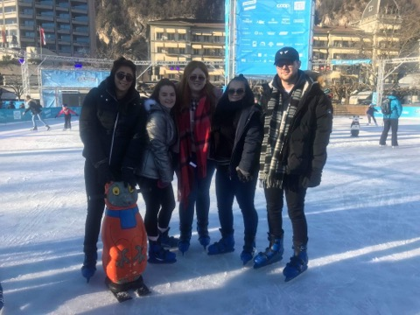
Image taken at a recent visit to Ice Magic.

On the topic of winter wonderlands, the UK’s version of Ice Magic is Winter Wonderland, however, when comparing the two attractions, Ice Magic has the upper hand. Although slightly more expensive to visit (18 CHF or approximately £13.50 per person compared to UK versions being typically £10 per person), with a larger rink, better ice conditions, consistent upkeep of the ice rink and being set in the picturesque winter escape of Interlaken, there is no competition both domestically and internationally for Ice Magic. For a chance to experience a true ice-skating experience and an activity that is different to the stereotypical adventure tourism activities, this attraction is perfect.
From the moment visitors exit Interlaken OST train station, the niche market of adventure tourism is brought to life in front of your very eyes. It isn’t typical to view individuals flying via parachute from the skies consistently – but this is the case in Interlaken. Paragliding Interlaken offer tourists and locals the opportunity to paraglide above the city of Interlaken no matter what season it may be (Paragliding Interlaken, 2019).
Starting the paragliding experience directly from the surrounding mountain tops and landing in Interlaken town centre (nearby Ice Magic), these sky-high tours are perfect for thrill seekers. The experiences can be quite expensive, with most paragliding adventures costing approximately 170 CHF or £131, but the opportunity to participate in this type of activity in such a unique destination like Interlaken is rare and thus is one of the reasons it is so popular.
Although not personally experienced, Outdoor Interlaken are an organisation based in the Swiss town that offers adventure tourists a range of activities to enjoy come rain, snow or shine (Outdoor Interlaken, 2019). Activities include kayaking in nearby Lake Brienz, river rafting, canoeing, bungy jumping, hang-gliding and mountain climbing to name a few in the summer months. This shows how Interlaken has adapted and now offers services and products to adventure tourists all year round and thus is investing into its appeal to these types of travellers.
In winter months, traditional activities such as skiing and snowboarding are offered by Outdoor Interlaken on the surrounding mountains of Interlaken – however, Interlaken is not primarily focused on the traditional winter adventure activities. There are countless destinations and ski resorts in Switzerland that can offer this service and therefore, the prime focus of organisations such as Outdoor Interlaken is to appeal to tourists seeking differing adventures – which they are achieving successfully.
Although the facilities, products and services are in place for adventure tourists in Interlaken, a negative aspect of the destination is the poor customer service. Adventure tourists are willing to pay a lot more for their trip than the average tourist, to ensure a fun and unique experience in a destination that is not commonly popular (UNWTO, 2014). When paying more for their trip than mass tourists and being met with poor customer service, this can have a negative effect on Interlaken.
The town is not as busy as other locations in Switzerland and therefore workers here should be expected to treat their guests well and spend some time getting to know them. Staff in Interlaken can be abrupt, blunt, rude and ignorant at times – with it being hard to place the blame on Swiss people in general as other places here feature great customer service. As the town of Interlaken is quite traditional, this could be one of the main reasons why individuals find it hard to adapt to guests visiting their workplaces, but with the everchanging tourism industry bringing differing customers annually, to truly succeed in offering a good service in all aspects; customer service must be improved upon first and foremost.
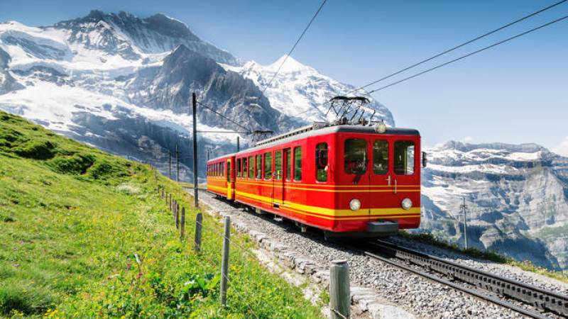
For most adventure travellers with heavy sports gear, public transportation is highly important to getting around a destination. Switzerland has one of the most reliable and vast public transportation links, with trams, trains, buses, bicycle hire and taxis available in almost all areas of the country – over 5,000 kilometres worth of railway tracks can be found in the relatively small country of Switzerland (Lost In Switzerland, 2017).
Source: On The Go Tours, (2019).
The city also caters to the use of Interrail passes, popular train tickets that allow travellers to journey across Europe all under one ticket for convenience and ease, which cuts down on travel times and hassle for adventure tourists. Getting to and around Interlaken for adventure tourists should be no problem – with Swiss train services especially being accurate to timings and taking guests directly into the town centre, while buses and trams direct guests to key tourist points.
Another key performance indicator that Interlaken faces is winter and snow conditions. During the months of May to mid-September, Switzerland experiences its summer season and is guaranteed to cater to adventure tourists seeking activities that do not relate to snow. However, Switzerland is primarily known for its appeal to ski and snowboarding tourists, with many high and low ski slopes found surrounding the Interlaken region. Prime winter season in the country is from mid-November until March, where the most snow falls and conditions for winter adventure activities are peak.
However, when snow seasons are poor and snowfall is lacklustre, low ski slopes can be at risk of closure (MySwissAlps, 2019). A lack of snow results in a lack of adventure tourists and for Interlaken, whom wishes to appeal to adventure tourists, it can be difficult to draw guests to the destination if the key facilities are not available. It is almost impossible for a destination to combat unreliable weather conditions and it is often out of their control – but Interlaken combats this issue by offering great adventure activities that can suit any weather all year round (Sadgrove, 2016).
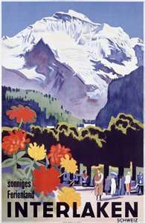
Interlaken is a relatively small player in the Swiss tourism game and find it hard to market themselves to the world. It is clear from the information above that the town offers significant amounts of adventurous activities for tourists, however, the destination is constantly overshadowed by larger European destinations e.g. Chamonix and St. Moritz. Upon arrival in Switzerland and while in the country, advertising of Interlaken will be rare and without prior knowledge of the destination, travellers are none the wiser regarding knowing about Interlaken. Even in Interlaken OST train station, adventure tourism marketing is no where to be seen – a major problem for a self-proclaimed ‘adventure capital’ by Paragliding Interlaken. The Swiss town is also rarely seen in travel agency brochures, even those showcasing European winter breaks. To truly keep up with demand for adventure tourism and to compete with larger cities/destinations, Interlaken must improve their marketing strategies.
Source: Pinterest, n.d.
A traditional Interlaken holiday advertisement.

Interlaken is a unique area of Switzerland with all the right tools to appeal and keep adventure tourists visiting the destination for years to come. The town has succeeded in adapting their year-round activities to suit travel trends and thus are aware of the importance adventure tourism has on the town. Where the Swiss destination fails to keep up with competitors is in its marketing and customer service departments. Europe is known to have great adventure destinations and it can be hard for smaller areas to compete, but Interlaken must do so with their marketing strategies. Online campaigns, advertising on social media and in travel agency brochures could all improve visitor numbers to the destination.
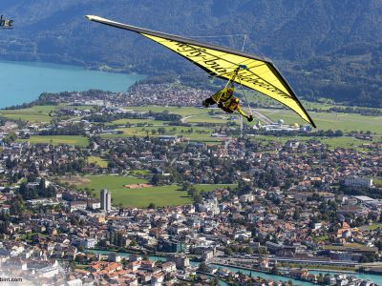
With more visitor numbers comes more demand, and with more demand brings the opening and development of new adventure/activity facilities. Also, without excellent customer service, guests will simply not become repeat visitors; perhaps the importance of this niche market is not on the radar of individuals that work in Interlaken. Switzerland is one of the most adventure driven countries in Europe, and Interlaken has everything required to succeed – the town simply needs to become consistent and showcase their selves to the wider public. In terms of the success rate of Interlaken for adventure; the town is one that thrill seekers and more timid adventure travellers could enjoy and thus is successful, with further success possible.
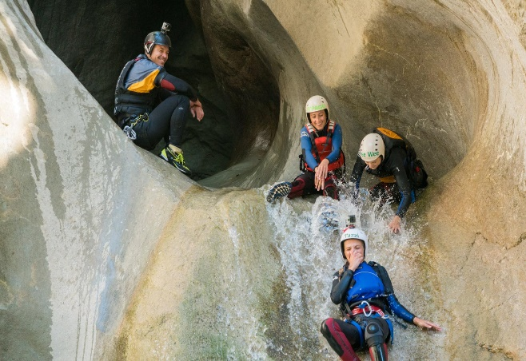
Source: Outdoor Interlaken, 2019. Source: MySwitzerland, 2019.
References
ABTA. (2018), ‘ABTA Holiday Habits Report 2018’, [Online]. Available: https://www.abta.com/sites/default/files/2018-10/Holiday%20Habits%20Report%202018%20011018.pdf, Last Accessed: [2019, March, 16].
Corporate Greenland. (n.d.), ‘Key facts on adventure tourism’, [Online]. Available: http://corporate.greenland.com/en/tools/adventure-in-greenland/key-facts-on-adventure-tourism/, Last Accessed: [2019, March, 13].
HolidaysToEurope. (2017), ‘Holidays to Switzerland’, [Online]. Available: https://www.holidaystoeurope.com.au/home/european-destinations/switzerland/1160-things-to-do-in-interlaken-switzerland, Last Accessed: [2019, March, 20].
Ice Magic. (2018), ‘Prices’, [Online]. Available: http://www.icemagic.ch/de/preise.html, Last Accessed: [2019, March, 16].
Interlaken Tourismus. (n.d.), ‘Facts & Figures’, [Online]. Available: https://www.interlaken.ch/en/region-resorts-cities-area/holiday-in-interlaken-matten-unterseen/facts-and-figures-interlaken-matten-unterseen.html, Last Accessed: [2019, March, 13].
Marson, D. (2011), ‘Research Themes for Tourism’, CAB International: Oxfordshire, pp. 1 – 2.
MySwitzerland. (2019), ‘Interlaken – Bern Region’, [Online]. Available: https://www.myswitzerland.com/en-gb/interlaken.html, Last Accessed: [2019, March, 13].
MySwitzerland. (2019), ‘Paradise for adventure and paragliding’, [Online]. Available: https://m.myswitzerland.com/en-us/paragliding/paradise-for-adventure-and-paragliding.html, Last Accessed: [2019, March, 20].
On The Go Tours. (2019), ‘Jungfraujoch Top of Europe Day Trip from Lucerne’, [Online]. Available: https://www.onthegotours.com/ca/Switzerland/Best-Places-to-Visit/Lucerne/Jungfraujoch-Top-of-Europe-Day-Trip, Last Accessed: [2019, March, 20].
Outdoor Interlaken. (2019), ‘Get Busy Living’, [Online]. Available: https://blog.outdoor-interlaken.ch/, Last Accessed: [2019, March, 20].
Outdoor Interlaken. (2019), ‘Summer Tours’, [Online]. Available: https://www.outdoor-interlaken.ch/en/summer, Last Accessed: [2019, March, 20].
Paragliding Interlaken. (2019), ‘Welcome to the adventure capital Interlaken!’, [Online]. Available: https://www.paragliding-interlaken.ch/en, Last Accessed: [2019, March, 16].
Pinterest. (n.d.), ‘A vintage tourism-ad for Interlaken’, [Online]. Available: https://www.pinterest.co.uk/pin/156289049539621131/, Last Accessed: [2019, March, 20].
Robinson, M & Novelli, M. (2005), ‘Niche Tourism: Contemporary Issues, Trends and Cases’, Butterworth-Heinemann: Oxford, pp. 1.
Sadgrove, K. (2016), ‘The Complete Guide to Business Risk Management’, (3rd Edition). Routledge: Oxon.
Schweizer Tourismus-Verband. (2018), ‘Swiss Tourism in Figures 2017’, Bern: Béatrice Hermann (STF).
Travel Monitor. (2017), ‘Switzerland launches three unique ‘back to nature’ themes for summer’, [Online]. Available: http://www.travelmonitor.com.au/category/news/todays-news/switzerland-launches-three-unique-back-nature-themes-summer/, Last Accessed: [2019, March, 13].
UNWTO. (2014), ‘Global report on adventure tourism’, UNWTO: Spain.

