

MARKETING MANAGEMENT

SUBJECT CODE : LCMB7001
LECTURER : TUSHARA BALENDRAN
COURSE : MBA MARKETING MANAGEMENT
STUDENT NAME : BASIL SLEEBA
STUDENT NUMBER : 2131205

Table of Contents
1. Introduction 3
2. Communication 3
2.1 Models of Communication 3
2.2 Schramm Model of Communication 5
2.2.1 Strengths of the Schramm Model 6
2.2.2 Limitations of the Schramm Model 6
3. Integrated Marketing Communications (IMC) 6
4. Promotion 8
4.1 Offline Promotional Strategies 8
4.2 New Promotional Strategies on Print Media 9
4.3 New Promotional Strategies on Non-Print Media 9
4.4 New Online Promotional Strategies 9
4.5 New Multi-Channel Promotional Techniques 9
4.6 New Sales Promotion Strategies 9
4.7 New Public Relations Strategies 9
5. Branding 10
5.1 Brand Equity 10
5.2 Keller’s Brand Equity Model 10
6. Customer Journey 12
6.1 Stages in a Customer Journey 12
7. Customer Touchpoints 12
7.1 Types of Customer Touchpoints 12
8. Customer Journey Map 13
8.1 Creating a Customer Journey Map for Sony PlayStation 14
8.1.1 Strengths of the Customer Journey Map for Sony PlayStation 15
8.1.2 Weaknesses of the Customer Journey Map for Sony PlayStation 15
9. The Total Engagement Model 15
10. Recommendations to Improve the Customer Journey Map for Sony PlayStation 16
11. Conclusion 17
12. Reference 17

Introduction
Sony is a multinational company renowned for its innovative technology and unique products with its headquarters in Tokyo, Japan. Since its founding in 1946, Sony has developed into a world authority in the fields of electronics, video gaming, entertainment, and finance (Raj et al., 2023). Televisions, audio components, cameras, smartphones, and gaming consoles are just a few of the company’s many products. The PlayStation game console is one of Sony’s most well-known and profitable offerings. Since its debut in 1994, the PlayStation series of gaming systems has grown in popularity. The PlayStation has sold over 100 million devices worldwide, making it a byword for excellent gaming. The PlayStation 5, officially debuted in November 2020, is the newest member of the PlayStation family (Sony, 2023).

Communication
Communication is the act of two or more people exchanging data, thoughts, thoughts, or feelings. There are several ways to communicate, including written, visual, and nonverbal. Effective communication, nevertheless, involves more than just disseminating information; it also involves active listening, receiving feedback, and comprehending (Kodheli et al., 2023).

2.1 Models of Communication
The process of sending and receiving messages is described using a variety of communication models. Each model can be used in a variety of communication scenarios and emphasises a distinct aspect of communication.
Shannon and Weaver’s model: According to this theory of communication, there is a sender, a message, a channel, a receiver, and noise in a linear process of communication. To eliminate noise and promote effective communication, the model stresses the significance of clear message encoding and decoding (Chowdhary et al., 2023).
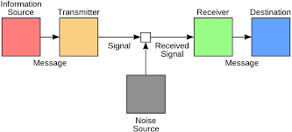
Figure: Shannon and Weaver model of communication
Source: Chowdhary et al., 2023
Berlo’s SMCR model: The receiver's role in the communication process is stressed by this concept. The source (sender), the message, the channel, and the receiver are its four constituent parts (Vickery et al., 2023).
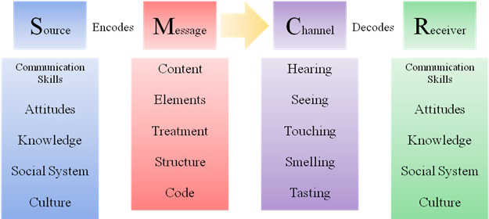
Figure: SMCR model
Source: Vickery et al., 2023
Westley and MacLean model: There are three components to communication: the message (content), the relationship (emotions and attitudes expressed), and the setting (context of the conversation). The concept stresses that communication involves more than just information transfer; it also involves the interaction between the sender and the recipient (Lee et al., 2019).
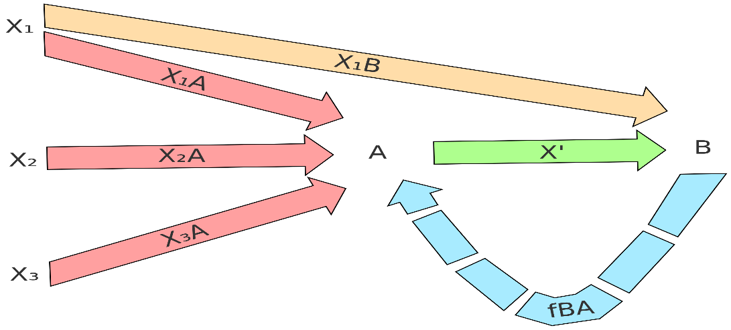
Figure: Westley and MacLean model
Source: Lee et al., 2019

2.2 Schramm Model of Communication
Wilbur Schramm, created the Schramm Model of communication in 1954. The communication process incorporates a two-way exchange of messages amongst the sender and the receiver, and is based on the feedback loop theory. The five fundamental components of the model are source, encoder, message, decoder, and receiver (Packard et al., 2023).
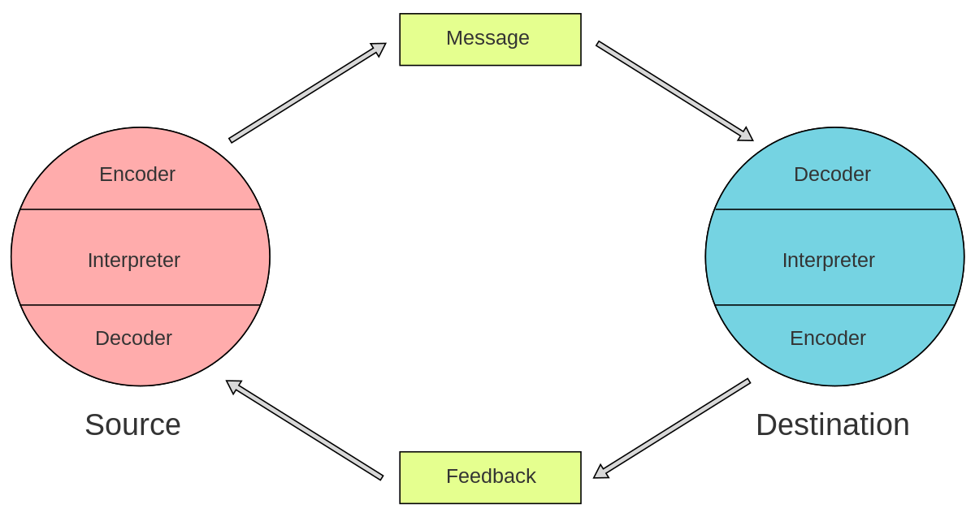
Figure: Schramm model of communication
Source: Packard et al., 2023
In the instance of Sony PlayStation, the brand itself serves as the source, crafting messages using a variety of platforms including public relations, social media, and advertising. The receiver is the intended audience, which consists of both present and future clients. The model emphasises the significance of feedback, which can be acquired through market research, polls, customer evaluations, and comments on social media (Matos et al., 2023).

2.2.1 Strengths of the Schramm Model
Simplicity: The simplicity of Schramm’s model makes it simple to grasp and use, which is one of its advantages. This makes it a helpful tool for examining how organisations like Sony PlayStation handle communication.
Feedback Loop: The significance of feedback in the exchange of information process is acknowledged by Schramm’s approach. This makes it possible to spot communication errors, allowing Sony PlayStation to fix them and enhance their communication approach.

2.2.2 Limitations of the Schramm Model
Linear Model: Since Schramm's paradigm is linear, it suggests that communication only occurs in one direction, from sender to receiver. This does not take into consideration the difficulties of communication, especially in the case of Sony PlayStation, which includes numerous customer touchpoints and exchanges.
Limited Emphasis on Context: The context of communication, encompassing cultural, social, including historical variables, is not taken into account by the model. This may limit its application in cross-cultural or international contexts, which are more important in the connected world of today.

3. Integrated Marketing Communications (IMC)
In order to engage with its target audience and offer a consistent message throughout every touchpoints, a corporation coordinates its usage of a variety of communication channels and promotional tools. In the example of the Sony PlayStation, the business successfully used an IMC strategy to market the item and connect with its target market. Utilising a variety of communication channels to come to its target audience, encompassing electronic newsletters, social media, events, influencer campaigns, and advertising, is one of the main tenets of Sony's IMC approach (Albanna et al., 2022).
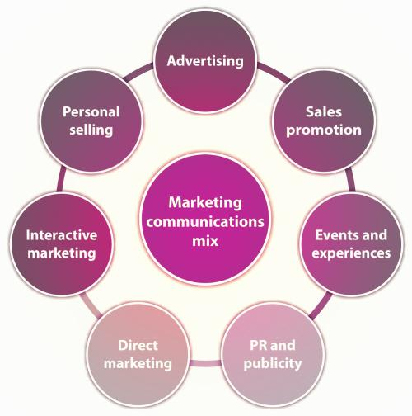
Figure: IMC
Source: Albanna et al., 2022
However, there are some areas where Sony's IMC approach may be strengthened. For instance, the business may put more effort into creating a solid content marketing plan that effectively informs its target audience about the advantages and capabilities of its gaming system. This may result in producing educational blog articles, videos, and other material that engages users and increases brand trust (Wan, 2022).
The different stages in IMC include:
Situation Analysis: At this stage, the market will be examined, target audiences will be chosen, and their demands and behaviours will be recognised. In the case of the Sony PlayStation, the situation analysis would require locating the gaming console market, reviewing the competition, and comprehending the target market's gaming habits.
Marketing Objectives: Setting SMART (specific, measurable, attainable, relevant, and time-bound) marketing goals is required at this point. The marketing goals for Sony PlayStation may include boosting brand recognition among the target demographic, driving sales, and increasing market share.
Message Strategy: This stage involves developing a message that resonates with the target audience and supports the marketing objectives. The message strategy for Sony PlayStation could include emphasizing the console’s advanced graphics, immersive gaming experience, and exclusive game titles (Yu et al., 2022).
Media Plan: In order to effectively deliver the message to the target audience, this stage involves deciding on the most profitable and effective media channels. The media strategy for Sony PlayStation may involve sponsorship of gaming competitions and events as well as advertising on video games websites, social networking sites, and video games magazines.
Budget Allocation: In this phase, the marketing money is distributed among various media outlets and advertising campaigns in accordance with their efficacy and efficiency. Considering the target market for game consoles, Sony PlayStation's budget allotment for digital advertising including social media marketing may be larger.
Implementation: This phase requires carrying out the marketing strategy and disseminating the message via the chosen media outlets. The execution for Sony PlayStation can involve rolling out new titles, providing discounts and promotions, and supporting gaming competitions.
Evaluation and Control: At this step, the marketing communications plan's effectiveness is evaluated, and any necessary modifications are made. Tracking profits and sales, keeping an eye on social media activity, and completing customer surveys might all be part of Sony PlayStation's monitoring and oversight process (Zhu et al., 2022).

4. Promotion

4.1 Offline Promotional Strategies
Sony PlayStation can use a variety of offline marketing techniques to spread the word about and create interest in their game consoles. To reach a large audience, Sony PlayStation can placeprint advertisements in publications such as newspapers, magazines, and gaming periodicals. These commercials frequently showcase the newest video games and highlight the console's special capabilities.

4.2 New Promotional Strategies on Print Media
Sony PlayStation can use a number of tactics to improve their promotional efforts in print media, which can be a very effective medium for advertising goods and services. Utilising augmented reality (AR) technology to produce interactive print advertisements is one cutting-edge strategy.

4.3 New Promotional Strategies on Non-Print Media
To improve its brand image and attract a larger audience, Sony PlayStation can implement a number of innovative promotional methods on non-print media. Working with well-known YouTubers and streamers of video games to produce sponsored material showcasing their newest gaming console might be a successful tactic.

4.4 New Online Promotional Strategies
Sony PlayStation can use a number of innovative online marketing techniques to make it to its target market and build brand recognition. Influencer marketing is one such tactic, in which the business collaborates with well-known gaming influencers or creators of content to market their goods. Sony PlayStation is able to reach a larger audience and gain trust with its customers by working with influencers who hold a sizable following and active following.

4.5 New Multi-Channel Promotional Techniques
To reach a larger audience and raise brand awareness, Sony PlayStation can use a variety of multi-channel promotional strategies. Influencer marketing is one such strategy, in which the business collaborates with well-known gaming influencers to advertise their goods on various platforms including social media, YouTube, and Twitch.

4.6 New Sales Promotion Strategies
Sony PlayStation can adopt various sales promotion strategies to attract and retain customers. One of the effective strategies is offering limited-time offers such as discounts or free accessories with the purchase of a console or game. This creates a sense of urgency and can lead to impulse purchases.

4.7 New Public Relations Strategies
Sony PlayStation can implement new public relations (PR) tactics to build a solid brand reputation and image. Working together with well-known social media influencers to generate awareness and interest in the product is one such tactic. The PlayStation console can be reviewed and material created by the influencers can be shared on social media sites like Instagram, Twitter, and YouTube.

5. Branding

5.1 Brand Equity
The worth that a brand brings to a good or service is referred to as brand equity. It is the significance that a brand has accrued over time in the eyes of consumers, incorporating the brand's perceived reputation for excellence, dependability, and success. Due to a number of variables, Sony PlayStation has a great brand equity. The iconic PlayStation logo and brand name are part of the brand's distinctive and recognisable brand identity. Additionally, the company has a solid reputation for creating high-quality video game consoles and games, that has helped buyers form favourable brand connections (Zhu et al., 2022).

5.2 Keller’s Brand Equity Model
A popular approach for analysing and maintaining brand equity is Keller’s Brand Equity model. This model includes four steps: brand identity, brand meaning, brand response, and brand relationships (Xu et al., 2022).
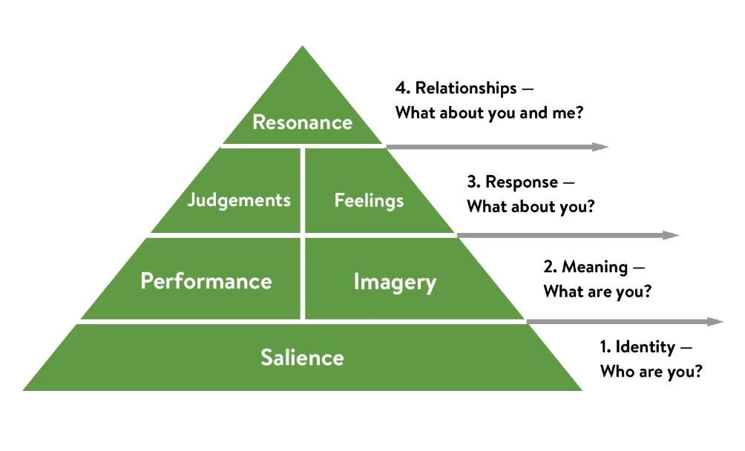
Figure: Keller’s brand equity model
Source: Xu et al., 2022
Brand Identity: This refers to the various sensory, linguistic, and visual components that go into creating a brand's image. This pertains to Sony PlayStation and includes the recognisable logo, colour palette, and general brand image. Together, these components build a distinctive visual character that consumers can recognise right away.
The verbal identity of Sony PlayStation, which consists of the company name, tagline, and other consumer-facing messages, supports its visual identity. As an illustration, the brand's message of anticipation, enthusiasm, and immersive experiences in gaming is conveyed through the phrase "Greatness Awaits.
Brand Meaning: Customers' opinions and beliefs regarding the brand are discussed. For a brand to stand out from its rivals, it must have a transparent and distinct meaning (Zha et al., 2022).
The feelings and perceptions that consumers have of Sony PlayStation serve as the foundation for the brand's meaning. Sony PlayStation is a brand that is connected with latest technology and excellent games. The company has concentrated on developing a premium brand that is connected to great performance and innovation.
Brand Response: Customers' responses to the brand are discussed here. Included in this are their general attitudes, feelings, and opinions of the brand as well as their behavioural responses, such as whether they would buy the product or promote it to others (Motoki et al., 2022).
With the help of its advertising and marketing efforts initiatives, Sony PlayStation has developed a strong brand response. The business has made significant investments to market its goods using a variety of platforms, including sponsorships, social media campaigns, and TV advertising.
Brand Relationships: Relationships, the fourth element in Keller's Brand Equity Model, is the bond a client has with a brand that goes beyond its practical and emotional advantages (Siano et al., 2022).
Customers and Sony PlayStation have developed solid brand partnerships. A devoted consumer base that values the brand and is prepared to pay more for the company's goods exists. In addition, Sony PlayStation has created a group of gamers who are devoted to the company and its goods.

6. Customer Journey
The whole interaction a consumer has with a business, from initial knowledge and curiosity to afterwards review and advocacy, is the customer journey (Chauhan et al., 2022).

6.1 Stages in a Customer Journey
Awareness: At this point, consumers are aware that a company, a product, or a service even exists. Since its founding, Sony has built an excellent track record for quality and innovation.
Evaluation and Consideration: Customers assess the brand or product and compare it to other alternatives at this point. Sony stands out in the market thanks to its renowned for quality and innovation, and customers frequently compare its goods favourably to those of rival companies.
Decision: The customer makes a decision about the degree to which to buy the product at this point. Customers may be persuaded to make a purchase by Sony's outstanding product offers and brand reputation, and by Sony PlayStation's emphasis on exclusive games and user experience.
Retention: Retaining a customer's loyalty and repeat business is crucial after they've completed a transaction. In order to guarantee client happiness, Sony has a robust customer care and support structure in place.
Advocacy: Customers who support a brand by recommending it to others can help draw in new clients. Positive word-of-mouth recommendations may result from Sony’s solid reputation, high-caliber products, and emphasis on customer happiness.

7. Customer Touchpoints
Any time a customer and a brand engage is referred to as a customer touchpoint. The Sony website, social media platforms, customer service encounters, and in-store experiences are a few instances of consumer touchpoints. Every one of these touchpoints presents Sony with a chance to interact with consumers and foster brand loyalty (Krey et al., 2023).

7.1 Types of Customer Touchpoints
Pre-purchase: These are the interactions potential buyers make with a brand before they commit to buying (Yang et al., 2023). Sony has the ability to employ advertising to spread knowledge and spark interest in their goods. This can apply to online, TV, and print advertisements. Sony can make a good first impression and draw people in by employing eye-catching imagery and marketing. Because they enable customers to engage with brands and gain a feel of their personality and beliefs, social media sites like Facebook, Twitter, and Instagram make great pre-purchase touchpoints.
Purchase: As the point at which the customer decides to purchase the good or service, it is a significant touchpoint in the customer journey (Zhang et al., 2023). The purchase touchpoint is crucial in the case of Sony and Sony PlayStation for turning potential customers into paying customers. Customers can buy products from Sony straight from their website or via authorised shops as a result of the company's robust internet presence.
Post-purchase: This relates to the communications a customer has with a business following a purchase (Lu et al., 2023). Following-up letters or surveys requesting consumers about their happiness with the product along with their experience with the firm could be post-purchase touchpoints for Sony and Sony PlayStation.

8. Customer Journey Map
The overall illustration of the journey of a customer is known as customer journey map. Thus, it presents every communication that the customer have with a business organization (Alvarez et al., 2020).

8.1 Creating a Customer Journey Map for Sony PlayStation

 | Awareness | Discover | Purchase | Use | Bond
Sony Website |  | 3. Review the PlayStation |  | 7. Use
Authorized Retailer |  | 5. Demo | 6. Buys the Product
Customer Service
Social Media |  |  |  |  | 8. Post reviews  Posts reviews
Reviews |  | 4. Looks out for genuine reviews  Looks out for genuine opinions
Email | 2. Gets an offer email  Gets an offer email
Post |  |  |  |  | 1.Existing Sony Customer  Existing Sony customer

Smith, a 25-year-old from an upper middle class background, is already a Sony customer. His curiosity gets excited when he receives an email from Sony with an offer for their PlayStation product. Smith then reviews the item on the Sony website and searches for trustworthy evaluations throughout social media and other online venues. Before making a purchase, he also visits an authorised merchant to test the thing out. Smith purchases the item, uses it, and develops a relationship with it. Finally, he publishes a review of his PlayStation experience on numerous web venues.

8.1.1 Strengths of the Customer Journey Map for Sony PlayStation
Provides a holistic view: From the first stage of awareness through to post-purchase, the customer journey map offers a thorough view of the client experience. Sony PlayStation can determine where customers are having problems, where they are interacting with the brand the most, and where there may be potential to enhance the experience by mapping out all the touchpoints and phases of the customer journey.
Highlights opportunities for improvement: In order to address these problems and enhance the customer experience, Sony PlayStation can detect the places where consumers are having trouble. For instance, Sony PlayStation can modify the website for making it easier to navigate and use if buyers are having trouble accessing it during the evaluation stage.

8.1.2 Weaknesses of the Customer Journey Map for Sony PlayStation
Lack of Personalization: Individual client preferences are not taken into consideration in the customer journey map. It makes the unrealistic assumption that all clients travel along the same path. Personalization may enhance the entire customer experience and increase the client's enjoyment of the journey.
Incomplete Data: The map makes many assumptions and heavy use of data, which may not accurately depict the consumer path. There can be gaps in the data collection, or the presumptions might not accurately represent how customers actually behave.

9. The Total Engagement Model
Building enduring connections with customers by providing a compelling and intuitive experience throughout all touchpoints is the goal of this paradigm for customer engagement. The objective is to develop a comprehensive and integrated expertise that builds brand loyalty and motivates users to promote the brand (Grovar and Kar, 2020).
The Total Engagement Model can be used in the Sony PlayStation situation to give gamers a smooth experience at all touchpoints, including the pre-purchase, purchase, and post-purchase phases. The concept emphasises four essential elements:
Discover: The first phase focuses on raising awareness of and interest in the company, its goods, and its brand. To contact prospective customers and promote them to its gaming systems and games, Sony PlayStation can employ a variety of marketing channels, including social media, internet advertising, and events.
Explore: The second phase is to assist customers in assessing and taking into account the products that Sony PlayStation has to offer. To assist consumers in making educated purchasing decisions, Sony could provide information to buyers about the characteristics and benefits of their goods as well as product displays and trials.
Buy: The third stage is making the purchase. Sony PlayStation may make buying easier by providing a range of options, such as online, in-store, and nearby third-party stores. They could additionally offer specials and discounts to persuade customers to make purchases.
Engage: The last phase is post-purchase engagement, during which Sony PlayStation can increase client loyalty by providing continuous assistance, support, and engagement opportunities. Through online forums, social media, and consumer feedback programmes, Sony can interact with its customers.

10. Recommendations to Improve the Customer Journey Map for Sony PlayStation
Increase Awareness: Sony might have done more to raise awareness of the PlayStation 5's new characteristics and features, particularly with casual players who might not carefully follow gaming news, even though the introduction of the device was eagerly anticipated and produced a lot of hype. This might involve influencer marketing, promotions in-store, and targeted advertising efforts across social media platforms.
Enhance Evaluation and Consideration: By giving prospective customers access to more thorough and educational product descriptions, video material, and hands-on experiences, Sony could enhance the evaluation and consideration stage. To aid users in comprehending the features and capabilities of the console, this could involve longer reviews, product demonstrations, and virtual events.
Build Loyalty and Advocacy: By giving reductions on games or accessories, access to special content, or getting firsthand access to new releases, Sony may forge stronger bonds with its customers. In order to increase brand loyalty and advocacy, Sony might also interact with its most devoted followers via social media and online groups by giving them access to special material, quick access to betas, and other benefits.

11. Conclusion
The present report provided a detailed discussion regarding the major marketing as well as branding principles. Many topics like communication, integrated marketing communication, promotion, branding, customer journey, customer touchpoints, customer journey map, total engagement map, and total engagement map were covered in the report. The report concluded by offering suitable recommendations to enhance the customer journey map for PlayStation.

12. Reference
Albanna, H., Alalwan, A.A. and Al-Emran, M. (2022) An integrated model for using social media applications in non-profit organizations. International Journal of Information Management, 63, p.102452.
Alvarez, J., Léger, P.M., Fredette, M., Chen, S.L., Maunier, B. and Senecal, S. (2020) An enriched customer journey map: how to construct and visualize a global portrait of both lived and perceived users’ experiences?. Designs, 4(3), p.29.
Chowdhary, S., Andres, E., Manna, A., Blagojević, L., Di Gaetano, L. and Iñiguez, G. (2023) Temporal patterns of reciprocity in communication networks. EPJ Data Science, 12(1), p.7.
Grover, P. and Kar, A.K. (2020) User engagement for mobile payment service providers–introducing the social media engagement model. Journal of Retailing and Consumer Services, 53, p.101718.
Kodheli, O., Lagunas, E., Maturo, N., Sharma, S.K., Shankar, B., Montoya, J.F.M., Duncan, J.C.M., Spano, D., Chatzinotas, S., Kisseleff, S. and Querol, J. (2020) Satellite communications in the new space era: A survey and future challenges. IEEE Communications Surveys & Tutorials, 23(1), pp.70-109.
Krey, N., tom Dieck, M.C., Wu, S. and Fountoulaki, P. (2023) Exploring the Influence of Touch Points on Tourist Experiences at Crisis Impacted Destinations. Journal of Travel Research, 62(1), pp.39-54.
Lu, X., Wu, C., Yang, X., Zhang, M. and Zheng, Y. (2023) Adapted water wave optimization for integrated bank customer service representative scheduling. International Journal of Production Research, 61(1), pp.320-335.
Matos, E.M.C., de Araujo Costa, T., Neto, M.C.A., Castro, B.S.L., de Souza Farias, F., de Araujo, J.P.L. and Barros, F.J.B. (2022) Video Quality Loss Model on Communication Networks: An Approach Based on Frame Loss. Journal of Communication and Information Systems, 37(1), pp.42-46.
Motoki, K., Park, J., Pathak, A. and Spence, C. (2022) The connotative meanings of sound symbolism in brand names: A conceptual framework. Journal of Business Research, 150, pp.365-373.
Siano, A., Confetto, M.G., Vollero, A. and Covucci, C. (2022) Redefining brand hijacking from a non-collaborative brand co-creation perspective. Journal of Product & Brand Management, 31(1), pp.110-126.
Vickery, R., Murphy, K., McMillan, R., Alderfer, S., Donkoh, J. and Kelp, N. (2023) Analysis of Inclusivity of Published Science Communication Curricula for Scientists and STEM Students. CBE—Life Sciences Education, 22(1), p.ar8.
Yang, B., Sun, Y. and Shen, X.L. (2023) Understanding AI-based customer service resistance: A perspective of defective AI features and tri-dimensional distrusting beliefs. Information Processing & Management, 60(3), p.103257.
Yu, X., Yao, X., Yang, J., Zhang, L., Kong, L. and Cui, G. (2022) Integrated waveform design for MIMO radar and communication via spatio-spectral modulation. IEEE Transactions on Signal Processing, 70, pp.2293-2305.
Zha, D., Foroudi, P., Jin, Z. and Melewar, T.C. (2022) Making sense of sensory brand experience: Constructing an integrative framework for future research. International Journal of Management Reviews, 24(1), pp.130-167.
Zhang, J.J., Følstad, A. and Bjørkli, C.A. (2023) Organizational factors affecting successful implementation of chatbots for customer service. Journal of internet commerce, 22(1), pp.122-156.
Zhu, Y., Wen, X., Chu, M. and Sun, S. (2022) Consumers’ intention to participate in food safety risk communication: A model integrating protection motivation theory and the theory of reasoned action. Food Control, 138, p.108993.

