VIOREL DINU S.N.1905713

PSYCHOLOGY FOR HEALTH AND SOCIAL CARE (ASSIGNMENT 2)

Table of Contents

Introduction 3
Main Body 3
Reflection on psychological theories 3
Explaining my role as a healthcare professional in applying psychological perspectives 6
Discussing the learning with health and social care practices 7
Conclusion 8
References 9

Introduction
Clinical psychology is always assistive of individual cognitive psychology especially in terms of diagnosing complex mental issues present in an individual. In order to uproot psychological turbulences from the society once and for all, one needs more candour, more open space of sharing thoughts and unquestionable support from people. The psychological theories could be of much help in such contexts because it provides an individual with a different perspective to view and understand the perspective of people who are slightly different from them. In this essay, the impact of psychological theories and their sheer application in health and social care contexts is going to be elucidated.

Main Body

Reflection on psychological theories
Piaget's theory of cognitive development
In this theory it is propounded that as a result of biological maturation and environmental experimentation human intelligence takes its developmental and comprehensive toll of understanding. Children always evolve a certain degree of understanding of the world surrounding them but when they grow up then their environmental experience gives birth to some kind of discrepancy in their perception. In accordance to Piaget’s theory of cognitive development sensorimotor, preoperational, concrete operational and formal operational are the four stages important in human psychology (Siegler, 2016). From infancy to the age group of at least 2 years old when the child evolves a certain understanding of the permanence of a subject then it is proclaimed as the sensorimotor stage. Then comes the preoperational stage and children from the age of 2 to 7 years undergo this experience because they learn about symbolic things here and also understand than certain things could stand for something else than itself. In the concrete operational stage children belonging to the age group of 7 to 11 years learn how to conserve mass, volume, weight and number and these calculations are done in their heads internally (Xu, 2019). Last but not the least there is the formal operational stage that is set for children from 11 years age till their lifetime and in this phase, they evolve the ability of thinking about abstract concepts, testing hypothesis and many more.
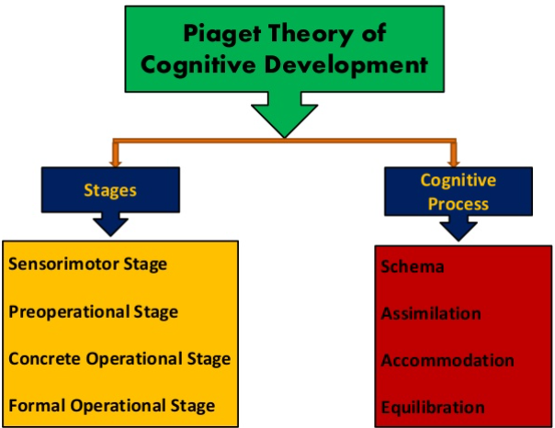
Figure 1: Piaget's theory of cognitive development
(Source: Xu, 2019)
Hence, according to this theory once children finally reach the formal operational stage then they learn taking decisions based on circumstantial evidences and also integrate their logical reasoning with emotion depending upon the context-dependent values. Once they possess these characteristics, they set out to be adults and we can easily locate a gap in terms of judging their ability in postformal thinking and also in terms of judging adolescents’ ability for dealing with emotional problems. This gap is also located in adult population and old age population because due to neural degeneration, terminal drop, alienation and insufficiency in technique older people lose the ability of cognitive thinking (Thakrar et al., 2019). The impact of demographic variables like age, sex, race, financial backdrop, social status and most importantly the presence of any chronic mental health issue could show predominant inconsistency in the thought process if old aged people.
Social cognitive theory
According to the social cognitive theory postulated by Albert Bandura, it is seen that an individual could learn things truly when a dynamic and reciprocal reaction is noticed among the behaviour, environment and the individual. It further puts stress on social influence and its relation to internal and external social reinforcement (Bandura, 2018). The theory emphasizes on social influence and its stress on internal and external social augmentation. It teaches people to regulate their individual behaviour and keep it in control and they also learn how to direct their behaviour in a positive way for accomplishing objective-oriented behaviour. This theory is especially important for judging the mental health issues of old age population because it teaches people that how they can act with their learnt experience and modify their behaviour via external environmental influence in order to achieve their goals. According to Sell et al. (2016) it goes on to offer a structure that could promote, plan and supervise physical exercise in elderly people as a remedy of their mental issues. It further claims that personal, environmental and behavioural factors are significant for predicting the behavioural changes in an old individual. Since, physical exercise is a suitable solution for elderly people in getting rid of their mental health problems so the factors like age, psychology, gender, self-efficacy, performance perception are some variables that could possibly influence the urge of taking part in physical exercise programs.
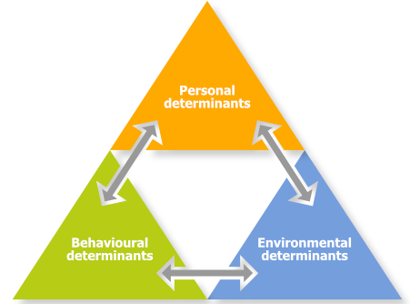
Figure 2: Bandura’s social cognitive theory
(Source: Bandura, 2018)
Social cognitive theory encourages social support and it takes under consideration the self-efficacy parameter and make proper use of observational learning technique. I have sometimes noticed that this theory is widely used for directing interventions and thus behavioural parameters are improved. For elderly people this theory demands a special significance because it shows what extent are, they able to communicate with their environment and how successfully thus deciding the degree of their psychological problems. It also argues that people believing in physical activity could anticipate certain outcomes and thus they would be able to take account of a self-regulatory set of habits that could create a sustained lifestyle. Fanning et al. (2018) opines that for establishing the relation between decreasing physical activity and reducing psychological functioning ability, a far broader set of evidences would be needed. Furthermore, I think that this theory would prove to be significant as it would test and validate strategies for improving psychological factors to develop physical activity and to see how and to what extent can they cast an influence on elders.

Explaining my role as a healthcare professional in applying psychological perspectives
As a healthcare professional I think I could only be liable to apply the social cognitive theory of Bandura if I am to judge the exercise behaviour in older adults. This theory could be well applied in the duty of care segment because elder people are more vulnerable and they possess a higher chance of forming psychological health issues than other age population (Silveira et al., 2020). The elderly population could check their outcome expectancy, self-efficacy and self-regulation for determining their orientation towards exercise. Since, physical exercise shares a direct proximity with age so firstly I need to see how many old aged people are actually incline to take part in these activities. In case the elder people are inclined to take part in these exercise programs then the outcome expectancy ratio automatically increases. On the other hand, in case the older individual has questionable feelings on its ability to take part in the physical activities then outcome expectation is likely to decrease. Thus, it can be seen that it is all related to psychological issues in the end and in that case even if the person is in a good shape then also, they cannot perform well in it because in their minds they have restricted their performance abilities (Schunk and DiBenedetto, 2020). I have also seen that for some elderly people taking part in physical exercises is direly related to better psychological and emotional wellbeing but if they cannot perform well in those tasks after taking part then it discourages them. Therefore, I think that if I am able to apply Bandura’s social cognitive theory in my healthcare context then I could certainly help the elder people achieve a better degree of psychological wellbeing by making them take active part in physical activity programs.
Then there is Piaget’s theory of cognitive development that has proven that between older people and adults, a comparatively lower degree of cognitive development is observed. It means that if an elderly individual is undergoing some recurring mental health problem then by applying the cognitive theory, we can check whether or not that person has encountered any traumatic event in its childhood. It also means that if a child is aware of the reversibility concept then he or she can apply it in learned relationship context between stimuli and events (Hanfstingl et al., 2019). This theory is focused on the entire mental orientation development in a child and that is why if an old individual is diagnosed with mental health issues then by revisiting its childhood, the cause of the problem could be discovered. In case the child has experienced the right experienced in its sensorimotor, preoperational and concrete operational stage then it is unlikely that the person evolved a mental health issue suddenly in its formal operational stage. When people evolve some unexplainable mental health issues in old age then those deep-rooted psychological problems are generally traced back to childhood fear or other traumatic incidents. Henceforth, if I manage to apply this theory in the duty of care context then I can successfully track down the past traumatic events in an individual’s life that could be associated with its present psychological problems. As a result of adult cognitive growth deficits, elder people could encounter depression, anxiety, autism and other mental issues. By bridging the gap among neuroscience, clinical practice and clinical modelling the roots of these issues could also be discovered (Sanghvi, 2020). With the evolving nature of neuromodulation technique transcranial stimulation and deep brain stimulation could continue to prosper and it could also give birth to some therapeutic approaches and new clinical strategies that could take a new toll on the treatment area of elder people with mental health issues.

Discussing the learning with health and social care practices
As Piaget’s cognitive development theory has shown that how adult cognitive deficiency could lead to late depression, autism and anxiety disorders so I could make use of the systematic desensitization technique in order to reduce anxiety and fear in elderly population. Bormanaki and Khoshhal, (2017) say that the major symptoms of old age mental health issues are palpitation, chronic fear, extreme mood swings, tiredness, excessive tension and so on. By applying the systematic desensitization technique, I have found out that if certain stimuli could increase fear or tension then certain stimuli could also reduce them. With the implementation of cognitive theory, I have also learnt that since those unnecessary fear or worries are associated with a trigger point so relaxation technique could teach those elder people to be in front of those trigger points and not get hyper excited. Not only relaxation technique but also operant conditioning technique is helpful for some elderly people because it could teach them to overcome the trigger points by making use of certain phrases or words or gestures or actions.
Not all the mental health issues found in elderly population are associated with deep-rooted traumatic events so all of the mental issues do not have a certain reason attached to them. That is why I can apply Bandura’s social development theory as it suggests for elders to take part in physical exercises and that could be a suitable solution to undefined mental health issues. Although Beauchamp et al. (2019) states that it certainly depends majorly upon the psychological ability of those older people because if they think they cannot perform well in the physical activities then they would not be able to do so. Nevertheless, if they think that they can perform well in the physical tasks no matter their age or physical condition then it would prove that external environment could positively influence the respondent conditioning nature of an individual. The gestalt perspective is also a major help in this context because it can make the care-givers understand individual mental issues with different lens and for the older individual who is undergoing such issue, it is extremely satisfying if the care-giver treats and respects their problems in an individualistic way and not in an universalistic way.

Conclusion
By the end of the discussion it can be seen that both Piaget’s cognitive development theory and Bandura’s social development theory could be helpful in health and social care contexts. Both the theories share different perspective about elderly people’s mental health issues and offer different insights on their diagnosing and treatment procedure. The understanding of both the theories could portray that elderly population suffering from mental health issues need to be well taken care of as they are the responsibilities of today’s generation. Hence, it can be seen that if the caregivers manage to apply those theories in their care giving context then the ratio of elderly population suffering from mental health issues would certainly reduce in society.

References
Bandura, A., 2018. Toward a psychology of human agency: Pathways and reflections. Perspectives on Psychological Science, 13(2), pp.130-136.
Beauchamp, M.R., Crawford, K.L. and Jackson, B., 2019. Social cognitive theory and physical activity: Mechanisms of behavior change, critique, and legacy. Psychology of Sport and Exercise, 42, pp.110-117.
Bormanaki, H.B. and Khoshhal, Y., 2017. The role of equilibration in Piaget’s theory of cognitive development and its implication for receptive skills: A theoretical study. Journal of Language Teaching and Research, 8(5), pp.996-1005.
Fanning, J., Walkup, M.P., Ambrosius, W.T., Brawley, L.R., Ip, E.H., Marsh, A.P. and Rejeski, W.J., 2018. Change in health-related quality of life and social cognitive outcomes in obese, older adults in a randomized controlled weight loss trial: Does physical activity behavior matter?. Journal of behavioral medicine, 41(3), pp.299-308.
Hanfstingl, B., Benke, G. and Zhang, Y., 2019. Comparing variation theory with Piaget’s theory of cognitive development: more similarities than differences?. Educational Action Research, 27(4), pp.511-526.
Sanghvi, P., 2020. Piaget’s theory of cognitive development: a review. Indian Journal of Mental Health, 7(2).
Schunk, D.H. and DiBenedetto, M.K., 2020. Motivation and social cognitive theory. Contemporary Educational Psychology, 60, p.101832.
Sell, K., Amella, E., Mueller, M., Andrews, J. and Wachs, J., 2016. Use of social cognitive theory to assess salient clinical research in chronic disease self-management for older adults: An integrative review. Open Journal of Nursing, 6(3), pp.213-228.
Siegler, R.S., 2016. Continuity and change in the field of cognitive development and in the perspectives of one cognitive developmentalist. Child Development Perspectives, 10(2), pp.128-133.
Silveira, S.L., Baird, J.F. and Motl, R.W., 2020. Examining Multilevel Environmental Correlates of Physical Activity Among Older Adults With Multiple Sclerosis. Journal of Aging and Physical Activity, 1(aop), pp.1-8.
Thakrar, M., Mukadam, P., Patel, F., Lakdawala, B.M. and Thakrar, R.A., 2019. Mythological conceptualization, cognitive and ego development: Is there a correlation?. Indian Journal of Mental Health, 6(2).
Xu, F., 2019. Towards a rational constructivist theory of cognitive development. Psychological review, 126(6), p.841.

