

Research title:

To explore both the positive and negative impacts of social media in family businesses with special reference to JCB

Student Name:Dorin Adrian Mihai
Dissertation Supervizor: Mr. Mohammad Rahman
Student ID:1921889
Module Number:LCBB6000

Declaration

I declare that this research study has been composed solely by myself and that it has not been submitted, in whole or in part previously.


Signed: Dorin Adrian Mihai
Student number: 1921889

Abstract

Social media marketing enhanced marketing activities by allowing businesses to employ various social media channels. Customer engagement has been improved through the use of social media as a marketing platform. Small businesses have been able to capture the attention and recognise the preferences of customers. The primary objectives of the research include demonstrating the positive impact that JCB gets due to social media. The negative impacts of social media on family businesses such as JCB have also been illustrated here. Phishing, privacy and security concerns along with the changing trends in the market and huge burdens are some of the negative impacts that JCB is experiencing due to social media. Moreover, the challenges such as engagement of the customers, lack of connectivity and development of engaging content that can attract the customers are troubling the company in the present situation. Some recommendations such as developing tactics that can help the company to reduce these challenges have been given so that JCB can gain a competitive advantage in the target market.

Table of Contents
Chapter 1: Introduction 3
Chapter 2: Literature Review 5
Chapter 3: Research Methods and Methodology 7
Chapter 4 Data analysis and discussion 3
4.1 Introduction 3
4.2 Analysis and discussion of findings 3
4.2.1 Findings of the data 3
4.2.2 Discussion of findings 6
4.2.2.1 Evaluation of the role of social media in running family businesses with particular reference to JCB 6
4.2.2.2 Positive impact of social media on family businesses 8
4.2.2.3 Negative impact of social media on running family businesses 10
4.2.2.4 Identification of the challenges associated with social media in terms of family businesses concerning JCB 12
4.3 Summary 13
Chapter 5 Conclusion, limitations and recommendations 14
5.1 Introduction 14
5.2 Conclusion of research objectives 14
5.3 Conclusions on research problem 14
5.4 Summary of research of findings and outcomes 15
5.5 Original contributions of research 16
5.6 Limitations of the research 16
5.7 Recommendations 17
5.8 Summary 20
Reference list 21
Appendices 25
Appendix 1: Survey Questions, Tables and Graphs 25

Chapter 1: Introduction

Background information
Nowadays, various sorts of social media platforms have become one of the most widely-used communications means with the help of which businesses and organizations throughout the world can easily interact with their customers and also share information in real time. It not only helps businesses in staying engaged with the customers but also helps in advertising, promotional giveaways and so on. Amongst different types of businesses, family businesses are getting the most out of social media. For example, the owners of Dyson have come forward and confessed that social media has helped them to significantly enhance their market reach. With the help of various social media platforms like Facebook, Twitter, Instagram, they now can easily stay connected with customers from all over the world.

Brief overview of the chosen organisation
JCB is one of the most popular British multinational manufacturers of various sorts of equipment for “construction”, “agriculture”, “waste handling”, “demolition” and so on. With its headquarters located at Staffordshire of England, JCB was reported to earn an annual revenue of over £4 billion in 2019. In addition to this, they have employed over 12,000 people from four continents in which they operate.

Aim
The aim of the research is to explore both positive and negative impacts of social media in family businesses with special reference to JCB.

Objectives
- To evaluate the role of social media in family businesses with special reference to JCB.
- To identify and further explore the positive impacts of social media in family businesses with special reference to JCB.
- To identify and further explore the negative impacts of social media in family businesses with special reference to JCB.
- To find out the challenges that are associated with social media faced by family businesses with special reference to JCB.
- To recommend a bunch of strategies that can be effectively used by the family businesses with special reference to JCB.

Research Questions
- What is the role of social media in family businesses with special reference to JCB?
- What are the positive impacts of social media in family businesses with special reference to JCB?
- What are the negative impacts of social media in family businesses with special reference to JCB?
- What are the challenges that are associated with social media faced by family businesses with special reference to JCB?
- What are the strategies that can be effectively used by the family businesses with special reference to JCB?

Chapter 2: Literature Review

Role of social media in family businesses

As per the opinion of Bhimani et al. (2019), various sorts of social media platforms like Facebook, Twitter, Instagram, YouTube, family businesses from all over the world can reach new and highly targeted potential customer base as over half of the world’s population is using some sort of social media. Olanrewaju et al. (2020) argued saying that amongst all the communication means that are currently available, social media can be considered to be the most useful in terms of developing and further maintaining real time human connections. The effective usage of social media can help businesses in introducing their followers to the people who make up their brand and further showcase how existing customers are using and benefiting from their products and services.

Positive impacts of social media in family businesses

As per the opinion of Itani et al. (2020), social media platforms can help the family businesses to present their brand as a tough leader in the market. LinkedIn, being one of the most popular publishing platforms, can be a great help in terms of focusing on building and further maintaining their brand reputation. Appel et al. (2020) said that after promoting their brand on various social media platforms by simply uploading engaging contents, businesses can start marketing their products and services for free of cost. In addition to this, businesses also can divert enormous quantities of traffic from social media to their official websites by uploading hyperlinks. Evans et al. (2021) further argued that with social media, businesses can stay engaged with their customers from all over the world and also take their fruitful feedback on their products and services with the help of which they can make further improvements in the same.

Negative impacts of social media in family businesses

As per the opinion of Muninger et al. (2019), although the whole idea of social media sounds useful, it has its own sets of benefits and limitations. For example, unlike several other means of communication, social media platforms do not forgive or forget. One foolish mistake can go viral within a blink of an eye and further destroy the reputation of the concerned brand. According to the opinion of Quesenberry (2020), making use of social media can sometimes be an extremely daunting task. This is mainly because social media is quite fast paced because of which it requires consistent monitoring and updating. To always stay up-to-date, businesses need to hire social media experts and analysts which can create a whole in the budget.

Challenges associated with social media in family businesses

There are a wide variety of challenges that are associated with using various sorts of social media platforms in businesses. As per the opinion of Evans et al. (2021), using social media can become one hectic and time-consuming job if one is unfamiliar with the ways in which it works. Hence, businesses need to at first research the risks and challenges that are associated with social media so that they can cope up with them better. As per the opinion of Bhimani et al. (2019), it can be extremely hard for businesses to choose which social media platform to leverage. The most-recent Coronavirus outbreak has led to people using social media more and more because of which it can get confusing as to which social media platform to use.

Chapter 3: Research Methods and Methodology

Research philosophy

Research philosophy can be defined as a systematic procedure which basically deals with the source, nature and further development of the knowledge (Pandey and Pandey, 2021). In other terms, it can be defined as the belief regarding the ways in which data should be collected during the whole research process (Mishra and Alok, 2022). It can be divided into four broad categories, namely, pragmatism, positivism, realism and interpretivism. For the present study, realism has been chosen as the data collection methods that have been shortlisted for the concerned research fit the subject-matter. In addition to this, as realism is more of a scientific approach towards the development of the subject-matter, it would significantly help in dealing with contemporary subject-matters.

Research approach

The whole concept of research approach can be defined as a systematic procedure that primarily deals with the collection of various sorts of plans and processes which helps in deciding the methods of data collection, interpretation and further analysis (Newman and Gough, 2020). The researchers need to consider a wide range of factors such as research aims, objectives, questions, experience of the research and the targeted audience while choosing the most appropriate research approach (Zhang, 2020). It can be divided into three different categories, namely, deductive, inductive and abductive approaches. For the present study, a deductive approach has been chosen. It has been chosen after much contemplation taking its various advantages into account. For example, a deductive approach will significantly help in understanding the interrelationship that exists between theoretical concepts and variables.

Data collection

Data collection can be defined as collecting and further analyzing data from various sources with an intention to find answers to research problems (Mishra and Alok, 2022). It can be divided into two categories, namely, primary and secondary data collection. For the present study, both the data collection methods will be used to find the most appropriate answers to the concerned research problem. Primary data collection methods involve collecting data from surveys, interviews, open discussions and so on. Secondary data collection methods involve collecting data from previously done research i.e. textbooks, articles, blogs and so on. For the present study, a small-scale survey will be conducted amongst 25 employees of JCB and a thematic table will be prepared for the secondary research.

Data analysis

Data analysis can be defined as cleaning, transforming and further modelling the collected data with an intention to gain deeper insights regarding the research problems (Pandey and Pandey, 2021). It can be divided into two broad categories, namely, quantitative and qualitative data analysis. For the present study, both the data analysis methods have been chosen. Quantitative data analysis involves analysing data that is primarily number-based. Qualitative data analysis involves analysing data that is non-numeric. To analyse the data which will be collected from the survey, quantitative data analysis method will be used. Simultaneously, to analyse the data collected from the secondary sources, a qualitative data analysis method will be used.

Ethical considerations

Ethical considerations play a crucial role in any sort of research study. For the present study, a few important things have been considered. For example, research participants will not be subjected to harm in any way. Voluntary consent will be obtained from the participants prior to the study. Their confidentiality and privacy will be prioritised. Lastly all the required provisions of the Data Protection Act of 2018 will be complied with.

Chapter 4 Data analysis and discussion

4.1 Introduction
Social media marketing usually helps family businesses to establish their brand of the business establishment. It also helps in driving the traffic of websites which further helps in the enhancement of sales. Significantly, as the sales margin of family businesses increases, it helps in the enhancement of the profitability of the companies as well. This section will delve into analysing the collected responses of the research respondents graphically. The negative and positive influences of social networking sites on family businesses will be analysed with special emphasis on JCB. This will also demonstrate the challenges that family businesses such as JCB are facing due to social media.

4.2 Analysis and discussion of findings

4.2.1 Findings of the data
- Do you think social media marketing helps change customers' buying behaviour?
The graph is representing the fact that social media helps in changing the buying behaviour of customers. It is quite evident from the graph that 04 respondents out of 25 participants strongly agreed that social networking channels are the platforms that help in changing the buying perceptions of customers (Refer to Appendix 1). 15 participants agreed with the view, however, 01 participant remained neutral. It is also evident from the graph that 02 research respondents have disagreed that social media usually do not alter the buying behaviour of consumers. 03 participants stringy disagreed with this view. According to Ringim and Reni, (2019), due to social media platforms, consumers can make direct purchases. The reviews on social media also help in affecting the buying perceptions of consumers. Hence, as most of the participants have agreed with this view, this fact is proven.
- What are some of the negative impacts of social networking channels on businesses?
The graphical representation showcased the negative impact of social media on family businesses such as JCB. Is observed that 05 research participants have stated that social media leads to a huge burden and shift in the trends of marketing. Moreover, 01 participant said that social media marketing leads to the accidental release of certain important data. 06 respondents have stated that one of the major negative impacts of social media marketing is phishing and other privacy issues. Significantly, most of the people that are 13 participants said that social media leads to tracking harmful and misleading content. According to, Maria et al., (2019), social media marketing impacts business establishments with negative impacts as well which leads to tarnishing the brand image.

- What do you think are the positive impacts of social media on family businesses?
The graphical representation is showcasing the positive impacts of social media marketing on family businesses. 10 participants said that social media helps family businesses such as JCB to reach a humongous number of customers. However, 07 participants said that social media is one of the best platforms that help businesses to promote their businesses through ad campaigns. It is evident that 05 respondents said that social media helps in receiving the feedback of consumers and 02 said it aids in the enhancement of the marketing reach. Only 01 participants said social networking helps in increasing the market revenue. As stated by Dolega, Rowe and Branagan, (2021), social networking channels usually helps business establishments to build a network of customers and enhanced advertising platform as well.
- Do you agree with the view that marketing through social media helps family businesses to reach a large number of target customers?
This graph is representing the responses that the research respondents have given regarding the impact of social media on family businesses such as JCB. It is significant to note that 05 respondents strongly agreed that social media helps JCB to reach a huge number of customers. However, there 09 respondents who agreed with the same fact and 05 people remained neutral. It is quite evident from the graph that 03 people disagreed and 03 people who strongly disagreed with this viewpoint. As argued by, Grewal, Stephen and Coleman, (2019), social media is one of the major platforms that help companies to reach a huge number of customers and make them aware of the potential products it offers customers.
- What are the main challenges that family businesses face due to social media?
This graph is representing the potential challenges that the family businesses such as JCB are experiencing. It is evident that 07 research participants view engagement in reaching the target customers as one of the major challenges that JCB is facing. However, 02 participants have stated that developing engaging content that helps in attracting customers is another major challenge that JCB faces. 12 research participants said that creating and executing social media channels for marketing is one of the biggest challenges that family businesses are usually facing. Only 01 participant said that trends and algorithms are other problems of social media and 03 people said that it becomes difficult for companies to have a consistent online presence. As per Chatterjee and Kar, (2020), understanding the target customers along with the lack of connectivity also poses threats to family businesses such as JCB.
- Do you think phishing is one of the main challenges of social media that are experienced by family businesses?
The graph (Refer to Appendix 1) represents the responses collected from the participant regarding phishing as one of the major challenges of social media marketing for JCB. It is observed that 04 research participants strongly agreed that phishing is one of the greatest problems for family businesses such as JCB. However, 09 participants agreed with the fact and 05 did not want to respond to the answer. Moreover, 05 respondents disagreed as they do not feel that phishing is the only challenge that threatens the growth of JCB and 02 strongly disagreed as well. As opined by Mason, Narcum and Mason, (2021), phishing in social media refers to an attack which is executed through sundry platforms involving Facebook, LinkedIn and Twitter.
- How likely are you to buy a product which is usually recommended online?
The graph (Refer to Appendix 1) is showcasing the likeliness of customers who refer to buy products from online platforms. 03 out of 25 participants have said that they very likely buy products that are recommended online. Moreover, 11 participants said that they likely buy products recommended on social media platforms and 04 respondents prefer not to answer. Significantly, 05 respondents have opined that they are unlikely to buy products after getting attracted by social media platforms. 02 said they are very unlikely to buy products that are recommended online. According to Kadam and Atre, (2020), in the global business world, there are 268 million people who are likely to buy the products recommended through social media platforms.
- What social media channels do family businesses such as JCB use mostly for reaching a large number of customers?
It is shown in the graph (Refer to Appendix 1) the most used social media platforms that the family businesses such as JCB are using for attracting customers. There are 04 participants who said that Reddit is the social networking channel that JCB is using. However, most of the participants that are 15 participants said that JCB and other family businesses mostly use Instagram for promoting their products and services. There are 03 are 02 research respondents respectively who said that JCB is using Facebook and Twitter for its brand promotion. 01 respondent said that the company is using LinkedIn for marketing purposes.
- Do you think family businesses have a scope of growing their market due to social media?
The graphical representation is showing the scope of growth o the brand that social media offers to family businesses such as JCB. It is evident that most of the research participants that is 12 strongly agreed that after Covid-19 social media has helped JCB to expand its business in the global market. Furthermore, 04 participants agreed with the view and 01 participant remained neutral. There are 04 participants who disagreed and strongly disagreed with the fact. Moreover, 04 participants strongly disagreed with this view as well. As opined by Eid, Abdelmoety and Agag, (2020), s social media helps delight consumers and build loyalty with customers, it offers scope to JCB to expand its market across the globe.
- Do you think social media marketing is one of the best policies for doing business for family businesses for engaging more customers?
It is significant to note that when research respondents were asked about the impact of social media on engaging more customers, 05 respondents strongly agreed with the fact. However, most of the participants agreed with the fact and their number 13. 04 participants disagreed with this viewpoint and 02 have strongly disagreed with the view. As per Sun and Wang, (2020), having efficient social media usually helps JCB to engage more customers which enhances the relationship of the brand establishment with that of customers.

4.2.2 Discussion of findings

4.2.2.1 Evaluation of the role of social networking sites in running family businesses with particular emphasis on JCB
Social media has been quite an effective platform for customer interaction, marketing and product and service promotion. The role of social media in running businesses is quite undeniable. Irrespective of the size of the business establishments, business entities employ social media for operating businesses. The extent of the usage of social networking pertains not only to marketing and promotion but also increases customer outreach. Visibility of the services and demonstration of the products through appropriate and popular channels facilitate the business organizations to enhance their marketing approaches (Cheung, Pires and Rosenberger III, 2019). Social media provides family businesses with the scope for communicating with lots of customers within less time. The businesses can intimate the customers regarding the products and services (Li, Larimo and Leonidou, 2021).
The participants were asked about the importance of social media in influencing consumer behaviour. The majority of the participants responded that consumer behaviours influence social media while the number of persons who strongly agreed on this is 4. This is indicative of the fact that social media platforms are effective mediums for influencing consumer purchasing intentions. The role of social media platform is quite extensive since it attracts a lot of customers (Hermanda, Sumarwan and Tinaprillia, 2019). The findings suggest that social media platforms are utilised by small businesses in terms of enhancing customer engagement. Customers are connected through various social networking sites such as Facebook Twitter Instagram and other social media channels. It has also been found that social media marketing techniques are used for generating customer feedback. Through the social media channel, customers provide their valuable feedback to businesses which helps other businesses improve their services. The role of social networking channels is not limited only to enhancing custom engagement but also to impacting customer values (Pop et al., 2022). Customers deliver their valuable insights regarding the value of the product and services they avail of from small businesses.
The respondents also replied that ad campaigns are also enhanced through social media. Thus, it can be said that social media platforms are effective tools for increasing the effectiveness of advertisements. Social networking platforms provide various advertisement tactics such as influencer marketing and content marketing which influence customers to a significant extent (Dwivedi et al., 2021). 5 of the participants responded that custom of it bags are collected on social media by small businesses. Whereas the majority which constituted 10 participants responded that social media platforms help reach a large network of customers. Through the use of innovative market tactics on social media marketers successfully increase their customer outreach. The most significant impact of which has been on brand awareness. Marketing through digital media enhances brand awareness to a significant degree. Brand awareness of businesses is enhanced by leveraging engageable marketing tactics (Ibrahim et al., 2023). Brand messaging has been strengthened by marketing on social media. Small businesses such as JCB have been effective in increasing their marketing outreach. Not only does the social media platform provide a marketing advertisement platform but also helps in content marketing. Content marketing refrigerator to the use of content such as text, pictures and videos and other engaging content to attract the attention of customers. Content marketing has a significant impact on the attention of customers since it uses various methods of manipulating the choices of customers (Syaifullah et al., 2021). Social media provides wide-ranging tools such as Facebook, Instagram, Twitter, Pinterest and many others. It can be referred to the survey of the participants who were asked about the most effective social media platform. The majority of the participants are responding that Instagram has been the most effective platform used by small businesses. Instagram has been the most suitable choice among the participants. Thus it can be inferred that customers prefer digital marketing platforms for buying products. It can also be referred to as the survey of the customers making purchases based on the recommendations they provided on online platforms.
Customers gather information from previous customers' experiences on a social media platform regarding the services and the quality of products. Through these reviews, customers app receive the value of the products and services and thereby it influences their buying decisions. Thus, the role of marketing using social networking channels in operating small businesses has been quite undeniable. The social media platform is also allowed small businesses to partner with influencers for endorsing their products. Influencer marketing is in the digital form of celebrity endorsement in which the influencers promoted the products and services of certain businesses (Talwar et al., 2019). The customers of influences are influenced by the convincing techniques of the influencers and consider buying the advertised products. Influencer marketing has quite an effective impact on the mind of customers as it affairs to them psychologically. Thus, the significance of social networking sites for small businesses is quite relevant.

4.2.2.2 Positive impact of social media on family businesses
Social media in terms of running small businesses is an effective medium for business entities. A wide impact of social media can be seen in business operations. The participants of the survey wiring quiet regarding the positive impact of social media. The findings of the responses state that social media platforms increase customer interaction. Referring to question number 3, it can be deduced that a large number of customers can be reached through social media. The same tag takes have been employed by small businesses for increasing their customer outrage processes. Thus, it can be said that custom engagement has been made possible and effective through social media. Social media marketing enhancement is a custom engagement process by facilitating interaction and communication. Digital marketing also helps the business as it promotes its customer loyalty programs and circulates the same through the channels leveraged by the business (Liu et al., 2021). Customer loyalty programs have been quite an effective tool which is integrated with social media platforms to influence the purchasing decisions of customers. In addition, several participants have responded the other agree and some of them responded that social media helps small business institutions reach a large number of customers.
Brand loyalty of the businesses is enhanced through social media marketing. Brand loyal is enhanced through meaningful customer relationships which is the facilitated in social media. Social media offer companies various forms of interacting with customers and developing an impactful bond with them. Brand communication is enhanced through the platforms on which customers are provided with clear and precise information. In the earlier stages, customers interacted through digital media platforms while launching new products and initiating new services (Cheung, Pires and Rosenberger III, 2019). The advent of social media platforms facilitated both these functions along with providing easy communication channels for small businesses. Customer introduction has been made quite effective, quick and responsive besides making it interactive. Thus it can be said that the positive impact of social media has been improved customer communication. Besides these, customers provide valuable feedback regarding the standard of services and products. JCB has been able to indirect with the customers regarding its product and the services it proposes to provide.
In general social media platforms extend customer outreach. Due to the global accessibility of social media platforms, businesses have been able to connect with global customers and communities through social networking platforms (Ebrahim, 2020). There it can be said that the most positive impact of social media platforms for small businesses and businesses, in general, has been global accessibility. However small businesses have been able to connect with customers in the domestic market as well as the regional markets (Zollo et al., 2020). Digital media platforms have reduced the geographical barriers and physical limitations which provided business organisations with a foundation for reaching the global community. Social media platforms transcended the boundaries and removed the blockades and thereby facilitating community outreach. This is no exception for small businesses. Digital word of mouth has been ensured through social media marketing. Traditional word-of-mouth practices have been replaced by digital media platforms (Jacobson, Gruzd and Hernández-García, 2020). The use of social networking platforms has been quite effective in persuading the intentions of customers. Small businesses through the application of social networking sites have been able to appeal to the demands of customers. This in addition has led to the popularity of the word of mouth practices and therefore led to increasing awareness among customers. Thus, the extent of the effects of social networking platforms has been immense and wide-ranging. It has been evident from the responses of the participants that digital media platforms have made the interaction process quite smooth and facilitative (Li, Larimo and Leonidou, 2021). Another positive implication of social media platforms has been their cost-effectiveness. These media channels are cost-effective since it is free of charge and marketers can integrate blogs and other content through which content marketing has been incorporated. The cost of advertising activities and promotional marketing has been reduced to significant degrees. Businesses post contents which are engaging and informative and thus intimate the customers and target audiences about the products and services. Since digital media platforms have curtailed and even to some extent replaced digital marketing advertising, the cost associated with digital media marketing has been reduced accordingly. This has been one of the most important aspects of social media marketing (Zafar et al., 2021). On the other hand, this tactic has proved to be cost-efficient for small businesses. Hence it can be affirmed that social media platforms deliver myriad positive implications for the operations of small businesses. The aforementioned discussion has added to the justification of the positive implications of social media on business affairs for small businesses.

4.2.2.3 Negative effects of social networking marketing on running family businesses
Despite the positive impact of the social media platforms availed by small business organisations, there are several negative factors as well. These negative implications have led to the issue of credibility for using social media marketing platforms. The participants were enquired regarding the negative impact of such platforms and responses centred around various aspects. The participants responded that the circulation of harmful content has been one of the negative implications of social media experienced by small businesses. Content spread on social media platforms is often harmful to audiences in the sense that they can be influenced by false information (Ebrahim, 2020). Customers are often misled regarding the information provided by the service providers. This circulates false information regarding the service offerings. Customers often feel betrayed by the false information provided in this regard. This has a detrimental impact on customer trust and brand loyalty as well. Customer perception of the brands is negatively impacted due to the circulation of false information. Brand credibility would deteriorate if significant information delivered is not capable of meeting the needs of customers. Phishing is one of the significant negative impacts that JCB experiences due to the marketing strategy of social media marketing (Evans, Bratton and McKee, 2021). Phishing is a social media attack the purpose of which is stealing personal facts and information for getting control over the accounts of social media. Instagram is one of the greatest social media sites that are famous for phishing in which hackers are responsible for creating fake accounts in this application. They sham pages and capture the user id and password of users and steal information (Zafar et al., 2021). With having credentials of Instagram, the hacker as well as the attacker has enhanced access to this account. Family businesses usually do not invest a lot of money in social media marketing and hence experience huge losses in the competitive business world.
Social media presence refers to the fact that it helps the brand establishment such as JCB to expose their business publically (Sanny et al., 2020). Due to the effective assessability of the internet, it is observed that there are hackers who always try to hack the data and facts of customers. The major aim of hackers is to damage the reputation of the brand. It is even significant that as it is quite easy to comment regarding the content and products or engage in social media platforms, negative feedback is also prevalent.
Another negative impact that the family businesses such as JCB face is a lower Return on Investment (ROI). It can also be referred to as one of the lowest marketing strategies and hence the company needs to put more effort, money and time to enhance its reputation of the company (Liu, Shin and Burns, 2021). Hence, the business organisation needs to post engaging content regularly so that the reputation and brand value of the company cannot be affected comprehensively. Businesses in social media generally need to be engaged and active. This usually helps the business establishment to engage more customers and attract a large number of target audiences. This will be helping the company to increase its annual sales and profit margin as well. As social media is changing drastically day by day (Moslehpour et al., 2021). It is significant for the family business establishments such as JCB to come up with more engaging content. Successful marketers know that the formula for getting success in the social media marketing strategy is spending money and time altogether to receive maximum monetary benefits in the target market. It is also observed that measuring the marketing plans and efforts is quite complex and complicated as well. The engagement and interactive process of social media is generally not an easy task that helps JCB to enhance the reputation of the brand. Security and privacy-related issues always exist in the marketing strategy through social media (Tarsakoo and Charoensukmongkol, 2020). It is significant to note that social media platforms are used for ad campaigns and storing data of customers and employees as well. This is hacked by the hackers that bring the marketing efforts of the company to a low level and also impact customer loyalty as well. Due to this the annual profitability of the organisation also affects extensively. It is also observed from the responses of the research participants that with the usage of social media platforms, unethical people or hackers are responsible for stealing the data and facts. Hence, marketing on social media sites is not safe most of the time.

4.2.2.4 Identification of the challenges related to social networking channels in terms of family businesses with special focus to JCB
It is quite evident from the responses of the research respondents that some of the major challenges which are associated with social media marketing for family businesses are phishing, trends and algorithms and so on. It also includes keep on posting engaging content for attracting customers and enhancing the online presence of the brand establishment. It is also quite evident in the current decade that there is a massive transformation in the efficacy of social networking channels for doing business (Shareef et al., 2019). One of the biggest challenges that the family businesses such as JCB are facing in this new era of marketing through social media is making an enhanced connection with the target audiences on an individual and personal level. Lacking this effort usually diminishes the brand's reputation and the brand establishment fails to make an authentic relationship with the customers. Hence, one of the mitigating policies that the companies must take is to utilise the free cost monitoring tools for the enhancement of the brand value which are TweetDeck and others. Proper handling of all the channels of digital media usually helps in responding to each comment in an appropriate manner (Iankova et al., 2019). This usually helps the family business organisations such as JCB to mitigate the problem and to reach the niche forum effectively. It is even significant that the development of a social media marketing policy is even a challenge for family businesses. Pondering the plan of making a social media road map for the complement of the goals is a mammoth task (Voorveld, 2019). Moreover, the landmarks along with experimentation that helps in creating solid social media marketing are quite complex and hence engaging content are needed to be developed. Key Metrics and some targets and tactics are needed to be made so that the development of some effective strategies can help the company to accomplish these goals easily. It is observed that organic reach and social media channels are quite blooming and hands the managers of social media are scrambling to find strategies that can bring more organic reach for JCB. This is another biggest challenge that the company is facing. To grow the organic reach the business organisation must have an opportunity of paid social media advertisements with the help of which the company can be able to reach a humongous number of customers and enhance its sales (Jin, Muqaddam and Ryu, 2019). Managing social media content is time-consuming and hence it is evident from the responses of the research participants that creating engaging content and staying consistently online is one of the biggest challenges that JCB needs to overcome. For overcoming this strategy curation and ideas like monitoring Facebook pages and scouring Quora for better content can be helping the company to enhance its market revenue. It will also help in more open the sun transparency of the business organisation in the target market. These are some of the challenges that affect the family businesses such as JCB comprehensively which are evident from the responses f the participants as well.

4.3 Summary
It can be summarised this chapter has graphically analysed all the responses gathered from the research respondents. Moreover, it is observed that social media is helping JCB to expand its market as it helps the company to delight more customers and do promotional activities on social media. This section has also demonstrated the positive and negative impacts on JCB due to social media. In addition, phishing is one of the biggest challenges that is affecting the company comprehensively and the company through ad campaigns on social networking channels gets enhanced benefits in the competitive edge.

Chapter 5 Conclusion, limitations and recommendations

5.1 Introduction
This section will summarising and pinpoint the core findings of the research. The implications of the entire research will be briefed taking into account the research objectives. Furthermore, the objectives of the research relating to the role of digital media in terms of small businesses will be put forward. The findings of the study will be discussed and a summative account will be provided as well. The implications of the findings will be followed by the contributions to this research. Moreover, this chapter will briefly outline the limitations of the study. Based on the evaluation of the findings and discussion recommendations will be provided as well so that small businesses can effectively implement social media in running business operations.

5.2 Conclusion of research objectives
Objective 1: The first objective was to identify the role of social media in facilitating small businesses. This research objective particularly deals with the benefits and the contribution made by social media in driving business activities. Social media has changed the way customers are interacted with. It has improved the customer interaction process through the incorporation of popular media platforms.
Objective 2: The second objective was to identify the challenges regarding social media for running small businesses. Choosing the appropriate and suitable channels has been one of the challenges faced by small businesses. Phishing has been found to be one of the challenges faced by small businesses in terms of social media usage.
Objective 3: The utilisation of integrated marketing communication tactics would be beneficial for small family businesses such as JCB. Through the help of marketing communication tactics, the business would be able to channelise its marketing activities and provide essential information regarding its services to the customers. This tactic is one of the effective tactics for increasing the visibility of business operations by small businesses.

5.3 Conclusions on the research problem
The statement of the problem in this research is all about the usage of social media by JCB. This issue is focusing light on the fact that the company with the assistance of digital media marketing can be able to reach a large number of target audiences and can be able to make them aware of the products that it offers. This will usually help them to buy products from this organisation so that the annual sales of the company can be increased. This will be helping the company in making more annual revenue. Twitter, Facebook, Instagram and other digital media platforms usually help entrepreneurs to connect and engage more customers with the business organisation so that this can be able to enhance the business of the company. It is significant to note that having a strong strategy of social networking marketing offers the ability to the entrepreneurs of JCB for developing engaging content with which the marketers can be able to engage more target audiences. This will also assist the family enterprise to gain maximum sustainability in the competitive edge.

5.4 Summary of research of findings and outcomes
It can be summarised that social media marketing helps in affecting the buying behaviours of customers. It is evident from the findings that as many as 15 participants have agreed on this. Consumer behaviour is shaped by innovative marketing tactics launched through social media. It has been observed that misleading content and information have been one of the main negative attributes of digital media marketing. The majority of the respondents agreed on this issue however security concerns and phishing have also added to the negative implications of social media usage for small businesses. Social media marketing has a considerable impact on customer outreach as it paves the way for reaching a humongous number of target audiences. Other positive impacts derived from the findings include enhanced advertisements and customer feedback generated and collected through social media platforms. Small businesses such as JCB have been able to accumulate the feedback of customers through the usage of digital media platforms. In addition, the marketing tactics through the media platforms have been quite effective in reaching out to the target customers. Regarding the responses about the efficiency of social networking channels in reaching customers, it has been observed that the majority of the respondents agreed with this fact. Social media marketing widens the process of customer outreach allowing businesses to communicate with customers effectively.
Thus, social media platforms have been quite effective in interacting with customers. Customer engagement has been one of the prominent challenges faced by small businesses. However, the majority of the participants responded that the execution of the tactics has been another challenge for small businesses. Other challenges experienced by small businesses include the propagation of engaging content and maintaining an online presence. Phishing has been one of the major problems faced by small businesses in terms of using social media marketing. Positive responses have been found regarding customer purchasing of products through online recommendations. Customers make purchases by getting influenced by engaging advertisements on social media platforms. Instagram has been found to be one of the most effective marketing social media platforms. Social networking platforms enhance advertisements by employing social media channels such as Facebook, Twitter and Instagram and entertainment channels such as YouTube. The participants responded that social media platforms facilitate the growth of the business market for small businesses. Social media also provides an engaging platform through which customers interacted with small businesses for various use such as customer concerns and quality of services.

5.5 Original contributions of research
The main contribution of this research is that this helps in having in-depth knowledge regarding the importance of digital media for family businesses such as JCB. It is evident that the utilisation of social media platforms such as Facebook, Instagram, Twitter and many more helps the company to reach its target audiences. Furthermore, it also helps the company to make customers aware of the existence of the brand which helps the company to gain maximum benefits in the competitive edge. More engagement of customers usually leads to an enhancement of sales that also leads to an increase in the profit margin. Hence, JCB can get enhanced success by expanding its market in the global business market (Di Domenico et al., 2021). Through social media, JCB can receive feedback from customers regarding its products and services. It offers scope to the company for improving its product line so that the sales of the company can increase and it helps the firm to accomplish a competitive advantage in the business world.

5.6 Limitations of the research
The limitations of research refer to the features of design or the methods of research that generally influence the demonstration of the entire research findings. One of the biggest limitations of this research is the formulation of the research objectives. Hence, the scholar sought help from the facilitator for the formulation of the research objectives. The choice of the research methodology is another limitation that the scholar has experienced while conducting the study. It is significant to note that the researcher was helped by the supervisor in choosing the appropriate methodology which usually helps in making the entire study authentic and justified. Moreover, choosing the sample size is another major limitation of the study as the sample size is too small usually distorts the findings of the research (Vrontis et al., 2021). Furthermore, measures for gathering the data and facts were not quite meagre which has affected the researcher comprehensively.

5.7 Recommendations
Learning the strategies of doing marketing on social media platforms usually helps JCB to enhance its sales during the promotion of the entire brand. It is evident that marketing using social media platforms is inexpensive and it usually helps in effectively delighting the customers. Hence, it can be recommended that -
- JCB can use social media for having a better online presence. This will be helping the company to make enhance its relationship with customers which will eventually lead to customer loyalty (Weismueller et al., 2020). Social media is one of the most effective tools with the utilisation of which the company can be able to increase its profitability as well. Using organic marketing with using social media will be helping JCB to understand its potential followers and find more effective approaches with the help of which the company can be able to promote its goods and commodities for gaining a competitive advantage. It will also help learn various ways through which family businesses can be able to advertise its brand on a low budget. It also helps in reaching content to more customers in the global business market (Arora et al., 2019).
- It can also be recommended that social media will be helping family businesses to get a plethora of opportunities for humanising the brand and driving the website and its traffic. This will be helping the brand establishment to enhance its sales which will automatically lead to better profitability for the company (Hudders, De Jans and De Veirman, 2021). It is important to note that social media will also be helping family businesses such as JCB in generating leads that will also aid in enhancing sales and enhanced brand awareness as well. Family businesses such as JCB also make use of social media for efficient customer services as it aids in allowing customers to message directly to the businesses so that the potential issues can be reduced and the organisation can be able to get a competitive advantage in the contemporary business world.
- Moreover, social media can be considered one of the best strategies of marketing that will be helping JCB to recognise potential target customers. Social media marketing will generally help in organising and understanding the target audiences so that the marketing goals can be easily accomplished by the competitive firm. It will usually help the company to compile facts so that the company can be able to reach the target market effectively. It will also be helping the company to engage potential customers significantly (Lou and Yuan, 2019). It will also dauntingly gather various facts and data so that it can be able to make stronger customer relationships and through customer loyalty, the company can be getting enhanced benefits in the competitive edge. Usage of the social media analytics will also be helping JCB to understand its potential customers and followers which involves their posts and other interests as well. It will also help the company to receive feedback from customers which will be helping the business establishment to come up with a wide variety of products so that the company can be getting a competitive advantage in the global business world (Harb et al., 2019).
- Social media will also be helping JCB in checking the current marketing trends along with the atrocity of the market competition. It is significant to note that getting enhanced knowledge regarding the market competition will be providing insights to the company to bring differentiated products. It will also help the company to look into the competitors and hence will provide scope to the company in fulfilling its gaps as well. Social media will be offering an enhanced platform for the family businesses such as JCB in defining its targets and Key performance indicators (KPIs). Fundamentally, goals must be developed this is a useful approach for the development of certain foundational goals and achieving the objectives of the customers as well. Through social media marketing, JCB can be able to develop SMART objectives that will be helping the company to accomplish all its goals within specified time bounds (Shanahan, Tran and Taylor, 2019). It will also help the company in allocating all the resources effectively so that the company can be able to expand its market effectively and get an enhanced profit margin in the long run. This will also help the company to sustain itself in the future for the long run as well. Social media marketing will generally also help the company to develop thinking strategically, skills of organisation and expertise in branding strategies that will be helping in the enhancement of sales of the company so that the company can be getting better profitability in the competitive marketplace.
- Considering myriad platforms of social media will be helping customers in buying several products through these platforms. These platforms usually involve Facebook, Instagram, Twitter, Reddit and many more. Ultimately, this action plan also be helping in reaching a large number of customers and the company must refocus all the channels accurately so that it can be able to satisfy the needs and requirements of the customers (Ansari et al., 2019). It is significant to note that the company will be responsible for posting engaging content for customers regularly so that viewing this content can attract customers easily. This will also be helping the company to gain enhanced benefits in the competitive run. This will also help JCB to gain more success in the contemporary business world.
- The success of family businesses which involves companies like JCB usually depends on marketing through posting engaging and compelling social media content will be helping JCB to reach a humongous number of customers so that the company can be getting huge sustainability in the long run in the competitive business world. This will not only help the company to look dependable, however, but it will also further assist the organisation in sharing the knowledge that it cares for the interests of the potential customer. This will also be helping the company in altering the algorithms with the help of which the company can be the ability to put enhanced emphasis on engaging content (Appel et al., 2020). This will be determining the company to show the algorithm that the posts on the social media sites are worthy and hence the family business will be gaining enhanced benefits in the competitive world.
- This will further help the company in making efficient communication with loyal and other potential customers. This will be helping the company in expanding its reach of the company in the globally competitive world. Moreover, this will also help the company to have cost-efficiency as social media marketing is not expensive. It also helps in boosting the awareness of the brand and social proofing of the organisation as well. Significantly, JCB will be getting enhanced assistance due to marketing through social media networks as it will be gaining a maximum opportunity for better returns of marketing. It is noted that as the other family businesses are gaining an advantage of enhancing the brand value by 83%, JCB will also get the chance through social media marketing for market expansion. Social media marketing can be considered one of the best policies that help family business organisations to improve annual sales and profit levels as well (Mishra, 2019). It also helps in investing in the protocols of security so that the company can be able to provide better services to the potential customers altogether.

5.8 Summary
It can be summarised that this section has provided recommendations with the help of which the JCB can be able to increase sales and profitability through social media marketing. It is analysed that social media will be helping the company in making a solid relationship with potential customers that will be helping the company to gain a competitive advantage in the competitive edge. It is noted that social media will be helping the company to have a better and consistent presence in the online platforms that will be helping to reach a large number of target customers as well. This section has also analysed the conclusion for the problem statements, significance and limitations of the research along with the conclusion of the entire study.

Reference list
Ansari, S., Ansari, G., Ghori, M.U. and Kazi, A.G., (2019). Impact of brand awareness and social media content marketing on the consumer purchase decision. Journal of Public Value and Administrative Insight, 2(2), pp.5-10.
Appel, G., Grewal, L., Hadi, R. and Stephen, A.T., (2020). The future of social media in marketing. Journal of the Academy of Marketing Science, 48(1), pp.79-95.
Arora, A., Bansal, S., Kandpal, C., Aswani, R. and Dwivedi, Y., (2019). Measuring social media influencer index-insights from Facebook, Twitter and Instagram. Journal of retailing and consumer services, 49, pp.86-101.
Chatterjee, S. and Kar, A.K., (2020). Why do small and medium enterprises use social media marketing and what is the impact: Empirical insights from India. International Journal of Information Management, 53, p.102103.
Cheung, M.L., Pires, G.D. and Rosenberger III, P.J., (2019). Developing a conceptual model for examining social media marketing effects on brand awareness and brand image. International Journal of Economics and Business Research, 17(3), pp.243-261.
Di Domenico, G., Sit, J., Ishizaka, A. and Nunan, D., (2021). Fake news, social media and marketing: A systematic review. Journal of Business Research, 124, pp.329-341.
Dolega, L., Rowe, F. and Branagan, E., (2021). Going digital? The impact of social media marketing on retail website traffic, orders and sales. Journal of Retailing and Consumer Services, 60, p.102501.
Dwivedi, Y.K., Ismagilova, E., Hughes, D.L., Carlson, J., Filieri, R., Jacobson, J., Jain, V., Karjaluoto, H., Kefi, H., Krishen, A.S. and Kumar, V., (2021). Setting the future of digital and social media marketing research: Perspectives and research propositions. International Journal of Information Management, 59, p.102168.
Ebrahim, R.S., (2020). The role of trust in understanding the impact of social media marketing on brand equity and brand loyalty. Journal of Relationship Marketing, 19(4), pp.287-308.
Eid, R., Abdelmoety, Z. and Agag, G., (2020). Antecedents and consequences of social media marketing use: an empirical study of the UK exporting B2B SMEs. Journal of Business & Industrial Marketing, 35(2), pp.284-305.
Evans, D., Bratton, S. and McKee, J., (2021). Social media marketing. AG Printing & Publishing.
Grewal, L., Stephen, A.T. and Coleman, N.V., (2019). When posting about products on social media backfires: The negative effects of consumer identity signalling on product interest. Journal of Marketing Research, 56(2), pp.197-210.
Harb, A.A., Fowler, D., Chang, H.J., Blum, S.C. and Alakaleek, W., (2019). Social media as a marketing tool for events. Journal of Hospitality and Tourism Technology, 10(1), pp.28-44.
Hermanda, A., Sumarwan, U. and Tinaprillia, N., (2019). The effect of social media influencers on brand image, self-concept, and purchase intention. Journal of Consumer Sciences, 4(2), pp.76-89.
Hudders, L., De Jans, S. and De Veirman, M., (2021). The commercialization of social media stars: a literature review and conceptual framework on the strategic use of social media influencers. International Journal of Advertising, 40(3), pp.327-375.
Iankova, S., Davies, I., Archer-Brown, C., Marder, B. and Yau, A., (2019). A comparison of social media marketing between B2B, B2C and mixed business models. Industrial Marketing Management, 81, pp.169-179.
Ibrahim, B., Aljarah, A., Hazzam, J., Elrehail, H. and Qalati, S.A., (2023). Investigating the Impact of Social Media Marketing on Intention to Follow Advice: The Mediating Role of Active Participation and Benevolence Trust. FIIB Business Review, p.23197145221147991.
Jacobson, J., Gruzd, A. and Hernández-García, Á., (2020). Social media marketing: Who is watching the watchers?. Journal of retailing and consumer services, 53, p.101774.
Jin, S.V., Muqaddam, A. and Ryu, E., (2019). Instafamous and social media influencer marketing. Marketing Intelligence & Planning, 37(5), pp.567-579.
Kadam, A.B. and Atre, S.R., (2020). The negative impact of social media panic during the COVID-19 outbreak in India. Journal of travel medicine, 27(3), p.taaa057.
Li, F., Larimo, J. and Leonidou, L.C., (2021). Social media marketing strategy: definition, conceptualization, taxonomy, validation, and future agenda. Journal of the Academy of Marketing Science, 49, pp.51-70.
Li, F., Larimo, J. and Leonidou, L.C., (2021). Social media marketing strategy: definition, conceptualization, taxonomy, validation, and future agenda. Journal of the Academy of Marketing Science, 49, pp.51-70.
Liu, H., Liu, W., Yoganathan, V. and Osburg, V.S., (2021). COVID-19 information overload and generation Z's social media discontinuance intention during the pandemic lockdown. Technological Forecasting and Social Change, 166, p.120600.
Liu, X., Shin, H. and Burns, A.C., (2021). Examining the impact of luxury brand's social media marketing on customer engagement​: Using big data analytics and natural language processing. Journal of Business Research, 125, pp.815-826.
Lou, C. and Yuan, S., (2019). Influencer marketing: How to message value and credibility affect consumer trust of branded content on social media. Journal of interactive advertising, 19(1), pp.58-73.
Maria, S., Pusriadi, T., Hakim, Y.P. and Darma, D.C., (2019). The effect of social media marketing, word of mouth, and effectiveness of advertising on brand awareness and intention to buy. Jurnal Manajemen Indonesia, 19(2), pp.107-122.
Mason, A.N., Narcum, J. and Mason, K., (2021). Social media marketing gained importance after Covid-19. Cogent Business & Management, 8(1), p.1870797.
Mishra, A.S., (2019). Antecedents of consumers’ engagement with brand-related content on social media. Marketing Intelligence & Planning, 37(4), pp.386-400.
Moslehpour, M., Dadvari, A., Nugroho, W. and Do, B.R., (2021). The dynamic stimulus of social media marketing on purchase intention of Indonesian airline products and services. Asia Pacific Journal of Marketing and Logistics, 33(2), pp.561-583.
Pop, R.A., Săplăcan, Z., Dabija, D.C. and Alt, M.A., (2022). The impact of social media influencers on travel decisions: The role of trust in the consumer decision journey. Current Issues in Tourism, 25(5), pp.823-843.
Ringim, K.J. and Reni, A., (2019), August. Mediating effect of social media on the consumer buying behaviour of cosmetic products. In 3rd International Conference on Accounting, Management and Economics 2018 (ICAME 2018) (pp. 291-308). Atlantis Press.
Sanny, L., Arina, A., Maulidya, R. and Pertiwi, R., (2020). Purchase intention on Indonesian male's skin care by social media marketing effect towards the brand image and brand trust. Management Science Letters, 10(10), pp.2139-2146.
Shanahan, T., Tran, T.P. and Taylor, E.C., (2019). Getting to know you: Social media personalization as a means of enhancing brand loyalty and perceived quality. Journal of Retailing and Consumer Services, 47, pp.57-65.
Shareef, M.A., Mukerji, B., Dwivedi, Y.K., Rana, N.P. and Islam, R., (2019). Social media marketing: Comparative effect of advertisement sources. Journal of Retailing and Consumer Services, 46, pp.58-69.
Sun, Y. and Wang, S., (2020). Understanding consumers’ intentions to purchase green products in the social media marketing context. Asia pacific journal of marketing and logistics, 32(4), pp.860-878.
Syaifullah, J., Syaifudin, M., Sukendar, M.U. and JUNAEDI, J., (2021). Social media marketing and business performance of MSMEs during the COVID-19 pandemic. The Journal of Asian Finance, Economics and Business, 8(2), pp.523-531.
Talwar, S., Dhir, A., Kaur, P., Zafar, N. and Alrasheedy, M., (2019). Why do people share fake news? Associations between the dark side of social media use and fake news sharing behavior. Journal of Retailing and Consumer Services, 51, pp.72-82.
Tarsakoo, P. and Charoensukmongkol, P., (2020). Dimensions of social media marketing capabilities and their contribution to business performance of firms in Thailand. Journal of Asia Business Studies, 14(4), pp.441-461.
Voorveld, H.A., (2019). Brand communication in social media: A research agenda. Journal of Advertising, 48(1), pp.14-26.
Vrontis, D., Makrides, A., Christofi, M. and Thrassou, A., (2021). Social media influencer marketing: A systematic review, integrative framework and future research agenda. International Journal of Consumer Studies, 45(4), pp.617-644.
Weismueller, J., Harrigan, P., Wang, S. and Soutar, G.N., (2020). Influencer endorsements: How advertising disclosure and source credibility affect consumer purchase intention on social media. Australasian marketing journal, 28(4), pp.160-170.
Zollo, L., Filieri, R., Rialti, R. and Yoon, S., (2020). Unpacking the relationship between social media marketing and brand equity: The mediating role of consumers’ benefits and experience. Journal of Business Research, 117, pp.256-267.

Appendices

Appendix 1: Survey Questions, Tables and Graphs

- Do you think social media marketing helps change customers' buying behaviour?
Responses | Number of respondents
Strongly Agree | 04
Agree | 15
Neutral | 01
Disagree | 02
Strongly Disagree | 03

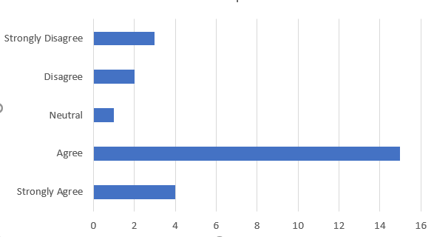
Figure 1: Social media marketing and the changed buying perceptions of consumers
Source: (Self-developed)
- What are some of the negative impacts of social media on businesses?
Responses | Number of Respondents
The burden of a shift in the market | 05
Tracking harmful and misleading contents | 13
Phishing and security concerns | 06
Accidental release of confidential facts | 01
Others | 00

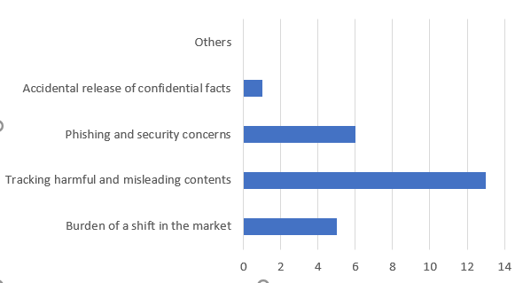
Figure 2: Negative impacts of social media faced by the family businesses
Source: (Self-developed)
- What do you think are the positive impacts of social media on family businesses?
Responses | Number of respondents
Reach a humongous number of target customers | 10
Getting feedback of customers | 05
Enhancement of the market reach | 02
Enhanced ad campaigns through social networking sites | 07
Enhanced market revenue | 01

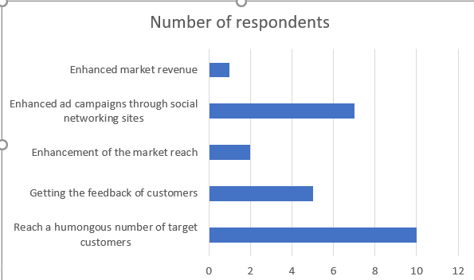
Figure 3: Positive impact of social media
Source: (Self-developed)
- Do you agree with the view that social media marketing helps family businesses to reach a large number of target customers?
Responses | Number of respondents
Strongly Agree | 05
Agree | 09
Neutral | 05
Disagree | 03
Strongly Disagree | 03

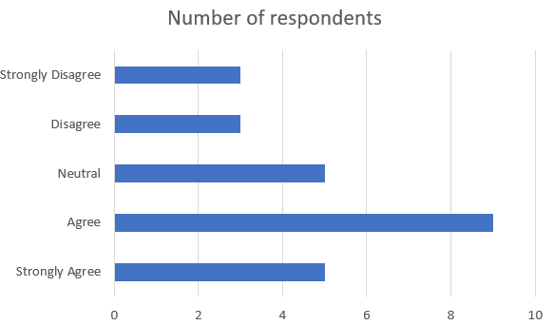
Figure 4: Social media and its help to reach a large number of target customers
Source: (Self-developed)
- What are the main challenges that family businesses face due to social media?
Responses | Number of Respondents
Engagement in reaching the target audience | 07
Development of engaging content | 02
Trends and algorithms of social media | 01
Creation and execution of social media strategies | 12
Keeping a consistent online presence | 03
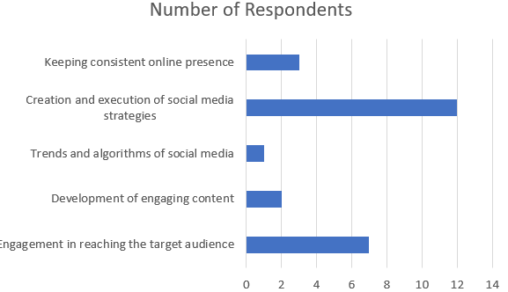
Figure 5: Main challenges faced by family businesses due to social media
Source: (Self-Developed)
- Do you think phishing is one of the main challenges of social media that are experienced by family businesses?
Responses | Number of Respondents
Strongly Agree | 04
Agree | 09
Neutral | 05
Disagree | 05
Strongly Disagree | 02

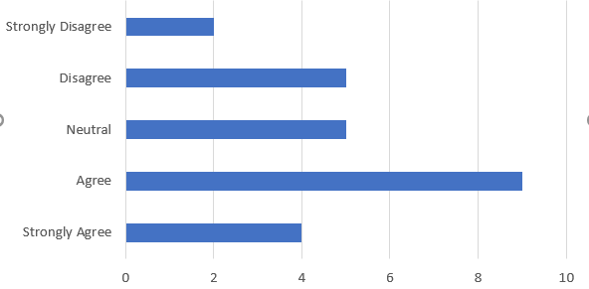
Figure 6: Phishing as one of the greatest challenges faced by family businesses
Source: (Self-Developed)
- How likely are you to buy a product which is usually recommended online?
Responses | Number of Respondents
Very likely | 03
Likely | 11
Prefer not to say | 04
Unlikely | 05
Very Unlikely | 02

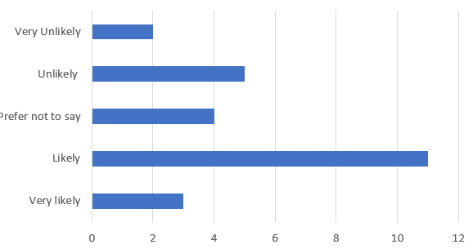
Figure 7: Likeliness of buying a product which is recommended online
Source: (Self-Developed)
- What social media channels do family businesses use mostly for reaching a large number of customers?
Responses | Number of Respondents
Facebook | 03
Twitter | 02
LinkedIn | 01
Instagram | 15
Reddit | 04

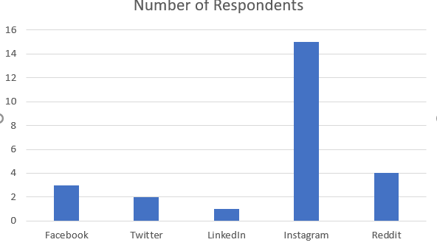
Figure 8: The social media channels mostly used by family businesses
Source: (Self-Developed)
- Do you think family businesses have a scope of growing its market due to social media?
Responses | Number of Respondents
Strongly Agree | 12
Agree | 04
Neutral | 01
Disagree | 04
Strongly Disagree | 04

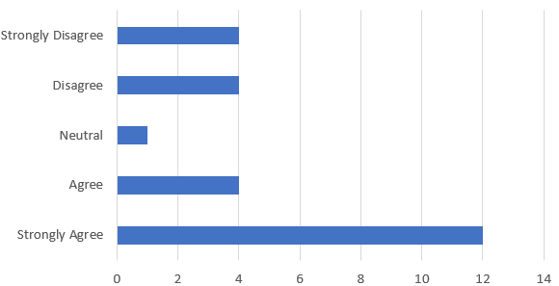
Figure 9: Social media channels that help in growing family businesses
Source: (Self-Developed)
- Do you think social media marketing is one of the best marketing policies for family businesses for engaging more customers?
Responses | Number of Respondents
Strongly Agree | 05
Agree | 13
Neutral | 01
Disagree | 04
Strongly Disagree | 02

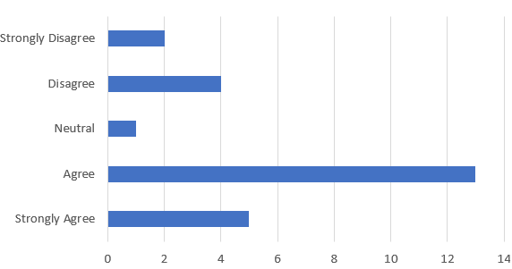
Figure 10: Social media marketing and more engagement of customers
Source: (Self-Developed)

