Student Name: Aisha Sultana
Student Number: 2409656
Assignment title: Component 1: Written Assignment (Case Study Report)
Module: Introduction to Physiology
Module Code: BMHP5023
Lecturer Name: Robert Nartowski

Contents:

Introduction…………………………………………………………………………………………
Case Study 2
Introduction of asthma and risk factors………………………………………………………….
Structure of the respiratory system and process of mechanical respiration
Gas exchange in the lungs
Effects of irritants on the Respiratory system
Monitoring asthma using peak flow readings.
Evidence based recommendations to improve asthma.
Conclusion
Reference List

Introduction and Key Summary:

This report will explore about understanding asthma disease, its risk factors, how the respiratory system works. It will explain the process of gas exchange in the lungs and examine how irritants cause inflammation and swelling in the airways. The case study focuses on adolescents attending a GP, asthma clinic, who are experiencing increased exacerbations of their condition as they grow older. The purpose of this report is to support the study of cases by improving adolescence, understanding of asthma and how their respiratory system works. The report will also highlight the importance of monitoring respiratory functions, including peak flow measurements, which will help individuals safely manage their conditions. It will provide evidence-based lifestyle recommendations to help adolescence improve their condition.

Asthma and its risk factors?

Asthma is a common condition that affects individuals’ ability to breathe effectively. Asthma is a chronic inflammatory airways disease in both children and adults ranging from intermittent, mild persistent, moderate persistent, and severe persistent. The main symptoms of asthma are wheezing, coughing, shortness of breath and tight chest (NHS, 2025). It is particularly common in children and adolescents. Symptoms can be mild to severe. Asthma triggers are things that make asthma symptoms worse. These include indoor allergens such as pollen and mold. Infections can trigger asthma such as colds and flu. Poor air quality or very cold air can trigger asthma. According to NIH 2024, many factors work together to develop asthma including cigarettes smoke or germs, viral infections, family history, being overweight, allergies such as food or pollen allergies. Race or ethnicity is a risk factor too. Occupational hazards like breathing in chemicals or industrial dust can raise risk of developing asthma.

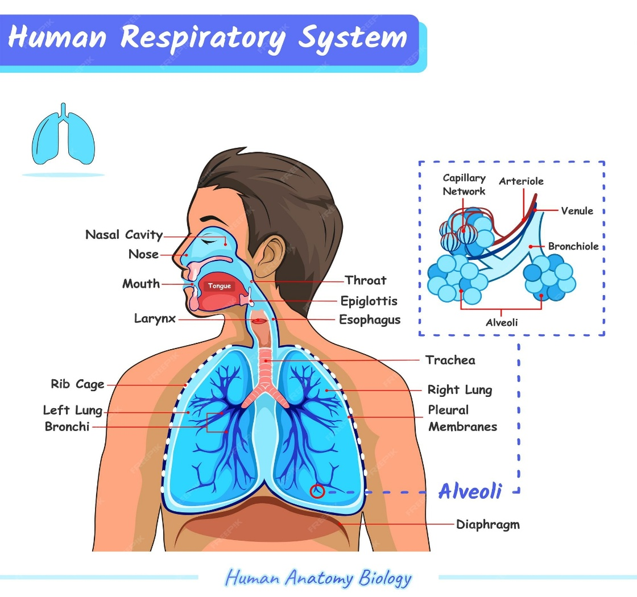
Structure of the respiratory system

Figure1.1: Respiratory System. (Animalia-life.club, 2025)
The respiratory system is an important body system responsible for supplying oxygen to the body and removing carbon dioxide. Oxygen is essential for cellular respiration. Sobhan (2024) explains that the respiration system has two parts, upper respiration tract, and lower respiration tract.
Upper respiratory tract Lower respiratory tract
Nostrils Lungs (bronchi,
Larynx bronchioles, alveoli,
Pharynx alveola ducts
Trachea

Upper respiratory tract
Nose: The nose is the main entry point for air into the respiratory system
Larynx: (voice box) Keeps the airway open and produces sound. It also prevents food from entering the lungs.
Pharynx: (throat) It is a hollow muscular tube inside the neck that starts behind the nose and opens into the larynx.
Trachea: The main air tube carrying air from the Larynx to the lungs. It has C-Shaped cartilage rings to keep it open. Its lining protects against infections.
Lower respiratory tract
This part carries air to the lungs and allows gas exchange.
Lungs: The lungs are two long cone-shaped spongy organs lying in the chest and major blood vessels. Right lung has 3 lobes while the left has two lobes.
Bronchi: two main tubes that carry air into each lung
Bronchioles: The smallest bronchi are called bronchioles. They are made of muscular, fibrous, and elastic tissue.
Alveoli: Tiny air sacks, whose walls are only one cell thick. Alveoli are surrounded by capillaries; this structure facilitates gas exchange.

Process of mechanical respiration
Mechanical respiration is the process of moving air into and out of the lungs. It consists of inspiration and expiration. The chest expands during inspiration and contracts during expiration. During inspiration, the muscle of diaphragm becomes lower and flatter. External intercostal muscles contract, lifting the ribs upwards and outwards. The thoracic cavity increases in volume, and pressure inside the lungs decreases. The lungs expand to fill the space, and air is sucked in via the bronchiole tree.
During expiration, the diaphragm relaxes and returns to its dome shape. Expiration is usually passive during normal breathing but becomes active during exercise for illness when muscles contract more forcefully.

Process of Gas Exchange in The Lungs

Watson (2018) explains the gas exchange in the lungs happens in tiny air sacks called alveoli and it is all about swapping oxygen and carbon dioxide. Gas exchange happens through diffusion. Diffusion is the net movement of particles from a region of higher concentration to a region of lower concentration. The lungs always contain some air and are never empty. When we breathe in, the alveoli fill with fresh air. In these tiny sacks, oxygen from the air passes into the blood in the surroundings capillaries, while carbon dioxide from the blood makes into the alveoli to be breathed out. The process of exchanging gases ensures that the blood gets oxygen and removes carbon dioxide.

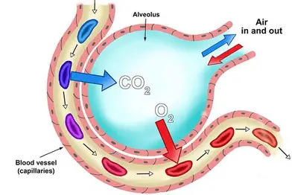
Figure1.2: Process of Gas Exchange (mammoth.net.com. 2025))
Increased level of irritants and its impact on respiratory system.

Lung irritants are substances in the environment that can worsen breathing and trigger symptoms like coughing and wheezing. This is especially important for people with asthma, as these irritants can make their symptoms flare up. Indoor irritants may include cleaning products with strong chemicals, dust mites, and smoke. Outdoor irritants can involve weather conditions, air pollution, and pollen. Some workplaces—such as construction, textile, or farming industry may also expose people to these irritants.
Campbells & Spara (2023) explain that frequent exposure to irritants, especially cigarette smoke, can increase airway sensitivity, promote access mucus production, and raise levels of inflammatory markers. The airway epithelium plays a key role in starting the inflammatory process and it is also affected by it. When irritants are inhaled, epithelial cells activate immune responses that lead to greater blood flow and increased mucus secretion. With prolonged exposures, these changes may become long term features of lung functions resulting in consistently high mucus production and swollen blood vessels. This can result in shortness of breath, increased respiratory rate and fatigue as the body must work harder to maintain adequate oxygen levels.

Recording and tracking respiratory functions (Peak flow readings)

Asthma disease is common in hospitals and community health care settings in the UK. Nurses therefore must be able to understand the physiology that underpins the care they provide for the people living with respiratory disorders. (Wheeldon, 2023). Peak flow is a simple handheld device that measures the fastest speed a person can blow air out after taking a deep breath. According to NHS (2022), It is used to help diagnose and monitor asthma. If a person is diagnosed with asthma, measuring peak flow regularly can be a useful way of monitoring conditions. Recording and tracking respiratory functions as a fundamental aspect of asthma management.
When the airways begin to narrow due to inflammation or muscle tightening, the reading will usually drop sometimes even before the person notices symptoms such as wheezing or shortness of breath. NICE`s, (2022), innovation bringing (MIB282) recognized smart peak flow as a digital alternative to mechanical peak flow meters for asthma monitoring. It is a digital device connecting to smart phone apps via Bluetooth or audio, recording peak expiratory flow (PEF) readings. It automatically charts readings, calculates a personal best and assigns color coded zones to indicate asthma control. It should be done twice daily, morning and evening before taking inhaler. It is suitable for individuals aged 5 and over. NICE recognized smart peak flow as a promising digital tool for asthma self-management.
Green (80-100%) Asthma is under control.
Yellow (50-79%) Warning asthma worsening
Red (Below 50%) Medical emergency
Tracking these patterns overtime helps individuals recognize triggers like pollen, cold air exercise, or respiratory infections. This allows the individuals to use their inhaler early to prevent a severe asthma attack. It also supports health care professionals in evaluating whether treatment Is effective or adjust inhaler doses are changing medication. Recording and tracking peak flow reading helps adolescence with asthma by deducing early changes which reduces hospital visits. It also gives individuals more control over their condition and prevents serious attacks.

Evidence based recommendations to improve asthma.

Maintain a healthy weight:
Extra weight places strain on the lungs and increases inflammation, making asthma harder to manage. Health care professionals should encourage safe and gradual weight management for asthma patients. Juel CTB, et al (2012) highlight that obesity is associated with the high incidence of asthma and its control. Research shows that weight reduction in individuals with obesity and asthma can greatly decrease symptoms and reduce reliance on medication. In some cases, symptoms may even disappear.
Healthy diet:
According to Cambridge University Hospital (2023), a high fiber diet improves asthma control. It has less fat and calories but is rich in vitamins and minerals. Eating two portions of fruit and 5 or more portions of vegetables per day has been associated with well controlled asthma. Processed and cured meat, fast food should be taken less regularly or not at all.
Exercise and yoga:
Stoodley, et al (2019) mentioned there is some evidence that shows meditation, yoga and breathing exercises may help individuals with asthma. Massage therapy also appears to have potential benefits for children with asthma.
Avoid triggers and quitting smoking.
Patients should avoid environmental triggers such as air pollution, pollen, and smoke, as these can worsen symptoms. Ask friends and family to help where they can like not smoking around you or keeping pets away (NHS, 2025).
Use of inhaled corticosteroids
Clinical guidelines state that inhaling corticosteroids are the first-choice preventer drug for asthma management. (British Thoracic Society, 2019).

Conclusion

In conclusion, asthma is a chronic inflammatory condition that affects the airways and normal respiration. Understanding of the anatomy of the respiratory system and how mechanical breathing work helps nurses understand why airflow becomes limited during an asthma attack. A good understanding of asthma conditions and its risk factors is clinically relevant for many health care professionals. Early recognition and preventive strategies can reduce hospital admissions. Increased level of irritancies reduced the amount of oxygen needing to shortness of breath, wheezing, chest tightness, and fatigue. Recording and tracking respiratory functions such as PEF readings play an important role in helping adolescence with asthma monitoring and safely managing their condition. Lifestyle changes play a significant role in improving asthma conditions safely and effectively. Evidence suggested that maintaining a healthy weight, having a nutrient-rich diet, engaging in regular exercise, avoiding smoke, and supporting mental well-being can enhance symptoms control. However, high-quality evidence is still required before firm guidance can be established. Overall, lifestyle measures are low-cost approaches that can enhance quality of life and improve asthma outcomes in both adults and children.

Reference List:
Animalia-life Club (2025). Respiratory system diagram. Available at:
https://animalia-life.club/qa/pictures/human-respiratory-system-diagram (Accessed on: 9 February 2026).
Asthma Lungs UK, (2022) Manage your severe asthma. Available at: https://www.asthmaandlungs.org.uk/condition/severeasthma/manage-your-severe-asthma (Accessed: 10 February 2026).
British Thoracic society, (2019) British guideline on the management of asthma. (SIGN 1:58) Available at https://www.brit-thoracic.org.uk (Accessed: 11 February 2026).
Campbell, M. and Sapra, A. (2023) Physiology, air flow resistance. PubMed. Treasure Island (FL): Stat Pearls Publishing. Available at: https://www.ncbi.nlm.nih.gov/books/NBK554401.
Cambridge University Hospital, (2023). Optimizing your diet to benefit your asthma. Available at: https://www.cuh.nhs.uk/patient-information/optimising-your-diet-to-benefit-your-asthma/ (Accessed: 12 February 2026).
Juel, et al. Asthma and obesity: does weight loss improve asthma control? A systematic review. J asthma allergy. 2021; 5:21-6 Doi: 10.2147/JAA.S32232.
Mammothmemory.net (2026). Available at: https://mammothmemory.net/images/user/base/uncategorised/1.22.22%20Further%20magnification%20of%20an%20alveoli.jpg (Accessed: 15 February 2026).
National Institute of Health and Care excellence, (2022). Smart peak flow for monitoring asthma. Available at: https://www.nice.org.uk (Accessed: 15 February 2026).
NHS (2022). Peak flow test. Available at: https://www.nhs.uk/tests-and-treatments/peak-flow-test/ (Accessed: 14 February 2026).
NIH (2024) Causes and triggers. Available at: https://www.nhlbi.nih.gov/health/asthma/causes (Accessed: 13 February 2026).
Sobhan, (2024). An overview of the anatomy and psychology of respiration. EJCMPR, 3 (2) pp.499-514. Available at: https://doi.org/EJCMPR/20241225 (Accessed: 17 February 2026).
Stoodley, et al (2019) `Evidence for lifestyle interventions in asthma`, Breathe 15 (2) Doi: 10.1183/207344735.0019-2019.
Watson, R. (2018) Anatomy and psychology for nurses. 14th edition. Elsevier Publications Ltd.
Wheeldon, A. (2023). The respiratory system and associated disorders. Br J Nurs. 2023 July 6;32(13) :613-619. Doi: 10.12968/bjon.2023.32.13.613.

