NAME: Deirdre Gould

ENROLE NUMBER: 1809630

MODULE TITLE: Project Management for Sustainability

Assignment 1

PROJECT MANAGEMENT FOR SUSTAINABILITY REPORT.

CONTENT:

Executive summary……………………………………………………………page 3

Introduction……………………………………………………………………..page 4

Definition of a project manager………………………………………………page 4-5

The importance of a project manager……………………………………….page 5

Role of a project manager…………………………………………………….page 6

Key elements of a project manager………………………………………….page 6-7

Stakeholder management and analysis……………………………………..page 7-8

Project manager methodologies...……………………………………………page 9-14

Risk management………………………………………………………………page 14-17

Project management plan……………………………………………………...page 17-18

Lifestyle of a project……………………………………………………………page 18

Conclusion………………………………………………………………………page 19

References………………………………………………………………………page 20-21

EXECUTIVE SUMMARY

In this report it will be a critical assessment and a plan of a project management role.
The report will use management tools and techniques explaining the stages that are
required to run a project. With a level of analysis over each topic of 3 of the
methodology tools and techniques from management stakeholders and risks. A
project management plan and a lifestyle of a project.

INTRODUCTION

The report will consist of a variety way a project manager works to obtain a final
result to a plan. Also, in the different approaches and all the elements that go
together to form a project manager result. An assessment of the usefulness of
project management techniques and tools needed for managing a project.

DEFINITION OF A PROJECT MANAGER

Relevant theories on project management range from its practice of introducing,
development, fulfilling, influencing and completing of a project. With the challenge to
achieve all the project goals with the chosen team and deadline. With help towards
the organisation of efficiency.
Project “a piece of planned work or an activity that is finished over a period of time
and intended to achieve a particular purpose” (dictionary, 2019).
Manager “the person who is responsible for managing an organization” (dictionary, 2019)
A project manager is different to an ongoing manager within a company as the
project manager has a final delivery date, a finite timespan, were as a manager does
not.
“Simply put, a project is a series of tasks that need to be completed in order to reach
a specific outcome. A project can also be defined as a set of inputs and outputs
required to achieve a particular goal. Projects can range from simple to complex and
can be managed by one person or a hundred. Projects are often described and
delegated by a manager or executive. They go over their expectations and goals and
it up to the team to manage logistics and execute the project in a timely manner.
Sometimes deadlines can be given or a time limitation. For good project productivity,
some teams break the project up into individual tasks so they can manage
accountability and utilize team strengths.” (wrike, n.d.).

THE IMPORTANCE OF A PROJECT MANAGER

To understand the role and foundations of a project manager helps to understand
the importance. From as far back as building the Pyramids to the Great Wall of
China project management of some kind has existed and evolved over time.

“By the early 20th century, Frederick Taylor applied concepts of project management
to the workday, developing strategies for working smarter and improving
inefficiencies rather than demanding laborers work harder and longer. Henry Gantt,
an associate of Taylor’s, took those concepts and used bars and charts to graph
when certain tasks, or a series of tasks were completed, creating a new way to
visualise project management.” (wrike, n.d.).
The importance of a project manager is to make sure everything that needs to be
delivered is done after evaluating the needs, risks and requirement of the
organisation. It is important that they have all the relative skills in place often
technical management people skills as well as good business awareness.

ROLE OF A PROJECT MANAGER

A project manager is brought into a business to produce an end product that will
effect a change within the organisation. The project could be something new, altered
tangible or intangible. The project manager is separate from the business manager
and is concerned with managing projects of work to achieve specific objectives.
“The project manager must have a combination of skills including an ability to ask
penetrating questions, detect unstated assumptions and resolve conflicts, as well as
more general management skills.” (Haughey, 2019).

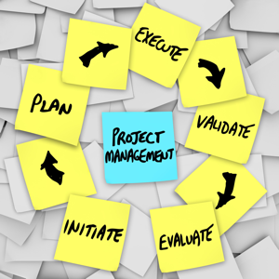 (Haughey, 2019).

This diagram shows the basic role of how the project manager will achieve the goal
appointed. The project manager needs to be able to communicate, motivate and
delegate and be good at planning and organise well.

KEY ELEMENTS OF A PROJECT MANAGER

SMART: is an acronym meaning: specific, measurable, attainable, relevant, timely,
this is a good start to establish the objectives for a project manager.
The key elements of a project manager entail firstly defining what has to be
achieved, product development, who is involved, communication, and the budget.
Also, how to get to the main goal through reports, graphs, assigned tasks and
collected data. All of the project members rely on the project manager to keep all
information updated and communicated. By breaking down the project into
manageable tasks, it will then be easier to see if there is anything else needs to be
considered. Who isn’t delivering the task assigned on time? needs to be addressed
for example, good communication and delegation skills comes into play.
“Whether your project is about improving an existing product or service, managing
change or implementing a new system, the same basic considerations are required
when managing projects.” (Chapman, 2012).
The project manager has tools in place as aids to assist individual or team to
organise work, projects and tasks efficiently. These are usually software based.

STAKEHOLDER MANAGEMENT AND ANALYSIS

“Stakeholder management is a critical component to the successful delivery of any
project, programme or activity. A stakeholder is any individual, group or organisation
that can effect, be affected by, or perceive itself to be affected by a programme” (Sowden, 2011).
Stakeholder management is a process and important discipline, communication and
good relations with all stakeholders involved whether internal or external within the
project. Project managers are dependent stakeholders for different reasons. Support,
investment and resources within many different roles and levels which can influence
the project, so communication throughout each stage of the project early on and
frequently with each stakeholder identified and their value is vital as it can mean
success or failure with the project.
The importance of the stakeholder needs to be analysed so they need to be
identified, recognised and acknowledged. Then determined their influence and
interest in achieving project goals into high to low priority.
“Stakeholder Analysis is an important technique for stakeholder identification &
analysing their needs. It is used to identify all key (primary and secondary)
stakeholders who have a vested interest in the issues with which the project is
concerned” (project-management.com, 2018).
It is important for any project manager to do a stakeholder analysis with a
power/interest grid or power/interest matrix as this can determine and categorize
stakeholders’ power and interest also motivation with the project, conflicting
interests, relationship and the level of participation required with each stakeholder.
The diagram shows it has four quadrants. “Each quadrant gives you an indication of
the level of stakeholder management that you’ll have to employ and may also
influence the type of communication style.

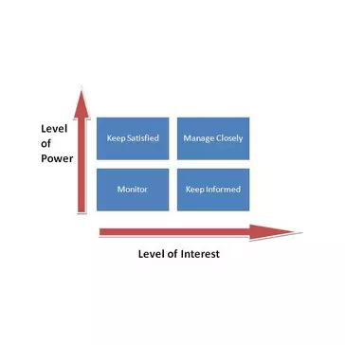
“ (Sharma, 2019).
This procedure helps the project manager identify the strengths and weakness within
the stakeholders and to satisfy the differing needs of the stakeholders inside the
project.

PROJECT MANAGEMENT METHODOLGIES

A project manager will select a certain methodology to get the project done more
efficiently. It is a system of practices, techniques, procedures and rules that can
guide the team through development and execution of phases processes and tasks
to aid the project managers life cycle. Which methodology to use on a project
depends upon the project, as each methodology has its own set of rules, principles,
processes and practices to maximise the use of time and resources available to the
project manager.
WATERFALL: follows in a linear sequence.
Waterfall is a traditional methodology for a project manger to use with its progressive
design approach where the progress flows downwards in one direction. Waterfall
definition “a cascade of water falling from a height, when a river or stream flows over
a precise or steep incline.” (dictionary G. , 2019). It only allows the team to move into
each phase of development once the existing one has been achieved. It always
relies on documentation to be updated so if any team member leaves during a
development phase a fellow team member can familiarise themselves with all the
relevant information needed to continue the development phase being completed on
time. The diagram below is displayed like a waterfall each showing the different
stages required to be achieved and finalised before the next stage is ready to be
completed and so on.
The 1st stage: Requirement Analysis = system and software requirement
specifications.
The 2nd stage: System design = planning and design of analysis requirement.
The 3rd stage: Implementation = construction and coding execution design
requirement.
The 4th stage: System testing = control and integration with coding requirement.
The 5th stage: System development = testing and debugging, testing validation
requirements.
The 6th stage: System maintenance = installation and maintenance operations
requirements.

(softwaretestinghelp, 2019).
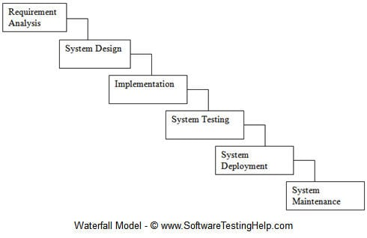

AGILE: follows in an iterative sequence.
Agile breaks down the project design and planning into smaller pieces, iterative and
then sprints, timeboxes are carried out in 2/4 weeks.
The iterative is a single development cycle involving cross-functional team working
on, planning, analysis, design, coding, unit testing and acceptance testing. With each
stage being reviewed and critiqued by the team and various stakeholders. It is then
from these understandings are used to determine what the next stage should be
within the project. The team will continuously build a rapid feedback practises called
continuous deployment (CD) and continuous integration (CI). The project teams will
also continuously evaluate all the time and cost implications. The overall goal of
each stage is to be able to adapt to change and to be able to still deliver.
“Agile methodology breaks the developmental process into iterative steps, allowing
flexibility, testing, and change throughout the lifecycle of the project” (team, 2017).
The diagram below is of an iterative model showing via the arrows how it goes back
and forth continuously until the outcome is resolved. The different stages are
Stage 1: Requirement gathering and analysis = customers’ requirements checked by an analyst.
Stage 2: Design = design requirements for different diagrams.
Stage 3: Implementation = coding requirements for software.
Stage 4: Testing = coding software tested using different methods e.g. box test.
Stage 5: Deployment = after completing phases above software is deployed.
Stage 6: Maintenance = debugging and new additional options.

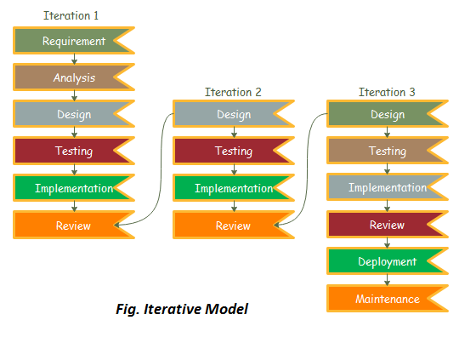 (javatpoint, 2018).

PRINCE2: follows a structured sequence.
Prince2 is an acronym for projects within controlled environments. This methodology
is mainly used within the UK government. Prince2 emphasis on the project being put
into controlled and manageable stages with flexibility over resources. Logical steps
are determined by all the questions answered. They are then put into an organised
and controlled plan before commencing forward on the project. Input and tasks to
preform is also given by customers, supplier as well as executives. The team is
given individual tasks to preform and update making sure it is executed properly and
on the time schedule, until the project is completed.
“Prince2 is processes-based approach that focuses on organisation and control over
the entire project, from start to finish.” (wrike, n.d.).
The diagram below is off a prince2 models showing the 7 stages of principles,
themes and processes.
Stage 1: = Principles = business justification =To determine its viable at each stage
Themes = business case = To determine its viable at each stage
Processes = start up = To determine its viable at each stage
Stage 2: = Principles = learning from experience = address work risk,
communication, configuration, and benefits.
Themes = organisation = address work risk, communication,
configuration, and benefits.
Processes =initiate = address work risk, communication, configuration,
and benefits.
Stage 3: = Principles =roles and reasonability = initiation off all tasks and stages.
Themes = quality = initiation off all tasks and stages.
Processes = direct = initiation off all tasks and stages.
Stage 4: = Principles = manage by stages = monitoring, authorising, progress.
Themes = plans = monitoring, authorising, progress.
Processes = control stages = monitoring, authorising, progress.
Stage 5: = Principles = manage by exception = accepting, executing, delivering work
package.
Themes = risk = accepting, executing, delivering work package.
Processes = manage delivery = accepting, executing, delivering work
package.
Stage 6: = Principles = focus on product = updates, planning for next stage.
Themes = change = updates, planning for next stage.
Processes = manage stage boundary = updates, planning for next stage.
Stage 7: = Principles = tailor to suit environment = make sure goal and objectives
have been obtained, plan closure, handover.
Themes = progress = make sure goal and objectives have been
obtained, plan closure, handover.
Processes = closure = make sure goal and objectives have been obtained,
plan closure, handover.

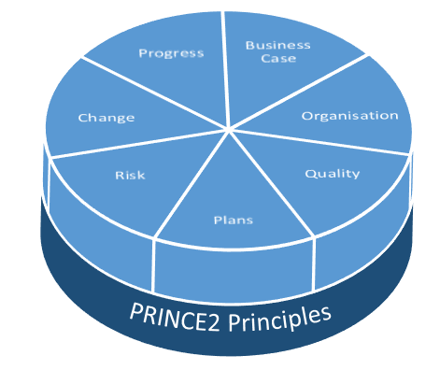 (theknowledgeacademy, 2019).

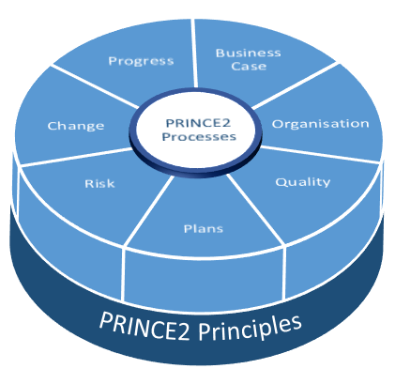 (theknowledgeacademy, 2019).

The Waterfall method was a very popular tool in its time. Although its flexibility made
industry leaders frustrated; the Agile method was developed for more flexibility
needed within certain industries. They both have advantages and disadvantages
with their methods off execution and both are still being used today. Prince2 method
is a waterfall style method with a predictive approach. The Agile method or the
prince2 is chosen between its pros and cons depending on the project to achieved.
With the UK government preferring Prince2 the insurance, banking and its industries
would prefer Agile.

RISK MANAGEMENT
The risk management for a project is vital towards the project being completed, as it
is used to minimise any problems, negativity of some kind that might affect the
processes, resources, people, technology, and cost. The weaknesses and strengths
and threat the project at any stage even before the project has started with what it
might encounter through the chosen methodology. It is an important part for the
project manager and all the assigned team and stakeholders if involved to be
assigned to tasks and stages are kept updated and communicated at all given times.
This will then help in any drawback which hopefully can be resolved in some way, so
the project can go ahead without too much or any deals. The process is iterative so
when all stages of risk have been put in place, a risk register, identified and
documented. A quantitative risk analysis will be preformed to carry out probability
thorough in depth investigating the negative blocks that could potentially halt the
project. It also enables the stakeholders to get a contingency plan together to accept,
relocate or reduce the risks.
The diagram below is a risk management model showing stages of principles.
Stage 1 = Identify the risk = in all aspects concerned within the project e.g. legal,
environmental, market, regulations, cost, extra.
Stage 2 = Analysis the risk = in all aspects concerned within the project placed into
documents, policy, procedure, processes, extra.
Stage 3 = Evaluate and Rank the risk = in all aspects concerned within the project
need to be ranked and prioritised into different categories.
Stage 4 = Treat the risk = in all aspects concerned within the project need to be
communicated within all team, managers, stakeholders.
Stage 5 = Monitor the risk = in all aspects concerned within the project some risk is
always present e.g. market, environmental, extra. Continuously monitor.

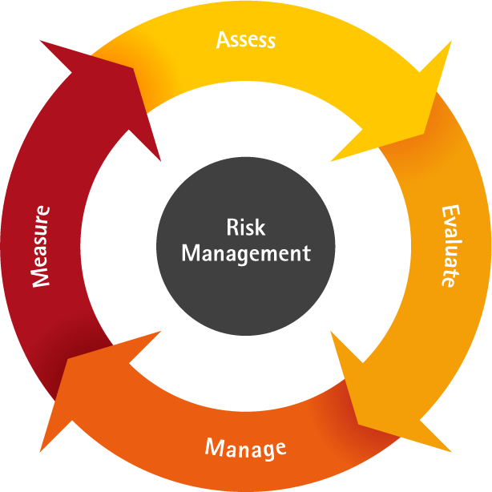 (zilicus, 2019).

With prioritising the impact and probability of the project from the analysing that has
been done to achieve all documentation of risks. It can then be placed into a chart
showing from high to low depending on risk involved.

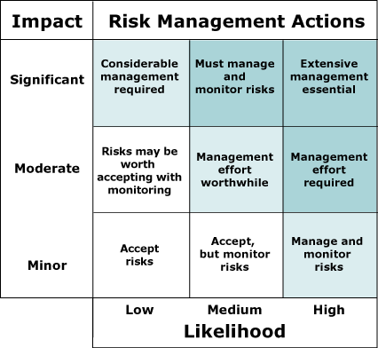 (Management, 2019).

PROJECT MANAGEMENT PLAN
A project management plan is a document created for the objectives with a view to
foresee or predict as many risks and problems laid ahead. Stakeholders should be
identified with their requirements and objectives so the project manager can prioritise
and deal with conflicting interests, risks in advance. The project manager can
then start:
Planning = deciding what is to be done.
Organising = deciding within the desired outcome.
Directing = instructions to be made and executed.
Monitoring = always looking for new solutions.
Representing = communicating and liaisons with users.
The objectives increase the chance of a specific ending, so the objectives need to be
specified so they are measurable on how successful a project has been. The project
manager will assign teams to achieve a series of objectives in pursuit of the final
objective.
Objective 1 = Performance and Quality: to achieve the end of the project to become
what it was intended to be.
Objective 2 = Budget: to achieve completion without exceeding budget resources.
Objective 3 = Time of Completion: progress to end on time or earlier than predicted.
As the project management plan that is ongoing by and created by developing,
refining, continuously revisiting, whilst being kept updated.

LIFESTYLE OF A PROJECT

The project manager as well as team carry out the work of the project in question.
Projects have a beginning, middle and finally the end. A typical project lifestyle of a
project follows four major stages:
INITIATION = objectives are identified, documentation is put in place being feasible.
If approved teams are allocated.
PLANNING = more development over the project get started workplans, tasks,
resources, requirements and strategy to achieve them. Risk is identified with actions
put into place. Stakeholders and sponsors need to be identified and communication
plan with delivery method. Documentation showing plan, targets, assurance and
control measures to be put in place.
IMPLEMENTATION = project plan is put into motion and work begins. Tasks and
progress information to be reported regularly. Project manager will control the
direction of the project comparing progress reports and activities. Communication
towards stakeholders and sponsors keeping them informed and updated. Also
documentation updated and published regularly with the emphasise on the final point
in terms of cost, schedule and quality of stages.
CLOSING = during the completion of a project the releasing of the final stages,
handing over project documentation to the business. Terminating suppliers,
releasing project resources and communicating closure to all stakeholders involved.

CONCLUSION
“A thriving project manager gets the best out of both people and projects. They work
in industries as diverse as information technology, construction, healthcare,
marketing, media and engineering. They keep projects or programs on schedule
and within scope and budget, working toward high efficiencies and flawless
execution.” (solutions, 2019).

References
Chapman, D. (2012, april 25). Project management from the archives. Retrieved from pm times resources for project managers: https://www.projecttimes.com/articles/5-essential-elements-of-a-successful-project.html
dictionary, c. (2019). dictionary cambridge. Retrieved from cambridge dictionary: https://dictionary.cambridge.org/dictionary/english/project
dictionary, G. (2019). google dictionary. Retrieved from dictiionary google: https://www.google.com/search?sxsrf=ACYBGNTAsegoET76iYq1EWxazHONV7wYqQ:1574674239923&q=Dictionary&stick=H4sIAAAAAAAAAONQesSoyi3w8sc9YSmZSWtOXmMU4-LzL0jNc8lMLsnMz0ssqrRiUWJKzeNZxMqFEAMA7_QXqzcAAAA&zx=1574674940214#dobs=waterfall
Haughey, D. (2019). projectsmart. Retrieved from projectsmart: https://www.projectsmart.co.uk/the-role-of-the-project-manager.php
javatpoint. (2018). java t point. Retrieved from iterative model: https://www.javatpoint.com/software-engineering-iterative-model
Management, E. P. (2019). risk management models. Retrieved from enterprise project management: http://www.tbs-sct.gc.ca/pubs_pol/dcgpubs/RiskManagement/giffs/RiskMgmtModel.gif
project-management.com. (2018, october 5). PM projecct management.com. Retrieved from project management articles: https://project-management.com/what-is-stakeholder-analysis/
Sharma, R. (2019). Bright hub project management. Retrieved from power/interest grid: https://www.brighthubpm.com/resource-management/80523-what-is-the-powerinterest-grid/
softwaretestinghelp. (2019, november 10). software testing help. Retrieved from what is sdlc waterfall model: https://cdn.softwaretestinghelp.com/wp-content/qa/uploads/2014/04/Waterfall-model-phases.jpg
solutions, l. t. (2019). buisness linkedin. Retrieved from project manager: https://business.linkedin.com/talent-solutions/job-descriptions/project-manager
Sowden, R. (2011, august 30). stackholder management. Retrieved from wikipedia: https://en.wikipedia.org/wiki/Stakeholder_management
team, l. c. (2017, september 13). lucidchart. Retrieved from what is agile methodology?: https://www.lucidchart.com/blog/what-is-agile-methodology
theknowledgeacademy. (2019). theknowledgeacademy.com. Retrieved from prince2 methodology: https://www.theknowledgeacademy.com/_files/images/PRINCE2_nearly_Finished%21.PNG
wrike. (n.d.). wrike.com project management. Retrieved from wrike.com: https://www.wrike.com/project-management-guide/faq/what-is-a-project-in-project-management/
zilicus. (2019). zilicus. Retrieved from blog.zilicus.com: http://i.imgur.com/wQLvt8g.png?1

