Andrei Lebedinschii 1917123
Global Business Environment – assessment 1
Lecturer – Rexon Nting

Environmental Analysis of car manufacturing industry

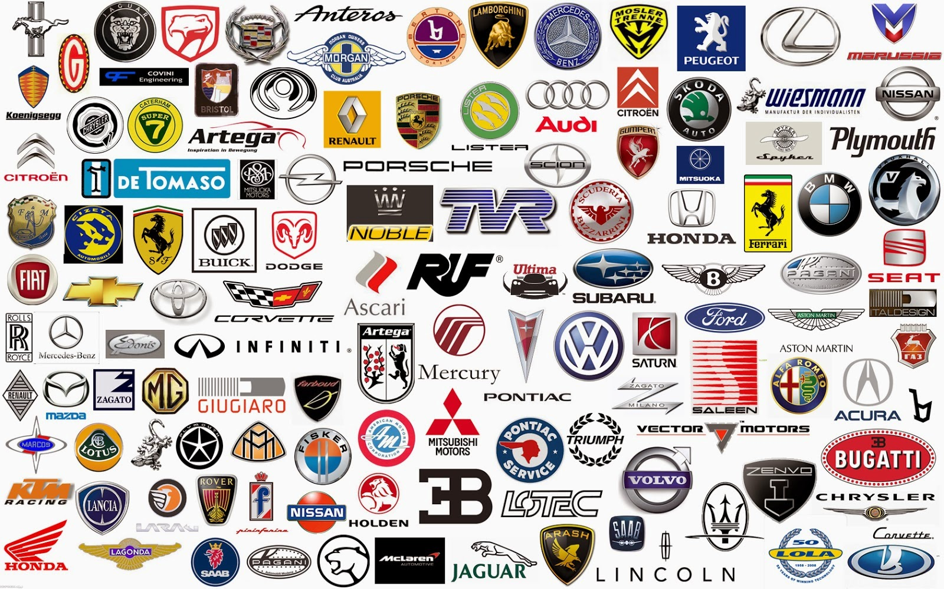

Executive Summary

The report explains the major factors that influence the business surrounding the car manufacturing industry. It examines the past changes in the car industry. It explains certain challenges and opportunities for the car industry. It elaborates certain views through which the car industry can get a competitive position in the automobile industry. It explains Pestle, and SWOT of the car manufacturing industry.

Table of Contents:
Introduction 4
Major Forces Changing the Business Environment of the Car Manufacturing Industry 5
Opportunities and Challenges of Car Manufacturing Industry 8
Conclusion 12
Reference List 13

Introduction

The report examines the major forces that affect business surrounding the car manufacturing industry. It explains the past changes in the car industry. It discusses challenges and opportunities for the car industry. It elaborates certain strategic options through which the car industry can gain a competitive position in the automobile industry. It explains Pestle, SWOT, and the value chain model of the car manufacturing industry.

Major Forces Changing the Business Environment of the Car Manufacturing Industry

External forces are rapidly changing the environment of the car industry as they are going through acceleration change. High internal competition often drove innovation mechanisms in the past which allowed the development of new sources by increasing the design and development of vehicles. Indeed, there is more software used in the car manufacturing industry by allowing entertainment capabilities and advanced driving. With the increased usage of parking technology and backup sensors, the car manufacturing industry is programmed to make environmental awareness. Connected cars are considered as kind of boon to the wireless industry and are considered as significant growth source for mobile carriers (Hoffman, 2019). Government regulations are increasingly engendering fuel-efficiency vehicles with certain safety levels. For instance, TESLA is a new entrant in the automobile sector which influences major changes by putting greater emphasis on the disruption of the business model and electric vehicles. Following are the major forces which influence the business surroundings of the car manufacturing industry:

Driverless Autos: Google is creating a driverless car by its program of Google Chauffeur. The car manufacturing industry has produced a prototype that experiences low incident rates than the average human driver's (Markoff, 2013). This technology has not yet approved by the state which hinders car makers from getting a license. Still, the car industry assumes that it will ready model until 2020 for public consumptions. These changes in new models, are much safer as compared to average vehicles.

Mobile connections in Cars: Telecom companies are increasingly connected cars number. Cars are the highest growth areas for the mobile sector. The door entry of the car can be controlled by smartphones as many cars are now having mobile hotspots. An interconnecting in car manufacturing takes immense due to sophisticated technology (Goggin, 2012). This force leads the car industry to communicate with each other for GPS systems and low traffic.

Regulations: This is another force that drives innovation in the car industry. The government raises fuel efficiency standards every year. The car manufacturing industry is increasing the efficiency of fuels using lightweight material for car manufacturing. For example: aluminum is used instead of heavier steel. This effort of replacing steels can allow vehicles to cut their weight that will also boost miles per gallon. Car industries are improving the efficiency of fuels through better designs of their vehicles. This comprises a smaller size of car engines, aerodynamic vehicles, and lower profiles. These measures require immense safety as the government instructs to install backup cameras in cars.

Software and chips: Software is implemented to increase the capabilities of a drive for effectively making routine maintenance. Implementation of software takes many forms like gauging the pressure into the tires, audio systems, and backup cameras. The car industry has become automate by parking assistance and review monitors. Semiconductors are essential in car manufacturing for operating higher software levels. Advancements in speech and image processing are continuously growing at high rates for driverless driving.
Thus, the car manufacturing industry is going through wide changes concerning some forces of internal and external aspects. The vehicle design change rate is highly accelerating cars to become like computers by relatively including high technology and low rates of ownerships (Agarwal, 2019). In every aspect of the car industry, competitions and regulations are forcing them to manufacture clean vehicles.

Changing Era of The Car Manufacturing Sector
The manufacturing of the car industry ran early on electricity and steam. The manufacturing of cars was powered by steam in the past years which became a more practical aspect for small cars. Despite many improvements, there were a lot of problems as their range was limited and they took a long time to start up vehicles. Then car manufacturing came to electric vehicles. These electric cars were popular as they do not involve problems with steam engines. It also does not involve hard gear shifts.

The electric cars were developed as carbon free. After that were produced hybrid cars powered by gas and electricity. Now the car manufacturing has expanded to Bluetooth, GPS, advanced systems of safety, Wi-Fi, and hard drives. It enlarged to windshields, speedometers, rearview mirrors, and seatbelts. Cars started getting fancy in terms of design, power steering, and heated seats. The manufacturing of cars adopted certain systems of electric doors, keyless entry, and sunroofs. At this period, technology became a big point of selling cars. Then driverless technology came, it is still in development and enforcement. Hybrid electric cars are on development way with an effective battery system. The high gasoline cost and concern for pollution lead to the development of electric cars.

Opportunities and Challenges of Car Manufacturing Industry

The UK car manufacturing industry has faced many problems or challenges-as Brexit looms large, we have also face global trade tension and economic headwind as well as innovative technology race. Honda announced closing the Sweden plant in 2021, it will lead to lossing of about 3500 roles, since Jaguar Land Rover and Nissan also focus on cutting the production and employment. Car manufacturing faces global crisis, because demand for cars decreased. It is very important to make informed strategic decisions regarding car manufacturer (Petrillo, 2019).

SWOT Analysis
The SWOT analysis helps to analyze the strength, weaknesses, opportunities, and threats faced by car manufacturing firms. The main points are explained below:

- Strength: The main strength of car manufacture is its product features and brand values. The company mainly focuses on related to success and more powerful business. Car producing industry has focused on continuous innovation in product and also use advanced technology to increase the value of cars (Vlados, 2019).

- Weaknesses: Controversies related to the recalled car on the version of technical dis-functionality or non-abidance to legal policy has become very important. The Competitor of the existing market in the UK can offer a high-quality car with unique features at reasonable rates. This will reduce the profitability of the other manufacturer and even affect the whole market of the car industry.

- Opportunities: The car industry use optimization of fuel ignition engines and cost reduction programs have become a good opportunity for the success of the vehicle industry. Changing in customer demand, expand the regulations for safety and security of customer, and increase the information available for customers. It leads to increase the economical growth and also expand the purchasing power of customer as well as an emerging market. The company must expand its business in Europe and also work with highly professional in car manufacturing skills with top brands (Gürel, 2017).

- Threats: Currently in the UK, there are some players in the car manufacturing industry. Macroeconomic uncertainty, recession, unemployment are the factors that affect the car manufacturing industry. New laws related to gas emission, a safety problem, increase competition, and changing technology is become the biggest threat of car manufacture.

PESTLE Analysis
These tools help to analyze the macro environment condition that influences the car manufacturing industry. It also helps to analyze the risk facing by car manufacture in the UK.

- Political Factor: It will help to analyze the challenges faced by car manufacturers in the UK. Changing in-country rules and regulations will create a high political problem for the car industry. Tax laws, service and labor family laws, regulation, trade restriction, and tariffs are the political risk analysis considered under political stability (Taniguchi, 2016).

- Economical Factor: It helps to analyze the possibilities to achieve economic success, foreign exchange rate, and population rate of price rises, interest rate, and availability of credits. The care industry is predicted to sell more cars during the sound inexpensive times and fewer cars during the depression and protracted time of cheap crisis.

- Social Factor: This factor mainly includes car civilization, taste, fashion, health, safety, age distribution, etc. Currently, a customer in the main cities of Europe and America prefers the environmentally friendly car and pay a premium cost for it. Car manufacture pollutes the environment considering due to emission of cO2 and noise that affects the environment and leads to skin and respiratory diseases (Policy, 2018).

- Technological Factor: These factors are becoming challenges but also provide more opportunities to increase the sales of car products and services. Analyzing technological factors is important to evaluate the technical changes in the UK’s economy and how it influences the car manufacture industry. The car manufacture industry started to establish alternative energy vehicles that are using electricity only, fuel cell, hydrogen, etc. but it increases the cost of the car, it becomes a solution to reduce energy, lower pollution, but it also affects other UK’s manufacturers.

- Environmental Factor: Nowadays, this factor is essential for car customers and government ecological focus. Government implements laws related to the maximum acceptable carbon dioxide emission for a car to be sold in the current marketplace. This is a challenging problem that threatens the globe, car manufacture industry should also pay more attention to this problem, by transforming their knowledge into electric vehicles and decrease emission (Perera, 2017).

- Legal Factor: Car manufacturing industry such as other industry is regulated by the government. Is important to follow the rules and regulations set by the government. Car manufacturing industry faces gas emission laws, protection and security issue, car regulation and compatibility, spare parts manufacture, etc.

Conclusion

Car manufacturing is the most important player in the global economy of the UK. In Europe, this industry provides above 12 million jobs, and in the US it about 8 million and in Japan, it provides more than 5 million employment. The car manufacturing industry has a long history of innovation and technological success. Continuously, this industry has spent a huge amount on technology to make driving safer for customers. In present, the situation may be more demanding and highly competitive. In car manufacturing industry maintaining a competitive advantage became the most important. The growing need for performance increase the cost and competition. It is important to invest in technology and ensure high quality and distribution of supply chain management. (Petrillo, 2019).

Reference List

Agarwal, A., Agarwal, K., Misra, G. and Pabshetwar, O., 2019. Driverless Car for Next Generation Commuters-Key Factors and Future Issues. American Journal of Electrical and Electronic Engineering, 7(3), pp.62-68.
Goggin, G., 2012. Driving the internet: mobile internets, cars, and the social. Future Internet, 4(1), pp.306-321.
Gürel, E. and Tat, M., 2017. SWOT analysis: a theoretical review. Journal of International Social Research, 10(51).
Hoffman, K., 2019. Driving force: the global restructuring of technology, labor, and investment in the automobile and components industry. Routledge.
Markoff, J., 2013. At High Speed, on the Road to a Driverless Future,”. New York Times.
Perera, R., 2017. The PESTLE analysis. Nerdynaut.
Petrillo, A., De Felice, F. and Zomparelli, F., 2019. Performance measurement for world-class manufacturing: a model for the Italian automotive industry. Total Quality Management & Business Excellence, 30(7-8), pp.908-935.
Policy, P., 2018. What is pestle analysis.
Taniguchi, E., Thompson, R.G. and Yamada, T., 2016. New opportunities and challenges for city logistics. Transportation research procedia, 12(12), p.1.
Vlados, C., 2019. On a correlative and evolutionary SWOT analysis. Journal of Strategy and Management.

