Dafydd Edwards (2417062)
synthesize a solution to a potential real life scenario
Vigilant Trust and Asset Management – Security report

Contents
Introduction 2
Identification of Modern Threats 3
Ransomware 3
Phishing & Vishing 3
Malware 3
Insider Threats 3
Distributed Denial of Service (DDoS) Attacks 4
Supply Chain Compromises 4
Modern Security Policies & Technical Mitigation Measures 5
Proactive Monitoring and Incident Response 7
Training and Awareness 8
Conclusion 9
Appendix 10
References 11

Introduction
Modern companies operate using computer systems which have become vital to any company operations. With technology being on the forefront of everything that is done today, the threat of cyber-attacks has become more prominent. This has meant the need for security policies and procedures to ensure that organisations can protect their data and operations from potential threats has become vital. Protecting sensitive information is crucial not only for maintaining business continuity but also preserving customers trust and complying with legal requirements. This report will explore several different potential cyber threats and potential policies that could be put in place to prevent this.

Identification of Modern Threats
There are several different threats that could be identified as threats within the cybersecurity industry. Companies rely heavily on digital systems and online services to operate, making them vulnerable to attacks.

Ransomware
Ransomware is a type of malicious software designed to block access to a computer system or data until a payment is made. It is typically spread through phishing emails or links where a user would click these or open attachments. Once inside the system, the ransomware will encrypt files making them unreadable for the user. The attacker would then demand a ransom to decrypt the system and restore access. [1]

Phishing & Vishing
Phishing is a form of cyber security attack that attempts to trick users into revealing sensitive data such as passwords, bank details and security questions. It will often be done using emails or websites posing as a trusted company. These attacks often use urgent or alarming content not giving them time to think about the situation. [2] Vishing is similar, but it is done using voice-based attacks. Most of these are often done using AI tools. [3]

Malware
Malware is a type of software that is designed to harm or disrupt services. It includes threats such as trojans, spyware and viruses that can gain unauthorised access to a system which can steal sensitive information, disrupt services and allow control to devices. This is often spread through emails, links or downloads. [4]

Insider Threats
Weak passwords and credentials are easy for attackers to guess which can lead to an increased risk of unauthorised access to systems and sensitive data. Often, if one account is breached, attackers can gain access to other connected systems.
The Bring Your Own Device policy allows employees to use personal devices such as laptops and phones for work purposes. It allows for flexibility and reduced costs for the company. However, it does bring its risks. Firstly, personal devices often have relaxed security measures. This can often lead to data breaches. Due to a lack of organisational control, it is difficult to enforce security updates which could lead to a gap for cyber-attacks. [5]
There is also the possibility of deliberate sabotage which is when an employee intentionally causes disruption to a service or device. This could include the deletion of data, spreading malware and leaking confidential information. It is often motivated by personal gain, making it a difficult threat to stop.

Distributed Denial of Service (DDoS) Attacks
A distributed denial of service (DDoS) attack is a type of cybersecurity attack where multiple devices flood a website, services or server with large amounts of traffic with the primary aim to disrupt services. These attacks often overwhelm systems and cause slowness and crashes. Attacks like this can be used to prevent customers from accessing online services, making purchases and communicating with the business. [6]

Supply Chain Compromises
A supply chain compromise occurs when attackers use trusted third party supplier or vendors to attack an organisation. This can be done by compromising software updates rolled out to companies by vendors and potentially attacking the third party through weak credentials and relaxed security. [7]

Modern Security Policies & Technical Mitigation Measures
There are a few modern security policies that should be implemented by Vigilant Trust and Asset Management. Some of these are highlighted below.
The first thing implemented should be Multi-Level Security which is a cybersecurity prevention approach that uses multiple protection measures to reduce the risk of a cybersecurity attack. An example of this is a firewall. This acts as a barrier between internal and external networks, blocking unauthorised traffic. [8] Another security measure is email filtering. This helps detect and remove phishing emails and spam before it reaches users.
Multi-factor Authentication (MFA) is a security method that requires users to verify their identity using two or more sets of credentials before gaining access to a system. This helps protect users from stolen passwords as often attackers may be able to find one set of credentials, but they require two to access the data. As MFA requires a real time code, it also stops automated attacks. [9]
An access control policy is a set of rules that is put in place to determine who is allowed to access specific systems, file and resources within an organisation. This is done using database systems such as Active Directory as users could be put into specific access control groups limiting access to potentially confidential data for specific users.
Encryption protects a device by converting data into a coded format that can only be accessed with a decryption key or password. This means that if a device is lost or stolen, it is impossible to read the information stored on it without the correct credentials. It helps protect confidential information and ensures only the authorised users can access this. [10]
The Zero Trust Architecture is a modern cybersecurity measure that ensures no user or device is automatically trusted, even if it is on the companies’ network. Instead, every access request is continuously authenticated using authentication methods such as identity, location and device security. It also enforces minimum privilege access and helps prevent attacks and movement within the network. This aligns with both the Zero Trust Architecture and ISO 27001 by reducing the risk of insider threats and limiting potential damage if an account is compromised. [11]
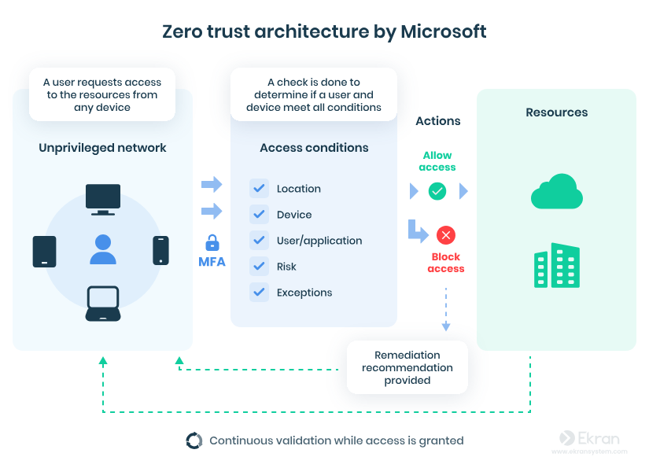

Figure 1 – Zero Trust Architecture Diagram [12]

Furthermore, Security Information and Event Management (SIEM) systems should be used to monitor and analyse security data from across the company in real time. This would require the company to deploy a SIEM tool such as Microsoft Sentinel and connect it to key data sources such as servers, firewalls and endpoints. This would then display alerts for any suspicious activity and repeated failed log in attempts. This would allow the company to respond to any cyber events as they happen, reducing the potential damage. [13]
Cloud Security Posture Management (CSPM) would also benefit the company massively as it would continuously monitor cloud systems to identify and fix security configurations and vulnerabilities. This is done by scanning cloud environments and providing recommendations and fixes in real time. This would reduce the risk of data breaches caused by human error or misconfigured cloud services. [14]

Proactive Monitoring and Incident Response
A proactive 24/7 monitoring and incident response plan involves continuously collecting logs from endpoints, servers, networks and cloud systems and entering this into a SIEM platform such as Windows Sentinel. Alerts generated by the SIEM system are reviewed by a Security Operations Centre (SOC) who would validate and prioritise incidents prior to response. Devices may then be isolated or blocked dependant on the activity logged. Once an incident is confirmed, it is managed through clears steps involving the containment of threat, removal of threat and then the restoration of systems. Everything completed during this process is then documented to help improve future detection and response, so the company is better prepared next time.

Training and Awareness
Training should be completed continuously and should be interactive and engaging. Some potential training could be:
- Phishing Simulation – the company could use BoxPhish which sends emails to staff posing as someone else and if links are clicked, it directs them to training.
- Role Based Training
- SIEM Refresher
- Vishing Simulation

Conclusion
Companies are being increasingly attacked by cybernetworks driven by ransomware, AI powered tools and supply chain vulnerabilities. As a result, companies can suffer great financial losses, damaged reputation and decreased productivity. This could also lead to legal issues, especially for those who rely heavily on computer systems. Therefore, companies are required to adopt proactive security systems. This involves the implementation of controls such as SIEM, CSPM, MFA and encryption. This reduces the overall risk of data being lost or stolen.

Appendix
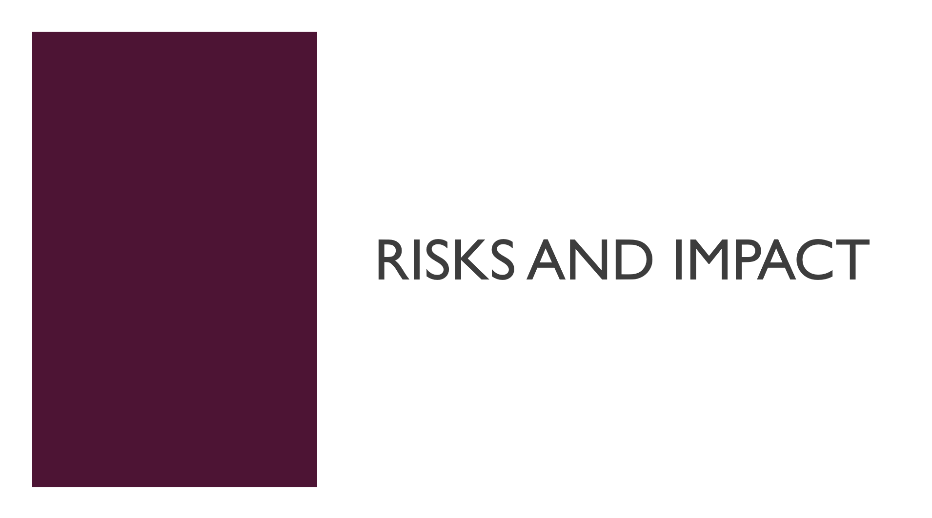

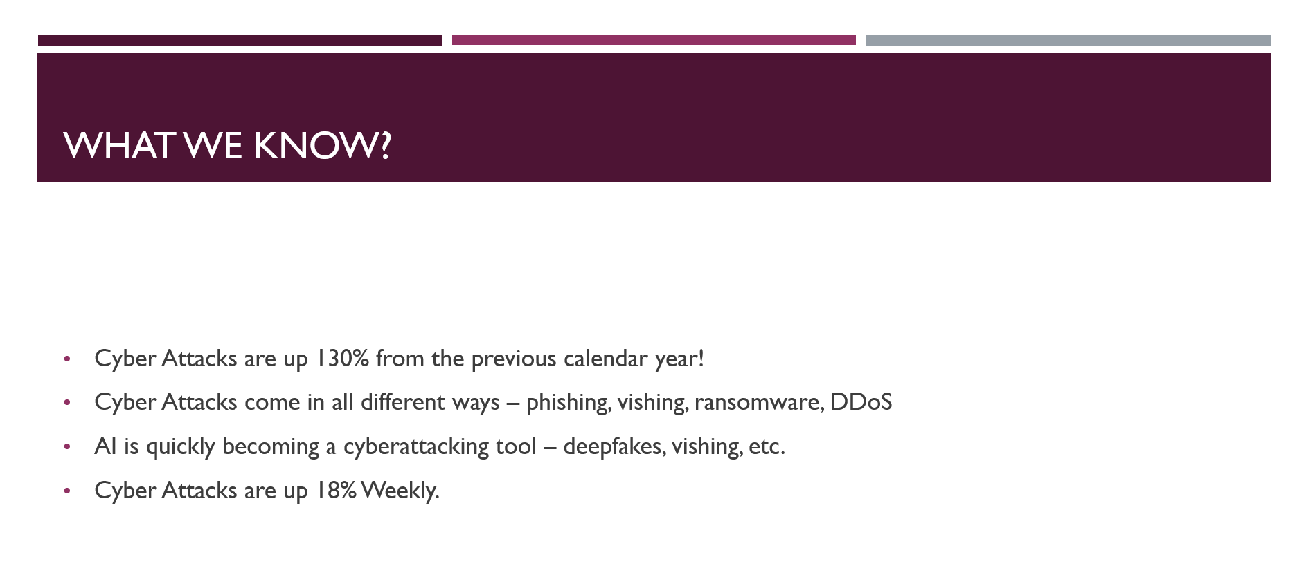

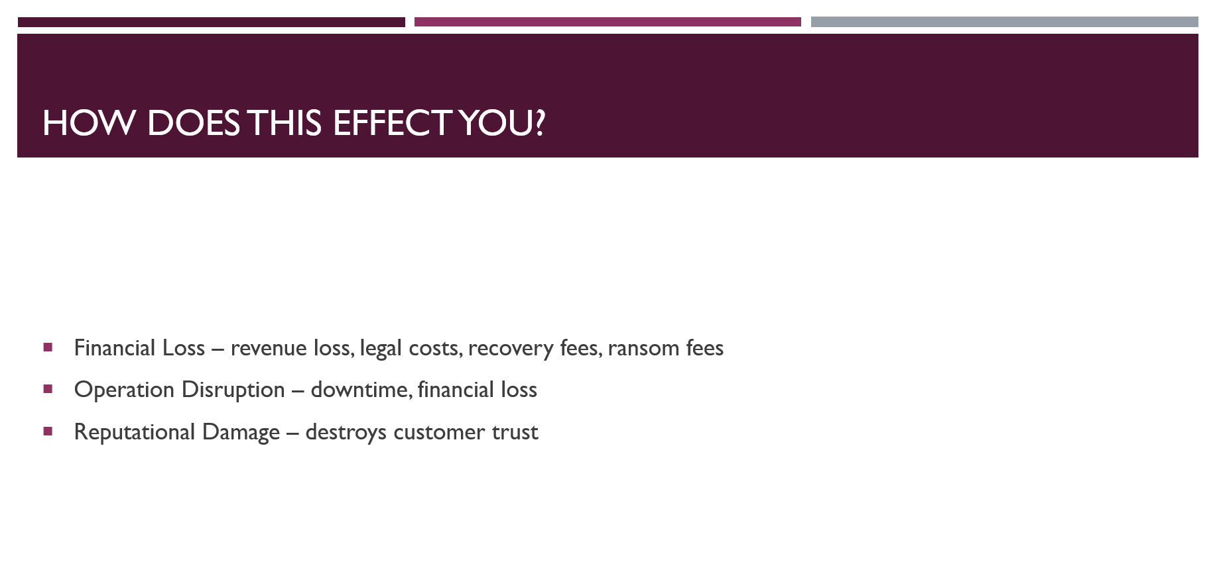

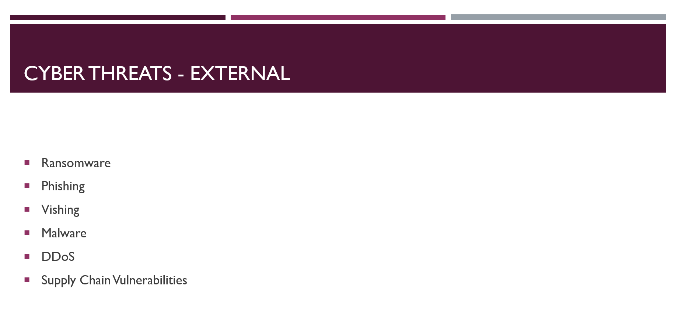

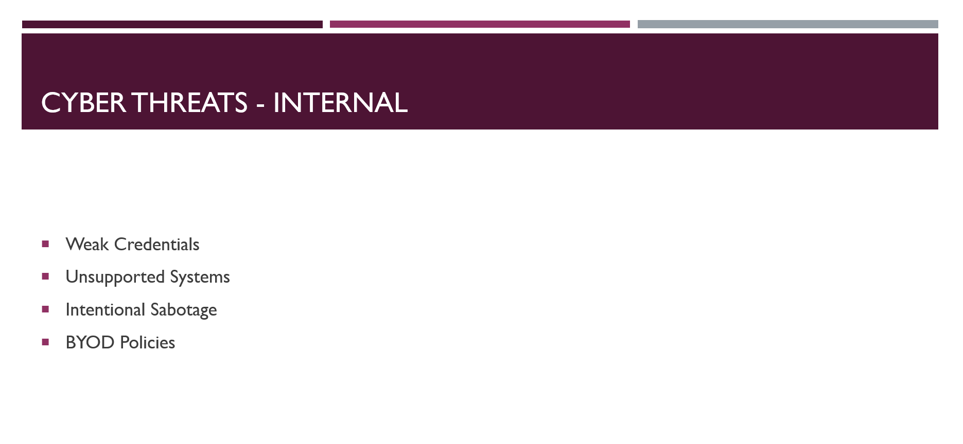

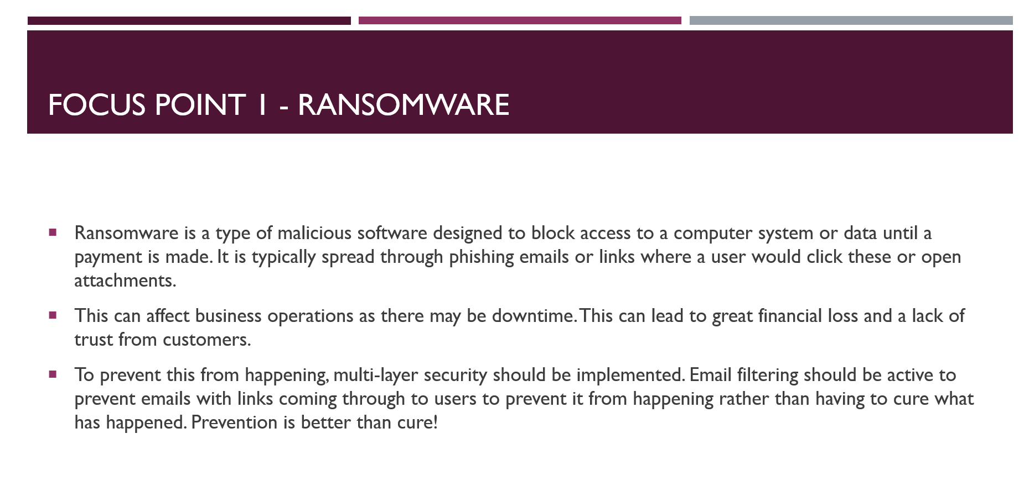

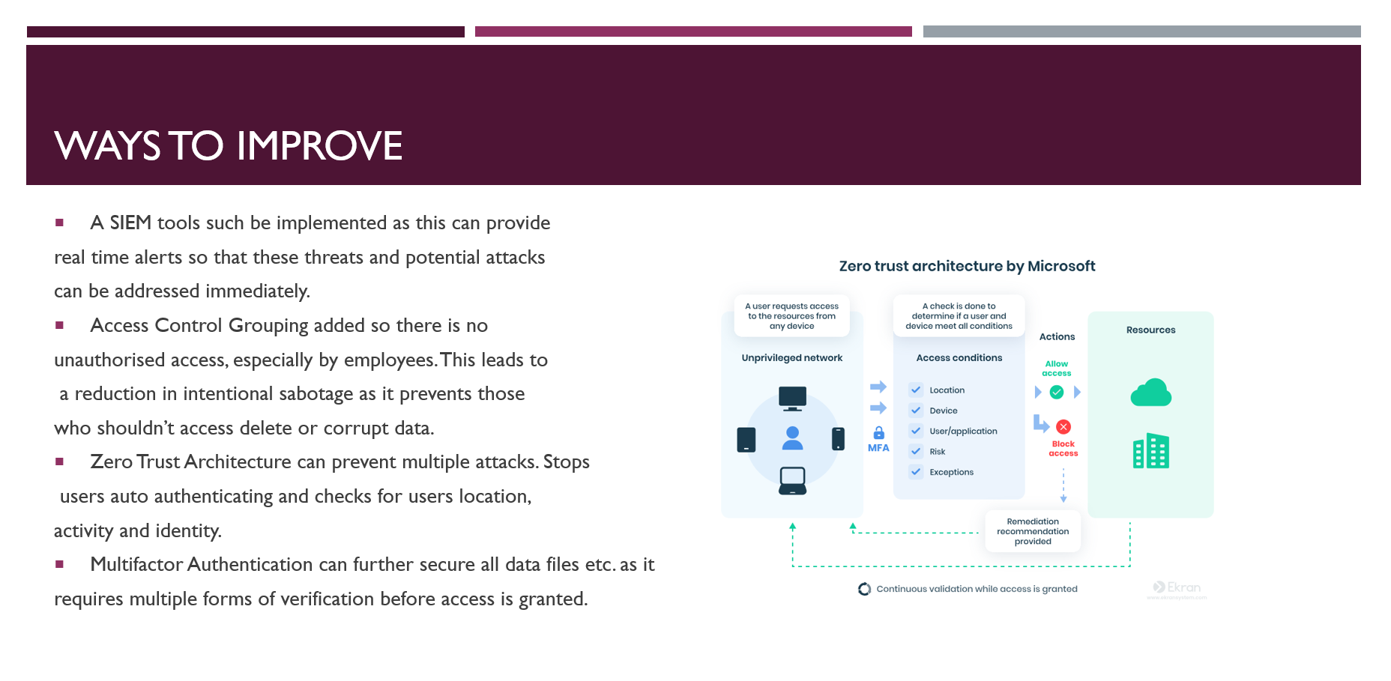

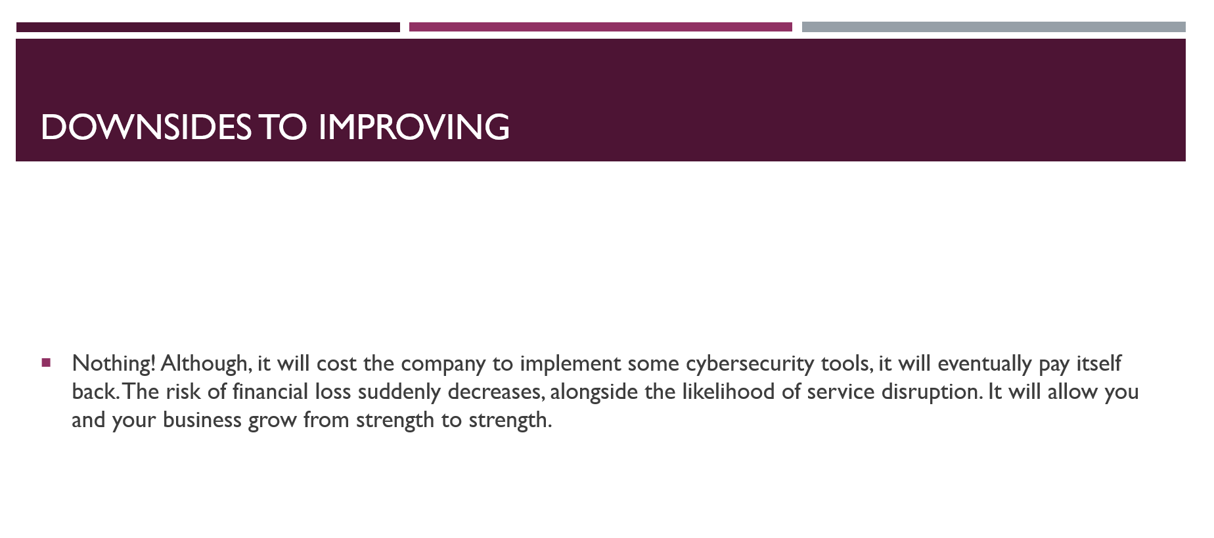

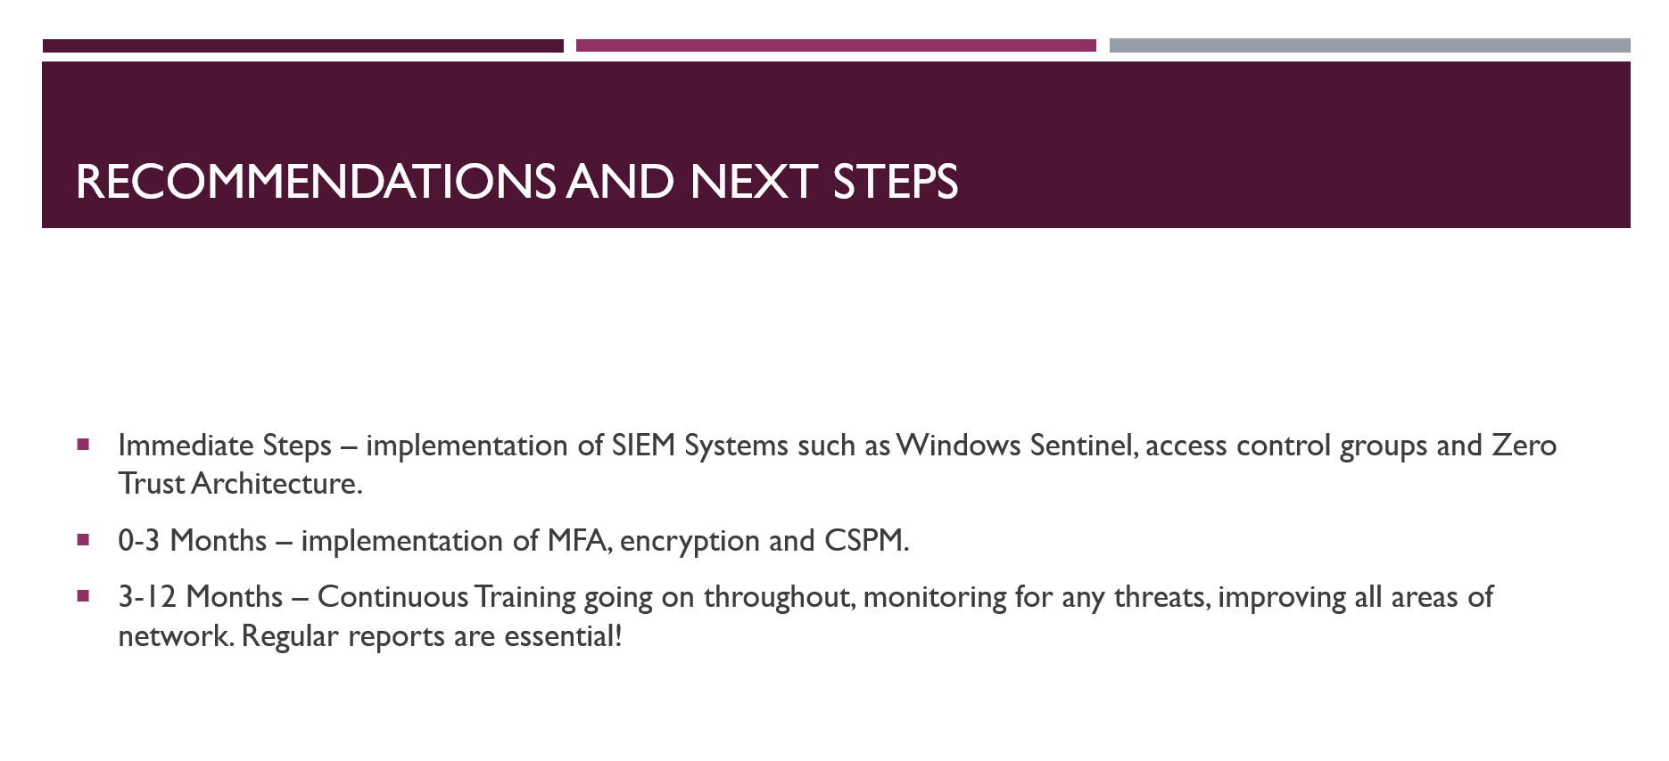

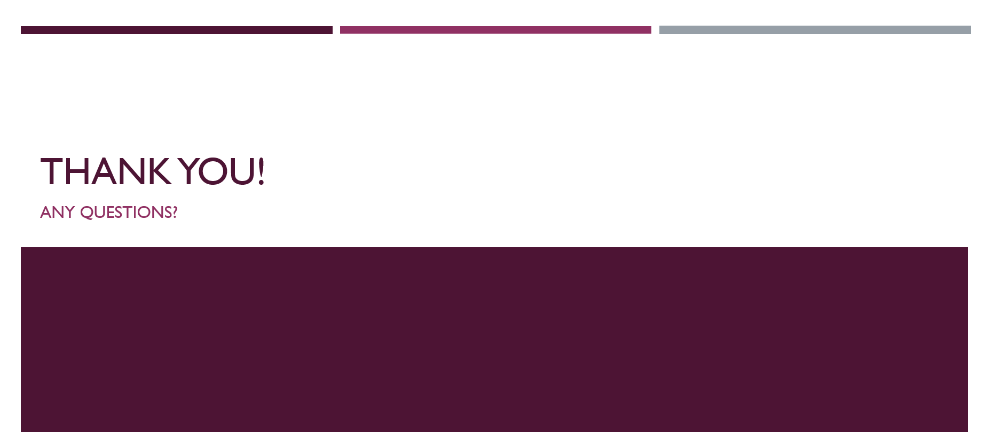

References
[1] "What you need to know about ransomware | National Cyber Security Centre." Accessed: May 4 2026. [Online]. Available: https://www.ncsc.gov.uk/ransomware/home
[2] "Phishing: Spot and report scam emails, texts, websites and calls | National Cyber Security Centre." Accessed: May 4 2026. [Online]. Available: https://www.ncsc.gov.uk/collection/phishing-scams
[3] "Vishing - Report Fraud," Accessed: May 5, 2026. Available at: https://www.reportfraud.police.uk/vishing/.
[4] "What is Malware? Malware Definition, Types and Protection" Malwarebytes. Accessed: May 5, 20262026, [Blog]. Available at: https://www.malwarebytes.com/malware
[5] "Bring your own device (BYOD) | National Cyber Security Centre." Accessed: May 5 2026. [Online]. Available: https://www.ncsc.gov.uk/collection/device-security-guidance/bring-your-own-device
[6] "What Is a DDoS Attack in Cybersecurity? How It Works and How to Prevent It." Accessed: May 5 2026. [Online]. Available: https://www.techtimes.com/articles/316221/20260429/what-ddos-attack-cybersecurity-how-it-works-how-prevent-it.htm
[7] "Supply chain security guidance | National Cyber Security Centre." Accessed: May 5 2026. [Online]. Available: https://www.ncsc.gov.uk/collection/supply-chain-security
[8] "What Is a Firewall? Definition and Types of Firewall." Accessed: May 6, 2026. [Online]. Available: https://www.fortinet.com/resources/cyberglossary/firewall
[9] "What is: Multifactor Authentication | Microsoft Support," Accessed: May 6, 2026. Available at: https://support.microsoft.com/en-US/security/what-is-multifactor-authentication.
[10] "What is Data Encryption?" Accessed: May 6 2026. [Online]. Available: https://www.geeksforgeeks.org/computer-networks/what-is-data-encryption/
[11] "What Is Zero Trust Architecture? | Microsoft Security." Accessed: May 6 2026. [Online]. Available: https://www.microsoft.com/en-us/security/business/security-101/what-is-zero-trust-architecture
[12] Y. Zhurer."Zero Trust Architecture: Definition & Key Components" Syteca. (-03-162021). Accessed: May 7, 20262026, [Blog]. Available at: https://www.syteca.com/en/blog/zero-trust-security-model
[13] "What Is SIEM? | Microsoft Security." Accessed: May 7 2026. [Online]. Available: https://www.microsoft.com/en-us/security/business/security-101/what-is-siem
[14] "What is CSPM? | Microsoft Security." Accessed: May 7 2026. [Online]. Available: https://www.microsoft.com/en-us/security/business/security-101/what-is-cspm

