

Project Name: Jayne Peirson School of Art, Design & Fashion
Project Ref: 6063
Date: 09/04/24
Proposed Structural Calculations for Jayne Perison School of Art, Design & Fashion.
Please note: All calculations are intended for preliminary design only; final calculations are to be carried out and approved by an engineer.
Prepared by Jack Keenan

The below drawings highlighted areas that have been selected to produce preliminary structural calculations. The calculations will be focused on the dead and imposed loads of the following structural elements:
- Calculations for structural columns
- Calculations & centres for structural beams
- Typical loads of columns for proposed pile foundations

Ground Floor plan:
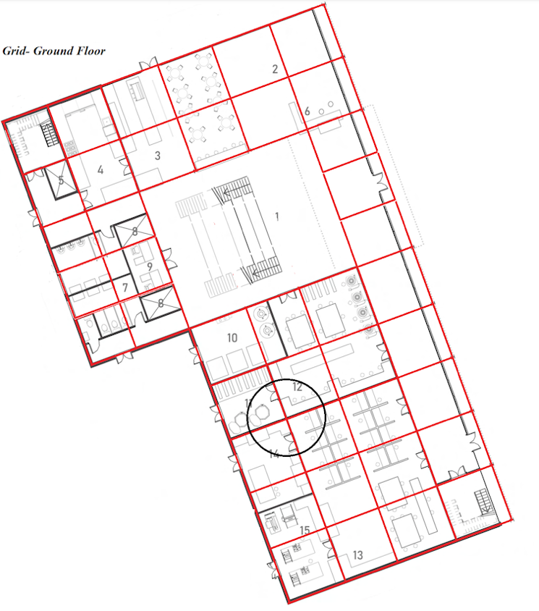

First Floor plan:

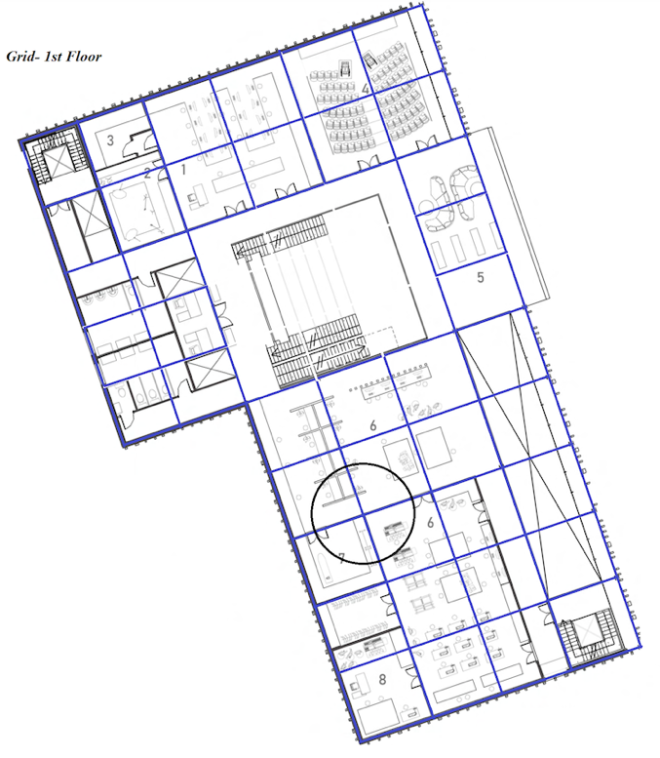

Second Floor plan:
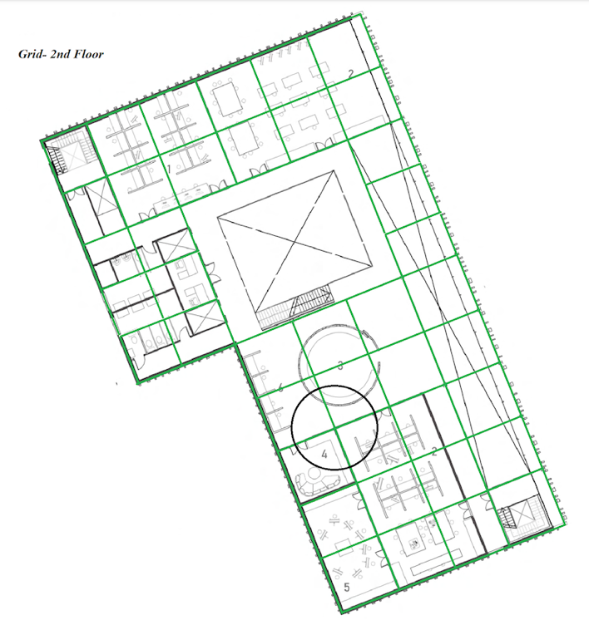

Ground Floor Calculations:

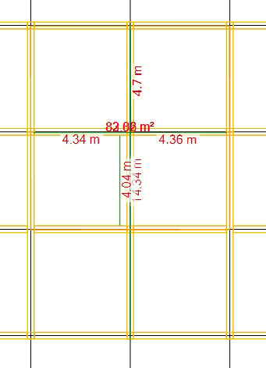 | 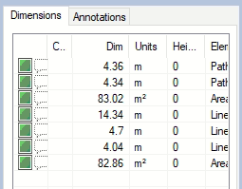

Beams Spans: | DIST to structural columns: | Area:
- 14.4m  - 4.4m  - 4.4m | - 4.7m  - 4.4m  - 4.4m  - 4.1m | - 83m2

Beam span & centres for first floor structure:
Strength class of Glulam = GL24h
4.5m span = 180 x 320 beam at 4.5m centres
14.4m span = 240 x 800 beam at 4.5m centres

Dead Loads/Imposed Loads:
plywood – 0.7kg per mm thick
300mm x 0.7kg = 210kg m-2
Screeding – Cement 13mm = 30kg m-2
210kg x 10 = 2100N per m2 /1000 = 2.1Kn per m2
30kg x 10 = 300N per m2/ 1000 = 0.3Kn per m2
Dead load = 2.1Kn + 0.3Kn = 2.4Kn per m2
Imposed load = 3Kn per m2
First Floor Calculations:

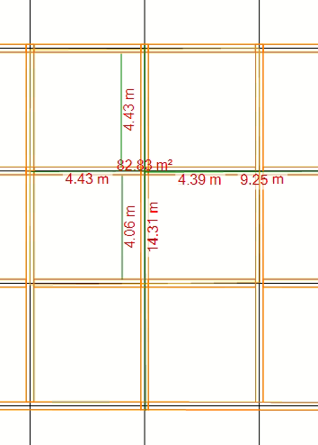 | 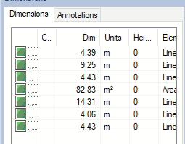

Beams Spans: | DIST to structural columns: | Area:
- 14.4m  - 4.4m  - 4.4m | - 4.4m  - 4.4m  - 4.4m  - 9.3m | - 83m2

Beam span & centres for second floor structure:
Strength class of Glulam = GL24h
4.5m span = 180 x 320 beam at 4.5m centres
14.4m span = 240 x 800 beam at 4.5m centres

Dead Loads/Imposed Loads:
plywood – 0.7kg per mm thick
300mm x 0.7kg = 210kg m-2
Screeding – Cement 13mm = 30kg m-2
210kg x 10 = 2100N per m2 /1000 = 2.1Kn per m2
30kg x 10 = 300N per m2/ 1000 = 0.3Kn per m2
Dead load = 2.1Kn + 0.3Kn = 2.4Kn per m2
Imposed load = 3Kn per m2
Second Floor Calculations:

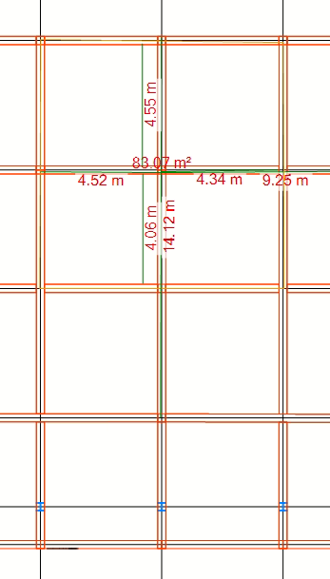 |  | 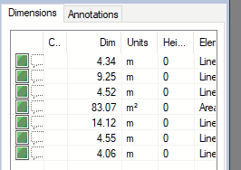
Beams Spans: | DIST to structural columns: |  | Area:
- 14.2m  - 4.4m  - 4.4m | - 4.6m  - 4.5m  - 9.3m  - 4.1m |  | - 83m2

Beam spans & centres for roof beams:
Strength class of Glulam = GL24h
4.5m span = 140 x 280 beam at 4.5m centres
14.4m span = 180 x 760 beam at 4.5m centres

Dead Loads/Imposed Loads:
plywood – 0.7kg per mm thick
300mm x 0.7kg = 210kg m-2
Screeding – Cement 13mm = 30kg m-2
210kg x 10 = 2100N per m2 /1000 = 2.1Kn per m2
30kg x 10 = 300N per m2/ 1000 = 0.3Kn per m2
Dead load = 2.1Kn + 0.3Kn = 2.4Kn per m2
Imposed load = 3Kn per m2
Imposed pile foundation Calculations:
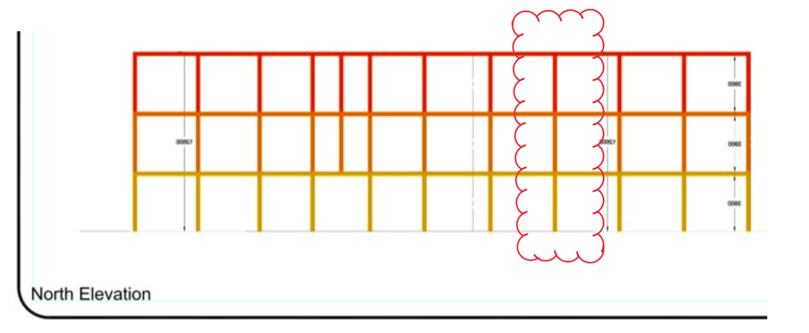
Description: | QTY: | Height:
Structural Columns | 3 No. | 3.6m

Total Load carried by central column:
Equation = (Dead load + imposed load) x area x floors
(2.4Kn + 3kn) x 20.7 x 3 = 335.34Kn

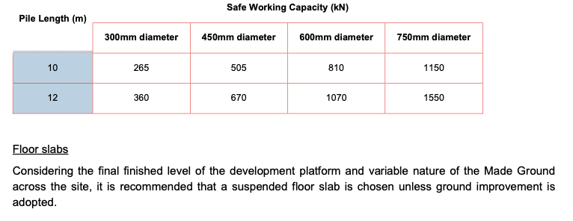
Pile Foundation will be at a 12m depth x 360mm diameter based on a 335.34Kn imposed load.

