26/04/2026
Trinity saint david University of Wales (London Campus)

Module NaMe: Changemakers, Creativity and Value creation
Module Code: ACCA 5033
Student NAME: Adriano Antonio Donda
Student ID: 2428051
Lecturer: Dr. Fahad Ahmad
Trinity saint david University of Wales (London Campus)

Assignment 2
Project Management & Innovation

Table of Contents
Table of Contents 1
Introduction 2
Task 1: Project Management 3
Q1. Project Management & Planning 3
Current market of AI-based demand forecasting system with Indian e-commerce supply chains 4
Q2. Project Design 5
Requirements specification 5
System flowchart (Process design) 6
Task 2: Enterprise & Innovation 7
T2-Enterprise 7
Q1 7
Q2 9
Task 3: Project reflection 11
Developing new skills 11
Contribution to society 12
Risks, challenges and mitigation strategies 12
Conclusion 14
Reference 15

Introduction

This report discusses the creation of a new project concept, FourcastIQ Technologies, which aims at developing an artificial intelligence-based demand forecasting system in e-commerce supply chains. In the modern, highly competitive and data-driven business world, organisations are shifting towards the use of the latest and more sophisticated technologies like artificial intelligence and machine learning in order to enhance the efficiency of their operations and decision-making data. Demand forecasting is especially essential in the e-commerce industry, where the changes in consumer demand may cause such problems as overstocking, stockouts, and higher operational expenses [4].
This report is aimed at showing how project management principles, enterprise and innovation strategies and reflective practice were applied to the development of a technology-based solution. It looks at important factors, which include project planning, system design, business feasibility and external environmental analysis. The report further supports the value of entrepreneurial thinking in turning a project idea to a possible start-up venture.
Through the application of both theoretical framework and practical application, this report will offer a holistic insight into the way innovative technological solutions can be used to generate value to businesses and society, as well as underpin the growth of both professional and technical competences.

Task 1: Project Management

Q1. Project Management & Planning

The chosen project is devoted to the creation of an AI-based demand forecasting system that operates with Indian e-commerce supply chains. The main objective is to overcome inefficiencies in inventory management due to poor prediction of demand. The solution suggested is the creation of a machine-learning model (such as time-series forecasting like ARIMA or LSTM) [3]. These will process historical sales data, seasonal trends and customer behaviour to produce precise predictions and aid decision-making.
The project scope will be data collection, model development, system integration, and performance evaluation. The technologies that are needed include Python, machine learning frameworks like TensorFlow and Scikit-learn, database system (MySQL), and visualisation (Power BI) [5]. The resources available include the small project team consisting of a developer, a data analyst, and a project manager and cloud computing support (such as AWS) to process large datasets.
The project will be scheduled to be completed within 12 weeks, which will include the following major phases: planning and research (Weeks 1 -2), data collection (Weeks 3-4), model development (Weeks 5-7), testing and validation (Weeks 8-9), deployment (Weeks 10-11), and final evaluation (Week 12).
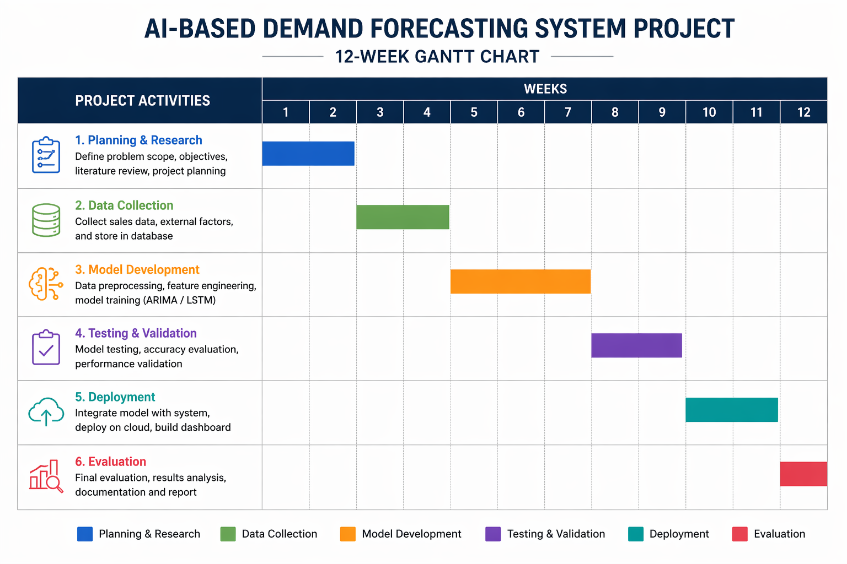
Figure 1: Gantt chart
(Source: Self-developed)
The Gantt chart is used to show the overlaps between activities in order to effectively utilise time and resources. However, the project can be affected by various constraints, such as a lack of access to real-time data, cloud services budget constraints, time limitations, and data privacy.
The project will use the Agile (Scrum) methodology of development as it helps to make the project go in short sprints to address these issues. This method allows continuous testing, feedback of stakeholders and flexibility to change whenever there is any change in the project [6]. This eventually enhances the chances of successful project delivery within the stipulated time.

Current market of AI-based demand forecasting system with Indian e-commerce supply chains
India's AI-driven retail and e-commerce industry is expected to expand significantly between 2025 and 2030 as a result of higher investments and better AI integration. As technology makes retail more human-centric, AI chatbots are enhancing customer service. Investments remained a primary priority even though AI funding fell from a peak of USD 5.2 billion in 2022 to USD 1.1 billion in 2023. In 2024, companies spent 3.32% of their earnings—a 52% increase—on AI projects. By providing individualised shopping experiences, AI is transforming India's retail and e-commerce industries. By 2024, 71% of retail businesses are expected to use generative AI [1]. Quick Commerce is anticipated to reach 70 million customers as it grows into a $50 billion enterprise. Due to hybrid models that combine offline and online shopping, non-grocery industries like electronics, fashion, and cosmetics are predicted to account for more than half of total spending as the model expands outside of cities [2].

Q2. Project Design

The design stage of AI-based demand forecasting systems aims at transforming the project needs into modeled and visualised project requirements, which serve as a development guide. The requirements specification and a system flowchart are two important design artefacts that will be employed in this project.

Requirements specification
The requirements specification outlines what the system has to do, and the criteria it has to satisfy.
Functional requirements are the possibility to gather historical sales and inventory data on e-commerce sites, pre-process, and clean data, and use machine learning algorithms (ARIMA or LSTM) to create demand forecasts [7]. The system should also provide outputs in the form of an interactive dashboard and give alerts when stocks are low or demand is high.
Non-functional requirements center on the attributes of quality of the system. The system must be highly accurate (at least 85 per cent), must be able to deal with large datasets and must be data security and privacy standards high. Usability is also paramount and they need to have a simple and intuitive interface amongst supply chain managers. These requirements make the system effective and reliable [8].

System flowchart (Process design)
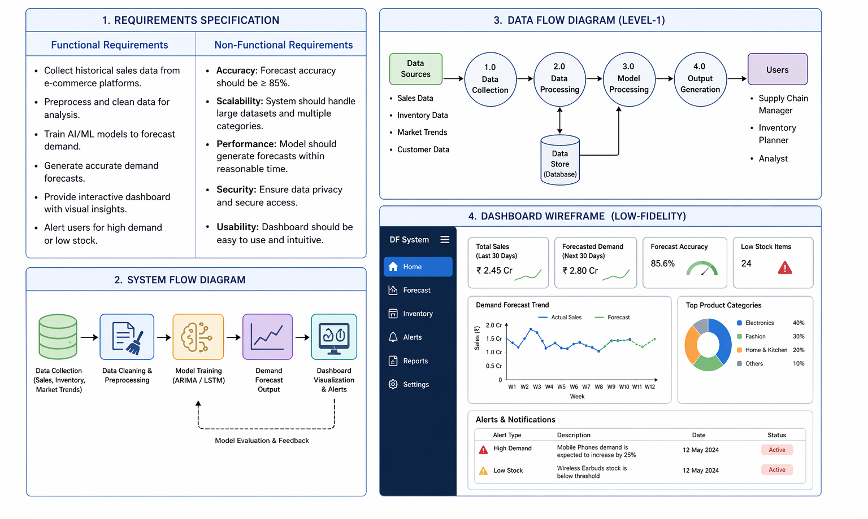
Figure 2: Project design
(Source: Self-developed)
System flowchart is a visual representation of the movement of data in the system [9]. It is initiated with data collection in which the data on sales, inventory and market trend are collected. This is then followed by preprocessing of data in which data is cleaned and organised. The model training phase is then used to feed machine learning algorithms with the patterns to make forecasts. The results are then presented in a dashboard form, and the user can easily interpret the results and make informed decisions.
This design guarantees a rational and effective workflow, less complexity, and assists developers to comprehend system interactions. Flowcharts and other visual tools are the most common visual representation tools in software engineering to enhance communication and reduce errors in development [10].

Task 2: Enterprise & Innovation

T2-Enterprise

Q1
PEST Analysis - Amazon
Factor | Analysis
Political | Amazon is highly influenced by the government regulations on data protection, taxation, and foreign direct investment [11]. Indicatively, e-commerce policies in India are stricter and this affects the strategies of operation.
Economic | Online sales are directly related to economic growth, inflation and consumer purchasing power [12]. In periods of economic recession, discretion consumption is greatly reduced, which impacts revenue.
Social | Altering consumer behaviour, including the willingness to shop online and quick delivery, are favourable to Amazon [13]. However, labour practices may be a source of concern and this may affect brand perception.
Technological | The innovations of AI, cloud computing, and automation make Amazon efficient. Use of technologies such as predictive analytics enhance the performance and customer experience of the supply chain.
Table 1: PEST analysis
(Source: Self-developed)

SWOT analysis - Amazon
Strengths:  - Good international brand network and logistic network [14]  - State-of-the-art AI and cloud infrastructure (AWS). | Weaknesses:  - High operational costs  - Working conditions criticism.
Opportunities:  - Growth in new markets (such as India)  - Expansion of artificial intelligence-based services and automation. | Threats:  - Great competition (such as Flipkart)  - Legal control and privacy regulations.
Table 2: SWOT analysis
(Source: Self-developed)

Legal and ethical considerations

Amazon should adhere to the laws of data protection like GDPR and IT laws in India. Some ethical issues are the privacy of data, fair labor practices and environmental sustainability [15]. Companies should ensure that they use data transparently and minimise carbon footprints to build trust.

Critical evaluation

It has been using Amazon for the past year, initially in the United Arab Emirates and India. It is now possible to shift thousands of items in less than twenty minutes. Clients adore this service. Amazon is expanding quickly, with over 360 micro-fulfillment sites in India. Since they started utilising it, Prime members' monthly orders have already grown by 25%, and their frequency of purchases has tripled. Amazon Now is beginning to grow in the US and Europe [21]. It offers same-day fresh food delivery in over 2,300 towns and cities around the country.Amazon is currently the second-largest grocery store in the US, with sales predicted to exceed $150 billion by 2025. AWS's revenue run rate was $58 million three years after it was founded. After three years of this AI wave, AWS's AI revenue run rate reached over $15 billion in Q1 2026 (almost 260 times greater than AWS at the time) and is still rising quickly. Customers need a lot more non-AI services as AI usage grows, and AWS offers the most comprehensive and reliable selection of these services. Of all the AI and infrastructure providers, AWS offers the best operational performance and security.

Q2

The proposed tech start-up is FourcastIQ Technologies, which is grounded on the project concept of designing an AI-based demand forecasting system of e-commerce supply chains. The start-up will assist online retailers to better manage inventory, minimise waste, and maximise customer satisfaction by accurately predicting analytics.

Start-up name and logo concept

FourcastIQ Technologies is a name that denotes intelligence and data-driven decision-making. These concepts like upward-trending graphs and the patterns of neural networks are included in the logo concept as they represent the prediction and the innovation of AI.

Figure 3: Logo
(Source: Self-developed)
Type of business (Legal classification)
The company will be incorporated in India as a Private Limited Company. This type of legal entity provides limited liability protection to the founders and increases credibility and external sources of funds through venture capital are easily accessible. It is among the most adequate forms of scalable technology start-ups.

Business strategy
FourcastIQ will take a differentiation approach, as it will offer the most accurate forecasting services based on AI and adjusted to the needs of Indian e-commerce companies. The company will be built on a Software-as-a-Service (SaaS) basis, with clients paying subscription fees to have access to the forecasting tools and dashboards. The most important strategic priorities are the high accuracy of prediction, developing good relationships with online shopping platforms, and constantly enhancing the system with machine learning updates.

Funding initiatives
The start-up will first use bootstrapping to make a prototype and then raise its initial capital through angel investors. Venture capital funding will be sought as the business grows to increase its operations. The government programs like Startup India, and crowdfunding to create awareness in the market may also provide further assistance.
Furthermore, FourcastIQ Technologies is an innovative and scalable business model that can revolutionise efficiency in the supply chain with the help of AI-driven insights.

Task 3: Project reflection

The suggested project, FourcastIQ Technologies, is aimed at creating an AI-based demand forecasting system in the e-commerce supply chains. Looking back on this project, the project can be seen as a potential means of not only a technical solution to a problem but also as a means of personal growth, contributing to society, and risk mitigation.

Developing new skills

The project is a great chance to acquire technical and transferable skills. Technically, I will become more familiar with the field of machine learning, especially time-series forecasting models like ARIMA and LSTM. The collaboration with programming languages such as Python, AI platforms such as TensorFlow, and tools of data visualisation will enhance my data analytics skills, which are getting more significant in the modern digital economy.
Moreover, the project will support in developing project management skills such as planning, scheduling, and resource allocation. Using Agile methodology, I will also have an opportunity to work on iterative development, teamwork, and continuous improvement. Presentation of findings, working with the stakeholders and the translation of technical complex outputs to actionable insights will also help in improving communication skills. All these skills are critical in professional lives in technology and business set-ups [16].

Contribution to society

The project can bring a positive impact to the society, especially when it comes to the sustainable and efficient supply chains. With enhanced accuracy in demand forecasting, businesses can minimise overproduction and inventory levels and, therefore, waste and environmental footprint are minimised. This would be connected with global sustainability and responsible consumption practices [17].
Moreover, the system will be able to increase customer satisfaction by making products available and decreasing delivery delays. In emerging economies like India, efficient supply chains would help the small and medium enterprises (SMEs) to compete better in the e-commerce industry. This helps in economic growth and creating jobs [18].
Innovation and digital transformation are also encouraged with the use of AI because organisations are encouraged to use advanced technologies that will enhance productivity and competitiveness. However, data and transparency should be used ethically to gain trust and fairness.

Risks, challenges and mitigation strategies
Although this project has potential, it is likely to encounter various risks and challenges. One of the significant issues is the availability and quality of data. Poor quality or missing data may have a big impact on the performance of the forecast. To alleviate this, good data sources must be employed and strong data preprocessing methods must be employed.
The other problem is the technical complexity, especially in creating and optimising machine learning models [19]. This can be overcome by an incremental development approach which involves the use of simple models and then moving to complex techniques.
Access to tools and cloud computing tools may also be restricted due to financial constraints. The open-source technologies can be used to minimise this risk, and the grants, or partnership opportunities can be found.
Moreover, there are ethical and legal issues, including data privacy and security, to be taken into account [20]. Data protection laws and adopting a secure data handling culture will be necessary to reduce these types of risks.
Lastly, competition in the market is an issue, since there are already other companies that have the same solution. In order to fight this, the project must concentrate on differentiation based on customisation and high accuracy to local markets.
Altogether, the given project is a powerful chance to acquire important technical and professional skills and help to create more efficient and sustainable supply chains. Despite these issues, it is possible to implement the project successfully and make it have long-term follow-up with proper risk management strategies and lifelong learning.

Conclusion

From the above discussion, it can be said that the case of the creation of FourcastIQ Technologies shows that a properly-organised project could integrate project management, innovativeness, and enterprise ideas to face the challenges of the real world in e-commerce supply chains. The project emphasises the significance of proper planning, scope, schedule, resources, and suitable development approaches like Agile which allow flexibility and constant enhancement.
Moreover, the enterprise and innovation analysis depicts the impact of external and internal forces, which are determined using the PEST and SWOT models, on business success. The suggested start-up model is characterised by the solid strategic background, backed by a clear value proposition, scalable SaaS business model, and various funding opportunities.
The reflective aspect focuses on the importance of skill acquisition, both in technical knowledge of AI and data analytics, and transferable skills, such as communication and project management. It also emphasises the larger societal gains of the project, especially in terms of efficiency, sustainability, and digital transformation.
Despite the existence of challenges like limitations in data, financial and ethical issues, the successful implementation can be supported by proper risk mitigation strategies. Altogether, this project evidences the possibility of innovation-based solutions to make significant improvements and enhance professional development and entrepreneurship.

Reference

[1] Business Wire. 2025. India Artificial Intelligence in Retail and E-commerce Market Report 2025-2030 with Case Studies from Amazon, Flipkart, Reliance Industries, and Zomato [online]. Available at: India Artificial Intelligence in Retail and E-commerce Market Report 2025-2030 with Case Studies from Amazon, Flipkart, Reliance Industries, and Zomato - ResearchAndMarkets.com [Accessed on 22nd April 2026].
[2] The Hindu Business Line. 2026. AI, creators and quick commerce to power India’s ecommerce growth to $250 billion by 2030 [online]. Available at: AI, creators and quick commerce to power India’s ecommerce growth to $250 billion by 2030 - The HinduBusinessLine [Accessed on 22nd April 2026].
[3] Albeladi, K., Zafar, B. and Mueen, A., 2023. Time series forecasting using LSTM and ARIMA. International Journal of Advanced Computer Science and Applications, 14(1), pp.313-320.
[4] Chowdhury, A.R., Paul, R. and Rozony, F.Z., 2025. A systematic review of demand forecasting models for retail e-commerce enhancing accuracy in inventory and delivery planning. International Journal of Scientific Interdisciplinary Research, 6(1), pp.01-27.
[5] Makhmudova, Z.I., Erkinova, R.E. and Xudoykulova, M.M., 2025. MODERN IT TOOLS FOR MANAGING AND ANALYZING MEDICAL DATABASES. Экономика и социум, (5-1 (132)), pp.424-428.
[6] Kuciapski, M. and Marcinkowski, B., 2023. Agile software development approach for'ad-hoc'IT projects. International Journal of Information Systems and Project Management, 11(4), pp.28-51.
[7] El Filali, A., Lahmer, E.H.B., El Filali, S., Kasbouya, M., Ajouary, M.A. and Akantous, S., 2022. Machine Learning Applications in Supply Chain Management: A Deep Learning Model Using an Optimized LSTM Network for Demand Forecasting. International Journal of Intelligent Engineering & Systems, 15(2).
[8] Susilo, F.A.T. and Suparno, S., 2025. The Influence of User Experience, E-Service Quality, and Supply Chain on User Satisfaction Mediated by Platform Usability. Asian Journal of Engineering, Social and Health, 4(5).
[9] Soheli, S.J., Jahan, N., Hossain, M.B., Adhikary, A., Khan, A.R. and Wahiduzzaman, M., 2022. Smart greenhouse monitoring system using internet of things and artificial intelligence. Wireless Personal Communications, 124(4), pp.3603-3634.
[10] Abba, S., Bizi, A.M., Lee, J.A., Bakouri, S. and Crespo, M.L., 2024. Real-time object detection, tracking, and monitoring framework for security surveillance systems. Heliyon, 10(15).
[11] Vander Maelen, C., 2023. GDPR Codes of Conduct and the Impact on Global Business: A Case Study of Amazon Web Services. Available at SSRN 4505297.
[12] Priyatna, H.N. and Suryadi, I., 2025. Facing Global Inflation: Economic Strategies to Strengthen People's Purchasing Power. MSJ: Majority Science Journal, 3(1), pp.73-81.
[13] Ologunebi, J., Taiwo, E.O. and Alli, K., 2024. Digital consumer behavior in e-commerce: A study of Amazon and Temu's customer purchase decision-making processes in the UK and the USA. Available at SSRN 5071874.
[14] Liu, F., 2025. The Strategic Path for Local American Brands to Achieve Internationalization through Cross-Border E-Commerce Platforms. International Journal of Social Sciences and Economic Management (2025), 6(2), pp.145-153.
[15] Dibie, E.U., 2024. The future of renewable energy: Ethical implications of AI and cloud technology in data security and environmental impact. Journal of Advances in Mathematics and Computer Science, 39(10), pp.10-9734.
[16] Martin, J., Dang, Q.H. and Gremyr, I., 2023. The influence of digitalisation on the role of quality professionals and their practices. Cogent Business & Management, 10(1), p.2164162.
[17] Farooq, A., Abbey, A.B.N. and Onukwulu, E.C., 2024. Inventory optimization and sustainability in retail: A conceptual approach to data-driven resource management. International Journal of Multidisciplinary Research and Growth Evaluation, 5(6), pp.1356-1363.
[18] Kalaiselvi, V. and MAITHILY, M.K., 2024. Small and medium enterprises (smes) to promote economic development in India. Cuestiones de Fisioterapia, 53(03), pp.4320-4347.
[19] Adeyeye, O.J. and Akanbi, I., 2024. Artificial intelligence for systems engineering complexity: a review on the use of AI and machine learning algorithms. Computer Science & IT Research Journal, 5(4), pp.787-808.
[20] Allahrakha, N., 2023. Balancing cyber-security and privacy: legal and ethical considerations in the digital age. Legal Issues in the digital Age, (2), pp.78-121.
[21] Amazon. 2026. Annual report 2025 [online]. Available at: Amazon.com, Inc [Accessed on 22nd April 2026].

