The most effective way to motivate staff



Assignment Title | The most effective way to motivate staff
Module | Academic and Employability Skills
Module code | BMSW4001
Student Name | Raluca Maria Ionita
Student ID | 2120292
Lecturer | Dr. Doreen Naya Amundam

Table of Contents

Introduction………………………………………………………………………….….……………3
KEY POINTS FOR MOTIVATING EMPLOYEES……………………………….……….………..4
BENEFITS…………………………………………………………………………………………….4
Conclusion………………………………………………………………………………..………….7
References……………………………………………………………………………...…...……….8

Introduction
The primary responsibility of management is to ensure that human resources are used effectively in order to accomplish organisational goals. Personnel management is concerned with managing human resources in such a manner that the firm receives the highest amount of production while also developing the talents of those who are employed to their utmost potential. An employee who is motivated by a manager is more likely to engage in action than one who is not motivated. In an organisational context, motivation implies that one person, in this case a manager, includes another, say an employee, by ensuring that a channel to satisfy those needs and aspirations becomes available to the person. Additionally, the strong requirements in a direction that is satisfactory to the latent demands in workers and harness them in a way that would be effective for the firm are important considerations. Employee motivation is one of the most difficult concerns that every firm must deal with. Motivating his or her employees, often known as instilling a 'will to work' in them, is the most important activity any manager can do. It should also be recalled that even if a worker is very competent of doing specific tasks, nothing will be accomplished unless he is willing to put in the effort.The motivation of employees is a vital aspect in the success of any firm. It is defined as the amount of dedication, motivation, and feeling of responsibility shown by employees in the course of carrying out day-to-day activities in an organisation.
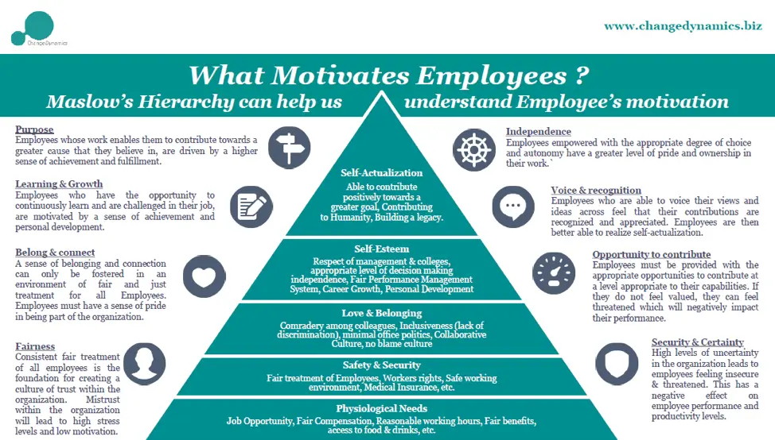

Key points for motivating employees
Employee motivation must be nurtured and monitored by management to ensure that staff remain motivated and focused on achieving the company's objectives, hence raising productivity levels and overall output. It has been shown that keeping a happy attitude has a huge impact on employee motivation, as it encourages people to stay up with and take on more responsibility in their job duties. Although it is important to strive for positive reinforcement, it is also necessary to call attention to poor employee behaviour on occasion. For example, defining work purpose, avoiding micromanagement, being clear on expectations, setting small and easily measurable goals and rewarding great work, staying healthy and well-nourished, creating a sense of security, encouraging inclusivity and teamwork, streamlining communication and upgrading tools are all effective methods of motivating employees.
It is the company's responsibility to specify the goal of the work to be done and to provide specific completion timeframes for a project. This helps to keep workers engaged since they are acknowledged as being a member of a team that is having a positive impact. It is possible that employee productivity varies, for example, some employees may be more productive in the morning while others may be more productive at the end of the day; therefore, allowing employees to choose when and how they work while adhering to strict time constraints increases employee productivity and efficiency. My organisation is quite clear about what it wants from its employees from the beginning to the end of the work that has been allocated to them. This clear and defined objective is critical in keeping the employees focused on achieving the stated goals and in keeping them engaged throughout their workday. The organisation establishes simple, readily quantifiable objectives to help the team members understand what has to be completed at each stage of the process leading up to the fulfilment of the given duties. This enables individuals to make visible progress on a certain work, which in turn serves to raise their motivation while adhering to the deadlines for completion of the assignment that have been established. Smaller objectives are more likely to be accomplished than a single large one. Setting minor objectives allows the organisation to get a large number of chances to appreciate the efforts of their employees as well as the outcomes of their efforts. Complementing an employee on a work well done while emphasising the specific reasons why the job is praiseworthy demonstrates respect to the employees, which in turn keeps them motivated to do the duties that have been allocated to them successfully. The organisation recognises outstanding performance at the conclusion of a large project or at the end of the year by offering bonuses, recognising the employee of the year, and coming up with other innovative strategies for rewarding personnel.
The organisation guarantees that workers maintain their health while working on their project since some employees are prone to neglecting their health owing to the strain of completing assignments within specified time frames. Encouraging workers to obtain adequate sleep and to engage in regular physical activity will help them remain healthy and fit so that they can do their jobs effectively. They must also keep fuelled in order to maintain their health, which means consuming nutritious foods and drinking enough of water. The employer offers snacks, water at regular intervals, and sometimes orders lunch for the employees in order to keep them healthy while working on a large project that requires them to spend long hours in the office. The organisation encourages its staff to take frequent breaks to rest and refresh their bodies. It also allows workers to de-stress and relax, which helps them to preserve their physical health and their ability to think creatively on the job.
Creating a feeling of security is essential for existence, and it comes second only to bodily necessities in terms of importance. Accordion to Abraham Maslow's theory of human motivation, safety is one of the two fundamental needs. It focuses on individual development and its influence on the motivation of workers. Another key strategy that the organisation does to increase motivation is to promote inclusion among its employees. Employees will be more aware of the organization's aims and management decisions if they are informed about them. Employees feel more important when they are given the opportunity to express their opinions, ideas, and viewpoints on specific issues. This enhances their drive. The organisation promotes collaboration among its employees, which fosters a sense of belonging among them, allowing them to feel strong as they face and overcome the problems of everyday life. This increases the productivity of the workplace since they may work together and share their expertise. It is also important to note that effective communication between management and the company's workers has had a big influence on the company's performance. It is important to streamline communication in order to avoid misunderstandings among junior staff and management, as well as to provide accurate instructions.
The ability to develop and maintain excellent performance from the organization's personnel is critical to the success of managers or organisational leaders in their respective roles. When it comes to performance, it is often defined as the result of the mix of an employee's ability and their level of motivation.
Consequently, in order to increase both individual and organisational performance, managers must establish an atmosphere that encourages workers to strive toward the achievement of the organization's goals and objectives, while also growing and upgrading the employees' technical skills. In this case, employee motivation may be described as the variables that drive or affect the activities and behaviours of workers in the direction of the established goals and objectives, as well as the rewards that satisfies the requirements of those who work for the organisation (Priest & Gass, 2005). Explaining various models of motivation techniques, discussing various theories and strategies that will increase staff motivational levels, and providing an explanation of extrinsic and intrinsic motivational factors that influence employee behaviours towards their duties are all objectives of this paper.
For example, the Maslow's hierarchy of needs model, Herzberg's hygiene model, and McGregor's theory X and theory Y models are all examples of motivational strategies. Abraham Maslow developed the hierarchy of needs model in 1943, which has had a significant influence on human motivation and provides reasons for why some individuals are naturally motivated while others struggle to be motivated under particular circumstances and settings. A five-stage tier system is often at the heart of this theory, which is shown in the shape of a pyramid to indicate its structure. The numerous categories of demands that must be supplied in a methodical way are represented by the different levels of the pyramid structure. Basic needs, security requirements, affiliation needs, esteem needs, and self-actualization needs are the needs that are listed in the pyramid in the order that they are met from the bottom to the top. The term "basic necessities" refers to the physiological requirements that individuals need in order to survive, which include food, shelter, and clothes, among other things. The presence of safety for one's job, one's property, and one's life are all examples of security requirements. The affiliation needs explain the need for people to experience a sense of belonging in certain groups, while the esteem requirements describe the desire for individuals to feel good about themselves as a result of their involvement in particular activities. The term "self actualization needs" refers to the urge for people to achieve their life aims and objectives. The hierarchy of needs model enables managers to encourage their staff by addressing their requirements in the order in which they have been identified as important. They, for example, provide them with a wage package sufficient to meet their basic requirements, provide job stability in exchange for increased performance, encourage employee sociability via outdoor activities, and provide advancement opportunities (Koontz & Weihrich, 2010).
McGregor's hypothesis X and Y model is the last model to be discussed. One of the primary arguments made by the proponent is that the control and motivating of individual's actions typically occurs in two ways: via the exercise of authority (theory x) and through participation (theoryy) (theory y). McGregor acknowledges that, despite the fact that the majority of managers use theory x (authoritative leadership), this method often leads in poor performance since it is more focused on punishment.
If employees fail to meet their responsibilities, they may be demoted or their employment contracts may be terminated. On the other hand, managers who apply theory y (participatory leadership) are successful because they encourage employees to demonstrate self-direction and self-control in pursuing organisational goals; employees accepting and frequently seeking responsibility; and the freedom to be innovative and express ideas (Cole, 2004).
There are also a variety of ideas and tactics that have been created to assist in improving the levels of motivation among employees in an organisation. The expectancy theory, the Hawthorne effect, the expectancy theory, and the three-dimensional theory of attribution are examples of such theories. Victor Vroom's expectation theory explains the relationship between reward and anticipated performance in a manner that is comparable to transactional leadership. Vroom proposes motivational levels that are based on how much an employee wants a certain end; if an employee has a strong enough desire to obtain a particular outcome, he or she is more likely to exert sufficient effort to accomplish it. Because of this, management and organisations are urged to devise strategies for setting realistic goals that may motivate both individual workers and whole companies by tying the goals to suitable incentives (Koontz & Weihrich, 2010).
According to Henry Landsberger's observation that certain workers tended to work harder and perform better while they were under the scrutiny of researchers, the Hawthorne effect idea was created in 1950.
As a result, workers are seen as putting in diligent effort in response to the attention that is directed at them. When applied broadly, the idea highlights the concept that workers are more inclined to work harder and perform better when they are being observed in the workplace. This, however, does not imply continual surveillance of the workers throughout the day, but rather engaging them, for example, by frequent feedback and being informed of their progress and accomplishments. Employees are also motivated when their employers or supervisors show them that they care about them and that they are concerned about their working circumstances.
The three-dimensional theory of attribution developed by Bernard Weiner provides explanations for how individuals commonly attach meaning to their own as well as other people's actions and inactions. The proponent of the idea underlines the fact that individuals are interested in discovering why others behave in certain ways. The explanations that individuals provide for specific acts have an impact on how they are likely to behave in the future. Examples of this include personnel who ascribe their failures to certain circumstances, with their future motivations likely to be altered as a result of the attributions they make.
Three qualities of attribution were found by Weiner that have an impact on the future motivation of workers. These characteristics are: stability, locus of control, and controllability (Priest & Gass, 2005).
As previously stated, attempts to encourage workers to work toward the intended objectives constitute a significant portion of employee motivation. Motivators may be employed in a variety of ways, and there are two sorts of motivators that can be used in this situation: internal motivators and extrinsic motivators. Intrinsic motivators are those who get internal, self-generated motivation as a result of achieving and feeling fulfilled while engaging in the activities that drive them. They are also known as intrinsic drivers. Intrinsic motivators may include the internal urge to learn new things as well as the accomplishment of activities that need the development of skills, knowledge, and experience, among other things. Extrinsic motivators, on the other hand, are external incentives that are offered to individuals in order to inspire them to achieve their goals. They include things like incentives, pay and bonuses, praise, and security, among other things.
CONCLUSION:
A motivated employee is a valuable asset, who can deliver immense value to the organization in maintaining and strengthening the business and revenue growth. This assignment concludes that the employee motivation is important to obtain organizational success. If they’re not driven properly, a management cannot achieve achieve their organizational goal easily and effectively.
Employee motivation is very important for a successful organisation, so the company should focus on it in order to stay competitive in the market and avoid some problems such as employees high turnover that will affect the business. Thus, effective motivational techniques should be practiced at the workplace. Through this study, companies will be able to understand better ways to motivate employees and the importance of employee motivation at the workplace. As a result, the job satisfaction of employees will increase then they will get motivated at the workplace. The result from this study had shown that motivator factors such as achievement, recognition, responsibilities, and advancement play an important role in motivating employees at the workplace. Thus, effective motivational techniques should be practiced at the workplace.
Finally, the contribution of the study is it will definitely benefit employeers, administrators and companies who lack of well-motivated employees by guiding them to have better ways to motivate their employees at the workplace in order to have a successful business.

REFERENCES

Ardian, P., (2019) Correlation between implementation reflection discussion, Gibbs cycle.
Austin,D (2020) Turning reflection into learning. Reflective practices
Beesley, P (2017) Developing your communication skills in work. London
Brierley, J (2019) Developing reflective practices. Routledge
Cooper. H (2019) Using feedback to boost your grades. London
Garcia Palao,C (2019) Improving teamwork competences. Action learning, 16(3)
Ghiasvand, A., (2017) Relationship between time management skills and anxiety and academic motivation.
Hanks, S (2018) The use of group-based reflection. Journal of coaching science 1(2)
Cole, G., (2004) Management theory and practices. London
Thomson, H., (2010) Essential management. New Delhi
McGraw Hill, (2005) Organisational behaviour and manage

