

BA BUSINESS MANAGEMENT
Assignment 1

Module: Marketing Fundamentals
Code: LCBB4004
Lecturer: Nadeem Mirza
Name: Nezabravka Vasileva
Student ID: 2129046

SUBMITTED ON THE 23/11/2022

Blogging to communicate

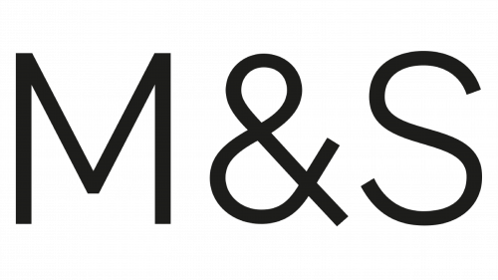

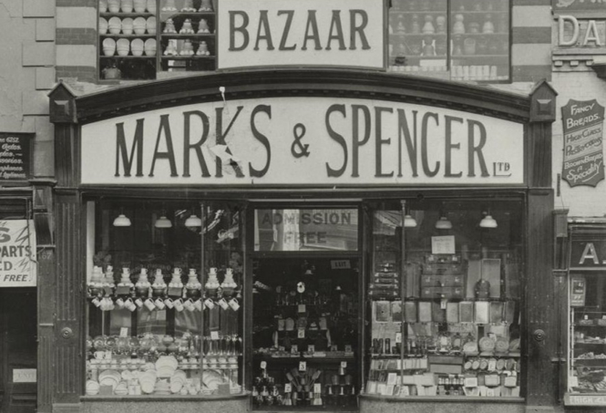

Overview
Since its founding in 1884, Marks and Spencer (M&S) have evolved from a single local market to a multi-channel, international business. One of the leading shops in the UK is M&S, which has more than 1,330 stores worldwide.
33 million people may buy high-quality products from M&S through its 852 UK outlets. Food, which accounts for 57% of M&S Company's revenue, and department stores, which accounts for the remaining 43%, are its multiple business areas. M&S is a market leader in the lingerie, menswear, and womenswear industries as well. (Integrated Reporting, 2022)

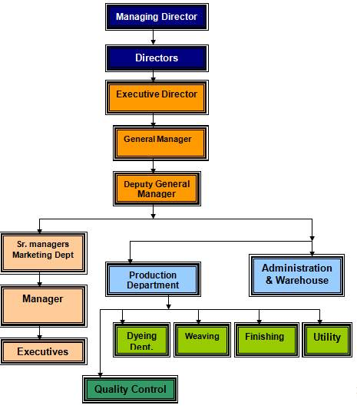
M&S began existence in 1884, once the immigrant Michael Marks moved to Northern England and succeeded to get a stand at Kirkgate Market in Leeds. He used the catchphrase "Don't ask the price, it's a Penny" to build his career after arriving with little money and little English. His stand selling straightforward household goods quickly prospered as a result of his hard effort and this straightforward notion. Tom Spencer, a cashier from wholesalers Dewhirst, joined forces with Michael to help his expanding firm. From this alliance, "Marks & Spencer" and its initial Penny Bazaar locations were created, and the company we are all familiar with started to take shape. (Our history, 2022)

Management
Currently, M&S practises largely consultative management, which means that before making major decisions, executives speak with their employees. (Marks & Spencer Company: Organisational Structure, 2022)

(Marks and Spencer Business Analysis: SWOT AND PESTLE, 2022)
MARKETING MIX OF M&S
A marketing mix includes numerous areas of attention as part of a complete advertising strategy. The term often refers to the classification system known as the 7Ps, which initially stood for product, pricing, placement, promotion, physical proof, people, and process. (Kenton, 2022)

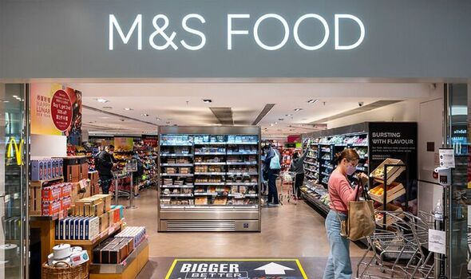
Products and services
Food, Clothing & Home, and Bank & Services. (M&S, 2022)

The clothes and home divisions of the British store Marks & Spencer are sourced from a variety of international vendors. M&S has 245 plants in China as of January 2022 that produced clothes and home goods for the store. With 105 plants, India has the second-highest concentration of suppliers behind China. (Smith, 2022)

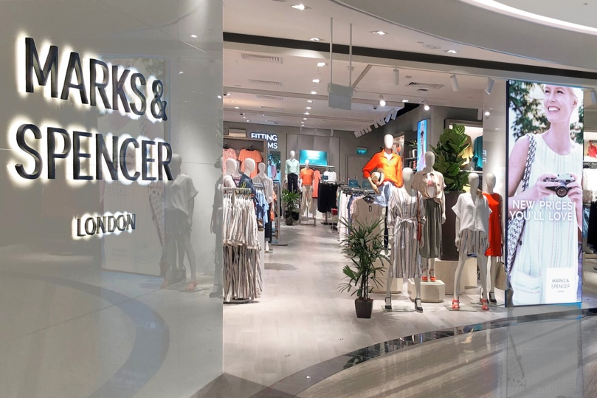
Quality is important to M&S, particularly when it comes to sourcing and producing their products. They want to make ethical decisions that benefit the environment, the people who made the items, and themselves. M&S has a dedicated team of specialists working to innovate and discover answers as they adjust the food business to the consequences of climate change.
To fulfil its promise to customers to supply products that are safe, legal, high-quality, and made with integrity, M&S has detailed rules, codes of practise, and standards that suppliers must abide by. Leadership management is required to fully understand and communicate M&S's operational specifications to every employee involved in producing every item. (M&S, 2022)
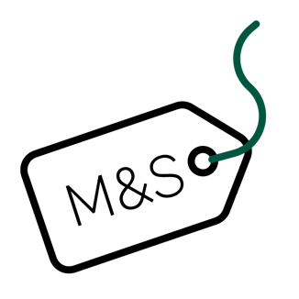
Prices
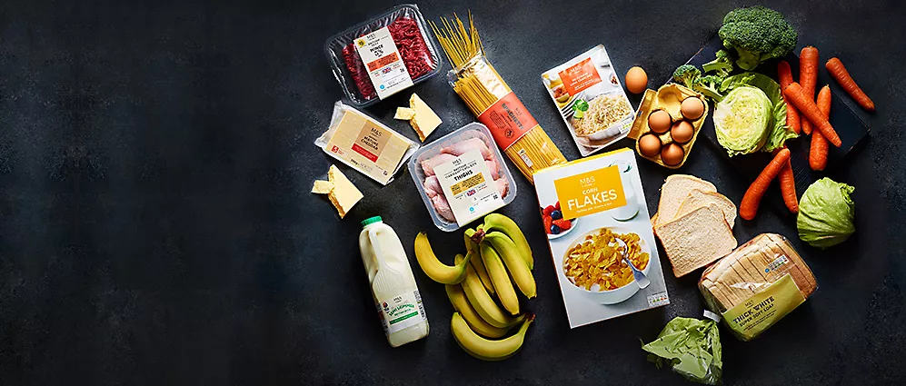
As retailers fight to retain customers affected by the cost-of-living problem, Marks & Spencer has become the most recent store to reduce prices. Considering more than £100 million in expenditures over the preceding three years to improve their value categories of food, M&S is lowering prices on a variety of daily grocery goods, including milk and bread. Price reductions occur as supermarkets struggle to maintain their market share in the face of rising inflation. Recent estimates place the rate of food inflation at 3.8%, which is encouraging consumers to purchase at German discounters Aldi and Lidl. (Curry, 2022)
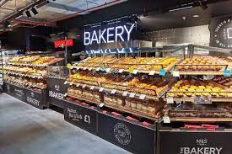
- • The pricing lock adds to the retailer's existing Remarksable Value collection, which provides over 100 everyday items at discounted costs without compromising quality or procurement guidelines pricing are tested against leading competitors.
- Price Lock and Remarksable are only two programmes that M&S offers to its 30 million customers in the UK as evidence of its commitment to offering dependable value.
- It occurs at the same time as the most current Family Matters Survey from M&S, which is based on surveys with more than 5,000 UK adults, reveals that 61% of customers prioritise value above accessibility when deciding where to shop, an increase of 2% from the prior ranking in July. (M&S Food Announces Price
Lock Extension and guarantees trusted value for customers, 2022)

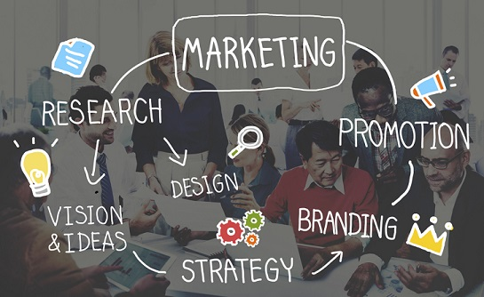
Promotion strategy
In order to survive in a market where customers were paying closer attention to the things they decided to buy, several clothing businesses in the UK were forced to create new business models. M&S achieved this through the employment of a marketing plan that concentrated on three crucial areas: creating the goods that customers would want to purchase, improving the environment already existent in the shop, and providing excellent customer service. (Marks & Spencer Company: Organisational Structure, 2022)

Marks & Spencer use print media, TV commercials, mobile ads, and other social media initiatives. On its own website, the company advertises its name as well as goods for men, women, and kids. (Marks & Spencer Marketing Strategy & Marketing Mix (4PS) 2021)

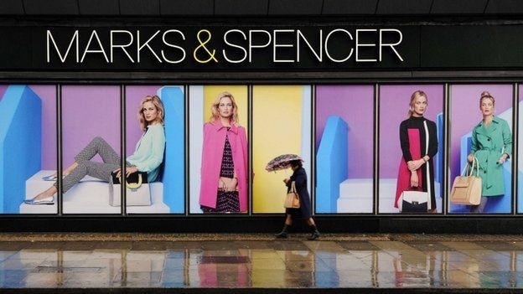

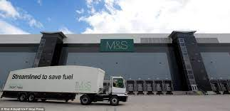
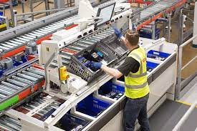
Place & Distribution / Physical evidence
More than over 1000 Marks & Spencer stores spread through more than 50 countries. The majority of the company's operations is conducted in the UK, whereby Marks & Spencer covers approximately 850 locations. It began doing operations in India in 2001 and currently has more than 50 locations there. Along with other countries, it is also present in Turkey, Spain, France, Ireland, Hungary, and Finland. Consumers may order products from Marks & Spencer's website and have them shipped to their houses. M&S furthermore provides the option of international delivery for a chosen few products. (Marks & Spencer Marketing Strategy, 2021)

These stores also provide as tangible proof for the business. Moreover, Marks & Spencer sells a wide range of products, such as apparel, furnishing, gifts, and home furnishings. These products can offer observable evidence.
People
- Marks & Spencer has roughly 70,000 employees overall. The company takes great care of its employees. The company has a competitive salary plan to maintain its employees.
- In addition to offering a base salary, the company rewards its staff with incentives based on their achievements.
- Regardless of whether purchased in-person or online, M&S products are subject to a special discount for employees. The corporation offers its workers share purchases, health insurance plans, pension benefits, and life insurance plans.
- Marks & Spencer provides training and development opportunities for its new recruits in addition to various courses for higher positions. The company also provides flexible work schedules as a service to working parents and employees who wish to explore other career options.
- M&S likewise places a high priority on diversification in each area to promote the recruitment of women by enacting additional policies that are inviting to women.
- The outbreak caused the company to lose money and fire employees for the very first time ever. (Marks & Spencer Marketing Strategy, 2021)

Process
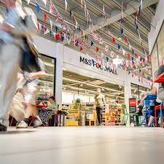
The Marks & Spencer stores are available in malls and affluent suburbs. Such shops are stunning and efficiently laid up when contrasted to others such as Pantaloons, Wills Lifestyle, etc. Clothing, flowers and presents, furniture, and other home products all have their own areas on the floors of Marks & Spencer stores.

Within each area, there's many distinct subcategories for adults, adolescents, and children. Furniture and personal items are frequently stored on the bottom floor. Men's, women's, and children's clothing can be seen on the ground floor. On the 2nd floor, there are gift shops and furniture stores. The latest floor has food and other items. Each establishment includes a check-out counter where clients can pay for their purchases after selecting the items they desire.

Customers may access the M&S website and place orders there, just as with other e-commerce platforms. Furthermore, customers can collect bonus pints if they possess a Marks & Spencer special Sparks cards as part of their rewards program. (Marks & Spencer Marketing Strategy, 2021)

M&S Mission, vision statement and values
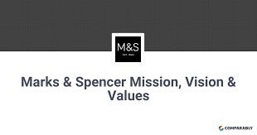
A mission statement is a declaration of the organization's business model and primary goal. - Marks & Spencer Our goal is to open inspirational qualities to
others.
A vision facilitates goal-congruent labour. It originates both within and outside. What it achieves is as follows Future-oriented language decision-making and strategy guidance builds a platform with the same goal Establish behavioural standards Encourage feeling displays the values The goal of Mark and Spencer is to serve as the benchmark for others.
Values of Marks & Spencer: Innovation, Quality, Service, and Trust
(M&S, 2022)
Strategy
Marks & Spencer asserts that its strategic plan is assisting in increasing its relevancy to customers as it makes investments in Nobody's Child, one of its partner brands. The company is developing several cutting-edge strategies to work with some other companies, exclusive collaborations, investments, and wholesaler agreements. (Rigby, 2022)

The expansion of the company's global reach is a key component of its "reconfiguration for development" plan, which will take effect by the end of 2022. The main objective is to boost partnership and internet sales, and M&S promotes partner growth by further localising its fulfilment and services. (Retail Week, 2022)

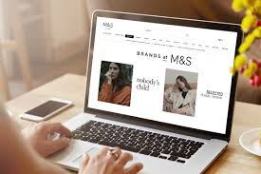

Future of M&S
67 of Marks & Spencer's larger locations will close during the next five years as part of an expedited retail restructuring.
The business's previously announced plans to shut 110 key sites as part of a big renovation under its departing chief executive Steve Rowe led to the closures. The company now intends to finalise the modifications earlier than expected.
Additionally, Marks & Spencer announced that 104 additional Simply Food locations will be opening. M&S chief executive Stuart Machin stated that by the beginning of 2028, the retailer hopes to operate 180 "full-line" stores retailing food, apparel, and home goods, down from 247. One in four stores, then.
The 67 locations to go were "full-line, lesser productivity stores."
Due to increased online spending by customers and a desire to grow its food sector, the corporation wants fewer, better primary storefronts.
M&S intends to execute these modifications in 3 years as opposed to five. It asserted that companies who have already relocated to fresh, modern sites are succeeding. Our freshly moved shops are performing well, and this gives us the confidence to move on with our rotational plans quickly while also making investments in bigger and better grocery stores, according to Mr. Machin. He stated, "We're building a store estate that's ready for the future, with stores in excellent places, that let our consumers shop the way they want to. (Simpson, 2022)

References:
Curry, R. (2022) Marks & Spencer cuts bread, milk and mince prices as supermarket price war heats up, Evening Standard. Evening Standard. Available at: https://www.standard.co.uk/business/marks-and-spencer-prices-milk-bread-mince-cost-of-living-inflation-aldi-lidl-b993722.html (Accessed: November 15, 2022).
Integrated Reporting (no date) Marks and Spencer (M&S), Integrated Reporting. Integrated Reporting. Available at: https://www.integratedreporting.org/profile/marks-and-spencer-group-plc/ (Accessed: November 15, 2022).
M&S (2022) Our products, Marks & Spencer. Available at: https://corporate.marksandspencer.com/sustainability/our-products (Accessed: November 16, 2022).
M&S (no date) Homepage, Marks & Spencer. Available at: https://corporate.marksandspencer.com/ (Accessed: November 15, 2022).
M&S (no date) Marks & Spencer Mission, Vision & Values | comparably, Comparably. Comparably. Available at: https://www.comparably.com/companies/ms/mission (Accessed: November 17, 2022).
M&S Food Announces Price Lock Extension and guarantees trusted value for customers (no date) Marks & Spencer. Available at: https://corporate.marksandspencer.com/media/press-releases/ms-food-announces-price-lock-extension-and-guarantees-trusted-value-customers (Accessed: November 16, 2022).
Marks & Spencer Company: Organisational Structure: Free Essay Example (2022) StudyCorgi.com. StudyCorgi.com. Available at: https://studycorgi.com/marks-and-amp-spencer-company-organisational-structure/ (Accessed: November 15, 2022).
Marks and Spencer Business Analysis: SWOT AND PESTLE (2022) UK Essays. UK Essays. Available at: https://www.ukessays.com/assignments/marks-and-spencer-business-analysis.php (Accessed: November 16, 2022).
Our history (no date) Marks & Spencer. Marks & Spencer. Available at: https://corporate.marksandspencer.com/about-us/our-history (Accessed: November 16, 2022).
Retail Week (2022) Marks & Spencer (strategy), Retail Week. Retail Week. Available at: https://www.retail-week.com/prospect/marks-and-spencer/marks-and-spencer-strategy/7038340.supplierarticle?authent=1 (Accessed: November 16, 2022).
Rigby, C. (2022) Marks & Spencer on how its brand strategy is making it more relevant to its customers, Internet Retailing. Internet Retailing. Available at: https://internetretailing.net/brands/marks-spencer-on-how-its-brand-strategy-is-making-it-more-relevant-to-its-customers-24081/ (Accessed: November 15, 2022).
Simpson, E. (2022) Marks & Spencer speeds up store closure plans, BBC News. BBC. Available at: https://www.bbc.co.uk/news/business-63224269 (Accessed: November 17, 2022).
Smith, P. (2022) Marks & Spencer: Number of suppliers 2022 by country, Statista. Statista. Available at: https://www.statista.com/statistics/1102485/number-of-suppliers-of-marks-and-spencer-by-country/ (Accessed: November 15, 2022).
Team, M.B.A.S. (2021) Marks & Spencer Marketing Strategy & Marketing Mix (4PS), MBA Skool. MBA Skool. Available at: https://www.mbaskool.com/marketing-mix/services/17122-marks-and-spencer.html (Accessed: November 16, 2022).
Team, M.B.A.S. (2021) Marks & Spencer Marketing Strategy & Marketing Mix (4PS), MBA Skool. MBA Skool. Available at: https://www.mbaskool.com/marketing-mix/services/17122-marks-and-spencer.html (Accessed: November 17, 2022).

