
CERTIFICATE OF HIGHER EDUCATION FOR WORKPLACE

2019
DIGITAL SKILLS AND RESEARCH METHODS
MODULE ID: BMSK4003 STUDENT ID: 1714747 LEVEL: 4
STUDENT NAME: SONIA WELBECK TUTOR : ANUPAM MAZUMDAR SUBMISSION DATE: 14 JAN. 2019
[Type the company address]

Introduction
Table of Contents
The Effects of Technology on Employees Performance 3
Introduction 2
Literature Review 3
Research methodology 5
Quantitative method 5
Data Collection 6
Secondary Data 6
Findings, Analysis and Discussions 6
The Effects of Technology on Factor Analysis 7
The Effects of Technology on Organisational Productivity 7
The Effects of Technology on Work Life Balance 7
The Effects of Technology on Job Satisfaction 8
The Effects of Technology on Employees Performance 9
Discussion 9
Recommendation 9
Conclusion 10
Bibliography 10

The Effects of Technology on Employees Performance in the Workplace
The aim of this study is to improve on personal digital skills acquired during the learning process and explore the means of creating individual research method that can be transform into workplace advantages, as well as creating awareness of the significance of effective data analysis into advance usage as a tool in an organisation. In other to achieve this, there is need to assess suitable use of modern techniques to develop workplace competency and employability skills, which will be an avenue for students to recognise and successfully determine means of gathering data and to demonstrate ability to manage collected data in a workplace.
However, the major focus of this study is to determine the effects of technology on job satisfaction, organisation productivity, employees performance and work life balance in the workplaces. Hence, a brief explanation of effects of technology in the workplace will be discussed, along with different factors that contributes to the implementation of successful modern technology in an organisation. The evaluation of quantitative research methodology will be use in this study to explain and predict the outcome of purpose of using technology in workplace .
The full implementation of how data generated in the course of this research on the job satisfaction, organisation productivity, employees performance and work life balance with the support of technology in workplace will be analysed and the analytical graphical representations will be also be discussed with appropriate recommendation will be provided, to ascertained whether technology influence the progress of work and provide exact solution to employees job satisfaction in the workplaces.
Having learned the importance of digital skills that can be transfer into workplace advantage during the class lectures, the researcher now realised that students can utilise this opportunity as an avenue to develop required skills needed to establish themselves in their potential career with the vision of contributing to the global markets.

Literature Review
The analysis of renowned scholars on the effects of technology on job satisfaction, organisation productivity, employees performance and work life balance in the workplace is vital to this study, whether technology influence the working system in an organisation will also be explore to bring about the description and outline significant influence of technology in the workplace.
Technological innovation is the method of merging and restructuring skills to generate new ideas. The adoption of modern technology has significant effects on organisational performance which comes from internal development and external growth that contributes to workers achievements. Thus, Technology cannot perform wonders by increasing productivity without combining human resources effectively and ethically (Chintalloo & Mahadeo, 2013).
The introduction of modern technology has change many organisation performance and will continue to speed up the future use. Constantly, modern technology has compel businesses to discover, acquire and adapt to change including technical knowledge of how workplaces, employment relations, individuals and the public in general perform their duties.
The challenges that most companies encounter in today world are more related to their inability to adapt to technological changes in various industry. (Madsen et al., 2005).
Technological evolution is part of the main motivating forces of global development. The role of technology in the development of world economy cannot be overlook. Therefore, there are three major drivers of global economy system: capital accumulation, market expansion, and technological innovation. It is only technological innovation that does not deteriorates rather increases from time to time. Thus, for the past century technological development products and services has been the key contribution to human development which enhance employees performance on daily basis (Mokyr, 2015).
The motive of every organisation in purchasing modern technology tools is to improve employee’s performance, smooth the progress of job-tasks, increase efficiencies, improve communication system and higher-levels of effectiveness in the workplace. The use of modern technology in the workplace is a tool to facilitate and increase company profitability and make the workplace more comfortable for staff to perform their duties more easy, meaningful and fun (Wantulok, 2015).
Some scholars consider technology as a new experience in some industry but a major tool in most successful industry around the world. Therefore, that there is needs to carefully incorporate the use of modern technology gradually into the operational system of such industry and consider both positive and negative effects before implementation. (Shapley et al., 2011).
Communication is fundamental in the business environment and one of the major advantages of technology is the quality of available resources to be communicated within the operational system of a company. Many organisation are now accepting the influence of mobile computing devices such as laptops, phones and tablets including other software applications like cloud systems Voice Over Internet Protocol (VOIP), and skype conference calls to communicate with their employees and bridging the gap between staffs and employers. Communication technology improves efficiencies and reduces time and cost of travelling to attend business meeting (Madsen et al., 2005).
The introduction of modern technology is the main advantages of automation and technology in businesses. Technology is a very important tool that can improve organisation's efficiency and reduce employees blunder by incorporating automated processes into the system. Many company make use of several technology to improve workers performance such as software applications like Quickbooks and contact management sites like SalesForce. As a result of technology implementation into small businesses, they can focus on the general administration and business strategy, while computer compliment the organisation function by providing automated reports and tracks projects (Sansone et al., 2011).

Research methodology
Technological devices have a tremendous influence on job satisfaction, organisation productivity, employees performance and work life balance within and outside workplace. However, there are certain problems and benefits associated with estimating the effects of technology devices. In other to provide stronger evidence, this research has a advanced measure of strength and also showcase knowledge gained in this research. Thus, the use of quantitative research method will be employ to analyse and evaluate the effects of technology on job satisfaction, organisation productivity, employees performance and work life balance in an organisation environment.

Quantitative method
The quantitative research method employed in this study intend to use available information and data in evaluating and providing valid analysis of variables. Thus, assess to the collection of statistical data from only secondary sources to determine sufficient solidity of the study, compare to qualitative research method that is easy to manipulate available data to align with the research objectives. The quantitative method been used majorly in this study in other to hold on the legality, dependability and generalisation of research findings, analysis and discussion. This method is the most appropriate means to address the objective of the study (Saunders, et al., 2016).

Figure:1
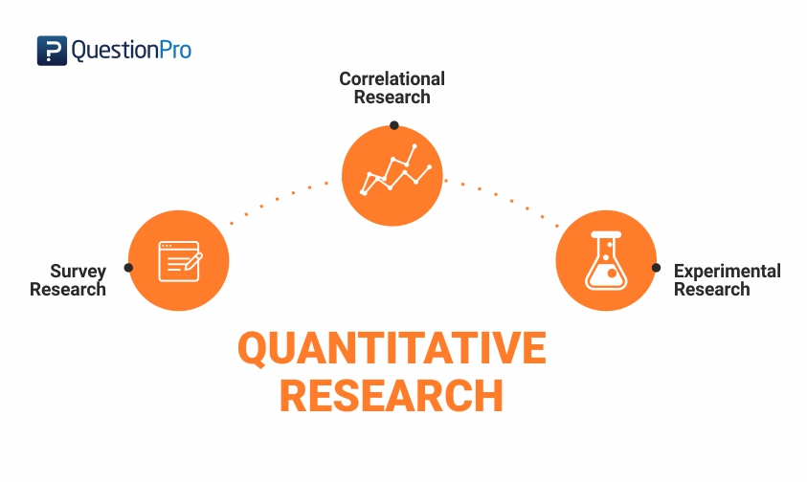
Source: (Tomlinson, 2011)

The figure above draw more attention to the research methods employed in this study. Hence, the study provides exact approach approved by the tutor in class to implement the research method, stressing that the research is motivated within time frame to carryout secondary data collection from verified sources.

Data Collection
Saunders, et al., (2016), explained that all secondary data sourced based on the quantitative research method must provide a more fine distinction assessment of the main results from which must be from reliable, reputable, sound and trustworthy academic background, bearing in mind the legality, sincerity and standard of quality of data collected, with the view of using appropriate procedure to implement the objective of the research.

Secondary Data
This are data initially in circulation generated by others scholars, that conducted similar research in the past using primary sources like interviews and questionnaire. However, Saunders, et al., (2016), explained that secondary data can be use to invent new set of data and convert it to primary data in the process of developing or expatiate on the outcome of the results of initial scholars. It is easier to advance on secondary data and discover a lot more than the original source and present different view at the end of the research conducted, within minimal time, less capital invested and data sampling is not necessary. Hence, secondary data fits perfectly into this study.

Findings, Analysis and Discussions
Following detailed research conducted in the literature review with appropriate use of quantitative research method that support this study on the effects of technology on the job satisfaction, organisation productivity, employees performance and work life balance with the support of technology in workplace. There has been significant increase in the adoption of modern technology in the past two decades, which has major effects on workplaces, individuals and society at large. This period has been experiencing frequent technological evolution in the digital computing field, along with the implementation of telecommunications technology, to connect various computer system together to build a very large single network. Data has become accessible globally with the adoption of technology, which has lead to various development changes in the workplace.
More attention has been drawn significantly to recognise the effects of modern technology on different factors that contributes to the job satisfaction, performance, productivity and work life balance and to identify which factor is the most affected by the adoption of modern technology.

The Effects of Technology on Factor Analysis
The Table 1 below graph shows factor analysis that with the adoption of modern technology contributed growth of the business in term of job satisfaction, employees achievement, health and safety, productivity and work life balance.

Table:1

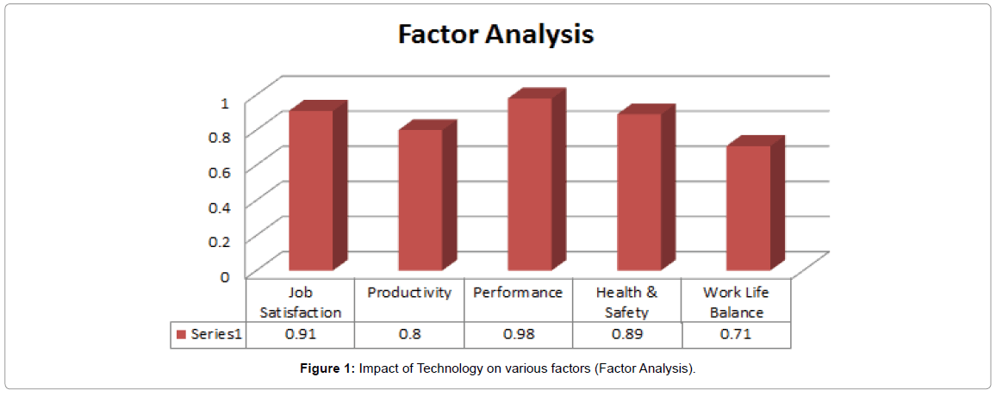

The Effects of Technology on Organisational Productivity
Findings: Pie-chart below clearly show that, when modern technology was introduced into the operational system of the organisation, there is 25% increase in the employees task accomplishments, which have made the job easy and efficient. Hence, there is 22% increase in the productivity and high level of flexibility and integration in the system. The duration of time to complete jobs was reduced by 20%, while 18% increased in the productivity of work and 15% of the workforce are now committed more to their task been given and delivered on time.

Table:2

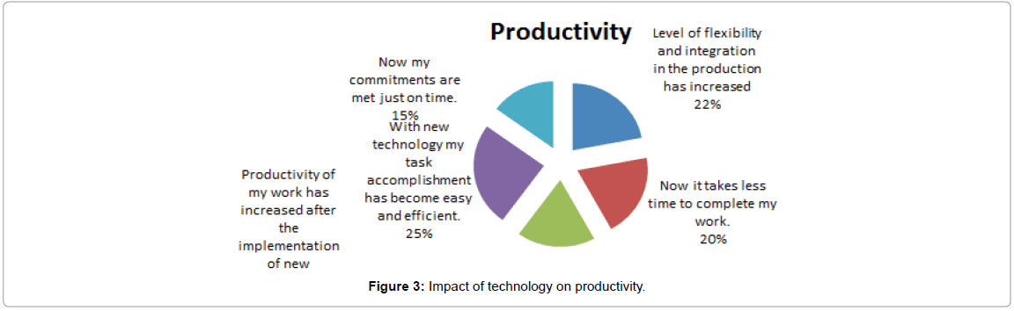

The Effects of Technology on Work Life Balance
Findings: From the pie-chart result below, with the implementation of new technology 25% of workers are less stress during the cause of carrying out their duties and 22% still have their usual social and personal life intact while working effectively. Also 20% increase in the number of employees who are more happier than before the adoption of the new technology, which has led to17% improved quality of work life and indeed 16% reduction in the working hours after the technological changes.

Table:3



The Effects of Technology on Job Satisfaction
Findings: As observed by the pie-chart below 23% of employees are now more committed to their task with new technology, because 18% of workforce are provided with all resources that cost less to carry out their duties after new technology adopted. That trigger 20% increase in the managers to have confidence in the production outcome than before. Thus, 20% boost in the number of employees that can handle multiple tasks at a time, which eventually create up to 19% bigger opportunities in the workplace in term of promotion and carer progression.

Table:4



The Effects of Technology on Employees Performance
Findings: According to the report presented on the below, 25% relatively improved in the job scope because of adoption new technology, which eventually enhance employees performance by 20% and 19% witness significant growth in competencies and skills, at the same time 18% observed efficiency in the work, with vital evidence of 18% advanced and improved trainings provided in various aspect of work since the newly acquired technology.

Table:5
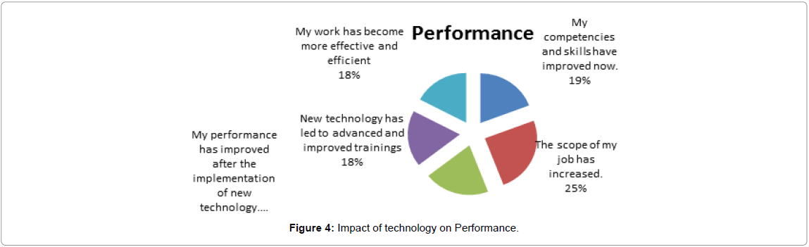

Discussion
In the recent time, organisations concentrates more on using new technology to accomplish their productives efficiencies by cutting back on time and costs with the objectives of increased output, and substitution of technology for the workforce. Ankli (2012), said the adoption of technology has three unique impact on organisation results: productive, coordinative and informative impact that contributes to production time reduction, replacement of employees with automated machines in other to minimise time gap across various geographical environments or the reform of relationships and the building of powerful database along with supports decision-making processes and better application of information to reduced of difficulty in decision making processes of the organisation.

Recommendation
Based on the study the recommendations are:
- Only the qualified trained workers shout be permitted to operate newly adopted technology.
- Modern technology to be installed for operation following adequate training and monitoring are provided.
- Provision of health and safety and maintenance is important.
- Employer should inform employees who will be directly in involve in the operation of the technology and request their opinion.

Conclusion
The research concluded that the use of innovative technology in the workplace increases employees performance in all 5 major sector of an organisation related factors examined which are productivity, work life balance, job satisfaction, performance, and health & safety.
Presently, as technology are still in early stage of adoption and presently making huge impact on various industries growth, there is tendency that technology is going to take over all function of human activities in the future provided there is continuous investment in innovation technology.

Bibliography
Aghion, P., & Howitt, P. (2012). Macroeconomic Effects of Major Technological Change: General Purpose Technologies and Economic Growth. Research Institution Collaborative Innovation , 121-144.
Alexopoulos, M., & Cohen, J. (2010). Volumes of Evidence - Examining Technical Change Last. Toronto: University of Toronto.
Ankli, R. E. (2012). Enabling a motivated workforce: exploring the sources of motivation. An International Journal , 7-10.
Chintalloo, S., & Mahadeo, J. D. (2013). Effect of Motivation on Employees’ Work Performance at Ireland Blyth Limited. Proceedings of 8th Annual London Business Research Conference Imperial College (pp. 1-16). London: London Business School.
Edwards, M. (2012). Our Digital Conversion. The Education Digest , 4.
Fernald, J. G. (2014). A Quarterly, Utilization-Adjusted Series on Total Factor Productivity. San Francisco: Federal Reserve Bank of San Francisco.
Katz, L. (2016). Technical Change and the Relative Demand for Skilled Labor: The United States in Historical Perspective. London: Harvard University Press.
King, R. G., Plosser, C. I., & Rebelo, S. T. (2000). Production, growth and business cycles: I. The basic neoclassical model. Journal of Monetary Economics , 191-196.
Madsen, S. R., Miller, D., & John, C. R. (2005). Readiness for organizational change: Do organizational commitment and social relationships in the workplace make a difference? Human Resource Development Quarterly , 213-233.
Mokyr, J. (2015). The Lever of Riches: Technological Creativity and Economic Progress. Oxford: Oxford University Press.
Sansone, C., Fraughton, T., Zachary, J. L., Butner, J., & Heiner, C. (2011). Self-regulation of motivation when learning online: The importance of who, why and how. JournalEducational Technology Research and Development , 199-212.
Saunders, M., Lewis, P., & Thornhill, A. (2016). Research Methods for Business Students. Surrey: Pearson; 8th edition.
Shapley, K., Sheehan, D., Maloney, C., & Caranikas-Walker, F. (2011). Effects of Technology Immersion on Middle School Students’ Learning Opportunities and Achievement. The Journal of Educational Research , 299-315.
Svensson, B. H. (2018). overestimate the effect of a new technology in the short run and underestimate the effect in the long run. The Wall Street Journal .
Tomlinson, G. (2011, April 12). The Marketing Director's Forum. Retrieved December 10, 2018, from www.themarketingdirectorshandbook.com: https://themarketingdirectorshandbook.com/2011/04/12/quantitative-vs-qualitative-research-the-great-debate-the-result-is-in-2/
Wantulok, T. (2015). How Important is Technology in Education? Bozeman: Pine Cove.

