DSA Manufacturing

Programme: BA (Hons) Leadership and Management Skills for the Workplace
Module: Strategic Management for SMEs
Student: Gabriela Grad (2027447)
Lecturer: Faizu Edu
Executive Summary
The report has demonstrated the case study of an SME named DSA Manufacturing a leading UK clothing manufacturer. It has examined the vision, mission, and organizational goals for the current strategic direction in the current clothing industry. The report has explained the environmental scanning tools to identify the internal and external environment to create a huge image among customer mindset. DSA Manufacturing mainly focuses on the current strategic growth of choice for long-term development. The report has highlighted the Ansoff Matrix, Porter generic strategy, and Bowman Strategic Clock to growth choice for organizational success. DSA manufacturing mainly focuses on stakeholder analysis to evaluate the expectation and requirements with relative power. Therefore, the report has illustrated the SWOT analysis to identify the strength and weaknesses of organizational growth in the current marketplace. It has highlighted the strategic recommendation for DSA manufacturing for future development and implementation for strategic direction. The report has identified the stakeholder with the most suitable, feasible, and acceptable strategic development.

Table of Contents
Introduction 4
Company Overview (DSA Manufacturing) 4
Organizational Current Strategic Direction 5
Business Environmental Scanning Tools 6
PESTLE Analysis of DSA Manufacturing 6
VRIN of DSA Manufacturing 8
SWOT Analysis of DSA Manufacturing 9
Strategic Growth Choice for SMEs 11
Porter’s Generic Strategy for DSA Manufacturing 11
Ansoff’s Growth Matrix for DSA Manufacturing 13
Bowman’s Strategic Clock for DSA Manufacturing 14
Stakeholder Analysis 16
Strategic Recommendation for Future Development 18
Conclusion 19
Reference List 20

Introduction
In simple terms, Strategic management is largely regarded as a rational procedure through which senior management identifies of course of action and response toward a complex environment (Thanos, 2023). In addition, the Strategic Manager of DSA Manufacturing mainly focuses on strategic direction to accomplish the desired outcome. The report has highlighted the vision, mission, values, and objectives to survive in the clothing industry. It has illustrated the environmental scanning tools like PESTLE, VRIN, and SWOT to identify the forces that affect organizational performance. The report has examined the strategic growth choice for the SME market and proposed a new strategy to become successful in the current marketplace. The report has examined the stakeholder analysis to critically evaluate the interest and power of the organization. The report has described the Porter generic strategy and Ansoff Growth matrix to identify potential growth choices in new ways. DSA manufacturing mainly focuses on the development of new quality products or services to fulfill customer needs. The report has provided suggestions to DSA Manufacturing for organizational development and strategic direction in new ways.

Company Overview (DSA Manufacturing)
DSA Manufacturing is a leading and premium UK clothing manufacturer. The Company offers a one-stop solution to launch a new brand or improve the current brand for organizational growth. DSA employs 5 people to improve the customer experience (DSA Manufacturing, 2023). The Company offers premium quality, competitive pricing, and a UK customer service team to fulfill the changing demand of customers. DSA manufactures a wide variety of garments ranging from streetwear, menswear, womenswear, children wear, and accessories for branding.
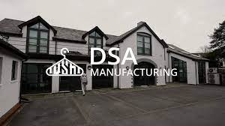
Source: (DSA Manufacturing, 2023)
The Company engaged in catering to all types of sized brands to establish brand and minimum order quantities from just 100 pcs style. DSA manufacturing good fit for a brand or business that needs additional information for organizational success. The Company engaged in tech pack design to improve the client experience.

Organizational Current Strategic Direction
Strategic management is the procedure of setting long-term goals, developing, implementing, and evaluating strategies to accomplish those goals (Thanos, 2023). The leader of DSA Manufacturing mainly focuses on setting up strategic direction to encourage team members to accomplish the organizational goals. DSA focuses on the full package of production as well as many other services to meet customer demand. DSA manufacturing mainly focuses on accessing customize products or services to improve their experience. The Company focuses on strategic decisions, and acting to adjust to evolving situations for continuous growth. DSA Manufacturing mainly focuses on monitoring the activities, resources, and others to become successful in the upcoming future.

Source: (DSA Manufacturing, 2023)
Mission: DSA Manufacturing's main mission is to lead as a manufacturer, supplier, and exporter of high-quality fabric across the globe (Christodoulou and Cullinane, 2019). The Company mainly focuses on developing a platform to share all size of products on a single platform to maintain its brand image among customer mindset. DSA Manufacturing is passionate about high-quality fabric, and garments to meet the client's expectations.
Vision: DSA Manufacturing's vision is to produce unique and exclusive premium clothing to fulfill customer demand. The Company bespoke manufacturing within the clothing sector for organizational success. DSA Manufacturing's vision is to serve customers with full of dedication, and specialized offers with quality assurance.
Values: DSA Manufacturing mainly focuses on helping to start up a brand in the very challenging clothing industry in the UK. The Company focuses on finding quality clothing manufacturing, designing clothing, configuring size charts, and so on to fulfill customer needs for future development. DSA Manufacturing looking toward high-quality garments by engaging lots of suppliers who supply quality fabric at the best cost to fulfill the demand effectively. The Company offers a minimum order quantity is 100 pcs style and an accessible brand for organizational enlargement. Nowadays, DSA mainly focus on the development of communication channel to fast response to any question or query. The Company develops a strong working relationship with the client to meet customer needs effectively.
Goals and Objectives: The Company is passionate about high-quality fabric and creating long-lasting garments for clients and contributing toward sustainable management (DSA Manufacturing, 2023). DSA Manufacturing focuses on the sustainable garment fashion industry to complete the product demand within the estimated timeframe. The Company's main goal is to build a bridge between men and fashion for a safe environment to create a good impression among customer mindset.

Business Environmental Scanning Tools
DSA Manufacturing mainly focuses on forces that affect organizational ability and maintain successful relationships with prospective clients (Thanos, 2023). The Company concentrates mostly on the member's great performance for the things they give to new clients. DSA focuses on identifying the business prospects needed to survive in the competitive UK clothing market.

PESTLE Analysis of DSA Manufacturing
The Company mainly focuses on forces that are a large part of society and affect the microenvironment effectively (Beelen et al., 2023). DSA Manufacturing uses this environmental scanning tool to understand the affecting factor of organizational activities.
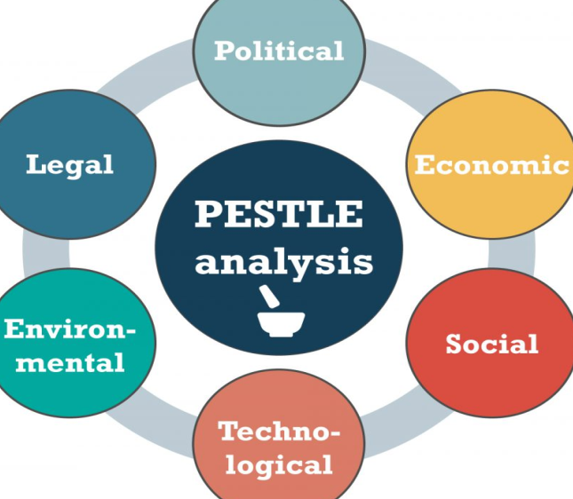
Source: (Christodoulou and Cullinane, 2019)
- Political Factor: Currently, the customer of DSA manufacturing needs to have multiple choices of clothing items or fashion accessories. The Company is a leading UK clothing brand with multiple sizes and styles to fulfill customer demand (Clarissia, 2020). DSA manufacturing maintains a healthy relationship with local and national communities to operate in the marketplace. The UK Government's political condition is favorable to operate clothing brands smoothly and efficiently in any location. To survive in the market, DSA manufacturing mainly focuses on changing government regulations, the political environment, and others to fulfill customer needs.
- Economic Factor: Nowadays, the economy forces some deep repercussions on the apparel and fashion industry. In a growing economy, several citizens are willing to spend on expensive clothing to produce products or services. Other economic forces negative impact on organizational performance. DSA manufacturing used device-like plans and strategies to support and survive in adverse conditions and remain unaffected due to the recession. The company mainly focuses on adopting a new strategy to meet the need of customer in the best possible way. DSA manufacturing focus on trade restriction affects the sales margin and profitability.
- Social Factor: To survive in the clothing industry, DSA manufacturing mainly focuses on a competitor in the industry to deal with trending changes in the fashion industry. The Company focuses on perishable clothes unlike a few years ago. DSA manufacturing looking toward designer and stylish clothing items with sustainable fabric to offer a fresh range of clothing to fulfill the changing demand of clients (Beelen et al., 2023). The Company mainly focuses on the development of artistic and designer culture to supply quality clothing to fulfill the demand effectively. DSA manufacturing mainly focuses on changing the sense of fashion for goods and clothes. Currently, the Company focuses on enough and ideal sound fashion sense to improve the organizational value effectively.
- Technological Factor: Today, DSA Manufacturing concentrates mostly on creating an online platform to present the newest fashions to potential consumers. The Company used environmentally friendly technology options to increase the sales margin and process in the fashion industry. DSA manufacturing focuses on the best creative designs with the support of automation and craftsmanship to meet demand. The Company mainly connects with multiple products to deliver products in countries. DSA manufacturing focus on the latest technologies to deliver products to increase organizational efficiency. Additionally, the company focuses mostly on social media channels for digital marketing in order to attract a sizable consumer base in the global market.
- Legal Factor: In the clothing industry, DSA manufacturing mainly focus on employees' rights, worker invests their time, energy, and hard work in manufacturing quality products or service to improve the organizational value. The Company follows the legal rights to protect the employees with all respect. DSA Manufacturing follows employment laws to ensure the good condition of the staff members and legal charges. The Company follows the anti-trust laws to make sure the organizational activities run smoothly and fairly.
- Environmental Factor: Nowadays, DSA manufacturing mainly focuses on eco-friendly business processes without harming the environment. The Company could use sustainable fiber to manufacture the new style of clothes to fulfill the customer demand effectively (Christodoulou and Cullinane, 2019). DSA manufacturing focuses on inserting renewable technologies for sustainability to achieve a competitive advantage. The company concentrates mostly on environmental factors that influence the desire for certain climate change or weather conditions.

VRIN of DSA Manufacturing
This strategic tool is used for the assessment and evaluates the resource for strategic advantage. The Company mainly focuses on the evaluation of internal resources, capabilities, and core competencies to develop sustainable development. DSA Manufacturing uses local products or services to fulfill the changing demand of the customer effectively. This strategic tool is based on a bundle of resources to improve organizational performance. Managers of DSA manufacturing mainly focus on administration level and goodwill to improve the supply chain of clothing items to fulfill the customer requirement effectively.
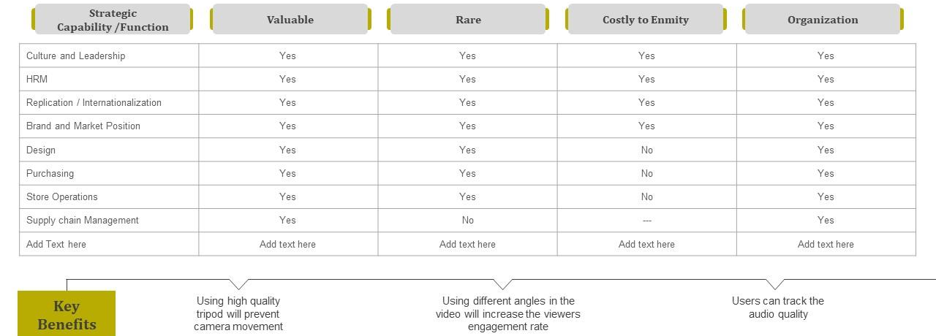
Source: (DSA Manufacturing, 2023)
- Value: The Company resource primarily focuses on delivering value that may be used to gain a competitive advantage. DSA keeps in mind that all the resources are not easily obtained. The Company needs to make an effort to bring sustainable fabric to products eco-friendly products or services to fulfill customer demand.
- Rareness: DSA manufacturing mainly focuses on available resources to all competitors with a significant and competitive edge. The Company focuses on the resources of DSA are valuable so the products or services are more expensive for customers.
- Imitability: An ideal resource is very essential to be obtained through competing businesses in the fashion industry. The Company's primary focus is on introducing key resources to the market in order to expand the organization. To scale, DSA manufacturing mainly focuses on the duplication of products from a competitor and its negative impact on organizational performance.
- Non-Substitutable: Simply, an ideal resource does not have any substitute for any other resources. DSA manufacturing products or services do not have any substitute in the clothing market (Arena et al., 2022). The Company engaged in the production of eco-friendly clothing fabric with new styles and trendy clothes to fulfill customer needs. Nowadays, the Manager of DSA focuses on the execution of the team, and the executive strategy of the firm.

SWOT Analysis of DSA Manufacturing
It is a special way to design new articles or collections of clothing to improve the customer experience. The Company needs to understand the brand image as a larger fashion marketplace to stay competitive. The manager of DSA Manufacturing mainly focuses on the production of quality and sustainable clothing items at the best cost to fulfill the changing demand of the customer.
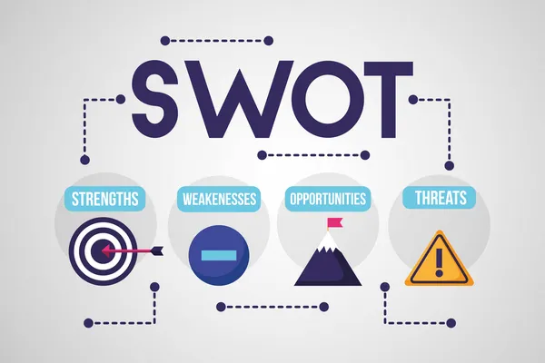
Source: (Tirpáková et al., 2023)
- Strengths: To accommodate client demand, DSA production prioritizes finding new quality apparel, inventing new approaches, selecting fabric, and establishing sizing charts (Villagrasa et al., 2020). The Company focuses on employing 5 qualified and talented employees to improve organizational performance. DSA Manufacturing looking toward garment quality to maintain its brand image among customer mindset (DSA Manufacturing, 2023). The Company's main aim is to provide a sustainable garment industry to retain customers with high-quality products or services. DSA manufacturing develops a good working environment to understand responses and questions for organizational enlargement. To be successful, DSA manufacturing focuses on providing advice and assisting with new approaches to increase organizational value among customers.
- Weaknesses: Nowadays, changing fashion trend for DSA manufacturing is highly competitive. The Company is 3rd party supplier; DSA mainly sources quality products from distinct suppliers to fulfill the changing demand of customers effectively. In sustainable management, DSA engages in low-quality fabric to make prices low as compared to other sustainable products. On the other hand, the ultimate goal to achieve low price compromise the quality of products or services for organizational success. The Company's major weakness is fashion market is continuously changing and the target market also belongs to different age groups.
- Opportunities: DSA manufacturing is primarily concerned with the development of new channels for delivering quality products or services in order to successfully fulfil customer demand. The company has a fantastic opportunity to capitalize on online purchasing trends in order to enhance sales margins and profitability. In the fashion world, DSA manufacturing focuses on investing in e-commerce platforms to improve organizational performance. Currently, customers shift toward sustainable clothing items to prevent the environment clean and safe for the upcoming generation. DSA manufacturing focus on the current brand image for the growth of the fashion world and its products (Clarissia, 2020). Moreover, the Company decided to establish a showroom in a distinct location to expand the market base and customers.
- Threats: DSA manufacturing faced tough competition with local as well as international markets. Mango, Zara, and Nike are the leading fashion store in the UK. Moreover, DSA manufacturing need to focus on changing fashion trend that negative impact on the performance of the firm (Beelen et al., 2023). Due to changes in new trends, the Company may lose its market share and customer demand. For a competitive fashion brand, DSA manufacturing needs to compete against them and win the current market share for organizational success. Moreover, the quick obsolesce of technology negative impact on overall performance and sales margin.

Strategic Growth Choice for SMEs

Porter’s Generic Strategy for DSA Manufacturing
Cost Leadership- A firm that wants to catch worthier growth in the market and gain a market advantage by controlling costs must implement a cost leadership strategy. There are 2 types of cost leadership strategies (Buzatu et al., 2019). These approaches are to be depicted as best-value strategy and low-cost strategy. More probable, one strategy objects to enhancing the earnings of the company by reducing expenses while maintaining industry-average costs. On the other side, the other strategy aims to improve the market share of the business firm in its potential marketplace by reducing costs and charging lower prices. Cost leadership strategy further includes the action of using discounts and promotions with the main aim of improving customer perception.
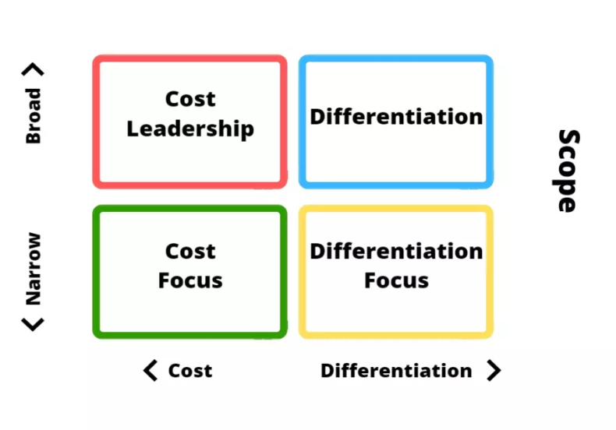
Source: (Arena et al., 2022)
- Differentiation- Implementing a differentiation approach by a business organization means that it must assess something new and different about its offering that is unique and distinct from its existing rivals. Considering the adaption of this strategy, a company could manufacture new specialized products and rebrand its offerings in the potential marketplace as well. Likewise, by being responsive and conscientious to the client's wants, requirements, and expectations, the company is capable to encourage the consumers to pay more and not go for any substitute. In analyzing differentiation, a business firm's leader must create the mission and the company's value statements (Villagrasa et al., 2020). The manager must keenly analyze the value proposition of the corporation to its potential market environment.
- Focus- The last but not least strategy included in Porter's Generic strategy is the focus strategy. This gives the choice to the companies to use either differentiation or cost leadership strategy within a niche market. Nonetheless, this doesn't means that the reach of the business organization goes too limited as it rather wants to create efficient product value as well as develop a loyal customer base in the existing as well as overseas markets. This strategy is profitable for the companies to improve their future customer base and improve their sales in the global market as well. There are 2 kinds of focus. One is low-cost focus and another is best-value focus. More probably, the best-value focus is also termed differentiation focus. These strategies differ by concentrating on either the best value for the price or the lowest cost possible.
Some suggestions that are made to the business firm, DSA Manufacturing to use Porter's generic strategies like choosing a relevant strategy, prioritizing necessary actions, considering the five industry forces, remaining firm, and so on (DSA Manufacturing, 2023). This will help the manager of the given business organization to effectually implement a suitable kind of Porter's generic approach in its workplace. Thus, it catches worthier growth and development in the potential and global markets. Plus, it also strengthens the current customer base of the business firm and assists it to build new ones.

Ansoff’s Growth Matrix for DSA Manufacturing
Ansoff Matrix approach gives a straightforward way of performing a seemingly complex growth project. Likewise, strategies associated with Ansoff's growth matrix help businesses like DSA Manufacturing to assess varied growth avenues, allowing it to create efficient customer satisfaction for their probable clients. As a result, strategies like market penetration and market development are discussed below:
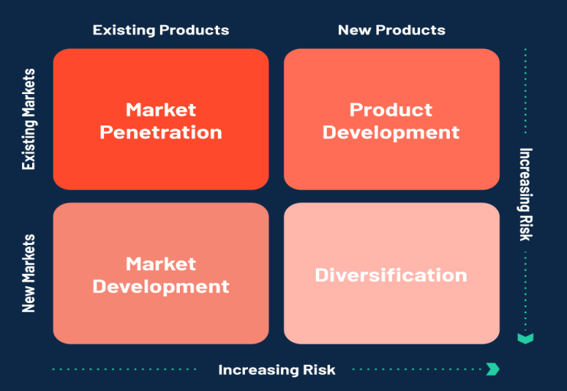
Source: (Buzatu et al., 2019)
- Market Penetration- When business firms in the marketplace object to sell more to their current customer base and want to enhance their market share in the potential marketplace, adopt a market penetration approach. For instance, all telecommunication, manufacturing, and automotive business firms serve customers in the global market, thus wanting to catch a worthier market share in the international markets throughout the world. Likewise, the companies create several offers for their probable clients and induce them to not go for any substitute from their rivals. Considering this, market penetration as a leading development strategy allows businesses to expand their current customer base and make their offerings to the existing customer base at a wide range in the potential marketplace (Almutairi, 2023).
- Product Development- Product Development kind of development strategy is often concerned with the development of new products by the companies and selling the products to their pre-established customer base. An instance in this context, manufacturers of sports shoes have insistently produced commodities like sports clothing to offer it to the common team of individuals who were initially just purchasing shoes.
- Market Development- Market development is generally concerned with the company's offering of its current line of products to an expanded or enhanced group of individuals. In simple terms, the business firms with the implementation of this kind of development strategy will majorly concentrate on assessing new market segments to make their offerings to a broad range of consumers throughout the overseas markets. However, these new customer segments will lie at the same stage of their expectations and requirements as the firm's current line of customers (Buzatu et al., 2019). Nonetheless, the manager of the business firm needs to create consciousness and awareness towards the expectations, requirements, and needs of a new targeted range of consumers.
- Diversification- A riskiest growth and development strategy of all 4 is to be depicted as a diversification strategy. This considers the actions of selling new products or services to new markets. The uncertainty lies in the firm's lack of familiarity with either needs of the market or the product. Nonetheless, diversifying into new markets can further lead to substantial development in the company's growth and organizational effectiveness.
Some suggestions can be provided to a SME, DSA Manufacturing towards the adaption of a suitable and profitable kind of development strategy. Like, before the adaption of any development approach, the manager must weigh all options, evaluate risks associated with all the strategies, select the best strategy, and implement it successfully. Considering this, it is recommended to DSA Manufacturing adopt a market penetration growth strategy. The reason is that it can help the company to effectually grow with its current line of products or services.

Bowman’s Strategic Clock for DSA Manufacturing
A framework i.e., Bowman’s Strategic Clock is used to assess the position of varied business organizations in the market concerning their rivals in the probable marketplace. Bowman's Strategic Clock model is used by firms to analyze the position or standard on which they currently operate and perform their business practices. Thus, through that determination, the companies are capable to identify the major issues or development benefits accessible in their path. The given framework classifies 8 varied positions that a brand or a business firm can hold in its potential market environment. These positions or levels are to be depicted as low level of price, low added value, and hybrid, focused differentiation, differentiation, monopoly pricing, high-risk margins, and at last the loss of market share (Buzatu et al., 2019). According to Bowman's Strategic Clock framework, varied business firms in the marketplace can perform their practices at different levels on this clock; nonetheless, each of these levels is linked with a different range of issues. In understanding, to effectually evaluate and assess the present position, a business organization must primarily identify its basic strategic positions in the marketplace. More often, with this understanding, it can able to pursue alterations to improve its current positioning and competitiveness in the potential market environment.
- Low Price and Low-Value Added- With this strategic model, the company can maintain itself as competent by fixing the prices as low as possible Thus, the price of the offerings is low and the distinctiveness of the products in the marketplace is not high. This results in attaining low customer value.
- Low Price- Products in large quantities are produced by the organizations using this strategy. In comparison with the previous strategy, the goods of the company are valued in the marketplace. Though the products have a low-profit margin from customers, it derives huge profit with output.
- Hybrid- With this strategy, the companies can provide good and consistent quality products to the customer with added value on a habitual basis. It is a combination of low prices and differentiation of products (Almutairi, 2023).
- Differentiation- With the differentiation strategy, the main aim is to provide the customers with a high level of value (Siddiqui and Marciniak, 2023). With this process, the company creates distinctive products providing a unique form of value.
- Focused Differentiation- With this strategy, the companies target customers that like to pursue the products of utmost high value (Okorie et al., 2023). The products are especially high value and the customers are willing to pay the price.
- Risky High Margins- This is regarded as the short-term strategy to use the unsteadiness in the economy and market supply. The customers have to purchase the products unless they found precise substitutes and replacements.
- Monopoly Pricing- A Company enjoying monopoly pricing is not concerned with the customer and fixes the prices of the products according to their own needs. The customers heavily rely on the products and the company exploits the fact and benefits from the market.
- Loss of Market Share- This strategy involves offerings at a high price but a low market value. This strategy is referred to be effective with the short-term trends of the market. It involves obtaining an inferior product and setting its price or value to match the same as competitor products or substitutes.
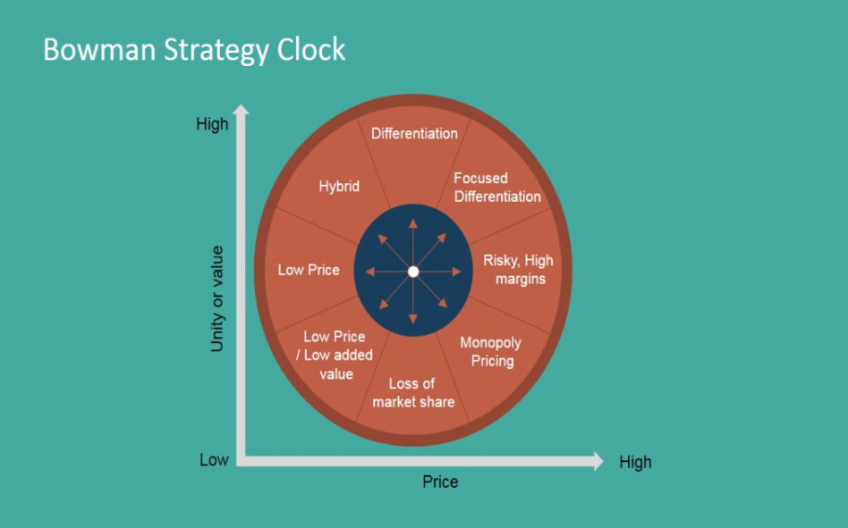
Source: (Tirpáková et al., 2023)
From considering the perspective of the market presence and the product line of DSA Manufacturing, it can be analyzed that this business organization deals in clothing products on a small scale that is less expensive and affordable to the consumers in the marketplace. Plus likely, DSA Manufacturing never compromises the quality of its products. Thus, the customer is ready to buy from it and is more likely to stay continue purchasing it for a very long duration (DSA Manufacturing, 2023). Considering this, DSA Manufacturing comes at the First stage or position of Bowman's Strategic Clock which is "Low Price and Low Value Added". In this strategy level, the business firm keeps the price of its offerings relatively low to compete in the market and thrive in the cut-throat environment. Thus, DSA Manufacturing makes its offerings at low costs to consumers. More mentioning to the previous, the product or service is not eminent, thus the clients perceive lesser value. On the contrary, prices are attractive enough for the company to encourage consumers to sporadically purchase its products or services.

Stakeholder Analysis
Simply, stakeholder analysis is the procedure of identifying these people to begin, grouping them, level of participation, and influencing the project to determine the best and communicate with others. The manager of DSA Manufacturing mainly focuses on new consultation to define holistic and concrete target positive impact on organizational enlargement. The Company hires designers to create clothing in a certain fashion to deliver the designer clothes to retail stores. Managers of DSA manufacturing focus on identifying a new target to cover purchase practices and circular design that positive impact on the fashion industry.
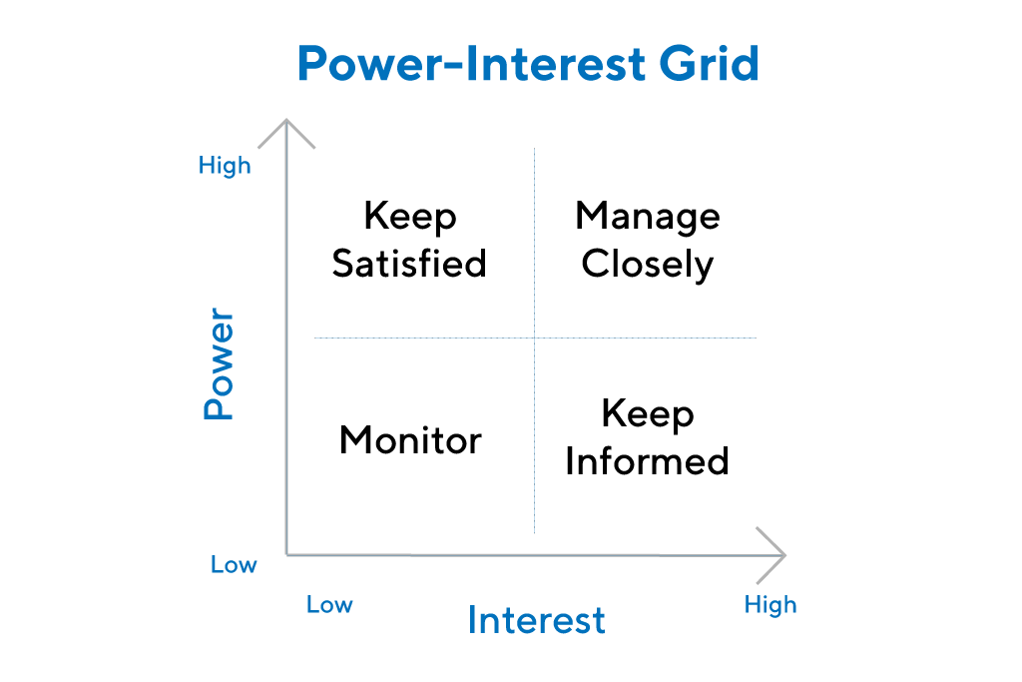
Source: (Thanos, 2023)
- High Power, High Interest: It is the main priority of stakeholders to keep them happy with the projected growth. DSA manufacturing mainly focuses on the development of a comfortable environment to encourage employees.
- High Power, Low Interest: It influences the organizational value and progress effectively, and does work to keep these people satisfied (Okorie et al., 2023). Apart from this, it has not shown a deep interest in the project and could over-communicate with them.
- Low Power, High Interest: It will help to keep the people informed and check their stakeholders regularly to ensure that they do not experience problems with the project (Tirpáková et al., 2023).
- Low Power, Low Interest: It is just to keep the people informed, while does not overdo it.
DSA Manufacturing mainly focuses on hiring workmen who operate the raw materials into clothing and create new designer clothes to fulfill customer demand. The Company focuses on advertisement, marketing, and involvement in raising awareness for the fashion industry. DSA focuses on transformation feasibility to deliver designed clothes to retail stores and sell other locations for organizational development. Product Manager of DSA Manufacturing focuses on the development of new products or designer clothes to fulfill customer demand. Fashion designers of DSA Manufacturing focus on current fashion trends and estimate their popularity with customers in the upcoming future.
Suppliers of DSA Manufacturing mainly focus on maintaining close connections with local vendors in the fashion industry. The Company engages design of new garment and makes products to improve organizational performance. DSA Manufacturing engages in developing new kinds of products to fulfill customer needs. The Company mainly focuses on the development of a stakeholder map to create clothing in a certain fashion to meet customer demand effectively. DSA Manufacturing focuses on sampling garments allocated to small retailers to enhance branding and functionality for organizational growth.

Strategic Recommendation for Future Development
In the fashion industry, the Manager of DSA Manufacturing focuses on the expansion of the brand including clothing, footwear, and other accessories to improve the organizational performance. The Company focuses primarily on a sustainable supply of fabric in order to make excellent products or services to meet the changing demands of the client. DSA manufacturing should currently focus on artificial intelligence to design new items in order to boost the success rate in the fashion market. The Company mainly focuses on identifying the most attractive design and style of clothing items with less capital to stay competitive. In the global fashion industry, the Manager of DSA Manufacturing expects variation in recovery profiles. The Company must continue to focus on the supply chain for the growth of fashionable brands and products (Okorie et al., 2023). DSA manufacturing mainly focuses on suggestions of strategic managers to improve customer needs as under:
- E-Commerce Platform with Fantastic Website: DSA Manufacturing mainly focuses on the development of a user-friendly site to come new fashion industry. The Company engages in designing a new e-commerce site with some special features to grab the customer's attention and make purchase decisions. Therefore, the organizational website shows the products with attractive content to improve the customer experience. The Company may bring positive and measurable impact on organizational success. DSA manufacturing also displayed personalized products as per customer demand to improve the experience.
- Effective Marketing Campaign: DSA Manufacturing's Strategic Manager works mostly on social media channels to reach a large audience. The company primarily focuses on connecting the brand to a diverse variety of social media channels, with the goal of conducting business activities smoothly (Tirpáková et al., 2023). Nowadays, DSA manufacturing mainly focuses on social media channels to enhance customer engagement and suggestions for organizational success in the fashion industry. With a strong media presence, the Strategic Manager of DSA reaches more and more customers effectively.
- Use Information Technology: DSA Manufacturing mainly focuses on technology to remain competitive in running of business successfully. The company focuses on innovation and technology to improve the production of sustainable products or services to fulfill customer demand effectively. With innovation, DSA brings new styles and designs of clothes for organizational success.

Conclusion
In conclusion, the report has examined the case study based on an SME named DSA Manufacturing as a fashion retailer. The report has critically analyzed the mission, vision, and values of DSA manufacturing for the current strategic direction. It has evaluated the environmental scanning tools like PESTLE, SWOT, and VRIN models to understand the competitive forces that affect organizational performance. The report has examined the value of the expectation of distinct stakeholders for better customer satisfaction. It has evaluated the strategic growth choice for DSA to enter into a new marketplace with innovative products or services. The report has explained the strategic recommendation to encounter for future development and implementation to deal with current challenges.

Reference List
About DSA manufacturing UK clothing manufacturer (2023) DSA Manufacturing. Available at: https://www.dsa-manufacturing.co.uk/about-us/ (Accessed: 12 July 2023).
Almutairi, M.M.Q., 2023. The Impact Of Market Analysis On The Company Strategy. Journal of Positive School Psychology, pp.401-412.
Arena, S., Florian, E., Zennaro, I., Orrù, P.F. and Sgarbossa, F., 2022. A novel decision support system for managing predictive maintenance strategies based on machine learning approaches. Safety science, 146, p.105529.
Beelen, K., Lawrence, J., Wilson, D.C. and Beavan, D., 2023. Bias and representativeness in digitized newspaper collections: Introducing the environmental scan. Digital Scholarship in the Humanities, 38(1), pp.1-22.
Buzatu, A.I., Pleșea, D.A., Iulian, C. and Valentin, W.P., 2019. Managing organizations for sustainable business development: Interaction between VRIO framework and Mckinsey 7s framework. New trends in sustainable business and consumption, pp.243-251.
Christodoulou, A. and Cullinane, K., 2019. Identifying the main opportunities and challenges from the implementation of a port energy management system: A SWOT/PESTLE analysis. Sustainability, 11(21), p.6046.
Clarissia, S.M.S., 2020. A study on Ansoff Matrix Technique: As a growth strategy and an adaptive learning technique adopted in the leading brand of products. BIMS Journal of Management, 18.
Okorie, O., Russell, J., Cherrington, R., Fisher, O. and Charnley, F., 2023. Digital transformation and the circular economy: Creating a competitive advantage from the transition towards Net Zero Manufacturing. Resources, Conservation and Recycling, 189, p.106756.
Siddiqui, N.Q. and Marciniak, R., 2023. Modesty as a Fashion Growth Opportunity? Exploring the Potential of Fashion, Sustainability, Production, Value, and Marketing. In Pioneering New Perspectives in the Fashion Industry: Disruption, Diversity and Sustainable Innovation (pp. 127-137). Emerald Publishing Limited.
Thanos, I.C., 2023. The complementary effects of rationality and intuition on strategic decision quality. European Management Journal, 41(3), pp.366-374.
Tirpáková, M., Blišťanová, M., Ondicová, M. and Galanda, J., 2023. Environmental Analysis as a Part of the Context in the Risk Management Process. TEM Journal, 12(1).
Villagrasa, J., Sánchez, F. and Donaldson, C., 2023. HOW TO WIND THE STRATEGIC CLOCK: A BEST PRACTICE EXAMPLE SHOWING THE DYNAMIC PROCESS THAT UNDERLIES. In INTED2023 Proceedings (pp. 943-955). IATED.

