Individual project
Mixing Chamber Liners

Coleg Sir Gar
HNC Mechanical Engineering Year 2
Howell Krampf (210827)

Summary
This project was started to attempt to extend the usable life of the liners, in the mixing chamber in a Farrel-Pomini CP550 mixer extruder widely used in the polymer extrusion industry, and improve overall product yield.
The product being mixed and extruded are carbon lengths which are used in collector strips on pantographs in overhead electrification rail applications. The product is highly abrasive due to containing hard raw materials such as quartz sand (7 on Mohs scale) and silica carbide (9 on Mohs scale) in certain recipes. These ingredients, even in the small percentages used, erode the walls of the liners through abrasive action, due to the volume of melt passing through the machine and the high temperatures and pressures involved in the mixing chamber.
When the wear starts becoming excessive it will eventually cause issues with the mix and lead to defects in the extruded product and can also cause the material to back up in the chamber and into hopper as it is not being moved, due to the shearing action of the mixing rotors, through the mixing chamber as intended due to having more space to occupy due to the wear. This means extended machine downtime to rectify any blockages and replace the worn liners.
The 3 options that were put forward were to continue purchasing OEM liners from Farrel-Pomini, which have a current serviceable life of approximately 10 weeks of production before the amount of scrap defective products produced starts becoming unviable. These liners are case hardened to 58-60HRC at a depth of 0.5mm and a cost of £30,000 per set. Options 2 and 3 involved having an external company manufacture liners and then have them HVOF coated in either a chrome carbide (58-62 HRC) or tungsten carbide (68-72 HRC) finish which would cost approximately £15,000 per set, with a 0.5mm coating.
Option 3 was chosen due to the higher hardness of the coating, compared to OEM liners the wear experienced while the trial liners were used in production was significantly less. In zone 4, the most wear was 7.5mm with an average of 3.66mm of wear across all measured zones in the upper and lower liners. The highest wear seen in trial liners was zone 4 in trial 2 at 0.53mm of total wear and average of 0.32mm across all measured zones. During this trials the recipes used contained higher percentages of abrasive ingredients (quartz sand, silica carbide) compared with the other trials which contributes to the higher wear seen.
The data shows that the HVOF coated liners showed good abrasion resistance during the production runs and reduced the total wear that the liners experienced was reduced compared with the OEM liners. One of the trial liners was able to be sent away for refurbishment and stayed within specification after being recoated.
One of the factors that attributed to a drop in good product yield was excessively worn mixing rotors. Going forward the recommendation would be to trial similarly coated rotors to reduce the wear, which has the potential to maintain a high yield of >94% and reduce production downtime with the related maintenance required to remove and install new rotors.

Contents

1. Acknowledgements 1
2. Introduction 2
3. Literature Review and Background Research 4
4. Project Specification and Testing Plan 6
5. Project Planning 8
6. Project Solutions 9
4. Design and Implementation 10
5. Analysis, Results and Evaluation 11
6. Conclusion 16
7. Recommendations 17
8. Bibliography 18
9. Appendices 19

Figure 1 Farrel-Pomini CP550 2
Figure 2 wear rate as a function of Brinell hardness in three-body abrasion wear test with silica particle of size 200-300mm 4
Figure 3 Mixing Chamber OEM Upper Liner 6
Figure 4 Mixing Chamber OEM Lower Liner 7
Figure 5 HVOF Diagram (EPC, 2018) 10
Figure 6 HVOF Process photo (EPC, 2018) 10
Figure 7 Trial Liners 11
Figure 8 OEM Lower Liners in M/C with Rotors 12
Figure 9 Excessive Wear in Zone 11, Lower Liners 12
Figure 10 New Trial Liner Compared to OEM at End of Use 14
Figure 11 Lower Liners in M/C Start of Trial 1 14

Graph 1 OEM Liners Product Yield 13
Graph 2 Trial 1 Product Yield 15
Graph 3 Trial 2 Product Yield 16
Graph 4 Trial 3 Product Yield 17

Acknowledgements

I would like to offer my thanks to Muhsin Haddad, Project Lead, and Rob Maddrick, Tooling Engineer and my main Project contact, for allowing me to participate in this project and giving access to information and much needed advice throughout.
I would also like to show my appreciation to the Maintenance team who assisted me in gathering data when I was away from site and the companies involved in the design, manufacture and coating of the linings:
Farrel-Pomini
Pontypridd Precision Engineering LTD
Wall Colmonoy

Introduction
Morgan Advanced Materials is a global company with 107 locations in 29 countries, that is involved in several different sectors including thermal ceramics, molten metal systems, seals and bearings, technical ceramics and electrical carbon.
The electrical carbon branch of the company develops and manufactures a wide range of electrical carbon brushes and collectors, brush holders, slip rings and linear transfer systems that transfer electrical current between stationary and rotating or linear moving parts in motor, generator and current collector applications.
The main markets are rail, industrial dries, power generation, iron and steel, mining and wind. The company manufactures products that have been designed and developed to operate in harsh or extreme environments.
The Swansea site is part of the electrical carbon branch of the business, manufacturing electrical components for industrial, rail and energy markets, particularly the renewable energy sector. Other electrical carbon manufacturing branches of the group include Hungary, Turkey, Japan, China, America, Brazil, Korea, South Africa, Hong Kong, Italy, Taiwan, Germany, Australia and Canada.
The Swansea site is unique amongst the group as it is one of two sites that has a line dedicated to mixing and extruding carbon lengths, which are then cut to size and can then be impregnated with various metals such as copper or silver if required in a metal impregnation autoclave. They are either used onsite to produce products sold to external buyers globally or sold internally to other sites (such as in Hungary and Turkey) to manufacture different products.
The plant being used to mix and extrude are designed for use in the polymer conversion industry a Farrel-Pomini CP Series IITM compact processor (CP550). The CP550 was designed to process highly abrasive materials for that application, but due to how abrasive certain raw materials in the mix required to produce the different carbon sections compared with any materials used in the plastics industry, there is an increased on the wear rate of the liners and rotors in the mixing chamber.
Feed Hopper
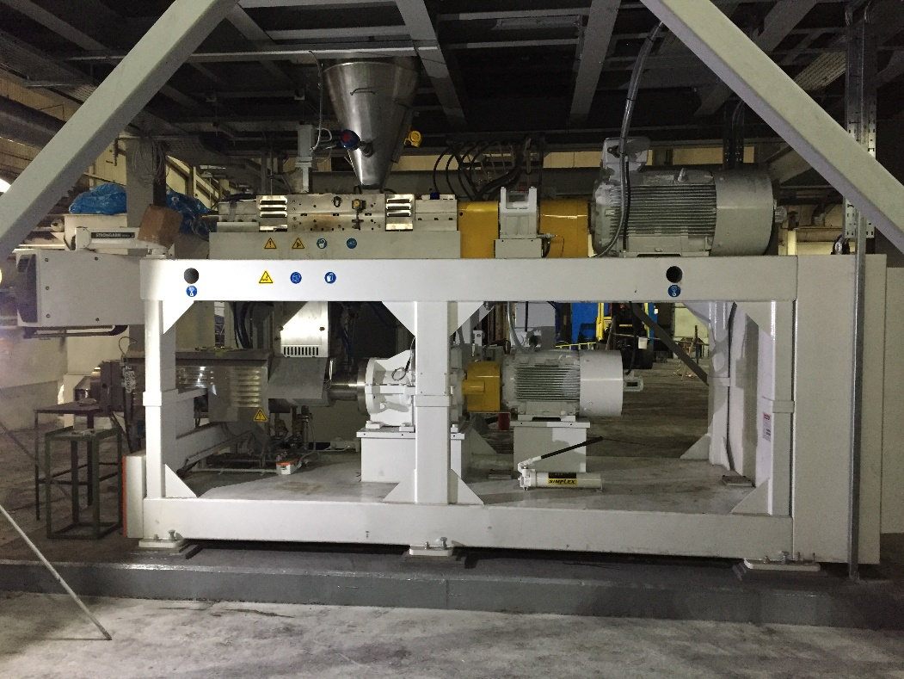
Extrusion Barrel
Mixing Chamber
Figure 1 Farrel-Pomini CP550
The extrusion process takes solid raw materials which are weighed and dispensed through an automated process into a mixing chamber which combines them in a melt through the mechanical shearing action of rotating screws and the heat provided by heating elements in the mixing chamber and extruder barrel. It is then extruded through a die to produce the desired cross section.
The aim of this project is to find a solution that extends the working life of the liners, allowing the machine to be run for longer periods with less downtime relating to liner changes which take around 3 hours to carry out a replacement.
Muhsin Haddad is the Project Lead and Rob Maddrick is the Site Tooling Engineer, the authors role was to research potential solutions for different mixing chamber liner options and then tracking the wear once implemented during the trial period with help from the Maintenance team. Data gathered includes weekly wear measurements during the TPM, total tonnage of product and scrap produced.
This part of the project will be carried out over a 70 week period, due to the lead times involved in the research, design and manufacturing of the replacement liners and time it will take to track and gather sufficient wear data.

Literature Review and Background Research
For the background research, papers and journal articles from reputable sources where gathered and studied. The focus of the research gathered was to do with the erosion of steels through abrasive or polishing mechanisms.
Abrasive action is one of the most common causes of polishing wear. The term polishing wear is used to describe interactions between two solids that remove material from, while at the same time producing a polished finish on, the surface of at least one of the two.
Abrasion involves the removal of material from a solid object when loaded against hard particles which have equal or greater hardness. These particles may originate externally or from debris created by fracture of asperities Examples of systems subjected to abrasive wear include chutes, hydraulic systems with dirt, extruders and rock crushers. (Chintha, 2019)
Based on the type of contact with hard particles the wear process can be categorised into two-body or three-body abrasion. In the former case, the hard particles remain rigid while in three-body abrasion they move during the wear process. Polishing a metal with a hard particle suspension is an example of three-body abrasion. It is found that the wear rates are an order of magnitude less in three-body as opposed to two-body abrasion, because the abrasive particles spend about 90% of the time rolling on the contact surface without causing much damage and only 10% time in abrading the surface. (Rabinowicz E, 1961). In Fig 1. a linear relationship between hardness wear rate can be noticed in abrasion.

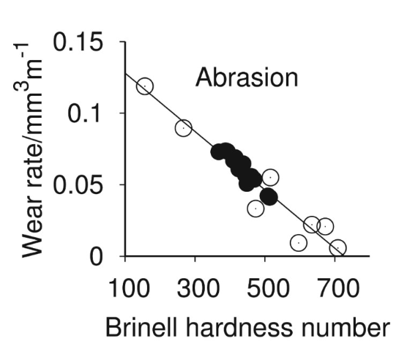
Figure 2 wear rate as a function of Brinell hardness in three-body abrasion wear test with silica particle of size 200-300mm
In some applications, abrasion wear resistance may be improved by increasing hardness. Materials tested under abrasion only conditions usually show a strong correlation with hardness, wear loss decreases with an increase of bulk hardness of the material. (Ratia V, 2013) The wear of hard steel subjected to a complex wear environment which involves impact or gouging correlates badly with hardness. Rendón et al. tested commercially available steels, including ferritic stainless steel, medium alloyed ferritic carbon steel and a medium alloyed martensitic carbon steel, under purely abrasion and impact abrasion conditions and found pure abrasion results were found to have a strong dependence on hardness. (José Rendón, 2009)
The liner walls are being eroded away due to the constant shearing mechanism that enables the melt to be properly mixed together, combined with the high pressure and high temperature environment that exists in the mixing chamber. The volume of material passing through has a constant polishing action which erodes the liner surface material away.
Once the liners are excessively worn it can cause issues where the material begins to back up into the conveyor section and puts excessive load on the rotors gearbox and motor and an increase in upstream pressure. This causes the machine to run sub-optimally and the result is an increase in scrap parts as the raw materials are not being mixed properly in the chamber before being extruded through the die orifice.
Current liners are OEM from Farrell, made of tool steel case hardened to 58-60HRC at a depth of 0.5mm. From previously gathered data and anecdotal evidence gathered after speaking the operators, line manager and members of the maintenance team, once this hardened layer is eroded away the wear rate rapidly increases. This may be caused by a number of hard abrasive materials used in some recipes. One of the common constituents used in recipes is quartz sand, which is 7 on Moh’s hardness scale (Cash, 2015), equivalent to 71HRC (WolframAlpha, 2020). Recipes with higher percentages of quartz sand will wear at a faster rate, as this value is higher than the OEM liners hardness of 58-60HRC at 0.5mm depth.
The cost for a set of liners is £30,000 and currently have a usable lifespan of approximately 10 weeks. They are imported from America and have a lead time of 10-12weeks.

Project Specification and Testing Plan
See Appendix 1. for PDS.

The testing plan will involve installing a brand new set of OEM liners and tracking the wear weekly during the machine TPM over 3 month period, or until the liners start causing production issues where they will be replaced with a set of trial liners.
The wear will be measured at 14 points across both the top and bottom liners, as seen below, measurements of the wall thickness will be taken using a digital calliper to get an idea of the wear pattern and rate. Numbers are punched into the mixing chamber housing, but do not show clearly in the photos, to take and record measurements in the same area each week.
12
13
14
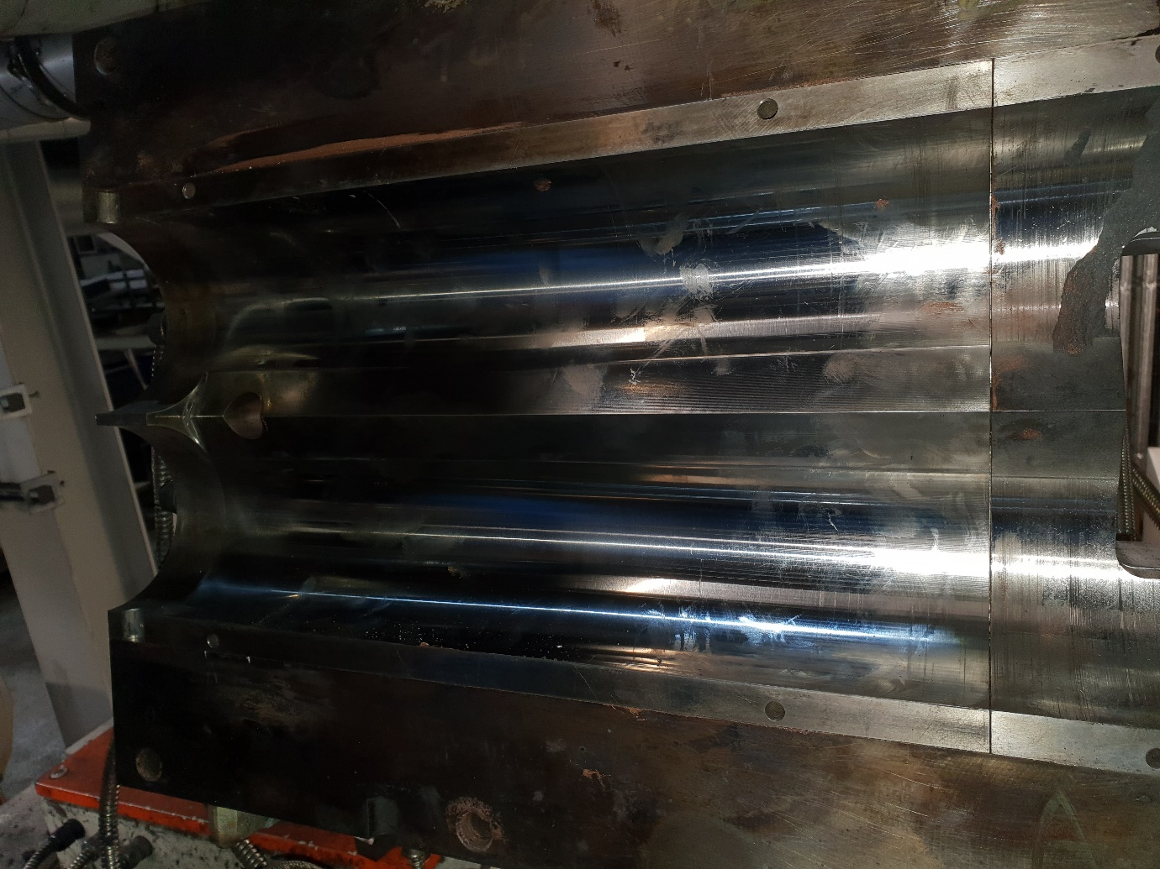
1
3
4
5
6
7
2
8
10
11
9
Mixing section
Figure 3 Mixing Chamber OEM Upper Liner
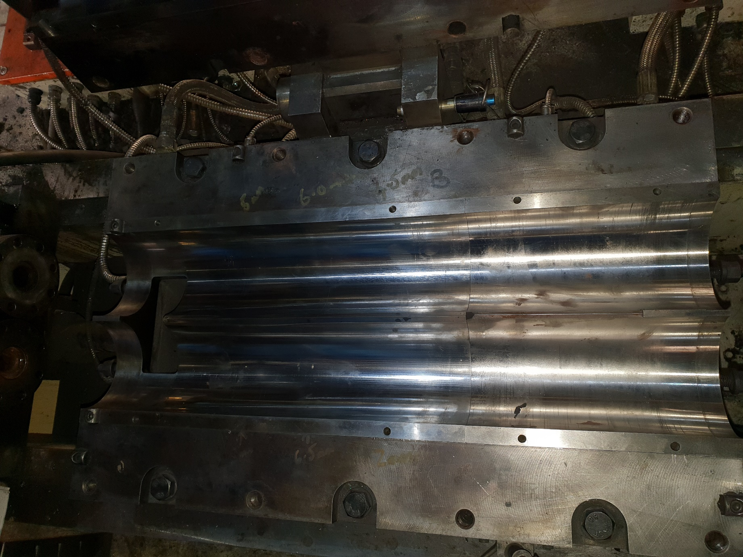
Conveyor section
Mixing section
1
3
4
5
6
7
2
8
10
11
12
13
14
9
Figure 4 Mixing Chamber OEM Lower Liner
Production volume and tonnage is recorded by the machine and any scrap product will be weighed weekly.

Project Planning
See Appendix 2. for project timing plan.

Project Solutions

- Continue purchasing liners from Farrel. Tool Steel, case hardened to 58-60HRC.

- Outsource liners manufactured to Farrel specification with Chrome carbide coating (58-62HRC).

- Outsource liners manufactured to Farrel specification with Tungsten carbide HVOF coating (68-72HRC).
Solution 1 Advantages of this solution are that they are purpose built for the machine, all dimensions and specifications should be within machine tolerance and be drop in replacements. Disadvantages are that there a long lead times of 8-12 weeks importing from America, which can be longer if there are any disruptions in the supply or transport chain. Costs for this solution would be approximately £120,000 a year which decreases the profit made on the parts produced by the line.
Solutions 2 and 3 involve finding a reputable engineering firm to manufacture the liner bodies and also a find a company that will be able to carry out HVOF coatings to produce the liners to the correct specifications. Common Tungsten Carbide and Chrome carbide coatings can have a hardness of 58-72HRC, which would be more suitable to resist abrasion from the 71HRC quartz sand, reducing the amount of wear the liners will undergo.
Approximate costs for the manufacture and coating of these liners would be £15,000 per set (£9,000 for manufacture and £6000 for the HVOF process) in either Chrome or Tungsten Carbide finishes, compared to £30,000. This makes them a more economically viable option dependant on results of the trials. These options mean the liners can be manufactured more locally to the factory compared with OEM, not overseas, reducing lead times and increasing profit on parts produced by the machine. If the wear of the coatings are tracked closely these liners could potentially be swapped out of the machine for a good set and be sent away to be stripped of the remaining coating and recoated before being returned, which would reduce costs further as it is approximately £7,000 to carry out the process of stripping the coating back to the base metal and recoating.

Design and Implementation
Chosen solution is 3, using a proprietary Tungsten Carbide (WC-Co) surface finish.
Type of steel chosen as a base material to manufacture the liners from is EN24T. This high tensile alloy has good machinability, high strength and renowned wear resistant properties.
Time to manufacture, coat and finish the liners require a lead time of 4-6 weeks.
The HVOF process involves injected a powder feed stock into a high velocity, high temperature gas stream which is fired at the workpiece. The jet of hot gas makes the powder partially melt in the stream and is then deposited on the work surface, resulting in low porosity and high bond strength. Cobalt based alloys, stainless steels, Carbide, Tungsten carbide (WC-Co) and chrome carbide (Cr2C3-NiCr) coatings can be applied with this process. Typical applications of HVOF include high wear conditions (due to sliding, abrasion or erosion), Corrosive environments (gases, acids, salt water) and high temperature environments (to prevent/reduce oxidation). (EPC, 2018)
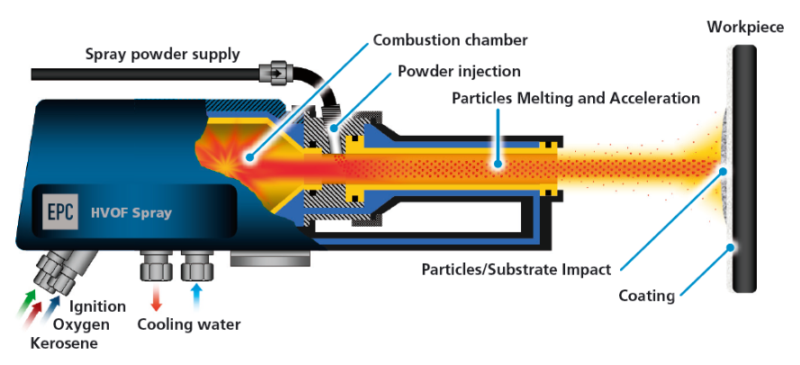
Figure 5 HVOF Diagram (EPC, 2018)
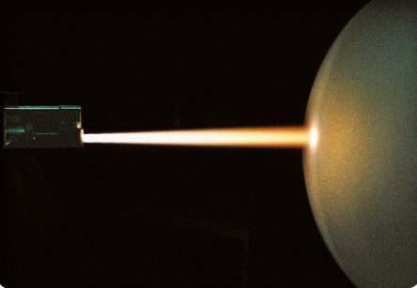
Figure 6 HVOF Process photo (EPC, 2018)
Brand new OEM liners were sent to chosen manufacturer, Pontypridd Precision Engineering LTD, to scan the liners to produce drawings and machine them. The liners will then be shipped to Wall Colmonoy to have a 0.5mm layer of tungsten carbide applied to the liners before being delivered to site stores ready for installation.
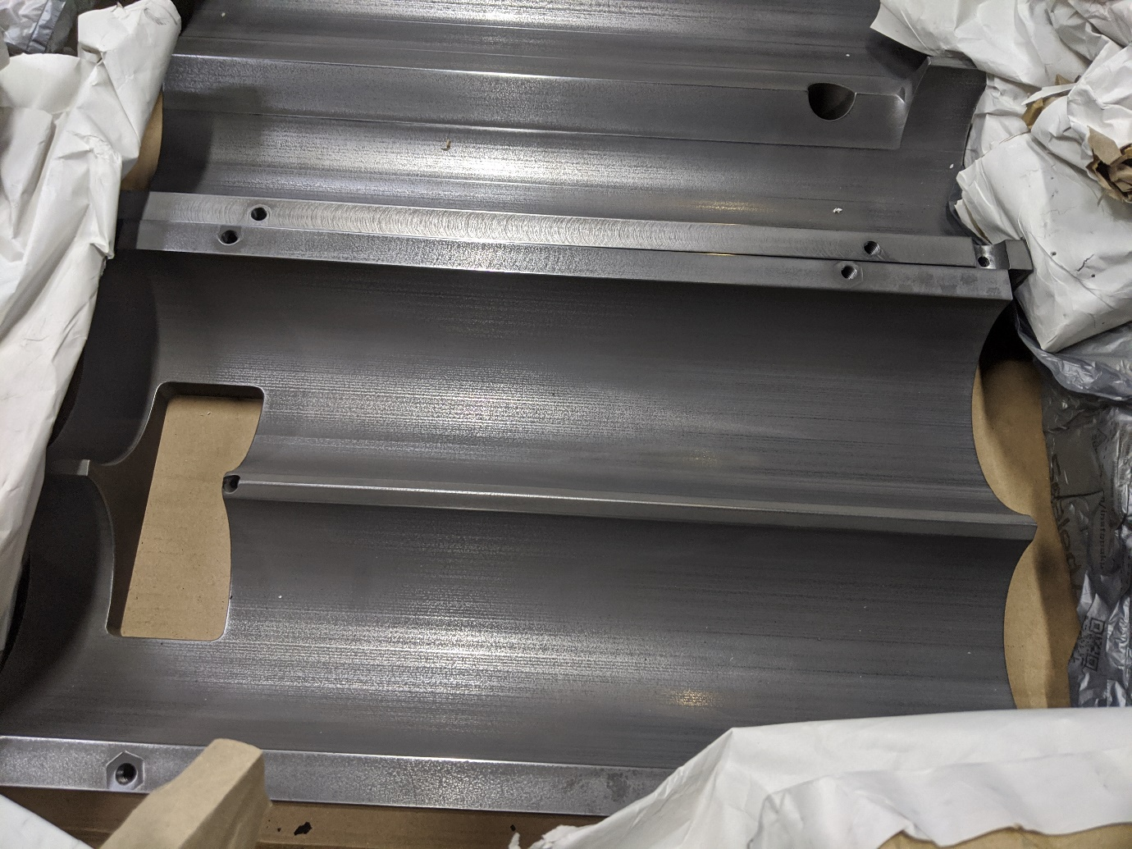
Figure 7 Trial Liners

Analysis, Results and Evaluation
Refer to Appendix 4. for full table of wear data and production yield.
With the OEM liners, in use in the machine, the most wear occurs in zones 4 and 11 with up to 7.5mm of wear occurring at zone 4 on the upper liner. An example can be seen below, these points are near the centre of the chamber, where the most pressure is occurring in the mix as the melt is forced against the liner walls through the chamber to the orifice into the extrusion barrel, causing increased erosion through abrasion at these points.
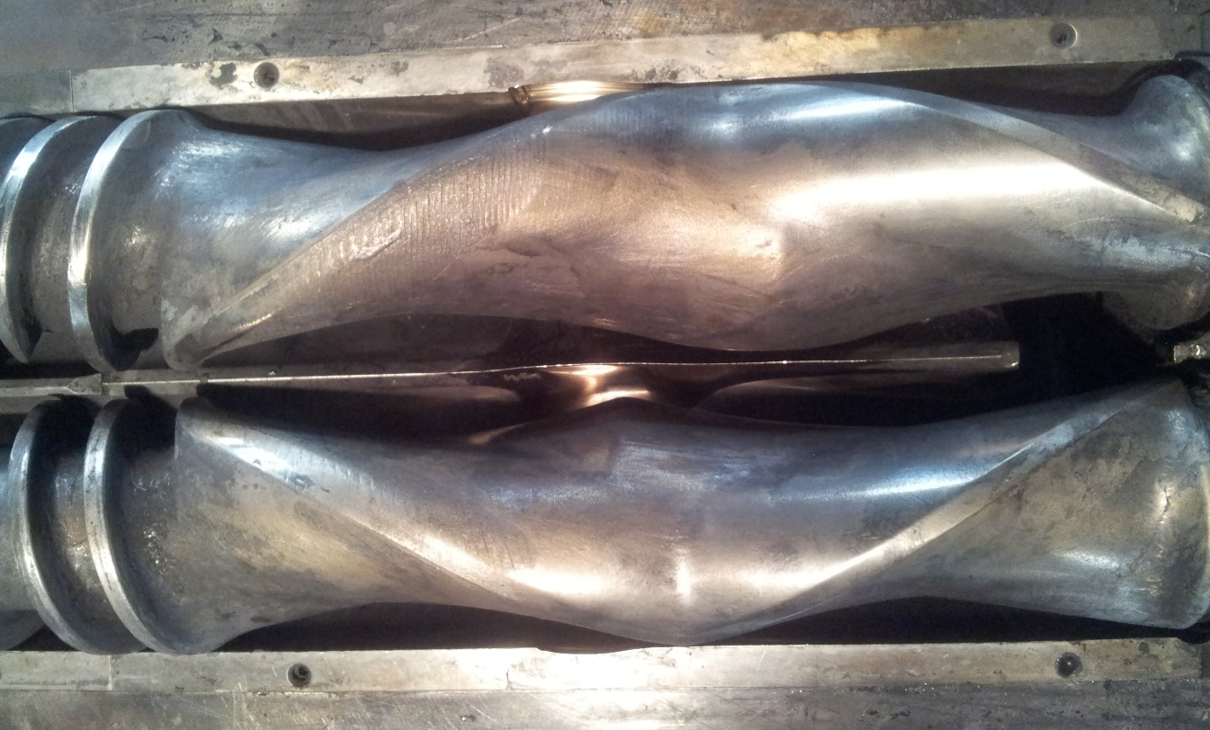
Figure 8 OEM Lower Liners in M/C with Rotors
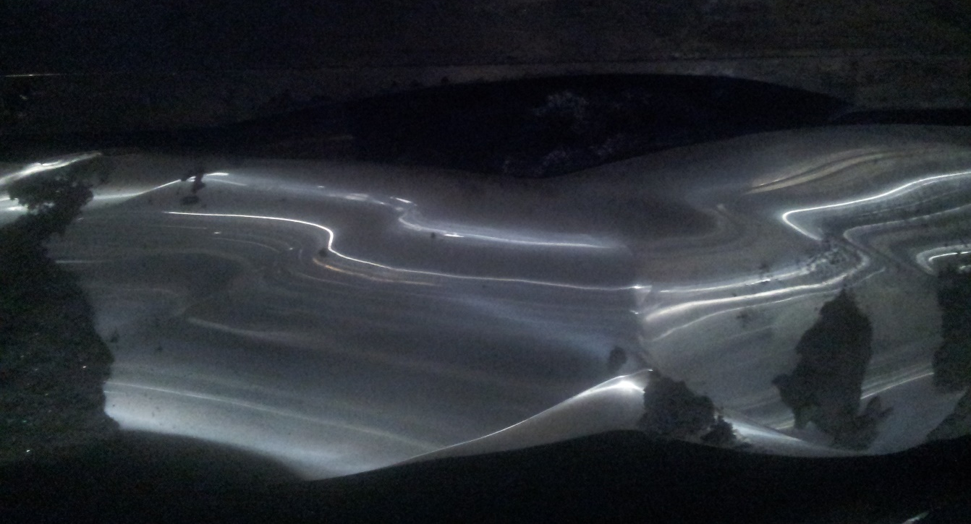
Figure 9 Excessive Wear in Zone 11, Lower Liners
As the liner wear increases, the amount of scrap material produced, which includes start-up waste and all lengths with defects, increases with an 83% yield at the end of the trial. The hardened layer of material lasts approximately 3 weeks of machine use before being worn through in zones 4 and 11 in both upper and lower liners. There the wear rate increases drastically once the 58-60HRC hardened layer was worn through during production.
These liners were run on a 3 shift pattern (mornings, afternoons, nights) before the line was transitioned to 2 shift (mornings, afternoon).

Graph 1 OEM Liners Product Yield

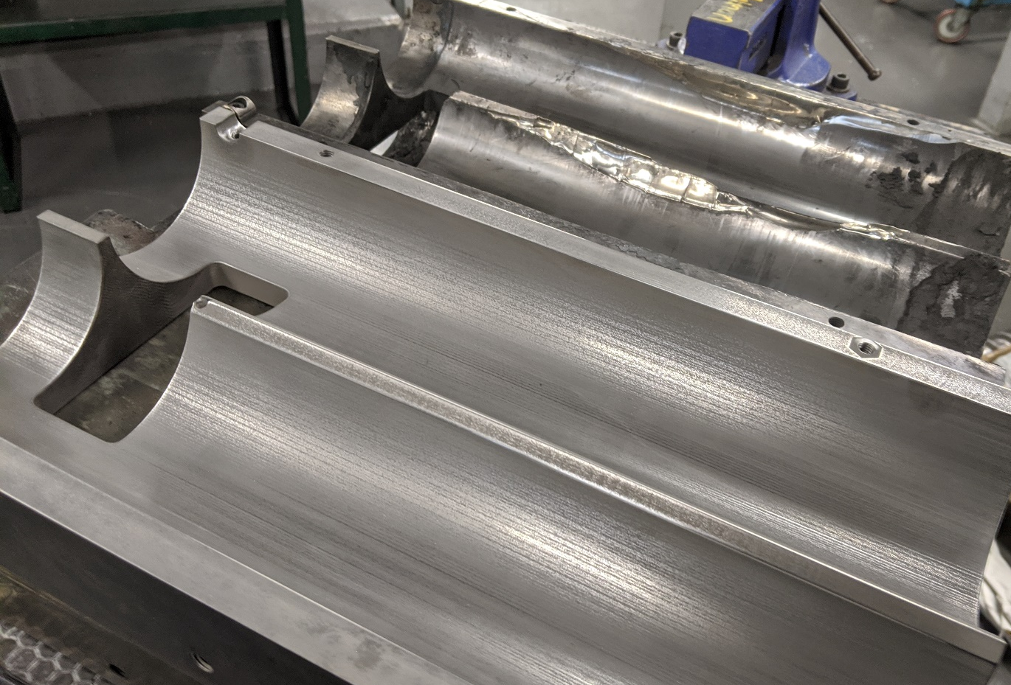
Figure 10 New Trial Liner Compared to OEM at End of Use
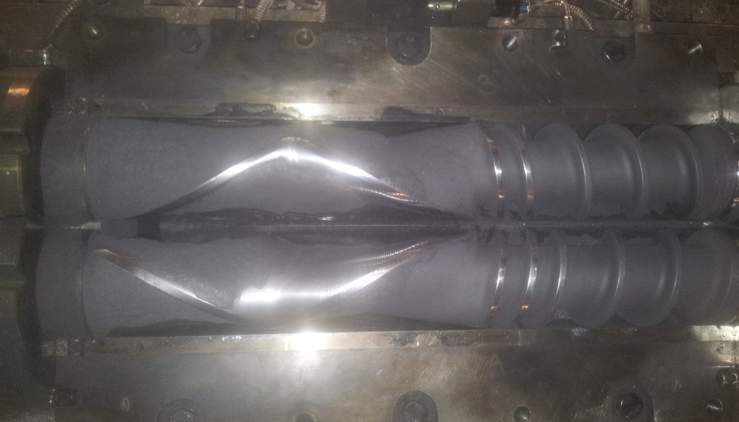
Figure 11 Lower Liners in M/C Start of Trial 1
From the wear data for Trial 1, it can be seen that the tungsten carbide layer maintains a serviceable thickness up until the final week of use in production, with zones 4 and 11 in both upper and lower liners again experiencing the most wear averaging 0.49mm across those points. The recipes used during this trial contained similar percentages of the highly abrasive materials that were used while gathering data from the OEM liners.
The amount of scrap produced was significantly less, with the lowest yield being in week 3 of the trial which was attributed to worn mixing rotors, once changed out the yield increased to average 98.5% for the remainder of the trial period. Production was almost consistently reaching or exceeding the goal of 5000kg of product per week. During this period the production was reduced from 3 shifts to 2 shift working due to restructuring that was occurring in the workplace which will reduce the amount of wear per week.

Graph 2 Trial 1 Product Yield

Throughout trial 2 the yield was similar to trial 1, with a large decrease in yield at week 8 of this trial due to worn rotors as when they were swapped for new, the yield increased again while producing parts with the same recipe. Recipe was changed for week 10 resulting in a higher yield, but the machine was not run in full production that week due to health and safety concerns when a problem occurred with the fume extraction plant, meaning it didn’t reach the 5000kg per week target. The recipes used in this trial contained higher percentages of abrasive materials compared to trial 1.

Graph 3 Trial 2 Product Yield

Trial 3, a different recipe was implemented during week 3 causing a lower overall yield for this trial compared to the others averaging at 95%, which is still above the target yield of 90% for the machine. During this trial there is much less wear compared to the other trials, with the most wear occurring in zones 4 of the upper and lower liners (0.30 and 0.29mm respectively), this could be down to the recipe using less abrasives (quartz sand, silicon carbide) in the mix.

Graph 4 Trial 3 Product Yield
The liners used in trial 1 were sent back to Wall Colomony to be stripped back to the base material and recoated. This was carried out to make sure that the liners would remain within specification for the machine or if the process would distort the dimensions making them unusable and whether this would be a more viable option instead of manufacturing a new set of liners each time the coating is worn through. These liners were measured on-site by the tooling engineer and were found to be within tolerance, allowing the appropriate clearance between rotors to turn freely for the mixing chamber to function correctly.

Conclusion
The solution of weld hardfacing has been evolved rapidly and applied in various industries including nuclear, steam power plants, agriculture, railways, mining, and even in aerospace. High velocity oxy-fuel (HVOF) coating techniques are employed mainly to improve the service life of engineering components, which is exposed to wear, erosion, corrosion or combination of both (Noor Aqilah Ahmad, 2018)
There are a number of factors which can effect the quality of the mix and amount of product produced, such as recipe used, wear of the liners and rotors. Plant breakdowns can also affect the production schedule meaning the target tonnage may not have been reached.
The line was changed from 3 shift working (approx.. 90-110 hours/week of production) to 2 shift (60-80 hours/week of production) between running the OEM liners in the machine and beginning the trial with the coated liners, this may skew results slightly as the OEM will have experienced more hours in production per week, increasing the wear experienced. Even so the trial liners showed a fairly consistent wear trend, with the most significant wear occurring in trial 2, zone 4 at 0.53mm of total wear during the trial.
The trial liners can be seen to be effective, as the output averaged 5200kg per week of production over the trials of the new liners with an average yield of 96.5% good product being produced. Compared to the OEM liners higher average total output of 89%, of good product.
The trial liners performed well with the coating wearing at a slower rate compared with the liners and being in a serviceable state at the end of each trial. The liners used in trials 1 were able to be sent out to be stripped back to the base metal and recoated before being returned to site stores. The liners stayed withing specification after this process, making it a viable option to repeat this going forward.

Recommendations
The final meeting to discuss results and signing off putting these liners in full time production is yet to go ahead at time of writing due to unforeseen delays onsite. The results from the trials look promising, the wear rate is reduced when compared to the OEM liners and are able to be sent to be stripped of the remaining coating and recoated while remaining within specification and not becoming distorted due to the HVOF process.
During the trial, causes of a decrease in production yield were changes in recipe and excessively worn rotors. When the worn rotors were changed for a new set, yield of good product increased again.
Going forward I would recommend carrying out trials with rotors coated with the same or similar HVOF tungsten carbide coating to reduce rotor wear, maintain a high good product yield. This would also reduce the machine and production downtime related to stopping production to carry out maintenance.
There is the potential to further reduce related plant costs through sending the worn rotors out to be rebuilt and recoated, rather than scrapping the worn parts and ordering new from Farrel-Pomini at £20,000 per set.

Bibliography
Cash, W., 2015. The Hard Truth About Particle Contamination. [Online]
Available at: https://www.machinerylubrication.com/Read/30095/hard-particle-contamination
[Accessed 13 01 2020].
Chintha, A. R., 2019. Metallurgical aspects of steels designed to resist abrasion, and impact-abrasion wear. Materials Science and Technology, 23 May, 35(10), pp. 1133-1148.
Douglas, J. F., Gasiorek, J. M., Swaffield, J. A. & Jack, L. B., 2011. Fluid Mechanics. 6th ed. Harlow: Prentice Hall.
EngineeredPerformanceCoatings, 2019. HVOF. [Online]
Available at: https://www.ep-coatings.com/processes/hvof/?gclid=CjwKCAjwhOD0BRAQEiwAK7JHmMdy-EQGkXdiSynGPL_rAPMwCRHe7mG-_Nvq26ngLvIsFHMOm9V0ihoCc2AQAvD_BwE
EPC, 2018. High Velocity Oxygen Fuel (HVOF). [Online]
Available at: http://www,ep-coatings.com/processes/hvof/?gclid=Cj0KCQjwybD0BRDyARIsACyS8muY6RRVBLd7I4qYOzjzsiX25-cnog-9eyUU-LDx46muG0SykLEypgaAt80EALw_wcB
José Rendón, M. O., 2009. Abrasive wear resistance of some comercial abrasion reistant steels evaluated by laboratory methods. Wear, 267(11), pp. 2055-2061.
Massey, B. S., 1975. Mechanics of Fluids. 3rd ed. s.l.:Van Nostrand Reinhold Company LTD.
Noor Aqilah Ahmad, Z. K. A. L. M. T., 2018. Wear and Corrosion Behavior of Tungsten Carbide Based Coating on Carbon Steel. International Journal of Integrated Engineering, 10(4), pp. 119-125.
Rabinowicz E, D. L. R. P., 1961. A study of abrasive wear under three-body conditions. Wear, 4(5), pp. 345-355.
Ratia V, M. I. K. V., 2013. Surface deformation of steels in impact-abrasion: the effect of sample angle and test duration. Wear, 301(1-2), pp. 94-101.
WolframAlpha, 2020. WolframAlpha. [Online]
Available at: https://www.wolframalpha.com/input/?i=Mohs+7

Appendices
Appendix 1 – Product Design Specification
Appendix 2 – Project Planning Gantt Chart
Appendix 3 – Liner Wear and Product Yield Data
Appendix 4 – Farrel-Pomini Compact Processor PDF

