ACADEMIC AND EMPLOYABILITY SKILLS
Student Name | Dumitru Lupascu
Student ID | 1814634
Lecturer Name | Sylvia Hoffmann
Module Title | Academic and Employability Skills
Module Code | BMSK4001_LON

Table of Contents

Introduction 4
The concept of Employability and Employability Skills 5
Employability skills employers look in the candidates during recruitment 5
Importance of employability skills for the employers 7
Various models of employability skills 7
Personal SWOT Analysis 11
Plan of actions to improve the lack of skills to match the employer’s criteria (SMART) 12
Conclusion 14
Reference List 15

1. Introduction
In today’s era, society is changing in a rapid pace which results in the increasing competition between the companies. This fierce level of competition between the companies forces the employers of the company to set high qualification standards for the candidates while recruiting them. In this report, a brief overview of the term ‘employability skills’ and its importance, from the perspective of both an employer and an employee, has been mentioned (Collet, 2015).The report also include SMART analysis of researcher’s existing skill sets to determine the actions he or she need to take to improve the lacking areas of his or her employability skills.

2. Procedure

The concept of Employability and Employability Skills
The term ‘employability’ refers to attributes or qualities that a person should have for being suitable for any paid job. Rather than simply getting a job, employability ensures continuous success in career path of a student irrespective of the industry that the student chooses. It helps the students or the job candidates to stay at a secure position as ‘To be employed is to be at risk; to be employable is to be secure’. To become employable, a student or a job candidate must have some attributes or skills which are generally known as employability skills (Univeristy, 2019).

Employability skills employers look in the candidates during recruitment
A student should have a certain numbers of employability skills as degrees or educational qualification no longer serve as the sole criteria to get a job and employers nowadays are looking for a lot of attributes in the students than just a degree. There are various types of employability skills that most of the employers required to be present in the students while hiring them. Some of them are as followed:

Communication skills
It is the most important and primary skill that every organizations across all industries demands in the students while hiring them. It helps the employees to maintain a good relationship with their colleagues, superiors and thus developing a good working environment within the organization (Stott, 2018).
Team Working skills
Working individually is easy but working on groups or team is quite complex. In this case, the opinions and views of all the team members need to be welcomed, analyzed and applied accordingly while making any business decision for the organization. Due to the accumulation of various thoughts and ideas from different employees, team working also helps to speed up the progress of any task and to achieve success quickly (UK, 2019).
Problem solving skills
In today’s competitive market, companies are facing a lot of market challenges on a frequent basis such as threat of new entrants, threat of competitions lack of product demand and others. Thus, solving these issues becomes essential for the companies to survive in the market (Sewell, n.d.).
Initiative and enterprising skills
In modern world, most of the companies have their operations in various countries, states or cities and thus they keep transferring their employees according to their skills and experience level (Robinson, 2019).
Planning and organizing skills
Any business organization has certain amount of resources available with them which they want to be utilized properly and to the fullest to minimize further investment on developing resources. Proper planning and organizing skills are required to ensure maximum utilization of the resources (Paadi, 2014).

Self-management skills
It is another important skill which any employer will demand which is the ability of an employee to complete a task assigned to him or her alone, without asking for any help or guidance. This saves time and effort of the other employees to help a new joiner to complete his or her individual work (Stott, 2018).
Learning skills
To keep pace with the rapid development happening in modern society, companies are incorporating various changes in their modes of operations on and off. Thus they look for employees having learning skills who can learn the new changes the company is incorporating, within a short span of time (Collet, 2015).
Technology skills
In the modern era of digitalization, technological skills i.e. knowledge and proficiency of the employees in using computers and telecommunications systems, analyzing the current trends are highly essential for the employers to save time and effort (Sewell, n.d.).

3. Findings

Importance of employability skills for the employers
In today’s era of competition and rapid technological advancements, the demand for skills is shift is getting modified frequently which results in the necessity of highly skilled employees. The reasons for which employers strive for employability skills are mentioned below:
- These skills help the employers to evaluate the performance level of the employees
- Employability skills help the employer company to grow in the market by overcoming challenges, utilising resources properly and saving company’s expenditures (UK, 2019).

Various models of employability skills
Employability skills are the primary needs of the employers in today’s job market rather than the educational qualifications, which will aid the company to grow further. There are various models which describe the concept of employability skills more precisely. Some of the popular models are as follows:
Bridgstock employability model
This model of employability puts emphasis on the importance of employees having career management skills. It states that the students of today’s rapidly changing and competitive economy must be able to self-manage their career building path. This requires having some career management skills which are more than the generic skills commonly required by any employer (Robinson, 2019).
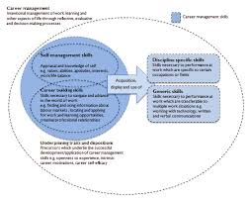
Source: (Robinson, 2019)

Usem employability model
The USEM model was proposed by Knight and Yorke in the year 2004, which shows an interrelation between skills, assessments, learning of the workforce and various skills to generate employability as the outcome. This model has helped teaching institutions to guide skilled graduates and prepare them as prospective good employees for the future (Sheffield.ac.uk. 2019)
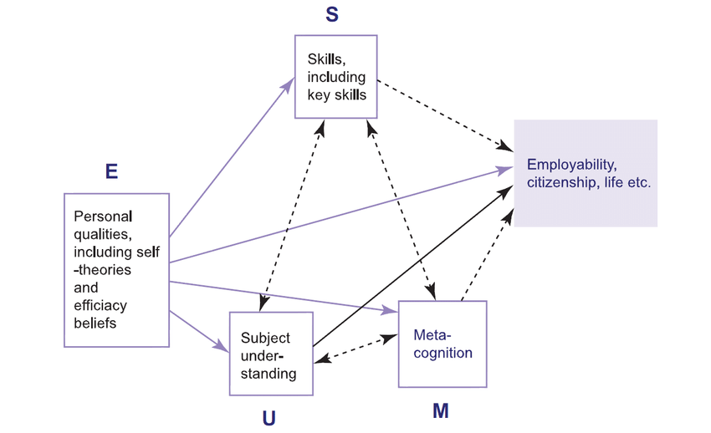
Fig 2: USEM Employability Model

Heuristic model of employability
This model was proposed by Fugate, Kinicki and Ashforth in 2004, which highlights three different dimensions of employability and shows an inter-relation between them. The first dimension is Career identity which refers to the role an individual plays in career opportunities and also the personal dispositions like “knowledge, skills, and abilities. The next dimension is Social and human capital which indicates the interpersonal skills and emotional intelligence of an individual which he or she uses on a regular basis to interact with other people around him or her (Paadi, 2014). The last dimension is Personal adaptability, which is the ability of an individual to adjust with any favorable or unfavorable situation by bringing in necessary changes within.
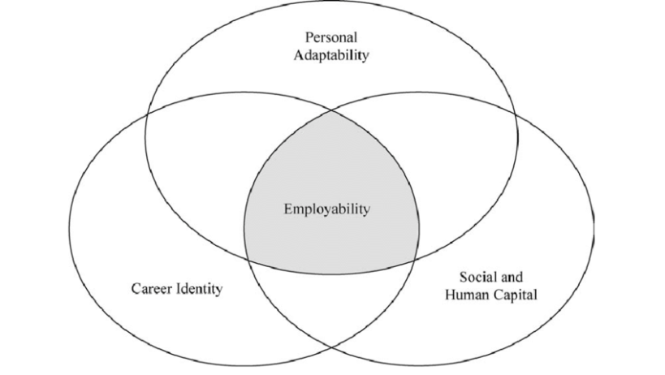
Fig 3: Heuristic Model of Employability

Dots employability model
The Dots model was developed by Bill Law and Tony Watts which is a four stage model of career planning. The stages are decision making, opportunity awareness, transition learning and self-awareness (). According to this model, decision-making highlights an individual’s ability to utilize personal attributes to prepare a fruitful career plan. Transition learning refers to the level of understanding of an individual about the ways to seek and secure employment opportunities. Self-awareness indicates the ability of an individual to identify the various positive attributes within and Opportunity awareness refers to the awareness level of an individual about any employment opportunity and the ability to research further information about it.
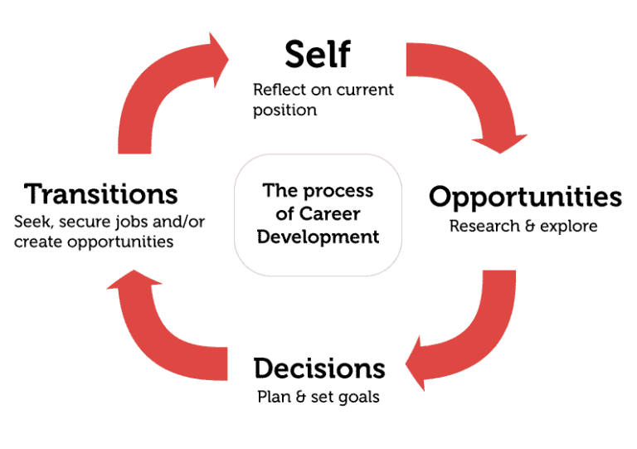
Source: (Graduate-careers.org., 2019)

Career EDGE model
This model was developed by (), which states that there are five elements or key areas of employability and those are Career Development Learning, Experience, Degree subject knowledge, understanding & skills, Generic skills and Emotional Intelligence. Absence of any of these elements reduces the employability level of a graduate employee to a great extent.
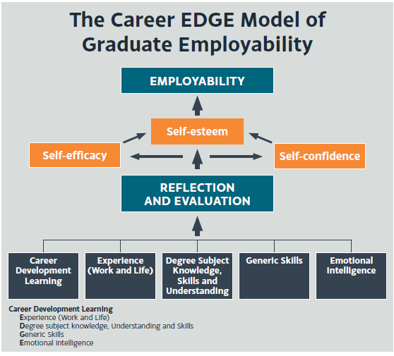
Source: (Graduate-careers.org., 2019)

Personal SWOT Analysis
I have done a personal SWOT analysis to determine my strengths in terms of having employability skills and to identify my weaknesses and areas of development. It will also help me to find the opportunities I have which can leverage upon utilizing my strengths and the threat areas or negative attributes which can pull me down. The detailed analysis is mentioned below:
Strengths  - I have good team work and organizing skills  - I am good at Self-management  - I have a lot of technology skills | Weakness  - I do not have any prior employment experience  - I am weak in problem solving and communication
Opportunity  - I can arrange a part-time job for me and learn new skills to enhance my CV  - Currently I am preparing a presentation on ‘business management skills’ as a part of my course assignment which will help me to learn about business skills in brief | Threat  - The current employment pressure in United Kingdom  - Skilled and experienced overseas students applying for jobs in United Kingdom
Table 1: Personal SWOT Analysis
(Source: Created by the learner)
I am not good at communication with my peers. However, it is necessary for me to work on communication and socializing skills. This can assist me in socializing and gathering information from people related to different professional and academic aspects.

Plan of actions to improve the lack of skills to match the employer’s criteria (SMART)
Above, it has been analysed about my weakness and skills that I lack. However, by implementing SMART Objectives, I am able to overcome my weakness.
Specific Actions | Measurable | Achievable | Resources | Time-Bound
To improve my communication skill | I will sit for a IELTS test which will help to assess the improvement level of my English speaking, reading, writing and listening skills. | I will participate in various activities organized by my graduation school  I will take a lot of initiative to make acquaintances | Internet | Summer holidays
To improve my problem solving skill | I will meet all the assignment requirements and criteria properly | I will learn problem solving skills by applying for summer internship project | A reputed company from retail sector where I will be sent to complete my SIP project | End date of my internship
To improve my planning and enterprise skills | I will work as a trainee in my university or any other company during second semester | I will arrange a part-time job in my university itself or at any other organization during SIP | A reputed company from retail sector where I will be sent to complete my SIP project | End date of my internship

4. Skills acquired
A student having a strong educational background and a good number of degrees will surely receive some advantages while applying for employment opportunities as degrees opens the door of employment initially. However, surviving in the job is much more complex than getting a job and for that skills and experience matter the most.
5. Improvement of the skills
In order to develop my communication skills, it is necessary for me learn the basic nonverbal communication process. Engage myself in speaking with people and also make efforts to socialize with people. This can provide me a basic ideology about external phenomenon and thus, this can also be effective for future aspect and can also be beneficial for my professional field.

Conclusion
After doing extensive research while preparing this report, I identified eight different kinds of employability skills which are mostly demanded by the companies. I also made a SWOT analysis of my skill sets in terms of required employability skills to become much more aware about my existing skills and their loopholes. Post that I made some action plans for myself based on SMART which I will follow strictly to improve my employability skills and make myself highly suitable to secure a job at a reputed organization after my graduation.
Recommendation
It is necessary for an individual to engage themselves in discussion sessions and also take initiatives to take part in the discussion session. This analysis has assisted me in identifying my weak areas in terms of employability skills and also the threats or negative areas which I need to improve by taking necessary actions.

References
Collet, C. e. (2015). Perspectives from a knowledge-intenise industry. In Employability Skills (pp. 532-559).
Paadi, K. (2014). Perceptions on employability skills necessary to enchance human resource management. European Scientific Journal, 10(10).
Robinson, D. (2019). University of Exter. Retrieved from https://www.exeter.ac.uk/careers/research/thecareerdevelopmentcycle/
Sewell, L. D. (n.d.). Sheffield. Retrieved from https://www.sheffield.ac.uk/polopoly_fs/1.18900!/file/UCLAN-model-of-graduate-employability.pdf
Stott, A. (2018, December 2018). Edutopia. Retrieved from https://www.edutopia.org/article/teaching-communication-skills
UK, Y. E. (2019). Youth Employment UK. Retrieved from https://www.youthemployment.org.uk/young-professional-training/teamwork-skills-young-professional/
Univeristy, R. (2019). RMIT University. Retrieved from http://www.graduate-careers.org/2016/03/21/dots-model/

