Introduction.

Northern Lights Pvt.
Northern Lights Pvt Ltd is an event organizing company located in Swansea that specializes in organizing events for more than 10 people. They offer a variety of events such as conferences, workshops, seminars, music festivals, or concerts. The company has recently expanded its operations to include branches in Neath and Carmarthen. Each branch is supervised by a branch manager who oversees a team of staff responsible for setting up audio and visual equipment, selling tickets, cleaning, maintaining, and administrating events. The company has a large customer base, which includes companies and associations related to the event topic. The company uses a manual administration process to manage its events. However, due to the expansion, they would like to move to a computerized system that will help ensure the success of the event.

Event organizing companies face many challenges in managing their business operations. They need to be able to handle multiple events simultaneously, track event progress, manage vendors, and ensure customer satisfaction. Achieving these goals requires a comprehensive solution that can automate many of the company's processes and provide real-time insights into the business's performance. In this regard, designing an effective solution requires the use of a robust database management system, which can store and manage all the data required for the company's operations.

One of the most effective design techniques for creating a database management system is the Entity Relationship Diagram (ERD). ERD helps in visualizing the database schema and understanding the relationships between the entities. It provides a clear and concise representation of the database structure, which is easy to understand and modify. By using ERD, event organizing companies can design an efficient database management system that enables them to manage their operations effectively.

In this essay, we will use Northern Lights Pvt Ltd as an example to demonstrate how ERD can be used to design a database management system for event organizing companies. We will explore the entities, relationships, degree of relationships, and membership class in the ERD for Northern Lights Pvt Ltd, emphasizing the significance of understanding the relationships between the entities in developing a suitable solution. [1]

Identifying Different Types of Users:

The event management system will have different types of users who will access it. The users will include the following:

1. Branch Manager: The branch manager will be responsible for managing the event from start to finish. They will be the primary point of contact for the event patrons and will receive requirements from them to run the event successfully. They will also assign tasks to department heads and ensure that everything runs smoothly.

2. Staff: The staff will be responsible for setting up audio and visual equipment, selling tickets, cleaning, maintaining, and administrating events. They will access the system to view the event details and their specific responsibilities.

3. Event Patrons: Event patrons will be companies and associations that are related to the event topic. They will access the system to view the event details, confirm their requirements, and make payments.

4. Suppliers: The company will have several suppliers that they will use to order resources required for the events as well as for day-to-day running. The suppliers will access the system to view orders, confirm deliveries, and make payments. [2]

Identifying Different Types of Departments:

Each branch will require different departments to manage the events. The departments will include the following:

1. Sales Department: This department will be responsible for selling tickets and confirming the requirements of event patrons.

2. Technical Department: This department will be responsible for setting up audio and visual equipment for the event.

3. Administrative Department: This department will be responsible for managing the administrative tasks such as cleaning and maintaining the event area.

4. Accounts Department: This department will be responsible for managing the financial transactions related to the event.

5. Marketing Department: This department will be responsible for promoting the event and attracting attendees. [3]

Querying and Viewing Information:

The system should allow both staff and clients to query and view information as required. The system should provide a centralized location for all event details, such as the event name, date, venue, and requirements. The system should also allow users to view their specific tasks and responsibilities related to the event. The system should be accessible to all authorized users and should provide real-time updates on the event status.

Recording and Generating Invoices:

When purchases are made from the supplier, the relevant department should be able to view, record, and generate invoices for the transactions. The system should be able to generate invoices automatically and keep track of the payments made by the event patrons. The accounting records should be complete and accurate, and the system should be able to provide quarterly and yearly reports on the profits generated by the events.

Conclusion:

In conclusion, Northern Lights Pvt Ltd is an event organizing company that has recently expanded its operations to include branches in Neath and Carmarthen. The company needs to move from a manual administration process to a computerized system to ensure the success of the events. The system should be accessible to different types of users, including branch managers, staff, event

Designing a suitable solution for the Northern Lights Pvt Ltd event organizing company requires the utilization of effective design techniques. The implementation of an Entity Relationship Diagram (ERD) helps in visualizing the database schema, which includes the entities, relationships, degree of relationships, and membership class. The ERD for Northern Lights Pvt Ltd shows that the company has several entities, including branch, event, patron, staff, and supplier. Each entity has several attributes that define its characteristics.

The relationships between the entities in the ERD show the interactions and dependencies between them. The degree of relationships indicates the number of entities involved in a particular relationship. The membership class describes the nature of the relationship between the entities. Understanding the relationships between the entities is crucial in developing a suitable solution for the Northern Lights Pvt Ltd event organizing company.

The ERD for Northern Lights Pvt Ltd shows that the relationships between the entities are mainly one-to-many and many-to-many. The relationship between the branch and event is a one-to-many relationship, which means that each branch can organize multiple events, but each event is organized by only one branch. The relationship between the event and patron is a many-to-many relationship, which means that each event can have multiple patrons, and each patron can be related to multiple events. The relationship between the branch and staff is a one-to-many relationship, which means that each branch can have multiple staff members, but each staff member works at only one branch. The relationship between the event and staff is a many-to-many relationship, which means that each event can have multiple staff members, and each staff member can be assigned to multiple events. The relationship between the supplier and event is a many-to-many relationship, which means that each supplier can provide resources for multiple events, and each resource can be provided by multiple suppliers.

The membership class for each relationship in the ERD for Northern Lights Pvt Ltd helps in understanding the nature of the relationship between the entities. The membership class for the branch-event relationship is "Organizes," which means that the branch organizes the event. The membership class for the event-patron relationship is "Attends," which means that the patron attends the event. The membership class for the branch-staff relationship is "Works at," which means that the staff member works at the branch. The membership class for the event-staff relationship is "Assigned to," which means that the staff member is assigned to the event. The membership class for the supplier-event relationship is "Provides," which means that the supplier provides the resources for the event.

Designing a suitable solution for the Northern Lights Pvt Ltd event organizing company requires the implementation of effective design techniques, including the ERD. The ERD helps in visualizing the database schema, including the entities, relationships, degree of relationships, and membership class. Understanding the relationships between the entities is crucial in developing a successful solution for the company. The ERD for Northern Lights Pvt Ltd shows that the relationships between the entities are mainly one-to-many and many-to-many, and each relationship has a membership class that describes the nature of the relationship between the entities.

Designing a suitable solution for the Northern Lights Pvt Ltd event organizing company is a complex process that requires the utilization of effective design techniques. The ERD is a crucial tool in developing a successful solution for the company. The ERD helps in visualizing the database schema, understanding the relationships between the entities, and describing the nature of the relationship between the entities. By implementing the ERD, the Northern Lights Pvt Ltd event organizing company can develop a successful solution that meets its requirements and enhances its operations.

The Entity Relationship Diagram (ERD) is a visual representation of the database schema. It shows the entities, relationships, degree of relationships, and membership class. The ERD for the Northern Lights Pvt Ltd event organizing company is shown below: [4]

Entity relationship diagram
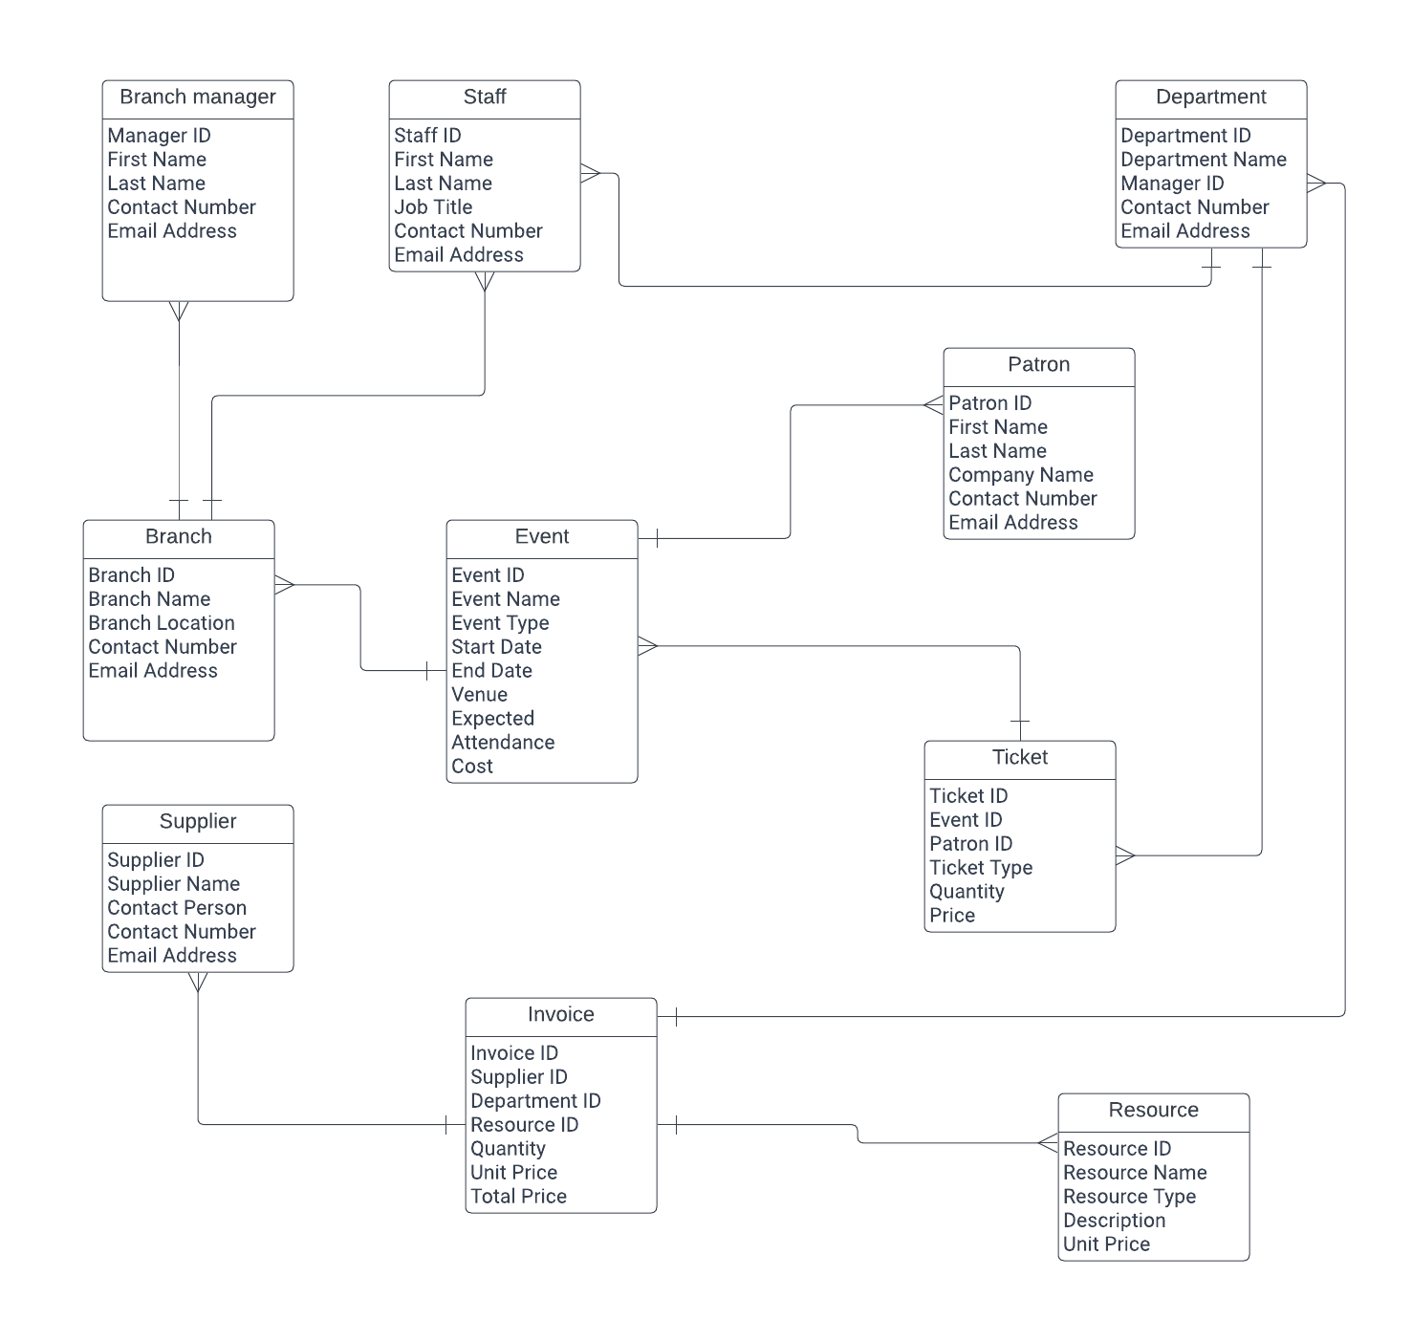

Entities:

1. Branch: This entity represents the different branches of the company, including Swansea, Neath, and Carmarthen.

2. Event: This entity represents the different events organized by the company, such as conferences, workshops, seminars, music festivals, or concerts.

3. Patron: This entity represents the companies and associations that are related to the event topic and are the customers of the company.

4. Staff: This entity represents the staff members who are responsible for setting up audio and visual equipment, selling tickets, cleaning, maintaining, and administrating events.

5. Supplier: This entity represents the suppliers from whom the company orders the resources required for the events.

Relationships:

1. Branch-Event: This relationship shows that each branch can organize multiple events, but each event is organized by only one branch.

2. Event-Patron: This relationship shows that each event can have multiple patrons, but each patron is related to only one event.

3. Branch-Staff: This relationship shows that each branch can have multiple staff members, but each staff member works at only one branch.

4. Event-Staff: This relationship shows that each event can have multiple staff members, but each staff member is assigned to only one event.

5. Supplier-Event: This relationship shows that each supplier can provide resources for multiple events, but each resource is provided by only one supplier.

Degree of Relationships:

1. Branch-Event: This is a one-to-many relationship, as each branch can organize multiple events, but each event is organized by only one branch.

2. Event-Patron: This is a many-to-many relationship, as each event can have multiple patrons, and each patron can be related to multiple events.

3. Branch-Staff: This is a one-to-many relationship, as each branch can have multiple staff members, but each staff member works at only one branch.

4. Event-Staff: This is a many-to-many relationship, as each event can have multiple staff members, and each staff member can be assigned to multiple events.

5. Supplier-Event: This is a many-to-many relationship, as each supplier can provide resources for multiple events, and each resource can be provided by multiple suppliers.

Membership Class:

1. Branch-Event: The membership class for the Branch-Event relationship is "Organizes" because the branch organizes the event.

2. Event-Patron: The membership class for the Event-Patron relationship is "Attends" because the patron attends the event.

3. Branch-Staff: The membership class for the Branch-Staff relationship is "Works at" because the staff member works at the branch.

4. Event-Staff: The membership class for the Event-Staff relationship is "Assigned to" because the staff member is assigned to the event.

5. Supplier-Event: The membership class for the Supplier-Event relationship is "Provides" because the supplier provides the resources for the event.

Annotated Descriptions for Each Relationship:

1. Branch-Event: Each branch can organize multiple events, but each event is organized by only one branch. This relationship shows which branch is responsible for organizing each event.

2. Event-Patron: Each event can have multiple patrons, and each patron can be related to multiple events. This relationship shows which patrons are attending which events.

3. Branch-Staff

Fields Created
Event
Event_ID (Primary Key)
Event_Name
Event_Date
Event_Type
Event_Location
Event_Description
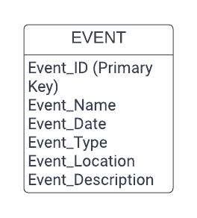
Customer
Customer_ID (Primary Key)
First_Name
Last_Name
Email_Address
Phone_Number
Company_Name
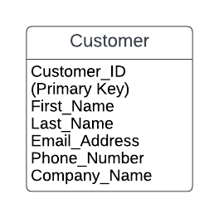
Ticket
Ticket_ID (Primary Key)
Event_ID (Foreign Key)
Customer_ID (Foreign Key)
Department_ID (Foreign Key)
Ticket_Price
Ticket_Status
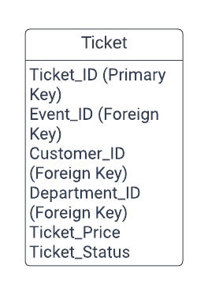
Department
Department_ID (Primary Key)
Department_Name
Branch_Location
Branch_Manager
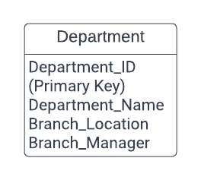
Supplier
Supplier_ID (Primary Key)
Supplier_Name
Supplier_Contact_Number
Supplier_Email
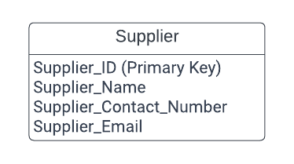
Purchase
Purchase_ID (Primary Key)
Supplier_ID (Foreign Key)
Purchase_Date
Purchase_Amount
Department_ID (Foreign Key)
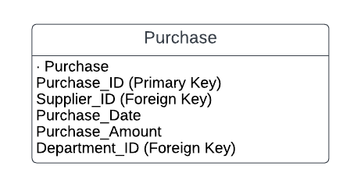
Foreign keys created:
Event_ID (in Ticket table)
Customer_ID (in Ticket table)
Department_ID (in Ticket table)
Supplier_ID (in Purchase table)
Department_ID (in Purchase table)
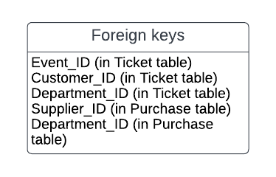
Relationships created:
Event to Ticket: One-to-Many (1:N)
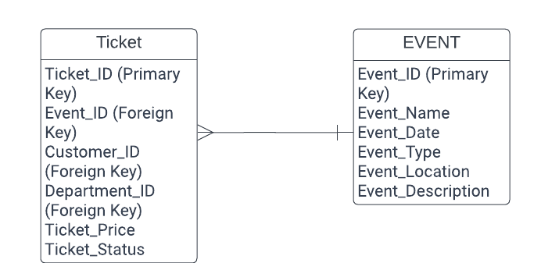
Customer to Ticket: One-to-Many (1:N)
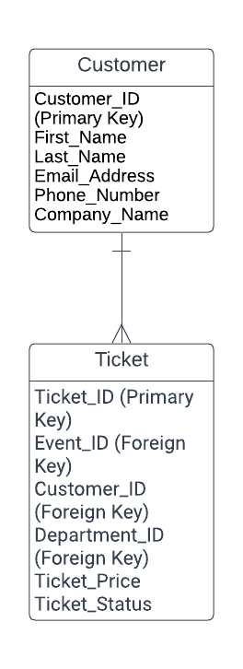
Department to Ticket: One-to-Many (1:N)
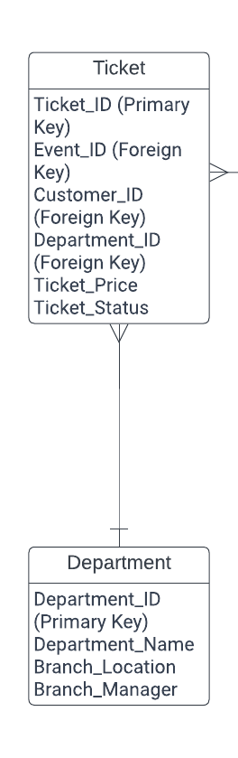
Supplier to Purchase: One-to-Many (1:N)
Department to Purchase: One-to-Many (1:N)
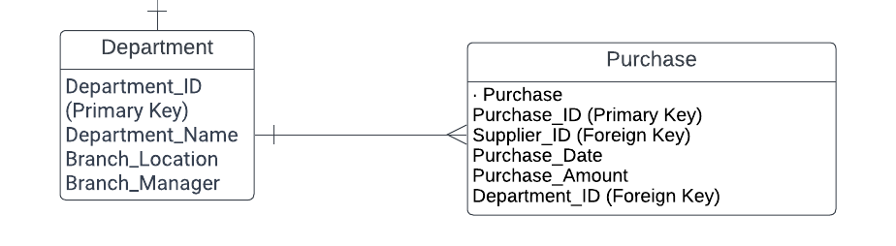

References

[1] | [Online]. Available: http://www.northern-lights.co.in/. [Accessed 06 2023].
[2] | [Online]. Available: https://learn.microsoft.com/en-us/dynamics365/marketing/set-up-event. [Accessed 06 2023].
[3] | [Online]. Available: https://www.salesforce.com/eu/blog/2021/09/small-business-departments.html. [Accessed 06 2023].
[4] | [Online]. Available: https://www.lucidchart.com/pages/landing/er-diagram-software?utm_source=google&utm_medium=cpc&utm_campaign=_chart_en_tier1_desktop_search_strategic_exact_&km_CPC_CampaignId=19866748684&km_CPC_AdGroupID=147236983637&km_CPC_Keyword=entity%20relationship%20d. [Accessed 06 2023].

