Lesson Plan Phase 1

Lesson Plan – Step 1 Cynllun Gwers – Cam 1
Video- https://uowtsd-my.sharepoint.com/:v:/g/personal/1901545_student_uwtsd_ac_uk/EdkSUCf7APlEvniJjOpUqLEBivmdEs-mCGbJPJgf1NGG9Q?e=abSNBV

Student-teacher | Lowri Johnson | Class: | Nursery
AoLE or Subject | Welsh Language Development | Date: | 04/03/2020
Lesson Focus: | Re-visiting and reinforcing welsh as a whole class.
Meaningful links to Curriculum | Welsh Language Development  Oracy  Skills  - Make themselves understood  - Show that they understand basic instructions  - Speak clearly using simple words, greetings and expressions  - Building on previous experience, speak with confidence  - Speak using correct pronunciation and appropriate intonation
Meaningful links to:  Cross Curricular Responsibilities | Language, Literacy & Communication  Oracy  Developing and presenting information and ideas  (Speaking)  - Talk about, in simple terms, drawings, models and actions  - speak clearly enough to be understood by adults and peers  - Talk about in simple terms, drawings, models and actions.  - Retell, in simple terms, an event or experience.  - Use newly learned vocabulary in and through play activities.  (Listening)  - Listen to and carry out a 2-step instruction  - Listen and respond with growing attention and concentration.  - Follow simple action words, e.g. through games and songs.  - Ask an appropriate question about something that has been said.  (Collaboration and discussion)  - Participate in discussions with other children and/or adults.  - Take part in activities alongside others.  Locating, selecting and using information.  (Reading Strategies)  - Recognise differences and similarities in pictures, shapes, patterns and textures.  - Recall and talk about visual images and objects.  Responding to what has been read.  (Comprehension)  - Begin to make links to own experiences when listening to or exploring books/texts.  (Response and analysis)  - Show an interest in books and enjoy their content.  - Follow picture books and texts read to them and respond appropriately.  Mathematical Development  Using Number skills  (use number facts and relationships)  - Count reliably up to 5 objects.  - Recognise numbers 0 to 5 and relate a number 0 to 5to its respective quantity.  Using measuring skills  (Temperature)  - Use words hat describe temperature during everyday activities, e.g. hot/cold.
Personal Targets (Linked to QTS and identifed in weekly review)

- Correlation of behaviour (particularly at carpet time) should be more frequent and direct.
- Try to develop a stronger teacher presence.
- Consider the main skill that I am teaching as part of my focus task.

Learning Objectives:
The pupils will learn to:
- Answer my instructions correctly in welsh.
- Count to 10 confidently in welsh.
- Identify the weather in welsh.
- Name the colours in welsh.
- Answer questions about a Tedi Twt book.

Success Criteria | Assessment of Pupils’ Learning  Evidence  (What have the learners to say/write/do/produce – to demonstrate learning)
Respond correctly to my instructions/ questions.  Count to 10 using their fingers confidently in welsh, with no mistakes or pauses.  Identifying the weather outside and being able to translate it in welsh.  Identify the colours that I point to and translate in welsh.  Answering my question about the Tedi Twt book reasonably. | Be able to identify what I am telling/asking them and respond accordingly.  Accurately and confidently count to 10 using their fingers along with their peers.  Using their own observations, responding correctly to my question on the weather in welsh.  Identify the colour I am pointing to and respond correctly out loud in welsh.  Engaging and listening to the Tedi twt book and being able to correctly respond to my questions in welsh.

Time | Activities/Methodology/Key Concepts | Pupil Tasks | Resources
Opening phase | To start the session off I will take the register. This will not be filmed due to confidentiality reasons; however, it will incorporate some welsh. I will read each name out by saying “Bore da….” and the pupil will respond with either ‘Yma” or “bore da”.  Filmed session  To begin the session, I will sing with the pupils the ‘bore da’ song. This is sang every morning and is a good warm up to a welsh lesson.  I will then ask the pupils to count to 20 in English and count backwards from 10 in English. This task is carried out every morning with the pupils as it reinforces their counting.  To relate to my welsh lesson, I will ask the pupils to count to 10 in welsh. This is where they currently are in terms of their welsh numbers at this moment but in future sessions I intent to encourage them to count to 20 in welsh. | I expect the pupils to respond to the register by saying “bore da” or “yma”.  There are some pupils that are shy and so will need some encouragement to respond in welsh.  Filmed session  The pupils will join in with the ‘Bore da’ song and sing it confidently and sensibly. The pupils will do this alongside and with their peers.  The pupils will show me that they are ready to count by holding up their fingers. This will indicate to me that they are ready. I will tell the pupils what number we are starting with so that they can start together and not get confused. They will count together and not rush off ahead of other pupils.  This will be done with every counting pattern in English and in Welsh.
Teaching & Core Learning | For the main session I intend to focus on practicing the pupil’s knowledge on the weather and colours in welsh. This will help the pupils to understand the Tedi Twt book that I will read at the end and respond appropriately to my questions.  For one of the main topics on weather, I will ask the pupils what the weather is like on this day- “Sut mae’r tywydd heddiw?” I will listen to their responses and correct them if they are wrong.  To challenge the pupil’s, I will ask them to be more specific in their responses. For example, if they say that it is raining- ‘bwrw glaw’, then I will ask them to expand and expect the response that it is also cold- ‘oer’.  To extend their knowledge and reinforce the weather’s that they already know, I have printed out and laminated some weather images from a Tedi Twt book. I will incorporate this by holding up each image and asking the pupils “Sut mae’r tywydd?”  I will try and extend the pupils responses by asking them to answer in full sentence e.g. ‘Mae hi’n ….’  I will also ask the pupils to repeat translations after me to reinforce the new vocabulary that they have learnt. I will ask the pupils if the specific weather that I am holding up is the same as the weather outside that day, so that the pupils can make real life links between the vocabulary and real-life weather.  As my objectives of this session is to revisit welsh vocabulary, I will play a song on YouTube on the colours of the rainbow. The song is in welsh, so it fits in with our welsh theme.  After the video I will shout out some random colours for the pupils to translate. This will show me if they are confident with their welsh colours or if they need additional help. | The pupils are familiar with the different types of weather, including sun, rain, snow and wind. Therefore, I expect the pupils to be able to respond to my questions.  I expect the pupils to look outside to see the weather so that they can use their observation to tell me what they can see.  I am aware that some pupils will just shout out the vocabulary that they know, so it is important that I acknowledge this and help them determine where they were wrong and to repeat the correct translation.  To expand some of the pupil’s vocabulary, I will ask certain pupils to repeat the full sentence after me, therefore it is important that the pupils are listening and focusing on my questions.  The pupils should be able to determine the different Tedi Twt images and the different weather types. I expect most of them to shout the different weather types in English rather than in welsh.  In this case I will ask the pupils to respond “yn cymraeg” so that they are practicing their welsh.  The pupils should be able to determine whether the image is showing the same weather condition as outside, so therefore I expect them to complete this activity with confidence.  The pupils have listening to this song before and have shown enthusiasm singing it. I expect the pupils to interact with the song well.  The pupils should be able to shout out the welsh translation of the different colours confidently and accurately as this topic is reinforced many times throughout the week.  I expect some pupils to struggle with the colours white and green as they are quite difficult for nursery aged pupils to remember and pronounce. | 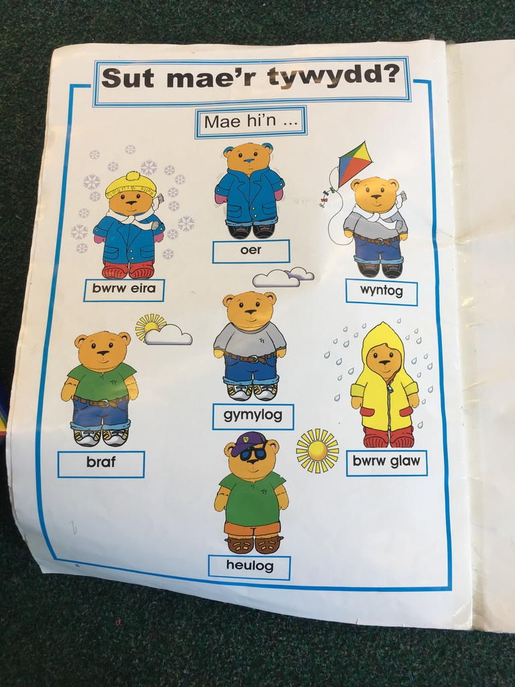  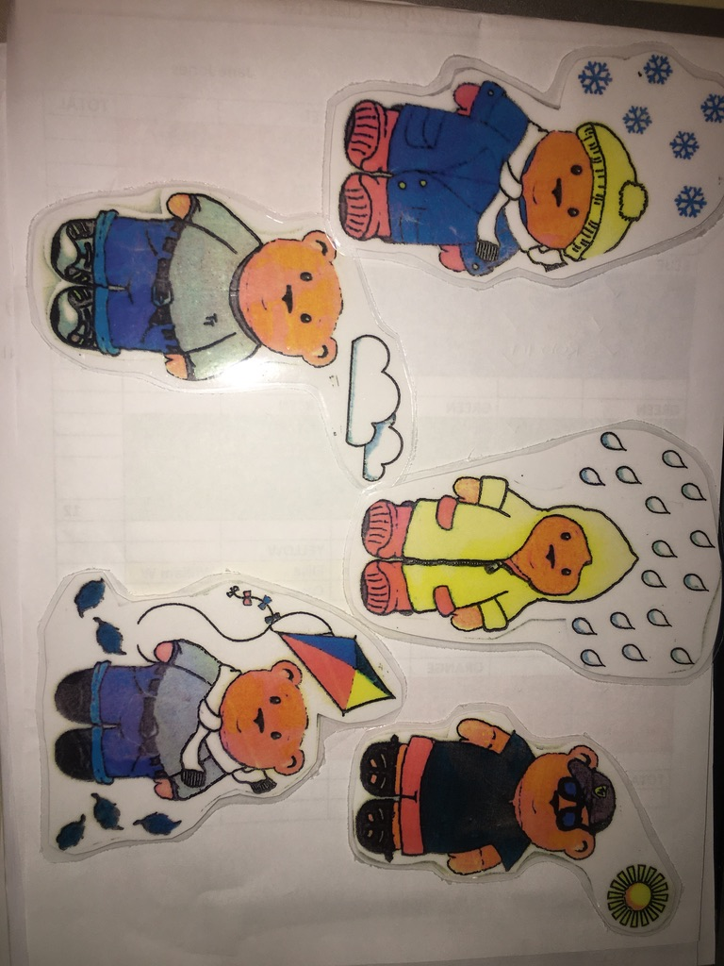
Plenary | To end the session, I intend to read the pupils a Tedi Twt book which is about the weather and the clothes that Tedi Twt wears in each weather condition.  My focus on this book will be reinforcing the weather and the colours of the clothes that Tedi Twt is wearing. I intend to read the book and ask questions such as:  “What shoes do you wear when it’s raining?”- ask the pupils to repeat the welsh translation.  “what colour is Tedi Twt’s gloves?”- ask them to repeat the colour in welsh.  I will point out the different pieces of clothing that Tedi Twt is wearing whilst saying it in welsh so the pupils can visually see what the vocabulary means. | I expect the pupils to listen and engage with the Tedi Twt book. I will be reading the book infront of the class so that all the pupils can see.  I expect the pupils to sit quietly and pay attention to the welsh phrases that I use.  The pupils should be able to respond correctly to my questions. They will be able to determine the different colours that Tedi Twt is wearing. I expect the pupils to make links to what clothing Tedi Twt is wearing and what they often wear. For example, if Tedi Twt is wearing trainers then I expect the pupils to recognise the resemblance.  In this case I will ask the pupils what colour their trainers are to reinforce the welsh vocabulary but in real life scenarios. | 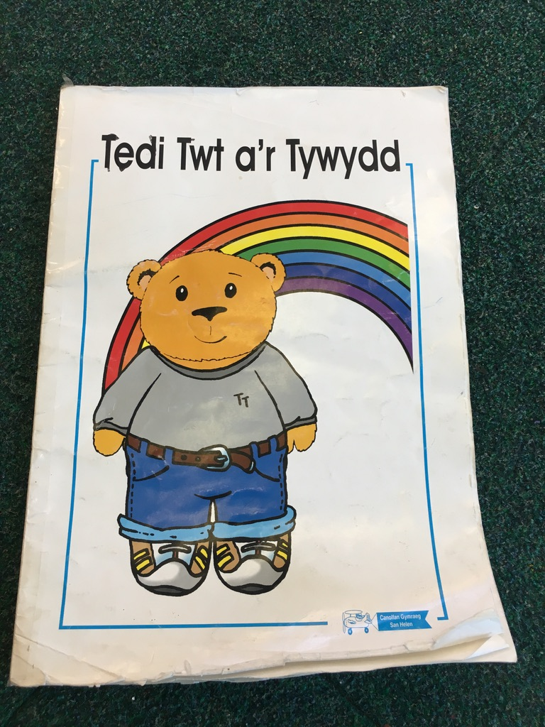

Lesson Plan – Phase 1
Evaluation of the Learning Experience
(include references to QTS)

Evaluation of Pupil Learning

Evidence of Learning (including attitude to learning over time)) | I will have one class out of the three that is within the nursery year group. I will be taking the pupils for their daily carpet session which is around 50 minutes long.  For this session the pupils will be assessed through me observing their behaviour and responses to my questions. I will also be looking for their involvement in each activity as this lesson will be completed with the whole class collaboratively.  There are many behaviours and attitudes that I will be looking for during this session. Concentration will be a major factor to the execution of this session as they will need to be looking at the resources that I will be using in order to answer the questions. I will be looking for engagement and enthusiasm throughout this session also, as learning a new language can be difficult for pupils especially in nursery. I will be incorporating songs, images and books into this lesson so the pupils will need to be engaged throughout and join in with the activity when necessary. The pupils will be expected to show me that they are ready to learn by their hands being in their laps and legs crossed. It is important that the pupils are quiet and listening as they could distract the other pupils in the class.
Next Steps for Progress | In order to progress the pupils welsh language, I intend to incorporate a few of the strategies I used in my lesson daily. I feel that if I ask the pupils to count to 10 in welsh everyday then they are more likely to remember it. Similarly, the same could be applied to asking the weather in welsh and asking certain colours also. I believe that the pupils will pick up the vocabulary more if I was to ask them the questions regularly.  I intend to ask the pupils questions during their own activities and ask them to repeat the answer in welsh (if applicable). For example, if they draw a picture then I will ask them what colour pencil they used. Therefore, I should find that the pupils will become more confident with their welsh.

Reflective Analysis of Teaching and Strategies For Development – including justification/rationale for pedagogical choices

Evidence of my Effective Practice | What went well:  For most of the session the pupils were engaged. I felt that most pupil contributed to the songs, interactive activities and questions that I asked. I was impressed with the confidence that the pupils had when counting to 10 in welsh, as well as their knowledge of the colours.  The majority of the pupils were able to determine the different weather images in welsh and were able to repeat the answers in full sentences. It was clear that the pupils had a good understanding on the weather translation for sun and rain. Most of the pupils made accurate perceptions of the weather outside and were able to answer my question with relevant answers.
Areas for my Development  Personal Targets for Progress | To Improve:  Towards the end of the session when I read the Tedi Twt book, it was clear that the pupils were getting unsettled. In the future I could sit on the carpet with the pupils so that I was at the same level as them and could monitor their behaviour better. I could also ask the pupils to sit in a circle so that all the pupils could see the book.  The pupils were able to count to 10 in welsh confidently so to improve I could’ve challenged them to count to 20.  To observe each pupil’s participation and understanding of welsh, I could’ve asked some questions where the pupils put their hands up or I chose on specific pupils. This would enable me to ask pupils that were not likely to contribute alongside the others.

