Programming 2
  - Name
  - Sarann Elizabeth Strange

Student No
1701763

Email
1701763@student.uwtsd.ac.uk

Course
BSC (Hons) Software Engineering

Table of Content
Table of Contents
Introduction 1
1. Understanding 2
1.1 Analytical approach to problem solving 2
2. Part B testing 4
2.1 Entering text instead of numbers 4
2.2 Only one input values to quite “YES” 6
2.3 Broken display 8
3. Programming exercise 9
3.1 Exercise 1 Numbers between -20 and +20 9
3.1.1 Testing the code 11
3.2 Exercise 2 Mapping Problem space to code 19
3.2.1 Testing 19
3.3 Exercise 3 Connect 4 game 23
3.3.1 Testing 25
4. References 29
5. Appendices 30
Part B 30
Exercise 1 35
Exercise 2 38
Exercise 3 Connect 4 41

Introduction
This report contains research into an analytical approach in solving problems, how it is used to solve issues within programming to successfully create a program.
Multiple programs testing results have been displayed, showing the bugs and unexpected results returned by the program. Images of the returned results are also displayed with comments of the results. Amendments have been to the code to fix the errors that were found. These amendments have been tested further with detailed reports on each of them.

Understanding

Analytical approach to problem solving
An analytical approach is the documentation and break down of a larger problem into smaller manageable elements, once broken down into sub-problems, individual solutions for the segmented problems can be recognised, understood, planed, designed and tested. Once each segmented problem is successfully resolved, they can then be brought together to solve the initial problem [1] [2].
Creating a list of specifications and requirements of the larger problem allows for a clearer understanding which helps to successfully break the problem down into sub problems. Once the sub problems have been identified, the individual can continue to analyse and break down those problems further into smaller problems until they are clear to that individual.
The individual can than map the sub problems to established knowledge, to create several potential solutions. If solutions cannot be created due to a lack of knowledge the individual can make note of this. Once they recognise what they do not understand they can advance and develop their knowledge through research, or advice from others who have a wider knowledge than their own.
Many problems, once broken down, can be grouped together as many aspects of a larger problem may have recurring themes, which can be solved using a similar solution.

Within programming an analytical approach is used to problem solve as it allows a programmer to break down a problem to easily recognise similar solutions that will use the same code to solve issues. The programmer can dictate the different methods to be used such as functions or classes as a solution, those functions and classes can be re-used creating an efficient and rounded solution to issues.
Within programming the programmer can create testing code to check if the individual solutions work as they should if they do not, more solutions can be tested and developed. [3]
The benefits of developing functions and classes is making the code more manageable and also futureproofing code as it is easier to read and implement alterations, the code once it is broken down in this way is also easier to debug.

Part B testing
The program allows a user to enter numbers that are then calculated, the total is then displayed to the user within hashes.

2.1 Entering text instead of numbers
1 | User enters numbers to be added
Description |  | The user enters text then a double instead of an integer.
 |  | Test Steps :
1 | Message displayed asking user to enter number.
2 | The user enters a character.
3 | The user enters a double.

Response |  | The program should not crash and allow the user to re-enter an integer value.
Status |  |  | Date |  |  | Description
Fail |  |  | 01/04/18 |  |  | The program crashed, and the console was shut down.
Pass |  |  | 01/04/18 |  |  | Passed
The image displays the results of the altered code that checks for an incorrect input and displays a message to the user.
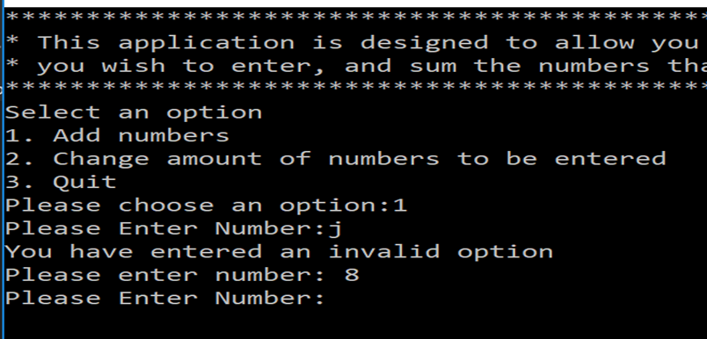

2.2 Only one input values to quite “YES”
There is only one way to quite the application by typing “YES” with capitals.
1 | User enters “YES” to quite
Description |  | The user enters YES to quite
 |  | Test Steps :
1 | The user selects option 3 to quit
2 | User enters YES
3 | User tried something other than YES

Response |  | The program should not produce an error message and should continue to next step which is to enter the numbers to added together
Status |  |  | Date |  |  | Description
Pass |  |  | 01/04/18 |  |  | The message Quitting is displayed to the user and the program ends.
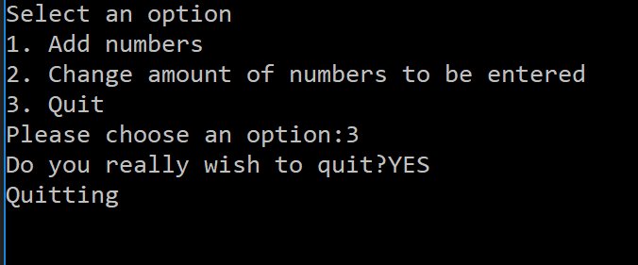
Fail |  |  | 01/04/18 |  |  | The user tries to enter anything other than capitol YES, the program re-prints the menu to the user.
Pass |  |  | 01/04/18 |  |  | 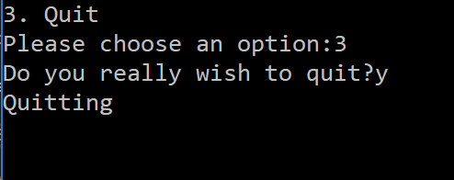
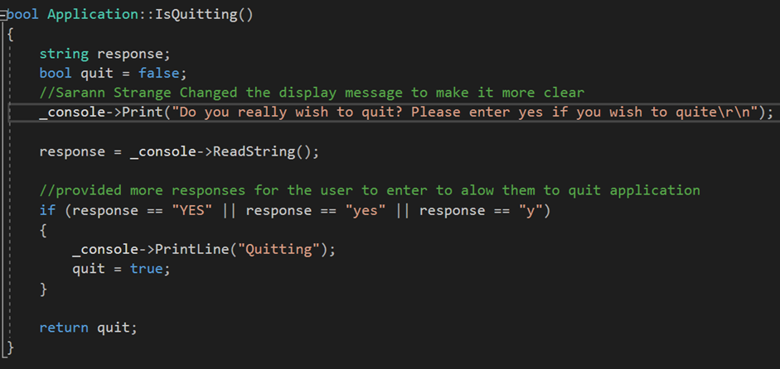

Broken display
1 | Display on the console is being broken
Description |  | The user enters numbers that add up to a number witch contains more than one digit.
 |  | Test Steps :
1 | The user enters numbers.
2 | The numbers are added together.

Response |  | The program should not unaline the hashes
Status |  |  | Date |  |  | Description
Fail |  |  | 01/04/18 |  |  | The hashes are being pushed out of place.

Programming exercise

3.1 Exercise 1 Numbers between -20 and +20
The game will generate a number between -20 and +20 and store it, a user has five chances to guess the number if they don’t guess it correctly the player loses the game. The game presents the player with a different hint each time they make a wrong guess.

Program requirements
List of Requirements | List of solutions
- For a message to display a hint corresponding to the checks that were made. | Printf(your number is -/+10 from the number);  Printf(your number is -/+5 from the number);  Printf(your number is -/+2 from the number);
- For the player to enter an integer number of their choice. | Scanf to store the user number choice.
- Display message that the number is a negative. | Printf (the number is a negative)
- Display message if the number if a posivive. | Printf(the number is a possitive)
- Tell player they have lost | Printf(you lose)
- Tell player they have won. | Printf(you won)
- For the program to select a random number. | num1 = RandomeValue(40) + 1; theTime;srand((unsigned)time(&theTime));
- For the random number to be between -20 and +20. | computerRandomNumber = computerRandomNumber – 20.
- To check if the users’ number is the same as the computers random number. | playerNumber == computerRandomeNumber
- For a check of the users number is a negative value. | playerNumber < 0;
- For a check if the users guess is between (-/+ 10), (-/+5) or (-/+ 2) of the computers randomly chosen number. | If playerNumber >= - 2 && playerNumber <= +2;  If playerNumber >= - 5 && playerNumber <= +5;  If playerNumber >= - 10 && playerNumber <= +10;
- Give the player a limit of 5 guesses. | Const int MAXNUMBERS = 5;  Create a loop within an if (index = 0; index < MAXNUMBERS; index ++)  {  Code to check if player has won, code to run the game until the 5 chances are used or player wins;
- Check if user has entered an invalid choice. | Int number;  Int checkInput;  checkInput = scanf(“%i”, &number);  if(checkInput != 1)
- Stop the game if the player has won | Bool checkGuess()  Int placeNumber  if (placeNumber == computerRandomeNumber)  return true;  check if player win == true

3.1.1 Testing the code
1 | Values entered by user
Description |  | The user enters different values such as integers, doubles, string and char.
 |  | Test Steps:
1. | The user inputs an integer.
2. | The user enters a minus number.
3. | The user enters a letter/string.
4. | The user enters a decimal number.

Response |  | After the user enters a number for the program it checks the choice to see if it is equal to the computers response
Status |  |  |  |  | Date |  |  |  | Description
1./ 2.Pass |  |  |  |  | 03/04/18 |  |  |  | The test of entering an integer value passed.
The image below displays the input of an integer value and the input of a minus value, the program ran correctly and returned the correct message for a win condition.
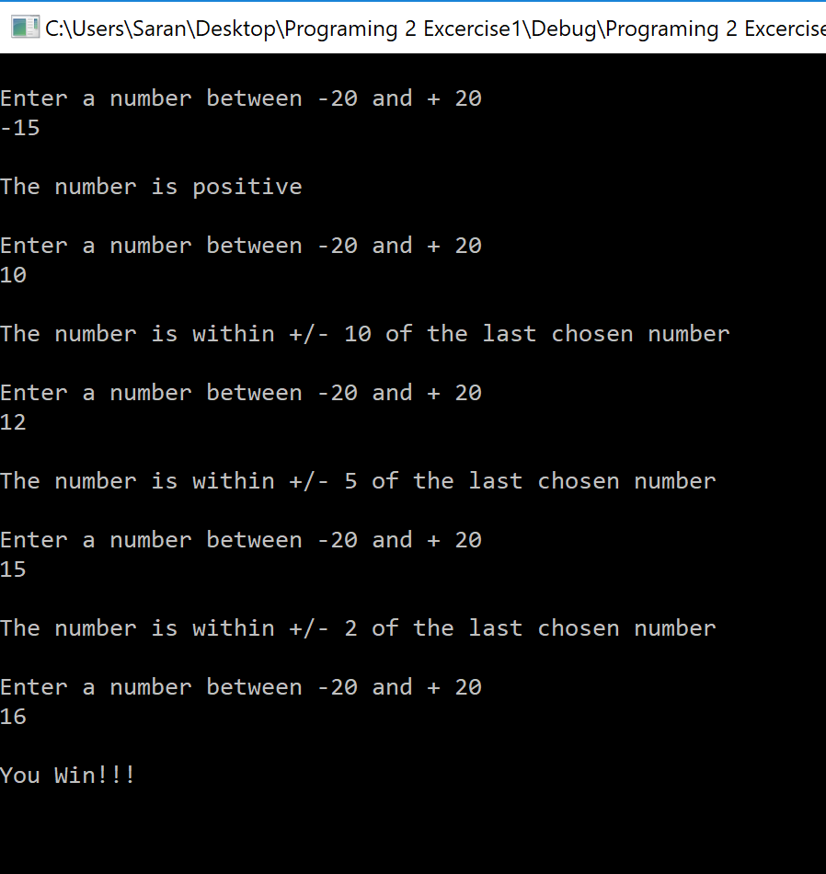
3. Fail |  |  |  |  |  | 03/04/18 |  |  |  | The test failed after the user enters a character value, the program doesn’t request a new input but runs with the initial value entered until the program ends.
The image below displays the input of a character/string the program failed as the incorrect value was entered into the scanf, which resulted in the program being unable to place the non-integer value into the computerRandomeNum.
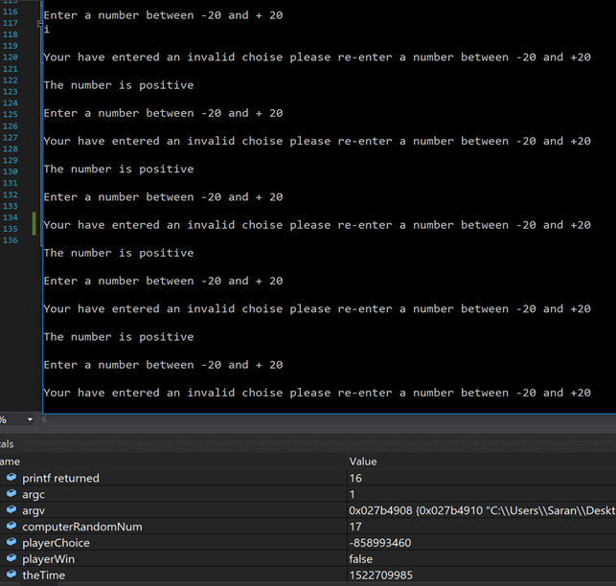
3.Pass |  |  | 03/04/18 |  |  |  |  | The test passed
The test passed as the code clears the buffer allowing the user to input a new value after they have entered a character.
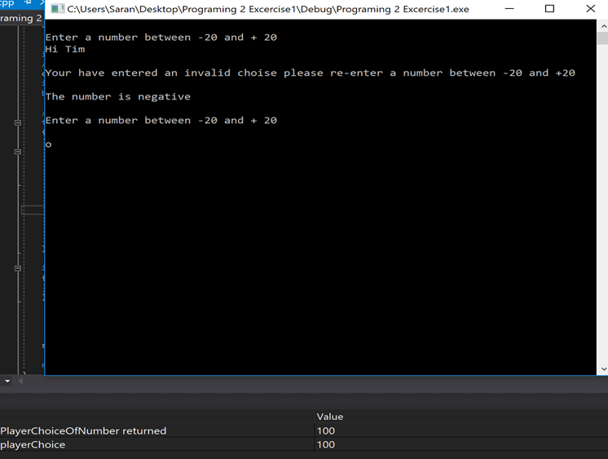
4. Fail |  |  | 03/04/18 |  |  |  |  | The test failed after the user enters a double value, the program doesn’t request a new input but runs with the initial value entered until the program ends.
The image below displays the user entering a decimal number it results in the same error as the previous test.
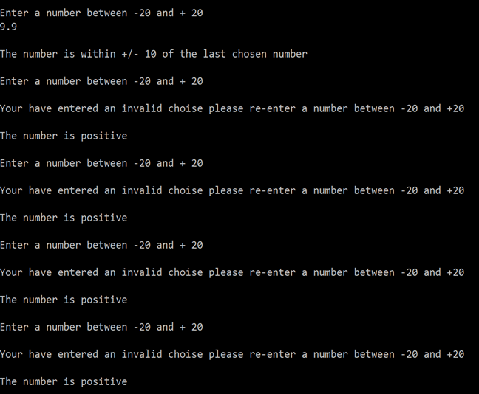
4.Pass |  |  |  | 03.04.18 |  |  |  |  |  |  | The test passed and used the first intager number of the double.
The image below displays the user entering a double value and the code successfully clearing the buffer after the decimal point.
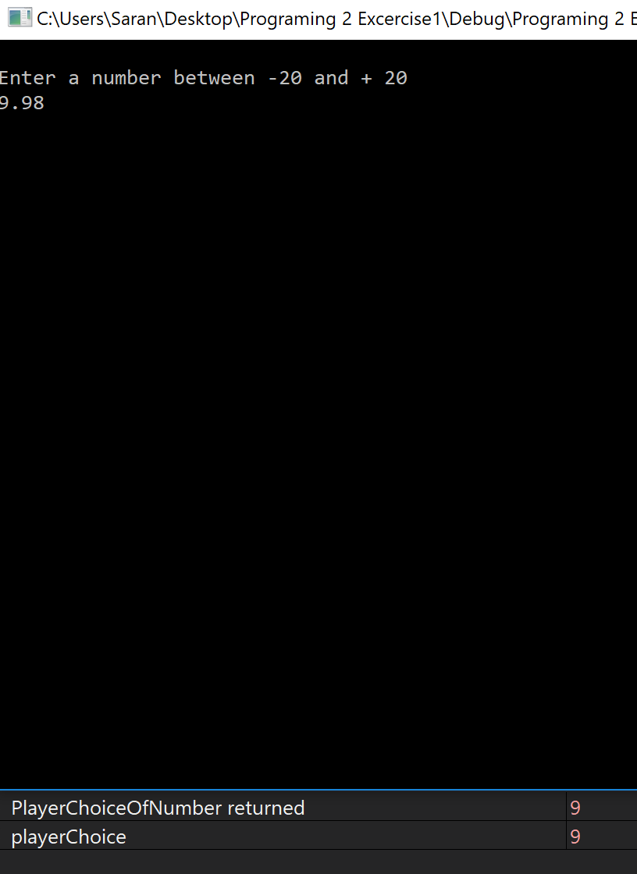

1 | Program randomising between -20 and +20
Description |  | The program randomises between -20 and +20
 |  | Test Steps:
1. | The program starts and the randomiser uses the computers time to select numbers from 0 to 40.
2. | The computerRandomiseNumber variable -20 to lower the initial number so the number is between -20 and +20.
3. | The computerRandomiseNumber variable replaces the original value and contains the subtracted value.

Response |  | Once the program begins the computerRandomiseBumber variable contains an intager value between -20 and +20.
Status |  |  | Date |  |  | Description
1.Pass |  |  | 01/04/18 |  |  | The test passed
The image displays the computerRandomeNum randomising the number 36, the image below displays the computerRandomeNum displaying the subtracted value and storing the new value of 16.
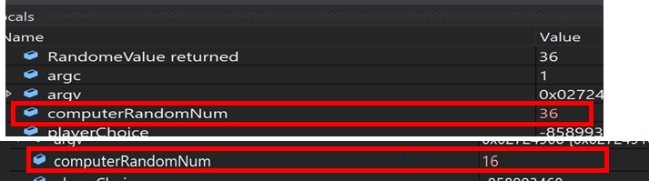
The image below displays the successful test of randomising and displaying the results of the randomiser and its subtracted value multiple times.
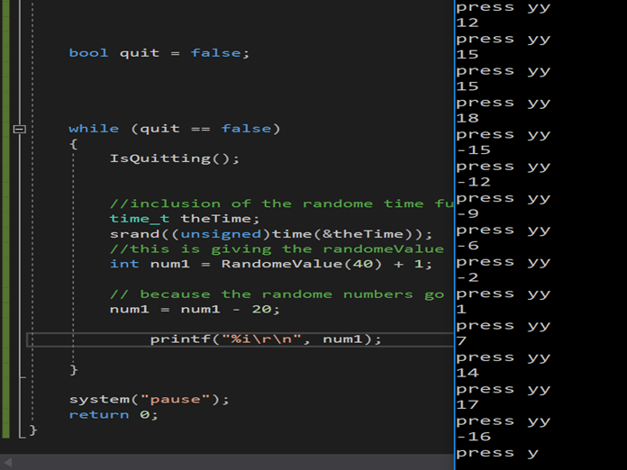

1 | Program displays the loss or the win message.
Description |  | The program displays the win message or the loss message
 |  | Test Steps:
1. | The program starts, and the user enters the same number as the randomised number.
2. | The user enters the wrong number until they run out of turns.

Response |  | The program comes to a stop and displays one of two messages. If the user enters the same number as the randomised number a win message is displayed, if they enter the wrong number until they no longer have tryes the loss message is displays and the game comes to an end.
Status |  |  | Date |  |  | Description
1./2.Pass |  |  | 01/04/18 |  |  | The test passed
The image displays the win message.
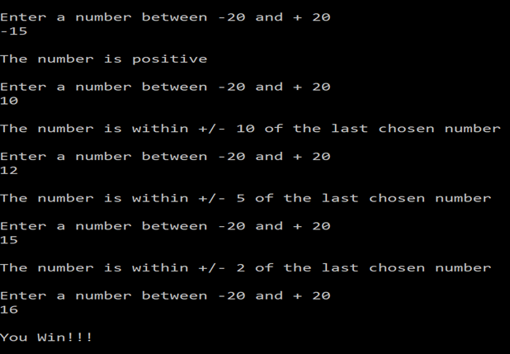
The image below displays the loss message.
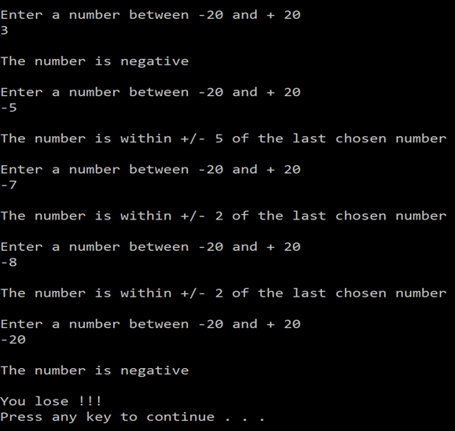

Exercise 2 Mapping Problem space to code
The program when used correctly would allow a user to input a string, which the program would then separate into integer arrays that were separated by hyphens.

Testing
1 | Testing splitIntoNumbers function
Description |  |  |  | The splitIntoNumbers function allows the user to enter a string of numbers using a specific format into an array, the function then splits the string into three intager arrays, and returns true if it was successful.
 |  |  |  | Test Steps:
1. | The user enters different value as the arguments.
2. | Runs the program.
3. | Check the Boolean that is returned.

Response
Status |  |  |  |  |  | Date |  |  |  | Description
1.Pass |  |  |  |  |  | 01/04/18 |  |  |  | The test passed
the image displays the user testing the code with the correct value where there are 3 array values that can store 3 numbers

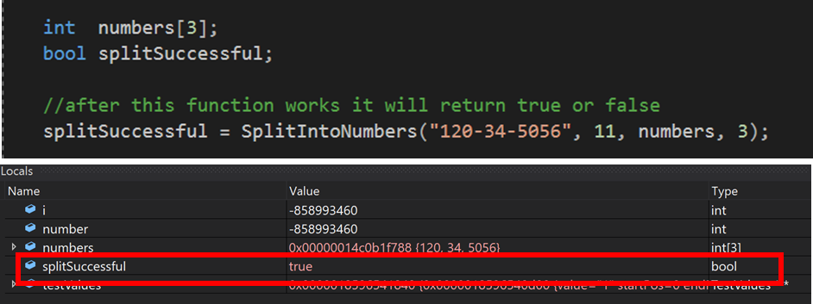
2. Fail |  |  |  |  | 01/04/18 |  |  |  |  |  |  | The test failed
The array size has been increased to [4] but the numbers that the code is testing has not been increased, so the array is looking for 4 numbers but can only find 3.
It is returning a false to the function because the number -858993460
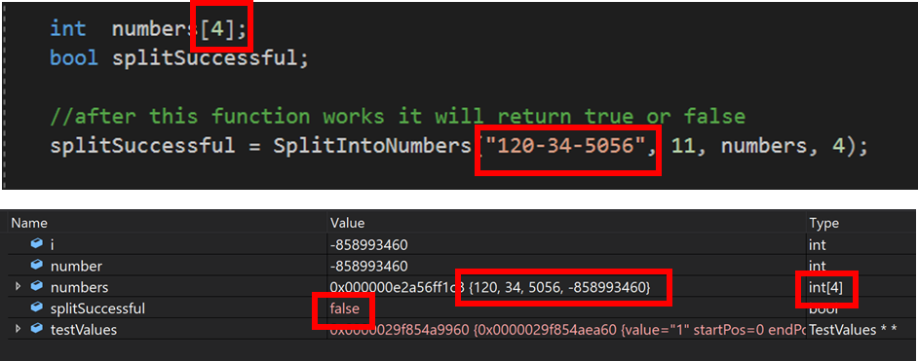
3.Fail |  |  | 01/04/18 |  |  |  |  |  |  |  | The test failed
The image displays a the program failing to accept the input of to many hyphens. The test failed as it returned a false.

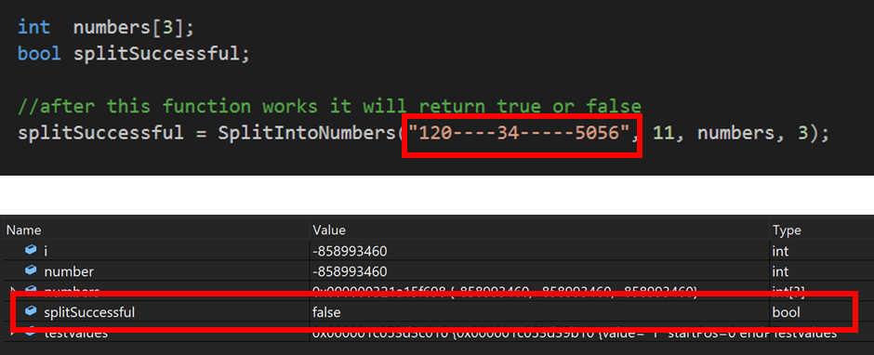
4.Fail |  | 01/04/18 |  |  |  |  |  |  | The test failed
The image below displays the testing of a single array with one digit and a single hyphen after the number.

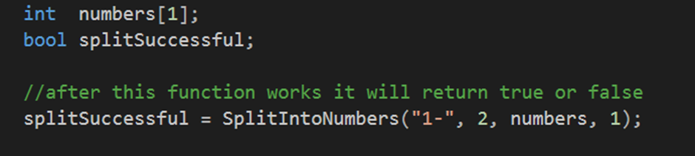

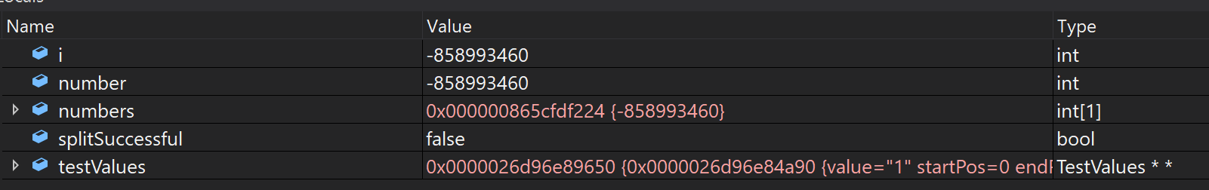

1 | Testing the ConvertToNumber function
Description |  | The convertToNumber function changes string into an array of intagers.
 |  | Test Steps:
1. | The user enters a string containing only number values.
2. | User enters a string containing numbers and letters
3. | User enters letters only

Response
Status |  |  | Date |  |  | Description
1./2.Pass |  |  | 01/04/18 |  |  | The test passed
The image displays the user entering a string containing only numbers, the test has passes as it has successfully altered the string and stored it as an int value.
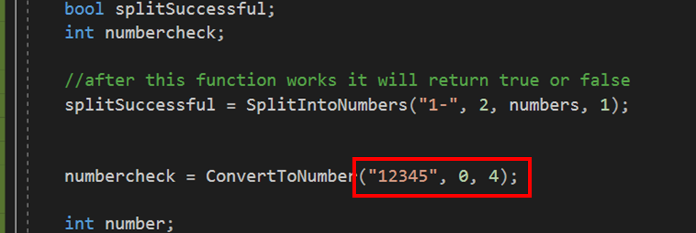

Exercise 3 Connect 4 game
Exercise 3 requires a program which allows two players to take turns to place a coloured disc into a grid of 7 row by 6 columns. Once one player matches 4 coloured discs either vertically horizontally or diagonally they win and the game ends.

List of Requirements | List of solutions
Win message to be displayed. | Printf (“congratulations %i you win”)
For a message to display who’s turn it is to place a disc. | Printf (“player %i it is your turn”)
For a player to exist. | Declare the player variable within the main  Int currentPlayer
To create a grid consisting of 6 rows and 7 columns | Multidimensional array grid = [6] [7] to establish the size of the grid.
For the player to chose a column to place the disc. | Scanf (“%i”, playersChoiceOfColumn);
For the players choice to be stored | Declaring an integer variable for the player choice.  Int playersChoiceOfColumn;
Switch between the two players | Int curentPlayerGo (place current player)
For the players choice to be visually displayed. | For the first player to display 1  For the second player to display 2
For the grid to be set to empty. | For (row = 0; row < 6; row ++)  {  For (int column = 0; column < 7; column++)  {  Grid [row] [column] = 0;  }  }
For the grid to be displayed to the screen. | For (row = 0; row < 6; row ++)  {  Printf(\r\n);  For (int column = 0; column < 7; column++)  {  Printf(“%i”, Grid [row] [column]);  }  }
For a check to check if there is a space in the grid to place the disc. | For (int row = 0; row < 6; row ++)  {  If (grid [row] [col] != 0)  {  Grid [row – 1] [col] = player;  }  }
The program to registers a win condition.  - Horizontal  - Vertical  - Diagonal left  - Diagonal right | For (int row = 6; row > 0; row --)  {  If (grid [row] [col] = player);  {  For (int row = 0; row < 6; row ++);  }  If (grid [6 – row] [col] = player;  }

Testing
1 | Program initialises and displays the grid.
Description |  | The program creates a grid of 6 rows and 7 columns the grid is then set with a value of 0 and displayed to the screen.
 |  | Test Steps:
1. | The program starts, and the grid is initialised.
2. | The grid has the value of 0 stored within it.
3. | The grid is displayed to the screen.

Response
Status |  |  | Date |  |  | Description
Pass |  |  | 01/04/18 |  |  | The test passed
The image below displays the grid being displayed.
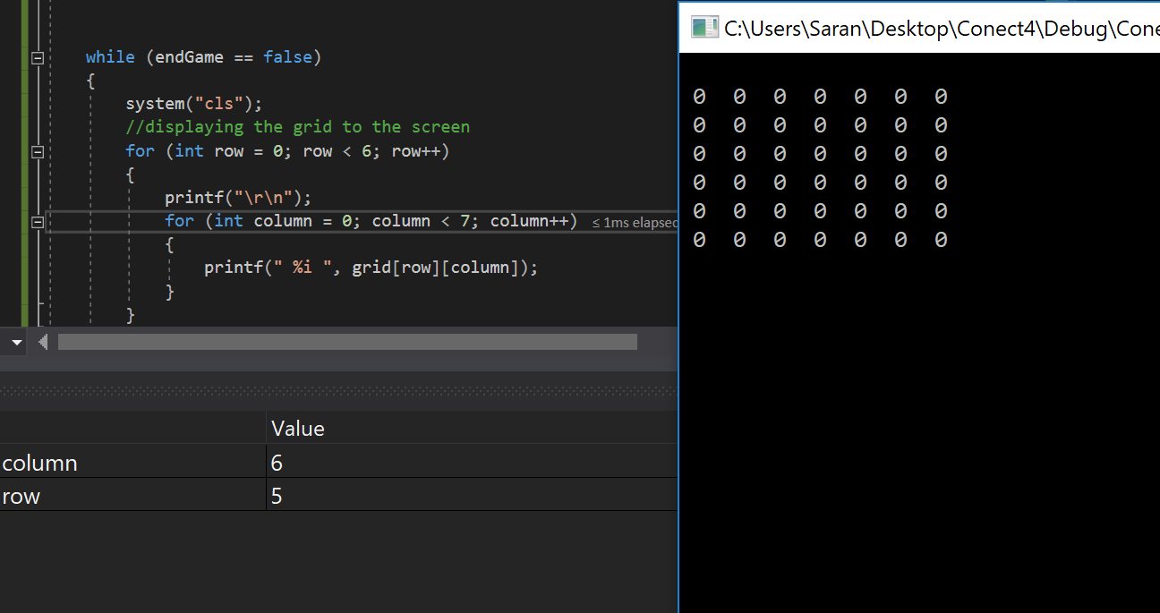

2 | Program scans and stores value entered by user.
Description |  | The program scans and stores the value entered by a user.
 |  | Test Steps:
1. | The program displays the current player.
2. | The program displays a message for the current player to select a column.
3. | The current player can enter a value.
4. | The value entered by the user is stored within the curentPlayer variable.

Response
Status |  |  | Date |  |  | Description
Pass |  |  | 01/04/18 |  |  | The test passed
The image below displays the player entering choice and the choice being stored successfully.
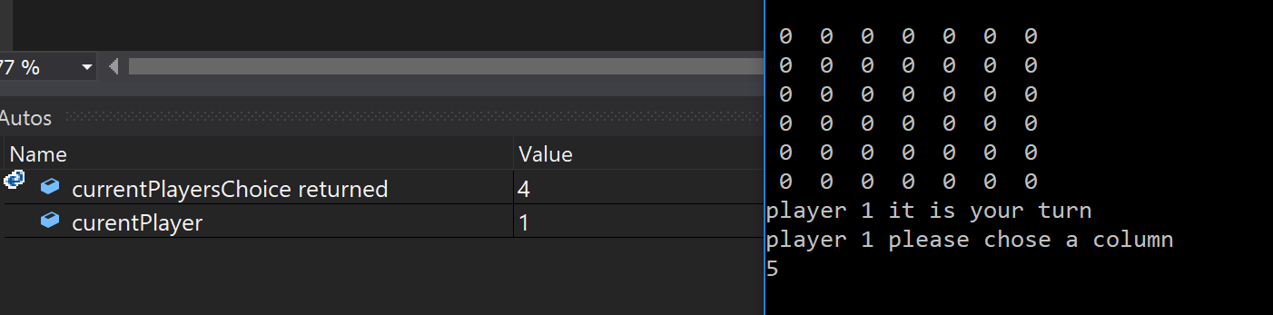

3 | Program switches between both players
Description |  | The program switches between player 1 and 2.
 |  | Test Steps:
1. | The program runs using the current player.
2. | The program displays a message for the current player to select a column.
3. | The current player can enter a value.
4. | Once the current player has made an input the player is switched with the second player.

Response
Status |  |  | Date |  |  | Description
Pass |  |  | 01/04/18 |  |  | The test passed
The image below displays the player being successfully switched from 1 to 2.
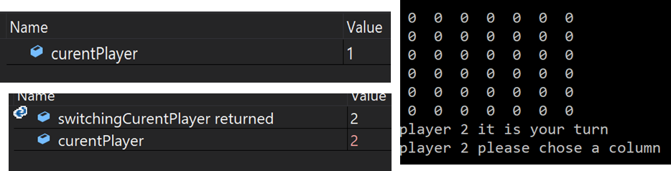

4 | Program fails to prevent user entering value that is not an intager.
Description |  | The program scans and stores the value entered by a user.
 |  | Test Steps:
1. | The program displays the current player.
2. | The program displays a message for the current player to select a column.
3. | The current player can enter a value.
4. | The value entered by the user is stored within the curentPlayer variable.

Response
Status |  |  | Date |  |  | Description
fail |  |  | 01/04/18 |  |  | The test passed
The image below displays the player entering a value that is not an integer and the choice braking the code.
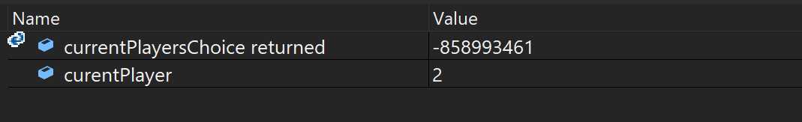

References
[1] “IS-0241.b: Decision Making and Problem Solving Job Aid: Analytical Approach Problem-Solving Model Job Aid: Analytical Approach Problem-Solving Model Step 1. Identify the Problem What Is a &quot; Problem &quot; ? Problem or Solution?”
[2] “What Is an Analytical Approach?” [Online]. Available: http://www.thwink.org/sustain/articles/000_AnalyticalApproach/index.htm. [Accessed: 05-Apr-2018].
[3] M. Sprankle and J. Hubbard, Problem solving &amp; programming concepts. Pearson Prentice Hall, 2012.

Appendices

Part B
Source.cpp
#include "stdafx.h"
#include "Console.h"
#include "Application.h"

int main(int args, char* argv[])
{
Console* console = new Console();
Application* application = new Application(console);
bool quit = false;

console->PrintLine("*****************************************************************************");
console->PrintLine("* This application is designed to allow you to select the number of numbers *");
console->PrintLine("* you wish to enter, and sum the numbers that you provide. *");
console->PrintLine("*****************************************************************************");

while (quit == false)
{
application->DisplayMenu();
application->ChooseOption();
quit = application->ProcessOption();
}

console->Pause();

delete application;
delete console;
return 0;
}
Console.cpp
#include "Console.h"

string Console::ReadString()
{
char text[100];

scanf("%99[^\n]s", text);
ClearInputBuffer();

return (string)text;
}

int Console::ReadInteger()
{
int number;
//Sarann Strange: creating a buffer intager varible
int buffer;
//Sarann Strange: the buffer is storing what the scanf returns because its returning an integer, if anything other than an int is entered scanf returns 0
buffer = scanf("%i", &number);
//sarann Strange: creating a while loop to check if buffer is equal to 0 if it is the while loop starts
while (buffer == 0) {
Print("You have entered an invalid option\r\n");
Print("Please enter number: ");
ClearInputBuffer();

//Sarann Strange scanf is returning either a 1 or a 0 into the buffer depending on if an intager was entered or if it wasnt
buffer = scanf("%i", &number);
}
ClearInputBuffer();

return number;
}

double Console::ReadDouble()
{
double number;

scanf("%lf", &number);
ClearInputBuffer();

return number;
}

//this is the function that clears the buffer
void Console::ClearInputBuffer()
{
char ch;
while ((ch = getchar()) != '\n' && ch != EOF);
}

void Console::Print(string text)
{
printf("%s", text.c_str());
}

void Console::PrintLine(string line)
{
Print(line + "\r\n");
}

void Console::Pause(void)
{
while (1) { if (_kbhit()) break; } // Pause
_getch();
}

Application.cpp
#include "Application.h"

Application::Application(Console * console)
{
_console = console;
_chosenOption = 0;
_numNumbersReqd = 5;
}

void Application::DisplayMenu()
{
_console->PrintLine("Select an option");
_console->PrintLine("1. Add numbers");
_console->PrintLine("2. Change amount of numbers to be entered");
_console->PrintLine("3. Quit");
}

void Application::ChooseOption()
{
_chosenOption = ReadNumber("Please choose an option:");
}

int Application::ReadNumber(string prompt)
{
_console->Print(prompt);
return _console->ReadInteger();
}

bool Application::ProcessOption()
{
bool quit = false;

switch (_chosenOption)
{
case 1:
int total;
total = GetTotal();
DisplayResult(total);
break;
case 2:
_numNumbersReqd = ReadNumber("Please enter the number of numbers to be entered:");
break;
case 3:
quit = IsQuitting();
break;
default:
_console->PrintLine("Unknown option value entered");
break;
}

return quit;
}

int Application::GetTotal()
{
int total = 0;
int index;

for (index = 0; index < _numNumbersReqd; index++)
{
total = total + ReadNumber("Please Enter Number:");
}

return total;
}

void Application::DisplayResult(int result)
{
_console->PrintLine("###############################################################################");
_console->PrintLine("###############################################################################");
_console->PrintLine("################## " + to_string(result) + " ##################");
_console->PrintLine("###############################################################################");
_console->PrintLine("###############################################################################");
}

bool Application::IsQuitting()
{
string response;
bool quit = false;

_console->Print("Do you really wish to quit?");

response = _console->ReadString();
//Sarann Strange: adding more ways to quit
if (response == "YES" || response == "y" || response == "yes" )
{
_console->PrintLine("Quitting");
quit = true;
}

return quit;
}
Application.h
#pragma once
#include "Console.h"

class Application
{
// Attributes
private:
Console * _console;
int _chosenOption;
int _numNumbersReqd;

// Constructors
public:
Application(Console* console);

// Properties
// NONE

// Methods
public:
void DisplayMenu();
void ChooseOption();
bool ProcessOption();
private:
int ReadNumber(string prompt);
int GetTotal();
void DisplayResult(int result);
bool IsQuitting();
};

Console.h
#pragma once
#include "stdafx.h"

class Console
{
// Attributes
// NONE

// Constructors
// NONE

// Properties
// NONE

// Methods
public:
string ReadString();
int ReadInteger();
double ReadDouble();
void Print(string text);
void PrintLine(string line);
void Pause(void);

private:
void ClearInputBuffer();
};

Stdafx.h
#pragma once
#define _CRT_SECURE_NO_WARNINGS
#pragma warning(disable:4996)

#include <string>
#include <conio.h>
#include <time.h>
#include <Windows.h>
#include <stdio.h>
#include <stdlib.h>

using namespace std;

Exercise 1
#pragma warning(disable:4996)
#include <stdio.h>
#include <string>
#include <stdlib.h>
#include <time.h>
using namespace std;

//this is clearing thebufer of values
void ignoreInput()
{
char ch;
while ((ch = getchar()) != '\n' && ch != EOF);
}

//this is returning an intager whitch is read by the user
int readIntager()
{
int placeNumber;
int checkInput;
//this is checking if scanf is successfully reading an intager if it did then it returns 1 if it doesnt it returns 0.
checkInput = scanf("%i", &placeNumber);
ignoreInput();
//this is checking to see if the scanf is successfull by seeing if checkInput is equal to 0
if (checkInput == 0)
{
//this is returning a value not in range of the game so its an instant fail
return 100;
}

return placeNumber;
}
//setting a maximum intager value
const int MAXNUMBERS = 5;

//function for the randome number generated
int RandomeValue(int maxValue)
{
return rand() % (maxValue+1);
}

// checking if user has guessed a number below -20 or above +20
void checkParamitersofPlayerChoice(int placePlayerChoiceOfNumber)
{
if (placePlayerChoiceOfNumber > 20 || placePlayerChoiceOfNumber < -20)
{
printf("\r\nYour have entered an invalid choise please re-enter a number between -20 and +20\r\n");

}
}

//this is alowing the player to make a choice
int PlayerChoiceOfNumber()
{
printf("\r\nEnter a number between -20 and + 20\r\n");
int playerChoice;
playerChoice = readIntager();
return playerChoice;
}

//function that returns a bool
bool checkIfGuessCorrect(int placePlayerChoice, int placeComputerRandomNum)
{
//varible X beeing declared within the checkIfGuessCorrct function
int placeNumberCheck;
//when the placePlayerChoice - placeComputerRandomNum it equals x
placeNumberCheck = placePlayerChoice - placeComputerRandomNum;
if (placePlayerChoice == placeComputerRandomNum)
{
printf("\r\nYou Win!!!\r\n");
return true;
}
else
{
if (placeNumberCheck >= -2 && placeNumberCheck <= 2) //Checking if the placeNumberCheck is between -2 and +2 of the number
{
printf("\r\nThe number is within +/- 2 of the last chosen number\r\n");
}
else
{
if (placeNumberCheck >= -5 && placeNumberCheck <= 5) //Checking if the placeNumberCheck is between -5 and +5
{
printf("\r\nThe number is within +/- 5 of the last chosen number\r\n");
}
else
{
if (placeNumberCheck >= -10 && placeNumberCheck <= 10) //Checking if the placenumberCheck is between -10 and +10
{
printf("\r\nThe number is within +/- 10 of the last chosen number\r\n");
}
else
{
if(placeComputerRandomNum < 0) // if the number is below a zero it displays a message of number is negative
{
printf("\r\nThe number is negative\r\n");
}
else
{
printf("\r\nThe number is positive\r\n"); //otherwise it displays the message that the number is a positive
}
}
}
}
}
return false;
}

int main(int argc, char** argv)

{
//inclusion of the randome time function
time_t theTime;
srand((unsigned)time(&theTime));

//this is giving the randomeValue function the numbers to 40 to randomise to
int computerRandomNum = RandomeValue(40);
// because the randome numbers go all the way to 40 this minuses 20 from the randomised number to make the randomised number between -20 to +20
computerRandomNum = computerRandomNum - 20;
int playerChoice;
bool playerWin = false;

//starting the look that gives the player 5 guesses
for(int index = 0; index < MAXNUMBERS; index ++)
{
//checking the playerWin varible if its true the loop will break
if(playerWin == true)
{
break;
}

playerChoice = PlayerChoiceOfNumber();
checkParamitersofPlayerChoice(playerChoice);
//checkingIfGuessCorrect is beeing handed the intager values from playerChoice and computerChoice, it then returns the result to playerWin
playerWin = checkIfGuessCorrect(playerChoice, computerRandomNum);

}

if(playerWin == false) // if the playerWin is equal to false display the message you lose
{
printf("\r\nYou lose !!!\r\n");
}

system("pause");

return 0;
}

Exercise 2
#pragma warning(disable:4996)
#include <stdio.h>
#include <string>
#include <stdlib.h>
#include <time.h>
using namespace std;

//this is clearing thebufer of values
void ignoreInput()
{
char ch;
while ((ch = getchar()) != '\n' && ch != EOF);
}

//this is returning an intager whitch is read by the user
int readIntager()
{
int placeNumber;
int checkInput;
//this is checking if scanf is successfully reading an intager if it did then it returns 1 if it doesnt it returns 0.
checkInput = scanf("%i", &placeNumber);
ignoreInput();
//this is checking to see if the scanf is successfull by seeing if checkInput is equal to 0
if (checkInput == 0)
{
//this is returning a value not in range of the game so its an instant fail
return 100;
}

return placeNumber;
}
//setting a maximum intager value
const int MAXNUMBERS = 5;

//function for the randome number generated
int RandomeValue(int maxValue)
{
return rand() % (maxValue+1);
}

// checking if user has guessed a number below -20 or above +20
void checkParamitersofPlayerChoice(int placePlayerChoiceOfNumber)
{
if (placePlayerChoiceOfNumber > 20 || placePlayerChoiceOfNumber < -20)
{
printf("\r\nYour have entered an invalid choise please re-enter a number between -20 and +20\r\n");

}
}

//this is alowing the player to make a choice
int PlayerChoiceOfNumber()
{
printf("\r\nEnter a number between -20 and + 20\r\n");
int playerChoice;
playerChoice = readIntager();
return playerChoice;
}

//function that returns a bool
bool checkIfGuessCorrect(int placePlayerChoice, int placeComputerRandomNum)
{
//varible X beeing declared within the checkIfGuessCorrct function
int placeNumberCheck;
//when the placePlayerChoice - placeComputerRandomNum it equals x
placeNumberCheck = placePlayerChoice - placeComputerRandomNum;
if (placePlayerChoice == placeComputerRandomNum)
{
printf("\r\nYou Win!!!\r\n");
return true;
}
else
{
if (placeNumberCheck >= -2 && placeNumberCheck <= 2) //Checking if the placeNumberCheck is between -2 and +2 of the number
{
printf("\r\nThe number is within +/- 2 of the last chosen number\r\n");
}
else
{
if (placeNumberCheck >= -5 && placeNumberCheck <= 5) //Checking if the placeNumberCheck is between -5 and +5
{
printf("\r\nThe number is within +/- 5 of the last chosen number\r\n");
}
else
{
if (placeNumberCheck >= -10 && placeNumberCheck <= 10) //Checking if the placenumberCheck is between -10 and +10
{
printf("\r\nThe number is within +/- 10 of the last chosen number\r\n");
}
else
{
if(placeComputerRandomNum < 0) // if the number is below a zero it displays a message of number is negative
{
printf("\r\nThe number is negative\r\n");
}
else
{
printf("\r\nThe number is positive\r\n"); //otherwise it displays the message that the number is a positive
}
}
}
}
}
return false;
}

int main(int argc, char** argv)

{
//inclusion of the randome time function
time_t theTime;
srand((unsigned)time(&theTime));

//this is giving the randomeValue function the numbers to 40 to randomise to
int computerRandomNum = RandomeValue(40);
// because the randome numbers go all the way to 40 this minuses 20 from the randomised number to make the randomised number between -20 to +20
computerRandomNum = computerRandomNum - 20;
int playerChoice;
bool playerWin = false;

//starting the look that gives the player 5 guesses
for(int index = 0; index < MAXNUMBERS; index ++)
{
//checking the playerWin varible if its true the loop will break
if(playerWin == true)
{
break;
}

playerChoice = PlayerChoiceOfNumber();
checkParamitersofPlayerChoice(playerChoice);
//checkingIfGuessCorrect is beeing handed the intager values from playerChoice and computerChoice, it then returns the result to playerWin
playerWin = checkIfGuessCorrect(playerChoice, computerRandomNum);

}

if(playerWin == false) // if the playerWin is equal to false display the message you lose
{
printf("\r\nYou lose !!!\r\n");
}

system("pause");

return 0;
}

Exercise 3 Connect 4
#pragma warning(disable:4996)
#include <stdio.h>
#include <string>
#include <stdlib.h>
#include <windows.h>

using namespace std;

//Checking current player and switching them to the alternat player
int switchingCurentPlayer(int placecurentPlayer)
{
if (placecurentPlayer == 1)
{
placecurentPlayer = 2;
}
else
{
placecurentPlayer = 1;
}
return placecurentPlayer;
}

//asking for curent players choice of column
int currentPlayersChoice(int placeCurentPlayer)
{
int palceChosenColumn;
printf("player %i please chose a column\r\n", placeCurentPlayer);
scanf("%i", &palceChosenColumn);
//this is returning the players chosen option but subtracting 1 because the program is working with an array and the array starts at 0
return palceChosenColumn - 1;
}

// message to the current player htat its their turn
void messagePlayer(int PlaceurrentPlayer)
{
printf("\r\nplayer %i it is your turn\r\n", PlaceurrentPlayer);
}

int main(int argc, char** argv)

{
//creating the grid of the game making it a 6 rows by 7 column
int grid[6][7];

//creating the current player varible setting it so player one goes first
int curentPlayer = 1;

//creating the chosen column varible to stor the players chosen colum to place the disc
int chosenColumn;

//creating varible for ending the game
bool endGame = false;

//setting all the values in the grid to 0
for (int row = 0; row < 6; row++)
{
for (int column = 0; column < 7; column++)
{
grid[row][column] = 0;
}
}

while (endGame == false)
{
system("cls");
//displaying the grid to the screen
for (int row = 0; row < 6; row++)
{
printf("\r\n");
for (int column = 0; column < 7; column++)
{
printf(" %i ", grid[row][column]);
}
}

messagePlayer(curentPlayer);
currentPlayersChoice(curentPlayer);

curentPlayer = switchingCurentPlayer(curentPlayer);

}

system("pause");
return 0;

}

