
Strategic Management Report on Inditex (Zara)
Competitive Position, Sustainability, and Strategic Implementation
Programme | Master of Business Administration
Module | Strategic Management
Module code | LCMB7003
Lecturer | Zulf Khan
Student name | Himadhri Bardhan Dhrubo
Student ID | 2505914
Word count | 5460 Words
Submission date | 25 march 2026

University of Wales Trinity Saint David

Table of Contents
Section 1: Critical Analysis of Inditex’s Strategic Management 1
1. Organisational context and overview 1
2. External and internal environment analysis 3
2.1 External environment: PESTEL analysis, critical success factors and strategic challenges 3
2.2 Internal environment: resources, capabilities, core competencies and VRIO 6
3. CSR and sustainability objectives 9
4. Comprehensive and holistic view of the organisation: Balanced Scorecard 10
5. Strategic choices and implementation 13
6. Strategic evaluation and recommendations 15
Section 2: Reflective account using Gibbs’ reflective cycle 18
Description 18
Feelings 18
Evaluation 18
Analysis 19
Conclusion 19
Action plan 19
References 21

Section 1: Critical Analysis of Inditex’s Strategic Management
The present report critically examines the strategic management of Inditex, and specifically Zara, being its flagship brand. The discussion will be framed in line with the assignment brief and considers the interaction between the external environment of the organisation, the internal capabilities, the sustainability agenda, the performance management system and strategic choices to support the competitive advantage and challenge it to a greater extent. The report is an integration of the traditional strategic management theory and the contemporary evidences in the official corporate reports, recent events of the industry and the academic literature. The thesis, consistently, is that, Inditex continues to be among the most robust performers in the world fashion retailing sector since it has established an exceptionally well-coordinated operating model based on design responsiveness, proximity sourcing, information-intensive merchandising and constrained capital distribution. But the same model is now under increased pressure by the ultra-fast-fashion digital new entrants, by the tightening of the regulatory control over sustainability assertions and textiles, and by the structural contradiction between the short-lived product turnover and the long-term sustainability aspirations.

1. Organisational context and overview
Inditex was established in Spain in 1985, but the history of Zara dates to 1975, and it has grown to be one of the largest fashion retail chains in the world. It has a portfolio of Zara, Pull&Bear, Massimo Dutti, Bershka, Stradivarius, Oysho and Zara Home, although Zara is the economic and strategic centre of gravity. According to the annual report of 2024, Inditex has a business of very significant size, with a sales volume of EUR38.6 billion, net income of EUR5.9 billion and presence in 214 markets that is facilitated by physical shops and online platforms (Inditex, 2025a; Inditex, 2025b). The scale is important as it provides the group with the purchasing power, the density of logistics, the visibility of the brand and the volume of data, which strengthens its position in the market.
The mission statement is not necessarily stated in the easy slogan format of other consumer brands; rather, Inditex position itself as having a mission based on the provision of fashion that is innovative, of high quality, customer-responsive and more sustainable (Inditex, 2025a). The business model is the most significant aspect of the organisation, in terms of strategies. In contrast to the slower fashion retailers that are established around long-term planning cycles and reliance on heavy markdowns, Zara became notorious due to a well-knit fast-fashion system of design, sourcing, production, logistics and store feedback, which is tied together in near real-time (Ghemawat and Nueno, 2003). This model does not compete mainly on the lowest price. Instead, it is a mixture of medium prices and speed, perpetual newness, fashionability and low obsolete inventory. This can be best discussed in terms of Porter (1985) and this is a differentiated model with a high cost discipline as opposed to pure cost leadership.
Inditex is in the global retail business of apparel and accessories which is typified by low switching costs, volatile demand, short product life cycles and high rivalry. Its major mainstream rivals are H&M, Uniqlo and Primark and its newer online competitors are Shein and Temu with ultra-fast and asset-light online business models that have put added price pressure and reduced trend cycles on the company (Reuters, 2025a; H&M, 2025). The market stability of Inditex is robust due to its ability to provide profitable growth in the market where most competitors have been unable to strike a balance between store productivity, online economics and inventory risk. But the situation in the market in this sphere is unstable. Fashion authority is lost easily, and competitive advantage is not only based on brand awareness but also on the recurring capability of an organisation to interpret market cues into commercially successful product streams quicker than competitors.

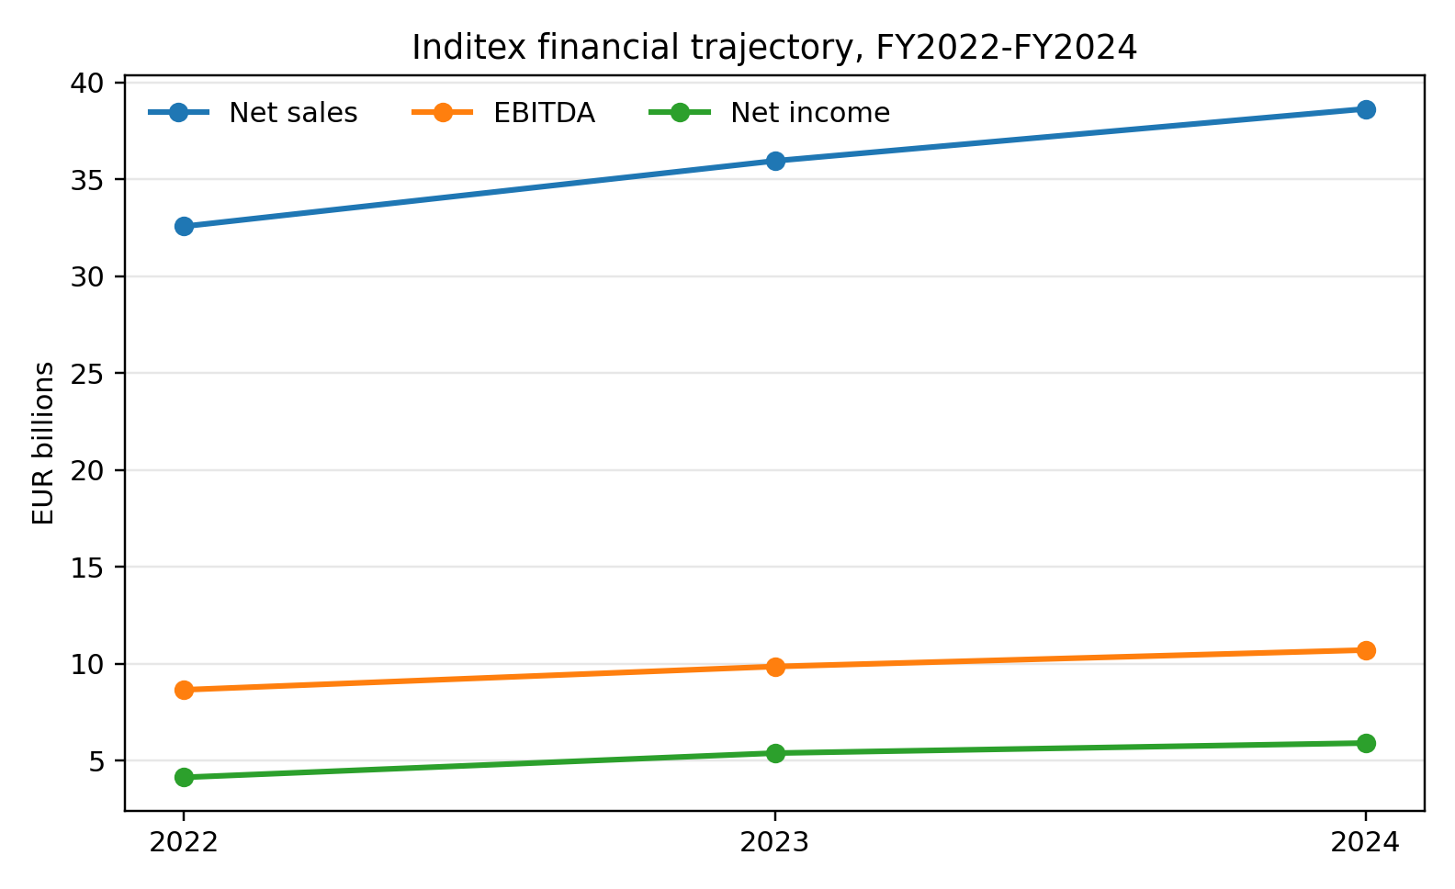
Figure 1. Inditex financial trajectory, FY2022-FY2024
Source: compiled from Inditex (2023), Inditex (2024b) and Inditex (2025b).

2. External and internal environment analysis

2.1 External environment: PESTEL analysis, critical success factors and strategic challenges
Politically and regulatory, the geographic diversification has been a strength to Inditex, which, however, also puts it at the risk of trade friction, concentration risk in sourcing and increasing compliance risks. The supply chain of the company includes various countries and any political changes like tariffs, changes in customs, labour enforcement and geopolitical changes can change cost and lead time assumption rapidly. The recent adaptations in the trade regulations of the United States of lower-value imports have been referred to primarily concerning the Chinese online retailers but also reflect how the fast-fashion economies are increasingly being influenced by the government, rather than the market forces alone (Reuters, 2025b). In the case of Inditex, whose model is based on the flexible cross-border replenishment, regulatory volatility is not only a background factor, but also a strategic one.
Economic forces are also important. The demand of apparels is discretionary and hence the variation of inflation, consumer confidence, exchange rate trends and wage trend has a direct impact on the volume sales and gross margins. Inditex registered a negative currency effect on 2024 sales and still indicates foreign exchange a significant factor in performance management (Inditex, 2025b). Simultaneously, the pressure of cost-of-living drives the consumers into value formats, which reinforces the low-price challengers and heightens the difficulty of maintaining the premium pricing unless the freshness of the product and the perceived design value are evident. The company has thus far succeeded a lot of rivals since it has not over-discounted and has preserved a large margin, however, a decline in the first part of fiscal 2025 indicates that the opportunity to make mistakes is less (Reuters, 2025a).
There are social factors that favour the business and pose threats to the business. The need to switch styles often, the fashion discovery and consumer desire to access trend affordably is all in favour of Zara core proposition. However, it is the same social environment, which now harbours more transparency, worker welfare and overconsumption expectations. Fast fashion has been accused of promoting short lives of garments and the large volumes of material throughput and these criticisms are increasingly becoming part of consumer and investor discourse, especially in Europe (Wren, 2022; European Commission, 2026). This brings a reputational paradox: the cultural logics which made Zara strong, i.e. the speed of translating trends, can be criticised when compared to the principles of circularity and sufficiency.
One of the biggest opportunities of Inditex is still technological factors. The fast sensing-and-response system that the group operates on is supported by data analytics, RFID, integrated inventory visibility, e-commerce platform and automated logistics. The strategic worth of technology in this case is not as much about digital glamour of standing alone, but in coordination power. Technology enables Inditex to relate demand signals, design choices, allocation decisions and replenishment flows faster than the conventional retailers. Nonetheless, technology also reduces the barriers to competitors who can apply algorithmic trend detection, digital marketing and platform-based fulfilment without the need to operate a massive store estate.
The environmental factors have become central and not peripheral. The clothing industry is facing pressure due to the emission, water intensity, chemical usage, waste and biodiversity effects. The aspects of the EU textile strategy, ecodesign law and anti-greenwashing efforts are rendering environmental functioning more quantifiable and being more challenging (European Commission, 2026; European Parliament, 2025). Inditex has reacted by posting climate and materials goals and investing in the next-generation fibres and transformation of supply-chain (Inditex, 2024a; Inditex, 2024b). However the strategic challenge does not just involve target setting. It is to balance a commercial model based on volumes with the absolute environmental reduction pathways. This tension is important since without sustainability being viewed as a risk management approach or reputational insurance, competitive advantage can suffer as regulators, investors and consumers insist on evidence of system-level change.
Legal factors are similar to politics and environment but should be singled out. The due diligence of labour rights, the traceability of products, the substantiation of claims and the waste requirement is getting tight. The more exposed to legal and quasi-legal scrutiny on modern slavery are fast-fashion companies that depend on sophisticated networks of suppliers regarding legal and quasi-legal matters. According to Reuters, the investors placed pressure on Inditex to become more transparent in its supply-chain, particularly regarding the manufacturing sites and resilience assumptions (Reuters, 2024a). This does not imply that the company is legally non-compliant, instead it merely indicates that legal legitimacy is shifting beyond minimum disclosure to more encompassing demands of auditable transparency.
Collectively, a number of critical success factors come out in the outside environment of Inditex. The former is controlled speed: the capacity to deliver speed and maintain quality, brand consistency or margin discipline. The second is omnichannel consistency: the customers are becoming more and more demanding of a smooth connexion between the app, the site, the store, and the fulfilment. The third one is the credibility of sustainability: companies need to demonstrate not only will but also action. The fourth one is supply-chain resilience, particularly the capability to balance the proximity sourcing and global diversification. The key strategic risks are thus growing digital price wars with Shein and Temu, tightening of regulations in the textile and claims, declining consumer demand in the world, and the reputational paradox of fast fashion cycles and sustainability demands. These difficulties do not cancel the advantage of Inditex, but they complicate it and render it more conditional and reliant on managerial renewal.

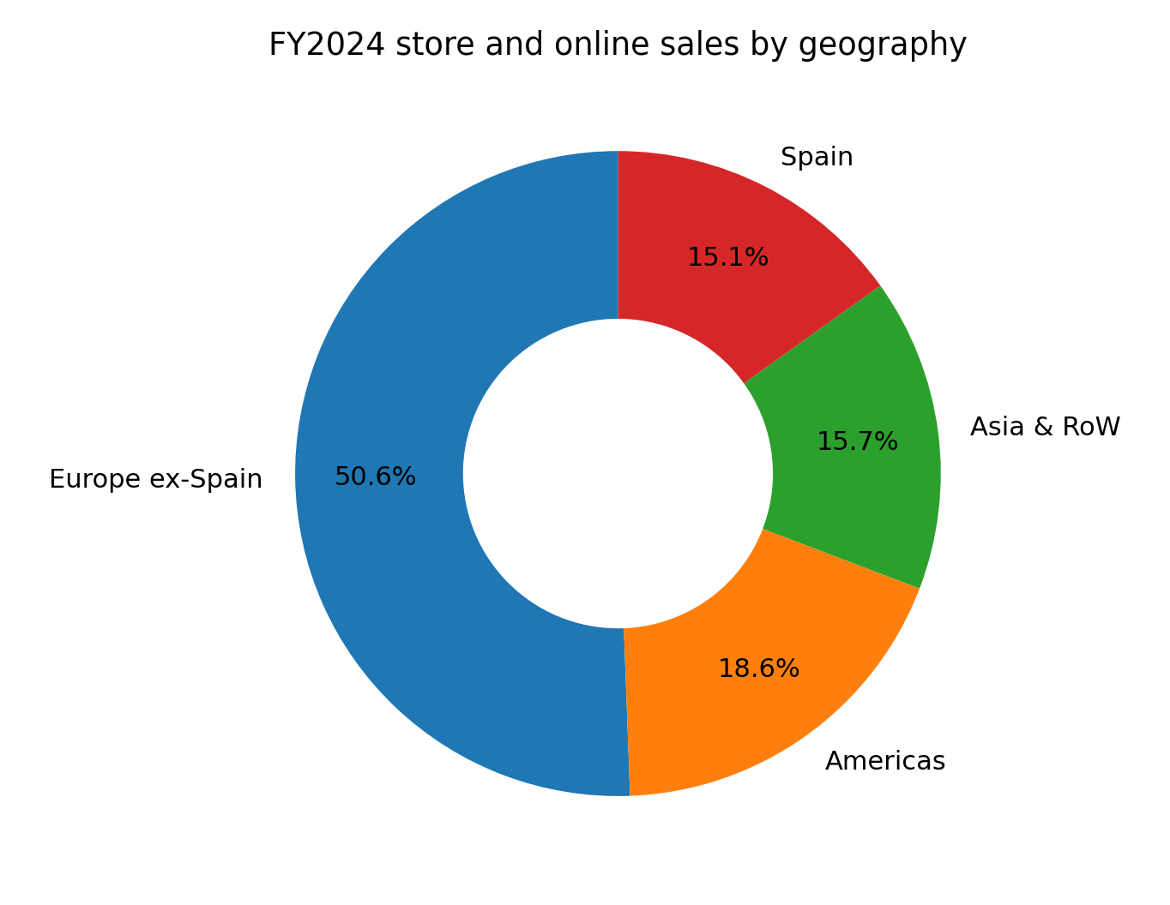
Figure 2. FY2024 store and online sales by geography
Source: compiled from Inditex (2025b).

2.2 Internal environment: resources, capabilities, core competencies and VRIO
Resource-based theory postulates that competitive advantage is sustainable based on resources and capabilities that are valuable, rare, difficult to imitated and well organised (Barney, 1991; Grant, 1991). When applied to Inditex, the most significant analysis aspect is that its strength is not fixed on one asset like a brand or stores. It is based on a combined system. That system integrates design capacity, merchandising skill, supplier connexions, logistics system, store network wisdom, electronic platforms and a managerial culture constructed on quick decision development. This systemic nature is important since competition is able to emulate isolated practises more than mutually reinforcing practises.
On the physical level, Inditex is financially strong, possesses an extensive yet optimisation-focused store portfolio, advanced logistics centres and a global digital system. The stronger resources are not tangible. Zara has a globally recognised brand that is linked with trendy, up to date merchandise at affordable prices; profound merchandising expertise; tight collaboration between market data and product creation; and good routines of inventory control. The store network is also more than a distribution asset as it is itself an information asset since it provides ongoing feedback on what customers notice, try and purchase.
This is because the strengths of the company can be defined as demand sensing, fast product development, coordinated sourcing and controlled stock management. These abilities are not too different with the dynamic capabilities perspective, which focuses on the capability of an organisation to create a sense of opportunity, capture it and re-align resources under the fluctuation environment (Teece, Pisano and Shuen, 1997). The design and replenishment system by Inditex was previously successful as it minimised the gap between the trend set and market implementation. This minimised the markdown risk, buttressed scarcity effects and enabled more frequent customer visits. Strategically, the company has not merely been selling clothing; operationalisation of responsiveness has been made possible.
The quality of strategic importance of key capabilities is summarised in the VRIO logic below. The brand recognition, the ability to sell online and internationally are also significant, but these are the features that other big stores have. The coordinated architecture in which Inditex integrates them is what makes them really rare.
Table 1. VRIO assessment of selected Inditex capabilities.
Capability / Resource | Valuable | Rare | Costly to imitate | Organised to exploit | Strategic implication
Brand portfolio led by Zara | Yes | Moderately | Moderately | Yes | Important but not sufficient alone
Integrated design to shelf cycle | Yes | Yes | Yes | Yes | Sustained advantage if renewed
Proximity and flexible sourcing mix | Yes | Yes | Moderately to yes | Yes | Strong temporary to sustained advantage
Global store network as data and fulfilment asset | Yes | Moderately | Moderately | Yes | Advantage, though partly imitable
Inventory discipline and low markdown culture | Yes | Yes | Yes | Yes | Strong performance advantage
Digital platform and omnichannel capabilities | Yes | No to moderate | Moderate | Yes | Competitive necessity rather than uniqueness
Financial strength and cash generation | Yes | No | No | Yes | Enabler, not unique source of advantage
The table reveals that the integrated design-to-shelf process, the flexible sourcing architecture and the unusual high level of discipline used by the organisation in controlling inventory and markdowns are the most strategically important capabilities. They are useful in that they enhance full-price sell-through, customer relevance and working-capital efficiency. They are fairly uncommon in that most of the competitors either are too slow, too reliant on low-cost sourcing at a distance, or as lacking the same degree of coordination between creative and operational processes. Their imitation is a challenge, as competitors can replicate observable behaviour, e.g. frequent drops, without replicating the underlying routines, relations with suppliers and decision-making, without which the system cannot function. Above all, the way Inditex is structured is to take advantage of these capabilities by having structures, data flows and capital investments aligned.
The further the market goes to app-based, platform-based and accelerated competition based on algorithms, the less unique may be traditional store-centred feedback loops. Similarly, at the low end of the market, a large store estate is unnecessary because ultra-fast-fashion players can operate test-and-repeat digital models and thereby diminish part of the speed advantage of Zara. Thus, the internal strengths of Inditex continue to add significant power to competitive advantage, but less as an unassailable moat and more as a platform of constant change. In the real world, the company is robust since it refreshes an integrated operating model that is superior to many competitors, not due to the fact that its existing formula cannot be contested.

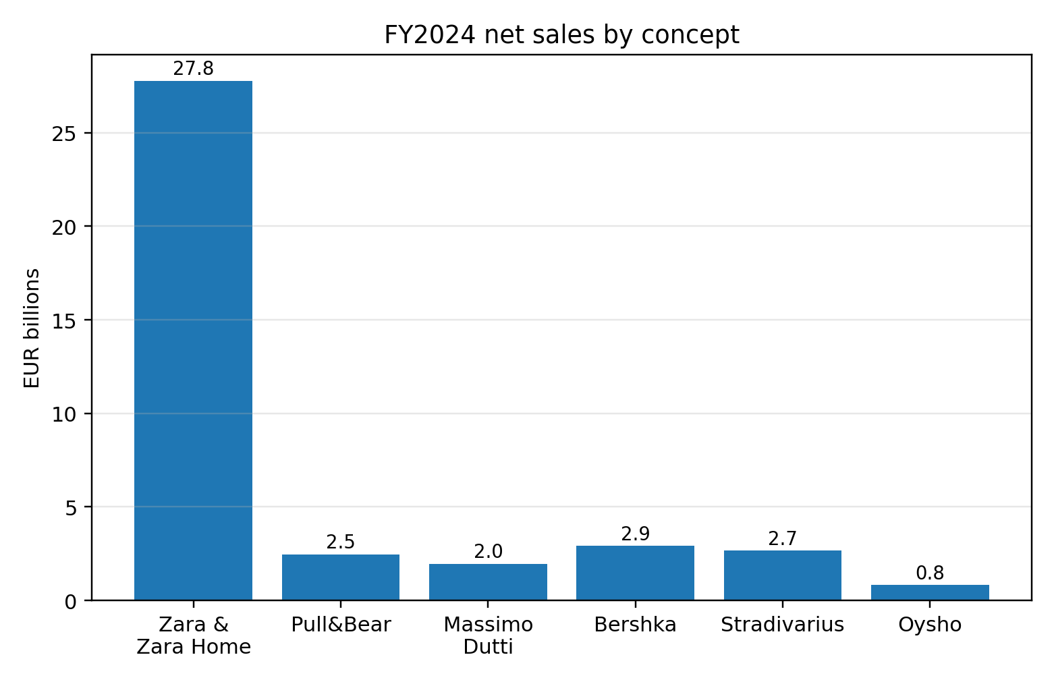
Figure 3. FY2024 net sales by concept
Source: compiled from Inditex (2025b).

3. CSR and sustainability objectives
Inditex does not introduce sustainability as a philanthropic activity but as a business model. Its recent pledges are: cutting emissions by over 50 per cent by 2030 in its own operations and value chain, transitioning to lower-impact textile fibres, cutting water usage in the supply chain, expanding and expanding the programmes of circularity and reaching millions of workers through its social programmes (Inditex, 2024a; Inditex, 2026).
The strong elements of the CSR approach of Inditex are that it is becoming more goal-oriented, integrated in operational programmes and backed by investing in innovation, such as next-generation materials and supply-chain transformation. This is a more strategic positioning than generic CSR messaging. It also complies with the stakeholder expectations that big box retailers must mitigate implications of materials, manufacturing, logistical and labour conditions. However, the strategy is still limited by the economics of fast fashion. An organisation can decarbonise fabrics, enhance traceability and invest in recycling, but it can be criticised when the expansion of business is based on high product throughput and quick replacement. According to Wren (2022), the existing fast-fashion sustainability efforts tend to make the processes better, but they do not address the environmental contradiction of the model entirely.
Thus, the CSR strategy of Inditex can be considered to be consistent with the business objectives in the limited strategic sense, as it defends the legitimacy, facilitates compliance, enhances the efficiency of operations and can potentially open the material benefits in the future. However, its sustainability remains questionable in the long run, as to whether sustainability can be permitted to affect fundamental business decisions, such as assortment design, material selection, lifecycle, logistics and consumption rate. The quality of the strategy is therefore not determined by whether there are targets but the extent of the targets reconstituting the operating model.

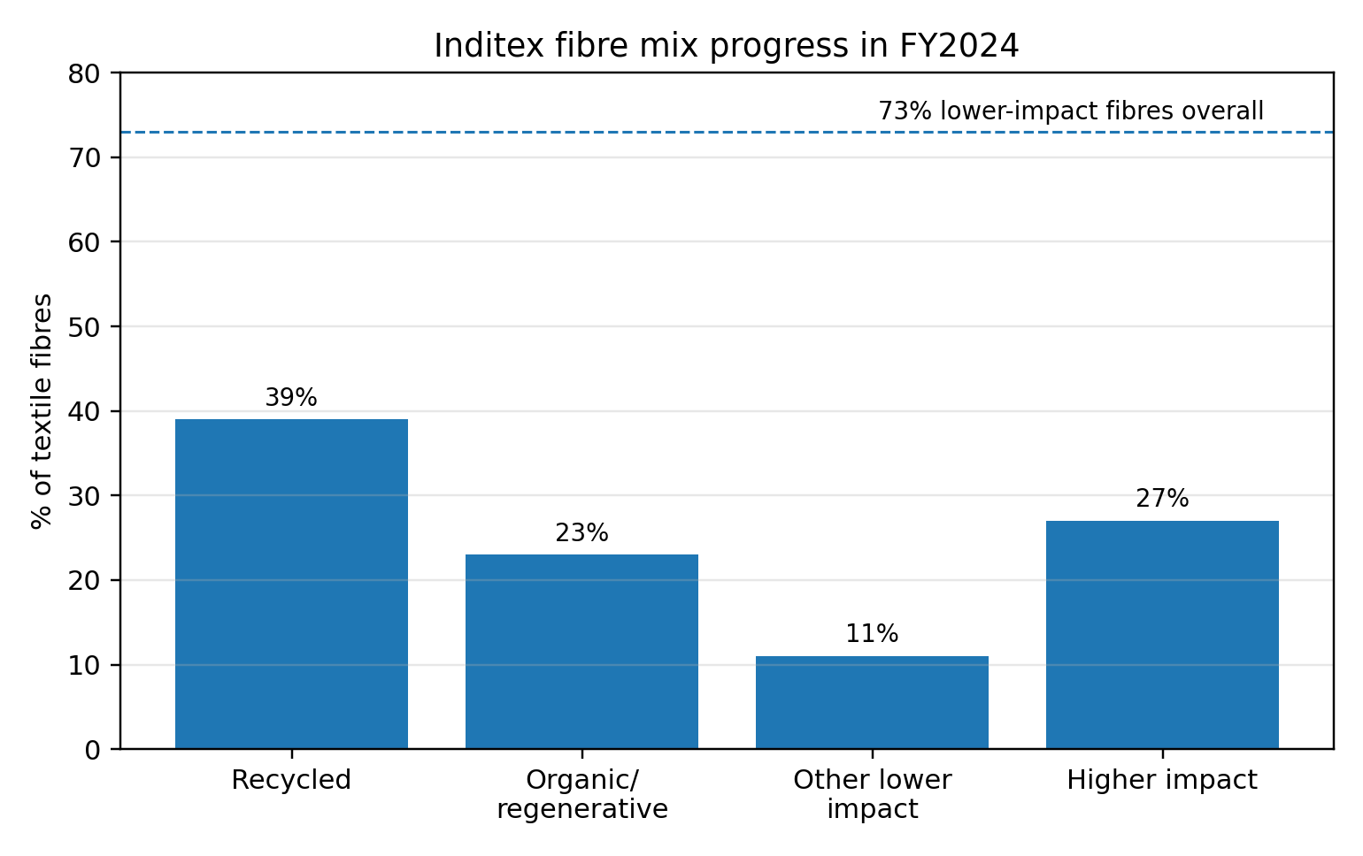
Figure 4. Inditex fibre mix progress in FY2024
Source: compiled from Inditex (2025a).

4. Comprehensive and holistic view of the organisation: Balanced Scorecard
Kaplan and Norton (1992) contend that organisations require a balanced mix of both the financial and non-financial measurements to translate strategy into action. The Balanced Scorecard is helpful in the case of Inditex, since sales growth is not the only factor in determining competitive advantage. Profitability, customer response, process speed and organisational learning should be aligned in the company. An adapted Inditex scorecard should thus be based on the mission to provide appealing, modern, and more sustainable fashion using a combination of both physical and digital model.
Table 2. Indicative Balanced Scorecard for Inditex.
Perspective | Strategic objectives | Illustrative KPIs | Targets | Key initiatives
Financial | Sustain profitable growth; protect gross margin; improve capital efficiency | Sales growth; gross margin; EBIT margin; inventory days; ROCE | Mid- to high-single-digit sales growth; stable margin; lower markdown ratio | Selective store optimisation; logistics investment; disciplined buying; balanced online and store economics
Customer | Increase perceived fashion relevance, convenience and trust | Full-price sell-through; repeat purchase; app engagement; conversion; customer satisfaction; returns rate | Higher repeat rate; faster fulfilment; fewer stock-outs; improved trust on sustainability claims | Sharper localisation; integrated store-app journeys; better product information and traceability
Internal business processes | Reduce design-to-delivery lead times; improve allocation accuracy; lower waste and emissions | Lead time; stock availability; forecast accuracy; air freight share; water and energy intensity | Shorter cycle times; higher first-time allocation accuracy; lower transport emissions | RFID and analytics upgrades; supplier transformation; nearshoring where justified; circular design protocols
Learning and growth | Strengthen design, digital, data and sustainability capabilities | Training hours; internal promotion; digital skill coverage; innovation pilots; employee engagement | Higher capability depth in data and circularity; stronger retention of key talent | Cross-functional training; sustainability innovation hub; data talent recruitment; leadership development
Financially, Inditex must remain focused on profitable expansion as opposed to volume on its part. Margins discipline has been the historical strength of the company thus the most relevant KPIs would be not only revenue and operating profit but also gross margin, inventory days and markdown intensity. The right target is thus profitable, capital efficient growth that is facilitated by selective not indiscriminate expansion.
On the part of the customers, the goal of Inditex is to be the retailer that customers relate to fashion relevance, convenience and confidence. Repeat purchase, full-price sell-through, app engagement, speed of order fulfilment, returns, and customer satisfaction are some of the KPIs. An organisation focused solely on sales of its customers would be too superficial since the competitive position is more and more based on whether the organisation can transform the browsing into the repeat full-price buying across the channels. Sustainability trust are also to be considered as one of the customer metrics, as vague or exaggerated claims could harm brand equity.
Under internal-process view, the strategic objective is to ensure that operating model becomes responsive with minimised waste and environmental intensity. Design-to-delivery lead time, accuracy of allocation, stock availability, dependence on air-freight, water use and energy intensity measures are thus more disclosure than the conventional measures of operational efficiency. In the case of Inditex, the process excellence does not mean cost reduction at any rate, rather it is a coordination of speed, availability, margin and sustainability. That is why the internal-process management is the focal point connecting the strategy of the company and its day-to-day running.
Regarding the learning-and-growth perspective, Inditex needs to invest in people, data, innovation and culture. The danger of the mature market leaders is over-dependence on past formula. Measures must thus include training on digital and sustainability skills and capabilities, retention of talent in design and analytics positions, internal promotion, employee engagement and commercially scaled innovation pilots. This point of view is particularly crucial since the ability to institutionalise adaptation will be the key to the further prosperity of the company, rather than simply maintaining old practises. The Balanced Scorecard, properly designed, would assist the management in escaping a tunnel vision of focusing on sales in the short term and instead control the entire strategic system.

5. Strategic choices and implementation
The key strategic decision that Inditex faces at the business level is either to protect and extend its differentiation logic or to approach the low-cost competition. Porter (1980, 1985) cautions that strategic drift between positions is dangerous to firms; they become strategically incoherent. Competing on price should not be among the top priorities of Inditex since it will negatively affect the quality of products, brand equity and margin discipline as well as compete as a structural competitive advantage of competitors. The more robust option is to strengthen differentiated fast fashion constructed on better design assortment, relied upon omnichannel service, quicker replenishment in principle categories and more plausible sustainability than low-cost digital competitors can provide. This would maintain the historical identity of the company and modernise it to a more competitive market.
On the corporate level, there are a number of alternatives: further intensive internationalisation, selective diversification into related lifestyle segments, increased vertical integration, or further investment in digital and material innovation. Inditex has been steadily broadening and streamlining its physical presence in stores and outsourcing logistics and online capacity (Inditex, 2025b). Assimilation and diversification internationally and through capabilities is not the most appealing corporate decision, but targeted diversification. International expansion must be discriminating and target markets where stores are productive, digitally adopted and logistically capable of generating economic returns. At the same time, a company should remain invested in technology, fulfilment and circular-material ecosystems, as it makes the company more resilient and strategic options more valuable in the future.
Among business-level and corporate-level options, the two choices that should be suggested are the differentiation-based omnichannel strengthening at the business level and the focused capability expansion at the corporate level. This is in lieu of aggressive cost-led growth since it is more in line with the current resources of Inditex and does not entail direct commodification. Resource-based logic implies that the more value a firm can generate is when strategy is developed based on the unique capabilities, and not denying them (Grant, 1991). Responsiveness, rather than low cost of production, is the unique capability in the case of Inditex.
On the implementation aspect, Inditex has been more successful in change management than most developed retailers. The team has updated stores, enhanced online connexions, invested in logistics and also persisted in increasing productivity despite the total number of stores declining (Inditex, 2025b). This implies the ability to reconfigure disciplinarily as opposed to accumulating assets in a fixed manner. The change management of the company is shown to be robust in three aspects. To start with, it has been willing to assimilate smaller stores into larger stores with better performances. Second, it has not considered online and offline as different channels but as a unit. Third, it has equated capital expenditure to scales of capabilities and not symbolic innovation.
Nevertheless, success should not be overestimated through a critical evaluation. Managing change is more akin to a good financial performance, and more difficult to do when growth is diminishing and trade-offs are becoming more intense. The present competitive landscape leaves questions as to whether Inditex can keep on developing its culture fast enough, particularly in comparison to digitally native competitors who can iterate rapidly without the store legacy factor. Sustainability implementation challenge is also there. Climate ambitions, fibre shifts and water ambitions need an in-depth supplier involvement, novel sourcing methods and sound traceability frameworks, which are more difficult to implement than to proclaim. Therefore, Inditex has been very effective in changing operations and channels, the next round of strategic execution will determine whether it can integrate environmental and transparency expectations in the very model of its operations without becoming less responsive in commercial terms.

6. Strategic evaluation and recommendations
An analysis of the SWOT-based analysis demonstrates that the strengths of Inditex are still significant: a strong flagship brand, built-in design and logistics, high profitability, omnichannel competence and global diversification. Its vulnerabilities are its reliance on a fast-fashion consumption logic that is increasingly challenged, lack of protection against digital price wars and remain vulnerable to the complex scrutiny of its supply chains. These opportunities are taking share against weaker mid-market competitors, being the leader in trusted sustainable fashion, and leveraging data and store networks to develop better customer experiences. The threats are low pricing disruption by Shein and Temu, macro-economic softness, tighter textile controls, reputational risk concerning supply-chain transparency, and that increased volume can lead to a loss of sustainability credibility.
The Matrix by Ansoff introduces discipline. Market penetration is also viable by enhancing better conversion, repeat purchase and category management in the existing markets. The market development is also appealing where Inditex can selectively copy its model. Development of products is also essential, but not in the form of the proliferation of random assortments, but with more traceable materials, more quality basics, circular services and digitally-assisted personalisation. The strategy of diversification beyond coherent lifestyle adjacencies must be done with a lot of care since the company benefit lies on the execution excellence of a well-integrated system. It is based on this that the existing approach is generally good but ought to be re-tuned. It is not a strategic re-invention. It is tactical strategizing with more precise decisions.
Firstly, it should be suggested that Inditex ought to rebrand Zara more clearly as the reliable premium-accessible fast-fashion leader instead of letting itself be positioned as yet another competitor in a generic race to the bottom. This is by putting design authority, fit, product quality, convenience and credibility higher than aggressive price-matching. The theoretical rationale is based on the argument by Porter (1985) who states that the performance is sustained through coherent positioning. Experience indicates that as the physical store apparel retailers pursue digital discounts on price, their margins tend to be undermined without loyalty being obtained. Instead of following the ultra-low-cost models, Inditex is in a better position to protect value.
The second suggestion is that sustainability should be operationally visible to the customers and investors with traceability at the product level that can be measured and disclosed in a better way. The legitimacy expectations are increasing as shown by investor pressure to have complete transparency in the suppliers (Reuters, 2024a). Enhanced disclosure would not be the panacea to all the sustainability contradictions, but it would improve information asymmetry, increase trust, and enhance defensibility against the accusation of greenwashing. The suggestion is also in line with the recent European policy focus on traceability, ecodesign and substantiated claims (European Commission, 2026; European Parliament, 2025). Transparency, when it comes to strategy, must be viewed as an ability, rather than a reporting requirement.
The third suggestion is to minimise over-reliance on high-speed fashion cycles by extending commercially disciplined circular and durability-based propositions. This might encompass repair, resale relationships, longer-lasting core product lines and design criteria which assist reuse and recyclability. It is not to drop fashion responsiveness which is a strength but to redistribute the model more in longer-value garments in specific categories. This would generate a strategic differentiation with competitors in the ultra-fast-fashion market as well as enhance the alignment between the CSR pledges and the real customer offer.
The fourth suggestion is to increase the capability investment on predictive analytics, local demand sensing and supply-chain scenario planning. Recent competition demonstrates that speed is now of various types: store-led speed, algorithmic speed and marketing speed. Instead of protecting the past practises blindly, Inditex ought to strive to embrace the best of these. According to dynamic capabilities perspective by Teece, Pisano and Shuen (1997), continuous reconfiguration is the key to gaining advantage in volatile markets. As such, the company ought to invest not only in additional technology but in the managerial ability to interpret and respond to faster messages in categories and geographies.
In general, the existing approach of Inditex is stronger than that of most competitors, however, the foundation of the advantage is changing. During the next stage, the fashion retail winners will probably be the ones that will be responsive, trusting, efficient and traceable. Inditex already has a lot of the necessities it has foundations. Its willingness to allow those foundations to develop into a more transparently differentiated and compatible with sustainability model will determine exceptional performance.

Section 2: Reflective account using Gibbs’ reflective cycle
This reflective report outlines my research, analysis and report writing process on the strategic management account of Inditex. I apply the reflective cycle of Gibbs (1988) since it offers a systematic manner through which I can shift between description and evaluation, analysis, conclusion and plan of action.

Description
The report needed more than an overall company profile. It required a related evaluation of organisational surroundings, external and internal examination, CSR and sustainability, Balanced Scorecard design, strategic decisions, implementation, evaluation and suggestions. I chose Inditex as it was a great mix of public reporting, evident strategic competencies, visible sustainability promises and up-to-date market competition. In the process of conducting the research, I collected pieces of evidence in the form of official annual and results reports, sustainability and climate reports, recent industry coverage and background academic literature on strategy, resources, dynamic capabilities, positioning and performance measurements.

Feelings
First, I was confident in my decision to select Inditex, as Zara is a well-known strategic case that has a unique business model. The first was the danger of writing an already known, too descriptive storey that only reiterated the old tale of Zara being fast and agile. The second was the difficulty of being able to write critically about sustainability without falling into simplistic reproach or mindless praise. These issues were fruitful. They challenged me to pose more difficult questions on whether the historical strengths of Inditex remain as unique as it used to be and whether the published sustainability commitments actually transform the business model.

Evaluation
It made sure that each of the major sections had a definite purpose of assessment. Second, this integration of theory and existing evidence contributed to the better quality of the argument. The idea of VRIO, dynamic capabilities and differentiation gave me an understanding of why Inditex has performed much better than most of its rivals, and recent findings on digital rivalry, slower current trading and sustainability regulation made me not make the company seem passive or unchallenged. Third, the Balanced Scorecard section also became more robust as I began not to regard it as a textbook requirement, but crafted the objectives, KPIs, targets and initiatives which were strategy-specific at Inditex.

Analysis
Going deeper into the reflection, I may observe that the most significant methodological learning was that I had to always switch between the outside and inside analysis instead of trying to think about those as different boxes. I had to enquire about how those threats transformed the value of the own resources and capabilities of Inditex. I had to consider the possibility that the external regulatory and stakeholder environment was rendering some capabilities, including transparency and traceability, strategically more significant than ever.

Conclusion
In general, the process enhanced my knowledge of what postgraduate strategic analysis should take. There is no such thing as a good report where the structures are used in a mechanical manner. It relies on them to give rational decisions under the circumstances of incomplete and even opposing information. My main conclusion was refined as I went through with this assignment. I started by having a notion that Inditex is successful since it is fast and efficient. I concluded with a more advanced point, that Inditex is robust because it has constructed a highly unusual system of responsiveness, but the value of that system in the future is determined by how it can be developed to be more transparent, trusted differentiation and sustainability-compatible implementation. The fact that this change in my thinking indicates that the process of research took me beyond summary to interpretation.

Action plan
In case I had to do a better job of this work or carry out a similar assignment in future, there are three things I would change. To start with, I would develop a more explicit source evaluation matrix in the beginning and differentiate between corporate, journalistic and academic evidence to make the strengths and biases even more obvious during the drafting process. Second, I would spend more time on comparative benchmarking with one or two competitors particularly on sustainability disclosure and digital economics as this would bring in a sharper evaluation of competitive position. Third, I would start the Balanced Scorecard section at the beginning of the research process and not later. These would aid in setting the entire assignment in terms of strategic goals and causal relationships, rather than post-hoc analysis. The key lesson that I will bring into my future professional practise is the fact that the most successful strategic judgements are made when evidence, theory and critical reflection are not applied sequentially or superficially but in combination.

References
Barney, J. (1991) ‘Firm resources and sustained competitive advantage’, Journal of Management, 17(1), pp. 99–120. Available at: https://doi.org/10.1177/014920639101700108 (Accessed: 8 March 2026).
European Commission (2026) Textiles strategy. Available at: https://environment.ec.europa.eu/strategy/textiles-strategy_en (Accessed: 8 March 2026).
European Parliament (2025) Fast fashion: EU laws for sustainable textile consumption. Available at: https://www.europarl.europa.eu/topics/en/article/20201208STO93327/fast-fashion-eu-laws-for-sustainable-textile-consumption (Accessed: 8 March 2026).
Ghemawat, P. and Nueno, J.L. (2003) Zara: Fast fashion. Harvard Business School Case 9-703-497. Available at: https://didierdiaz.com/wp-content/uploads/2019/10/Zara-fast-fashion-Case-study-HVR.pdf (Accessed: 8 March 2026).
Gibbs, G. (1988) Learning by Doing: A Guide to Teaching and Learning Methods. Oxford: Further Education Unit, Oxford Polytechnic.
Grant, R.M. (1991) ‘The resource-based theory of competitive advantage: implications for strategy formulation’, California Management Review, 33(3), pp. 114–135. Available at: https://doi.org/10.2307/41166664 (Accessed: 8 March 2026).
H&M (2025) H&M Hennes & Mauritz AB full-year report 2024. Available at: https://hmgroup.com/wp-content/uploads/2025/01/H-M-Hennes-Mauritz-AB-Full-year-report-2024.pdf (Accessed: 8 March 2026).
Inditex (2023) FY2022 results. Available at: https://www.inditex.com/itxcomweb/es/en/press/news-detail/3dbc9f5d-2f00-46d2-bd45-8bb2ab945261/fy2022-results (Accessed: 8 March 2026).
Inditex (2024a) Climate transition plan. Available at: https://www.inditex.com/itxcomweb/api/media/450e8c9d-3266-4ffe-abb0-62fe206a188c/Inditex%2BClimate%2BTransition%2BPlan.pdf (Accessed: 8 March 2026).
Inditex (2024b) FY2023 results. Available at: https://www.inditex.com/itxcomweb/es/en/press/news-detail/10da31b6-0c12-43e4-9e33-103766d27821/fy2023-results (Accessed: 8 March 2026).
Inditex (2025a) Inditex Group annual report 2024. Available at: https://www.inditex.com/itxcomweb/api/media/604197b9-50de-4f4f-ab84-c1e379cb3fd0/Inditex_Group_Annual_Report_2024.pdf (Accessed: 8 March 2026).
Inditex (2025b) FY2024 results. Available at: https://www.inditex.com/itxcomweb/api/media/16843322-c524-4f36-b84f-133989e4e569/INDITEXFullYear2024Results.pdf (Accessed: 8 March 2026).
Inditex (2026) Sustainability. Available at: https://www.inditex.com/itxcomweb/es/en/sustainability (Accessed: 8 March 2026).
Kaplan, R.S. and Norton, D.P. (1992) ‘The balanced scorecard: measures that drive performance’, Harvard Business Review, 70(1), pp. 71–79.
Porter, M.E. (1980) Competitive Strategy: Techniques for Analyzing Industries and Competitors. New York: Free Press.
Porter, M.E. (1985) Competitive Advantage: Creating and Sustaining Superior Performance. New York: Free Press.
Reuters (2024a) ‘Investors push Zara owner Inditex to publish full supply chain’, 11 March. Available at: https://www.reuters.com/business/retail-consumer/investors-push-zara-owner-inditex-publish-full-supply-chain-2024-03-11/ (Accessed: 8 March 2026).
Reuters (2025a) ‘Shares in Zara owner Inditex tumble as slowing growth worries investors’, 12 March. Available at: https://www.reuters.com/business/retail-consumer/zara-owner-inditex-meets-fourth-quarter-sales-forecast-2025-03-12/ (Accessed: 8 March 2026).
Reuters (2025b) ‘Shein, Temu and Amazon Haul set for price hikes as US shuts trade loophole’, 4 February. Available at: https://www.reuters.com/business/retail-consumer/shein-temu-amazon-haul-set-price-hikes-us-shuts-trade-loophole-2025-02-04/ (Accessed: 8 March 2026).
Teece, D.J., Pisano, G. and Shuen, A. (1997) ‘Dynamic capabilities and strategic management’, Strategic Management Journal, 18(7), pp. 509–533. Available at: https://doi.org/10.1002/(SICI)1097-0266(199708)18:7%3C509::AID-SMJ882%3E3.0.CO;2-Z (Accessed: 8 March 2026).
Wren, B. (2022) ‘Sustainable supply chain management in the fast fashion industry: a comparative study of current efforts and best practices to address the climate crisis’, Cleaner Logistics and Supply Chain, 4, 100032. Available at: https://doi.org/10.1016/j.clscn.2022.100032 (Accessed: 8 March 2026).

