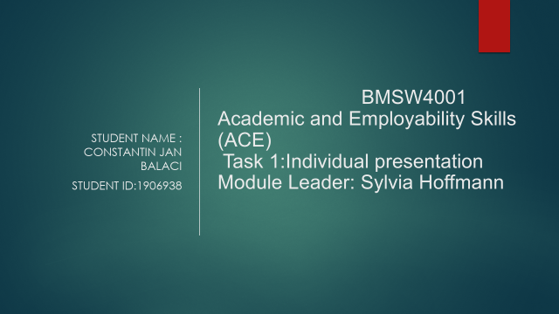
Task 1

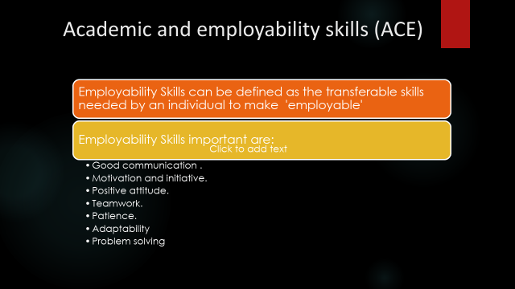

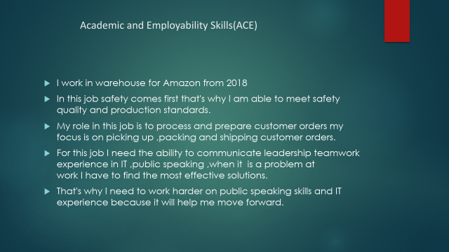

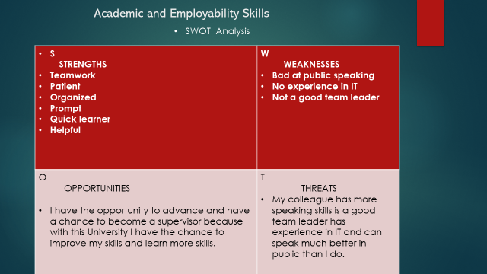

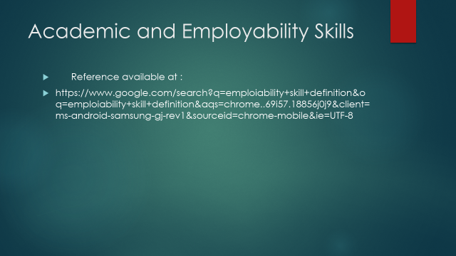

BMSW4001

Academic and employability skills

Module Leader: Sylvia Hoffman

Assignment title: ACE Practical Portfolio

Name student: Constantin Jan Balaci

Student id: 1906938

Group 1

Task 2

Table of Contents

1 0 Introduction

2.0 What academic and employability skills I have developed through this module

3.0 How the learning in this module helped me to develop the academic skills.

· Writing skills.

· Research skills.

· Referencing skills.

· Presentation skills.

4.0 Writing skills

In this module, according to the requirement I had to write to reports. By writing those reports my skills in writing got improved. My grammars, spellings, punctuations got corrected and I learned to write a job application. As writing can make it easy to express, my skills to express my thoughts and experiences got improved. I got to learn to show my personality through my writing. Now, I can write and express all of my concepts, logics and conflicts in an understandable way where my readers will not get confused. Through this module, I gained skills of giving others feedback with a clear concept and explaining the readers in a most comprehensible way through my writing. Team working skills.

· Communication skills.

· Problem solving.

5.0 CV writing

6.0 Summarising

7.0 Conclusion.

References.

- Introduction

Academic and employability skills helped me develop my skills.

Employability skills are transferable skills that you need all the time at work, these skills that I learned in this module make me much more attractive for jobs.

Employability skills sometimes they improve your performance, promote collaboration with colleagues to fulfil the role better.

Employability

· Skills

· Knowledge

· Qualification

· Attitude&Behaviour

· Personal attributes

· Experience

Examples Employability skills:

Communication

Communication is the most important hiring skill, because it is the essential part for every job. The communication process involves 5 elements: sender, receiver, message, means and feedback. When they work together they can transmit and understand messages efficiently and clearly expelling unnecessary errors, misunderstandings.

Advanced skills make us employees because they can expand a company‘s efficiency, productivity and help prevent the loss of valuable resources and time.

Listening to the instructions, ideas and intentions of your colleagues, the involvement of clear transmission of ideas, thoughts means being an effective communicator. Depending on the job you need to be competent in several different types of communication such as verbal, nonverbal, written and visual. For example, in my workplace we use verbal, visual and written communication. In order to improve our communication skills, we need to communicate as often as possible. The 4 types of communication are: Verbal, Nonverbal, Visual, Written.

Team working

Good teamwork skills refer to the ability to work harmoniously with colleagues to have a common goal. Teamwork can increase the chances of being hired. More things we can do to be hired is to do volunteering, working with others in an organization or joining a sports team.

Problem-solving

Problem solving is identifying problems and their implications, understanding the problems of the best solutions.

An example of a problem at work is in my opinion when you have to work for your colleague but they will be more appreciated and you will have paid the same but you do much more work. Here this problem must be solved by talking to the manager of the job and telling him that it is not right for you to work for your colleagues and that you just want to work the same because you are paid the same as them.

2. Through academic skills, one student can enhance their language skills, listening skills, writing skills, and learning skills. In the term of academic skills, through this module, my skills level in research, language, listening, learning, reflection, referencing, analysis and creativity got improved. Employability is very essential to achieve the job of desire. Employability skills include interpersonal skills, transferable skills along career management skills .My expertise in time management, communication, leadership, teamwork, research and analysis got enriched through this module. My abilities in the area of ​​problem-solving, decision making, technical side and critical analysis got rectified by participating in this module.

3.0 In order to have a better career, the role of academic skills and employability is vital.

For those who want to have a better career, continuously improving their academic skills is important. Because technologies are often advancing, they need to have higher education in order to devote themselves to all the latest technologies. Employers want people with a much greater edifice for these jobs. To be a successful person, much more confident In it and without anxiety it should have an academic ability. These are the factors that we need at work. From this module I have had enough help to improve my academic skills and to be employed. Module I have acquired knowledge in writing, research and references in an academic style. Through this module my academic skills have been improved, these are, paraphrasing, structuring, presentation and writing skills.

Taking part in this module increased my reference skills, I learned how to write reports correctly, write essays, thesis papers and research. At this point I know what a text reference means and arranging references in the style of Harvard Referencing. In the next courses I will do this reference skill will be very helpful.

4.0 Writing skills

In this module, according to the requirement I had to write to reports. By writing those reports my skills in writing got improved. My grammars, spellings, punctuations got corrected and I learned to write a job application. As writing can make it easy to express, my skills to express my thoughts and experiences got improved. I got to learn to show my personality through my writing. Now, I can write and express all of my concepts, logics and conflicts in an understandable way where my readers will not get confused. Through this module, I gained skills of giving others feedback with a clear concept and explaining the readers in a most comprehensible way through my writing.

5.0 CV writing

Writing a CV is very important when you want to get hired because in that CV you describe where you worked, what skills you have, what education you have, personal information, references from the last jobs, what qualifications you have hobbies and interests knowing all this and depending on your experience and education, it will be easier for you to get the job you want.

Thanks to this module I managed to make a CV because through it I learned how to do it .

6.0 Summarising

In order to make a summary we need to read and understand the promotions or writing instructions, about what we will have to write. For example we will take an article from a newspaper and we will have to take out the main ideas. We will have to find very important details that support the ideas of that article in the newspaper. We will make a summary in our own words. We should avoid copying sentences from the article we should write in our own words and make a summary of that article.

Thanks to this module I learned how to make a correct summary, and learning to make a correct summary will help me in the future.

Conclusion

In conclusion, in this module I have advanced several speaking skills, writing, doing team work, writing a resume, being able to make a summary, all these things I have learned through this module.

Also how can I solve problems at work.

I will attach what I wrote on the notebook in class.

References available at:
04/12/2021
https://www.globalcoursework.com/academic-and-employability-skills-assignment-sample-gc0547/

https://www.studentsassignmenthelp.co.uk/answers/unit-42-employability-skills-assignment/
https://www.indeed.com/career-advice/finding-a-job/employability-skills

 | K, ㄥㄥs Wekfé
 |  | 
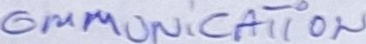 |  | T4pt 0

 |  | 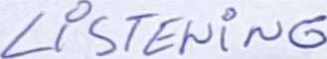
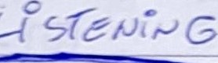 |  | 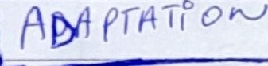
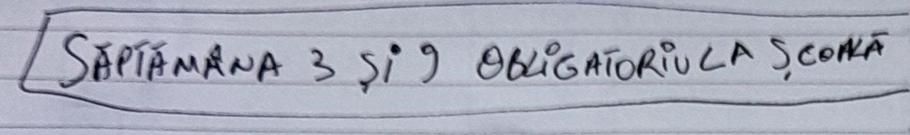
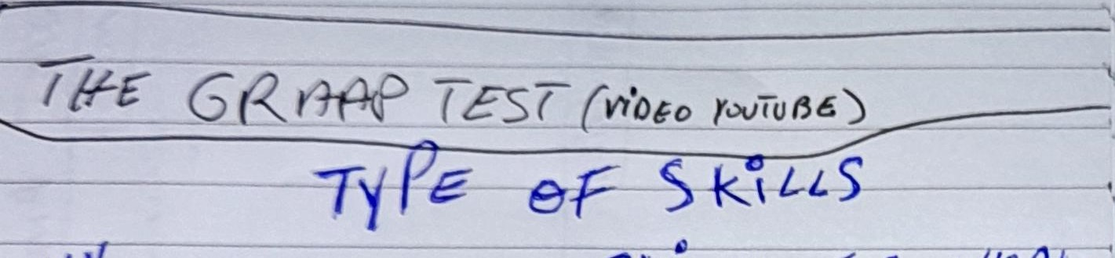
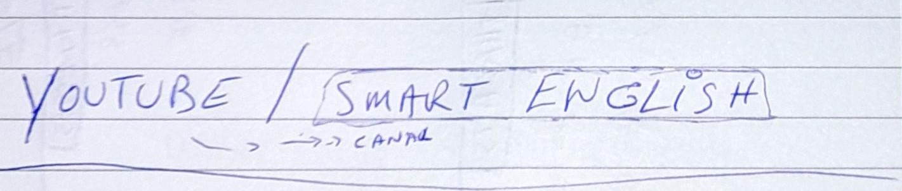

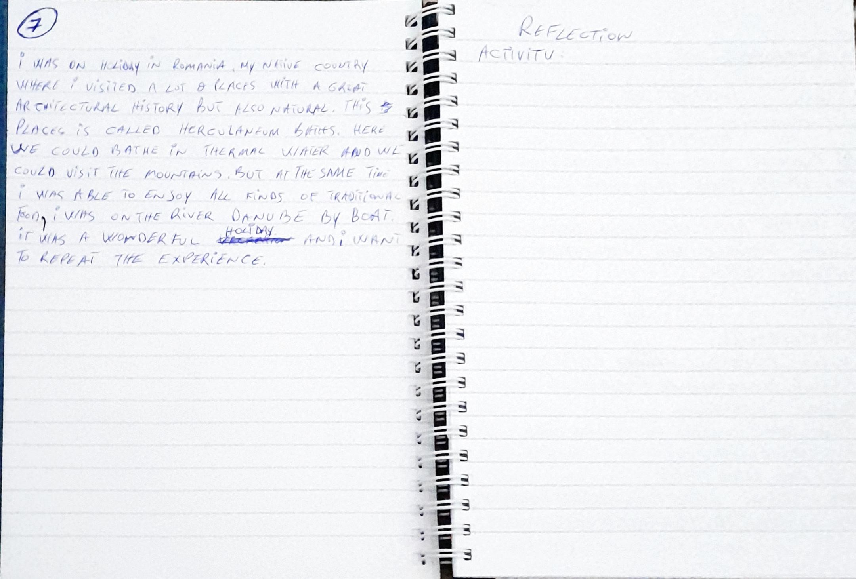
V
旅
に
C
ん
ん
3
ツ



