

Applied Computing

Wales Institute of Science and Art (WISA)

Advanced Networking (ACCA5024)

Lab 3: Design and Configure IPv4 Network

Kindly note that the step by step instruction for this lab is demonstrated during the tutorial session. After completing the lab, you

have to submit both the packet tracer file and the document via moodle

n.kaliyamurthy@uwtsd.ac.uk 1

Objectives
Task 1: Determine and Calculate IPv4 Address Subnetting
Task 2: Calculate VLSM Subnetting
Task 3: Build a Network and configure End and Intermediate devices Required Resources
- 1 PC (Windows with Internet access)
- Optional: IPv4 address calculator
- Packet Tracer (Latest version)




ABC Corporation is a small business company which has an existing network which requires some modifications. Based on the requirements, you are expected to subnet the network and configure the devices. Do Variable Length Subnet Masking. You are asked to use IP Addressing Scheme:

Network
A 50
Hosts
Network C
20
Hosts
Network
B
2
Hosts

Fill the tables with appropriate information/ details.
 | Subnet as per the Requirement
Specification | Network: A | Network: B | Network: C
Network Address | 192.168.100.0/26 | 192.168.100.96/30 | 192.168.100.64/27
Subnet Mask | 255.255.255.192 | 255.255.255.252 | 255.255.255.224
No. of asked hosts/subnet | 50 | 2 | 20
No. of usable hosts/ subnet | 62 | 2 | 30
First Usable Host (FUH) | 1 | 97 | 65
Last Usable Host (LUH) | 62 | 98 | 94
Broadcast Address | 192.168.100.63 | 192.168.100.99 | 192.168.100.95

 |  | Addressing Table
Device | Requirement | IP address | Subnet Mask | Gateway
PC1 | 1st Usable Host  Network: A | 192.168.100.1 | 255.255.255.192 | 192.168.100.62
Laptop1 | 2nd Usable Host  Network: A | 192.168.100.2 | 255.255.255.192 | 192.168.100.62
PC2 | 1st Usable Host  Network: B | 192.168.100.97 | 255.255.255.252 | 192.168.100.98
PC3 | 1st Usable Host  Network: C | 192.168.100.65 | 255.255.255.224 | 192.168.100.94
Laptop0 | 2nd Usable Host  Network: C | 192.168.100.66 | 255.255.255.224 | 192.168.100.94
RAI G0/0/0 | Last Usable  Host  Network: A | 192.168.100.62 | 255.255.255.192 | N/A
RIBC G0/0/1 | Last Usable  Host  Network: B | 192.168.100.98 | 255.255.255.252 | N/A
RIBC G0/0/0 | Last Usable  Host  Network: C | 192.168.100.94 | 255.255.255.224 | N/A
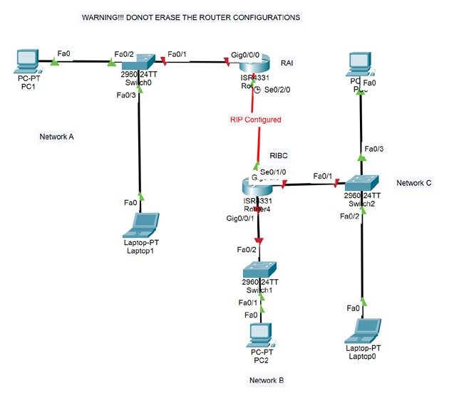
Create the below Topology

Initialize the Device and configure step by step:
- Initialize ALL the Switches.
- Delete the Old VLan Database in ALL the Switches (S0, S1 & S2) and reload.
- Check the Switches with appropriate command to find Old VLan Database is deleted.
Write down the above command here:
- Configure all the End devices (Hosts) with appropriate IP Address, Subnet Mask and Default Gateway.
- Assign host names as per the topology for all intermediate devices.
- Set a minimum length for passwords as 7 in all routers.
- Assign Encrypted Privileged Passwords for all routers.
- Configure Console Connection: Set password for RAI Console as ciscocon.
- Configure Line Connection and allow only Telnet Access for RAI:
Total 5 Lines, Password for Line Connection is ciscovty.
- Encrypt all the Clear Text Passwords for all routers.
- Create a Banner (MOTD) for all routers "ONLY AUTHORISED ACCESS".
- Based on the Addressing Table derived by you at IPv4 Addressing Scheme Part, Configure the G0/0/0, G0/0/1 for RIBC and G0/0/0 Interface of Router RAI and activate the interface with appropriate IP Address. Add Descriptions suitable to the Topology.
- Disable DNS Lookup in Router RAI.
- Configure Domain Name as www.advancednetworking.com Configure all the switches:
- Assign Names as per the Label for Switches.
- Shut down all unused ports in switches.
- Ping Test from all Hosts to confirm the working Network. Troubleshoot if needed.

