

University of Wales Trinity Saint David
School of Engineering

Heat Exchanger Laboratory Analysis
Thermofluid Mechanics M5X00406

Michael James George Heys
1702352
26.04.2020
Contents
1 Introduction 1
1.1 Aims 1
1.2 Objectives 1
1.3 Background 2
2 Experimental Procedure 3
3 Results 4
3.1 Experiment 3 Tables 4
3.2 Equations 5
3.3 Graphs 7
4 Discussion of Results 12
5 Conclusion 14
6 Evaluation 15
7 References 16
8 Appendix 17
8.1 Experiment 2 Tables 17
8.2 Experiment 1 Tables 17

List of Figures
Figure 1 TD1007 Water to Air Heat Exchanger 3
Figure 2 List of Constants 4
Figure 3 Heat Transfer Coefficient Values from Experiment 1 13

List of Graphs
Graph 1 Experiment 3 7
Graph 2 Experiment 3 7
Graph 3 Experiment 3 8
Graph 4 Experiment 2 8
Graph 5 Experiment 2 9
Graph 6 Experiment 2 9
Graph 7 Experiment 1 10
Graph 8 Experiment 1 10
Graph 9 Experiment 1 11

Introduction

Aims
This report aims to discuss the thermodynamic characteristics of a heat exchanger, discuss the theory and show how adjusting different aspects of the heat exchanger affects its performance. We will be adjusting variables such as air pressure, fluid flow rate and temperature and collecting data to analyse and see how they influence our results.

Objectives
We will be performing a set of experiments using a cross flow heat exchanger with the fluid banks in a parallel flow configuration. The first experiment will be adjusting the fluid flow rate from 1.75 l/min down to 0.25 l/min at 250Pa, the second experiment will be changing the air pressure from 250Pa down to 25Pa at 60°C, and the third and final experiment will also be changing the air pressure from 250Pa down to 25Pa but this time it will be conducted at 45°C.

Background
A heat exchanger is a component of a system that allows heat to transfer from one fluid to another. Heat exchangers work by means of two fluids coming into thermal contact with a material or interface between the two (Woodford, 2009/2018). As heat only flows from hot to cold, the hotter of the two fluids will start to heat up the cooler, thus removing energy from the hotter and lowering the temperature. There is no mass exchange or interactions, only energy changes. This is because the fluids do not mix due to the interface separating the fluids. A common example of a heat exchanger is a car radiator; as the coolant passes through the radiator (hot flow) air is pushed through the radiator by the moving vehicle, removing some of the energy from the coolant causing it to leave the radiator cooler than when it entered. Subsequently the air will leave the radiator at a higher temperature. This configuration is known as a cross flow heat exchanger because the two fluids are moving perpendicular to each other, with one fluid passing over the other.
Heat exchangers are used in many applications and can be used to boil or condense fluids, and indeed cool them to a more appropriate temperature. There are several different types of heat exchanger, Parallel Flow, Counter Flow and Cross Flow.
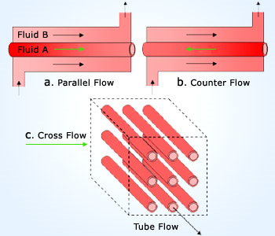
(Simply Science, n.d.)

Experimental Procedure
The brief specifies that we start with the experiment in which we adjust the flow rate of the hot fluid, however in practise we began with the third experiment, followed by the second and then the first experiment. We carried out the experiments in this order because of timings. We had a two-hour slot to complete the experiments and record all the data, so we had to make best use of the time. We were informed by the lecturer that it would take longer for the water temperature to cool from 60°C to 45°C than it would to heat up from 45°C to 60°C, hence the order of our experiments.
We began our first experiment (experiment three) with ensuring the hot flow banks were in a parallel configuration, and that all the temperature sensors were in place and connected correctly. We then set the temperature at 45°C and the flow rate to 0.25 l/min, set our pressure to 250Pa and waited for 4 minutes for the temperature sensors and other sensors to settle before we began to record data. Once the sensors had settled and were reading a consistent result, we recorded the temperatures of the air and water at their inlets and outlets. Then we adjusted the pressure down to 200Pa and waited another 4 minutes until the results settled and recorded the data. The process is then repeated until one reaches 25Pa. The same process is then repeated at 60°C, varying the pressure through 250, 200, 150, 100, 50, and 25Pa’s (experiment two).
Our third and final experiment was experiment one, in which we adjusted the hot flow rate from 1.75 l/min down to 0.75 l/min and kept the pressure constant at 250Pa and the temperature at 60°C. The same procedure as Experiments two and three was followed; we waited for 4 minutes after changing the flow rate before recording the temperature results.
The tolerance for the water flow rate was +/- 0.01 l/min, and the tolerance for the air pressure was +/- 5 Pa.
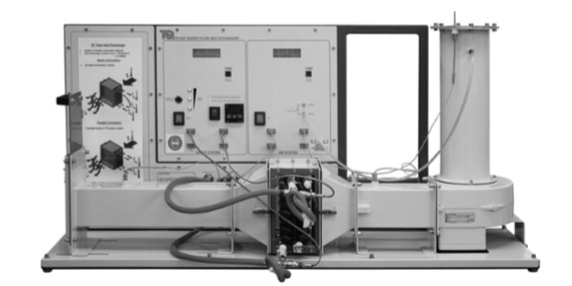

(TecQuipment)

Figure 1 TD1007 Water to Air Heat Exchanger

Results

Experiment 3 Tables
Coefficient of discharge | 0.6
Diameter of Orifice | 0.10011 | m
Area of Orifice | 0.007871 | m^2
Barometric Pressure | 100900 | Pa
 | 1.009 | bar
Room Temperature | 27 | °C
R | 287 | J/kg·K
Area of Hot Flow Piping | 0.1558 | m^2
V̇w | 0.25 | l/min
ṁw | 0.004154 | kg*s^-1
CpA | 1005 | J.kg^-1K^-1
Figure 2 List of Constants

Equations
Water Flow conversion:

Air Flow:
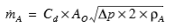

Temperature Efficiencies (ƞ):
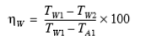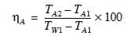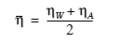

Densities (ρ):
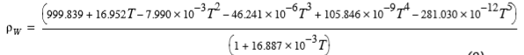
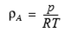

Specific Heat Capacity of Water (C_{pW}):
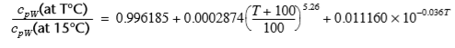

Heat Transfer (Q):
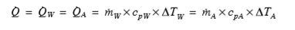

Logarithmic Mean Temperature Difference (LMTD):
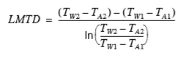

Energy Balance Coefficient (C_{EB}):
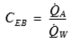

Heat Transfer Coefficient (U):
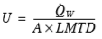

(TecQuipment) This citation covers all of the equations above.

Graphs
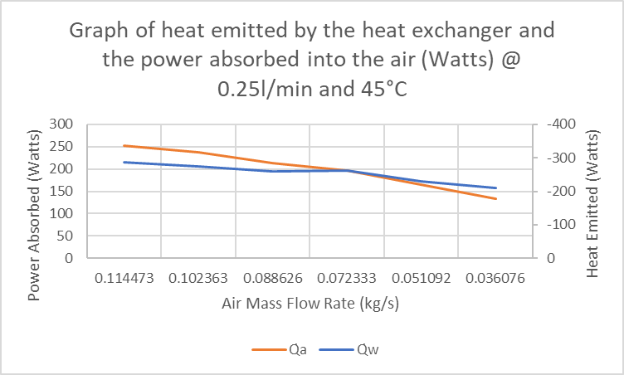
Graph 1 Experiment 3

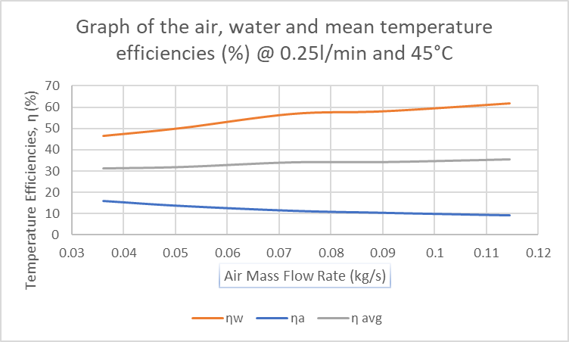
Graph 2 Experiment 3

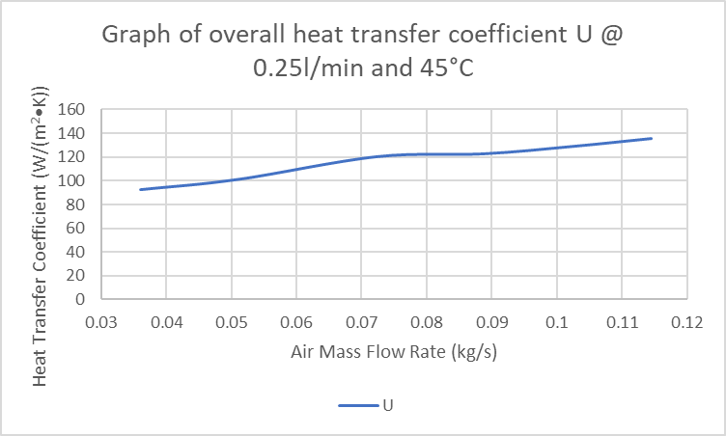
Graph 3 Experiment 3

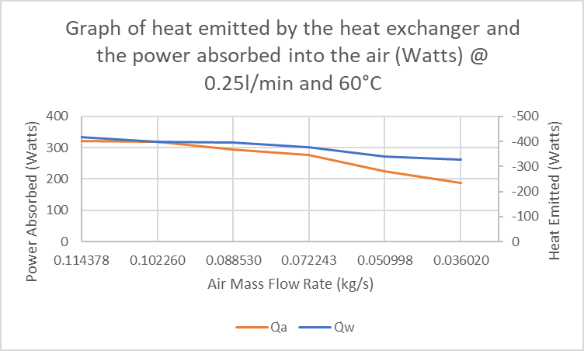
Graph 4 Experiment 2

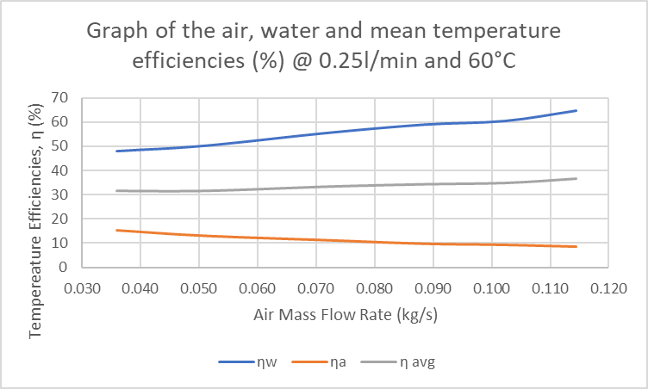
Graph 5 Experiment 2

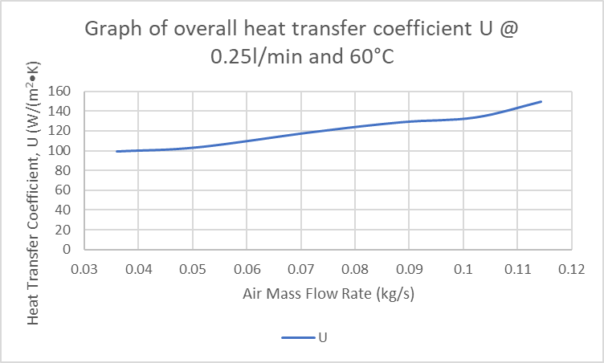
Graph 6 Experiment 2

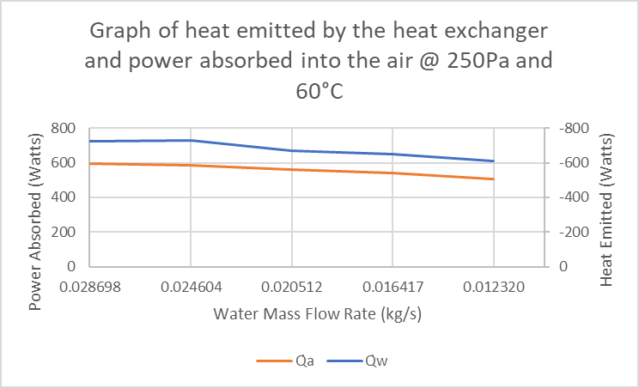
Graph 7 Experiment 1

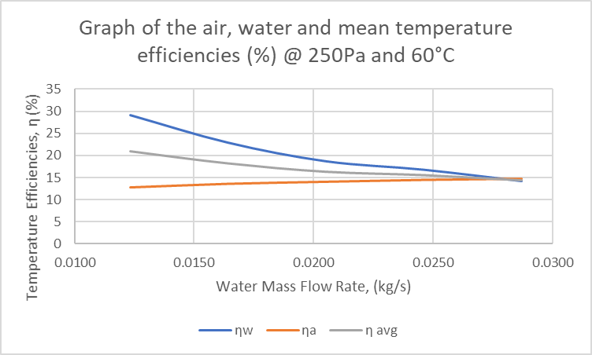
Graph 8 Experiment 1

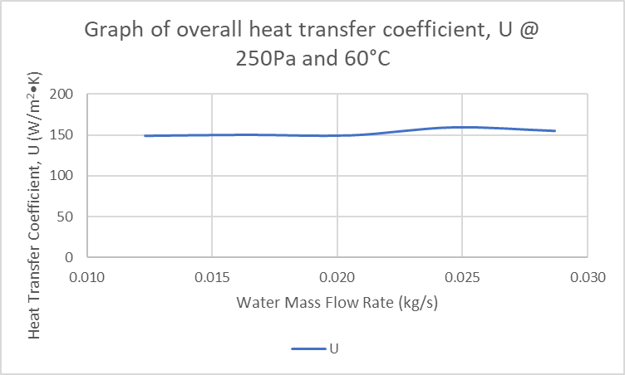
Graph 9 Experiment 1

Discussion of Results
Graph 1 shows the heat emitted from the hot flow pipes and the power absorbed into the air passing over the pipes during experiment 3. The graph shows that as the air mass flow rate drops, the heat transferred by the hot water and the power absorbed into the air also drops. This is because with a decreased air flow, less air flows over the pipe in a given time, resulting in less opportunities for heat to transfer from the hot pipes into the air. The graph also shows that the two lines follow each other very closely. This is because of the law of conservation of energy, which states that energy can neither be created nor destroyed but transformed (J.M.K.C. Donev et al., 2018). This graph clearly shows that when the water loses energy the air gains most of that energy loss, supporting this theory. It is possible that not all the energy given off by the pipe would be absorbed into the air, this could be down to things such as air leaks in the heat exchanger affecting the efficiency of the heat exchanger.
Graph 2 shows the temperature efficiencies of the air, water and the combined temperature efficiency of the whole heat exchanger for Experiment 3. As the air flow rate increases the thermal efficiency of the water increases from 46% to 61%, and the thermal efficiency of the air drops from 16% down to 9%. This is because of the different densities of the fluids and their capacity to store energy due to their atomic structure. With air being a gaseous liquid with a density of 1.16 to 1.17 kg.m³, it requires less energy to change its temperature as the atoms are further apart but already have more energy than the water molecules, which means they require less energy to interact with other air atoms. This is compared with water being a liquid with a density of 990 to 991 kg.m³ with a much lower proximity to its neighbouring atoms and a much lower internal energy value, meaning that it takes more energy than air to change temperature.
Graph 3 shows the overall heat transfer coefficient of the heat exchanger during Experiment 3. It clearly shows that as the air flow rate increases so does the heat transfer coefficient, proving that there is a positive correlation between heat transfer and the air flow rate. The graph also shows that the increase in heat transfer coefficient is relatively linear, suggesting that the air mass flow rate and heat transfer coefficient are proportional values. As one increases, so does the other. This is because of the increased air flow rate forcing more air over the hot flow pipes.
Graphs 4, 5 and 6 from Experiment 2 follow the same trends and patterns as those from Experiment 3 (graphs 1, 2 and 3). This is because we carried out the experiment in the same way, just at a temperature increase of 25%, 60°C. As such the results are increased and exaggerated. The maximum and minimum values for both the Q_{w} and Q_{a} increased by over 100W for the water and around 70W for the air compared with the values from Experiment 3. This demonstrates that more heat transfer occurs when a higher starting temperature of the water is used.
Graph 7 is from Experiment 1 and shows the heat emitted from the water and power absorbed into the air when adjusting the water flow rate instead of the air pressure, whilst keeping the temperature and pressure constant at 60°C and 250Pa respectively. This graph also follows the same pattern as the trends in graphs 1 and 4, only with a larger difference between the two lines. This graph proves that adjusting the water mass flow rate has a similar effect to adjusting the air pressure and so the air mass flow rate, resulting in an increase in heat transfer and power absorption.
Graph 8 shows the air, water and mean temperature efficiencies for Experiment 1, at 250Pa and 60°C. The graph follows a similar trend, but the lines are inversed because it is the water flow rate that changes with the air pressure remaining constant (opposite to Experiments 2 and 3). The water efficiency figures start much lower than Experiments 1 and 2, starting at 29.15% dropping down to 14.16%. Whereas the air efficiency increases from 12.82% to 14.73%. The smaller efficiency range is due to the smaller scale of adjustments made to the water flow rate, compared to the 225Pa change made to the air pressure in Experiments 2 and 3. At 0.0275 kg/s the water and air efficiency lines intersect.
Graph 9 shows the overall heat transfer coefficient of the heat exchanger during Experiment 1. The values generated to create this line fluctuate from 148.579 to 159.392 W/(m²•K) as shown in the table below, but do not steadily increase. This leads me to believe that whilst the heat transfer rate for the air and water increases with increased flow rate, the overall coefficient in this instance does not. There may be an anomaly somewhere which I haven’t seen, but I believe these results to be accurate.

Figure 3 Heat Transfer Coefficient Values from Experiment 1

Conclusion
To conclude, the experiments were successful in demonstrating the thermodynamic characteristics of a cross flow heat exchanger. By adjusting variables such as the water flow rate and the air pressure, we can clearly see that the performance is affected and that fluid flow rates are proportional to the amount of heat transfer that occurs; as you increase the flow rates the amount of heat transfer also increases, as one would expect to see from a conventional heat exchanger. It is also evident that as the hot flow temperature is increased there is an increased amount of heat transfer from the water to the air.

Evaluation
If I were to do the entire experiment again, I would do numerous things differently. Whilst I believe that our experiments were a success and provided good clear results, it would be interesting to see if by making a few small changes, how much it would impact the new results.
Initially I would run the experiments in the suggested order, starting with Experiment 1 (adjusting hot fluid flow rate); but whilst doing the first experiment I would also raise our maximum fluid flow value from 1.75l/min to either 2 l/min or 2.25 l/min. This is because I would like to see if the higher ceiling would change the heat transfer coefficient graph and values for Experiment 1. I would also like to see how long it takes the heat exchanger to cool down from 60°C to 45°C, as this was the driving force behind our final decision on the order that we carried out the experiments.
Another thing that would do differently in the repeat experiment is adjust the waiting period for allowing the sensors in the heat exchanger to settle in equilibrium. This is because we only waited for 4 minutes due to time constraints and the suggestion of the lecturer, however the TD1007 User Guide said to wait for 5 minutes. Whilst this may not sound like a big difference, another 60 seconds could mean the results gathered would be different, and as such produce similar but slightly different graphs.
When doing the repeat experiment, I would also create an excel document using the same format as suggested (as we have) with the equations already inputted into the spreadsheet. This would save time and provide a swifter idea as to whether the experiments were successful or not.
In using the suggested table layout, I have found that my figures and graphs generally appear to be as expected. There are however a few potential anomalies that I am unsure of their origin and would like to see if they appear in a repeat experiments data.

References
J.M.K.C. Donev et al. (2018). Law of Conservationof Energy. Retrieved from Energy Education: https://energyeducation.ca/encyclopedia/Law_of_conservation_of_energy
Simply Science. (n.d.). Applications of heat-exchangers in food industry. Retrieved from Simply Science: https://www.simply.science/popups/App_Food_Industry.html
TecQuipment. (n.d.). TD1007 Water to Air Heat Exchanger User Guide.
Woodford, C. (2009/2018). Heat Exchangers. Retrieved from Explain That Stuff: https://www.explainthatstuff.com/how-heat-exchangers-work.html

Appendix

Experiment 2 Tables

Experiment 1 Tables

