Landscape & Sustainable Recreation assignment 2
Student name: Tamin Trongklang
Student number: 1902236
Module code: BMOE6003
Module: Landscape & Sustainable Recreation

Introduction
In this reflective journal, I aim to use my experiences from visiting the two places that I have chosen. These two places are Big Pit in Blaenafon and The Wildfowl and Wetland Trust centre in Llanelli. In many parts of the world, cultural heritage has also been destroyed or transformed through large-scale construction projects such as dams, railways, etc., in order to develop resources and create profit (Critical Perspectives on Cultural Memory and Heritage, 2020). Heritage is a vehicle of communication, a means of transmission of ideas, values and knowledge, which includes the tangibles and intangibles of both cultural and natural heritage (Ashworth 2007).
In the past years there have been several Scholoars ( Holtorf 2015, 2018; Harrison 2013; DeSilvey 2017) in heritage studies, who have developed a provocative but helpful discussion about the heritage process from a different perspective. Their argument is that in order to develop new heritage and new memories; it is necessary to destroy and transform old culture and heritage. However, due to these studies being quite new, there are still concerns on whether there is enough attention paid to the ethical side of the destruction and transformation of heritage.

Big pit
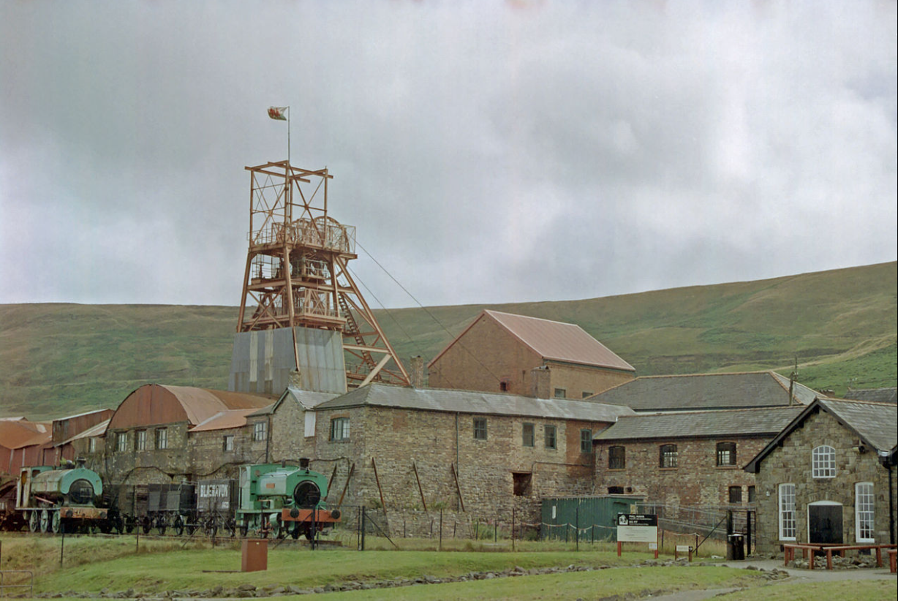
Image of big Pit from wikipedia

Big Pit is a well-known coal mine in Wales, Blaenafon. To this day it is still a coal mine, however, it is now used and maintained by miners to showcase how the mine was operated when it was functional. There were multiple mines in Blaenafon, including Forge Level, that were initially used to mine for ironstone in an effort to support their local ironworks. Coal was still mined to aid the local demand however it was not until the nineteenth century when the reign of “King Coal” was introduced to South Wales.

One of the main qualities of Welsh coal was for its steam producing qualities. Consequently, the demand for this coal rose in the second half of the nineteenth century when steam-powered engines came into place. This led to new collieries opening and an increase in miner employment. The mines were now getting dug deeper and deeper. At its peak in 1913, the South Wales Coalfield was the most productive in Britain and employed nearly a quarter of a million men (National Museum of Wales).

The unusual shape of Big Pits shaft being large and elliptical is what gives it its character. From my visit to this place, instantly I felt the presence of Big Pit and how its location was built in a way where you could look down on the valley below and feel like you were really high up. The moment when I looked up at the big red mechanical lift system, it reminded me of the Welsh dragon overlooking the valley.

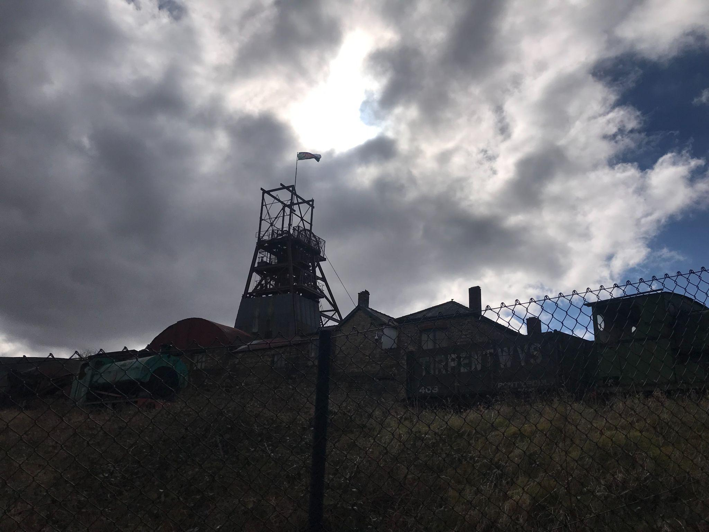
Image of Big pit from Tamin (2022)

The National Museum of Wales mentions that there is evidence of mining in Blaenafongoing back to the 14th century and the mine at Mostyn dating as far back as 1261. Due to the high demand of coal, many children were also employed and boys and girls as young as 6 years old would be down the mines opening and closing the doors to keep the mines ventilated. They were known as “door boy” and “door girls '. They would sit for hours in the cold and dark with one candle for light. (National Museum of Wales)

Landscape Quality
The majority of Britain's coal came from remains of plants which are 289-300 million years old. There are similar forests found today like the Everglades in Florida, the USA however the types of plants are different. The forests formed in Britain’s coal seams existed in the period called the Carboniferous period (National Museum of Wales). The National Museum of Wales also states that:
Covering an area of about 1,000 square miles, the South Wales Coalfield is the largest continuous coalfield in Britain. This region has played a very important role in the development of Britain and the world. Used for smelting metals and powering steam engines, Welsh coal helped fuel the Industrial Revolution.
Designations
Big Pit is now a unique industrial landscape so it has been made into a World Heritage Site by The United Nations Educational, Scientific and Cultural Organization (UNESCO) in the year 2000. UNESCO aims to encourage the identification, protection and preservation of cultural and natural heritage around the world considered to be of outstanding value to humanity(UNESCO World Heritage Convention) . This is embodied in an international treaty called the Convention concerning the Protection of the World Cultural and Natural Heritage, adopted by UNESCO in 1972 (UNESCO World Heritage Convention). The uniqueness of a World Heritage Site is that it belongs to the people all over the world irrespective of where the site is located. The sites are designated as having “outstanding universal value” under the Convention Concerning the Protection of the World Cultural and Natural Heritage (Britannica, T. Editors of Encyclopaedia, 2018).
Use
Although Big Pit no longer produces coal, it is still classed as a coal mine under the Coal Mines Act (Museum. Wales). Currently, Big Pit is used as a museum to show people how the miners used to work down in the mine and the facilities such as the baths above the mine. The miners now take people on tours around the mine rather than actually mining for coal. The underground tours usually last around 1 hour and they take you down 300 feet underground.
There are also galleries showcasing “King Coal” and audio/visual experience telling the story of how the Welsh mining industry evolved. Further up from the mine shaft are the Pit Head Baths where there are items and exhibitions showing what equipment the miners carried and stories of how a life of a miner has changed from 1850 to 2000
Access
Big Pit is located on a side of a steep hill on a number of different levels so there are ramps available for disabled access however it is long and the climb can be arduous. The fact that not much has changed from when the mine was in use means that the ground above and below is typical of an industrial site so they advise to wear sturdy shoes.
Future Potential
I believe that in order to protect the heritage and culture of Big Pit, schools should make a point in teaching about the history of Big Pit as well as the importance of coal back when the demand was high. This will ensure that children are aware of the history that made South Wales such an important place. I also think that visiting a few times helps to remember better because as a child, I could only remember simple things that fascinated me whereas now after a recent visit, I can remember the important facts that relate to coal mining because I am old enough to understand.

LLanelli Wetland Centre

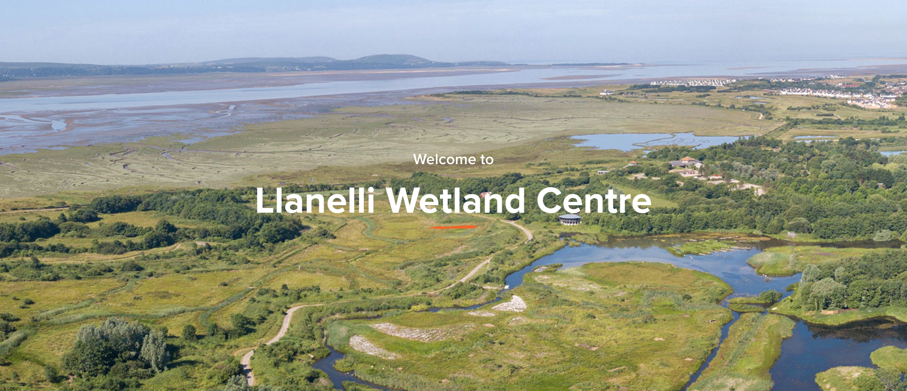
WWT.org.uk

The Wildfowl and Wetland Trust in Llanelli includes marshes, fens, peatlands, and coastal areas which are not only among the richest ecosystems in biodiversity, but also among the most fragile environments (Russi et al, 2013). The point of a wetland area is to mimic natural water level dynamics, prevent disturbance and nutrient loading, and buffer pollutants and runoff, respectively, among other positive benefits (Tozer, D.C., Steele, O. and Gloutney, M., 2018). Wetlands are valuable for numerous ecological and social reasons, such as greenhouse gas sequestration, commercial fishing, flood control, pollution mitigation, and recreation (Sierszen et al., 2012). Most importantly, they are critical hotspots for biodiversity conservation (Gibbs, 2000). As a result, various policies, regulations, and other mechanisms exist at a number of scales to conserve wetlands. According to the Wildfowl and Wetlands Trust, all of their sites include wetland treatment systems, using the natural functions of vegetation, soil and organisms to treat different wastewater streams.

Indeed, they are subject to a process of continuous deterioration driven by anthropogenic pressures such as infrastructure development and land conversion, water withdrawal, eutrophication and pollution, and overharvesting and overexploitation (Elliott et al. 2014; Seilheimer et al. 2009).

Forty-seven percent of the world's population currently lives in cities, and by 2030 more than sixty percent will be urban dwellers. As commerce and culture become more globalized, natural habitats become more remote for most of us. Even the countryside is becoming ever increasingly managed, with agribusiness often dictating how habitats are constituted. Many of today's children, although fascinated by animals and wildlife on television, have never seen a truly "natural" habitat.

( KNAPP, 2000. pp. 877)

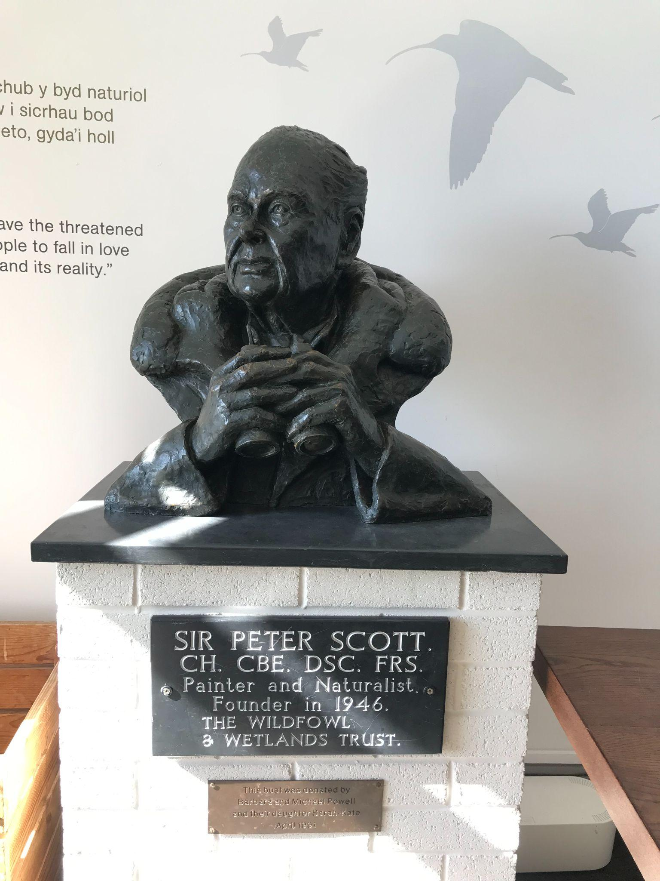
Image of Sir Peter Scott from Tamin (2022)

Sir Peter Scott was the son of Antarctic explorer Captain Scott who, in his dying letter, urged Peter’s mother to “make the boy interested in natural history” (Wildfowl & Wetlands Trust). Sir Peter Scott’s fascination with geese that had flown from unknown habitats led to him protecting the birds and then going on to protect their wetland habitats. Furthermore, Sir Peter Scott set up the Wildfowl and Wetlands Trust in 1946 at Slimbrudge as a centre for science and conservation (Wildfowl & Wetlands Trust). This was also made open to the public because Sir Peter Scott wanted them to also get closer to nature. He and his family influenced the people of Britain to love the countryside by watching their wildlife show which they presented from their studio overlooking the lakes at Slimbridge.

Landscape Character
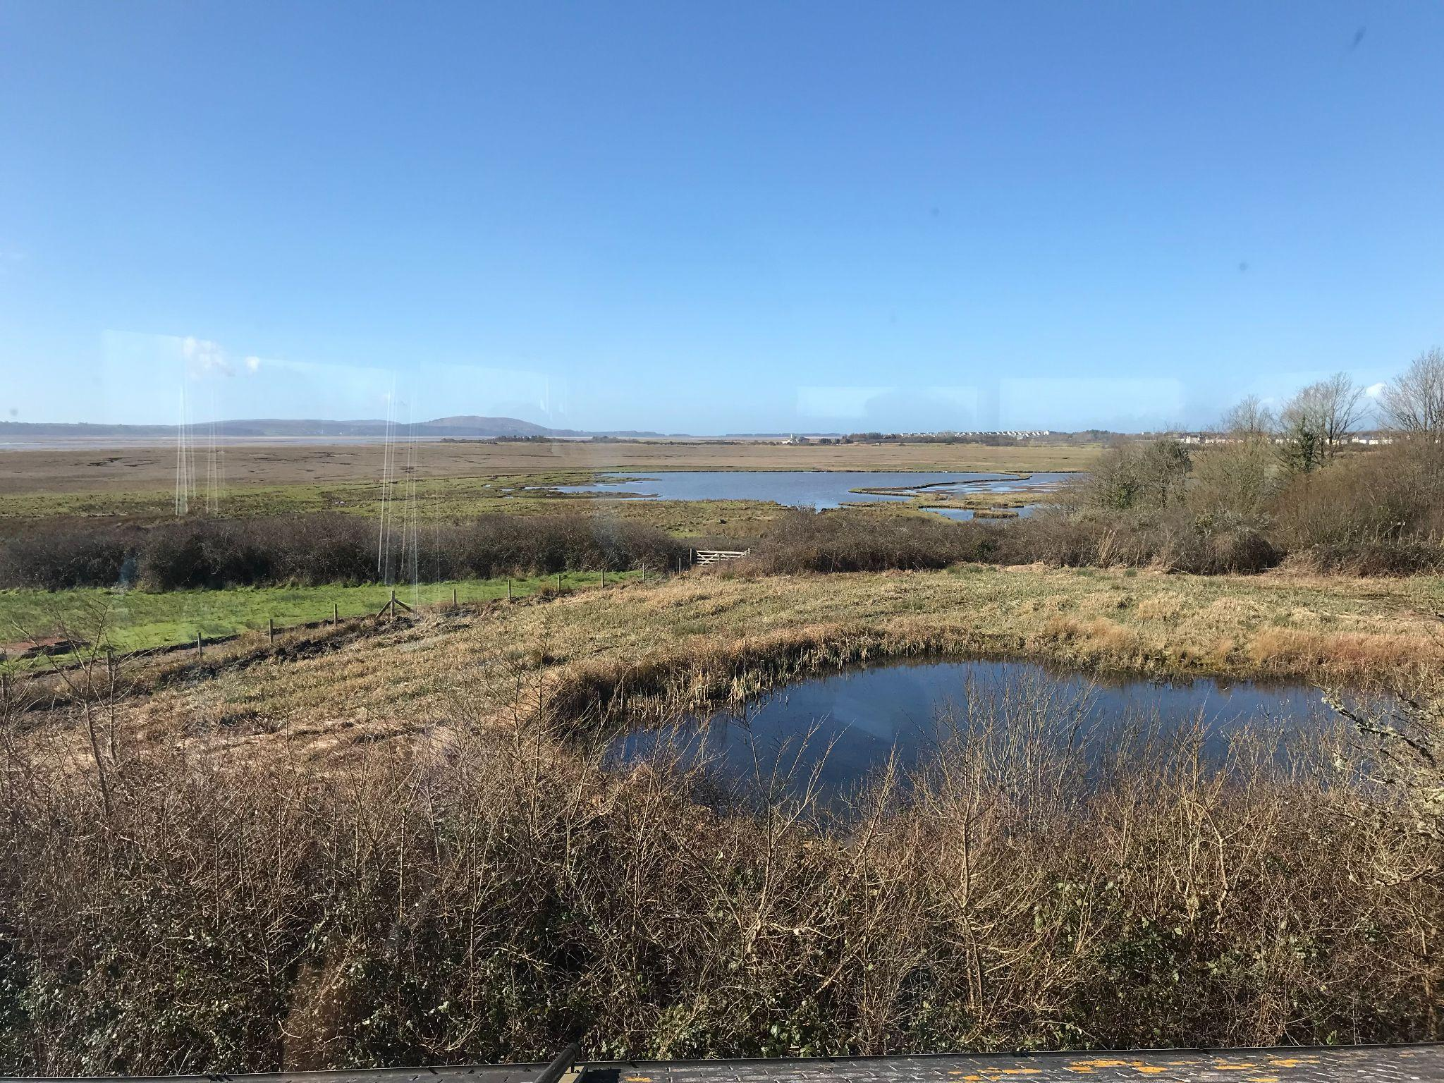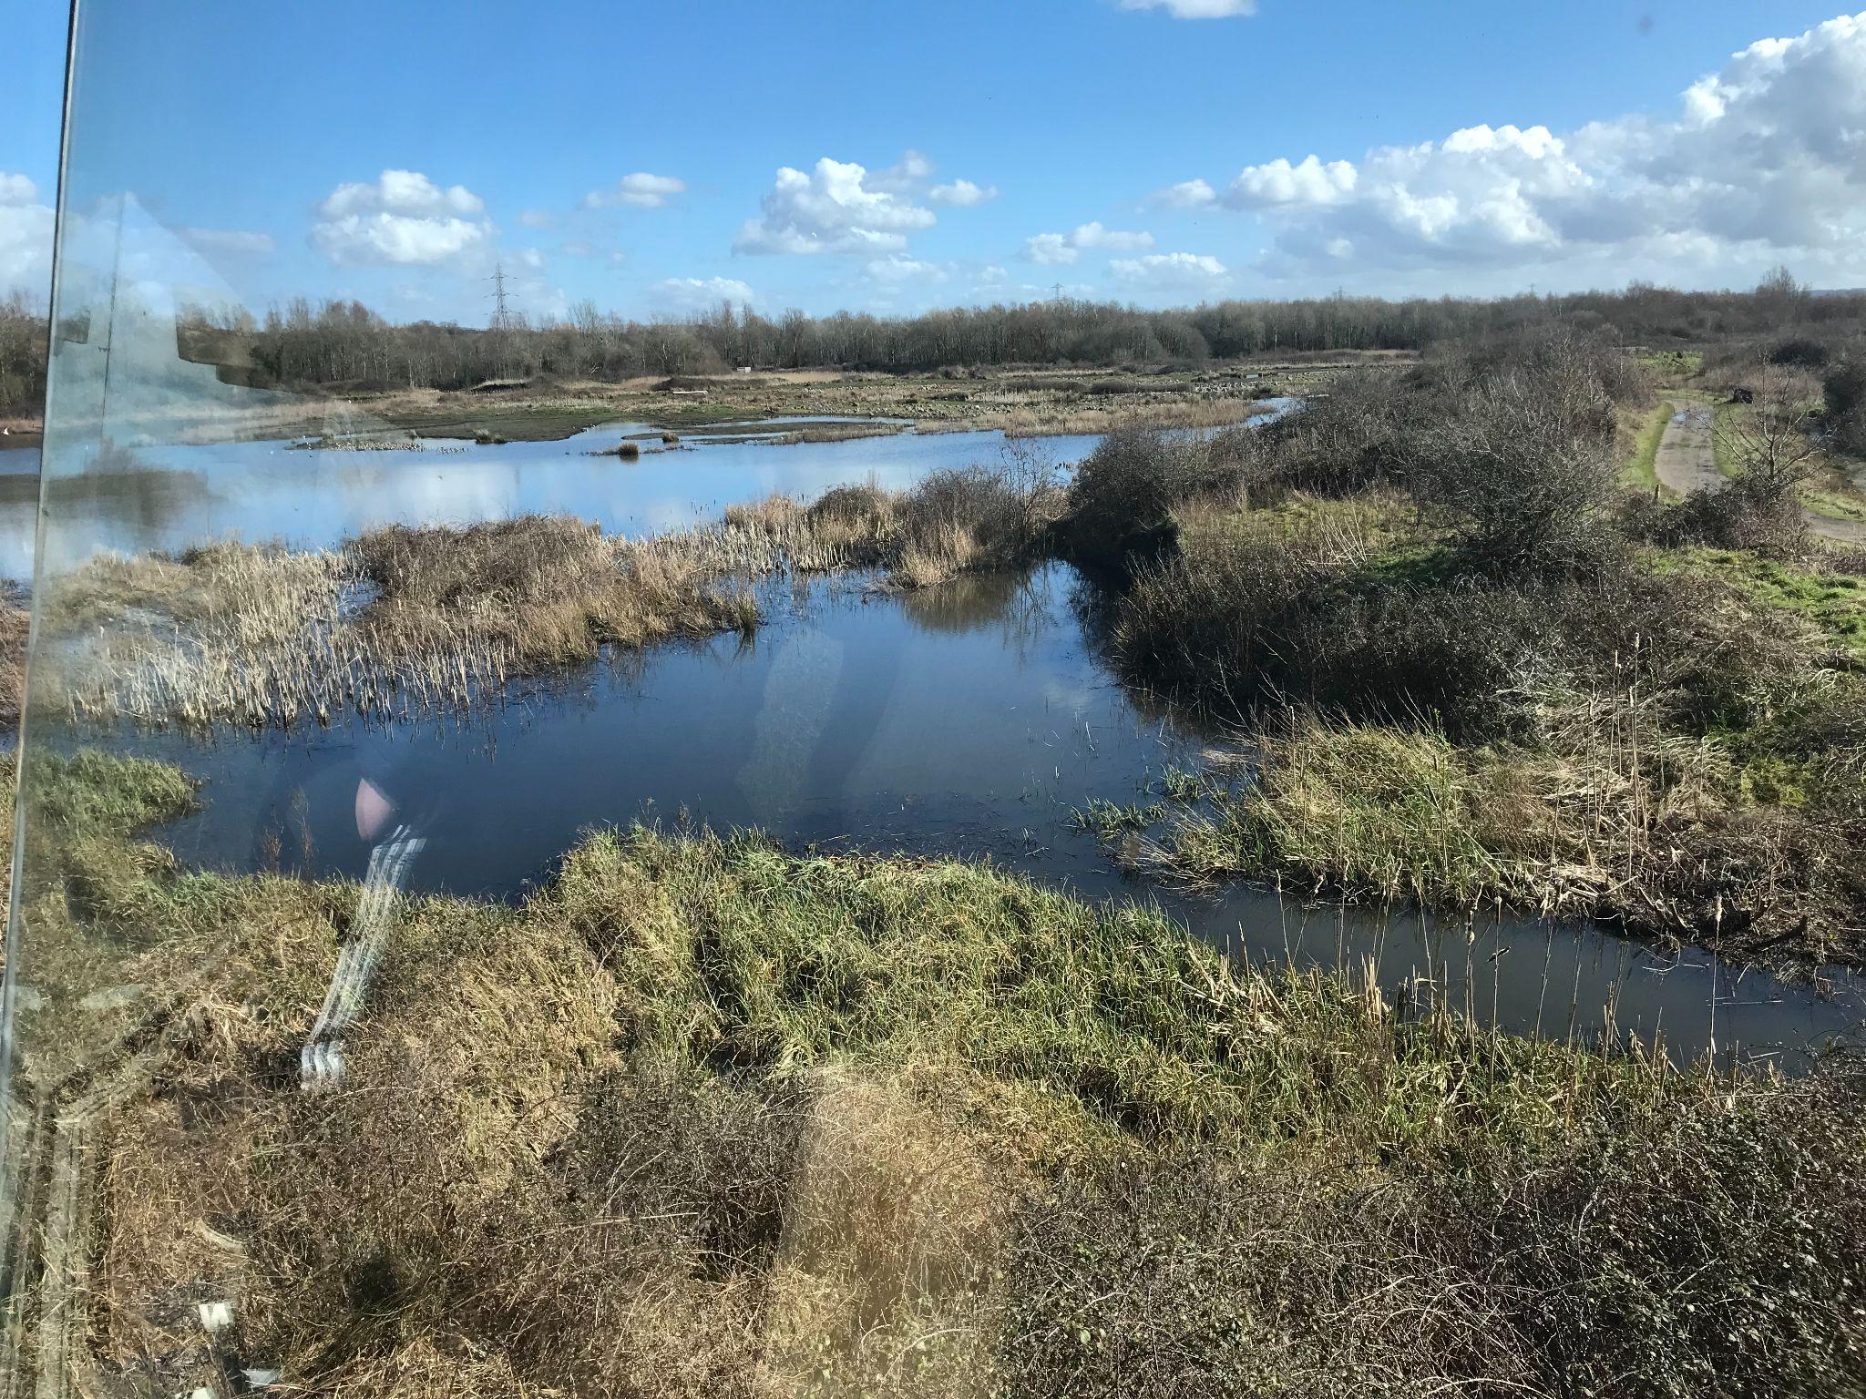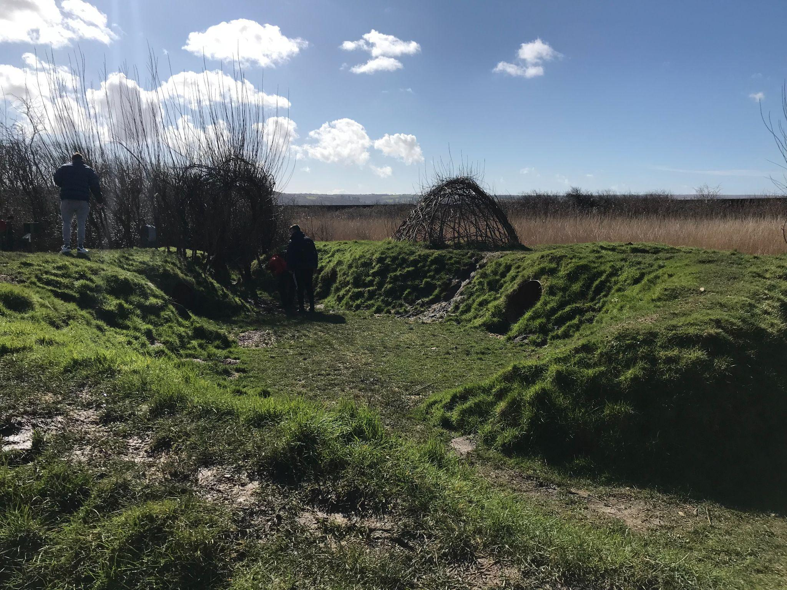Images showing the landscape taken by Tamin (2022)
The Wildfowl and Wetlands Trust Centre in Llanelli is a planned landscape that consists of 450 acre mosaic of lakes, woods, pools, and reedbeds and is a vital refuge for many spectacular birds which in some cases are rare or even endangered. The centre seemed very peaceful on the one side where there were more open spaces and pools whereas the other side of the centre contained smaller sections of different birds and this made it quite noisy and suddenly birds were interacting with visitors. Whereas the birds in the bigger pools were staying away from visitors.

Landscape Quality
Areas within WWT sites are delineated as ‘reserve’ refers to those areas of the site where its main function are associated with biological management and conservation (IUCN NCUK, 2012). They also have Sustainable Drainage Systems (SuDS) in place at many of their centres. These mimic natural drainage systems and so reduce surface water flooding, improve water quality and enhance the biodiversity of the environment rather than directly channelling rainwater to the nearest river as fast as possible (Wildfowl & Wetlands Trust).
Each of the nine WWT reserves have boundaries clearly marked on maps, typically following natural boundaries on the ground (e.g. field boundaries) these boundaries have been digitised across all sites however these digital boundaries have not been fully ground-truthed/verified.
(IUCN NCUK, 2012)
Designations
All WWT reserves have statutory designations, some multiple, including SSSI (8), SNCI (1), SPA (6), SAC (4) Ramsar (6), NNR (2), MNR (1), AONB/NSA (3) and National Park (1) (IUCN NCUK, 2012).
A Site of Special Scientific Interest (SSSI) is a formal conservation designation. Usually, it describes an area that’s of particular interest to science due to the rare species of fauna or flora it contains - or even important geological or physiological features that may lie in its boundaries.
(Woodland Trust, 2019)
A SSSI can be designated to give higher levels of protection than other designations (Woodland Trust, 2019). Most SSSIs are privately-owned or managed. Others are cared for by public bodies or non-government organisations (Woodland Trust, 2019)
JNCC (2021) explains that Special Protection Areas (SPAs) are protected areas for birds in the UK classified under:
- the Wildlife & Countryside Act 1981 (as amended) and the Conservation (Natural Habitats, & c.) Regulations 2010 (as amended) in England, Scotland and Wales,
- the Wildlife (Northern Ireland) Order 1985; the Nature Conservation and Amenity Lands (Northern Ireland) Order 1985; the Conservation (Natural Habitats, &c.) (Northern Ireland) Regulations 1995 (as amended) in Northern Ireland,
- the Conservation of Offshore Marine Habitats and Species Regulations 2017 (as amended) in the UK offshore area, and
- other legislation related to the uses of land and sea
Ramsar Sites are wetlands of international importance that have been designated under the criteria of the Ramsar Convention on Wetlands for containing representative, rare or unique wetland types or for their importance in conserving biological diversity (JNCC, 2019).
Use
For energetic adventurers, the centre has got plenty of exciting outdoor play areas to conquer. Run to the super-wild Explore play area and challenge friends and family to a race through the obstacle course (WWT Llanelli Wetland Centre).

In our daring outdoor adventure playground, Explore, laugh as you leap across mini mud swamps, walk the ropes, balance along beams and hop around like a fearless frog. Race to the wishing well, tiptoe past the Wetland Wizard’s hut, rustle through the reeds, make some noise with our outdoor instruments and see if you’re brave enough to tackle the ‘adventurer route’.
(Wildfowl & Wetlands Trust).
Access
All WWT centres exist to fulfil founder Sir Peter Scott’s vision of connecting people with nature, so we make it a principle that our wetlands and wildlife are accessible to everyone. Llanelli Wetland Centre has excellent access throughout, with wide, flat paths and disabled parking close to the centre. A mobility scooter is available to hire at a cost of just £10 per day (plus a refundable deposit), so please call us to reserve the scooter for your visit.
WWT Llanelli Wetland Centre

There is free visitor parking and racks for cyclists to secure their bikes when they visit. There is also parking for coaches. Please note that the car park is locked after the centre closes at 5pm each day. WWT Llanelli Wetland Centre
Future Potential
This WWT centre does very well to keep its carbon footprint as minimal as possible. As stated by the WWT, they have ‘reduced our site carbon footprint by 40% between 2013 and 2018’. I can see that they are very concerned about how they treat the environment as well as the birds, so an idea that I thought would also get the visitors to feel the same about protecting the birds and the environment is to allow members of the public to volunteer on a weekly basis. This way they can truly see the work that is put into keeping these places open but they can also learn how to care for the wildlife.
Conclusion
To conclude, I think that both of these sites are very important for communities as well as the things that they are trying to preserve. Whether that is culture and heritage or wildlife. As Crooke (2007) mentions ‘heritage and memory are significant for people who are searching for descriptions of themselves and for terms that represent their identity. Cultural heritage generally keeps its importance, however – particularly tangible heritage, because it provides both grounds and resources for constructing collective identity (Critical Perspectives on Cultural Memory and Heritage, 2020). I believe it is crucial for people to learn about the history of the landscape and the people in it in order to move forward and not repeat their mistakes. The lessons of Big Pit have taught me to look at life from a miner's perspective; trying to feed their family even though the job is extremely dangerous. In the work of Sir Peter Scott where his goal was to get people to fall in love with nature through his own desire of protecting birds.
Words: 2566

References

Ashworth, G. J. 2007. ‘1848 and All That’, International Journal of Heritage Studies 13, 511–13.

Britannica, T. Editors of Encyclopaedia (2018). World Heritage site. Encyclopedia Britannica. Available at: https://www.britannica.com/topic/World-Heritage-site (Accessed: 15 April 2022).

Critical Perspectives on Cultural Memory and Heritage (2020). London: UCL Press. doi:10.14324/111.9781787354845.

Crooke, E. 2007. Museums and Community. Ideas, Issues and Challenges. London; New York: Routledge.

DeSilvey, C. 2017. Curated Decay. Heritage Beyond Saving. Minneapolis, MN: University of Minnesota Press. London; New York: Routledge.

Elliott M, Cutts ND, Trono A (2014) A typology of marine and estuarine hazards and risks as vectors of change: a review for vulnerable coasts and their management. Ocean Coast Manage 93:88–99. doi:10.1016/j.ocecoaman.2014.03.014

Gibbs, J.P., 2000. Wetland loss and biodiversity conservation. Cons. Biol. 14, 314-317.

Harrison, R. 2013. Heritage. Critical Approaches. Abingdon; New York: Routledge

Holtorf, C. 2015. ‘Averting Loss Aversion in Cultural Heritage’, International Journal of Heritage Studies 214: 405–21.DOI:10.1080/13527258.2014.938766.

Holtorf, C. 2018. ‘Embracing Change: How Cultural Resilience is Increased through Cultural Heritage’, World Archaeology. DOI: 10.1080/00438243.2018.1510340.

Image of big Pit from wikipedia. Available at: https://upload.wikimedia.org/wikipedia/commons/a/aa/Big_Pit%2C_Blaenavon.jpg

Image of Sir Peter Scott from Tamin (2022)

IUCN NCUK (2012); Putting nature on the map - identifying protected areas in the UK: A handbook to help identify protected areas in the UK and assign the IUCN management categories and governance types to them, IUCN National Committee for the United Kingdom, UK http://www.iucn-uk.org/Portals/0/PNOTM%20Final%20January.pdf

JNCC (2019) Available at: https://jncc.gov.uk/our-work/ramsar-convention/ (Accessed: 15 April 2022).
KNAPP, S., (2000). Wet and wild. Science, 289(5481), pp. 877.
Museum.Wales. Big Pit National Coal Museum. Available at: https://museum.wales/bigpit/visit/access/ (Accessed: 17 April 2022).
National Museum of Wales. Available at: https://museum.wales/media/45813/pitheadsresourceENGLISH.pdf (Accessed: 15 April 2022).

Russi D, ten Brink P, Farmer A, Badura T, Coates D, Fo¨rster J, Kumar R, Davidson N (2013) The Economics of Ecosystems and Biodiversity for Water and Wetlands. Ramsar Secretariat, Gland, IEEP, London and Brussels

Seilheimer TS, Mahoney TP, Chow-Fraser P (2009) Comparative study of ecological indices for assessing human-induced disturbance in coastal wetlands of the Laurentian Great Lakes. Ecol Indicat 9(1):81–91. doi:10.1016/j.ecolind.2008.02.001

Sierszen, M.E. et al. (2012) ‘A review of selected ecosystem services provided by coastal wetlands of the Laurentian Great Lakes’, Aquatic ecosystem health & management, 15(1), pp. 92–106. doi:10.1080/14634988.2011.624970.

Tozer, D.C., Steele, O. and Gloutney, M. (2018) ‘Multispecies benefits of wetland conservation for marsh birds, frogs, and species at risk’, Journal of environmental management, 212, pp. 160–168. doi:10.1016/j.jenvman.2018.01.055.

UNESCO World Heritage Convention. Available at: https://whc.unesco.org/pg.cfm?cid=160 (Accessed: 15 April 2022).
Wildfowl & Wetlands Trust. Available at: https://www.wwt.org.uk/about-us/our-history (Accessed: 13 April 2022).
Woodland Trust (2019) SSSI definition: what is it and what does it mean for conservation and development? Available at: https://www.woodlandtrust.org.uk/blog/2019/03/sssi-definition/ (Accessed: 15 April 2022).
WWT Llanelli Wetland Centre. Available at: https://www.visitwales.com/attraction/nature-or-wildlife/wwt-llanelli-wetland-centre-1971390 (Accessed: 13 April 2022).

