Effective Teamwork and communication
Report

Vladimir Totev

Student: 2024467
Group: 7

Module: Effective Team Work and Communication

—

Module code: BMSW4002

—

Teacher – Anita Nan

TABLE OF CONTENTS

1.Introduction – pg.2-4

2.Models of communication – pg.5-7

3.Example of poor communication – pg.8

4.Conclusion – pg.9

5.References – pg.10

Introduction

The goal of this report is to demonstrate my comprehension of the communication models and communication skills discussed in class.
Communication is each act of transmitting information, which may include thoughts ideas or emotions. For example, giving someone a box of chocolate is communicating a certain message adding to that a verbal compliment is another simple act of communication.
In our daily lives we spoke words, we use non-verbal gestures, signs, and symbols.
To accomplish this, we can use our hands, voice, and eyes to communicate.
Sometimes we also use media to communicate a message, it means that we construct things to amplify the communication.
The communication can be verbal or nonverbal.
Verbal and nonverbal communication is happening more and more in the digital environment. The use of emoticons is becoming more and more common on social networks like Instagram, Facebook etc.
Over the last few years, we've seen a significant increase in their use for marketing purposes. The main reason is straightforward: brands and businesses have discovered that this type of communication is an excellent way to connect with and engage users.
Let’s give an example, with the modern day society its never been easier to connect to the customer services of lets say your broadband provider, so when you have some issue or a billing question you don’t need to dial and wait, it’s enough for you just to pick up your mobile device or Laptop and use the customer services chat to resolve your issue faster, that’s an example for verbal communication in the digital world.
According to Quintanilla, Kelly M Effective communication allows for accurate interpretation of the verbal messages of others because meaning is shared. Otherwise, the meaning of the word you are conveying is not understood. As an expert, you need to use your language skills effectively to improve your ability to interpret the messages of others. Robinson and Robinson (1982) conclude that if the speaker is consistently efficient in conveying the intended meaning orally to the listener, it is necessary to understand that a few factors can lead to aggregation in which the intended meaning is not fully conveyed by the message.
Now the next logical question should be what a nonverbal communication is?
Nonverbal communication encompasses all modes of communication that do not involve the use of words. Nonverbal communication is defined more precisely as: “communication other than written or spoken language that creates meaning for someone" (Ivy & Wahl, 2014, p.5).
We tend to use lasts for the most formal communication, but nonverbal symbols are everywhere. In fact, nonverbal symbols make up 65-93% of the full meaning of communication. (Birdwhistell, 1970; Mehrabian, 1981).
Many theories of language evolution, according to Nolan (1975), shared one important claim: "Nonverbal behaviour precedes verbal behaviour in the evolution of communication" (p.101).
In terms of behaviour there are a lot of different examples of nonverbal communication.
The way you walk, posture, stance and even your footsteps are form of nonverbal communication.
What you wear and how you look, move, and gesture, as well as the facial and eye
expressions you make all count as nonverbal communication" (Ivy & Wahl,2014, p. 6)

MODELS OF COMMUNICATON

There are different models of communication.
Let’s start with Shannon Weaver model of communication.
It was founded in 1948, when Claude Elwood Shannon and Warren Weaver published “A Mathematical Theory of Communication” in the Bell System Technical Journal.
Shannon was a mathematician from the United States, but Weaver was a scientist. The mathematical theory was later dubbed the Shannon Weaver communication model or "the mother of all models." This linear model is more technical than others.

Shannon Weaver model of communication
Sender (information source) - The person who composes the message and selects a channel before sending it is referred to as the sender.
Encoder (Transmiter) - An encoder is a sender who uses a system to convert a message into a signal or binary data. You can also refer to the machine directly.
Channel - A channel is a medium for transmitting messages.
Decoder (Reciever) - A decoder is a machine that converts signals or binary data into messages, or a receiver that does the same.
Receiver (Destination) - The recipient of the message or the location to which the message must be delivered is referred to as the Receiver. He responds to the message by providing feedback.
Noise - Noise is a physical disturbance to the environment, people, or other objects that prevents a message from being delivered to the intended recipient in the way it was sent.

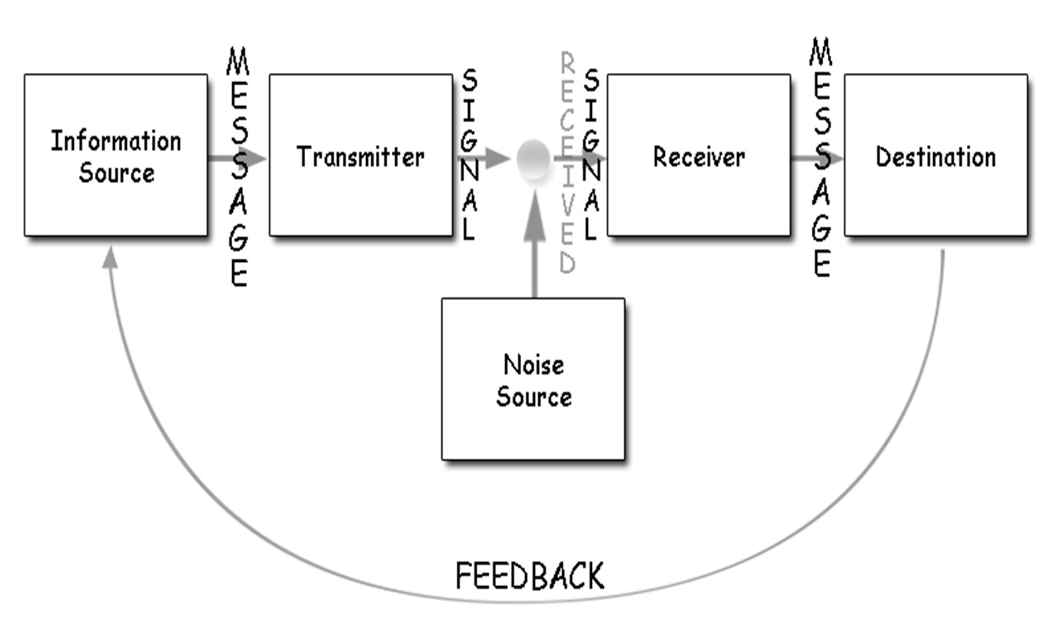
The sender encrypts the message before transmitting it to the recipient via a technology channel such as telephone or telegraph. The message is converted into machine-readable code by the sender. The message is transmitted in code via a medium.
Before the message can be understood and interpreted, the receiver must decrypt it. The receptor machine can also act as a decoder in some cases. The channel may be noisy, and there may be times when the receiver is unable to decode, causing communication problems. In this case, for example, the sender's mouth can be encoded in a specific language. It's possible that air is the channel, someone else's ear is the receptor, and his brain is the receiver and decoder.
Similarly, in this case, air is a channel, the environment that prevents signal transmission is noise, and his response is feedback. When the model was created, there were only five parts. Following that, noise was added.
Being a engineer, Shannon created it primarily to improve the communication of technology for telephone communication. It was built to maximize phone capacity with minimal noise.
After that, Weaver applied it to all kinds of communication to develop the effective communication and became famous as the Shannon Weaver model.
For example:
Nasa`s ground centre sends a message to International Space Station about a medical trial that will happen between the crew on the station. The crew did not receive the full message because of noise:
Nasa: We have a medical trial happening today including all the crew at (1300 CET goes missing due to radio interference.)
Crew: At what time, connection is bad?
Sender: NASA
Encoder: Nasa encrypted network
Channel: Satellite 22
Noise: Missing text due to radio interference
Decoder: Satellite network

Receiver: International space station crew
The transmission error in that case is the radio interference.
The feedback from the crew informs NASA that the message was received incomplete.
Only after the feedback, the receiver gets the chance to Get the full message.

Schramm’s model of communication

Another communication model is Schramm's model, which is derived from the Shannon weaver model. It was proposed by Wilber Schramm in 1954.
Information is meaningless unless carefully spoken and passed on to others. By transforming thoughts into content, encoding plays a critical role in initiating the communication process. When information is delivered to the recipient, his primary responsibility is to comprehend what the speaker is attempting to convey. Until the other party is able to decipher the messages, they are useless. Without decoding and encoding, there would be no communication. He also emphasizes that the sender has not received feedback from the recipient and the communication up to that point is incomplete. Schramm believed that communication was actually a two-way process between the two parties.

Sender
M↓ ↑M
Receiver

Poor communication and examples

I can suggest as an example of poor communication on my previous working place.
I have been an Optician for a few years in the town I used to live.
As a part of my job, I was responsible for all contact lenses in the branch, including insertion and removal, contact lens trial, contact lens fitting etc.
Each change is supposed to be made by optometrist must be written in a special folder with the name of the patient, the date, and the type of the lenses.
One day we were testing with around 17 patients and the manager was supposed to organize those folders, unfortunately he did not hear clearly that the patient was with diabetes and that resulted in a wrong calculation for the contact lenses.
The result was unfortunate for the client who was waiting couple of days for his new lenses only to realise that its wrong dioptre because of wrong calculations regarding the poor communication between the manager and me as a dispensing optician.

Another example of poor communication is a very recent story regarding our group presentation for this module.
As we supposed to have a group presentation with a 5 members incl. a group leader and communicate during the whole term and prepare the presentation.
Unfortunately, our group leader was most of the times absent during our group calls, so we had to re-do the design because it was terrible.
Because of the poor communication last day before the submission, she thought it’s a good idea to change all of our design and even deleted one of the slides of my colleagues and upload it without even asking for confirmation.

That can be improved by more listening, focusing, and taking the project seriously, including reading all the updates in our group regularly and communicate more between participants and asking each other opinion. When there is a team task with a group leader, he is supposed to unite and resolve issues. If there is a failure in the team task, the leader is the one who must take responsibility for the team actions.

Communication, as well as other relationships, is the key to strong business relationships. It is relationship between a business and a customer, or a similar internal relationship between various employees of an important company.

Poor communication is very important issue in the workplace, but it is not always easy. Employees should have the right motivation to resolve the situation at work.

Conclusion

Communication is very important in virtually any workplace, regardless of industry and size.
After all, it is the only way information can spread effectively throughout your business, making sure everyone is informed to the extent necessary to properly achieve their goals.
Ideally, people need clear communication at a comfortable speed with practical vocabulary and a compelling tone. The point must be reached before the listener loses interest or misses the point altogether.
Communication is an important part of our lives. Therefore, we need to recognize the barriers to effective communication and decide how to overcome them. Effective communication is essential to the proper implementation of the communication proc

References
Maund, A. (2017). Certificate in higher education: skills for the workplace student yearbook. London: Sage Publications. ‌
Quintanilla, K.M. and Wahl, S.T. (2020). Business and professional communication keys for workplace excellence. Los Angeles Sage.
Griffith, B.A. and Dunham, E.B. (2015). Working in teams: moving from high potential to high performance. Los Angeles: Sage.

